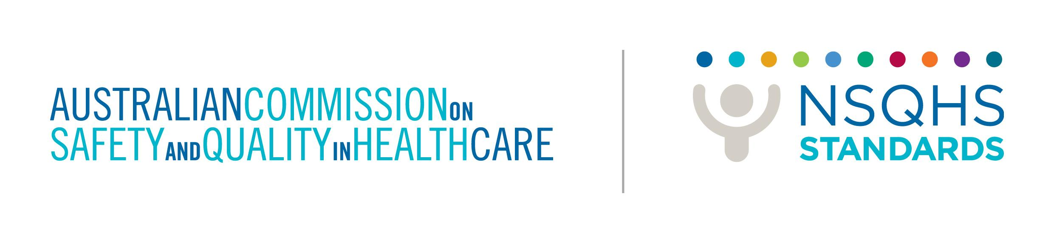


TRIM 71845

Non Applicable Actions
The Commission has negotiated with Regulators and Accrediting Agencies the process of health service organisations applying for actions to be non applicable and verifying applications. Two mechanisms exist for conferring not applicable actions:
- Actions declared by the Commission
Health service organisations can review the actions that have been ‘declared’ non applicable by the Commission. Tables have been developed for categories of hospital and day procedure services that identify actions that may not be applicable, and these can be found on the Commission’s website at www.safetyandquality.gov.au
When applying for these actions with an accrediting agency, health service organisations need to submit details of declared non applicable actions that apply to their service and confirm that they are non applicable to their service.
- Written submissions
For all other actions that health services are seeking to be considered not applicable, written applications need to be submitted to the accrediting agency for consideration.
Non applicable actions can relate to:
- Health care - including diagnosis, treatment and management
- Equipment - including tools, resources, diagnostic, implantable or invasive equipment and equipment for the delivery of care
- Processes - including governance, implementation or management processes.
Applications can be made for whole standards, items or individual actions.
Assessment criteria
A submission for non applicable status of a standard, item or action must meet one or more of the following criteria:
- The regulator has specified the level or type of service, therefore the Standard, item or action cannot be provided or performed by the health service organisation.
- The Standard, item or action is not provided or performed by the health service organisation under its model of service provision.
- The mix and skills of the workforce limit the services provided by the health service organisation, therefore the Standard, item or action is not provided or performed by the health service organisation.
- The type and methods of care delivered by a service is determined by its patient population, therefore it is not appropriate for the Standard, item or action to be provided or performed by the health service organisation.
Submission of applications for not applicable status to accrediting agencies
Health service organisations applying for not applicable status are to submit information on any action being sought for consideration with their application. This may include:
- Unique number for all core actions (including ‘declared’ non applicable actions)
- Unique number for all developmental actions (including ‘declared’ non applicable actions)
- Description of the health service organisation, including demographics, which may be detailed in the organisation’s role delineation documentation or on a private health facility license
- Detail of relevant clinical pathways and/or models of care
- Detail of relevant policies, procedures or protocols
- Strategic or operational plans
- Evidence of history of low or no risk in the service
- Staff profile and their location in service units
- Inclusion or exclusion criteria for patients

Exclusion: Not applicable status cannot be awarded to a health service organisation, if it provides a service, even if it is on an infrequent basis.

Both core and developmental actions can be considered non applicable. Accreditation will involve the assessment of developmental actions to ensure that they are being addressed by the organisation. If a developmental action is considered by the health service organisation to be non applicable, an application for not applicable status must be made to the accrediting agency and have it considered in the same way as core items are considered.

