# Australian COmmission on Safety and Quality in Health Care logo with Radar imageOn the Radar

Issue 433

9 September 2019

*On the Radar* is a summary of some of the recent publications in the areas of safety and quality in health care. Inclusion in this document is not an endorsement or recommendation of any publication or provider. Access to particular documents may depend on whether they are Open Access or not, and/or your individual or institutional access to subscription sites/services. Material that may require subscription is included as it is considered relevant.

*On the Radar* is available online, via email or as a PDF or Word document from <https://www.safetyandquality.gov.au/publications-and-resources/newsletters/radar>

If you would like to receive *On the Radar* via email, you can subscribe on our website <https://www.safetyandquality.gov.au/publications-and-resources/newsletters>   
or by emailing us at H[Umail@safetyandquality.gov.auU](mailto:mail@safetyandquality.gov.au).   
You can also send feedback and comments to H[Umail@safetyandquality.gov.auU](mailto:mail@safetyandquality.gov.au).

For information about the Commission and its programs and publications, please visit <https://www.safetyandquality.gov.au>

You can also follow us on Twitter @ACSQHC.

**On the Radar**

Editor: Dr Niall Johnson [niall.johnson@safetyandquality.gov.au](mailto:niall.johnson@safetyandquality.gov.au)

Contributors: Niall Johnson

**Reports**

*Implementing health in all policies: Lessons from around the world*

Greszczuk C, editor

London: The Health Foundation; 2019.

|  |  |
| --- | --- |
| URL | <https://www.health.org.uk/publications/reports/implementing-health-in-all-policies> |
| Notes | The state of our health has an impact or influence on almost every part of our lives while many facets of our lives and our environments can influence our health (as is made explicit in social determinants of health or public health approaches). Consequently, the mantra of health being a consideration in all public policy has been often mouthed. This report from the UK’s Health Foundation is a collection of nine case studies of attempts to implement “health in all policies” from around the world. The nine case studies provide insights into the practicalities of delivering a health in all policies approach in different contexts, sectors and levels of government. Each example offers ideas and learning points that policymakers and practitioners may draw on and adapt to design and deliver initiatives in their areas. The nice case studies are:   1. Embedding social sustainability across Malmö 2. Improving air quality in Paris 3. Tackling social exclusion in South Australia 4. Coordinating US action on prisoner reoffending 5. Increasing access to healthy foods in Pennsylvania 6. Targeting health inequalities through government reform in Norway 7. Tackling obesity in Canada through urban design 8. Boosting cross-sector work through coaching in the Netherlands 9. Taxing unhealthy foods to improve health in Hungary. |

**Journal articles**

*Automated detection of wrong-drug prescribing errors*

Lambert BL, Galanter W, Liu KL, Falck S, Schiff G, Rash-Foanio C, et al

BMJ Quality & Safety. 2019 [epub]

|  |  |
| --- | --- |
| DOI | <https://doi.org/10.1136/bmjqs-2019-009420> |
| Notes | Medication errors are one of the more common errors in healthcare and the promise of technology/artificial intelligence to assist in detecting and reducing these has been held out for some time. This paper describes how one academic medical centre (comprising a 495-bed hospital and outpatient clinic) developed an algorithm to detect look-alike/sound-alike (LASA) medication prescribing errors in electronic health record (EHR) data. The algorithm triggered for LASA errors based on name similarity, the frequency with which a patient received a medication and whether the medication was justified by a diagnostic claim. Using a dataset of 8 years of medication orders and diagnostic claims, ‘algorithm was used to analyse 488 481 orders and generated 2404 triggers (0.5% rate). Clinicians reviewed 506 cases and confirmed the presence of 61 errors, for an overall PPV [positive predictive value] of 12.1% (95% CI 10.7% to 13.5%). It was not possible to measure sensitivity or the false-negative rate.’ The authors claim that ‘Automated detection of LASA medication errors is feasible and can reveal errors not currently detected by other means.’ However, they also noted that ‘Real-time error detection is not possible with the current system, the main barrier being the real-time availability of accurate diagnostic information.’ |

For information on the Commission’s work on medication safety, see <https://www.safetyandquality.gov.au/our-work/medication-safety>

*Machine learning in clinical practice: prospects and pitfalls*

Scott IA, Cook D, Coiera EW, Richards B

Medical Journal of Australia. 2019;211(5):203-5.e1.

|  |  |
| --- | --- |
| DOI | <https://doi.org/10.5694/mja2.50294> |
| Notes | This piece in the *Medical Journal of Australia* provides a current perspective on machine learning (ML) in contemporary (and future) clinical practice. While there is (as seen in the previous item and in examples in this paper) demonstrable utility, this piece also identifies some of the challenges. The authors conclude that ‘While ML will likely disrupt clinical practice over coming decades, particularly imaging‐based disciplines, it requires judicious application. ML can provide better, more patient‐specific information, affording clinicians greater capacity to make the most appropriate clinical decisions in partnership with their patients.’ |

*Medication Use to Reduce Risk of Breast Cancer: US Preventive Services Task Force Recommendation Statement*

U. S. Preventive Services Task Force

JAMA. 2019;322(9):857-67.

*Medication Use for the Risk Reduction of Primary Breast Cancer in Women: Updated Evidence Report and Systematic Review for the US Preventive Services Task Force*

Nelson HD, Fu R, Zakher B, Pappas M, McDonagh M

JAMA. 2019;322(9):868-86.

*Medications to Reduce Breast Cancer Risk: Promise and Limitations*

Pace LE, Keating NL

JAMA. 2019;322(9):821-3.

*Medications to Reduce Breast Cancer Risk*

Jin J

JAMA. 2019;322(9):900.

|  |  |
| --- | --- |
| DOI | U.S. Preventive Services Task Force <https://doi.org/10.1001/jama.2019.11885>  Nelson et al <https://doi.org/10.1001/jama.2019.5780>  Pace and Keating <https://doi.org/10.1001/jama.2019.9689>  Jin <https://doi.org/10.1001/jama.2019.12858> |
| Notes | Breast cancer is among the most prevalent of cancers and in a recent issue we included the U.S. Preventive Services Task Force recommendation on risk assessment, genetic counselling, and genetic testing for potentially harmful BRCA1/2 mutations. The US Preventive Services Task Force has now released their recommendation on medications to reduce breast cancer risk. Their statement, the evidence report and systematic review that inform the recommendation. (Nelson et al) and an editorial (Pace and Keating) have all been published, along with a ‘Patient Page’ (Jin) in *JAMA*.  The USPSTF recommends that:   * Clinicians offer to prescribe risk-reducing medications, such as tamoxifen, raloxifene, or aromatase inhibitors, to women who are at increased risk for breast cancer and at low risk for adverse medication effects. (B recommendation) * The USPSTF recommends against the routine use of risk-reducing medications, such as tamoxifen, raloxifene, or aromatase inhibitors, in women who are not at increased risk for breast cancer. (D recommendation)   [The USPSTF recommends that: Clinicians offer to prescribe risk-reducing medications, such as tamoxifen, raloxifene, or aromatase inhibitors, to women who are at increased risk for breast cancer and at low risk for adverse medication effects. (B recommendation)  The USPSTF recommends against the routine use of risk-reducing medications, such as tamoxifen, raloxifene, or aromatase inhibitors, in women who are not at increased risk for breast cancer. (D recommendation)](https://doi.org/10.1001/jama.2019.12858) |

*Competencies for improving diagnosis: an interprofessional framework for education and training in health care*

Olson A, Rencic J, Cosby K, Rusz D, Papa F, Croskerry P, et al.

Diagnosis 2019 [epub].

|  |  |
| --- | --- |
| DOI | <http://doi.org/10.1515/dx-2018-0107> |
| Notes | Issues around diagnosis, including diagnostic error, misdiagnosis, delayed diagnosis, have emerged in recent years. How to address such issues has not been obvious. This paper describes a framework for improving diagnostic competency across health professions education programs. An interprofessional group sought to identify the key competencies that should be considered for inclusion in health professions education programs to improve the quality and safety of diagnosis in clinical practice.  ‘Twelve competencies were identified.  Six of these are **individual competencies**: The first four (#1–#4) focus on **acquiring the key information needed for diagnosis and formulating an appropriate, prioritized differential diagnosis**; individual competency #5 is taking advantage of **second opinions, decision support, and checklists**; and #6 is using **reflection and critical thinking** to improve diagnostic performance.  Three competencies focus on **teamwork**: Involving the patient and family (#1) and all relevant health professionals (#2) in the diagnostic process; and (#3) ensuring safe transitions of care and handoffs, and “closing the loop” on test result communication. The final three competencies emphasize **system-related aspects** of care: (#1) Understanding how **human-factor elements** influence the diagnostic process; (#2) developing a **supportive culture**; and (#3) **reporting and disclosing diagnostic errors** that are recognized, and **learning** from both successful diagnosis and from diagnostic errors.’ |

*American Journal of Medical Quality*

Volume: 34, Number: 5 (September/October 2019)

|  |  |
| --- | --- |
| URL | <https://journals.sagepub.com/toc/ajmb/34/5> |
| Notes | A new issue of the *American Journal of Medical Quality* has been published. Articles in this issue of the *American Journal of Medical Quality* include:   * Prevention of **Nosocomial Catheter-Associated Urinary Tract Infections** Through Computerized Feedback to Physicians and a Nurse-Directed Protocol (Jeffrey Topal, Sandra Conklin, Karen Camp, Victor Morris, Thomas Balcezak, and Peter Herbert) * TeamSTEPPS: Assuring **Optimal Teamwork in Clinical Settings** (Carolyn M Clancy and David N Tornberg) * The **Quality of Qualitative Research** (Dave S Collingridge and E E Gantt) * Systematic Review of **Handoff Mnemonics Literature** (Lee Ann Riesenberg, Jessica Leitzsch, and Brian W Little) * Approaching the Evidence Basis for **Aviation-Derived Teamwork Training** in Medicine (Marina V Zeltser and David B Nash) * **Physician Assistant and Nurse Practitioner Utilization** in Academic Medical Centers (Marc Moote, Cathleen Krsek, Ruth Kleinpell, and B Todd) * **United States Registered Nurse Workforce** Report Card and Shortage Forecast (Stephen P Juraschek, X Zhang, V Ranganathan, and V W Lin) * Big Things Come in Bundled Packages: Implications of **Bundled Payment Systems** in Health Care Reimbursement Reform (Dennis R Delisle) * Reduction in **Central Line–Associated Bloodstream Infection** Rates After Implementations of Infection Control Measures at a Level 3 Neonatal Intensive Care Unit (Vikramaditya Dumpa, Bonny Adler, Delena Allen, Deborah Bowman, Amy Gram, Pat Ford, and Sulaiman Sannoh) * Clinical Decision Support for **Early Recognition of Sepsis** (Robert C Amland and Kristin E Hahn-Cover) * What Is the Return on Investment for Implementation of a **Crew Resource Management Program** at an Academic Medical Center? (Susan D Moffatt-Bruce, Jennifer L Hefner, Hagop Mekhjian, John S McAlearney, Tina Latimer, Chris Ellison, and Ann Scheck McAlearney) * **Unifying the Health Care Ecosystem to Eliminate Preventable Harm** (Joe Kiani) * **Code-Switching and Handoff Communication** Processes (Jessica Wendorf Muhamad, Tyler R Harrison, Fan Yang, and Sean Sawicki) * Addressing Internal Medicine Residents’ Discomfort With **Basic Dermatology in Persons of Color** in the Primary Care Clinic (Shankar N Mundluru, Nirmala D Ramalingam, and H Nicole Tran) * Issues of **Version Control in EHR-Generated Clinical Summaries for Patients** (Erin Sarzynski, Kevin Brooks, Kirsta Bray, Michele C Fritz, and Mathew J Reeves) * **Medical Student Resiliency**: An Approach to Improving Quality of Health Care (Don Hayes, Jr) * One-Year Changes in **Intern Physicians’ Quality Improvement and Patient Safety** Knowledge, Awareness, Engagement, and Interest (Ari B Filip, Carol R Thrush, Timothy Atkinson, Paula Podrazik, Travis Eastin, Muhammad Jaffar, and James A Clardy) * “Celebrating the 20th Anniversary of **To Err is Human**” (Mary Reich Cooper, Aline Holmes, Arlene Seid, C E Gonzalez, and L-Q MacDonald) |

*Health Affairs*

Volume 38, No. 9

|  |  |
| --- | --- |
| URL | <https://www.healthaffairs.org/toc/hlthaff/38/9> |
| Notes | A new issue of *Health Affairs* has been published with the themes “Neighborhoods & Health, Medicaid & More”. Articles in this issue of *Health Affairs* include:   * For The Uninsured In Memphis, **A Stronger Safety Net** (Bara L Vaida) * **Gentrification And The Health Of Low-Income Children** In New York City (Kacie L Dragan, Ingrid Gould Ellen, and Sherry A Glied) * Cooling The Hot Spots **Where Child Hospitalization Rates Are High**: A Neighborhood Approach To Population Healthm (Andrew F Beck, Kristy L Anderson, Kate Rich, Stuart C Taylor, S B Iyer, U R Kotagal, and R S Kahn) * Experiment To Decrease **Neighborhood Poverty** Had Limited Effects On **Emergency Department Use** (Craig E Pollack, Shawn Du, Amanda L Blackford, and Bradley Herring) * Can Medicaid Expansion Prevent **Housing Evictions**? (Heidi L Allen, Erica Eliason, Naomi Zewde, and Tal Gross) * When Crises Converge: **Hospital Visits Before And After Shelter Use** Among Homeless New Yorkers (Dan Treglia, Eileen L Johns, Maryanne Schretzman, Jacob Berman, Dennis P Culhane, David C Lee, and K M Doran) * **Enabling Services Improve Access** To Care, Preventive Services, And Satisfaction Among Health Center Patients (Dahai Yue, Nadereh Pourat, Xiao Chen, Connie Lu, Weihao Zhou, Marlon Daniel, Hank Hoang, Alek Sripipatana, and Ninez A Ponce) * Transforming City Streets To **Promote Physical Activity And Health Equity** (Keshia M Pollack Porter, Tyler Prochnow, Patricia Mahoney, Haley Delgado, Christina N Bridges Hamilton, Emily Wilkins, and M R U Meyer) * Variability In States’ **Coverage Of Children With Medical Complexity** Through Home And Community-Based Services Waivers (Jessica Keim-Malpass, Leeza Constantoulakis, and Lisa C Letzkus) * **Emergency Department Closures And Openings**: Spillover Effects On Patient Outcomes In Bystander Hospitals (Renee Y Hsia, and Yu-Chu Shen) * Spending On **Postacute Care After Hospitalization** In Commercial Insurance And Medicare Around Age Sixty-Five (Scott E Regenbogen, Anne H Cain-Nielsen, John D Syrjamaki, Lena M Chen, and Edward C Norton) * Marketwide Price Transparency Suggests Significant Opportunities For **Value-Based Purchasing** (Anna D Sinaiko, Pragya Kakani, and M B Rosenthal) * The Centers For Medicare And Medicaid Services **Hospital Ratings**: Pitfalls Of Grading On A Single Curve (Jeanette W Chung, Allison R Dahlke, Cynthia Barnard, John O DeLancey, Ryan P Merkow, and Karl Y Bilimoria) * **Prescription Drug Monitoring Program** Mandates: Impact On Opioid Prescribing And Related Hospital Use (Hefei Wen, Jason M Hockenberry, Philip J Jeng, and Yuhua Bao) * Financial Incentives Increase **Purchases Of Fruit And Vegetables Among Lower-Income Households** With Children (Alyssa Moran, Anne Thorndike, Rebecca Franckle, Rebecca Boulos, Heather Doran, Aarohee Fulay, Julie Greene, Dan Blue, Jason P Block, Eric B Rimm, and Michele Polacsek) * The Relationship Between **Health Spending And Social Spending** In High-Income Countries: How Does The US Compare? (Irene Papanicolas, Liana R Woskie, Duncan Orlander, E John Orav, and Ashish K Jha) * In Low- And Middle-Income Countries, Is **Delivery In High-Quality Obstetric Facilities** Geographically Feasible? (Anna D Gage, Fei Carnes, Jeff Blossom, Jalemba Aluvaala, Archana Amatya, Kishori Mahat, Address Malata, Sanam Roder-DeWan, Nana Twum-Danso, Talhiya Yahya, and M E Kruk) * Students Shouldn’t Merely **‘Survive’ Medical School** (Eli M Cahan) |

*BMJ Quality and Safety* online first articles

|  |  |
| --- | --- |
| URL | <https://qualitysafety.bmj.com/content/early/recent> |
| Notes | *BMJ Quality and Safety* has published a number of ‘online first’ articles, including:   * **Coproduction**: when users define quality (Glyn Elwyn, Eugene Nelson, Andreas Hager, Amy Price) * Editorial: Challenges in **translating mortality risk to the point of care** (Vincent J Major, Yindalon Aphinyanaphongs) * Impact of a system-wide quality improvement initiative on **blood pressure control**: a cohort analysis (Elizabeth R Pfoh, Kathryn Martinez, Nirav Vakharia, Michael Rothberg) |

**Online resources**

*World Sepsis Day 2019*

<https://www.australiansepsisnetwork.net.au/world-sepsis-day>

[www.world-sepsis-day.org](http://www.world-sepsis-day.org)

13 September is World Sepsis Day. World Sepsis Day is a Global Sepsis Alliance initiative that started in 2012 and occurs every year with events held all over the world to raise awareness about sepsis.

World Sepsis Day is an opportunity for people worldwide to unite in the fight against sepsis which accounts for at least 8 million deaths worldwide annually.

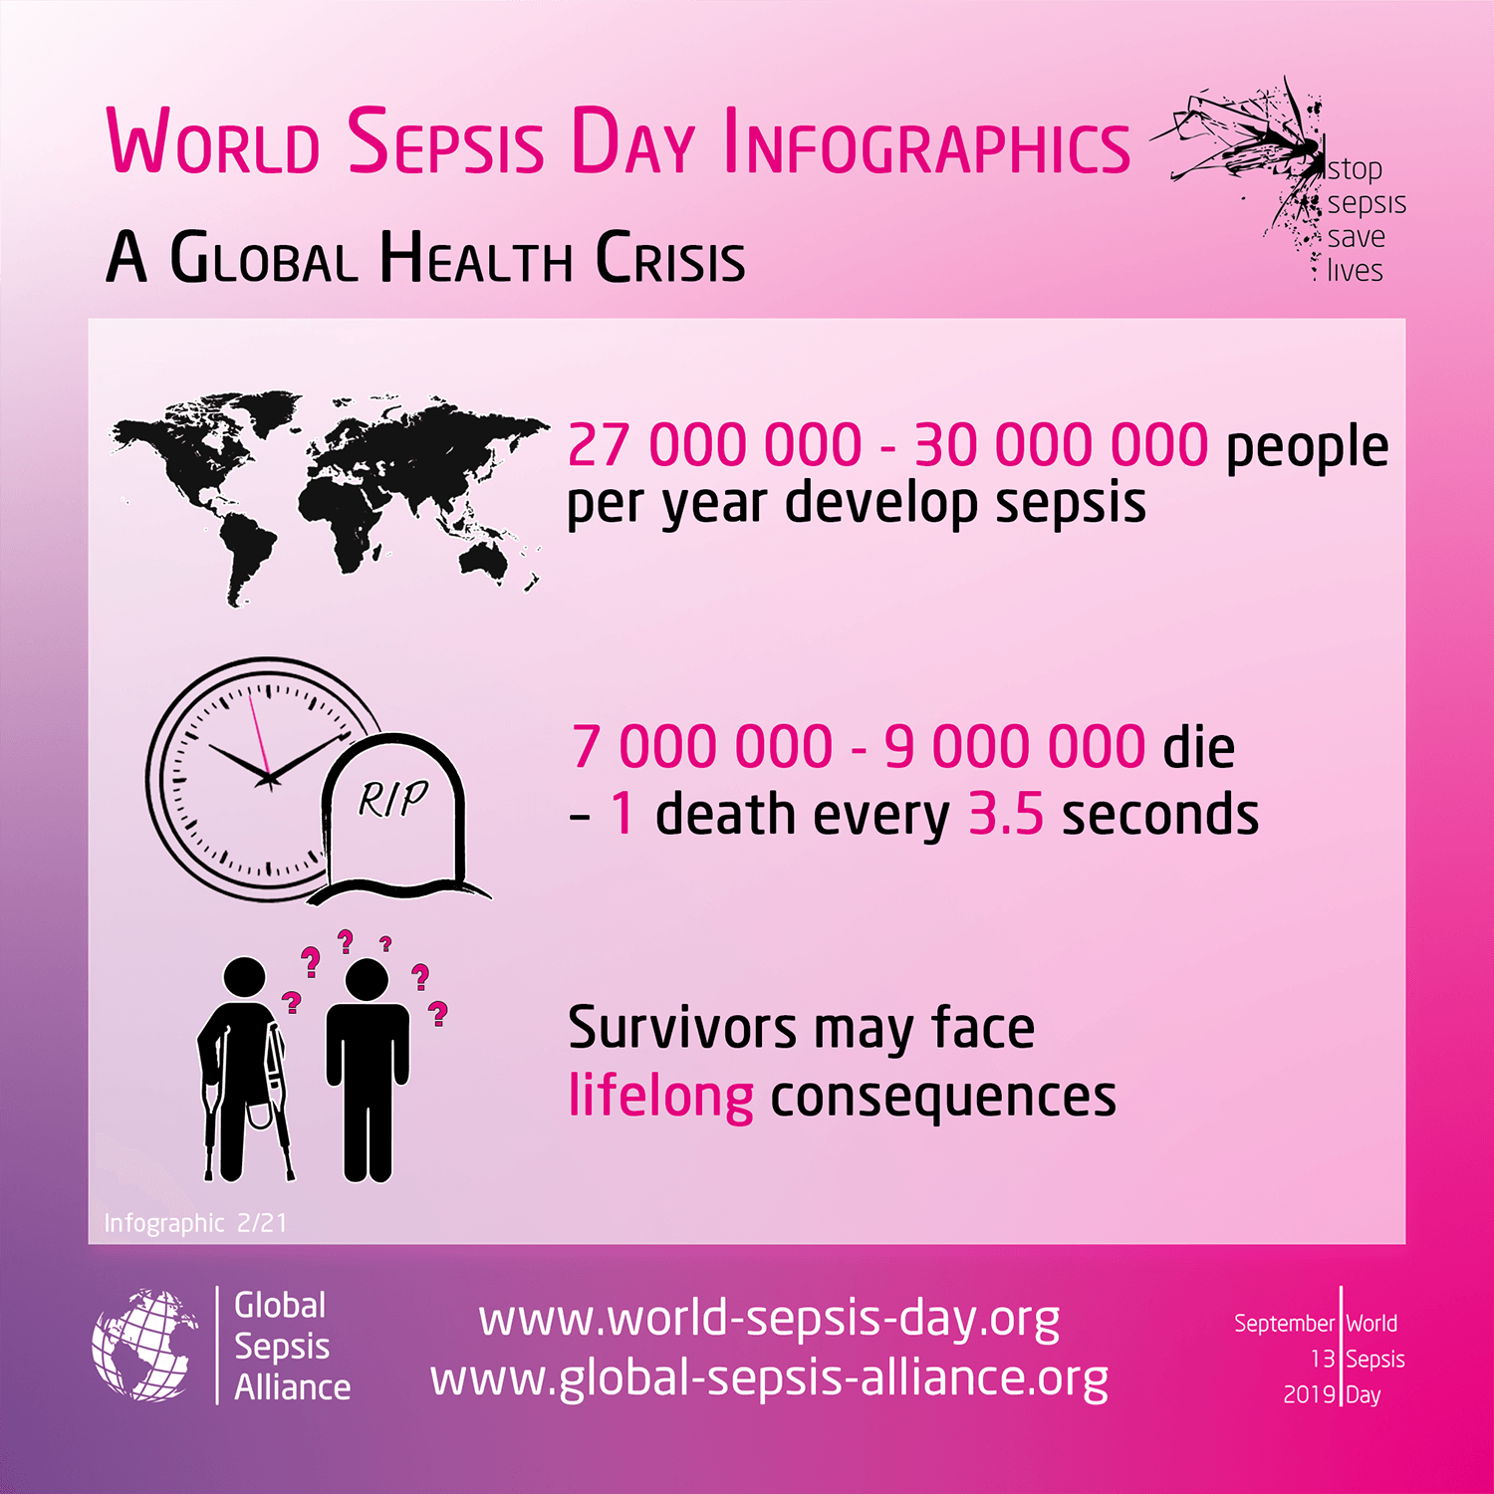

*[UK] NICE Guidelines and Quality Standards*

<https://www.nice.org.uk/guidance>

The UK’s National Institute for Health and Care Excellence (NICE) has published new (or updated) guidelines and quality standards. The latest reviews or updates are:

* NICE Guideline NG137 ***Twin and triplet pregnancy*** <https://www.nice.org.uk/guidance/ng137>
* Quality Standard QS46 ***Multiple pregnancy****: twin and triplet pregnancies* <https://www.nice.org.uk/guidance/qs46>

*[USA] Effective Health Care Program reports*

<https://effectivehealthcare.ahrq.gov/>

The US Agency for Healthcare Research and Quality (AHRQ) has an Effective Health Care (EHC) Program. The EHC has released the following final reports and updates:

* *Antipsychotics for the Prevention and Treatment of* ***Delirium***  
  <https://effectivehealthcare.ahrq.gov/products/antipsychotics/research>
* *Comparative Effectiveness of* ***Analgesics*** *To Reduce Acute Pain in the* ***Prehospital Setting***<https://effectivehealthcare.ahrq.gov/products/acute-pain-ems/research>
* *Web Interactive Presentation of EPC Reports: A Foray Into* ***Interactive Reports***<https://effectivehealthcare.ahrq.gov/products/web-interactive-presentation/methods-report>

**Disclaimer**

On the Radar is an information resource of the Australian Commission on Safety and Quality in Health Care. The Commission is not responsible for the content of, nor does it endorse, any articles or sites listed. The Commission accepts no liability for the information or advice provided by these external links. Links are provided on the basis that users make their own decisions about the accuracy, currency and reliability of the information contained therein. Any opinions expressed are not necessarily those of the Australian Commission on Safety and Quality in Health Care.