
On the Radar
Issue 435
23 September 2019

On the Radar is a summary of some of the recent publications in the areas of safety and quality in health care. Inclusion in this document is not an endorsement or recommendation of any publication or provider. Access to particular documents may depend on whether they are Open Access or not, and/or your individual or institutional access to subscription sites/services. Material that may require subscription is included as it is considered relevant.

On the Radar is available online, via email or as a PDF or Word document from https://www.safetyandquality.gov.au/publications-and-resources/newsletters/radar

If you would like to receive On the Radar via email, you can subscribe on our website https://www.safetyandquality.gov.au/publications-and-resources/newsletters
or by emailing us at HUmail@safetyandquality.gov.auU.
You can also send feedback and comments to HUmail@safetyandquality.gov.auU.

For information about the Commission and its programs and publications, please visit https://www.safetyandquality.gov.au
You can also follow us on Twitter @ACSQHC.
On the Radar
Editor: Dr Niall Johnson niall.johnson@safetyandquality.gov.au
Contributors: Niall Johnson

Reports

The State of Patient Experience 2019: A Call to Action for the Future of Human Experience
Wolf JA
Nashville: The Beryl Institute; 2019. p. 40.
URL | https://www.theberylinstitute.org/general/custom.asp?page=PXBENCHMARKING
Notes | The Beryl Institute in the USA produces a biennial ‘state of the art’ report on patient experience. The report aims to identify trends and share insights on patient experience including how healthcare professionals are structuring their experience efforts across the globe. The report suggests that:  - Patient experience efforts continue to mature and remain established within healthcare organisations  - An integrated view of experience continues to be supported and is grounded in the engagement of patients and families  - Focused leadership remains the greatest support of experience, while diluted leadership emerges as the biggest roadblock  - Culture is vital for achieving positive experience efforts, signifying a growing recognition that the types of organizations we build in healthcare are the foundations for experience provided  - Healthcare organisations are utilizing social media feedback as a tool to measure their overall improvement in patient experience.

For information on the Commission’s work on person-centred care, see https://www.safetyandquality.gov.au/our-work/partnering-consumers/person-centred-care

PHE Strategy 2020 to 2025
Public Health England
London: Public Health England; 2019. p. 40.
URL | https://www.gov.uk/government/publications/phe-strategy-2020-to-2025
Notes | Public Health England (PHE) has released their strategic plan setting out their priorities for the coming 5 years. PHE’s stated purpose is ‘keeping people safe, preventing poor health, narrowing the health gap and supporting a strong economy’. The priorities for the next five years include:  - smoke-free society  - healthier diets, healthier weight  - cleaner air  - better mental health  - best start in life  - effective responses to major incidents  - reduced risk from antimicrobial resistance  - predictive prevention  - enhanced data and surveillance capabilities  - new national science campus.  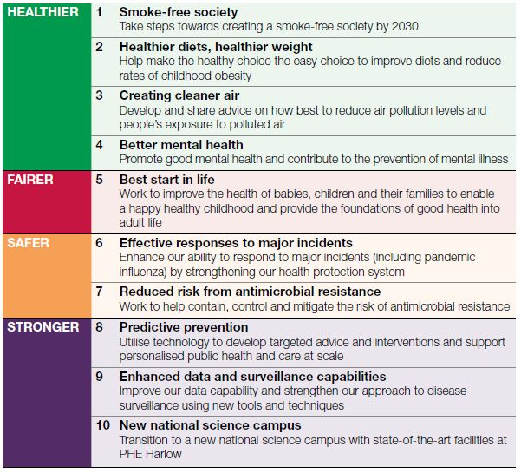
Journal articles

Five reasons for optimism on World Patient Safety Day
Fontana G, Flott K, Dhingra-Kumar N, Durkin M, Darzi A
The Lancet. 2019 [epub].

Patient safety: too little, but not too late
The Lancet
The Lancet. 2019;394(10202):895.
DOI | Fontana et al https://doi.org/10.1016/S0140-6736(19)32134-8  The Lancet https://doi.org/10.1016/S0140-6736(19)32080-X
Notes | These pieces appeared in The Lancet to mark World Patient Safety Day (17 September).  The editorial notes that ‘Protecting patients from errors, injuries, accidents, and infections is an essential goal for every health system, but no health system has so far successfully addressed patient safety.’ The editorial goes on to observe:  - Worldwide, the risk of patient death because of a preventable medical accident is one in 300. One in ten patients suffer injury while receiving health care, and 15% of all hospital expenses are incurred as a result of treating failures in patient safety.  - Patient safety hinges on quality of care.  - The safety of patients must be the paramount concern of professionals and the systems they work in.  - Health professionals must recognise that patient safety is a two-way partnership. Patients must be involved—indeed be central—in their own care.  - Awareness of the burden that patient safety requirements place on low to middle income countries is needed: addressing all improvements necessary for increased patient safety require resources.  - In the treatment of immediate illness, health-care systems must offer best practice and consistent treatment for all patients, and at all levels, to ensure further damage is prevented.  While recognising the continuing need for vigilance and work to address patient safety, the Fontana et al observed five trends that give cause for optimism about patient safety. These five trends that provide hope for the future are:  - we understand patient safety better than ever before  - global leaders now consider patient safety a priority  - patient safety has become a crucial component of the WHO and universal health care agenda  - international collaboration on patient safety is increasing  - the approaches and methods that could help improve patient safety are expanding. Digital and data-driven innovations—e.g., analysis of patient data and action based on this information—could have the potential to transform health care and patient safety and are of interest to health system leaders.

Raising and responding to frontline concerns in healthcare
Mannion R, Davies H
BMJ. 2019;366:l4944.
DOI | https://doi.org/10.1136/bmj.l4944
Notes | The theme for the recent World Patient Safety Day was “Speak Up for Patient Safety”. However, speaking up is not always easy to do. Nor is responding to concerns when they are raised. This piece looks at the individual and situational/organisational factors that can hinder or enable speaking up and responding to concerns. The key messages the authors identify are:  - Frontline health professionals are often best placed to identify substandard care and alert colleagues and managers if patients are at risk  - Staff can be afraid to raise legitimate concerns and have sometimes been bullied and victimised for doing so  - Managers need to redouble efforts to create the right organisational environments where frontline voices can be aired and responded to appropriately  - Management education and leadership training must find ways to encourage this.  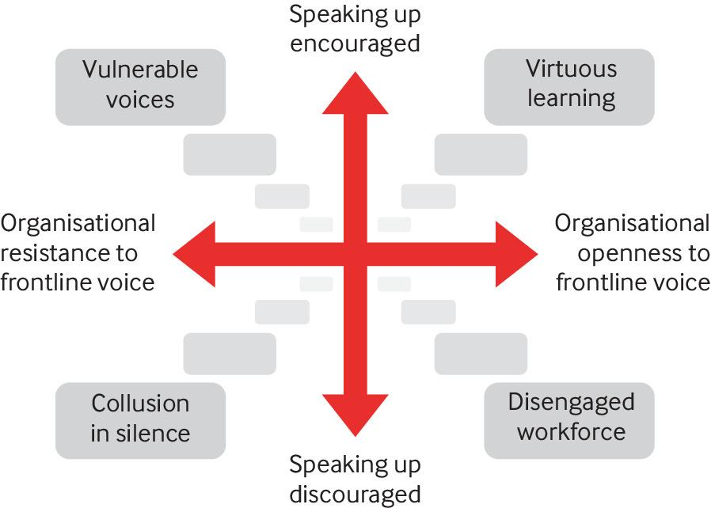

Hospitalisation for medication misadventures among older adults with and without dementia: A 5‐year retrospective study
Mullan J, Burns P, Mohanan L, Lago L, Jordan M, Potter J
Australasian Journal on Ageing. 2019 [epub].
DOI | https://doi.org/10.1111/ajag.12712
Notes | Dementia is a common affliction in older patients. This Australian study sought to ascertain if dementia played a role in medication ‘misadventures’ leading to hospitalisation. This study was a retrospective analysis of hospital admissions between 2012 and 2016 of older adults living in regional Australia. The authors report that ‘medication misadventures contributed to 10 555 (4.6%) of the total 228 165 admissions for older adults over the study period. Among these admissions, older adults with dementia were three times more likely to be hospitalised with medication misadventures (14.0%), than their non‐dementia counterparts (4.2%). Medication misadventures relating to “anticoagulants” and “opioids/related analgesics” accounted for the majority of admissions (24.3% dementia vs 30.7% non‐dementia).’
For information on the Commission’s work on cognitive impairment, including dementia and delirium, see https://www.safetyandquality.gov.au/our-work/cognitive-impairment

For information on the Commission’s work on medication safety, see https://www.safetyandquality.gov.au/our-work/medication-safety

Recognizing the Dying Patient, When Less Could be More: A Diagnostic Framework for Shared Decision-Making at the End of Life
Kalsi D, Ward J, Lee R, Wee B, Fulford KWM, Handa A
Journal of Patient Experience. 2019 [epub].
DOI | https://doi.org/10.1177/2374373519869153
Notes | As the authors of this piece state at the outset: ‘Recognizing dying patients is crucial to produce outcomes that are satisfactory to patients, their families, and clinicians.’ This has led to the development of a novel diagnostic framework to support shared palliative decision-making that can be summarised as  - Is the acute pathology reversible?  - What is the patient’s physiological reserve?  - What is important to the patient? Will they be fit enough for discharge for a reasonable length of time?  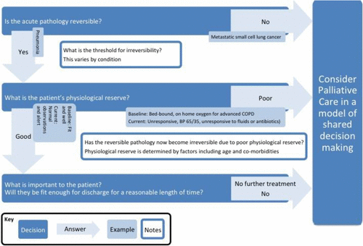

For information on the Commission’s work on shared decision making, see https://www.safetyandquality.gov.au/our-work/partnering-consumers/shared-decision-making

For information on the Commission’s work on end-of-life care, see https://www.safetyandquality.gov.au/our-work/end-life-care

Compassionate Coverage: A Patient Access Linen System
Rabin JM, Farner KC, Brody AH, Peyser A, Kline M
Journal of Patient Experience. 2018;6(3):185-93.
DOI | https://doi.org/10.1177/2374373518793411
Notes | Hospital gowns have been a source of patient discomfort, unease (and sometimes) complaint. There have been some attempts to improve them, but this paper presents one of the more comprehensive descriptions of an attempt to offer obstetrics and gynaecology patients greater choice and engagement in patient attire.  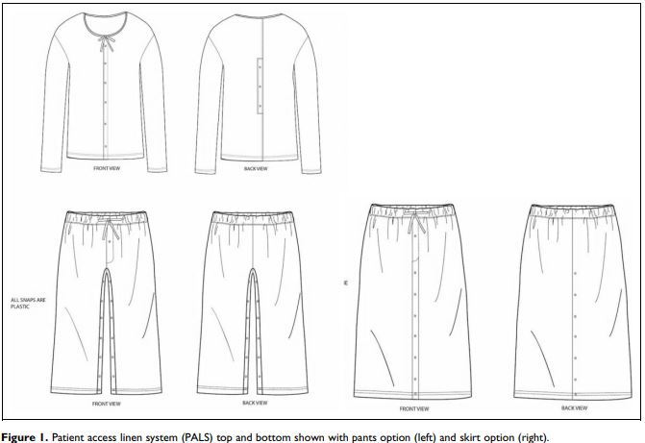  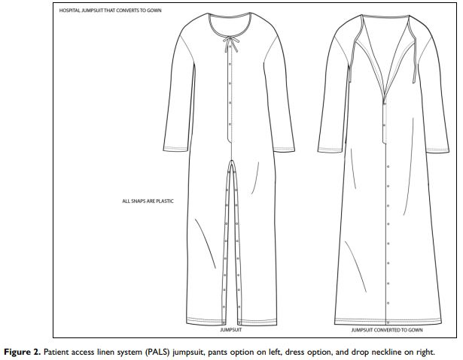

Realising the potential of health information technology to enhance medication safety
Sheikh A
BMJ Quality & Safety. 2019 [epub].
DOI | http://dx.doi.org/10.1136/bmjqs-2019-010018
Notes | In this editorial the author identifies six key issues that that need to be addressed to realise the potential of health information technology (HIT) to improve medication safety. The issues identified are:  - A need for more accurate data on the absolute and relative burden of preventable harm associated with different medications across care settings and an appreciation of which subpopulations are at highest risk of these errors.  - A need to develop valid and reliable indicators of errors associated with these drugs to allow meaningful benchmarking and an assessment of progress in enhancing patient safety over time or in relation to the effectiveness of interventions.  - A need to develop interventions that capitalise on the increasingly ubiquitous electronic health record (HER) infrastructures and accompanying CPOE and CDSS functionality, but which also attend to wider sociotechnical considerations.  - A need to evaluate the acceptability, effectiveness and cost-effectiveness of these complex HIT-based interventions using robust study designs, preferably randomised controlled trials.  - Mechanisms to enable standardised reporting of progress in enhancing medication safety nationally.  - Far more open in reporting on the (many) limitations of EHRs in hampering progress towards the goal of medication safety together with mandatory reporting of any new HIT/EHR-associated risks to medication safety. Such transparency should lead to more informed choices about the relative strengths and limitations of different EHRs and, more importantly, provide important insights into how to improve the design of EHRs.

For information on the Commission’s work on medication safety, see https://www.safetyandquality.gov.au/our-work/medication-safety

Patient safety incidents caused by poor quality surgical instruments
Dominguez ED, Rocos B
Cureus. 2019;11(6):e4877.
DOI | http://doi.org/10.7759/cureus.4877
Notes | The saying ‘A bad workman always blames his tools’ is quite familiar. But in considerations of safety and quality in health care, the equipment involved is frequently not considered. This UK study examined the National Reporting and Learning Service database to ascertain the scale of the problem of poor quality instruments failing. From the data for August 2004–December 2010, 161 incidents were identified the led to five re-operations, one incident of severe harm, six incidents of moderate harm, 35 of low harm, and 119 no harm incidents. No patient deaths were discovered. Drill bits were the most commonly broken instrument. The authors considered their findings to ‘be the tip of the iceberg. Poor reporting of patient safety incidents means that there may be as many as 1500 incidents a year of poor quality surgical instruments causing harm. We suggest that forming a Surgical Instrument Quality Service at Trusts within the National Health Service (NHS) could prevent harm coming to patients, reduce cost, and improve the outcomes of surgical procedures.’
Investigating for improvement? Five strategies to ensure national patient safety investigations improve patient safety
Macrae C
Journal of the Royal Society of Medicine. 2019;112(9):365-9.u
DOI | https://doi.org/10.1177/0141076819848114
Notes | This piece has been spurred by the establishment of national, independent safety investigation bodies that will investigate serious patient safety risks that span the healthcare system and develop system-wide recommendations for learning and improvement in both England and Norway. In England, the Healthcare Safety Investigation Branch became operational in April 2017 while in Norway, the State Investigation Commission for Health and Care Services will commence operations in 2019. In this piece, five core strategies are discussed with the understanding that they ‘translate the fundamental principles of national, system-wide safety investigation into more concrete objectives for strategic development and draw on both early experiences in the English health system combined with insights from other learning-oriented, systems-focused investigative practices.’  The five strategies are:  - Untangle systemic risks: explain the sources of system-wide safety problems  - Reconfigure systems: construct innovative and co-creative recommendations  - Show your working: develop methodology and share ongoing evaluation  - Narrative and voice: reveal the complexity of practice and experience  - Make risks visible: generate active responsibility and practical knowledge.  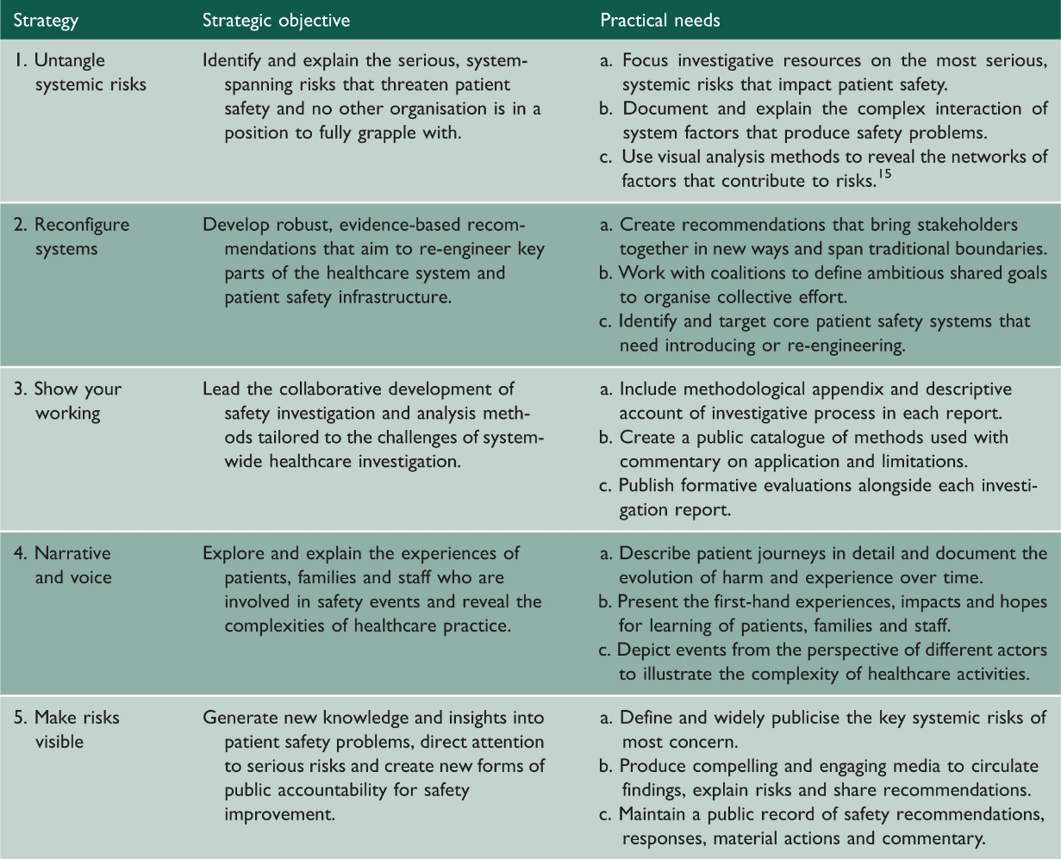

BMJ Quality & Safety
October 2019 - Volume 28 - 10
URL | https://qualitysafety.bmj.com/content/28/10
Notes | A new issue of BMJ Quality & Safety has been published. Many of the papers in this issue have been referred to in previous editions of On the Radar (when they were released online). Articles in this issue of BMJ Quality & Safety include:  - Editorial: Improving patient outcomes following total joint arthroplasty: is there an app for that? (Jesse I Wolfstadt, Christine Soong, Sarah E Ward)  - Editorial: Clinical considerations when applying machine learning to decision-support tasks versus automation (Trevor Jamieson, Avi Goldfarb)  - Patient activation intervention to facilitate participation in recovery after total knee replacement (MIME): a cluster randomised cross-over trialEditor's Choice (Jo McDonall, Richard de Steiger, John Reynolds, Bernice Redley, Patricia M Livingston, Anastasia F Hutchinson, Mari Botti)  - Robot for health data acquisition among older adults: a pilot randomised controlled cross-over trial (Roel Boumans, Fokke van Meulen, Koen Hindriks, Mark Neerincx, Marcel G M Olde Rikkert)  - Standardising hospitalist practice in sepsis and COPD care (Steven Bergmann, Mary Tran, Kathryn Robison, Christine Fanning, Simran Sedani, Janet Ready, Kelly Conklin, D Tamondong-Lachica, D Paculdo, J Peabody)  - Major reductions in unnecessary aspartate aminotransferase and blood urea nitrogen tests with a quality improvement initiative (Rachel Strauss, Alex Cressman, Mark Cheung, Adina Weinerman, Suzanne Waldman, Edward Etchells, Alireza Zahirieh, Piero Tartaro, Jeremy Rezmovitz, Jeannie Callum)  - Assessing the quality of health care in the management of bronchiolitis in Australian children: a population-based sample survey (Nusrat Homaira, Louise K Wiles, Claire Gardner, Charlotte J Molloy, Gaston Arnolda, Hsuen P Ting, Peter Damian Hibbert, Jeffrey Braithwaite, Adam Jaffe)  - Management of low back pain in Australian emergency departments (Giovanni E Ferreira, Gustavo C Machado, Christina Abdel Shaheed, Chung-Wei Christine Lin, Chris Needs, James Edwards, Rochelle Facer, Eileen Rogan, Bethan Richards, Christopher G Maher)  - Stepped-wedge randomised trial to evaluate population health intervention designed to increase appropriate anticoagulation in patients with atrial fibrillation (Shirley V Wang, James R Rogers, Yinzhu Jin, David DeiCicchi, Sara Dejene, Jean M Connors, David W Bates, Robert J Glynn, M A Fischer)  - Patient experience surveys: reflections on rating a sacred trust (Catherine C Ferguson)  - Altering standard admission order sets to promote clinical laboratory stewardship: a cohort quality improvement study (Benjamin Leis, Andrew Frost, Rhonda Bryce, Andrew W Lyon, Kelly Coverett)  - MRI for patients with cardiac implantable electronic devices: simplifying complexity with a ‘one-stop’ service model (Anish N Bhuva, Patricia Feuchter, Angela Hawkins, Lizette Cash, Redha Boubertakh, Jane Evanson, Richard Schilling, Martin Lowe, James C Moon, Charlotte H Manisty)

Patient Safety
Vol. 1 No. 1, September 2019
URL | https://patientsafetyj.com/index.php/patientsaf/issue/view/September-2019
Notes | The first issue of Patient Safety has been published by the Pennsylvania Patient Safety Authority. Items in this first issue of Patient Safety include:  - Letter From the Editor  - Patient Commentary: Dwight McKay – Why everyone should care  - Data Snapshot – A battery’s moment of death may come as a beep, a red warning light, or a complete surprise  - One-on-One With: Dr. Rachel Levine – How Pennsylvania is fighting the opioid crisis—an interview with the secretary of health  - The Walking Gallery – This self-proclaimed army of patient advocates is transforming healthcare  - Data Interpretation – A guide to understanding patient safety data  - Pressure Injuries – educational impact on accuracy of pressure injury staging  - Allergy-Related Medication Errors –where and when an error is most likely  - Vascular Access – Risks associated with peripheral and central venous catheters  - Sepsis Awareness Campaign – How do you prevent blood poisoning? Hire Miss Sepsis!  - Process Measures Survey Results – Best practice implementation across 10 domains in Pennsylvania hospitals  - Bedside Story: Sherry – Inappropriate testing for Clostridioides difficile in long-term care facilities highlight the need for an algorithm

BMJ Quality and Safety online first articles
URL | https://qualitysafety.bmj.com/content/early/recent
Notes | BMJ Quality and Safety has published a number of ‘online first’ articles, including:  - Editorial: Realising the potential of health information technology to enhance medication safety (Aziz Sheikh)  - Identifying and quantifying variation between healthcare organisations and geographical regions: using mixed-effects models (Gary Abel, Marc N Elliott)  - Sustaining effective quality improvement: building capacity for resilience in the practice facilitator workforce (Tanya T Olmos-Ochoa, David A Ganz, Jenny M Barnard, Lauren S Penney, Neetu Chawla)  - Medication-related harm in older adults following hospital discharge: development and validation of a prediction tool (Nikesh Parekh, Khalid Ali, John Graham Davies, Jennifer M Stevenson, Winston Banya, Stephen Nyangoma, Rebekah Schiff, Tischa van der Cammen, Jatinder Harchowal, Chakravarthi Rajkumar)  - Impact of a system-wide quality improvement initiative on blood pressure control: a cohort analysis (Elizabeth R Pfoh, Kathryn Martinez, Nirav Vakharia, Michael Rothberg)  - Editorial: The ageing surgeon (Natalia Kurek, Ara Darzi)  - When do trials of diabetes quality improvement strategies lead to sustained change in patient care? (Emily L Kearsley-Ho, Hsin Yun Yang, Sathya Karunananthan, Celia Laur, Jeremy M Grimshaw, Noah M Ivers)

Online resources

[UK] NICE Guidelines and Quality Standards
https://www.nice.org.uk/guidance
The UK’s National Institute for Health and Care Excellence (NICE) has published new (or updated) guidelines and quality standards. The latest reviews or updates are:
- NICE Guideline NG87 Attention deficit hyperactivity disorder: diagnosis and management https://www.nice.org.uk/guidance/ng87
- NICE Guideline NG138 Pneumonia (community-acquired): antimicrobial prescribing https://www.nice.org.uk/guidance/ng138
- NICE Guideline NG139 Pneumonia (hospital-acquired): antimicrobial prescribing https://www.nice.org.uk/guidance/ng139
- Quality Standard QS17 Lung cancer in adults https://www.nice.org.uk/guidance/qs17
- Clinical Guideline CG176 Head injury: assessment and early management https://www.nice.org.uk/guidance/cg176

[UK] Key Therapeutic Topics
https://www.nice.org.uk/guidance
The UK’s National Institute for Health and Care Excellence (NICE) publishes Key therapeutic topics (KTTs). These are summaries of the evidence base on a specific topic. New (or updated) KTTs include:
- KKT3 Lipid-modifying drugs https://www.nice.org.uk/advice/ktt3
- KKT5 Asthma: medicines safety priorities https://www.nice.org.uk/advice/ktt5
- KTT6 Hypnotics https://www.nice.org.uk/advice/ktt6
- KTT7 Antipsychotics in people living with dementia https://www.nice.org.uk/advice/ktt7
- KTT9 Antimicrobial stewardship: prescribing antibiotics https://www.nice.org.uk/advice/ktt9
- KTT12 Type 2 diabetes mellitus: medicines optimisation priorities https://www.nice.org.uk/advice/ktt12
- KTT14 Wound care products https://www.nice.org.uk/advice/ktt14
- KTT16 Anticoagulants, including direct-acting oral anticoagulants (DOACs) https://www.nice.org.uk/advice/ktt16
- KTT17 Acute kidney injury (AKI): use of medicines in people with or at increased risk of AKI https://www.nice.org.uk/advice/ktt17
- KTT18 Multimorbidity and polypharmacy https://www.nice.org.uk/advice/ktt18
- KTT19 Psychotropic medicines in people with learning disabilities whose behaviour challenges https://www.nice.org.uk/advice/ktt19
- KTT20 Safer insulin prescribing https://www.nice.org.uk/advice/ktt20
- KTT21 Medicines optimisation in chronic pain https://www.nice.org.uk/advice/ktt21
- KTT22 Chemotherapy dose standardisation https://www.nice.org.uk/advice/ktt22
- KTT23 Shared decision making https://www.nice.org.uk/advice/ktt23
- KTT24 Suicide prevention: optimising medicines and reducing access to medicines as a means of suicide https://www.nice.org.uk/advice/ktt24

Disclaimer
On the Radar is an information resource of the Australian Commission on Safety and Quality in Health Care. The Commission is not responsible for the content of, nor does it endorse, any articles or sites listed. The Commission accepts no liability for the information or advice provided by these external links. Links are provided on the basis that users make their own decisions about the accuracy, currency and reliability of the information contained therein. Any opinions expressed are not necessarily those of the Australian Commission on Safety and Quality in Health Care.

