# Australian COmmission on Safety and Quality in Health Care logo with Radar imageOn the Radar

Issue 447

20 January 2020

*On the Radar* is a summary of some of the recent publications in the areas of safety and quality in health care. Inclusion in this document is not an endorsement or recommendation of any publication or provider. Access to particular documents may depend on whether they are Open Access or not, and/or your individual or institutional access to subscription sites/services. Material that may require subscription is included as it is considered relevant.

*On the Radar* is available online, via email or as a PDF or Word document from <https://www.safetyandquality.gov.au/publications-and-resources/newsletters/radar>

If you would like to receive *On the Radar* via email, you can subscribe on our website <https://www.safetyandquality.gov.au/publications-and-resources/newsletters>   
or by emailing us at H[Umail@safetyandquality.gov.auU](mailto:mail@safetyandquality.gov.au).   
You can also send feedback and comments to H[Umail@safetyandquality.gov.auU](mailto:mail@safetyandquality.gov.au).

For information about the Commission and its programs and publications, please visit <https://www.safetyandquality.gov.au>

You can also follow us on Twitter @ACSQHC.

**On the Radar**

Editor: Dr Niall Johnson [niall.johnson@safetyandquality.gov.au](mailto:niall.johnson@safetyandquality.gov.au)

Contributors: Niall Johnson, Helen Dowling

**Infection Prevention and Control e-learning modules and Workbook**

<https://www.safetyandquality.gov.au/publications-and-resources/resource-library/infection-prevention-and-control-workbook-2019>

The Australian Commission on Safety & Quality in Health Care has updated the Infection Prevention and Control e-learning modules and Workbook.

The modules can be accessed via <https://nhhi.southrock.com>

This is a new platform for users of these modules and users will need to register before they can access the modules. There is also a companion workbook for the modules which is available from <https://www.safetyandquality.gov.au/publications-and-resources/resource-library/infection-prevention-and-control-workbook-2019>

[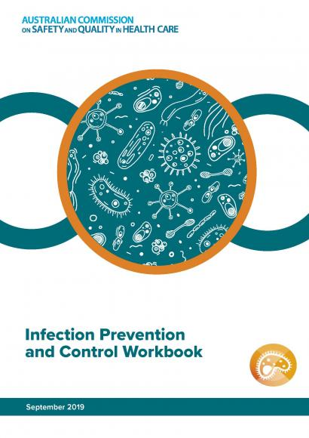](https://www.safetyandquality.gov.au/publications-and-resources/resource-library/infection-prevention-and-control-workbook-2019)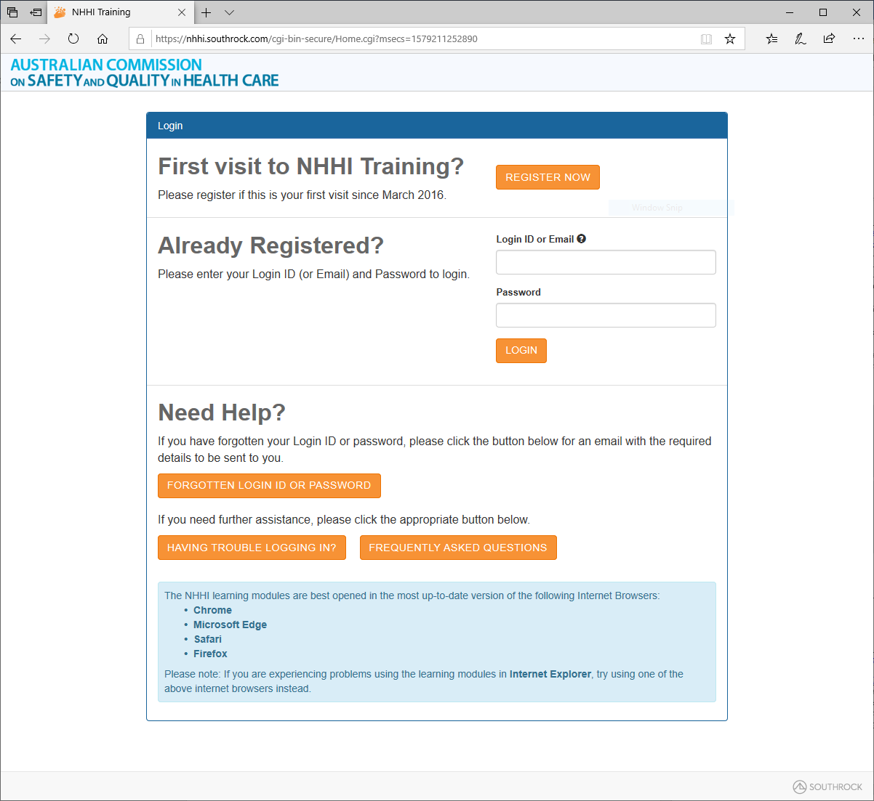

**Reports**

*Over-diagnosis and over-treatment in the frail elderly*

Agency for Clinical Innovation

Sydney: ACI; 2019. p. 36.

|  |  |
| --- | --- |
| URL | <https://www.aci.health.nsw.gov.au/resources/aged-health/other/over-diagnosis-and-over-treatment-in-the-frail-elderly> |
| Notes | The NSW Agency for Clinical Innovation has produced this report looking at the issues of over-diagnosis and over-treatment in frail elderly patients. The report includes sections on Identifying frailty, What is appropriate care for frail elderly patients?, What drives over-diagnosis and over-treatment?, and Leveraging change. The report observes that   * Providing appropriate care for frail elderly people is a challenge for healthcare systems. * Frailty is complex and multifaceted and varies in onset, progression and recovery. * Good care requires responsive, patient-centred, evidence-based approaches that distinguish care likely to be beneficial from care with high risk of harm.   [Matrix of treatment/non-treatment versus benefit](https://www.aci.health.nsw.gov.au/resources/aged-health/other/over-diagnosis-and-over-treatment-in-the-frail-elderly) |

*Improving care by using patient feedback*

Themed review

National Institute for Health Research

London: NHS NIHR; 2019. p. 34.

|  |  |
| --- | --- |
| URL / DOI | <https://discover.dc.nihr.ac.uk/content/themedreview-04237/improving-care-by-using-patient-feedback>  <https://doi.org/10.3310/themedreview-04237> |
| Notes | The UK’s National Institute for Health Research (NIHR) has produced this themed review of the evidence from the NIHR and others on the issue of using patient feedback/complaints to improve care. This review brings together nine recent studies looking at how NHS organisations use patient feedback to make improvements to services. The evidence in this review ranges from online ratings to real-time feedback in different settings, from hospital wards to general practice and mental health. This research may aid health providers to make best use of patient surveys and other data from patients.  [Different purposes of patient experience feedback data for healthcare organisations or practitioners](https://doi.org/10.3310/themedreview-04237) |

**Journal articles**

*Rising to the challenge of multimorbidity*

Whitty CJM, MacEwen C, Goddard A, Alderson D, Marshall M, Calderwood C, et al.

BMJ. 2020;368:l6964.

|  |  |
| --- | --- |
| DOI | <https://doi.org/10.1136/bmj.l6964> |
| Notes | In recent years the extent and significance of multimorbidity – having two or more medical conditions (usually chronic conditions) simultaneously has been gaining recognition. This editorial in the *BMJ* is a brief recapitulation of the issue by senior leaders in the British health system. The authors observe that multimorbidity ‘presents challenges to the entire medical profession, from general practice and community care to acute and long term hospital settings. Greater specialisation, especially for hospital based doctors, has improved our ability to treat single diseases, but unless we react to the increase in multimorbidity it will disadvantage the increasing proportion of patients with multiple seemingly unrelated diseases.’ They see a need to address ‘clusters of disease’. This will require more nuanced guidance/guidelines, integration and coordination of care and work by many parties, as ‘Medical schools, the royal colleges, guideline groups, the General Medical Council, and the governments of the UK need to work together with the whole profession to tackle this.’ |

*Achieving greater clinician engagement and impact in health care improvement: a neglected imperative*

Scott IA, Kallie J, Gavrilidis A

Medical Journal of Australia. 2020;212(1):5-7.e1.

|  |  |
| --- | --- |
| DOI | <https://doi.org/10.5694/mja2.50438> |
| Notes | This Perspectives piece in the Medical Journal of Australia rehearses the plea for greater quality and safety improvement (QSI) efforts, and particularly the importance of clinician engagement and leadership. The authors offer their ‘pragmatic, simplified quality and safety improvement framework’ (see below) and ‘strategies for securing wider and more committed clinician engagement in quality and safety improvement’. They also suggest something of a shopping list of preconditions necessary for clinician engagement. Clinician engagement – and leadership – are undoubtedly essential to successful and sustained quality and safety improvements, but some readers may feel a sense of over-privileging of that perspective and wish for a co-design approach that engages all actors and perspectives.  **A pragmatic, simplified quality and safety improvement framework**  ***Preparing for change***   * What is the quality and safety issue we want to address, and why? * What is our goal and by when are we hoping to achieve it? * Who are the key stakeholders, what do they do, what matters to them, and what drives their behaviour? * What are the key behaviours and practices we may want to change? * Can we identify individuals who are predisposed to, and can help lead, change? * How can we provide a safe environment in which people can express their views about change openly and constructively, increase common understanding, come to own the rationale for change, and forge new relationships? * How will we determine whether we are achieving change with the desired effect? What will be our process and outcome measures, and how will we collect and analyse such data?   ***Operationalising the change***   * What might be possible strategies for changing behaviour? * Can we adapt change interventions that have proved successful elsewhere and that better fit with local context? * Do we have candidate intervention(s) that everyone involved feels is (are) potentially feasible and acceptable to clinicians, and therefore worth progressing? * Does the intervention emphasise enablement (making it easier for people to do the right thing) rather than rules and forcing functions (which people may resist)? * What resources, support and incentives do we need to implement and test the intervention? * How do we evaluate and refine the intervention over time in a manner that ensures all involved remain informed, engaged and listened to? * How will we ensure that the intervention, if successful, becomes sustained as business as usual? |

*Associations between work satisfaction, engagement and 7-day patient mortality: a cross-sectional survey*

Brubakk K, Svendsen MV, Hofoss D, Hansen TM, Barach P, Tjomsland O

BMJ Open. 2019;9(12):e031704.

|  |  |
| --- | --- |
| DOI | <https://dx.doi.org/10.1136/bmjopen-2019-031704> |
| Notes | Paper reporting on a study that involved hospitals in a region comprising more than half of the Norwegian population. The study sought to examine the association between the hospital working environment, worker engagement and mortality. Covering a 3-year period the study included all patients (46 026) admitted with acute myocardial infarction (AMI), stroke and hip fracture in 56 patient wards at 20 hospitals and used data from 8800 survey responses from physicians, nurses and hospital managers. From their analyses, the authors report that ‘We observed a **significant increase in patient mortality in hospital units where nurses reported excessive workload and middle managers reported a lack of professional and organisational engagement**. No such associations were found between physician reported work environment and patient mortality.’ |

*Toward a Person-Centred Learning Health System: Understanding Value from the Perspectives of Patients and Caregivers*

Kuluski K, Guilcher SJT

HealthcarePapers. 2019;18(4):36-46.

|  |  |
| --- | --- |
| DOI | <https://doi.org/10.12927/hcpap.2019.26030> |
| Notes | The authors of this paper observe that three current themes in health care – **person-centred care**, **value-based healthcare** and **learning health systems** – could be drawn together in a mutually reinforcing union to create ‘**person-centred learning health systems** (PC-LHS’). Such a system would be more attuned to patient needs, perspectives, experiences and outcomes and uses them to tune their activity. This could deliver on value in its greater sense; not purely the efficiency, cost-effectiveness but also in line with what patients’ value. As the authors write ‘improving value for patients and caregivers, by capturing the things that matter most to them, within their life contexts, needs to be part of the continuous quality improvement cycle that lies at the heart of a learning health system.’ |

For information on the Commission’s work on person-centred care, see <https://www.safetyandquality.gov.au/our-work/partnering-consumers/person-centred-care>

*Can an Evidence-Based Approach Improve the Patient-Physician Relationship?*

Cifu AS, Lembo A, Davis AM

Journal of the American Medical Association. 2020;323(1):31-32.

|  |  |
| --- | --- |
| DOI | <https://doi.org/10.1001/jama.2019.19427> |
| Notes | This editorial in *JAMA* reflects upon the patient-physician relationship. Responding to a study in the same issue, the authors note that study proposed a number of evidence-based practices that may lead to more meaningful connections between patients and physicians. The 5 recommendations were   1. prepare with intention 2. listen intently and completely 3. agree on what matters most 4. connect with the patient’s story, and 5. explore emotional cues.   The authors of this editorial argue that while these 5 practices ‘focus on the valuable habit of presence…other habits and characteristics deserve similar exploration as physicians pursue providing care that is effective, efficient, and more satisfying for patients and themselves.’ |

*Pharmacist–Physician Collaboration to Improve the Accuracy of Medication Information in Electronic Medical Discharge Summaries: Effectiveness and Sustainability*

Elliott RA, Tan Y, Chan V, Richardson B, Tanner F, Dorevitch MI

Pharmacy. 2020;8(1).

|  |  |
| --- | --- |
| DOI | <https://doi.org/10.3390/pharmacy8010002> |
| Notes | This is one of a series of papers for a special issue of on **Medication Management in Care Transitions**. This study evaluates the effectiveness of a collaborative intervention in which ward-based pharmacists reviewed, contributed and verified medication information in patients’ Electronic Medical Discharge Summaries (EDSs) prior to sign-off by the physician. The intervention was implemented into a range of inpatient wards at a major public teaching hospital in Melbourne, Australia. The paper describes the results of a pre- and post-intervention study that used retrospective medical record audits to assess the accuracy of EDSs for patients discharged from inpatient wards. As a result of the intervention, a significant reduction in medication list discrepancies along with a significant increase in the proportion and communication of clinically significant medication changes stated in the EDS was achieved in all study wards. A follow up audit after two years demonstrated that the improvements in care transition information about medications in the EDS were sustained, especially when incorporated into ‘usual care’. |

For information on the Commission’s work on medication safety, see <https://www.safetyandquality.gov.au/medication-safety>

*Embedding best transfusion practice and blood management in neonatal intensive care*

Flores CJ, Lakkundi A, McIntosh J, Freeman P, Thomson A, Saxon B, et al

BMJ Open Quality. 2020;9(1):e000694.

|  |  |
| --- | --- |
| DOI | <https://dx.doi.org/10.1136/bmjoq-2019-000694> |
| Notes | This paper is a quality improvement report describing the embedding of blood management and best transfusion principles in a neonatal intensive care unit (NICU). |

*Journal for Healthcare Quality*

Vol. 42, No. 1, January/February 2020

|  |  |
| --- | --- |
| URL | <https://journals.lww.com/jhqonline/Pages/currenttoc.aspx> |
| Notes | A new issue of the *Journal for Healthcare Quality* has been published. Articles in this issue of the *Journal for Healthcare Quality* include:   * **Falls in Hospital** Causing Injury (Trinh, Lieu Thi Thuy; Assareh, Hassan; Wood, Michael; Addison-Wilson, Cathleen; Sathiyaseelan, Yasoda) * Alerting Wisely: Reducing **Inappropriate Blood Chemistry Panel Orders** Using a Clinical Decision Support Tool (Anderson, Jonathan W; Greenwood, Mark R; Borsato, Gisele G; Kuttler, Kathryn G) * 7 Is the New 8: Improving Adherence to Restrictive **PRBC Transfusions** in the Pediatric ICU (Badke, Colleen M; Borrowman, Julie A; Haymond, Shannon; Rychlik, Karen; Malakooti, Marcelo R) * Patient-Centered Care: Total Hip Arthroplasty for **Displaced Femoral Neck Fracture** Does Not Increase Infection Risk (Campbell, Abigail; Lott, Ariana; Gonzalez, Leah; Kester, Benjamin; Egol, Kenneth A) * Common **Risk Stratification of Hospital and Ambulatory Patients** (Cowen, Mark E; Walsh, Martha M; Posa, Patricia J; Leeman, Lauren R; Van Hoek, Elizabeth; Czerwinski, Jennifer L) * Factors Associated With **Nurses' Acceptance of the Electronic Intensive Care Unit** (Beasley, Brittany; Barone, Claudia P; Heo, Seongkum; Wright, Patricia B; Selig, James P; Rhoads, Sarah; Griebel, Jack) * Improving **Nonvocal Critical Care Patients' Ease of Communication** Using a Modified SPEACS-2 Program (Trotta, Rebecca L; Hermann, Robin M; Polomano, Rosemary C; Happ, Mary Beth) * **Hospital Readmissions** to Nonindex Hospitals: Patterns and Determinants Following the Medicare Readmission Reduction Penalty Program (Hasan, Md. Mahmudul; Noor-E-Alam, Md.; Wang, Xiaoyi; Zepeda, E David; J Young, G) * Using Simulation and Competency Assessment to Decrease **Inappropriate Referrals to a Comprehensive Vascular Access Team** (Nguyen, Somali; Jones, Allison; Polancich, Shea; Poe, Terri; Garrigan, April; Talley, Michele) |

*Journal of Health Services Research & Policy*

Volume: 25, Number: 1 (January 2020)

|  |  |
| --- | --- |
| URL | <https://journals.sagepub.com/toc/hsrb/25/1> |
| Notes | A new issue of the *Journal of Health Services Research & Policy* has been published. Articles in this issue of the *Journal of Health Services Research & Policy* include:   * Editorial: **Partnership and accountability in the era of integrated care**: a tale from England (Graham Martin) * **Excellence in elective hip and knee surgery**: what does it look like? A positive deviance approach (Lesley Hughes, Laura Sheard, Lisa Pinkney, and Rebecca L Lawton) * What is the **relationship between mortality alerts and other indicators of quality of care**? A national cross-sectional study (Elizabeth Cecil, Alex Bottle, Aneez Esmail, Charles Vincent, and Paul Aylin) * Moving towards **strategic commissioning**: impact on clinical commissioning groups as membership organizations (Lynsey Warwick-Giles, Imelda McDermott, Kath Checkland, and Valerie Moran) * Reforming medical regulation: a qualitative study of the implementation of **medical revalidation** in England, using Normalization Process Theory (Abigail Tazzyman, Jane Ferguson, Alan Boyd, Marie Bryce, John Tredinnick-Rowe, Tristan Price, and Kieran Walshe) * Partnership or insanity: why do **health partnerships** do the same thing over and over again and expect a different result? (Neil Perkins, David J Hunter, Shelina Visram, Rachael Finn, Jennifer Gosling, Lee Adams, and A Forrest) * The influence of health systems on **breast, cervical and colorectal cancer screening**: an overview of systematic reviews using health systems and implementation research frameworks (Jennifer Priaulx, Eleanor Turnbull, Eveline Heijnsdijk, Marcell Csanádi, C Senore, H J de Koning, and M McKee) * Identifying approaches for synthesizing and summarizing information to support **informed citizen deliberations in health policy**: a scoping review (Michael G Wilson, Aditya Nidumolu, Inna Berditchevskaia, Francois-Pierre Gauvin, Julia Abelson, and John N Lavis) |

*BMJ Quality and Safety* online first articles

|  |  |
| --- | --- |
| URL | <https://qualitysafety.bmj.com/content/early/recent> |
| Notes | *BMJ Quality and Safety* has published a number of ‘online first’ articles, including:   * Preventing critical failure. **Can routinely collected data be repurposed to predict avoidable patient harm?** A quantitative descriptive study (Benjamin Michael Nowotny, Miranda Davies-Tuck, Belinda Scott, Michael Stewart, Elizabeth Cox, Karen Cusack, Martin Fletcher, Eva Saar, Tanya Farrell, Shirin Anil, Louise McKinlay, Euan M Wallace) * **Does team reflexivity impact teamwork and communication** in interprofessional hospital-based healthcare teams? A systematic review and narrative synthesis (Siobhan Kathleen McHugh, Rebecca Lawton, Jane Kathryn O'Hara, Laura Sheard) * Multistate programme to reduce **catheter-associated infections** in intensive care units with elevated infection rates (Jennifer Meddings, M Todd Greene, David Ratz, Jessica Ameling, Karen E Fowler, Andrew J Rolle, Louella Hung, Sue Collier, Sanjay Saint) * How can **patient-held lists of medication enhance patient safety**? A mixed-methods study with a focus on user experience (Sara Garfield, Dominic Furniss, Fran Husson, Mike Etkind, Marney Williams, John Norton, Della Ogunleye, Barry Jubraj, Hanaa Lakhdari, Bryony Dean Franklin) * **What do emergency department physicians and nurses feel?** A qualitative study of emotions, triggers, regulation strategies, and effects on patient care (Linda M Isbell, Edwin D Boudreaux, Hannah Chimowitz, Guanyu Liu, Emma Cyr, Ezekiel Kimball) |

*International Journal for Quality in Health Care* online first articles

|  |  |
| --- | --- |
| URL | <https://academic.oup.com/intqhc/advance-articles> |
| Notes | *International Journal for Quality in Health Care* has published a number of ‘online first’ articles, including:   * **Quality healthcare in extreme adversity**: Developing a framework for action (Sheila Leatherman, Linda Tawfik, Dilshad Jaff, Grace Jaworski, Matthew Neilson, Mondher Letaief, Shamsuzzoha Babar Syed) * Improvements in **patient safety culture**: a national Taiwanese survey, 2009–16 (Brian Yu, Cheng-Fan Wen, Heng-Lien Lo, Hsun-Hsiang Liao, Pa-Chun Wang) |

**Online resources**

*[UK] NICE Guidelines and Quality Standards*

<https://www.nice.org.uk/guidance>

The UK’s National Institute for Health and Care Excellence (NICE) has published new (or updated) guidelines and quality standards. The latest reviews or updates are:

* Quality Standard QS33 ***Rheumatoid arthritis*** *in over 16s* <https://www.nice.org.uk/guidance/qs33>
* Quality Standard QS190 ***Flu vaccination****: increasing uptake* <https://www.nice.org.uk/guidance/qs190>
* NICE Guideline NG149 ***Indoor air quality*** *at home* <https://www.nice.org.uk/guidance/ng149>

**Disclaimer**

On the Radar is an information resource of the Australian Commission on Safety and Quality in Health Care. The Commission is not responsible for the content of, nor does it endorse, any articles or sites listed. The Commission accepts no liability for the information or advice provided by these external links. Links are provided on the basis that users make their own decisions about the accuracy, currency and reliability of the information contained therein. Any opinions expressed are not necessarily those of the Australian Commission on Safety and Quality in Health Care.