
Trim: D19-22484

August 2019
Clostridium difficile infection

2017 Data Snapshot

Background
Clostridium difficile* is an anaerobic, spore-forming, gram-positive bacillus typically associated with gastrointestinal disease. The bacteria is ubiquitous in its spore form in the natural environment as well as in built environments where there is the potential for the bacteria to spread from human and other animal carriers to environmental surfaces. Transmission of Clostridium difficile occurs by ingestion of spores either through person-to-person contact, animal-to-person contact or environment-to person contact.¹
Symptomatic Clostridium difficile infection (CDI) is mediated through toxin production by the bacteria. Non-toxigenic strains of Clostridium difficile are rarely associated with symptomatic illness.² Production of toxin A and toxin B results in hyper inflammation and necrosis of the gut lining.³ The spectrum of the disease associated with Clostridium difficile is wide, ranging from asymptomatic colonisation through to fulminant colitis and peritonitis.⁴ In addition to intracolonic symptoms, severe CDI is characterised by the following systemic markers: fever (>38.5◦C), haemodynamic instability, elevated lactate, elevated creatinine, rigors, leucocytosis (>15x10⁹/L, <20% neutrophils) and lowered albumin levels.^{5,6} Approximately 20% of patients with an initial infection will have at least one recurrent episode of symptomatic infection usually within 21 days of the initial episode.⁷
The Australian Commission on Safety and Quality in Health Care (the Commission) annually monitors the prevalence of CDI in Australian public hospitals. The 2017 Data Snapshot report is the second Data Snapshot report published by the Commission. Patient administrative data from the 2016-2017 and 2017-2018 Admitted Patient Care National Minimum Data Set (APC NMDS) has been utilised to generate this report. The use of the APC NMDS for the annual monitoring of national CDI rates was established by the Commission in 2016 and is supported by the Commission’s Inter-Jurisdictional Committee.
No exclusion or filtering criteria has been applied to the APC NMDS. Data are based on the state or territory of the hospital that collected the data, not the state or territory where the patient resides. For the purposes of this analysis, the diagnosis code A04.7 Gastroenterocolitis caused by Clostridium difficile was used to identify separations affected by CDI, and will be referred to as a CDI diagnosis in this report. Patient bed days are calculated by counting the total patient days of patients who separated during the specific period, including those admitted before the specific period. Separation days are episodes of patient care, in which care can include a total hospital stay (from admission to discharge, transfer or death), or a portion of a hospital stay beginning or ending in a change in type of care.^{8, 9}
CDI diagnoses are categorised into either a principal diagnosis or a non-principal diagnosis. A principal diagnosis describes the ‘primary’ condition resulting in admission of an individual to hospital. A non-principal diagnosis describes a condition that may have contributed to the admission but is not the main reason for admission to hospital.^{9, 10}

*Clostridium difficile may also be known as Clostridioides difficile.

Rate of CDI diagnoses

Figure 1. CDI (A04.7) diagnoses in Australian public hospitals (n=686), 2017
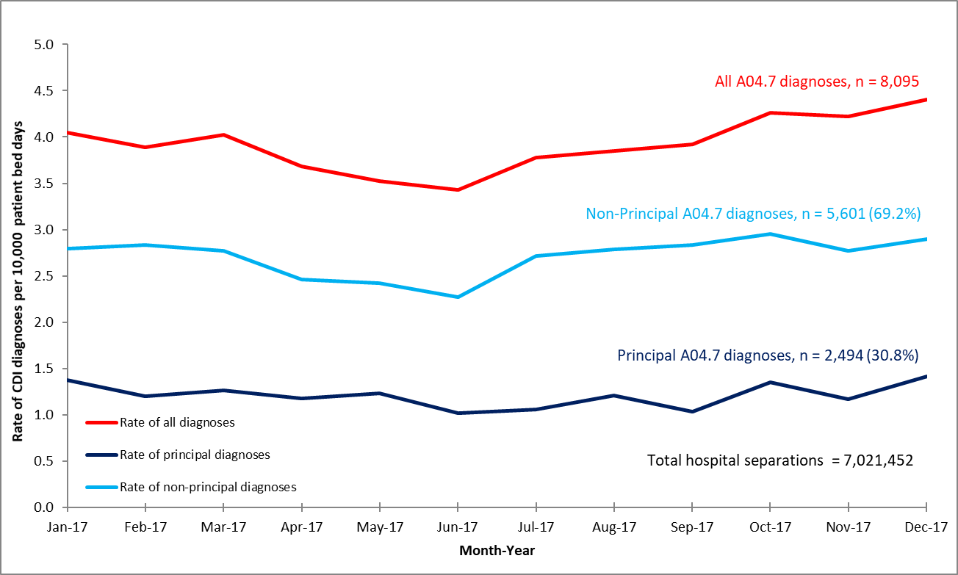

Table 1: Average yearly rate of CDI (A04.7) diagnoses, per 10,000 patient bed days, Australian public hospitals, 2012-2017
Year | Principal CDI diagnoses (range) | Non-principal CDI  diagnoses (range) | All CDI hospital diagnoses (range)
2012 | 1.21 (0.98-1.72) | 3.10 (2.85-3.43) | 4.30 (3.91-5.04)
2013 | 1.13 (1.01-1.30) | 2.80 (2.63-3.05) | 3.94 (3.70-4.31)
2014 | 1.08 (0.89-1.23) | 2.74 (2.47-2.94) | 3.81 (3.42-4.17)
2015 | 1.11 (1.00-1.35) | 2.74 (2.61-2.98) | 3.85 (3.64-4.20)
2016 | 1.23 (1.02-1.41) | 2.68 (2.48-2.91) | 3.91 (3.54-4.32)
2017 | 1.21 (1.05-1.50) | 2.71 (2.27-2.95) | 3.92 (3.43-4.40)

Figure 2. Statistical process control chart for CDI (A04.7) diagnoses in Australian public hospitals, 2014-2017
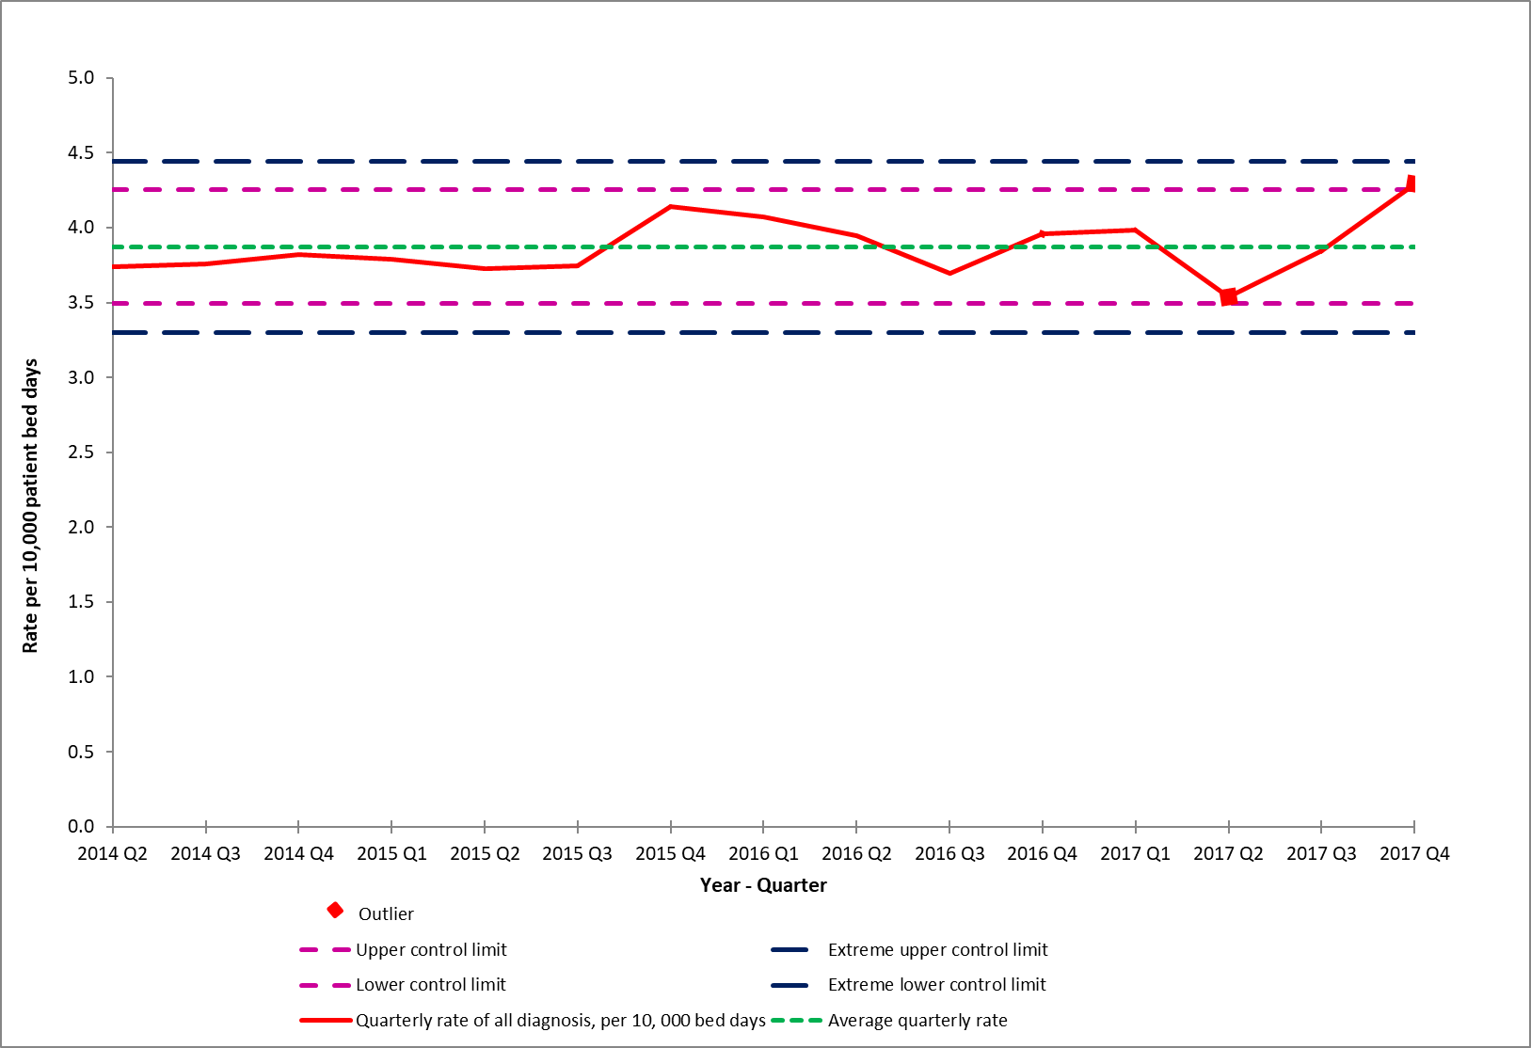

Figure 3. Rate of CDI diagnoses and antibiotic usage for 2017
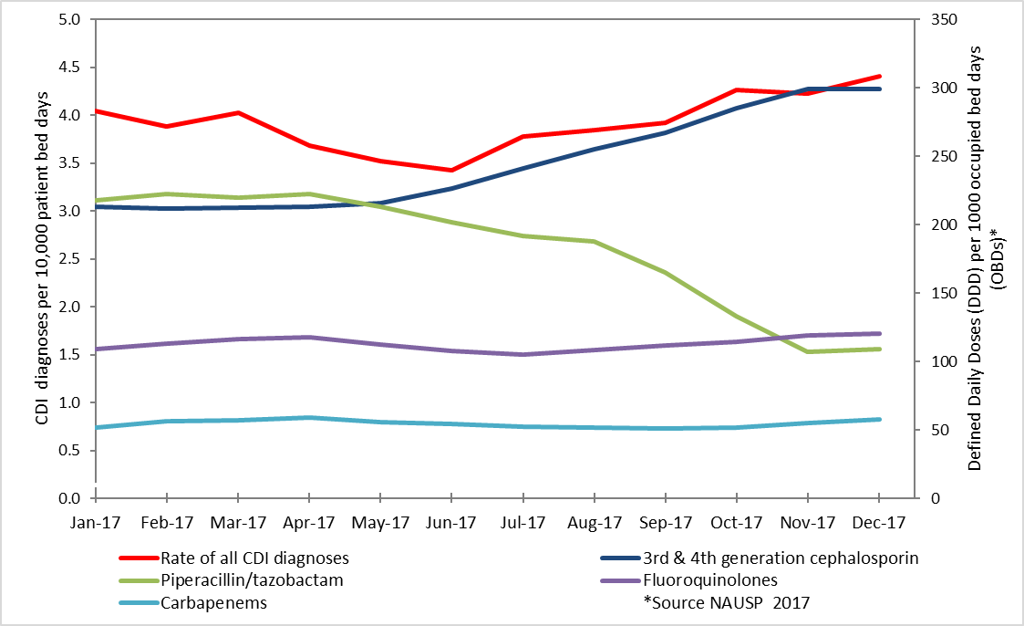

Commentary

Principal CDI diagnoses accounted for 30.8% of all CDI diagnoses in 2017 compared to 69.2% non-principal CDI diagnoses (Figure 1). The average rate of all CDI diagnoses in 2017 was 3.92 diagnoses per 10,000 patient bed days, with the range varying from 3.43 to 4.40 diagnoses per 10,000 patient bed days. The average yearly rate for all CDI diagnoses (principal and non-principal) among Australian public hospitals has remained relatively unchanged from 2012 to 2017 (Table 1).

There was some variation in the rate of non-principal CDI diagnoses throughout the year (Figure 1). Between January 2017 and June 2017, the average rate of all CDI diagnoses appeared to be decreasing; however, an upward trend was observed between June 2017 and December 2017 (Figure 2). This annual trend is consistent with the 2015 and 2016 data.^{9, 11} The average rate of non-principal CDI diagnoses was highest in October (2.95 diagnoses per 10,000 patient bed days) and the average rate of principal CDI diagnosis was highest in December (1.50 diagnoses per 10,000 patient bed days).

The rate of all CDI diagnoses closely approached the statistical process control limits in the second and fourth quarters of 2017. The overall rate of all CDI diagnoses in the second quarter of 2017 was 3.54 diagnoses per 10,000 patient bed days, which was just within the lower control limit of 3.49 diagnoses per 10,000 patient bed days. In the fourth quarter of 2017, the overall rate was 4.29 diagnoses per 10,000 patient bed days; this exceeded the upper control limit of 4.25 diagnoses per 10,000 patient bed days (Figure 2).

Data from the National Antimicrobial Utilisation Surveillance Program (NAUSP) on total-hospital antibiotic usage rates for 2017 indicated there was increases in the usage of third- and fourth-generation cephalosporin antibiotics in 2017.¹² The increased usage of third- and fourth-generation cephalosporin antibiotics in late 2017 may be linked to a shortage of piperacillin-tazobactam antibiotics in Australia which occurred at the same time.¹³ Third- and fourth-generation cephalosporin antibiotics were the recommended alternative treatment for infections treated with piperacillin-tazobactam antibiotics.¹⁴ Third- and fourth generation cephalosporin antibiotics are known to be associated with a higher risk of developing CDI.¹⁵ Figure 3 shows the rate of CDI diagnoses and the rates of piperacillin-tazobactam antibiotics and third- and fourth-generation cephalosporin antibiotic use during 2017.

Rate of non-principal CDI diagnoses

Figure 4. Rate of CDI (A04.7) non-principal diagnoses by Condition of Onset Flag (COF) in Australian public hospitals, 2017*

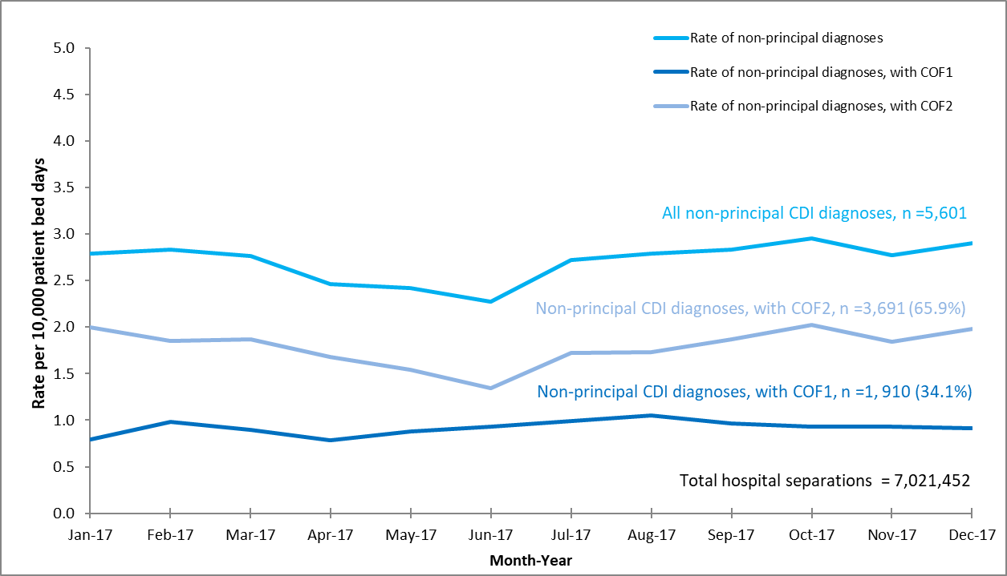

Figure 5. Estimated burden of pre-existing CDI (A04.7) presenting to hospitals, 2017*
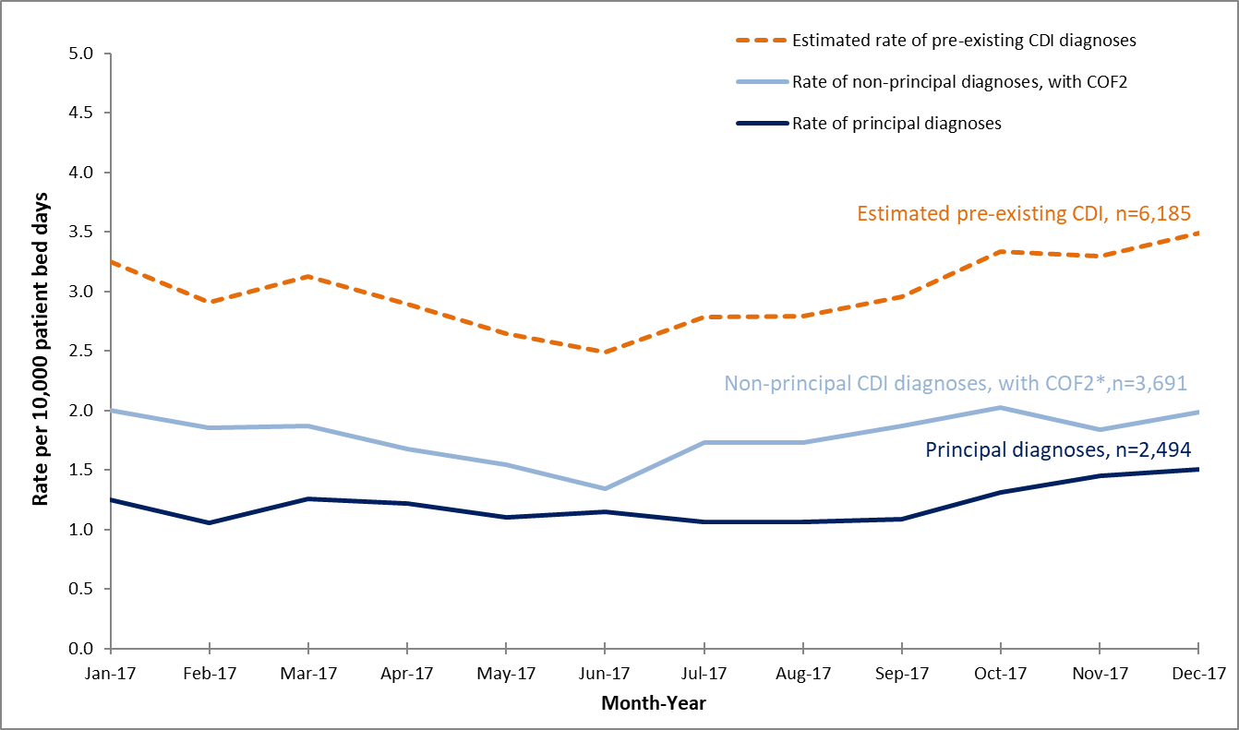
*Based on hospitals with highly reliable Condition Onset Flag (COF) coding (n=528)

Note: COF 1: Conditional Onset Flag 1, refers to a condition that has arisen during the episode of admitted care that would not have been present or suspected on admission.
COF 2: Condition Onset Flag 2, refers to a condition previously existing or suspected on admission such as the presenting problem, a comorbidity or chronic disease. For further information on Conditional Onset Flags, see: Australian Institute of Health and Welfare. Episode of admitted patient care- condition onset flag, code N [online]: Available from: https://meteor.aihw.gov.au/content/index.phtml/itemId/496512

Table 2. Number of CDI (A04.7)-related separations in Australian public hospitals (n=686), 2016 and 2017
 | 2016 | 2017 | Relative change
Number of separations in Australian public hospitals | 6,747,532 | 7,021,452 | + 4.1%
Number of separations with a CDI diagnosis | 7,836 | 8,095 | + 3.3%
Number of separations with a principal CDI diagnosis | 2,444 | 2,494 | + 2.0%
Number of separations with a non-principal CDI diagnosis | 5,392 | 5,601 | + 3.9%
Number of separations with a non-principal CDI diagnosis, with COF1* | 1,767 | 1,910 | + 8.1%
Number of separations with a non-principal  CDI diagnosis, with COF2* | 3,476 | 3,691 | + 6.2%
Estimated pre-existing burden  Principal CDI+ non-principal CDI, COF2* | 5,920 | 6,094 | + 2.9%

*Based on hospitals with highly reliable COF coding only (n=528)

Commentary

More than a third (34.1%) of non-principal CDI diagnoses were directly related to the health care provided during the separation for which a CDI diagnosis was assigned (COF1) (Figure 4). Monthly rates of CDI diagnoses varied throughout 2017:

The rate of all non-principal CDI diagnoses ranged from 2.27 to 2.95 diagnoses per 10,000 patient bed days. The average rate was 2.71 diagnoses per 10,000 patient bed days
- The rate of CDI non-principal diagnoses flagged as a COF1 ranged from 0.79 to 1.06 diagnoses per 10,000 patient bed days. The average rate was 0.9 diagnoses per 10,000 patient bed days
- The rate of CDI non-principal diagnoses flagged as a COF2 ranged from 1.34 to 2.02 diagnoses per 10,000 patient bed days. The average rate was 1.79 diagnoses per 10,000 patient bed days.

It is estimated that 76.4% of CDI diagnoses made in Australian public hospitals in 2017 were due to previous exposure, either in the community or during a previous health care admission, and were not related to the health care delivered during the separation for which the diagnosis was assigned (Figure 5).

Between 2016 and 2017, the total number of hospital separations in Australia increased by 4.1% (Table 2). The total number of CDI diagnoses during this period increased by 3.3%. Of note is the number of non-principal CDI diagnoses classified as COF1, which increased by 8.1%. The estimated proportion of pre-existing CDI increased by 2.9% between 2016 and 2017. The degree at which these cases are increasing is substantially less than that reported between 2015 and 2016, where there was a 6.8% increase during that period.^{9, 11}

Hospital length of stay for patients with a CDI diagnoses

Table 3. Average length of stay (days) for patients with a CDI (A04.7) diagnosis in Australian public hospitals, 2012-2017
Year | Principal CDI diagnosis | Non-principal CDI diagnosis | Any CDI diagnosis
2012 | 8.34 | 22.73 | 18.69
2013 | 7.91 | 20.91 | 17.17
2014 | 7.79 | 22.10 | 18.05
2015 | 7.60 | 20.68 | 16.91
2016 | 7.38 | 19.78 | 16.08
2017 | 7.76 | 19.99 | 16.16
Overall average | 7.80 | 21.03 | 17.18
Overall rate of change (slope), 2012-2017 | -0.60 | -0.72 | -0.78

Commentary
In 2017, the average length of stay for patients with any CDI diagnosis (principal and non-principal CDI diagnosis) was 16.16 days, while the average length of stay for a patient with a non-principal CDI diagnosis was almost three times longer than the average length of stay for a patient with a principal CDI diagnosis (Table 3).
The average length of stay in 2017 for a patient with a CDI diagnosis remained consistent with previous years, however, the average length of stay associated with a CDI diagnosis has been gradually decreasing since 2012. The average length of stay for a principal CDI diagnosis decreased by 0.6 days, the average length of stay for a non-principal CDI diagnosis decreased by 2.7 days and the average length of stay for any CDI diagnosis (principal and non-principal CDI diagnosis) decreased by 2.5 days (Table 3).

Snapshot summary
The overall average rate of all CDI diagnoses has remained relatively unchanged from 2012 to 2017. There was some variation in the yearly trend for 2017. The rates of CDI closely approached the lower statistical process control limit in the second quarter of 2017 and closely approached the upper statistical process control limit in the fourth quarter of 2017. These events may have been influenced by a national shortage in a specific class of antibiotics that occurred at the same time.
Patients with a non-principal CDI diagnosis continued to have a longer hospital length of stay than those with a principal CDI diagnosis, however the length of stay has decreased since 2012.
The highest rate of CDI in 2017 was detected in the summer months, with a steady increase in the rate of CDI from September 2017 onwards. This trend was also observed in both 2015 and 2016 and could be used to inform local infection prevention and control strategies.

References
- NICE. Clostridium difficile infection: risk with broad-spectrum antibiotics. [Online] 2015; [cited 5 August 2019] Available from: https://www.nice.org.uk/advice/esmpb1/chapter/Key-points-from-the-evidence
- Natarajan M, Walk ST, Young VB and Aronoff DM. A clinical and epidemiological review of non-toxigenic Clostridium difficile. Anaerobe. 2013; 22: 1-5.
- Awad MM, Johanesen PA, Carter GP, Rose E and Lyras D. Clostridium difficile virulence factors: Insights into an anaerobic spore-forming pathogen. Gut Microbes. 2014; 5: 579-93.
- Napolitano LM and Edmiston CE. Clostridium difficile disease: Diagnosis, pathogenesis, and treatment update. Surgery. 2017; 162: 325-48.
- Trubiano JA, Cheng AC, Korman TM, et al. Australasian Society of Infectious Diseases updated guidelines for the management of Clostridium difficile infection in adults and children in Australia and New Zealand. Internal Medicine Journal. 2016; 46: 479-93.
- Henrich TJ, Krakower D, Bitton A and Yokoe DS. Clinical risk factors for severe Clostridium difficile–associated disease. Emerging Infectious Diseases. 2009; 15: 415-22.
- Kachrimanidou M and Malisiovas N. Clostridium difficile infection: A comprehensive review. Critical Reviews in Microbiology. 2011; 37: 178-87.
- Australian Institute of Health and Welfare. Admitted patient care NMDS 2016-17. [Online] 2016 [cited 5 August 2019]; Available from: http://meteor.aihw.gov.au/content/index.phtml/itemId/612171.
- Australian Commission on Safety and Quality in Health Care. Clostridium difficile infection. Monitoring the national burden of Clostridium difficile. Sydney: ACSQHC; 2018
- Australian Institute of Health and Welfare. Principal diagnosis data cubes [Online] 2017 [cited 5 August 2019]; Available from:http://www.aihw.gov.au/hospitals-data/principal-diagnosis-data-cubes/
- Australian Commission on Safety and Quality in Health Care. Clostridium difficile infection 2016 Data Snapshot report. Sydney: ACSQHC; 2018
- SA Health, Australian Commission on Safety and Quality in Health Care. Antimicrobial use in Australian hospitals: 2016 annual report of the National Antimicrobial Utilisation Surveillance Program; [Online] 2018 [cited 5 August, 2019]; Available from: https://www.sahealth.sa.gov.au/wps/wcm/connect/public+content/sa+health+internet/about+us/health+statistics/healthcare+infection+statistics/antimicrobial+utilisation+surveillance+statistics
- NSW Health. Clinical Excellence Commission. Safety Notice 012/17: Intravenous piperacillin-tazobactam- Disruption to supply, [Online] October 2017 [cited 5 August 2019]; Available from:https://www.health.nsw.gov.au/sabs/Documents/2017-sn-012.pdf
- Melbourne Health, National Centre for Antimicrobial Stewardship (NCAS). Piperacillin-tazobactam - medication shortage. Fact Sheet – for adults in hospital and acute care facilities, [Online] 2017 [cited 5 august 2019]; Available from: https://www.ncas-australia.org/education
- Australian Commission on Safety and Quality in Health Care. Clostridium difficile infection. A model to improve the management and control of Clostridium difficile in Australia. Sydney: ACSQHC; 2018

