
On the Radar
Issue 452
24 February 2020

On the Radar is a summary of some of the recent publications in the areas of safety and quality in health care. Inclusion in this document is not an endorsement or recommendation of any publication or provider. Access to particular documents may depend on whether they are Open Access or not, and/or your individual or institutional access to subscription sites/services. Material that may require subscription is included as it is considered relevant.

On the Radar is available online, via email or as a PDF or Word document from https://www.safetyandquality.gov.au/publications-and-resources/newsletters/radar

If you would like to receive On the Radar via email, you can subscribe on our website https://www.safetyandquality.gov.au/publications-and-resources/newsletters
or by emailing us at HUmail@safetyandquality.gov.auU.
You can also send feedback and comments to HUmail@safetyandquality.gov.auU.

For information about the Commission and its programs and publications, please visit https://www.safetyandquality.gov.au
You can also follow us on Twitter @ACSQHC.
On the Radar
Editor: Dr Niall Johnson niall.johnson@safetyandquality.gov.au
Contributors: Niall Johnson

Reports

The health, safety and wellbeing of shift workers in healthcare environments
NHS Staff Council
London: NHS Employers; 2020. p. 13.
URL | https://www.nhsemployers.org/case-studies-and-resources/2020/02/the-health-safety-and-wellbeing-of-shift-workers-in-health-care-environments
Notes | Shift work is part of the day-to-day operation of many health facilities, especially acute care. However, shift work can be detrimental for those doing it. NHS Employers in the UK has published this short guidance document. The guidance explores:  - how shift work can impact on health, safety and wellbeing  - what can employers and employees do  - the importance of partnership working on shift working patterns.

Journal articles

Deepening our Understanding of Quality in Australia (DUQuA): An overview of a nation-wide, multi-level analysis of relationships between quality management systems and patient factors in 32 hospitals
Braithwaite J, Clay-Williams R, Taylor N, Ting HP, Winata T, Hogden E, et al
International Journal for Quality in Health Care. 2020;32(Supplement 1):8-32.
DOI | https://doi.org/10.1093/intqhc/mzz103
Notes | As was noted in the previous issue of On the Radar, a supplement to the International Journal for Quality in Health Care has been published devoted to the Deepening our Understanding of Quality in Australia (DUQuA) study (https://academic.oup.com/intqhc/issue/32/Supplement_1). This paper was one of those in that supplement. This overview ‘examines relationships between  - organization-level quality management systems and department-level quality management strategies and  - patient-level measures (clinical treatment processes, patient-reported perceptions of care and clinical outcomes) within Australian hospitals.’  The DUQuA study involved 32 hospitals containing 119 participating departments, across metropolitan, inner and outer regional Australia. This paper reports on the examination of hospital quality improvement structures, processes and outcomes, collecting data at organization, department and patient levels for acute myocardial infarction (AMI), hip fracture and stroke. The authors report:  ‘We did not find clear relationships between hospital-level quality management systems, ED or department quality strategies and patient-level outcomes. ED-level clinical reviews were related to adherence to clinical practice guidelines for AMI, hip fracture and stroke, but in different directions. The results…are suggestive that front line interventions may be more influential than department-level interventions when shaping quality of care and that multi-pronged strategies are needed.’’

Conclusion: the road ahead: where should we go now to improve healthcare quality in acute settings?
Braithwaite J, Taylor N, Clay-Williams R, Ting HP, Arnolda G
International Journal for Quality in Health Care. 2020;32(Supplement 1):99-103.
DOI | https://doi.org/10.1093/intqhc/mzz098
Notes | This paper was the final paper in the supplement to the International Journal for Quality in Health Care devoted to the Deepening our Understanding of Quality in Australia (DUQuA) study. The ‘main message’ from the 5-year research program is that ‘there is no gold standard, one-size-fits-all methodology or guarantee of success in quality improvement activities, whether the initiatives are conducted at departmental, organization-wide or whole-of-systems levels. Further, the authors state that ‘In our view, quality improvement initiatives are perennially challenging, and progress hard won. Effective measurement, evaluating progress over time, selecting a useful suite of quality methods and having the persistence to climb the improvement gradient over time, using all the expertise and tools available, is at the core of the work of quality improvement and will continue to be so.’  Essentially, safety and quality is endless, vital activity.

Population Preferences for Treatments When Critically Ill: A Discrete Choice Experiment
Anstey MH, Mitchell IA, Corke C, Norman R
The Patient - Patient-Centered Outcomes Research. 2020 [epub].
DOI | https://doi.org/10.1007/s40271-020-00410-1
Notes | There are occasions when clinicians cannot consult with patients, for example in emergency departments or intensive care units. This paper describes an interesting approach to the problem of trying to understand what patients may want in given situations. This study involved 984 respondents to a survey that canvassed their ‘willingness to accept treatments, faced with a variety of possible outcomes and probabilities (low, moderate or high). The outcomes were across four domains: loss of functional autonomy, pain, cognitive disability and degree of burden on others.’ The authors report that ‘With the increasing likelihood of negative post-intensive care unit sequelae, there was a higher probability of the respondent preferring to stop ongoing active treatment, with the largest coefficients being on caring assistance and the need for full-time residential care. Those who identified as very religious, were younger or who had children under 5 years of age were more likely to choose to continue active treatment.’ Given that ‘Respondents valued their independence as the most important factor in deciding whether to receive ongoing medical treatments in the intensive care unit’ the author suggest that ‘When clinicians are unable to obtain specific patient information, they should consider framing their decision making around the likelihood of the patient achieving functional independence rather than survival.’

What patients want to ask their doctors: Data analysis from Question Builder, an online question prompt list tool
Tracy MC, Shepherd HL, Ivers RG, Mann M, Chiappini L, Trevena LJ
Patient Education and Counseling. 2019.
DOI | https://doi.org/10.1016/j.pec.2019.11.023
Notes | The Question Builder tool was developed to assist patients in their conversations with clinicians. This paper examined a little more than a year’s worth of data to understand how the tool as being used. The analysis found that more lists was for general practice consultations rather than specialist consultation. The most frequently selected question was ‘do I need any tests?’ Questions characterised as being related to shared decision making, such as about treatment options, made up 40% of questions prioritised.

For information on the Commission’s work on partnering with consumers, see https://www.safetyandquality.gov.au/our-work/partnering-consumers

For information on the Commission’s work on shared decision making, see https://www.safetyandquality.gov.au/our-work/partnering-consumers/shared-decision-making

Shared decision aids in pregnancy care: A scoping review
Kennedy K, Adelson P, Fleet J, Steen M, McKellar L, Eckert M, et al.
Midwifery. 2020;81:102589.
DOI | https://doi.org/10.1016/j.midw.2019.102589
Notes | Paper describing a review of shared decision tools for use in pregnancy care. This Australian study found 27 ‘quality shared decision aids’ that are ‘readily adoptable for use in pregnancy care’. The review also found that most of these included decision aids concerned antenatal screening or birth and that ‘Effective decision aids can reduce decisional conflict and increase knowledge.’

Lessons Learned from a Systems Approach to Engaging Patients and Families in Patient Safety Transformation
Hatlie MJ, Nahum A, Leonard R, Jones L, Nahum V, Krevat SA, et al
The Joint Commission Journal on Quality and Patient Safety. 2020.
DOI | https://doi.org/10.1016/j.jcjq.2019.12.001
Notes | Partnering with consumers for safety and quality improvement is widely regarded as beneficial when done well. This paper describes how one US health care system with multiple hospitals and ambulatory care delivery sites adopted a system-wide approach to Patient and Family Advisory Councils on Quality and Safety in 2012 and their subsequent experience.

Can evidence-based decision support tools transform antibiotic management? A systematic review and meta-analyses
Laka M, Milazzo A, Merlin T
Journal of Antimicrobial Chemotherapy. 2020 [epub].
DOI | https://doi.org/10.1093/jac/dkz543
Notes | The importance of appropriate antimicrobial usage has gained wide acceptance. But how to encourage it has not always been readily achieved. This paper reviewed the literature on whether clinical decision support systems (CDSS) are effective in ‘reducing unnecessary and suboptimal antibiotic prescribing within different healthcare settings.’ Based on 57 studies, ‘The meta-analyses indicated that appropriate antibiotic therapy was twice as likely to occur following the implementation of CDSSs (OR 2.28, 95% CI 1.82–2.86, k = 20). The use of CDSSs was also associated with a relative decrease (18%) in mortality (OR 0.82, 95% CI 0.73–0.91, k = 18). CDSS implementation also decreased the overall volume of antibiotic use, length of hospital stay, duration and cost of therapy. The magnitude of the effect did vary by study design, but the direction of the effect was consistent in favouring CDSSs.’

For information on the Commission’s work on antimicrobial stewardship, see https://www.safetyandquality.gov.au/our-work/antimicrobial-stewardship

Surviving Sepsis Campaign International Guidelines for the Management of Septic Shock and Sepsis-Associated Organ Dysfunction in Children
Weiss SL, Peters MJ, Alhazzani W, Agus MSD, Flori HR, Inwald DP, et al
Pediatric Critical Care Medicine. 2020;21(2).

Weiss SL, Peters MJ, Alhazzani W, Agus MSD, Flori HR, Inwald DP, et al
Intensive Care Medicine. 2020;46(1):10-67.
DOI | Pediatric Critical Care Medicine https://doi.org/10.1097/PCC.0000000000002198  Intensive Care Medicine https://doi.org/10.1007/s00134-019-05878-6
Notes | Published in two journals simultaneously, these guidelines have been developed by a panel of 49 experts organised by the Surviving Sepsis campaign. The panel sought to develop evidence-based recommendations for clinicians caring for children (including infants, school-aged children, and adolescents) with septic shock and other sepsis-associated organ dysfunction. The panel provided 77 statements on the management and resuscitation of children with septic shock and other sepsis-associated organ dysfunction. Overall, six were strong recommendations, 49 were weak recommendations, and nine were best-practice statements.  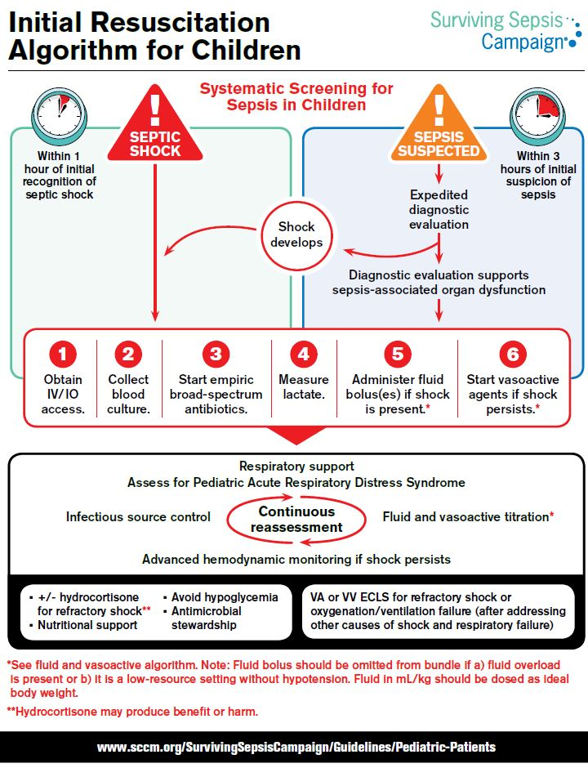

Australian Journal of Primary Health
Volume 26 Number 1 2020
URL | https://www.publish.csiro.au/py/issue/9743
Notes | A new issue of the Australian Journal of Primary Health has been published. Articles in this issue of the Australian Journal of Primary Health include:  - Aboriginal and Torres Strait Islander men and parenting: a scoping review (Kootsy Canuto, Stephen G. Harfield, Karla J. Canuto and A Brown)  - Building capacity in primary health care to respond to the needs of asylum seekers and refugees in Melbourne, Australia: the 'GP Engagement' initiative (Mark Timlin, Alana Russo and Jacquie McBride)  - Education of the medical profession to facilitate delivery of transgender health care in an Australian health district (Maansi Arora, Kaete Walker, Judy Luu, Robbert J. Duvivier, Tinashe Dune and Katie Wynne)  - Home medicines reviews: a qualitative study of GPs' experiences (Kristie Rebecca Weir, Vasi Naganathan, Debbie Rigby, Kirsten McCaffery, Carissa Bonner, Lyndal Trevena, Andrew J McLachlan and Jesse Jansen)  - Updating and validating quality prescribing indicators for use in Australian general practice (Cuu Phuong Linh Dang, Li Shean Toh, Nick Cooling, Shane Jackson, Colin Curtain, Angus Thompson and Gregory Peterson)  - Identifying hotspots of type 2 diabetes risk using general practice data and geospatial analysis: an approach to inform policy and practice (Nasser Bagheri, Paul Konings, Kinley Wangdi, Anne Parkinson, Soumya Mazumdar, Elizabeth Sturgiss, Aparna Lal, Kirsty Douglas and Nicholas Glasgow)  - Implications for GP endorsement of a diabetes app with patients from culturally diverse backgrounds: a qualitative study (Julie Ayre, Carissa Bonner, Sian Bramwell, Sharon McClelland, R Jayaballa, G Maberly and K McCaffery)  - A uniform data set for determining outcomes in allied health primary contact services in Australia (Nicole Moretto, Michelle Stute, Sonia Sam, Marita Bhagwat, Maree Raymer, Peter Buttrum, M Banks and T A Comans)  - Developmental vulnerability of Australian school-entry children with hearing loss (Andrea Simpson, Bojana Šarkic, Joanne C Enticott, Zoe Richardson and Kimberly Buck)  - Prevalence, perceived barriers and sociodemographic correlates of advance care planning in a sample of outpatients (Elise Mansfield, Sarah Jeong, Amy Waller and Sally Chan)  - Barriers and enablers to implementation of antenatal smoking cessation guidelines in general practice (Rohan Reeks, Govind Padmakumar, Bridgette Andrew, Danica Huynh and Jo Longman)  - Primary healthcare providers' attitudes and beliefs about the menopause-related care needs of women who have migrated from low- and middle-income countries to Australia (Karin A. Stanzel, K Hammarberg and J Fisher)

BMJ Quality and Safety online first articles
URL | https://qualitysafety.bmj.com/content/early/recent
Notes | BMJ Quality and Safety has published a number of ‘online first’ articles, including:  - Editorial: What are we doing when we double check? (Yvonne Pfeiffer, Chantal Zimmerman, David L B Schwappach)  - Editorial: Nothing soft about ‘soft skills’: core competencies in quality improvement and patient safety education and practice (Joanne Goldman, Brian M Wong)  - Editorial: Identifying adverse events: reflections on an imperfect gold standard after 20 years of patient safety research (Kaveh G Shojania, Perla J Marang-van de Mheen)

International Journal for Quality in Health Care online first articles
URL | https://academic.oup.com/intqhc/advance-articles
Notes | International Journal for Quality in Health Care has published a number of ‘online first’ articles, including:  - An innovative quality improvement approach for rapid improvement of infection prevention and control at health facilities in Sierra Leone (Ilka Rondinelli, Gillian Dougherty, Caitlin A Madevu-Matson, Mame Toure, Adewale Akinjeji, Irene Ogongo, Amy Kolwaite, Jamine Weiss, Brigette Gleason, Meghan Marie Lyman, Hassan Benya, Miriam Rabkin)

Disclaimer
On the Radar is an information resource of the Australian Commission on Safety and Quality in Health Care. The Commission is not responsible for the content of, nor does it endorse, any articles or sites listed. The Commission accepts no liability for the information or advice provided by these external links. Links are provided on the basis that users make their own decisions about the accuracy, currency and reliability of the information contained therein. Any opinions expressed are not necessarily those of the Australian Commission on Safety and Quality in Health Care.

