# Australian COmmission on Safety and Quality in Health Care logo with Radar imageOn the Radar

Issue 454

9 March 2020

*On the Radar* is a summary of some of the recent publications in the areas of safety and quality in health care. Inclusion in this document is not an endorsement or recommendation of any publication or provider. Access to particular documents may depend on whether they are Open Access or not, and/or your individual or institutional access to subscription sites/services. Material that may require subscription is included as it is considered relevant.

*On the Radar* is available online, via email or as a PDF or Word document from <https://www.safetyandquality.gov.au/publications-and-resources/newsletters/radar>

If you would like to receive *On the Radar* via email, you can subscribe on our website <https://www.safetyandquality.gov.au/publications-and-resources/newsletters>   
or by emailing us at H[Umail@safetyandquality.gov.auU](mailto:mail@safetyandquality.gov.au).   
You can also send feedback and comments to H[Umail@safetyandquality.gov.auU](mailto:mail@safetyandquality.gov.au).

For information about the Commission and its programs and publications, please visit <https://www.safetyandquality.gov.au>

You can also follow us on Twitter @ACSQHC.

**On the Radar**

Editor: Dr Niall Johnson [niall.johnson@safetyandquality.gov.au](mailto:niall.johnson@safetyandquality.gov.au)

Contributors: Niall Johnson

**Journal articles**

*“Thank You for Listening”: An Exploratory Study Regarding the Lived Experience and Perception of Medical Errors Among Those Who Receive Care*

Terry D, Kim J-a, Gilbert J, Jang S, Nguyen H

International Journal of Health Services. 2019:0020731419893036.

|  |  |
| --- | --- |
| DOI | <https://doi.org/10.1177/0020731419893036> |
| Notes | Australian study looking at how patients/consumers perceive and experience errors in health care. Based on 304 survey responses, the authors focus on ‘the **importance of effective health professional–patient communication**, enhanced capacity to deliver high quality care, and improved mechanism for **error reporting** and **resolution** where **patients feel safe and confident about positive changes being made**.’ |

For information on the Commission’s work on open disclosure, including the *Australian Open Disclosure Framework*, see <https://www.safetyandquality.gov.au/our-work/clinical-governance/open-disclosure>

*Patient safety in marginalised groups: a narrative scoping review*

Cheraghi-Sohi S, Panagioti M, Daker-White G, Giles S, Riste L, Kirk S, et al

International Journal for Equity in Health. 2020;19(1):26.

|  |  |
| --- | --- |
| DOI | <https://doi.org/10.1186/s12939-019-1103-2> |
| Notes | Safety and quality efforts are often focused on the general situation, for the entire patient population of a facility or service. However, there are certain settings and certain patient groups for whom the safety and quality issues can be quite different. This review looked the literature on marginalised groups (using a board definition of “populations outside of mainstream society” to understand   1. which marginalised groups have been studied in terms of patient safety research, 2. what the particular patient safety issues are for such groups and 3. what contributes to or is associated with these safety issues arising.   From the 67 identified studies, the authors report that ‘**marginalised patient groups are vulnerable to experiencing a variety patient safety issues** and points to a number of gaps’ and need for further research, particularly for ‘groups that have been under-researched, including those with mental health problems, communication and cognitive impairments’. The authors also advocate ‘’working collaboratively to co-design training, services and/or interventions designed to remove or at the very least minimise these increased risks.’ |

*Systemic causes of in-hospital intravenous medication errors: a systematic review*

Kuitunen S, Niittynen I, Airaksinen M, Holmström A-R

Journal of Patient Safety. 2020 [epub].

|  |  |
| --- | --- |
| DOI | <https://doi.org/10.1097/pts.0000000000000632> |
| Notes | Medication errors, broadly defined, are among the most common errors. This paper looks at one particular type of medication errors – those occurring in hospitals and involving intravenous (IV) medications. This review sought to examine the literature on systemic causes these errors. Focused on 11 studies, the reviewers found ‘A**dministration, prescribing, and preparation were the process phases most prone to systemic errors**. Insufficient actions to secure **safe use of high-alert medications**, **lack of knowledge** of the drug, **calculation tasks**, failure in **double-checking** procedures, and confusion between **look-alike, sound-alike medications** were the leading causes of intravenous medication errors.’ |

For information on the Commission’s work on medication safety, see <https://www.safetyandquality.gov.au/our-work/medication-safety>

*Health Affairs*

Volume 39, No. 3, March 2020

|  |  |
| --- | --- |
| URL | <https://www.healthaffairs.org/toc/hlthaff/39/3> |
| Notes | A new issue of *Health Affairs* has been published with the theme ‘The Affordable Care Act Turns 10’. Articles in this issue of *Health Affairs* include:   * A **New Approach To Mental Health Care**, Imported From Abroad (Rob Waters) * A Ten-Year Engagement: The **Media And The ACA** (Julie Rovner) * How Have **ACA Insurance Expansions Affected Health Outcomes**? Findings From The Literature (Aparna Soni, Laura R Wherry, and K I Simon) * Did The ACA Lower Americans’ **Financial Barriers To Health Care**? (Sherry A Glied, Sara R Collins, and Saunders Lin) * **Women’s Coverage, Utilization, Affordability, And Health** After The ACA: A Review Of The Literature (Lois K Lee, Alyna Chien, A Stewart, L Truschel, J Hoffmann, E Portillo, L E Pace, M Clapp, and A A Galbraith) * The ACA’s Impact On **Racial And Ethnic Disparities In Health Insurance Coverage And Access** To Care (T C Buchmueller, and H G Levy) * How The **ACA Dented The Cost Curve** (Melinda B Buntin, and J A Graves) * **Transforming Medicare’s Payment Systems**: Progress Shaped By The ACA (Michael E Chernew, Patrick H Conway, and Austin B Frakt) * The **Changing Landscape Of Primary Care**: Effects Of The ACA And Other Efforts Over The Past Decade (Deborah Peikes, Erin Fries Taylor, Ann S O’Malley, and Eugene C Rich) * The **ACA’s Individual Mandate** In Retrospect: What Did It Do, And Where Do We Go From Here? (Matthew Fiedler) * The ACA’s Effect On The **Individual Insurance Market** (Sabrina Corlette, Linda J. Blumberg, and Kevin Lucia) * How The ACA Reframed The **Prescription Drug Market** And Set The Stage For Current Reform Efforts (Rena Conti, Stacie B Dusetzina, and R Sachs) * **Specialty Substance Use Disorder Treatment Admissions** Steadily Increased In The Four Years After Medicaid Expansion (Brendan Saloner, and Johanna Catherine Maclean) * The Past, Present, And Possible Future Of **Public Opinion On The ACA** (Mollyann Brodie, Elizabeth C Hamel, Ashley Kirzinger, and Drew E Altman) * The Ten Years’ War: **Politics, Partisanship, And The ACA** (J Oberlander) * **The ACA And The Courts**: Litigation’s Effects On The Law’s Implementation And Beyond (Timothy Stoltzfus Jost, and Katie Keith) * **Federalism And The ACA**: Lessons For The 2020 Health Policy Debate (Michael S. Sparer) * State Politics And The Uneven Fate Of **Medicaid Expansion** (Philip Rocco, Ann C Keller , and Andrew S Kelly) * **Health Insurance Coverage**: What Comes After The ACA? (B D Sommers) * Building On The Gains Of The ACA: Federal Proposals To **Improve Coverage And Affordability** (C Brooks-LaSure, E Fowler, and G Mauser) * Closing The **Medicaid Coverage Gap**: Options For Reform (Sara Rosenbaum, and Gail Wilensky) * A Pathway To **Consumer-Driven Universal Coverage** (Avik Roy) * **The ACA Turns 10**: Reflections Of Four Industry Leaders (Alan R. Weil) * The **Power Of Access To Affordable Care** (Rachel J. Stern) |

*BMJ Quality and Safety* online first articles

|  |  |
| --- | --- |
| URL | <https://qualitysafety.bmj.com/content/early/recent> |
| Notes | *BMJ Quality and Safety* has published a number of ‘online first’ articles, including:   * Editorial: Beyond CLABSI and CAUTI: **broadening our vision of patient safety** (Kaveh G Shojania) * Editorial: Whiteboards: important part of the toolbox for improving **patient understanding during hospitalisation** (Sara Dunbar, Kathlyn E Fletcher) * Cluster randomised controlled trial evaluating the clinical and humanistic impact of a **pharmacist-led minor ailment service** (Sarah Dineen-Griffin, Shalom I Benrimoj, Kris Rogers, Kylie A Williams, Victoria Garcia-Cardenas) * Reduction of **paediatric head CT** utilisation at a rural general hospital emergency department (Jeffrey Paul Louie, Joseph Alfano, Thuy Nguyen-Tran, Hai Nguyen-Tran, Ryan Shanley, Tara Holm, Ronald A Furnival) * Going the extra mile — **cross-border patient handover** in a European border region: qualitative study of healthcare professionals' perspectives (Juliëtte A Beuken, Daniëlle M L Verstegen, Diana H J M Dolmans, Laura Van Kersbergen, Xavier Losfeld, Saša Sopka, Lina Vogt, Mara E J Bouwmans) * Does team reflexivity impact **teamwork and communication in interprofessional hospital-based healthcare teams**? A systematic review and narrative synthesis (Siobhan Kathleen McHugh, Rebecca Lawton, Jane Kathryn O'Hara, Laura Sheard) |

*International Journal for Quality in Health Care* online first articles

|  |  |
| --- | --- |
| URL | <https://academic.oup.com/intqhc/advance-articles> |
| Notes | *International Journal for Quality in Health Care* has published a number of ‘online first’ articles, including:   * Beyond ‘find and fix’: **improving quality and safety through resilient healthcare** systems (J E Anderson, A J Ross, J Back, M Duncan, P Snell, A Hopper, P Jaye) |

**Online resources**

*ISMP Guidelines for Optimizing Safe Implementation and Use of Smart Infusion Pumps*

<https://www.ismp.org/guidelines/safe-implementation-and-use-smart-pumps>

Institute for Safe Medication Practices (ISMP) has released this expanded guidance on smart infusion pumps. The safe practice statements are designed to support optimization of smart infusion pump technology and to assist organizations in their transition to interoperability. Specific error-reduction strategies are presented in the guidelines to address:

* Infrastructure
* Drug Libraries
* Continuous Quality Improvement (CQI) Data
* Clinical Workflow
* Interoperability with the Electronic Health Record (EHR).

*Data breach action plan for health service providers*

<https://www.oaic.gov.au/privacy/guidance-and-advice/data-breach-action-plan-for-health-service-providers>

The Office of the Australian Information Commissioner has produced this four-step action plan specifically aimed at the health sector to help them contain and manage data breaches, including those involving the My Health Record system.

[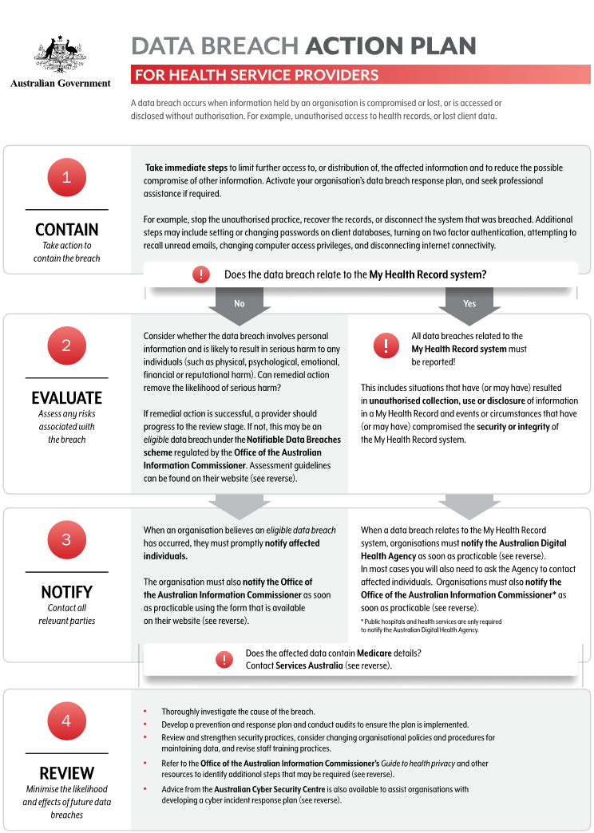](https://www.oaic.gov.au/privacy/guidance-and-advice/data-breach-action-plan-for-health-service-providers)

*[UK] National Institute for Health Research*

<https://discover.dc.nihr.ac.uk/portal/search/signals>

The UK’s National Institute for Health Research (NIHR) Dissemination Centre has released the latest ‘Signals’ research summaries. This latest release includes:

* Melatonin shows potential for reducing **delirium** among older people **after surgery**
* **Structured nurse ward rounds** support accountability and risk management but not nurse-patient communication
* People leave hospital after surgery sooner if hospitals follow ‘**enhanced recovery protocols**’
* Surgery to fix the womb in position after **prolapse** is an alternative to hysterectomy
* **ICU admission decision support tool** showed promise but was rarely used
* Age of **stored blood used for transfusions** in critically ill children doesn’t affect outcomes
* **NHS health check attendance** improves with changes to the invitation letter
* Outcomes similar for full or partial hip replacement after **hip fracture**
* Text messaging support helps **smokers quit**, but apps not yet shown to work
* Increasing omega-3 intake does not prevent **depression or anxiety**.

**Disclaimer**

On the Radar is an information resource of the Australian Commission on Safety and Quality in Health Care. The Commission is not responsible for the content of, nor does it endorse, any articles or sites listed. The Commission accepts no liability for the information or advice provided by these external links. Links are provided on the basis that users make their own decisions about the accuracy, currency and reliability of the information contained therein. Any opinions expressed are not necessarily those of the Australian Commission on Safety and Quality in Health Care.