
On the Radar
Issue 455
16 March 2020

On the Radar is a summary of some of the recent publications in the areas of safety and quality in health care. Inclusion in this document is not an endorsement or recommendation of any publication or provider. Access to particular documents may depend on whether they are Open Access or not, and/or your individual or institutional access to subscription sites/services. Material that may require subscription is included as it is considered relevant.

On the Radar is available online, via email or as a PDF or Word document from https://www.safetyandquality.gov.au/publications-and-resources/newsletters/radar

If you would like to receive On the Radar via email, you can subscribe on our website https://www.safetyandquality.gov.au/publications-and-resources/newsletters
or by emailing us at HUmail@safetyandquality.gov.auU.
You can also send feedback and comments to HUmail@safetyandquality.gov.auU.

For information about the Commission and its programs and publications, please visit https://www.safetyandquality.gov.au
You can also follow us on Twitter @ACSQHC.
On the Radar
Editor: Dr Niall Johnson niall.johnson@safetyandquality.gov.au
Contributors: Niall Johnson, Vannary Sar

Reports

Making Healthcare Safer III: A Critical Analysis of Existing and Emerging Patient Safety Practices
Bacon O, Costar D, Earl T, Fitall E, Gale B, Gall E, et al
Rockville, MD: Agency for Healthcare Research and Quality; 2020. p. 1403.
URL | https://www.ahrq.gov/research/findings/making-healthcare-safer/mhs3/index.html
Notes | The US Agency for Healthcare Research and Quality (AHRQ) has released this substantial (>1400 page) report reviewing a range of patient safety practices. The report reviews 47 practices that target patient safety improvement in hospitals, primary care practices, long-term care facilities, and other healthcare settings.  The 47 practices were examined across 17 chapters looking at “harm areas” including medication management, healthcare-associated infections, nursing-sensitive practices, procedural events, and diagnostic errors. The practices include clinical decision support technologies, use of rapid-response teams, special hygiene and disinfection interventions to prevent HAIs, and several practices designed to prevent medication errors and reduce opioid misuse and overdose.

Potentially Preventable Readmissions: Conceptual Framework To Rethink the Role of Primary Care: Final Report`
Maxwell J, Bourgoin A, Crandall J
Rockville, MD: Agency for Healthcare Research and Quality; 2020.
URL | https://www.ahrq.gov/patient-safety/settings/ambulatory/reduce-readmissions.html
Notes | Along with many other safety and quality bodies, the US Agency for Healthcare Research and Quality (AHRQ) has been examining the issue of readmissions and what proportion may be considered as “potentially preventable”. In this latest report, the role of primary care is to the fore. Acute, hospital care tends to be much more costly than primary care. The view is that better primary care can be more appropriate and more cost-effective in treating patients and thus averting the need for hospital admission for many of these cases. However, in many contexts, primary care is not always well supported and prepared for this role. Along with the report (and a separate executive summary) the AHRQ has also made available the Environmental Scan of Primary Care-Based Efforts To Reduce Readmissions.

Journal articles

Engaging patients and families in communication across transitions of care: An integrative review
Bucknall TK, Hutchinson AM, Botti M, McTier L, Rawson H, Hitch D, et al
Patient Education and Counseling. 2020 [epub].
DOI | https://doi.org/10.1016/j.pec.2020.01.017
Notes | This review sought to examine the current evidence about patient and family engagement in communication with health professions during transitions of care to, within and from acute care settings. The review found that while attitudes towards engaging patients and their families in transition communication was generally positive, current practices are variable. Organisational strategies to improve communication must incorporate an understanding of patient needs; and a structured approach that considers timing, privacy, location and appropriateness for patients and families is needed. Communication training is also required for patients, families and health professionals, with health professionals respecting a patient’s right to be informed by regularly communicating.

For information on the Commission’s work on patient-clinician communication, see https://www.safetyandquality.gov.au/our-work/communicating-safety/patient-clinician-communication
For helpful resources visit the Communicating for Safety resource portal at https://c4sportal.safetyandquality.gov.au/

Clinical guideline for homeless and vulnerably housed people, and people with lived homelessness experience
Pottie K, Kendall CE, Aubry T, Magwood O, Andermann A, Salvalaggio G, et al
Canadian Medical Association Journal. 2020;192(10):E240.
DOI | https://doi.org/10.1503/cmaj.190777
Notes | A critique that has been made of clinical guidelines is that they tend to be for a single condition and/or not based on “real world” lived experience. This guideline published in the Canadian Medical Association Journal seeks to provide guidance on how clinicians can assist/treat homeless and vulnerably housed people, particular Indigenous people. Clearly, this guideline is specific to the Canadian context, but many have much that could be considered and applied or amended to suit other contexts.

Implementing a sustainable medication reconciliation process in Australian hospitals: The World Health Organization High 5s project
Stark HE, Graudins LV, McGuire TM, Lee CYY, Duguid MJ
Research in Social and Administrative Pharmacy. 2020;16(3):290-298.
DOI | https://doi.org/10.1016/j.sapharm.2019.05.011
Notes | Paper reporting on the Australian experience in implementing the World Health Organization High 5s project for medication reconciliation (medrec). The project sought to ‘determine the feasibility of implementing the World Health Organization (WHO) Medrec Standard Operating Protocol (SOP) in a range of Australian acute care facilities to achieve measurable and sustainable reductions in medication discrepancies occurring at admission.’ Co-ordinated by the Australian Commission on Safety and Quality in Health Care, this was a multicentre national study conducted in ten academic, urban and regional hospitals to implement the SOP using WHO High 5s project and quality improvement methodology. The authors concluded that implementing ‘The WHO SOP was feasible, although challenging, to implement in a range of acute health services, and produced measureable and sustainable improvements in medicines information accuracy on admission. Sustaining the quantum of quality and timely medrec requires investment in pharmacist resources and electronic systems integration.’

For information on the Commission’s work on medication safety, including medication reconciliation, see https://www.safetyandquality.gov.au/our-work/medication-safety

For information on the Commission’s work on the World Health Organization’s High 5s Medication Reconciliation Project, see https://www.safetyandquality.gov.au/our-work/medication-safety/medication-reconciliation/world-health-organizations-high-5s-medication-reconciliation-project

Prevalence, nature and predictors of omitted medication doses in mental health hospitals: a multi-centre study
Keers RN, Hann M, Alshehri GH, Bennett K, Miller J, Prescott L, et al
PLOS ONE. 2020;15(2):e0228868.
DOI | http://doi.org/10.1371/journal.pone.0228868
Notes | Paper reporting on a study of medication omission errors in two English National Health Service mental health trusts with 9 psychiatric hospitals. The study examined inpatient prescription charts for scheduled and omitted medication doses within 27 adult and elderly wards across the 9 psychiatric hospitals. The pharmacy teams looked at 18,664 scheduled medication doses for 444 inpatients and found:  - 2,717 omissions, resulting in a rate of 14.6% (95% CI 14.1–15.1).  - The rate of ‘time critical’ omitted doses was 19.3% (95% CI 16.3–22.6%). ‘Preventable’ omitted doses comprised one third of all omissions (34.5%, 930/2694).  - Medicines affecting the central nervous system were 55% less likely to be omitted compared to all other medication classes (9.9% vs. 18.8%, OR 0.45 (0.40–0.52))  - Scheduled doses administered using non-oral routes were more likely to be omitted compared the oral route (inhaled OR 3.47 (2.64–4.57), topical 2.71 (2.11–3.46), ‘other’ 2.15 (1.19–3.90)).  - ‘Preventable’ dose omissions were more than twice as likely to occur for ‘time critical’ medications than non-time critical medications (50.4% vs. 33.8%, OR 2.24 (1.22–4.11)).

Screening for Hepatitis C Virus Infection in Adolescents and Adults: US Preventive Services Task Force Recommendation Statement
U. S. Preventive Services Task Force
Journal of the American Medical Association. 2020;323(10):970-975.

Screening for Hepatitis C Virus Infection in Adolescents and Adults: Updated Evidence Report and Systematic Review for the US Preventive Services Task Force
Chou R, Dana T, Fu R, Zakher B, Wagner J, Ramirez S, et al.
Journal of the American Medical Association. 2020;323(10):976-991.

Universal Screening for Hepatitis C Virus Infection: A Step Toward Elimination
Graham CS, Trooskin S
Journal of the American Medical Association. 2020;323(10):936-937.

Updated Hepatitis C Virus Screening Recommendation—A Step Forward
Price JC, Brandman D
JAMA Internal Medicine. 2020 [epub].

USPSTF’s Hepatitis C Screening Recommendation—A Necessary Step to Tackling an Evolving Epidemic
Rosenberg ES, Barocas JA
JAMA Network Open. 2020;3(3):e200538.

Screening for Hepatitis C Virus Infection
Jin J
Journal of the American Medical Association. 2020;323(10):1008.
DOI | U.S. Preventive Services Task Force https://doi.org/10.1001/jama.2020.1123  Chou et al https://doi.org/10.1001/jama.2019.20788  Graham and Trooskin https://doi.org/10.1001/jama.2019.22313  Price and Brandman https://doi.org/10.1001/jamainternmed.2019.7334  Rosenberg and Barocas https://doi.org/10.1001/jamanetworkopen.2020.0538  Jin https://doi.org/10.1001/jama.2020.1761
Notes | Hepatitis C is a blood-borne virus that can lead to liver disease and liver cancer. In the USA, Hepatitis C virus (HCV) is the most common chronic blood-borne pathogen and a leading cause of complications from chronic liver disease. HCV is associated with more deaths than the top 60 other reportable infectious diseases combined, including HIV. The US Preventive Services Task Force has released their updated recommendation on screening for HCV infection. Their recommendation statement, the evidence report and systematic review that inform the recommendation. (Chou et al) and editorials (Graham and Trooskin, Price and Brandman, and Rosenberg and Barocas) have all been published, along with a ‘Patient Page’ (Jin) in JAMA.  The USPSTF recommends screening for HCV infection in adults aged 18 to 79 years. (B recommendation). The recommendation applies to all asymptomatic adults aged 18 to 79 years without known liver disease.  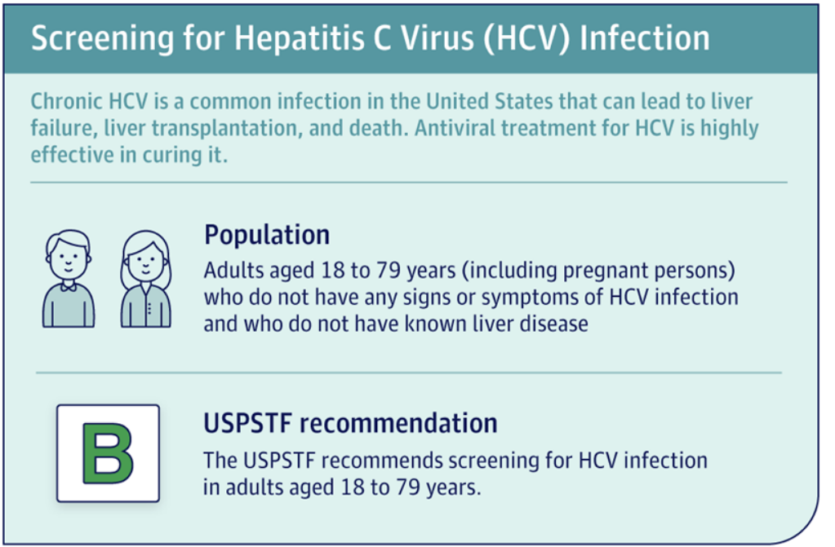

Public Health Research & Practice
Volume 30, No. 1, March 2020
URL | https://www.phrp.com.au/issues/march-2020-volume-30-issue-1/
Notes | A new issue of Public Health Research & Practice has been published. Articles in this issue of Public Health Research & Practice include:  - On a knife’s edge of a COVID-19 pandemic: is containment still possible? (C Raina MacIntyre)  - Improving palliative and end-of-life care for rural and remote Australians (Sarah Wenham, Melissa Cumming, Emily Saurman)  - How readable are Australian multilingual diabetes patient education materials? An evaluation of national English-language source texts (Shanshan Lin, Julie Ayre, Danielle M Muscat)  - Predictors of ceasing or reducing statin medication following a large increase in the consumer copayment for medications: a retrospective observational study (Karla Seaman, Frank Sanfilippo, Max Bulsara, Libby Roughead, Anna Kemp-Casey, Caroline Bulsara, Gerald F Watts, David Preen  - An evaluation of the 2016 influenza vaccination in pregnancy campaign in NSW, Australia (Samantha Carlson, Aditi Dey, Frank Beard)  - Examining the use of antiviral prophylaxis for influenza outbreaks in residential aged care facilities in NSW, Australia (Wedyan Meshreky, Daneeta Hennessy, Robin Gilmour, Sean Tobin, Vicky Sheppeard)  - The equitable reach of a universal, multisector childhood obesity prevention program (Live Life Well @ School) in Australian primary schools (Andrea Bravo, Bridget C Foley, C Innes-Hughes, B J O'Hara, B McGill, C Rissel)  - Falling short: examination of the validity of methods used to identify paediatric hospital falls in NSW, Australia (Daniela Feuerlicht, Maria Agaliotis, Reece Hinchcliff)  - Capture of systemic anticancer therapy use by routinely collected health datasets (Hanna E Tervonen, Nicola Creighton, George W Zhao, Megumi Ng, David C Currow)  - Children’s trips to school dominated by unhealthy food advertising in Sydney, Australia (Korina J Richmond, Wendy L Watson, Clare Hughes, Bridget Kelly)
BMJ Quality and Safety online first articles
URL | https://qualitysafety.bmj.com/content/early/recent
Notes | BMJ Quality and Safety has published a number of ‘online first’ articles, including:  - Estimating misclassification error in a binary performance indicator: case study of low value care in Australian hospitals (Tim Badgery-Parker, Sallie-Anne Pearson, Adam G Elshaug)  - Does team reflexivity impact teamwork and communication in interprofessional hospital-based healthcare teams? A systematic review and narrative synthesis (Siobhan Kathleen McHugh, Rebecca Lawton, Jane Kathryn O'Hara, Laura Sheard)  - Multistate programme to reduce catheter-associated infections in intensive care units with elevated infection rates (Jennifer Meddings, M Todd Greene, David Ratz, Jessica Ameling, Karen E Fowler, Andrew J Rolle, Louella Hung, Sue Collier, Sanjay Saint)  - Out of sight, out of mind: a prospective observational study to estimate the duration of the Hawthorne effect on hand hygiene events (Alon Vaisman, Grace Bannerman, John Matelski, Kathryn Tinckam, Susy S Hota)  - Application of human factors to improve usability of clinical decision support for diagnostic decision-making: a scenario-based simulation study (Pascale Carayon, Peter Hoonakker, Ann Schoofs Hundt, Megan Salwei, Douglas Wiegmann, Roger L Brown, Peter Kleinschmidt, Clair Novak, Michael Pulia, Yudi Wang, Emily Wirkus, Brian Patterson)  - Appropriateness of peripherally inserted central catheter use among general medical inpatients: an observational study using routinely collected data (Amol A Verma, Alexander Kumachev, Sonam Shah, Yishan Guo, Hae Young Jung, Shail Rawal, Lauren Lapointe-Shaw, Janice L Kwan, Adina Weinerman, Terence Tang, Fahad Razak)

International Journal for Quality in Health Care online first articles
URL | https://academic.oup.com/intqhc/advance-articles
Notes | International Journal for Quality in Health Care has published a number of ‘online first’ articles, including:  - Using parent-reported experience measures as quality improvement tools in paediatric cardiothoracic services: making it happen (Jo Wray, Geralyn Oldham)  - Improving quality of care in conflict settings: access and infrastructure are fundamental (Dilshad Jaff, Sheila Leatherman, Linda Tawfik)  - Prediction of medical expenditures of diagnosed diabetics and the assessment of its related factors using a random forest model, MEPS 2000–2015 (Jing Wang, Leiyu Shi)  - A systematic review of patient-reported outcome measurement (PROM) and provider assessment in mental health: goals, implementation, setting, measurement characteristics and barriers (Marc Gelkopf, Yael Mazor, David Roe)

Online resources

[UK] NICE Guidelines and Quality Standards
https://www.nice.org.uk/guidance
The UK’s National Institute for Health and Care Excellence (NICE) has published new (or updated) guidelines and quality standards. The latest reviews or updates are:
- NICE Guideline NG155 Tinnitus: assessment and management https://www.nice.org.uk/guidance/ng155

[Canada] QI Power Hour
https://hqc.sk.ca/news-events/qi-power-hour-webinars
The Saskatchewan Health Quality Council produces a free monthly series, the QI Power Hour, that examines topics related to quality improvement in health care and other sectors.

Disclaimer
On the Radar is an information resource of the Australian Commission on Safety and Quality in Health Care. The Commission is not responsible for the content of, nor does it endorse, any articles or sites listed. The Commission accepts no liability for the information or advice provided by these external links. Links are provided on the basis that users make their own decisions about the accuracy, currency and reliability of the information contained therein. Any opinions expressed are not necessarily those of the Australian Commission on Safety and Quality in Health Care.

