Australian Commission on Safety and Quality in Health Care logo 


TRIM: D17-41652

March 2018

*Clostridium difficile* infection

A model to improve the management and control of *Clostridium difficile* in Australia

Published by the Australian Commission on Safety and Quality in Health Care  
Level 5, 255 Elizabeth Street, Sydney NSW 2000

Phone: (02) 9126 3600  
Fax: (02) 9126 3613

Email: mail@safetyandquality.gov.au   
Website: www.safetyandquality.gov.au

ISBN: 978-1-925665-37-6

© Australian Commission on Safety and Quality in Health Care 2018

All material and work produced by the Australian Commission on Safety and Quality in Health Care is protected by copyright. The Commission reserves the right to set out the terms and conditions for the use of such material.

As far as practicable, material for which the copyright is owned by a third party will be clearly labelled. The Australian Commission on Safety and Quality in Health Care has made all reasonable efforts to ensure that this material has been reproduced in this publication with the full consent of the copyright owners.

With the exception of any material protected by a trademark, any content provided by third parties, and where otherwise noted, all material presented in this publication is licensed under a [Creative Commons Attribution-NonCommercial-NoDerivatives 4.0 International licence](http://creativecommons.org/licenses/by-nc-nd/4.0/).

Creative Commons Licence

Enquiries about the licence and any use of this publication are welcome and can be sent to [communications@safetyandquality.gov.au](mailto:communications@safetyandquality.gov.au).

The Commission’s preference is that you attribute this publication (and any material sourced from it) using the following citation:

Australian Commission on Safety and Quality in Health Care. *Clostridium difficile* infection. A model to improve the management and control of *Clostridium difficile* in Australia. Sydney: ACSQHC; 2018

**Disclaimer**

The content of this document is published in good faith by the Australian Commission on Safety and Quality in Health Care for information purposes. The document is not intended to provide guidance on particular healthcare choices. You should contact your healthcare provider on particular healthcare choices. Please note that there is the potential for minor revisions of this report.

The Commission does not accept any legal liability for any injury, loss or damage incurred by the use of, or reliance on, this document.

Contents

Summary 1

Background 2

*Clostridium difficile* in Australia……………………………………………………………2

Existing infection prevention and control strategies for Australian healthcare settings………………………………………………………………………………………4

2017 CDI Community of Practice 7

Introduction……………………………………………………………………………….....7

Methods……………………………………………………………………………………...7

Findings…………………………………………………………………………………….9

Priorities for future action…………………………………………………………………11

Future action for the Commission 14

References 16

Appendix 1 - Community of Practice membership…………………………………….19

Appendix 2 - Variations, gaps and constraints in the current management and prevention of CDI in Australia……………………………………………………………20

Appendix 3 - Structured discussions……………………………………………………21

Appendix 4 - Driver diagram series……………………………………………………..28

Appendix 5 - Action prioritisation………………………………………………………..33

Appendix 6 - Context mapping…………………………………………………………..34

# Summary

In order to identify the measures that are needed in the future to maintain low rates of *Clostridium difficile* infection (CDI) in Australia, the Australian Commission on Safety and Quality in Health Care (the Commission) established a Community of Practice (CoP) in October 2016 to investigate the variations and gaps associated with the current surveillance and management of *Clostridium difficile* infection. Using the driver diagram methodology, the CoP identified the barriers affecting CDI surveillance in Australia and used this information to identify targeted solutions to address each of these barriers. Each solution was then assessed for ease of implementation and scope of impact.

The CoP identified that improvements to the management and prevention of CDI in Australia were impeded by knowledge gaps, practice variations and practical constraints related to laboratory testing, clinical case management, hospital-based surveillance and uncertainty about the burden of disease in the community. The following actions were identified by the CoP as a priority to improve CDI prevention and control in Australia:

1. Recommend that the Australian Infection Prevention and Control guidelines include a requirement for contact precautions for all patients with diarrhoea until pathology results are known
2. Develop educational resources for clinicians and bed managers on bed placement priorities for patients with diarrhoea or known/suspected CDI
3. Develop a national monitoring mechanism for healthcare associated CDI
4. Update the ASID/ACIPC 2011 infection control position statement
5. Disseminate guidance to promote the requirement for contact precautions, including appropriate bed placement, for all patients with diarrhoea until pathology results are known
6. Review the barriers to appropriate CDI testing
7. Perform a desktop audit of all CDI clinical management and treatment guidelines available in Australia and identify inconsistencies
8. Review utility of other indicators for providing more meaningful outcome data to drive practice change
9. Review utility of current hospital administrative data, hospital laboratory surveillance and identify and review any other mechanisms for monitoring CDI in the community.

Given that work has already been undertaken to address Actions 1, 3 and 4, the CoP recommends that future work is undertaken to address the remaining priority actions:

* Developing national educational resources on bed placement prioritisation (Action 2)
* Reinforcing the need for contact precautions, including appropriate bed placement, at the jurisdictional and health service level (Action 5)
* Expanding the current knowledge base on CDI laboratory testing, case management and surveillance of community exposure through targeted research (Actions 6-9).

The CoP has also scoped which outstanding actions are within the remit of the Commission and which actions are best led by other agencies or organisations.

# Background

## *Clostridium difficile* in Australia

### Prevalence

Between 2011 and 2016 the average rate of *Clostridium difficile* infection (CDI)-related diagnoses in Australian public hospitals was 4.0 diagnoses per 10,000 patient days.1 As seen in Figure 1, the rate of CDI-related diagnoses peaked in early 2012 (5.0 diagnoses per 10,000 patient days) and again in late 2012 (4.9 diagnoses per 10,000 patient days). Previous work suggested that these peaks may have been the result of changes in laboratory testing processes and the emergence of ribotype 0272; this latter theory however has been since discounted given that there has been little circulation of ribotype 027 has been observed in Australia to date.3, 4

Figure 1. Monthly rate of A047 diagnoses in Australia, 2011-20161

* Refers to ICD-10 diagnosis code A04.7 *Gastroenterocolitis caused by Clostridium difficile*5

The rate of CDI diagnosis in Australia is comparable to recent infection rates reported in the United Kingdom (UK). This is despite considerable circulation of ribotype 027 in Europe in the early 2000s.6, 7 In the United Kingdom (UK), strict adoption infection control measures, including mandatory reporting in 2004 and enhanced surveillance and routine ribotyping in 2007, was required to contain this particular strain.8, 9 Prolonged adherence to these measures had a significant effect on the CDI rate in the UK: the CDI rate dropped from 14.9 cases per 10,000 patient days in 2007-08 to 3.67 cases per 10,000 patient days in 2016-17.10

The rate of CDI diagnosis varies between states. As seen in Table 1, there is a 10-fold difference in the rate of diagnosis between the states. In 2015 the highest rate was in the Australian Capital Territory (6.96 CDI diagnoses per 10,000 bed days); the lowest rate observed was in the Northern Territory (0.66 CDI diagnoses per 10,000 bed days).

Table 1. Rate of CDI diagnosis by state, 201511

|  |  |  |
| --- | --- | --- |
| State | Total Bed Days | Rate of CDI diagnosis  per 10,000 bed days |
| Australian Capital Territory | 403,765 | 6.96 |
| New South Wales | 6,388,427 | 4.35 |
| Northern Territory | 346,379 | 0.66 |
| Queensland | 3,702,250 | 2.43 |
| South Australia | 1,479,654 | 3.75 |
| Victoria | 4,889,193 | 3.91 |
| Western Australia | 1,938,631 | 4.63 |
| Tasmania | 396,435 | 4.96 |

As the rate of hospital-diagnosed CDI only accounts for symptomatic illness requiring hospital care and treatment and does not account for individuals with asymptomatic CDI or milder cases of CDI where hospitalisation is not required, it is likely that the burden of CDI in the Australian population is larger. Analysis by the Australian Commission on Safety and Quality in Health Care (the Commission) in 2017 indicates that healthcare delivery is the cause of CDI acquisition in fewer than 25% of hospital admissions with a CDI diagnosis. Instead, it is likely that the majority of CDI acquisition occur prior to hospitalisation, either in the community or from a prior episode of care.1

### Severe disease

Currently only Victoria collects surveillance data on severe CDI consistent with the *Implementation Guide for Surveillance of Clostridium difficile Infection*.12-14 Surveillance data regarding severe CDI from 2011 to 2017 were provided by VICNISS. Using this data it is estimated that 2.2% of all CDI cases result in severe disease and 0.7% CDI cases result in death due to severe disease. It is estimated that this equated to 112 cases of severe disease and 45 deaths from severe CDI in Australia in 2015. These estimates are useful given that the true burden of severe disease and mortality in Australia is unknown due to gaps in current CDI surveillance.

## Existing infection prevention and control strategies for Australian healthcare settings

There is a suite of existing infection prevention and control strategies that should be used to prevent and contain the spread of CDI in Australian healthcare settings. These strategies include:

#### Hand hygiene

To minimise the spread of infection, hand hygiene should always be employed by healthcare workers and other people caring for patients with, or suspected of having, CDI. While using soap and water to perform hand hygiene is more effective against *Clostridium difficile* than alcohol-based hand rub (ABHR)15, 16, hand hygiene with ABHR is effective if gloves have been used during patient care17 as glove use substantially reduces the microbial load present on hands.18, 19 If gloves have not been used, hand hygiene should be performed using soap and water and then dried thoroughly with a single-use towel to ensure the removal of the bacteria and its spores.20, 21

#### Standard and transmission-based precautions

Standard precautions should be employed when caring for all patients, regardless of whether CDI is present or suspected.20 Given that CDI is spread by contact transmission, contact precautions should also be employed when caring for patients with, or suspected of having, CDI in order to minimise the spread of the pathogen.17, 20 Specific requirements under contact precautions include20:

* Use of gloves and gown in the patient area when in direct physical contact with the patient and their immediate environment
* Use of single use equipment or reusable equipment that is dedicated to the affected patient and undergoes appropriate reprocessing between patients
* Ideally, a patient suspected of having or known to have CDI should be placed in a single room with dedicated bathroom facilities
* Minimising unnecessary movement of affected patients around the healthcare facility
* Increased frequency of environmental cleaning to include daily cleaning using detergent and disinfectant, of frequently touched surfaces and objects, and thorough terminal cleaning of the patient room on discharge.

#### Antimicrobial stewardship

It is critical that strategies are in place to ensure appropriate antimicrobial use given the possible link between antibiotic exposure in hospital and CDI.22, 23 Appropriate antimicrobial usage refers to appropriate clinical indication, dosage, duration and route of administration.24

#### Surveillance and reporting

Infection surveillance also informs understanding of current and local disease incidence and prevalence and epidemiology and can be used to identify areas for improvement and innovation. Relevant surveillance findings should be reported back to surveillance teams and relevant clinicians in a timely manner to enable an informed interpretation of surveillance findings, as well as engage clinicians to identify opportunities to improve their own clinical practice. Health service organisations are required to undertake infection surveillance as per the National Safety and Quality Health Service Standards.25 In addition, CDI surveillance is a specific requirement of the national Performance and Accountability Framework (PAF)26, which is the reporting instrument for the National Health Reform Agreement. The Commission has previously prescribed a set of standardised data parameters to enable a consistent approach to CDI surveillance across Australia.12, 27 Laboratory-based surveillance is used in most states and territories to monitor cases of hospital identified CDI as outlined in Table 2.

#### Consumer engagement

Healthcare consumers who have CDI, or who are at risk of getting CDI, should be provided with information on the cause of infection, disease effects and strategies consumers can use to prevent further disease spread. A [consumer factsheet](https://www.nhmrc.gov.au/_files_nhmrc/publications/attachments/cd33_cdiff_brochure_131106.pdf) on CDI is available and will be updated in line with the 2018 update of the Australian Guidelines for the Prevention and Control of Infection in Healthcare.20, 28

Table 2. Summary of state and territory-based CDI surveillance programs

|  |  |  |  |  |  |
| --- | --- | --- | --- | --- | --- |
| State or Territory | Year that jurisdictional surveillance program commenced | Surveillance elements | | | |
| **Hospital-identified** | **Exposure classification** | **Severity** | **Recurrence** |
| **ACT** | There is no jurisdictional CDI surveillance | | | | |
| **NSW** | 2010 | YES | NO | NO | NO |
| **NT** | There is no jurisdictional CDI surveillance | | | | |
| **Qld** | 2008§ | YES | YES | NO | NO |
| **SA** | 2006† | YES | YES* | NO | NO |
| **Tas** | 2008† | YES | YES | NO | NO |
| **Vic** | 2010§ | YES | YES | YES | YES |
| **WA** | 2010§ | YES | NO | NO | NO |

*Only collects healthcare-associated, health facility onset

† The national surveillance definition for CDI has been used since 2009

§ The national surveillance definition for CDI has been used since the beginning of the jurisdictional surveillance program

### 

### Reference material

In addition to the Australian Guidelines for the Prevention and Control of Infection in Healthcare20, the Implementation Guide for Surveillance of *Clostridium difficile* infection12, the national definition and calculation of hospital identified *Clostridium difficile* infection27 and the *Clostridium difficile* DSS29, a number of other national agencies have developed material that informs on the clinical management of and the infection prevention and control of CDI.

### Public Health Laboratory Network laboratory case definition

The Public Health Laboratory Network developed a standard laboratory case definition in 2016 to reduce the variation associated with the laboratory testing and diagnosis of CDI. Key aspects of case definition are30:

* Diagnosis requires laboratory detection of *C. difficile* toxins or toxigenic *C. difficile* in faeces, rectal swab or bowel contents PLUS relevant clinical manifestations (diarrhoea, ileus, toxic megacolon or pseudomembranous colitis)
* Criteria for diagnostic testing
* tests for toxigenic *C. difficile* should only be performed on unformed stool specimens (or gut contents from patients with diarrhoea), unless ileus is suspected
* all adults and children over 2 years, who have been hospitalized for >48 hours and develop diarrhoea (>3 unformed stools on a 24-hour period) should be tested for CDI
* all adults and children over 2 years, in whom diarrhoea has persisted for >48 hours and no other enteropathogen has been identified should be tested for CDI
* repeat testing of faecal specimens during the same episode of diarrhoea is not recommended a) within 4 weeks of a positive test (response to treatment is determined by clinical criteria) or b) following a negative test – unless CDI is strongly suspected and a more sensitive method (e.g. Nucleic Acid Amplification Testing) is used after a negative immunoassay
* tests for *C. difficile* in children <2 years old should be performed in consultation with a paediatrician.

The laboratory case definition provides a description of the different types of laboratory tests available to identify CDI, but does not indicate a preferred testing strategy.

### Australian Infection Control Association and Australasian Society of Infectious Diseases infection control position statement

In 2011 the Australian Infection Control Association (now the Australasian College of Infection Prevention and Control (ACIPC)) and the Australasian Society of Infectious Diseases (ASID) published a position statement summarising strategies that should be in place in healthcare facilities to prevent the spread of CDI.17 The position statement reinforces the need for infection surveillance, hand hygiene, contact precautions, environmental cleaning, staff and patient education, and outbreak management as effective mitigation against CDI. The position statement was disseminated as an open-access article in Healthcare Infection (the official journal of the former Australian Infection Control Association).

### Australasian Society of Infectious Diseases guidelines

In response to there being little clinical experience with severe CDI at the time, the Australasian Society of Infectious Diseases (ASID) published guidelines in 2011, with an update in 2016, to inform clinicians on the best practice approaches for CDI diagnosis and treatment.31, 32 These guidelines provide advice relevant to the principles of diagnosis, patient assessment, use of laboratory methods, disease prevention and management, antibiotic therapy and patient monitoring.

# 2017 CDI Community of Practice

## Introduction

Since 2012, the rate of CDI diagnosis in Australia has been relatively stable. In order to continue to reduce the overall disease burden and to prevent further disease spread, further effort is needed to ensure that the rate of disease in this country remains low.

The purpose of this paper is to report on the work undertaken by a Community of Practice that was established to identify what future measures need to be put in place to further improve CDI prevention and control in Australia.

## Methods

### CDI Community of Practice

A community of practice (CoP) was established in October 2016 with the objective of examining the practice variations and gaps associated with the monitoring and management of CDI in Australia. Membership of the CoP is included in Appendix 1. The main functions of the Community of Practice were to:

* Identify opportunities to address existing and emerging practice variations and gaps in CDI surveillance
* Examine the predictors of best practice CDI surveillance
* Explore and develop models to integrate CDI surveillance data into quality improvement activity
* Promote and disseminate the learnings obtained from projects undertaken by members.

### Process

The CoP met every six weeks via teleconference between October 2016 and October 2017 (9 meetings). The key activities of each teleconference are detailed in Figure 2 and key elements of the process are described below.

Figure 2. Outline of CoP meetings

#### Structured discussions

Structured discussions focussed on better understanding the cause of a single knowledge gap, practice variation or practical constraint. Discussion firstly centred on identifying all the underlying barriers that contributed to the practice gap, variation or constraint, and the relevant stakeholders that need to be engaged to overcome these barriers. A diagrammatic representation of this discussion is included in Appendix 2. Potential solutions were then workshopped to address each barrier.

The discussion template was used to focus dialogue within the group. This template was also used to record the discussion. Completed templates on laboratory testing, clinical case management, hospital based surveillance and community burden and impacts are included in Appendix 3.

#### Driver diagrams

A series of driver diagrams were built using the information gathered from the structured discussions. According to the Institute of Healthcare Improvement, a driver diagram illustrates the relationship between a project aim, the primary drivers that contribute to the achievement of the project aim, the secondary drivers that underpin the primary drivers and the specific change ideas that respond directly to the secondary drivers.33 It was necessary to develop five separate driver diagrams in order to reflect that change and improvement was required at the national level, the jurisdictional and local health service level and within the broader community and that change also need to occur in the context of disease prevention, clinical management and community

Each driver diagram begun with the same aim - to improve the control and management of CDI in Australia - and the same primary drivers. Primary drivers were determined from the practice variation, knowledge gaps and practical constraints identified in the structured discussions. Secondary drivers and change ideas were populated based on the barriers and solutions identified in the structured discussions and their applicability to the context at hand. Change ideas that were related to at least two secondary drivers were highlighted for priority assessment. The driver diagram series is included Appendix 4.

### 

### Action prioritisation

Highlighted change ideas were assessed by the CoP on the basis of ease of implementation and potential impact. Ease of implementation was determined as easy or hard. Change ideas that were easy to implement were those that were able to be rapidly actioned, not dependent on other actions being undertaken or were relatively close to the status quo. Potential impact was judged as low impact (i.e. few people would benefit or be impacted upon by the change) or as a high impact (i.e. many people would benefit).

Change ideas that were deemed easy to implement and of high impact were considered as priority actions for future testing and implementation. The completed action prioritisation grid is included in Appendix 5.

### Context mapping

Change ideas were also mapped back to the variations, constraints and knowledge gaps affecting CDI management and control in Australia in order to visualise the specific contexts in which these actions would likely have greatest effect. Context maps are included in Appendix 6.

## Findings

### Variation, gaps and constraints

The group identified that improvements to the management and prevention of CDI in Australia were impeded by a mixture of knowledge gaps, practice variations and practical constraints related to laboratory testing, clinical case management, hospital-based surveillance and uncertainty about the burden of disease in the community.

#### Laboratory testing

Currently there is an inconsistent approach to laboratory testing for CDI across Australia which impairs understanding of how much disease is in circulation. This inconsistency has arisen because there is wide variation in the testing practices of individual laboratories and, more broadly between private and public laboratories. For example, in some settings all diarrhoeal specimens are routinely screened for CDI whereas in other settings, diarrhoeal specimens will only be tested for CDI only if requested by the doctor.

It was highlighted that the practical constraints that lead to inadequate pre-analytic preparation, such as inappropriate storage and transportation, may also impact on the ability to control disease spread. Inadequate pre-analytic preparation results in poor specimen quality which may affect both whether laboratory testing can be performed and the quality of the results generated. In turn this can limit the usefulness of laboratory testing for clinical management and infection prevention and control purposes. Additionally, there is also potential for inappropriate and unnecessary diagnostic testing to occur which may further question the validity of current laboratory-based surveillance methods.

#### Clinical case management

Considerable unwarranted clinical variation is likely to occur given that there is no national standardised approach used to assess, manage and treat patients with CDI. While the ASID guidelines do exist, these are not necessarily adopted in all clinical settings. As a result, there is still much variation in the clinical management approaches used by individual clinicians as well as variation between health services. The lack of a standardised clinical management approach, combined with diagnostic uncertainty, may result in delayed and inconsistent clinical decision-making and patient placement decisions.

It also remains largely unknown what current clinical management strategies are effective in reducing the disease spread as the ASID guidelines have not been evaluated for effect and there has been very little investigation into which strategies are most effective for mitigating disease spread in the community.

#### Hospital-based surveillance

The utility of existing hospital-based infection surveillance programs for infection prevention and control purposes is limited. Firstly, current hospital-based surveillance methods (i.e. detection of hospital-identified CDI) cannot be used to distinguish the burden of CDI acquired directly from the delivery of health care. Enhanced surveillance classification is needed to provide this level of detail however to do this requires extra resourcing and is cost-prohibitive for many health services. Without this additional information it is difficult to identify where to focus local infection prevention and control efforts.

Secondly, the data generated from hospital-based infection surveillance programs cannot be used to inform national infection control programs because there variation between states regarding denominators (despite the publication of a national CDI definition) and data validation. As such state-level data cannot be aggregated with a high level of confidence. Lastly, existing hospital-based infection surveillance programs are not useful for identifying CDI outbreaks or monitoring disease recurrence, meaning that others methods need to be employed in parallel to track disease spread.

#### Uncertainty about the burden of disease in the community

Control and prevention of CDI in Australia is hampered very much by a lack of knowledge about the transmission of CDI in community. Specifically, there is little understanding about the risk factors for acquisition of CDI in the community and the relationship between hospital-acquired CDI and community-acquired CDI. Developing this knowledge is hard at the moment, given that a wide spectrum of disease exists in the community and there are no surveillance definitions that presently suitable for this setting. As a result of this knowledge gap, it is unclear whether the burden of CDI in community is indeed problematic.

## Priorities for future action

Improving CDI prevention and control is currently limited by a number of knowledge gaps, practice variations and practical constraints related to laboratory testing, clinical management and surveillance of CDI. In order to further reduce the overall disease burden and to prevent further disease spread, nine change ideas have been identified to address these gaps, variations and constraints and, in turn, improve CDI prevention and control in Australia. These change ideas, their current status, which context of effect and a proposal for how to progress each of these ideas are described in Table 3. Each change idea has been determined as a priority action because of its ease of implementation (i.e. can be readily actioned) and its anticipated broad impact (i.e. many people will benefit).

Table 3. Proposed change ideas to improve CDI prevention and control in Australia

| **Change ideas identified by the Community of Practice** | **Current status and proposed action** | **Context of effect** | | | | |
| --- | --- | --- | --- | --- | --- | --- |
| Improving prevention and control at the national level | Improving clinical management at the national level | Improving prevention and control at the jurisdictional or health service level | Improving prevention and control in community settings | Developing the evidence base to improve future efforts for CDI control and management |
| **1. Recommend Australian Infection Prevention and Control guidelines include requirement for contact precautions for all patients with diarrhoea until pathology results are known** | Updated Australian Infection Prevention and Control Guidelines is due for release in 2018. Recommendation 23 is relevant to this action:  **“Recommendation 23: It is suggested that contact precautions, in addition to standard precautions, are implemented in the presence of known or suspected infectious agents that are spread by direct or indirect contact with the patient or the patient's environment.”**  **“**A single-patient room is recommended for patients who require contact precautions.”  ***Proposed action:*** It is proposed that states, territories and individual health service organisations continue to support the implementation of contact precautions, including appropriate bed placement, in line with the updated Australian Guidelines for the Prevention and Control of Infection in Healthcare. | ✓ | ✓ |  |  |  |
| **2. Develop educational resources for clinicians and bed managers on bed placement priorities for patients with diarrhoea or known/suspected CDI** | No action has been undertaken to date.  ***Proposed action:*** It is proposed that the Commission adapt existing state resources (listed under (5)) as national guidance. | ✓ |  |  |  |  |
| **3. Develop national monitoring mechanism for healthcare acquired CDI** | As reported at the October 2017 meeting, the Commission has developed a mechanism to monitor hospital-identified CDI using administrative data available from the Admitted Patient Care National Minimum Data Set. The ongoing use of this approach was supported by the Interjurisdictional Committee in October 2017. Monitoring will commence in 2018.  ***Proposed action:*** A snapshot report on 2016 administrative data will be provided at the April IJC meeting. | ✓ |  |  |  |  |
| **4. Update ASID/ACIPC infection control position statement** | This update is currently in progress. A consultation draft has been provided to ASID/ACIPC members. It is anticipated that the updated statement will published by mid 2018.  ***Proposed action:*** A copy of the updated statement will be provided to the IJC for noting when it becomes available. |  | ✓ |  |  | ✓ |
| **5. Disseminate guidance to promote single room placement and contact precautions for all patients with diarrhoea until pathology results are known** | SA: Some guidance was produced and disseminated within the context of the [management of patients with multi-resistant organisms](http://www.sahealth.sa.gov.au/wps/wcm/connect/0044dc004295084780b0ba80c298878e/SA-Health-bed-management-toolkit-v1.2-20170914.pdf?MOD=AJPERES&CACHEID=0044dc004295084780b0ba80c298878e) (2017).  NSW: Produced and disseminated [clinician factsheet on patient placement](http://www.cec.health.nsw.gov.au/__data/assets/pdf_file/0005/303746/IPC_Considerations_for_Patient_Placement.pdf) (2016).  Qld: Some guidance was produced and disseminated within the context of the [management of patients with multi-resistant organisms](https://www.health.qld.gov.au/__data/assets/pdf_file/0026/444626/multi-resistant-organisms.pdf) (2014).  ***Proposed action:*** It is proposed that states, territories and individual health service organisations continue to support the implementation of contact precautions, including appropriate bed placement, in line with the updated Australian Guidelines for the Prevention and Control of Infection in Healthcare. |  | ✓ | ✓ |  |  |
| **6. Review barriers to appropriate CDI testing** | No action has been undertaken to date.  ***Proposed action:*** It is proposed that the Commission will write to relevant Commonwealth agencies and professional colleges to encourage these groups to undertake targeted and exploratory research on these specific topics. |  |  |  |  | ✓ |
| **7. Perform desktop audit of all CDI clinical management and treatment guidelines in Australia and identify inconsistencies** | No action has been undertaken to date.  ***Proposed action:*** It is proposed that the Commission will write to relevant Commonwealth agencies and professional colleges to encourage these groups to undertake targeted and exploratory research on these specific topics. |  |  |  |  |  |
| **8. Review utility of other indicators for providing more meaningful outcome data to drive practice change** | No action has been undertaken to date.  ***Proposed action:*** It is proposed that the Commission will write to relevant Commonwealth agencies and professional colleges to encourage these groups to undertake targeted and exploratory research on these specific topics. |  |  |  | ✓ |  |
| **9. Review utility of current hospital data for the monitoring CDI in the community** | The Commission has developed a mechanism to monitor hospital-identified CDI using administrative data made available from the Admitted Patient Care National Minimum Data Set. This mechanism allows for the monitoring of the CDI cases which present to hospital, including those cases that have been acquired prior to hospitalisation. It is unable to inform on the prevalence of CDI acquisition where hospitalisation is not required. Other mechanisms for monitoring CDI acquisition when hospitalisation does not occur need to be identified and evaluated.  ***Proposed action:*** It is proposed that the Commission will write to relevant Commonwealth agencies and professional colleges to encourage these groups to undertake targeted and exploratory research on these specific topics. | ✓ |  |  | ✓ |  |

# Future action for the Commission

In response to the change ideas proposed by the CoP, the Commission has identified the following three pieces of work are needed to drive further improve the prevention and control of CDI in Australia.

#### National educational resources on bed placement prioritisation needs to be developed

Decision-making around patient bed placement is an area of substantial variation between individual health organisations and between jurisdictions. National guidelines recommend single room placement for patients who require contact precautions.20 Bed placement decisions, however, are impacted by a number of factors, including:

* Unknown infection status at the time of admission
* Configuration and availability of beds
* Availability of suitable patient equipment
* Competing demands for the limited number of single room available (e.g. other infectious diseases, protective isolation, patient palliation, patient security).

The ability to contain the spread of CDI in a hospital is much easier if affected patients can be placed in single rooms. However, hospital infrastructure and high patient volume affects the availability of single rooms. Jurisdictions and health services need to consider the risk of CDI transmission when making patient placement decisions, particularly when resource prioritisation is necessary. Given the current variation in patient placement decision-making across the country, there is a need to develop national educational resources that supports bed managers, patient flow personnel and other clinicians to make patient placement decisions that consistently minimises transmission risks and adequately manages competing resource demands.

Currently, New South Wales, South Australia and Queensland provide local guidance to health services on resource prioritisation in the context of managing the spread of infectious disease.34-36 The development and dissemination of national educational resources addressing this topic would be very useful for health services in other states as well as those in the private sector.

To ensure the utility of educational resources in preventing disease spread, it is important that the resources address the symptomatic presentation of disease, such as diarrhoea and vomiting, rather than just the presence of a CDI diagnosis as this information is not always available on admission. Addressing symptomatic disease rather than disease aetiology will also expand the usefulness of these resources beyond CDI and will enable local decision-makers to use a consistent bed placement approach for all acute gastroenteritis presentations.

#### Support for contact precautions at the jurisdictional and health service level

The updated Australian Guidelines for the Prevention and Control of Infection in Healthcare will provide a recommendation for contact precautions in the presence of known or suspected infectious agents. To ensure the application of this recommendation at the bedside, it is critical that jurisdictional health departments and individual health services continually support clinicians to employ contact precautions, including appropriate bed placement, for known or suspected CDI cases. Clinicians need to also be made aware that suspected CDI cases include those patients who have presented with diarrhoea but do not yet have definitive laboratory results. This information needs to be disseminated as part of ongoing clinician education and through different teaching modes (e.g. teaching on the run, clinical assessment, in-service training, promotional activity, peer learning).

Enabling additional single room capacity should also be considered by jurisdictions and individual health services as part of routine service planning cycles. Provisions for single room capacity should be in line with the specifications provided in Part D of the Australian Health Facility Guidelines.37

#### More evidence is needed on CDI laboratory testing, case management and community-based surveillance methods

Several of the identified change ideas (Actions 6-9) indicate that further improvement in CDI prevention and control in Australia is contingent on the development of a more detailed evidence base with regards to the mitigation, surveillance and management of CDI. These change ideas are effectively targeted research questions which will provide critical information needed to inform more appropriate and accurate laboratory testing, more appropriate case management and more robust community-based surveillance. In particular, understanding of the extent of variation associated with clinical case management of patients with CDI is still very limited. As a first step to understanding whether this variation is a significant problem and why variation may be occurring, further work needs to be undertaken to establish the extent of variation among the clinical management guidelines currently used in Australia. Findings from this work can then be used to identify the optimal and most efficient practice for managing CDI.

As this work is outside the remit of the Commission, the CoP has suggested a number of key stakeholder groups which may be in a position to undertake these specific research questions (see Appendix 3). It is proposed that the Commission write to the identified stakeholders and encourage these groups to focus on addressing these specific research questions as part of their future work.

# References

1. Independent Hospital Pricing Authority. Activity Based Funding Admitted Patient Care 2011-12, 2012-13, 2013-14, 2014-15, 2015-16. 2017.

2. Slimings C, Armstrong P, Beckingham WD, et al. Increasing incidence of Clostridium difficile infection, Australia, 2011-2012. *Med J Aust*. 2014; 200: 272-6.

3. Knight DR, Giglio S, Huntington PG, et al. Surveillance for antimicrobial resistance in Australian isolates of *Clostridium difficile*, 2013-14. *Journal of Antimicrobial Chemotherapy*. 2015; 70: 2992-9.

4. Eyre DW, Tracey L, Elliott B, et al. Emergence and spread of predominantly community-onset *Clostridium difficile* PCR ribotype 244 infection in Australia, 2010 to 2012. *Euro Surveillance*. 2015; 20: 21059.

5. *ICD-10-AM/ACHI/ACS.* 9th ed. 2015.

6. O'Connor JR, Johnson S and Gerding DN. *Clostridium difficile* infection caused by the epidemic BI/NAP1/027 Strain. *Gastroenterology*. 2009; 136: 1913-24.

7. Valiente E, Cairns MD and Wren BW. The Clostridium difficile PCR ribotype 027 lineage: a pathogen on the move. *Clinical Microbiology and Infection*. 2014; 20: 396-404.

8. Freeman J, Bauer MP, Baines SD, et al. The changing epidemiology of *Clostridium difficile* infections. *Clinical Microbiology Reviews*. 2010; 23: 529-49.

9. Health Protection Agency and Department of Health. *Clostridium difficile* infection: How to deal with the problem. [Online] 2008 [cited Available from: https://[www.gov.uk/government/uploads/system/uploads/attachment_data/file/340851/Clostridium_difficile_infection_how_to_deal_with_the_problem.pdf](http://www.gov.uk/government/uploads/system/uploads/attachment_data/file/340851/Clostridium_difficile_infection_how_to_deal_with_the_problem.pdf).

10. Public Health England. *C. difficile* infections: quarterly counts by acute trust and CCG, and financial year counts and rates by acute trust and CCG, up to financial year 2016 to 2017 (Table 8a: Financial year counts and rates of *C. difficile* infection (patients aged 2 years and over)) - All reported cases. [Internet] 2017 [cited 19 January 2018]; Available from: https://[www.gov.uk/government/uploads/system/uploads/attachment_data/file/625307/C_difficile_annual_tables_2017.ods](http://www.gov.uk/government/uploads/system/uploads/attachment_data/file/625307/C_difficile_annual_tables_2017.ods).

11. Independent Hospital Pricing Authority. Activity Based Funding Admitted Patient Care 2014-15, 2015-16. 2017 [cited Available from.

12. Australian Commission on Safety and Quality in Healthcare. Implementation Guide for Surveillance of *Clostridium difficile* infection. [Online] 2013 [cited 1 August 2017]; Available from: https://[www.safetyandquality.gov.au/wp-content/uploads/2012/02/1303-CDI-Implementation_Guide-_V10.pdf](http://www.safetyandquality.gov.au/wp-content/uploads/2012/02/1303-CDI-Implementation_Guide-_V10.pdf).

13. Worth LJ, Spelman T, Bull AL, Brett JA and Richards MJ. Epidemiology of *Clostridium difficile* infections in Australia: enhanced surveillance to evaluate time trends and severity of illness in Victoria, 2010-2014. *Journal of Hospital Infection*. 2016; 93: 280-5.

14. Bull AL, Worth LJ and Richards MJ. Implementation of standardised surveillance for *Clostridium difficile* infections in Australia: initial report from the Victorian Healthcare Associated Infection Surveillance System. *Internal Medicine Journal*. 2012; 42: 715-8.

15. Oughton MT, Loo VG, Dendukuri N, Fenn S and Libman MD. Hand hygiene with soap and water is superior to alcohol rub and antiseptic wipes for removal of Clostridium difficile. *Infection Control and Hospital Epidemiology*. 2009; 30: 939-44.

16. Jabbar U, Leischner J, Kasper D, et al. Effectiveness of alcohol-based hand rubs for removal of Clostridium difficile spores from hands. *Infection Control and Hospital Epidemiology*. 2010; 31: 565-70.

17. Stuart RL, Marshall C, McLaws ML, et al. ASID/AICA position statement – Infection control guidelines for patients with *Clostridium difficile* infection in healthcare settings. *Healthcare Infection*. 2011; 16: 33-9.

18. Landelle C, Verachten M, Legrand P, Girou E, Barbut F and Brun-Buisson C. Contamination of healthcare workers' hands with *Clostridium difficile* spores after caring for patients with *C. difficile* infection. *Infection Control and Hospital Epidemiology*. 2014; 35: 10-5.

19. Johnson S, Gerding DN, Olson MM, et al. Prospective, controlled study of vinyl glove use to interrupt *Clostridium difficile* nosocomial transmission. *Americal Journal of Medicine*. 1990; 88: 137-40.

20. National Health and Medical Research Council and Australian Commission on Safety and Quality in Health Care. Australian Guidelines for the Prevention and Control of Infection in Healthcare. [Online] 2010 [cited 9 October 2017]; Available from: <http://www.nhmrc.gov.au/guidelines/publications/cd33>.

21. Hand Hygiene Australia. ABHR is the hand hygiene product of choice. [Online] 2017 [cited 3 October 2017]; Available from: <http://www.hha.org.au/About/ABHRS.aspx>.

22. Dubberke ER, Carling P, Carrico R, et al. Strategies to prevent *Clostridium difficile* infections in acute care hospitals: 2014 update. *Infection and Hospital Epidemiology*. 2014; 35: S48-S65.

23. Patton A, Davey P, Harbarth S, Nathwani D, Sneddon J and Marwick CA. Impact of antimicrobial stewardship interventions on *Clostridium difficile* infection and clinical outcomes: segmented regression analyses. *Journal of Antimicrobial Chemotherapy*. 2017; *ePub*.

24. Lieberman JM. Appropriate antibiotic use and why it is important: the challenges of bacterial resistance. *Pediatric Infectious Diseases Journal*. 2003; 22: 1143-51.

25. Australian Commission on Safety and Quality in Health Care. National Safety and Quality Health Service Standards (second edition). [Online] 2017 [cited 8 December 2017]; Available from: https://[www.safetyandquality.gov.au/publications/national-safety-and-quality-health-service-standards-second-edition/](http://www.safetyandquality.gov.au/publications/national-safety-and-quality-health-service-standards-second-edition/).

26. Australian Institute of Health and Welfare. Performance and Accountability Framework. [Online] 2011 [cited 1 August 2017]; Available from: <http://www.aihw.gov.au/health-performance/performance-and-accountability-framework/>.

27. Australian Commission on Safety and Quality in Health Care. National definition and calculation of Hospital identified *Clostridium difficile* infection [Online] 2017 [cited 4 September 2017]; Available from: https://[www.safetyandquality.gov.au/our-work/healthcare-associated-infection/national-hai-surveillance-initiative/national-definition-and-calculation-of-hospital-identified-clostridium-difficile-infection/](http://www.safetyandquality.gov.au/our-work/healthcare-associated-infection/national-hai-surveillance-initiative/national-definition-and-calculation-of-hospital-identified-clostridium-difficile-infection/).

28. National Health and Medical Research Council and Australian Commission on Safety and Quality in Health Care. Healthcare associated infection *Clostridium difficile* consumer factsheet. [Online] 2013 [cited 4 October 2017]; Available from: https://[www.nhmrc.gov.au/_files_nhmrc/publications/attachments/cd33_cdiff_brochure_131106.pdf](http://www.nhmrc.gov.au/_files_nhmrc/publications/attachments/cd33_cdiff_brochure_131106.pdf).

29. Australian Institute of Health and Welfare. Surveillance of healthcare associated infection: Clostridium difficile infection DSS. [Online] 2012 [cited 4 October 2017]; Available from: <http://meteor.aihw.gov.au/content/index.phtml/itemId/391654>.

30. Public Health Laboratory Network. *Clostridium difficile* infection laboratory case definition. [Online] 2016 [cited 22 March 2017]; Available from: <http://www.health.gov.au/internet/main/publishing.nsf/Content/FA6E8CED3C4D067FCA257FC30009EBF8/$File/Clostridium-difficile-infection-LCD-May2016.pdf>.

31. Cheng AC, Ferguson JK, Richards MJ, et al. Australasian Society for Infectious Diseases guidelines for the diagnosis and treatment of *Clostridium difficile* infection. *Medical Journal of Australia*. 2011; 194: 353-8.

32. Trubiano JA, Cheng AC, Korman TM, et al. Australasian Society of Infectious Diseases updated guidelines for the management of *Clostridium difficile* infection in adults and children in Australia and New Zealand. *Internal Medicine Journal*. 2016; 46: 479-93.

33. Institute of Healthcare Improvement. Driver diagram. [Online] 2017 [cited 6 October 2017]; Available from: <http://www.ihi.org/resources/Pages/Tools/Driver-Diagram.aspx>.

34. Clinical Excellence Commission. Infection prevention and control considerations for patient placement. Information for NSW hospitals. [Online] 2016 [cited 11 October 2017]; Available from: <http://www.cec.health.nsw.gov.au/__data/assets/pdf_file/0005/303746/IPC_Considerations_for_Patient_Placement.pdf>.

35. Department of Health (Qld). Guideline. Management of multi-resistant organisms. [Internet] 2014 [cited Available from: https://[www.health.qld.gov.au/__data/assets/pdf_file/0026/444626/multi-resistant-organisms.pdf](http://www.health.qld.gov.au/__data/assets/pdf_file/0026/444626/multi-resistant-organisms.pdf).

36. SA Health. Bed management toolkit for infectious diseases and multi-resistant organisms. [Internet] 2017 [cited 30 October 2017]; Available from: <http://www.sahealth.sa.gov.au/wps/wcm/connect/0044dc004295084780b0ba80c298878e/SA-Health-bed-management-toolkit-v1.2-20170914.pdf?MOD=AJPERES&CACHEID=0044dc004295084780b0ba80c298878e>.

37. Australian Health Facility Guidelines. Part D: Infection Prevention and Control. [Online] 2016 [cited 11 October 2017]; Available from: https://healthfacilityguidelines.com.au/full-guidelines.

## Appendix 1 - Community of Practice membership

The CoP brought together a group of individuals who have a shared interest in improving and using surveillance data and infection prevention and control strategies to reduce the incidence of CDI in Australia. The following individuals were members of the CoP:

* Lisa Hall, Queensland University of Technology, *Chair*
* Ann Bull, VICNISS
* Philip Russo, Deakin University
* Leanne Frazer, Hunter New England Local Health District (NSW)
* Mareeka Gray, Queensland Health/Sydney Local Health District Mental Health services (NSW)
* Rebecca McCann, Healthcare Infection Surveillance Western Australia
* Tom Riley, Pathwest/University of Western Australia
* Brett Mitchell, Avondale College of Higher Education
* Fiona Wilson, Tasmanian Infection Prevention and Control Unit
* Leon Worth, VICNISS
* Allison Peterson, Healthcare Infection Surveillance Western Australia
* Simone Tempone, Healthcare Infection Surveillance Western Australia
* Janet Li, Liverpool Hospital (NSW)
* Jennifer Caldwell, Liverpool Hospital (NSW)
* Christine Cope, SA Health
* John Gerrard, Gold Coast University Hospital (Qld)

## Appendix 2 - Variations, gaps and constraints in the current management and prevention of CDI in Australia

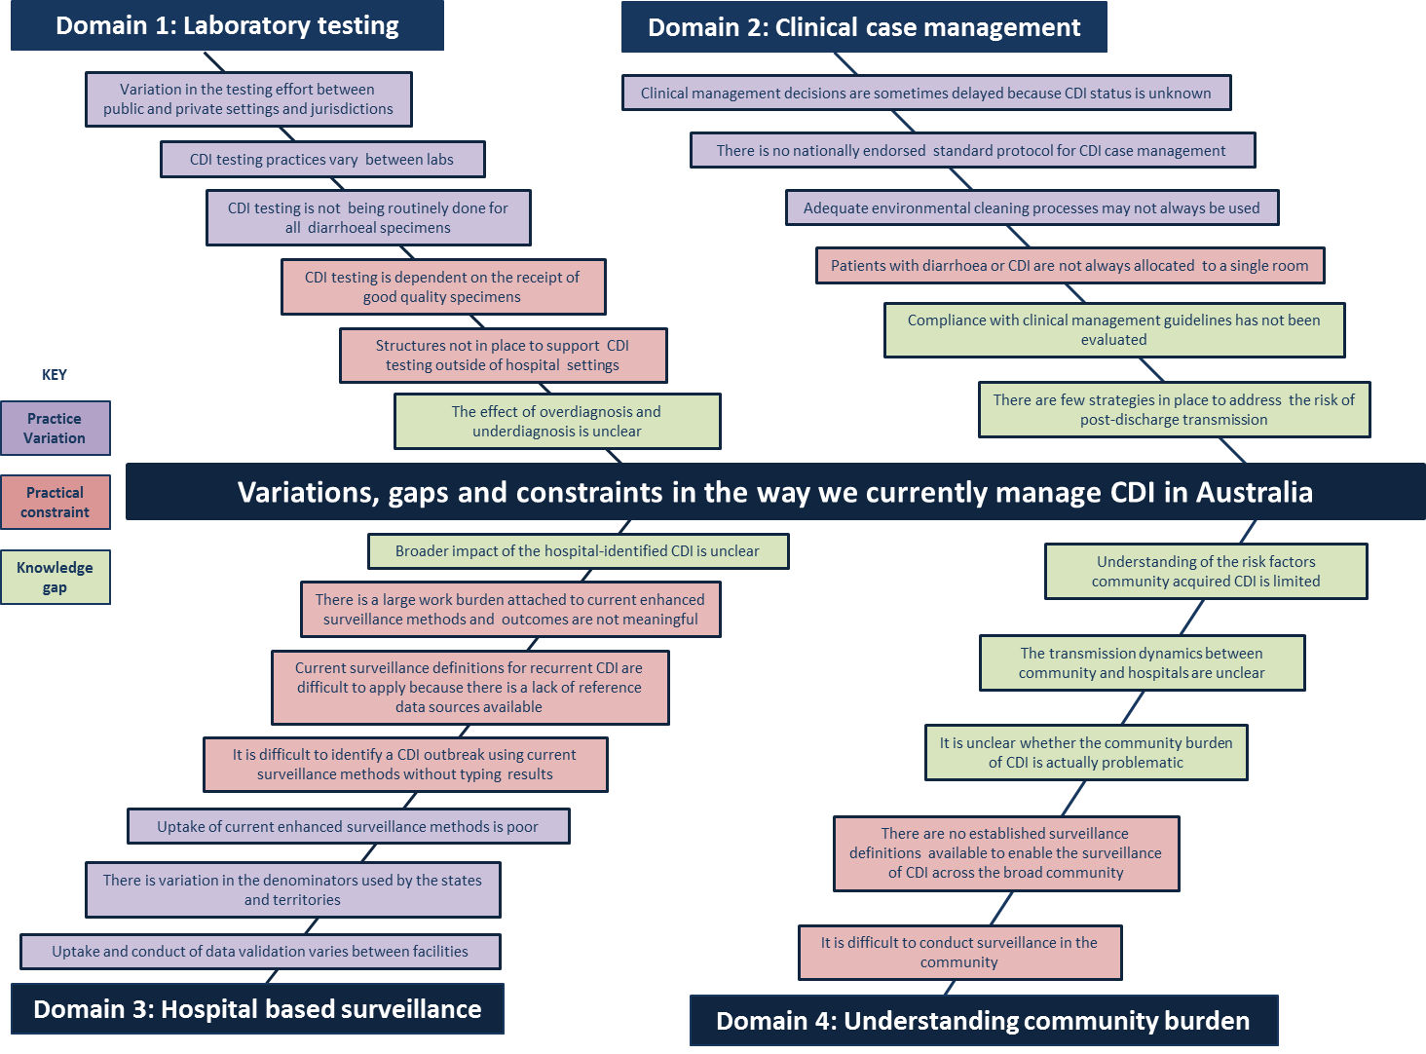

## Appendix 3 - Structured discussions

| **Domain** | **Issues** | **Why are these issues occurring? (Barriers)** | **Identified stakeholders** | **Estimated time frame** | **Possible solutions** |
| --- | --- | --- | --- | --- | --- |
| **A. LABORATORY TESTING** | **1. There is no standard testing practice for CDI in the country** | 1.1 The PHLN case definition provides a review of the literature but does not provide explicit recommendations for diagnostic testing | Public Health Laboratory Network Department of Health – MBS (Medical services advisory committee) Royal College of Pathologists of Australasia  Private labs (Pathology Australia) Australasian Society for Infectious Diseases Australian Commission on Safety and Quality in Health Care Australian College of Infection Prevention and Control Royal Australian College of General Practitioners States and territories (IJC) | 1-2 years | * Develop and disseminate easy to read recommendations for clinicians on diagnostic testing * Mandate a recommended testing procedure * Review financial incentives/disincentives for CDI testing |
| 1.2 There is no national diagnostic testing algorithm for CDI |
| 1.3 The level of compliance with the approaches described by PHLN is not monitored | Royal College of Pathologists of Australasia (Quality Assurance Program) National Association of Testing Authorities, Australia Public Health Laboratory Network  States and territories (IJC) | 1-2 years | * Develop and carry out regular compliance surveys |
| **2. There is variation in the testing effort between public and private settings** | 2.1 Private laboratories do not have any incentive to test unformed stools if a laboratory order has not been placed for CDI testing | Department of Health Private labs (Pathology Australia) Australian Institute of Health and Welfare  States and territories (IJC) | 1-2 years | * Develop and disseminate easy to read recommendations for who needs to be testing and when (expand on ASID management guidelines) * Create and disseminate factsheet on who needs to be testing and when * Make CDI nationally notifiable * Report CDI nationally |
| 2.2 There is no national diagnostic testing algorithm for CDI |
| 2.3 There is a lack of clinician awareness of indications for CDI testing |
| **3. It is difficult to do micro testing in aged care environments** | *REFER TO TABLE D. COMMUNITY* | | | |
| **4. Laboratories often receive poor quality specimens for CDI testing** | 4.1 The PHLN case definition provides information about specimen quality but this information has not been disseminated to clinicians working at the bedside. | Royal Australian College of General Practitioners Acute care physician networks (e.g. Agency of Clinical Innovation, professional societies) Therapeutic Guideline: Gastrointestinal | 1-2 years | * Disseminate case definition in Australian Doctor or Australian Family Physician * Perform desktop audit of all CDI management/treatment guidelines used in Australia and address inconsistencies between guidelines |
| 4.2 Some clinicians are not aware of when and why specimens should be collected for CDI testing |
| 4.3 The timeliness of sending specimens to the lab is not prioritised |
| 4.4 The geographic distance between some hospitals and laboratories make it difficult to get specimens to the lab in a timely manner |

|  |  |  |  |  |  |
| --- | --- | --- | --- | --- | --- |
| **A. LABORATORY TESTING** | **5. Overdiagnosis and underdiagnosis of CDI is likely** | 5.1 Some clinicians are not aware of when and why specimens should be collected for CDI testing | Clinical networks working with high risk groups (Haematology Society of Australia and New Zealand, Clinical Oncology Society of Australia, Transplantation Society of Australia and New Zealand, Renal Dialysis Society of Australia, Australian and New Zealand Society for Geriatric Medicine) | 1 year | * Factsheets for high risk patient populations e.g. elderly, paediatric, cancer patients * Provide guidance as appendices in Australian Infection Prevention and Control Guidelines. |
| 5.2 Asymptomatic patients are being tested and diagnosed with infection based on microbiological findings only (not based on overall clinical picture) |
| 5.3 Symptomatic people with disease are not being testing for CDI and are not being diagnosed with infection |
| 5.4 Some co-morbidities and medications replicate CDI symptoms and get treated as CDI without proper investigation |
| 5.3 High risk patient groups are often subjected to overtesting and asymptomatic colonisation in these groups may be misinterpreted as infection |
| **6. CDI testing is not routinely done for all diarrhoeal specimens** | 6.1 CDI is not included in the usual testing battery for diarrheal specimens | Royal Australian College of General Practitioners Acute care physician networks (e.g. Agency of Clinical Innovation, professional societies) Therapeutic Guideline: Gastrointestinal | 1-2 years | * Disseminate case definition in Australian Doctor or Australian Family Physician * Perform desktop audit of all CDI management/treatment guidelines used in Australia and address inconsistencies between guidelines |
| 6.2 Clinicians are not aware that CDI is not included in routine diarrhoeal testing |
| 6.3 Use of multiplex PCR may prohibit simultaneous CDI testing | Academic researchers Public Health Laboratory Network | 1 year | * Review pros and cons of new technology and disseminate findings through Pathology or MJA |
| 6.4 Medicare and hospital billing influence the decision to order/not order the CDI test | Department of Health – MBS (Medical services advisory committee) States and territories (IJC) | 2-5 years | * Review financial incentives/disincentives for CDI testing |

|  |  |  |  |  |  |
| --- | --- | --- | --- | --- | --- |
| **Domain** | **Issues** | **Why are these issues occurring? (Barriers)** | **Identified stakeholders** | **Estimated time frame** | **Possible solutions** |
| 1. **B. CLINICAL CASE MANAGEMENT** | **1.There is no standard protocol for case management** | 1.1 Clinical management guidelines from ACIPC are not current | National Health and Medical Research Council Australian Society for Infectious Diseases Australasian College of Infection Prevention and Control States and territories (Safety and Quality departments) Australian Commission on Safety and Quality in Health Care | 2-5 years | * Recommend CDI to be included as a topic for review for next update of the Australian Infection Prevention and Control guidelines. * Investigate if the ASID/ACIPC clinical management guidelines for CDI are being updated. |
| **2. Compliance with clinical management guidelines has not been evaluated** | 2.1 There is no system currently available to monitor compliance with guidelines | States and territories (Safety and Quality departments) Australian Commission on Safety and Quality in Health Care |  | * Survey healthcare facilities to assess compliance with CDI guidelines (although compliance with various guidelines is within the remit of Standard 3 of the NSQHC Standards). * Include as part of accreditation (inclusion in Std 3 Safety and Quality Improvement Guide or example material to support Safety and Quality Improvement Guide) * Measure compliance with CDI clinical management guideline as part of larger compliance surveys (e.g. compliance with transmission-based precautions) |
| **3. Patients with CDI are not always allocated a single room** | 3.1 There is limited availability of suitable decision support tools for resource prioritisation | National Health and Medical Research Council Australian Society for Infectious Diseases (HICSIG) Australasian College of Infection Prevention and Control States and territories (Safety and Quality departments) Australian Commission on Safety and Quality in Health Care | 1-2 years | * Develop resource prioritisation tool for the management of known and suspected patients. * Ensure guidelines address the requirement for contact precautions for patients with diarrhoea until pathology results are known (and if transmissible cause of diarrhoea found, then CP should continue). |
| 3.2 Older facilities usually only have a limited number of single room available |
| 3.3 In rural areas there is limited ICP capacity to advise on room allocations |
| **4. Clinical management decisions are delayed** | 4.2 Pathology results may not yet be available to inform decision making |
| 4.1 CDI status is not always included during clinical handover |
| **5. Clinicians are not always aware of CDI status** | 5.1 Visibility of flags/alerts in some patient administration systems requires interrogation of the patient record (i.e. the flag is not obvious to clinicians) |
| 5.2 CDI status is not always included during clinical handover |
| **6. Inadequate environmental cleaning processes are sometimes used** | 6.1 Usual cleaning products may not be sufficient for cleaning CDI-contaminated areas | National Health and Medical Research Council Australian Commission on Safety and Quality in Health Care Australasian College of Infection Prevention and Control States and territories (Safety and Quality departments, Environmental Cleaning services) | 1-2 years | * Awaiting environmental recommendations from updated Australian Infection Prevention and Control Guidelines * Develop online education resources for environmental cleaning staff |
| 6.2 Staff are not always aware that usual cleaning products may not be sufficient for cleaning CDI-contaminated areas |
| 6.3 In rural areas there is limited ICP capacity to advise on and monitor environmental cleaning processes |
| **7. Limited patient information is available about post-discharge care** | 7.1 NHMRC consumer factsheet does not provide sufficient information on post-discharge care | National Health and Medical Research Council Australian Commission on Safety and Quality in Health Care States and territories (Safety and Quality departments) | 1 year | * Review and update NHMRC CDI factsheet with additional information with post discharge precautions |

|  |  |  |  |  |  |
| --- | --- | --- | --- | --- | --- |
| **Domain** | **Issues** | **Why are these issues occurring? (Barriers)** | **Identified stakeholders** | **Estimated time frame** | **Possible solutions** |
| **C. HOSPITAL-BASED SURVIELLANCE** | **1. Data validation is not done in all facilities** | 1.1 Data validation is not standard practice in all facilities | Australian Commission on Safety and Quality in Health Care States and territories (S&Q departments) | 2 years | * Develop and publish national specifications for CDI surveillance data validation |
| 1.2 Jurisdictions have limited access to private laboratory data which makes it difficult to do data validation on cases identified in private hospitals | Private laboratories, Individual hospital services States and territories  Office of Health Protection/Communicable Diseases Network, Australia | 5 years | * Establish legislation, documentation (including definitions and guidelines) and processes required to make CDI a notifiable condition |
| **2. There are varied processes for data validation** | 2.1 The incompatibility between some surveillance databases and other electronic data sources means manual workarounds often need to be employed to perform data validation | IT systems vendors State IT services | 5 years | * Allocate specific funding to infection control units or health networks for surveillance * Establish structures that enable existing surveillance databases to easily interface with existing data sources (e.g. patient admissions system, electronic medical record) * Develop and publish national specifications for CDI surveillance data validation * Explore a range of data sources to develop an algorithm to validate data |
| 2.2 Scope of some hospital surveillance programs does not include data validation | Australian Commission on Safety and Quality in Health Care Hospital networks/districts States and territories (S&Q departments)  National Classification in Health group (ICD10)  Individual hospital services |
| 2.3 There is variation in data validation processes within health networks/health districts |
| **3. There is variations in the denominators used across states and territories** | 3.1 States are currently choosing their own denominators | Australian Commission on Safety and Quality in Health Care Hospital networks/districts States and territories (S&Q departments) | 2-5 years | * Harmonise state denominators: * reinforce that patient days be used as the denominator for reporting as per the national CDI definitions * Replicate SABSI requirement for denominators, with relevant exclusions |
| 3.2 Completeness/incompleteness of surveillance data influences the denominators that being used |
| 3.3 Historical IT specifications in various states are in place to collect patient bed days/OBDs/separations |
| **4. Poor uptake and a large work burden associated with enhanced surveillance** | 4.1 Too many elements in the enhanced surveillance data collection (attribution, severity, recurrence, antimicrobial use | Australian Commission on Safety and Quality in Health Care States and territories (S&Q departments)  IT systems vendors State IT services | 2-5 years | * Establish a smaller set of core data items for enhanced surveillance. * Prioritise surveillance in high risk units (e.g. ICU with ANZICS) * Establish better definitions and mechanisms to identify true burden associated hospital and community * Review and update current enhanced surveillance definitions * Identify other indicators that provide more meaningful information for enabling practice change |
| 4.2 There is no standardised approach to enhanced surveillance |
| 4.3 Hospitals have limited IT and human resources available to support the data collection required for enhanced surveillance |
| 4.4There is little motivation for doing enhanced surveillance for case attribution as it does not provide meaningful hospital performance outcomes |
| 4.5 Enhanced surveillance definitions are extremely difficult to interpret and apply |
| 4.6 Current data handling and management is not timely enough to have a positive effect on changing practice |

|  |  |  |  |  |  |
| --- | --- | --- | --- | --- | --- |
| **C. HOSPITAL-BASED SURVIELLANCE** | **5. There is substantial work burden associated with doing enhanced surveillance for severity** | 5.1 Both non-laboratory data and laboratory results are required to confirm severity | Australian Commission on Safety and Quality in Health Care States and territories (S&Q departments) | 1-2 years | * Make CDI severity status a mandatory surveillance data item * Prioritise severity surveillance over other enhanced surveillance data collection * Prioritise surveillance in high risk units (e.g. ICU with ANZICS) * Employ structured lab reporting/standardisation reporting specifications (AURA) to streamline laboratory data collection |
| 5.2 The 30-day follow up windows makes data collection difficult |
| 5.3 There is a large work burden associated with identifying a history of surgery for toxic megacolon, perforation and refractory colitis as this requires manual review of patient records. Other severity markers can be easily identified through electronic admissions and incident management systems. |
| **6. It is difficult to do surveillance for recurrence** | 6.1 Difficult to identify recurrent infection if diagnostic typing is not available | Australian Commission on Safety and Quality in Health Care States and territories (S&Q departments)  State pathology services  Private laboratories  Public Health Laboratory Network | 1-2 years | * Review and update current enhanced surveillance definition for recurrence * Explore other mechanisms for monitoring recurrence (e.g. snapshots) * De-prioritise recurrence for enhanced surveillance purposes |
| 6.2 Definition for recurrence is difficult to interpret and apply |
| 6.3 Patient admission history is not always easily available |
| **7. There is little understanding of the national burden of CDI in hospitals** | 7.1 There is no national mechanism for collating and monitoring true healthcare associated CDI at a national level | Australian Commission on Safety and Quality in Health Care Office of Health Protection/Communicable Diseases Network, Australia | 2-5 years | * Develop a mechanism to monitor true healthcare associated CDI at a national level |
| **8. It is difficult to identify a CDI outbreak** | 8.1 There is little understanding of what is a satisfactory baseline rate of infection | Office of Health Protection/Communicable Diseases Network, Australia  Australian Commission on Safety and Quality in Health Care | 2-5 years | * Establish satisfactory baseline rate * Establish notification/legislation for CDI * Set outbreak case definition for CDI * Explore other mechanisms for monitoring outbreak potential that do not rely on diagnostic typing (e.g. Liverpool method where 2 cases or more in 1 ward constitutes an outbreak) |
| 8.2 No tipping point for CDI outbreaks has been established so unable to easily identify if an outbreak has occurred |
| 8.4 Reporting lines for CDI outbreaks are unclear |
| 8.3 Difficult to confirm transmission and identify outbreaks if diagnostic typing is not available | State pathology services  Private laboratories  Royal College of Pathologists of Australasia  Public Health Laboratory Network |

|  |  |  |  |  |  |
| --- | --- | --- | --- | --- | --- |
| **Domain** | **Issues** | **Why are these issues occurring? (Barriers)** | **Identified stakeholders** | **Estimated time frame** | **Possible solutions** |
| **D. UNDERSTANDING THE COMMUNITY BURDEN** | **1. It is unclear whether the burden of CDI in the community is problematic** | 1.1 There are no suitable data collection systems or proxy markers available to determine the burden of CDI in the community | Australian Commission on Safety and Quality in Health Care Office of Health Protection/Communicable Diseases Network, Australia  Royal Australasian College of General Practitioners  Office of Health Protection  State and territory Public Health Units  Aged care facilities |  | * Adopt the Victorian continuous surveillance in aged care for 2017/2018 in aged care facilities across the country * Explore utility of hospital administrative data and laboratory surveillance data to develop a community-based surveillance system * Make CDI notifiable |
| 1.2 Have no understanding of the extent of normal disease endemicity in the community |
| 1.3 No thresholds have been established to define CDI outbreaks |
| 1.4 CDI testing (particularly in aged care) is sporadic, therefore even if private laboratory data was readily accessible to jurisdictions, the true burden may not be reflected |
| **2. Understanding of risk factors for community acquisition of CDI is limited** | 2.1 All reservoirs of infection in the community have not been definitively identified | Academic research |  |  |
| 2.2 The link between antimicrobial usage in the community and the impact on CDI acquisition in the community is not well understood | National Centre for Antimicrobial Stewardship  National Prescribing Service  Australian Commission on Safety and Quality in Health Care Office of Health Protection/Communicable Diseases Network, Australia  Royal Australasian College of General Practitioners |  | * Increase uptake of acNAPS in across the country * Develop primary care NAPS |
| **3. It is difficult to do surveillance of CDI in the community** | 3.1 Disease may present asymptomatically and may not require medical attention, testing or treatment | Office of Health Protection/Communicable Diseases Network, Australia  Public Health Laboratory Network  Royal Australasian College of General Practitioners  National Prescribing Service |  | * Identify whether there are alternative non-laboratory mechanisms to monitor for CDI in the community * Monitor severe disease on admission separately to HCA inpatient severe disease |
| 3.2 It is difficult, expensive and not clinically appropriate to screen the community for CDI using laboratory methods |
| **4. There are no established surveillance definitions to do comprehensive CDI surveillance in the community** | 4.1 Current surveillance definitions for aged care settings are not sensitive enough to identify asymptomatic infection | Australian Commission on Safety and Quality in Health Care Australian Aged Care Quality Agency  Office of Health Protection/Communicable Diseases Network, Australia  Public Health Laboratory Network |  | * Update current aged care definitions to enable better identification of asymptomatic infection * Develop a community-based surveillance system |
| 4.2 Besides those that exist for aged care settings, there are no other established CDI surveillance definitions for other community settings. |
| 4.3 Aged care definitions may not be suitable in Australian settings |
| **5. The transmission dynamics between community and hospitals are unclear** | 5.1 CDI status is not always available at time of transfer into and out of hospital | Australian Commission on Safety and Quality in Health Care Australian Aged Care Quality Agency  State and territories (S&Q departments)  Individual hospital facilities  Individual aged care facilities |  | * Mandate that CDI status be determined on hospital admission * Include CDI status on discharge/transfer summary * Establish a standardised stool testing protocol for all laboratories receiving specimens from residential aged care facilities |

## Appendix 4 - Driver diagram series

Driver diagram 1: National actions to improve the control of CDI

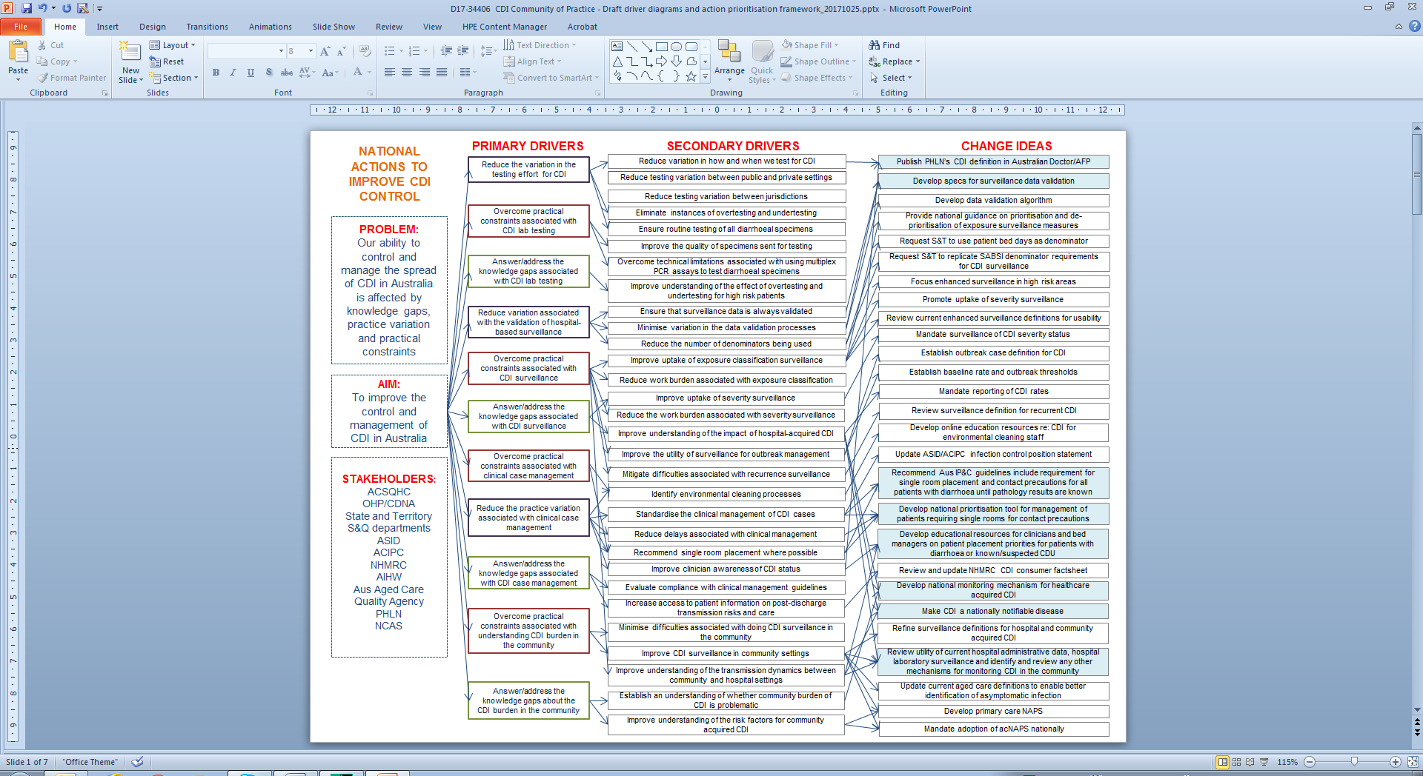

Practice variation

Addresses

2 or more secondary drivers

Knowledge gap

Practical constraint

**KEY**

Driver diagram 2: National actions to improve the clinical management of CDI

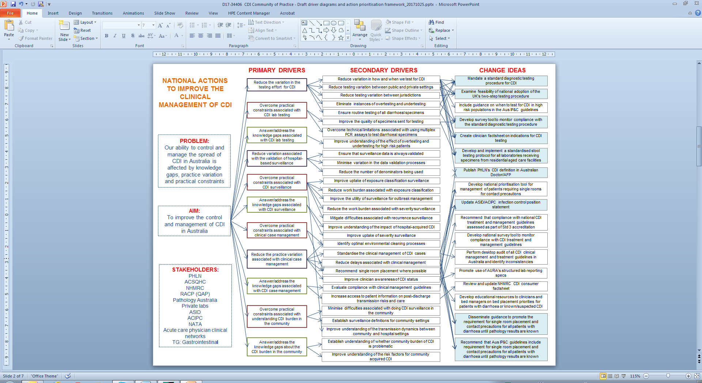

Addresses

2 or more secondary drivers

Practice variation

Practical constraint

Knowledge gap

**KEY**

Driver diagram 3: Jurisdiction and health service actions to improve the control of CDI

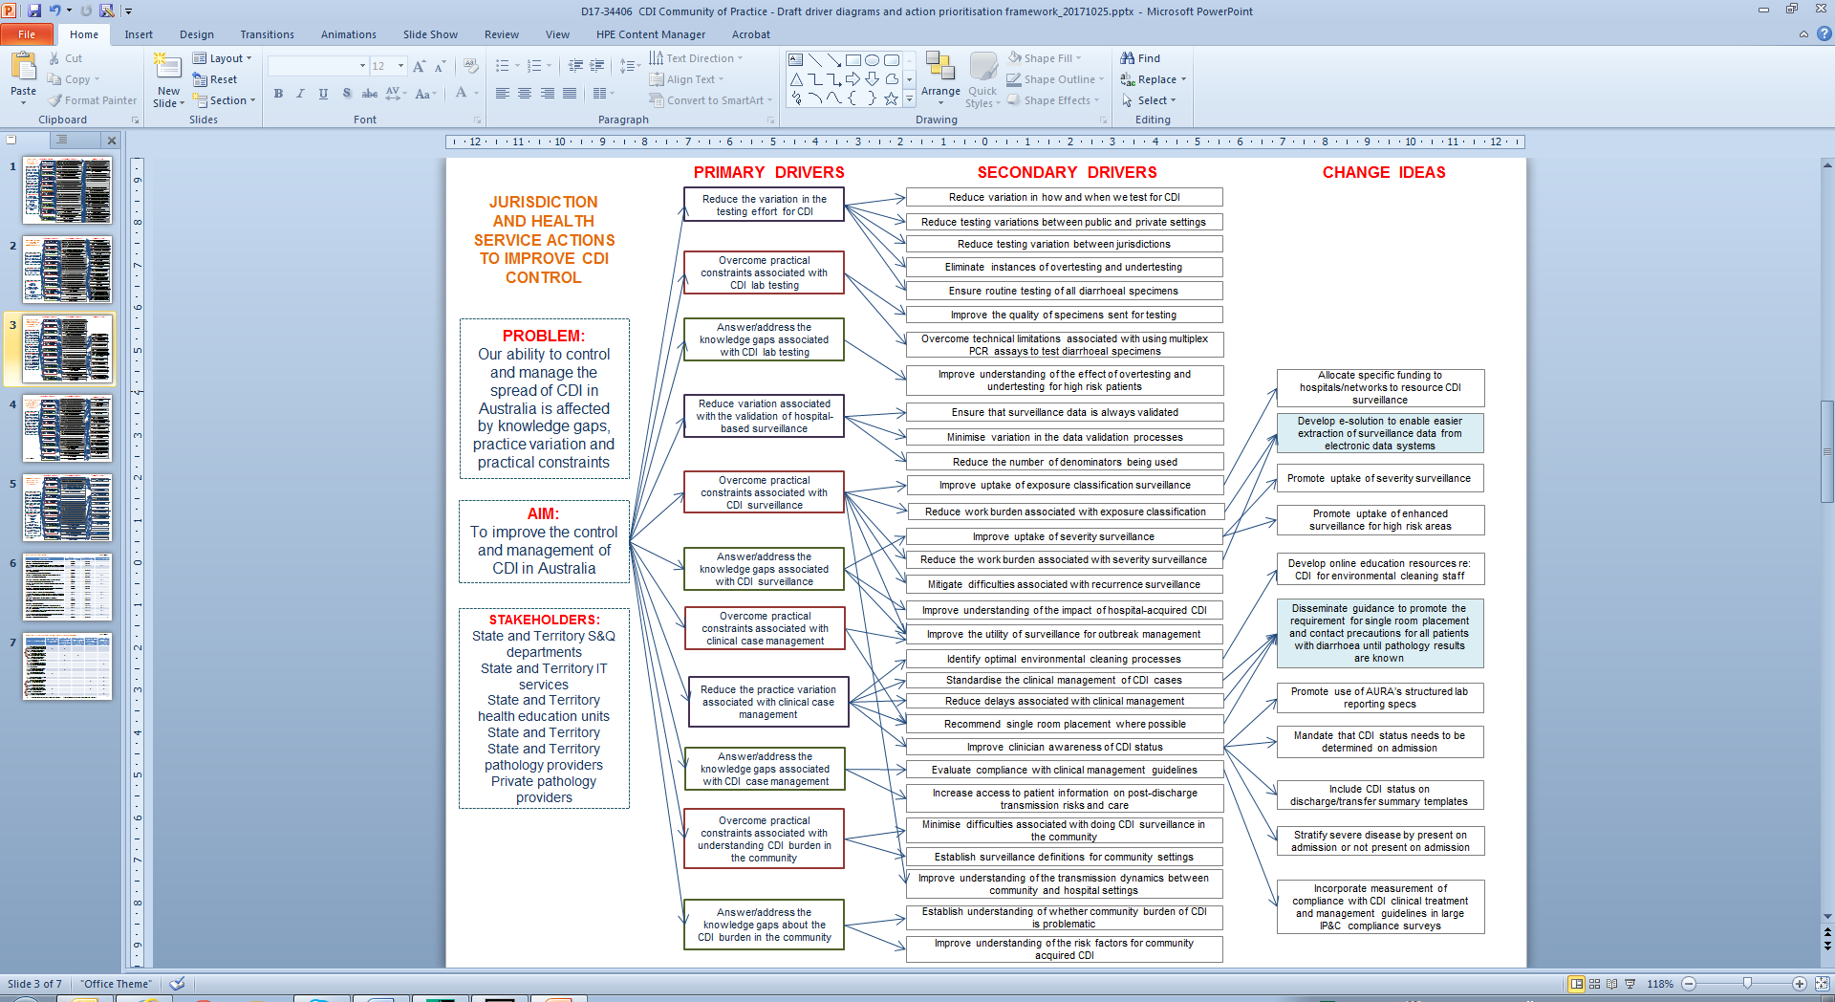

Addresses

2 or more secondary drivers

Knowledge gap

Practical constraint

Practice variation

**KEY**

Driver diagram 4: Research actions to improve the control of CDI

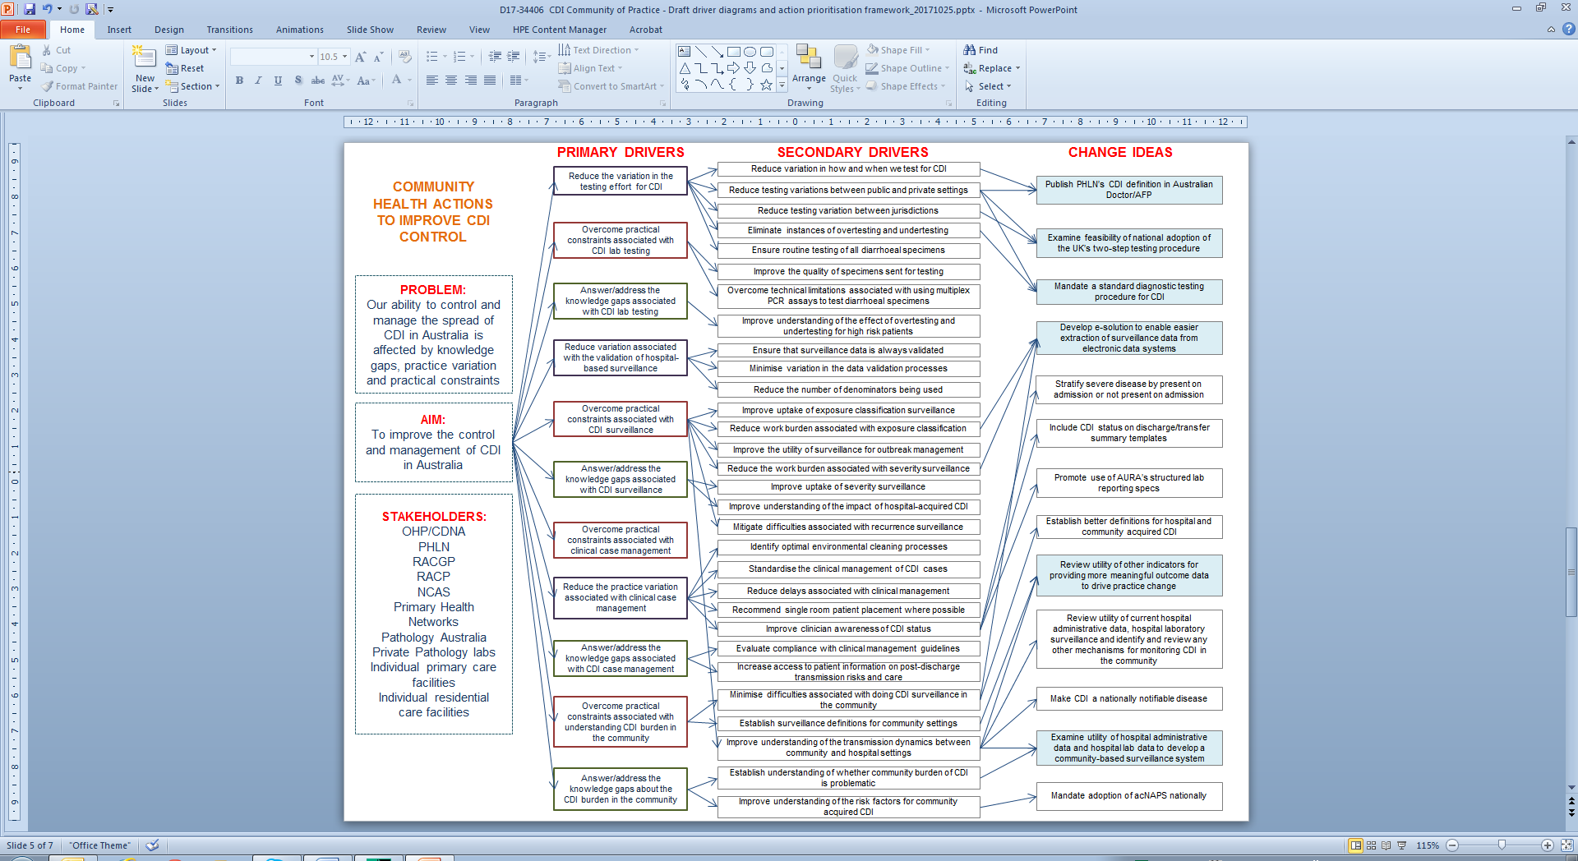

**KEY**

Addresses

2 or more secondary drivers

Knowledge gap

Practical constraint

Practice variation

Driver diagram 5: Actions for further research and exploration

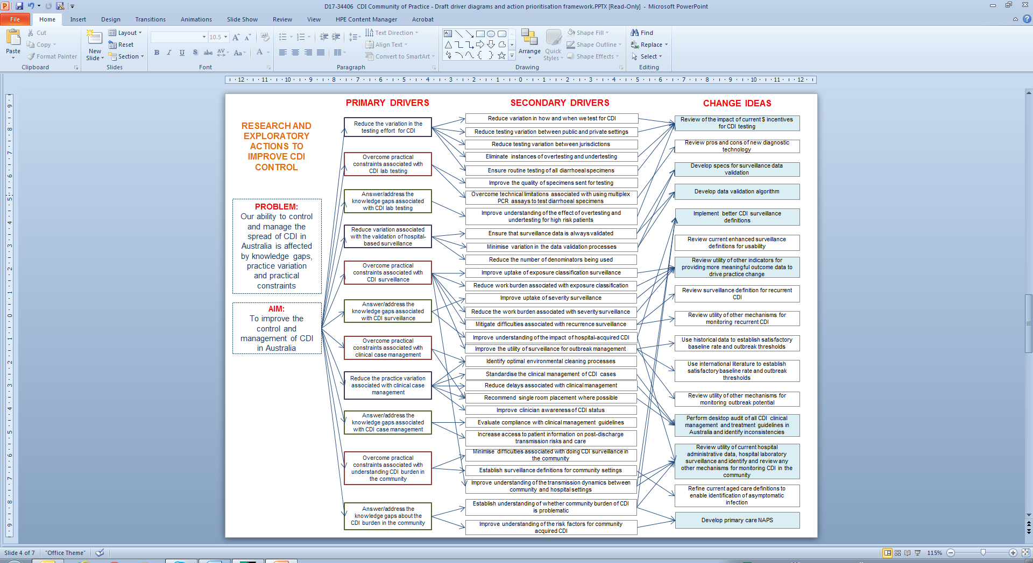

Practice variation

Practical constraint

Knowledge gap

**KEY**

Addresses

2 or more secondary drivers

Figure 3. Driver diagram 5: Community-level actions to improve the control of CDI

## Appendix 5 - Action prioritisation

|  |  |  |  |
| --- | --- | --- | --- |
| **Highlighted change ideas** | **Ease of Implementation**  **(EASY/HARD)** | **Anticipated Impact**  **(HIGH/LOW)** | **Priority for testing** |
| Publish PHLN’s CDI definition in Australian Doctor or AFP | EASY | LOW |  |
| Examine feasibility of national adoption of the UK’s two-step testing procedure | HARD | HIGH |  |
| Develop specs for surveillance data validation | HARD | LOW |  |
| Recommend Australian IP&C guidelines include requirement for contact precautions for all patients with diarrhoea until pathology results are known | EASY | HIGH | YES |
| Develop national resource prioritisation tool for management of patients with known or suspected CDI | HARD | HIGH |  |
| Develop educational resources for clinicians and bed managers on bed placement priorities for patients with diarrhoea or known/suspected CDI | EASY | HIGH | YES |
| Develop national monitoring mechanism for healthcare acquired CDI | EASY | HIGH | YES |
| Make CDI a nationally notifiable disease | HARD | LOW |  |
| Mandate a standard diagnostic testing procedure for CDI | HARD | HIGH |  |
| Develop survey tool to monitor compliance with the standard diagnostic testing procedure | HARD | HIGH |  |
| Create clinician factsheet on indications for CDI testing | EASY | LOW |  |
| Develop and implement a standardised stool testing protocol for all laboratories receiving specimens from residential aged care facilities | HARD | LOW |  |
| Update ASID/ACIPC infection control position statement | EASY | HIGH | YES |
| Disseminate guidance to promote the requirement for single room placement and contact precautions for all patients with diarrhoea until pathology results are known | EASY | HIGH | YES |
| Review the barriers to appropriate CDI testing | EASY | HIGH | YES |
| Develop e-solution to enable easier extraction of surveillance data from electronic data systems | HARD | HIGH |  |
| Develop data validation algorithm | HARD | LOW |  |
| Implement better CDI surveillance definitions | HARD | HIGH |  |
| Review utility of other indicators for providing more meaningful outcome data to drive practice change | EASY | HIGH | YES |
| Perform desktop audit of all CDI clinical management and treatment guidelines in Australia and identify inconsistencies | EASY | HIGH | YES |
| Examine utility of hospital administrative data and hospital lab surveillance to develop a community-based surveillance system | EASY | HIGH | YES |
| Develop and implement primary care NAPS | HARD | HIGH |  |

## Appendix 6 - Context mapping

|  |  |  |  |  |  |  |  |  |  |  |  |
| --- | --- | --- | --- | --- | --- | --- | --- | --- | --- | --- | --- |
| **Priority change ideas** | **Topic Domain** | | | | | | | | | | |
| **CDI laboratory testing** | | | **Hospital-based surveillance** | | | **Clinical case management** | | | **Community CDI burden** | |
| Reduce variation in the testing effort | Overcome practical constraints | Answer knowledge gaps | Reduce variation associated with surveillance validation | Overcome practical constraints | Answer knowledge gaps | Reduce practice variation | Overcome practical constraints | Answer knowledge gaps | Overcome practical constraints | Answer knowledge gaps |
| 1.Recommend Aus IP&C guidelines include requirement for contact precautions for all patients with diarrhoea until pathology results are known |  |  |  |  |  |  | X |  |  |  |  |
| 2.Develop educational resources for clinicians and bed managers on bed placement priorities for patients with diarrhoea or known/suspected CDI |  |  |  |  | X |  | X |  |  |  |  |
| 3.Develop national monitoring mechanism for healthcare acquired CDI |  |  |  |  |  | X |  |  |  |  | X |
| 4.Update ASID/ACIPC infection control position statement |  |  |  |  |  |  | X |  |  |  |  |
| 5.Disseminate guidance to promote the requirement for contact precautions, including appropriate bed placement, for all patients with diarrhoea until pathology results are known |  |  |  |  |  |  | X |  |  |  |  |
| 6.Review the barriers to appropriate CDI testing | X |  | X |  |  |  | X |  |  |  |  |
| 7.Perform desktop audit of all CDI clinical management and treatment guidelines in Australia and identify inconsistencies |  |  |  |  |  |  | X |  |  |  |  |
| 8.Review utility of other indicators for providing more meaningful outcome data to drive practice change |  |  |  |  | X |  |  |  |  | X |  |
| 9.Review utility of current hospital administrative data, hospital laboratory surveillance and identify and review any other mechanisms for monitoring CDI in the community |  |  |  |  | X | X |  |  |  | X | X |