# Australian COmmission on Safety and Quality in Health Care logo with Radar imageOn the Radar

Issue 468

15 June 2020

*On the Radar* is a summary of some of the recent publications in the areas of safety and quality in health care. Inclusion in this document is not an endorsement or recommendation of any publication or provider. Access to particular documents may depend on whether they are Open Access or not, and/or your individual or institutional access to subscription sites/services. Material that may require subscription is included as it is considered relevant.

*On the Radar* is available online, via email or as a PDF or Word document from <https://www.safetyandquality.gov.au/publications-and-resources/newsletters/radar>

If you would like to receive *On the Radar* via email, you can subscribe on our website <https://www.safetyandquality.gov.au/publications-and-resources/newsletters>   
or by emailing us at H[Umail@safetyandquality.gov.auU](mailto:mail@safetyandquality.gov.au).   
You can also send feedback and comments to H[Umail@safetyandquality.gov.auU](mailto:mail@safetyandquality.gov.au).

For information about the Commission and its programs and publications, please visit <https://www.safetyandquality.gov.au>

You can also follow us on Twitter @ACSQHC.

**On the Radar**

Editor: Dr Niall Johnson [niall.johnson@safetyandquality.gov.au](mailto:niall.johnson@safetyandquality.gov.au)

Contributors: Niall Johnson, Kim Stewart

**COVID-19 resources**

https://www.safetyandquality.gov.au/covid-19

The Australian Commission on Safety and Quality in Health Care has developed a number of resources to assist healthcare organisations, facilities and clinicians. These and other material on COVID-19 are available at <https://www.safetyandquality.gov.au/covid-19>

The latest additions include:

* **Medicines Management COVID-19** <https://www.safetyandquality.gov.au/our-work/medication-safety/medicines-management-covid-19>, including position statements on medicine-related issues
  + ***Managing fever associated with COVID-19***
  + ***Managing a sore throat associated with COVID-19***
  + ***ACE inhibitors and ARBs in COVID-19***
  + ***Clozapine in COVID-19***
  + ***Management of patients on oral anticoagulants during COVID-19***
  + ***Ascorbic Acid: Intravenous high dose in COVID-19***
  + ***Treatment in acute care, including oxygen therapy and medicines to support intubation***
  + ***Nebulisation and COVID-19***
  + ***Ongoing medicines management in high-risk patients***
  + ***Medicines shortages***
* ***Potential medicines to treat COVID-19*** (updated) <https://www.safetyandquality.gov.au/publications-and-resources/resource-library/potential-medicines-treat-covid-19>
* ***Break the chain of infection: Stopping COVID-19*** poster<https://www.safetyandquality.gov.au/publications-and-resources/resource-library/break-chain-poster-a3>
* ***COVID-19: Elective surgery and infection prevention and control precautions*** <https://www.safetyandquality.gov.au/publications-and-resources/resource-library/covid-19-elective-surgery-and-infection-prevention-and-control-precautions>
* ***FAQs for clinicians on elective surgery*** <https://www.safetyandquality.gov.au/node/5724>
* ***FAQs for consumers on elective surgery*** <https://www.safetyandquality.gov.au/node/5725>
* ***Infection prevention and control Covid-19 PPE*** poster <https://www.safetyandquality.gov.au/publications-and-resources/resource-library/infection-prevention-and-control-covid-19-personal-protective-equipment>
* ***Special precautions for Covid-19 designated zones*** poster <https://www.safetyandquality.gov.au/publications-and-resources/resource-library/special-precautions-covid-19-designated-zones>

**[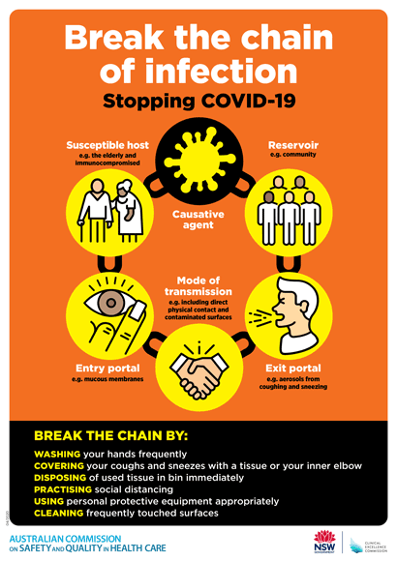](https://www.safetyandquality.gov.au/publications-and-resources/resource-library/break-chain-poster-a3https:/www.safetyandquality.gov.au/publications-and-resources/resource-library/break-chain-poster-a3)**

**Safe care for people with cognitive impairment during COVID-19**

<https://www.safetyandquality.gov.au/our-work/cognitive-impairment/cognitive-impairment-and-covid-19>

During COVID-19, people with cognitive impairment may find hospital even more frightening than usual. At this time, clinicians and visitors are using personal protective equipment (PPE) and there may be restrictions on family and carers who are usually there to support them.

In recognition of this changed environment, the Australian Commission on Safety and Quality in Health Care has developed new resources to support health service organisations to provide safe care for people with cognitive impairment during COVID-19.

The resources include a fact sheet for clinicians and a poster, which provide an important reminder of key actions in the National Safety and Quality Health Service (NSQHS) Standards that remain crucial at this time. These key actions include:

* Goals of care discussions with the patient, support person or, if required, the substitute decision maker
* The involvement of carers
* Delirium prevention strategies, and
* The use of antipsychotics only as a last resort.

To reduce the risk of harm, it is important that clinicians continue to use the strategies of their hospital or health service organisation to keep people with cognitive impairment safe.

The Commission acknowledges the contribution of people living with dementia, carers, clinicians and researchers in the development of these resources.

**[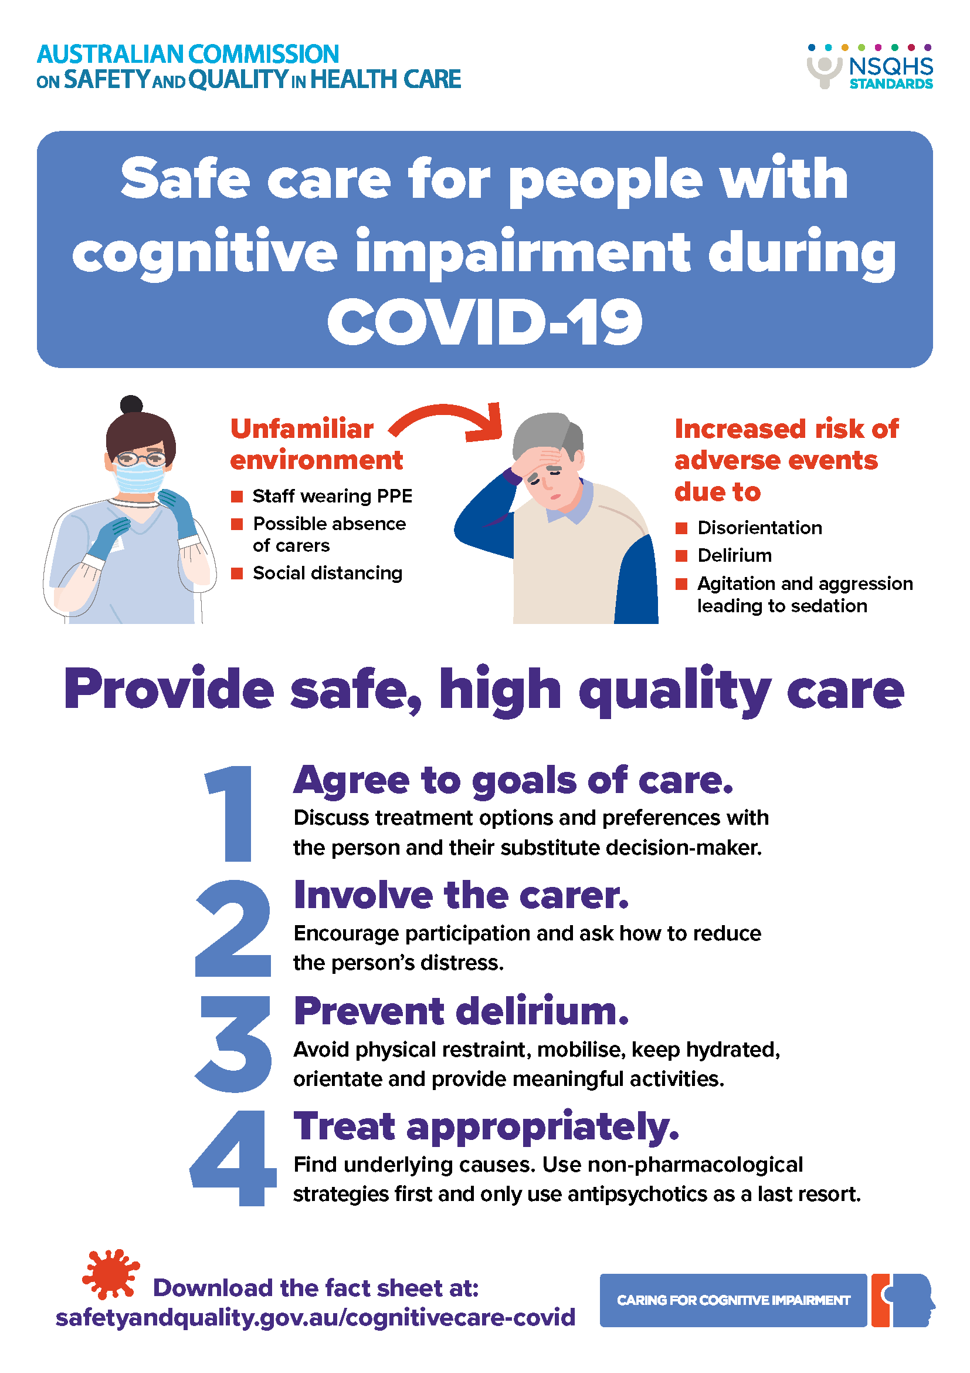](https://www.safetyandquality.gov.au/our-work/cognitive-impairment/cognitive-impairment-and-covid-19)**

**Reports**

*2019 CARAlert Annual Report*

Australian Commission on Safety and Quality in Health Care

Sydney: ACSQHC; 2020. p. 41.

*CARAlert Data Update 16: 1 January 2020 - 29 February 2020*

Australian Commission on Safety and Quality in Health Care

Sydney: ACSQHC; 2020. p. 26.

|  |  |
| --- | --- |
| URL | Annual Report <https://www.safetyandquality.gov.au/publications-and-resources/resource-library/caralert-annual-report-2019>  Data Update 16 <https://www.safetyandquality.gov.au/publications-and-resources/resource-library/caralert-data-update-16-1-january-2020-29-february-2020> |
| Notes | The *2019 CARAlert Annual Report* provides analysis of data on confirmed critical antimicrobial resistances (CARs) submitted to the National Alert System for Critical Antimicrobial Resistances (CARAlert) for 2019, and trend data for 2017 to 2019.  There was an overall increase of 27% in CARs reported in 2019 compared to 2018, excluding new CARs introduced in 2019. Carbapenemase-producing Enterobacterales (CPE) are of most concern, because the number of reports and distribution has increased annually since 2016. This CAR poses a significant risk to patient safety, because bacteria that produce carbapenemase enzymes are almost always resistant to other important antibiotic classes, such as other ß-lactams, ß-lactamase inhibitor combinations, fluoroquinolones and aminoglycosides. This means that effective treatment options for infections may be limited, and lengths of hospital admissions may increase.  The number of reports of multidrug-resistant (MDR) *Shigella* species increased by 218% in 2019 (n = 331 versus n = 104), which is concerning because empirical antimicrobial therapy choices for shigellosis may not be reliable. The proportion of shigellosis notifications that were MDR increased in all jurisdictions in 2019 compared to 2018, most notably in Victoria, Queensland and the Australian Capital Territory.  Other patient safety issues identified by the analyses include:   * Reports of CARs from aged care homes - the majority of these were daptomycin-nonsusceptible *Staphylococcus aureus*, followed by CPE * Emerging CARs, specifically an increase in reports of linezolid non-susceptible *Enterococcus* species increased.   The Commission has also released the *CARAlert Data Update 16: 1 January 2020 - 29 February 2020*. This updateshowed a 10.8% increase in critical antimicrobial resistances (CARs) reported compared to the previous two-month reporting period (n = 369).  CPE (including those with ribosomal methyltransferase or transmissible resistance to colistin) remained the most frequently reported CAR (n = 135, 36.6%), followed by MDR *Shigella* species (n = 102, 27.6%). The number of MDR *Shigella* species (n = 102) increased by 64.5% compared to the previous two-month reporting period. The majority of MDR *Shigella* species were reported from New South Wales (n = 53, 52%) and Victoria (n = 28, 27%). The vast majority (91%, 93/102) were *S. sonnei*. ESBL types were detected in 71% (20/28) of mdr *Shigella* species reported from Victoria and 49% (26/53) from NSW. Where ESBL type was known, the vast majority (93%, n = 42/45) were CTX-M-27 *S. sonnei*. |

*Realising the Potential of Primary Health Care*

OECD

Paris: OECD Publishing; 2020. p. 208.

|  |  |
| --- | --- |
| DOI | <https://doi.org/10.1787/a92adee4-en> |
| Notes | Primary health care is where so much of health care delivery happens. Appropriate, timely and effective primary care can mean further, often more expensive, care is not required. This report from the OECD examines primary health care across OECD countries and draws attention to how primary health care is not living up to its full potential. The report argues that doing things differently – through new models of organising services, better co-ordination among providers, better use of digital technology, and better use of resources and incentives – can help to improve care, reduce the need for hospitalisations, and mitigate health inequalities. The report identifies policy challenges that OECD countries may address to realise the full potential of primary health care, and reviews progress and innovations towards transforming primary health care. |

For information on the Commission’s work on primary care, see <https://www.safetyandquality.gov.au/our-work/primary-health-care>

*Culture as a cure: Assessments of patient safety culture in OECD countries*

OECD Health Working Papers No. 119

de Bienassis K, Kristensen S, Burtscher M, Brownwood I, Klazinga NS

Paris: OECD Publishing; 2020. p. 103.

|  |  |
| --- | --- |
| DOI | <https://doi.org/10.1787/6ee1aeae-en> |
| Notes | The culture within which care is delivered is a key factor in whether that care is safe, of good quality, appropriate and effective. As the authors of this report from the OECD observe, ‘A growing research body has found that PSC [patient safety culture] is associated with numerous positive outcomes, including improved health outcomes, improved patient experience, and organisational productivity and staff satisfaction.’ They suggest that ‘Meaningful information about PSC can guide policy makers, hospital mangers, and staff in improving and strengthening their cultures and improving safety outcomes’ and note that the measuring of PSC with various tools has become quite common. To date, most of this measurement is taking place in hospital settings with measures ‘primarily used to inform internal learning and improvement’, and ‘not commonly used for accountability purposes, though some countries serve as exceptions’. It is suggested that measurement of patient safety culture ‘is best integrated into a broader policy framework and its results should be made available and visible to relevant actors. In many health care systems, PSC tools will form part of a larger set of measurement indicators that include traditional patient safety indicators as well as patient-reported outcomes. International learning and benchmarking has significant potential for better understanding and improvement of patient safety and health care quality.’ |

*Waiting Times for Health Services: Next in Line*

OECD

Paris: OECD Publishing; 2020. p. 72.

|  |  |
| --- | --- |
| DOI | <https://doi.org/10.1787/242e3c8c-en> |
| Notes | Waiting time for health services, particularly surgery, can be a sensitive and political topic. This report from the OECD   * reviews the importance of waiting times issues across OECD countries * provides an overview of how waiting times differ across OECD countries up to 2019, focussing on waiting times for consultations with general practitioners (GPs), specialist consultations and elective treatments * reviews evidence about the impact of waiting times on access to care and health outcomes for patients * reviews a range of policy interventions that countries have used to tackle waiting times for different services, including elective surgery, primary care, cancer care and mental health services, with a focus on identifying successful policies. |

**Journal articles**

*Economic analysis of the prevalence and clinical and economic burden of medication error in England*

Elliott RA, Camacho E, Jankovic D, Sculpher MJ, Faria R

BMJ Quality & Safety. 2020 [epub].

|  |  |
| --- | --- |
| DOI | <https://10.1136/bmjqs-2019-010206> |
| Notes | Medication errors are recognised as being rather common and their consequences can range from trivial to fatal. However, the economic costs are not well understood. This paper presents an attempt to determine the prevalence and burden, in both clinical and economic terms, of medication error across the National Health Service in England. While acknowledging the limitations of the data the authors estimated that:   * **237 million medication errors** occur at some point in the medication process **in England annually** * **38.4%** occurring in **primary care** * **72%** have **little or no potential for harm** * **66 million** are **potentially clinically significant** and prescribing in primary care accounts for 34% of all potentially clinically significant errors * Definitely **avoidable ADEs** are estimated to cost the NHS **£98 462 582 per year**, consuming **181 626 bed-days**, and causing/contributing to **1708 deaths**. |

For information on the Commission’s work on medication safety, see <https://www.safetyandquality.gov.au/our-work/medication-safety>

*American Journal of Medical Quality*

Volume 35 Number 3 May/June 2020

|  |  |
| --- | --- |
| URL | <https://journals.sagepub.com/toc/ajmb/35/3> |
| Notes | A new issue of the *American Journal of Medical Quality* has been published. Articles in this issue of the *American Journal of Medical Quality* include:   * Prioritizing Health Care Solutions for P**ressure Ulcers** Using the Quality Function Deployment Process (Simon C Mathews, Robert A Stoll, Wayne I Sternberger, Patrick W Cox, Tammy L Tober, Jennifer Di Mattina, Cindy Dwyer, Noah Barasch, Howard Carolan, Mark Romig, Peter J Pronovost, John F Barnes, Alan D Ravitz, and Adam Sapirstein) * Problematic **Risk Adjustment** in National Healthcare Safety Network Measures (Richard L Fuller, John S Hughes, G Atkinson, and B S Aubry) * A Quality Strategy to Advance the **Triple Aim** in California’s Medicaid Program (Desiree R Backman, Neal D Kohatsu, Orion T Stewart, Rachel L Barrington, and Kenneth W Kizer) * Disagreement Between **Hospital Rating Systems**: Measuring the Correlation of Multiple Benchmarks and Developing a Quality Composite Rank (Bala Hota, Thomas Webb, Avanthi Chatrathi, Elizabeth McAninch, and O Lateef) * A Multidisciplinary Intervention to Improve Care for **High-Risk COPD Patients** (Elizabeth Gay, Sonali Desai, and Debra McNeil) * Clinical Transformation in Care for Patients With **Sickle Cell Disease** at an Urban Academic Medical Center (Sanaa Rizk, David Axelrod, Gaye Riddick-Burden, Elisabeth Congdon-Martin, Steven McKenzie, Carol Haines, Lawrence Ward, John McAna, and Albert G Crawford) * A Longitudinal **Ambulatory Quality Improvement Curriculum** That Aligns Resident Education With Patient Outcomes: A 3-Year Experience (Natasha Parekh, Elena Lebduska, Erika Hoffman, Amar Kohli, David Demoise, Kwonho Jeong, S Rothenberger, G S Fischer, C Spagnoletti, and J Hariharan) * Electronic Health Record–Assisted Reflex Urine Culture Testing Improves **Emergency Department Diagnostic Efficiency** (Ryan F Coughlin, David Peaper, Craig Rothenberg, Marjorie Golden, Marie-Louise Landry, Jeffrey Cotton, Vivek Parwani, Marc Shapiro, Andrew Ulrich, and A K Venkatesh) * The Use of Online Physician Training Can Improve **Patient Experience and Physician Burnout** (Susan Congiusta, Eric M Ascher, S Ahn, and I S Nash) * Evaluation of Care Processes and Health Care Utilization in Newly Implemented **Medical Homes** in Italy: A Population-Based Cross-sectional Study (Matthew Alcusky, David Singer, Scott W Keith, Sarah E Hegarty, Marco Lombardi, Elena Saccenti, and Vittorio Maio) * Publication Bias Among Conference Abstracts Reporting on **Pediatric Quality Improvement Projects** (Dmitry Tumin, Uduak S Akpan, John A Kohler, Sr, and Joshua C Uffman) * Stressed Out: The Challenging Task of **Ordering Stress Tests** Among Non-Cardiologists (Joshua S Ellis, Grayson C Eubanks, and Amy W Shaheen) * Using a Structured Quality Improvement Process to Generate **High-Quality Family Satisfaction Data** (Kevin Hummel, Morgan Millar, and L Olson) |

*BMJ Quality & Safety* online first articles

|  |  |
| --- | --- |
| URL | <https://qualitysafety.bmj.com/content/early/recent> |
| Notes | *BMJ Quality &Safety* has published a number of ‘online first’ articles, including:   * Economic analysis of the **prevalence and clinical and economic burden of medication error** in England (Rachel Ann Elliott, Elizabeth Camacho, Dina Jankovic, Mark J Sculpher, Rita Faria) * Removing hospital-based triage from **suspected colorectal cancer pathways**: the impact and learning from a primary care-led electronic straight-to-test pathway (Philippa Orchard, Nitin Arvind, Alison Wint, James Kynaston, Ann Lyons, Eric Loveday, Anne Pullyblank) * **Improving access** in a VA primary care clinic using an innovative Panel Retention Tool: a quality improvement report (Andrew T Harris, Catherine Hoover, Brendan Cmolik, Mariel Zaun, Corinna Falck-Ytter, Mamta K Singh) |

*International Journal for Quality in Health Care* online first articles

|  |  |
| --- | --- |
| URL | <https://academic.oup.com/intqhc/advance-articles> |
| Notes | *International Journal for Quality in Health Care* has published a number of ‘online first’ articles, including:   * Associations of types of primary care facilities with **adult vaccination and cancer screening** in Japan (Takuya Aoki, Shunichi Fukuhara) * The Unrecognized Power of **Health Services Accreditation**: More than External Evaluation (Jonathan I Mitchell, Ian D Graham, Wendy Nicklin) |

**Online resources**

*National COVID-19 Clinical Evidence Taskforce*

<https://covid19evidence.net.au/>

The National COVID-19 Clinical Evidence Taskforce is a collaboration of peak health professional bodies across Australia whose members are providing clinical care to people with COVID-19. The taskforce is undertaking continuous evidence surveillance to identify and rapidly synthesise emerging research in order to provide national, **evidence-based guidelines and clinical flowcharts for the clinical care of people with COVID-19**. The guidelines address questions that are specific to managing COVID-19 and cover the full disease course across mild, moderate, severe and critical illness. These are ‘living’ guidelines, updated with new research in near real-time in order to give reliable, up-to-the minute advice to clinicians providing frontline care in this unprecedented global health crisis.

*[UK] NICE Guidelines and Quality Standards*

<https://www.nice.org.uk/guidance>

The UK’s National Institute for Health and Care Excellence (NICE) has published new (or updated) guidelines and quality standards. The latest reviews or updates are:

* NICE Guideline NG29***Intravenous fluid therapy*** *in children and young people in hospital* <https://www.nice.org.uk/guidance/ng29>

**Disclaimer**

On the Radar is an information resource of the Australian Commission on Safety and Quality in Health Care. The Commission is not responsible for the content of, nor does it endorse, any articles or sites listed. The Commission accepts no liability for the information or advice provided by these external links. Links are provided on the basis that users make their own decisions about the accuracy, currency and reliability of the information contained therein. Any opinions expressed are not necessarily those of the Australian Commission on Safety and Quality in Health Care.