# Australian COmmission on Safety and Quality in Health Care logo with Radar imageOn the Radar

Issue 469

22 June 2020

*On the Radar* is a summary of some of the recent publications in the areas of safety and quality in health care. Inclusion in this document is not an endorsement or recommendation of any publication or provider. Access to particular documents may depend on whether they are Open Access or not, and/or your individual or institutional access to subscription sites/services. Material that may require subscription is included as it is considered relevant.

*On the Radar* is available online, via email or as a PDF or Word document from <https://www.safetyandquality.gov.au/publications-and-resources/newsletters/radar>

If you would like to receive *On the Radar* via email, you can subscribe on our website <https://www.safetyandquality.gov.au/publications-and-resources/newsletters>   
or by emailing us at H[Umail@safetyandquality.gov.auU](mailto:mail@safetyandquality.gov.au).   
You can also send feedback and comments to H[Umail@safetyandquality.gov.auU](mailto:mail@safetyandquality.gov.au).

For information about the Commission and its programs and publications, please visit <https://www.safetyandquality.gov.au>

You can also follow us on Twitter @ACSQHC.

**On the Radar**

Editor: Dr Niall Johnson [niall.johnson@safetyandquality.gov.au](mailto:niall.johnson@safetyandquality.gov.au)

Contributors: Niall Johnson

**COVID-19 resources**

https://www.safetyandquality.gov.au/covid-19

The Australian Commission on Safety and Quality in Health Care has developed a number of resources to assist healthcare organisations, facilities and clinicians. These and other material on COVID-19 are available at <https://www.safetyandquality.gov.au/covid-19>

The latest additions include:

* **Medicines Management COVID-19** <https://www.safetyandquality.gov.au/our-work/medication-safety/medicines-management-covid-19>, including position statements on medicine-related issues
  + ***Managing fever associated with COVID-19***
  + ***Managing a sore throat associated with COVID-19***
  + ***ACE inhibitors and ARBs in COVID-19***
  + ***Clozapine in COVID-19***
  + ***Management of patients on oral anticoagulants during COVID-19***
  + ***Ascorbic Acid: Intravenous high dose in COVID-19***
  + ***Treatment in acute care, including oxygen therapy and medicines to support intubation***
  + ***Nebulisation and COVID-19***
  + ***Ongoing medicines management in high-risk patients***
  + ***Medicines shortages***
* ***Potential medicines to treat COVID-19*** (updated) <https://www.safetyandquality.gov.au/publications-and-resources/resource-library/potential-medicines-treat-covid-19>
* ***Break the chain of infection: Stopping COVID-19*** poster<https://www.safetyandquality.gov.au/publications-and-resources/resource-library/break-chain-poster-a3>
* ***COVID-19: Elective surgery and infection prevention and control precautions*** <https://www.safetyandquality.gov.au/publications-and-resources/resource-library/covid-19-elective-surgery-and-infection-prevention-and-control-precautions>
* ***FAQs for clinicians on elective surgery*** <https://www.safetyandquality.gov.au/node/5724>
* ***FAQs for consumers on elective surgery*** <https://www.safetyandquality.gov.au/node/5725>
* ***Infection prevention and control Covid-19 PPE*** poster <https://www.safetyandquality.gov.au/publications-and-resources/resource-library/infection-prevention-and-control-covid-19-personal-protective-equipment>
* ***Special precautions for Covid-19 designated zones*** poster <https://www.safetyandquality.gov.au/publications-and-resources/resource-library/special-precautions-covid-19-designated-zones>

**[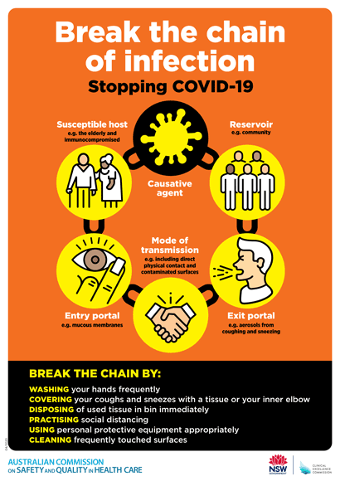](https://www.safetyandquality.gov.au/publications-and-resources/resource-library/break-chain-poster-a3https:/www.safetyandquality.gov.au/publications-and-resources/resource-library/break-chain-poster-a3)**

**Safe care for people with cognitive impairment during COVID-19**

<https://www.safetyandquality.gov.au/our-work/cognitive-impairment/cognitive-impairment-and-covid-19>

During COVID-19, people with cognitive impairment may find hospital even more frightening than usual. At this time, clinicians and visitors are using personal protective equipment (PPE) and there may be restrictions on family and carers who are usually there to support them.

In recognition of this changed environment, the Australian Commission on Safety and Quality in Health Care has developed new resources to support health service organisations to provide safe care for people with cognitive impairment during COVID-19.

The resources include a fact sheet for clinicians and a poster, which provide an important reminder of key actions in the National Safety and Quality Health Service (NSQHS) Standards that remain crucial at this time. These key actions include:

* Goals of care discussions with the patient, support person or, if required, the substitute decision maker
* The involvement of carers
* Delirium prevention strategies, and
* The use of antipsychotics only as a last resort.

To reduce the risk of harm, it is important that clinicians continue to use the strategies of their hospital or health service organisation to keep people with cognitive impairment safe.

The Commission acknowledges the contribution of people living with dementia, carers, clinicians and researchers in the development of these resources.

**[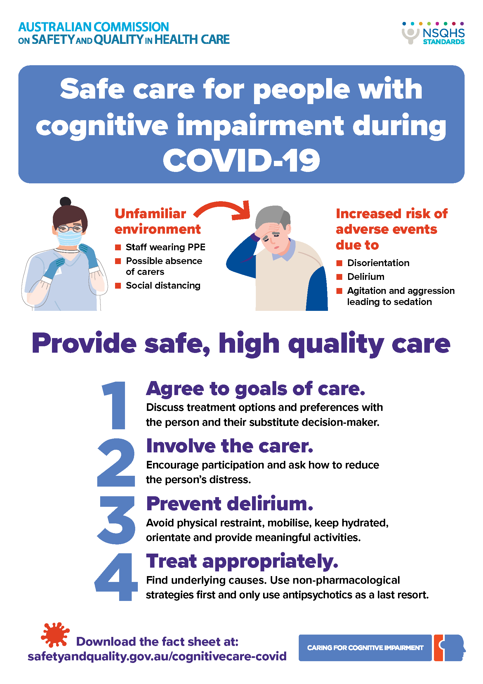](https://www.safetyandquality.gov.au/our-work/cognitive-impairment/cognitive-impairment-and-covid-19)**

**Reports**

*Data collection for community-based allied health chronic disease management*

Deeble Institute Issues Brief No. 36

Foo J

Canberra: Australian Healthcare and Hospitals Association; 2020. p. 27.

|  |  |
| --- | --- |
| URL | <https://ahha.asn.au/publication/health-policy-issue-briefs/deeble-issues-brief-no-36-data-collection-community-based> |
| Notes | This Issues Brief from the Australian Healthcare and Hospitals Association’s Deeble Institute examines the use (or not) of data around allied healthcare for chronic disease management. Community-based allied health services can offer much for those living with chronic disease. Such care can help patients avoid hospitalisations – and may be more cost-effective and patient-centred. However, as is argued in this Issues Brief, there is a lack of data to guide patients, providers, funders and others on how this healthcare may best be provided and the patient outcomes being achieved. The brief’s author calls for the additional collection of clinical data to inform optimal treatment approaches, innovative service delivery, appropriate workforce supply, and design of the Chronic Disease Management program. It is suggested that the design of data collection should include national consistency of data elements; infrastructure to support data collection, reporting, and sharing, as well as incentives for the data collection. |

**Journal articles**

*The quality of diagnosis and triage advice provided by free online symptom checkers and apps in Australia*

Hill MG, Sim M, Mills B

Medical Journal of Australia. 2020;212(11):514-519.

|  |  |
| --- | --- |
| DOI | <https://doi.org/10.5694/mja2.50600> |
| Notes | While we use our mobile phones and their many apps to do many things, this piece in the *Medical Journal of Australia* suggests that perhaps we should not place too much credence in what free online and mobile symptom checkers say. The authors reviewed 36 symptom checkers seeking to ascertain the accuracy of diagnosis and appropriateness of the triage advice. The symptom checkers were tested with 48 medical condition vignettes (1170 diagnosis vignette tests, 688 triage vignette tests). The authors found that ‘The quality of diagnostic advice varied …and triage advice was generally risk‐averse, often recommending more urgent care than appropriate.’  Given that we are still not particularly confident in clinicians using AI in more controlled settings for specific tasks it is perhaps unsurprising that these less sophisticated technologies in the hands of anyone are not impressing. The propensity for these tools to overstate the urgency of a condition may reflect a desire on the developer of making sure that they do not miss anything potentially serious. The upshot is that the doctor in your pocket is not quite good enough (yet). |

*Failure to follow medication changes made at hospital discharge is associated with adverse events in 30 days*

Weir DL, Motulsky A, Abrahamowicz M, Lee TC, Morgan S, Buckeridge DL, et al

Health Services Research. 2020 [epub].

|  |  |
| --- | --- |
| DOI | <https://doi.org/10.1111/1475-6773.13292> |
| Notes | Change to medication on admission to hospital, during inpatient stays and on discharge are understood to be areas of potential risk. This paper looks at the issue of medication changes after discharge from hospital. The paper reports on a prospective cohort study undertaken in Montreal, Canada between 2014 and 2016 that included 2655 patients. The study looked at whether patients complied with changes to their medication regimens by comparing the medications they had dispense in the community with those prescribed at hospital discharge. The study found that ‘Almost **half of patients** (n = 1161, 44%) were **nonadherent to at least one medication change**, and 860 (**32%)** were **readmitted to hospital, visited the emergency department, or died in the 30 days postdischarge**. Patients who were not adherent to any of their medication changes had a 35% higher risk of adverse events compared to those who were adherent to all medication changes’ |

For information on the Commission’s work on medication safety, see <https://www.safetyandquality.gov.au/our-work/medication-safety>

*Healthcare Policy*

Volume 15 Number 4 May 2020

|  |  |
| --- | --- |
| URL | <https://www.longwoods.com/publications/healthcare-policy/26220> |
| Notes | A new issue of *Healthcare Policy* has been published. Articles in this issue of *Healthcare Policy* include:   * Editorial: Engaging with Policy Makers: The Need for **Accessible and Timely Health Services and Systems Research** in 2020 (J M Sutherland) * The Courts and **Two-Tier Medicare** (Colleen M Flood, Bryan Thomas and Kelli White) * Commentary: The **Consequences of Private Involvement in Healthcare — The Australian Experience** (Stephen Duckett) * Health Canada’s Proposal to Accelerate **New Drug Reviews** (Joel Lexchin) * Commentary: Expedited **Regulatory Review of Low-Value Drugs** (Jonathan J Darrow and Reed F Beall) * Developing a Canadian Real-World Evidence Action Plan across the **Drug Life Cycle** (Mina Tadrous, Tarry Ahuja, Basanti Ghosh and Rhonda Kropp) * Ten Years of **Inaction on Antimicrobial Resistance**: An Environmental Scan of Policies in Canada from 2008 to 2018 (Susan Rogers Van Katwyk, Jeremy M Grimshaw and Steven J Hoffman) * Examining the Association between **Community-Level Marginalization and Emergency Room Wait Time** in Ontario, Canada (Erica J McDonald, Matthew Quick and Mark Oremus) * Triggering Institutional Change: Examining the Development of the 2001 Quebec **Breastfeeding Policy** (Maria Carolina Agnolon, Charo Rodríguez and Julie Lauzière) * On Portfolios of **Preventive Decisions for Multiple Health Risks** – Evidence from US-Based Data (Christophe Courbage and V Kalouguina) |

*BMJ Quality & Safety*

July 2020 - Volume 29 - 7

|  |  |
| --- | --- |
| URL | <https://qualitysafety.bmj.com/content/29/7> |
| Notes | A new issue of *BMJ Quality & Safety* has been published. Many of the papers in this issue have been referred to in previous editions of *On the Radar* (when they were released online). Articles in this issue of *BMJ Quality & Safety* include:   * Editorial: **Weekend effect**: complex metric for a complex pathway (Julian Bion) * Editorial: Approach to making the **availability heuristic** less available (Donald A Redelmeier, Kelvin Ng) * Editorial: Improving **cardiac surgical quality**: lessons from the Japanese experience (David Shahian) * Editorial: What are we doing when we **double check**? (Yvonne Pfeiffer, Chantal Zimmermann, David L B Schwappach) * The relationship between off-hours admissions for primary percutaneous coronary intervention, door-to-balloon time and mortality for patients with **ST-elevation myocardial infarction** in England: a registry-based prospective national cohort study (Sahan Jayawardana, Sebastian Salas-Vega, Felix Cornehl, Harlan M Krumholz, Elias Mossialos) * ‘Immunising’ physicians against **availability bias in diagnostic reasoning**: a randomised controlled experiment (Sílvia Mamede, Marco Antonio de Carvalho-Filho, Rosa Malena Delbone de Faria, Daniel Franci, Maria do Patrocinio Tenorio Nunes, Ligia Maria Cayres Ribeiro, Julia Biegelmeyer, Laura Zwaan, Henk G Schmidt) * **Quality improvement in cardiovascular surgery**: results of a surgical quality improvement programme using a nationwide clinical database and database-driven site visits in Japan (Hiroyuki Yamamoto, Hiroaki Miyata, Kazuo Tanemoto, Yoshikatsu Saiki, Hitoshi Yokoyama, Eriko Fukuchi, Noboru Motomura, Yuichi Ueda, Shinichi Takamoto) * **Impact of structured interdisciplinary bedside rounding on patient outcomes** at a large academic health centre (Padageshwar R Sunkara, Tareq Islam, Abhishek Bose, Gary E Rosenthal, Parag Chevli, Hanumantha Jogu, Luqman Arafath TK, Chi-Cheng Huang, Dipendra Chaudhary, Daniel Beekman, Abhishek Dutta, Suma Menon, Jaime L Speiser) * On **selecting quality indicators**: preferences of patients with breast and colon cancers regarding hospital quality indicators (Benjamin H Salampessy, Ward R Bijlsma, Eric van der Hijden, Xander Koolman, France R M Portrait) * **Novel quality improvement method** to reduce cost while improving the quality of patient care: retrospective observational study (Kedar S Mate, Jeffrey Rakover, Kay Cordiner, Amy Noble, Noura Hassan) * Effectiveness of **double checking to reduce medication administration errors**: a systematic review (Alain K Koyama, Claire-Sophie Sheridan Maddox, Ling Li, Tracey Bucknall, Johanna I Westbrook) * Accuracy of quality measurement for the **Hospital Acquired Conditions Reduction Program** (Kyle H Sheetz, Andrew Ryan) |

*Journal of Health Services Research & Policy*

Volume: 25, Number: 3 (July 2020)

|  |  |
| --- | --- |
| URL | <https://journals.sagepub.com/toc/hsrb/25/3> |
| Notes | A new issue of the *Journal of Health Services Research & Policy* has been published. Articles in this issue of the *Journal of Health Services Research & Policy* include:   * Editorial: Whose data is it anyway? **Patient experience and service improvement** (Glenn Robert and Sara Donetto) * How do they measure up? Differences in **stakeholder perceptions of quality measures** used in English community nursing (Katherine Pollard, Sue Horrocks, Lorna Duncan, Christina Petsoulas, Pauline Allen, Ailsa Cameron, Jane Cook, Emma Gibbard, Lizanne Harland, Pete Husband, Geoff Loydon, Ruth McDonald, Lesley Wye, and Chris Salisbury) * **How do frontline staff use patient experience data for service improvement?** Findings from an ethnographic case study evaluation (Louise Locock, Catherine Montgomery, Stephen Parkin, Alison Chisholm, Jennifer Bostock, Sue Dopson, Melanie Gager, Elizabeth Gibbons, Chris Graham, Jenny King, Angela Martin, John Powell, and Sue Ziebland) * Stakeholder views on **publication bias in health services research** (Iestyn Williams, Abimbola A Ayorinde, Russell Mannion, Magdalena Skrybant, Fujian Song, Richard J Lilford, and Yen-Fu Chen) * Responding to the **mental health consequences of the 2015–2016 terrorist attacks** in Tunisia, Paris and Brussels: implementation and treatment experiences in the United Kingdom (Eva Cyhlarova, Martin Knapp, and Nicholas Mays) * Is the rise of **crowdfunding for medical expenses** in the United Kingdom symptomatic of systemic gaps in health and social care? (Isabel Pifarré Coutrot, Richard Smith, and Laura Cornelsen) * Reorganizing and integrating public health, health care, social care and wider public services: a theory-based framework for **collaborative adaptive health networks** to achieve the triple aim (Betty Steenkamer, Hanneke Drewes, Kim Putters, Hans van Oers, and Caroline Baan) * The effectiveness of **community-based social innovations for healthy ageing** in middle- and high-income countries: a systematic review (Ioana Ghiga, Emma Pitchforth, Louise Lepetit, Celine Miani, Gemma-Clare Ali, and Catherine Meads) |

*The Milbank Quarterly*

Volume 98

|  |  |
| --- | --- |
| URL | <https://www.milbank.org/quarterly/issues/june-2020/> |
| Notes | A new issue of *The Milbank Quarterly* has been published. Articles in this issue of *The Milbank Quarterly* include:   * Detailing the **Primary Care Imperative**–Remembering Barbara Starfield (James M Perrin) * **COVID-19 and Underinvestment in the Health** of the US Population (Nason Maani, Sandro Galea) * **COVID-19 and Underinvestment in the Public Health Infrastructure** of the United States (Nason Maani, Sandro Galea) * **Redefining the “Public Option”**: Lessons from Washington State and New Mexico (Michael S Sparer) * **Bending the Cost Growth Curve and Expanding Coverage**: Lessons from Germany’s All‐Payer System (Tsung-Mei Cheng) * **Can Social Policies Improve Health?** A Systematic Review and Meta‐Analysis of 38 Randomized Trials (Emilie Courtin, Sooyoung Kim, Shanshan Song, Wenya Yu, Peter Muennig) * Which **Priorities for Health and Well‐Being** Stand Out After Accounting for Tangled Threats and Costs? Simulating Potential Intervention Portfolios in Large Urban Counties (Bobby Milstein, Jack Homer) * **Leading Innovative Practice**: Leadership Attributes in LEAP Practices (Benjamin F Crabtree, Jenna Howard, William L Miller, Deann Cromp, Clarissa Hsu, Katie Coleman, B T Austin, M Flinter, L Tuzzio, E H Wagner) * **Rethinking Integrated Care**: A Systematic Hermeneutic Review of the Literature on Integrated Care Strategies and Concepts (Gemma Hughes, Sara E Shaw, Trisha Greenhalgh) * Measuring **Community‐Engaged Research Contexts, Processes, and Outcomes**: A Mapping Review (Tana M Luger, Alison B Hamilton, G True) * The Role of the Legal System in the **Flint Water Crisis** (Peter D Jacobson, Colleen Healy Boufides, Denise Chrysler, Jennifer Bernstein, Toby Citrin) * **Personalized Medicine, Disruptive Innovation, and “Trailblazer” Guidelines**: Case Study and Theorization of an Unsuccessful Change Effort (Alex Rushforth, Trisha Greenhalgh) |

*BMJ Quality & Safety* online first articles

|  |  |
| --- | --- |
| URL | <https://qualitysafety.bmj.com/content/early/recent> |
| Notes | *BMJ Quality &Safety* has published a number of ‘online first’ articles, including:   * Reporting **incidents involving the use of advanced medical technologies by nurses in home care**: a cross-sectional survey and an analysis of registration data (Ingrid ten Haken, Somaya Ben Allouch, Wim H van Harten) * Cutting edge or blunt instrument: how to decide if a **stepped wedge design** is right for you (Richard Hooper, Sandra M Eldridge) * Impact of providing **patients access to electronic health records** on quality and safety of care: a systematic review and meta-analysis (Ana Luisa Neves, Lisa Freise, Liliana Laranjo, Alexander W Carter, Ara Darzi, Erik Mayer) * Correspondence: **Communication and resolution programmes** need to be effectively marketed to leadership and stakeholders (Doug Wojcieszak) * Correspondence: Key marketing message for **communication and resolution programmes**: the authors reply (Thomas H Gallagher, Richard C Boothman, Leilani Schweitzer, Evan M Benjamin) |

**Online resources**

*National COVID-19 Clinical Evidence Taskforce*

<https://covid19evidence.net.au/>

The National COVID-19 Clinical Evidence Taskforce is a collaboration of peak health professional bodies across Australia whose members are providing clinical care to people with COVID-19. The taskforce is undertaking continuous evidence surveillance to identify and rapidly synthesise emerging research in order to provide national, **evidence-based guidelines and clinical flowcharts for the clinical care of people with COVID-19**. The guidelines address questions that are specific to managing COVID-19 and cover the full disease course across mild, moderate, severe and critical illness. These are ‘living’ guidelines, updated with new research in near real-time in order to give reliable, up-to-the minute advice to clinicians providing frontline care in this unprecedented global health crisis.

*COVID-19 Critical Intelligence Unit*

<https://www.aci.health.nsw.gov.au/covid-19/critical-intelligence-unit>

The Agency for Clinical Innovation (ACI) in New South Wales has developed this page summarising rapid, evidence-based advice during the COVID-19 pandemic. Its operations focus on systems intelligence, clinical intelligence and evidence integration. The content includes a daily evidence digest and evidence checks on a discrete topic or question relating to the current COVID-19 pandemic. Recent evidence checks date include:

* ***Efficacy of cloth face masks for the prevention of COVID-19 transmission***
* ***Hydrotherapy and COVID-19***

*[UK] NICE Guidelines and Quality Standards*

<https://www.nice.org.uk/guidance>

The UK’s National Institute for Health and Care Excellence (NICE) has published new (or updated) guidelines and quality standards. The latest reviews or updates are:

* Quality Standard QS161***Sepsis***<https://www.nice.org.uk/guidance/qs161>

**Disclaimer**

On the Radar is an information resource of the Australian Commission on Safety and Quality in Health Care. The Commission is not responsible for the content of, nor does it endorse, any articles or sites listed. The Commission accepts no liability for the information or advice provided by these external links. Links are provided on the basis that users make their own decisions about the accuracy, currency and reliability of the information contained therein. Any opinions expressed are not necessarily those of the Australian Commission on Safety and Quality in Health Care.