# Australian COmmission on Safety and Quality in Health Care logo with Radar imageOn the Radar

Issue 471

6 July 2020

Ten years of On the Radar

\\central.health\DfsUserEnv\Users\User_07\JOHNNI\Pictures\10 years.pngThe first issue of *On the Radar* appeared on 5 July 2010 – just after I returned to work after the birth of my daughter. Initially produced as an internal resource for Commission personnel it quickly developed an audience beyond the Commission. Ten years and 471 issues on my editorial task remains much the same – compiling a succinct synopsis of recent material relevant to safety and quality in health care. I hope you find it useful and relevant to your work.

Dr Niall Johnson

Editor

*On the Radar* is a summary of some of the recent publications in the areas of safety and quality in health care. Inclusion in this document is not an endorsement or recommendation of any publication or provider. Access to particular documents may depend on whether they are Open Access or not, and/or your individual or institutional access to subscription sites/services. Material that may require subscription is included as it is considered relevant.

*On the Radar* is available online, via email or as a PDF or Word document from <https://www.safetyandquality.gov.au/publications-and-resources/newsletters/radar>

If you would like to receive *On the Radar* via email, you can subscribe on our website <https://www.safetyandquality.gov.au/publications-and-resources/newsletters>   
or by emailing us at H[Umail@safetyandquality.gov.auU](mailto:mail@safetyandquality.gov.au).   
You can also send feedback and comments to H[Umail@safetyandquality.gov.auU](mailto:mail@safetyandquality.gov.au).

For information about the Commission and its programs and publications, please visit <https://www.safetyandquality.gov.au>

You can also follow us on Twitter @ACSQHC.

**On the Radar**

Editor: Dr Niall Johnson [niall.johnson@safetyandquality.gov.au](mailto:niall.johnson@safetyandquality.gov.au)

Contributors: Niall Johnson, Victoria Young

**My Healthcare Rights - A guide for people with cognitive impairment**

<https://www.safetyandquality.gov.au/publications-and-resources/resource-library/my-healthcare-rights-guide-people-cognitive-impairment>

**About healthcare rights for people with cognitive impairment - Easy English Guide**

<https://www.safetyandquality.gov.au/publications-and-resources/resource-library/about-healthcare-rights-people-cognitive-impairment-easy-english-guide>

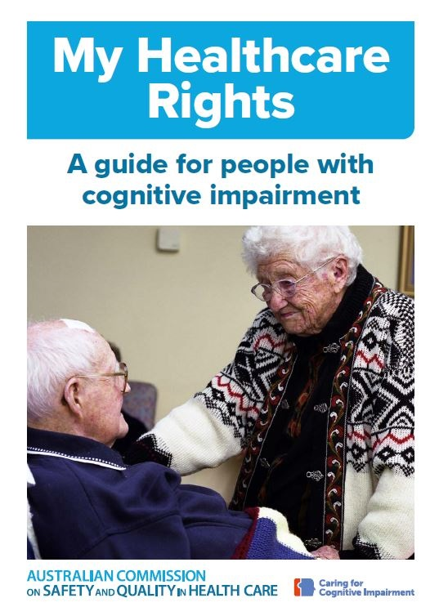

The Australian Commission on Safety and Quality in Health Care has published two new resources:

* *My Healthcare Rights - A guide for people with cognitive impairment* and
* *About healthcare rights for people with cognitive impairment – Easy English Guide*.

These guides were developed in collaboration with Dementia Australia, people living with dementia, and carers, to provide important information about healthcare rights that is accessible to people living with cognitive impairment. The resources have been aligned with the Australian Charter of Healthcare Rights (<https://www.safetyandquality.gov.au/consumers/understanding-your-rights>), and are part of the suite of cognitive impairment resources available at <https://www.safetyandquality.gov.au/our-work/cognitive-impairment/cognitive-impairment-resources>

**COVID-19 resources**

https://www.safetyandquality.gov.au/covid-19

The Australian Commission on Safety and Quality in Health Care has developed a number of resources to assist healthcare organisations, facilities and clinicians. These and other material on COVID-19 are available at <https://www.safetyandquality.gov.au/covid-19>

The latest additions include:

* **Medicines Management COVID-19** <https://www.safetyandquality.gov.au/our-work/medication-safety/medicines-management-covid-19>, including position statements on medicine-related issues
  + ***Managing fever associated with COVID-19***
  + ***Managing a sore throat associated with COVID-19***
  + ***ACE inhibitors and ARBs in COVID-19***
  + ***Clozapine in COVID-19***
  + ***Management of patients on oral anticoagulants during COVID-19***
  + ***Ascorbic Acid: Intravenous high dose in COVID-19***
  + ***Treatment in acute care, including oxygen therapy and medicines to support intubation***
  + ***Nebulisation and COVID-19***
  + ***Ongoing medicines management in high-risk patients***
  + ***Medicines shortages***
* ***Potential medicines to treat COVID-19***   
  <https://www.safetyandquality.gov.au/publications-and-resources/resource-library/potential-medicines-treat-covid-19>
* ***Break the chain of infection: Stopping COVID-19*** poster<https://www.safetyandquality.gov.au/publications-and-resources/resource-library/break-chain-poster-a3>
* ***COVID-19: Elective surgery and infection prevention and control precautions*** <https://www.safetyandquality.gov.au/publications-and-resources/resource-library/covid-19-elective-surgery-and-infection-prevention-and-control-precautions>
* ***FAQs for clinicians on elective surgery*** <https://www.safetyandquality.gov.au/node/5724>
* ***FAQs for consumers on elective surgery*** <https://www.safetyandquality.gov.au/node/5725>
* ***Infection prevention and control Covid-19 PPE*** poster <https://www.safetyandquality.gov.au/publications-and-resources/resource-library/infection-prevention-and-control-covid-19-personal-protective-equipment>
* ***Special precautions for Covid-19 designated zones*** poster <https://www.safetyandquality.gov.au/publications-and-resources/resource-library/special-precautions-covid-19-designated-zones>

**[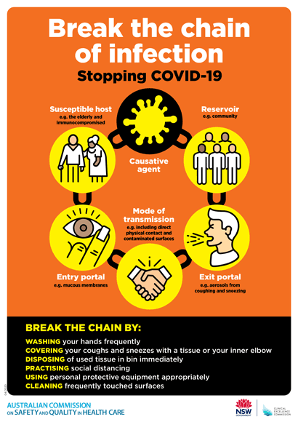](https://www.safetyandquality.gov.au/publications-and-resources/resource-library/break-chain-poster-a3https:/www.safetyandquality.gov.au/publications-and-resources/resource-library/break-chain-poster-a3)**

**Safe care for people with cognitive impairment during COVID-19**

<https://www.safetyandquality.gov.au/our-work/cognitive-impairment/cognitive-impairment-and-covid-19>

During COVID-19, people with cognitive impairment may find hospital even more frightening than usual. At this time, clinicians and visitors are using personal protective equipment (PPE) and there may be restrictions on family and carers who are usually there to support them.

In recognition of this changed environment, the Australian Commission on Safety and Quality in Health Care has developed new resources to support health service organisations to provide safe care for people with cognitive impairment during COVID-19.

The resources include a fact sheet for clinicians and a poster, which provide an important reminder of key actions in the National Safety and Quality Health Service (NSQHS) Standards that remain crucial at this time. These key actions include:

* Goals of care discussions with the patient, support person or, if required, the substitute decision maker
* The involvement of carers
* Delirium prevention strategies, and
* The use of antipsychotics only as a last resort.

To reduce the risk of harm, it is important that clinicians continue to use the strategies of their hospital or health service organisation to keep people with cognitive impairment safe.

The Commission acknowledges the contribution of people living with dementia, carers, clinicians and researchers in the development of these resources.

**[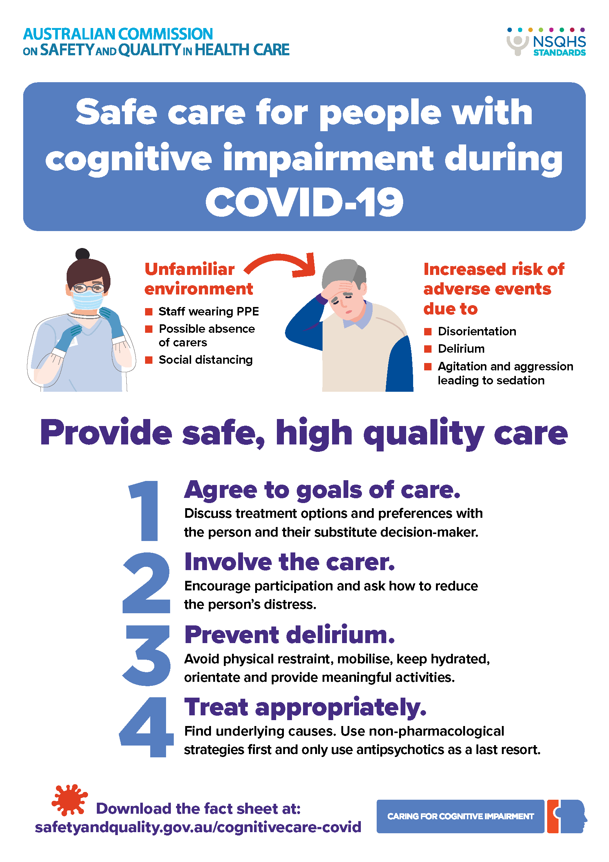](https://www.safetyandquality.gov.au/our-work/cognitive-impairment/cognitive-impairment-and-covid-19)**

**Journal articles**

*Systemic Defenses to Prevent Intravenous Medication Errors in Hospitals: A Systematic Review*

Kuitunen SK, Niittynen I, Airaksinen M, Holmström A-R

Journal of Patient Safety. 2020 [epub].

|  |  |
| --- | --- |
| DOI | <https://doi.org/10.1097/PTS.0000000000000688> |
| Notes | Following an earlier review paper (*Systemic Causes of In-Hospital Intravenous Medication Errors: A Systematic Review* <http://doi.org/10.1097/PTS.0000000000000632>) these authors have produced this review on methods of prevent intravenous medication errors in the hospital setting. Looking at 46 studies form 11 countries, the reviewers found that **closed loop medication management systems** and the use of **smart pumps** were the most common systemic defenses identified. The systemic defenses tended to focus on the medication administration rather than prescribing, preparation, monitoring and dispensing. |

For information on the Commission’s work on medication safety, see <https://www.safetyandquality.gov.au/medication-safety>

*Processes and tools to improve teamwork and communication in surgical settings: a narrative review*

Espin S, Indar A, Gross M, Labricciosa A, Arpino M

BMJ Open Quality. 2020;9(2):e000937.

|  |  |
| --- | --- |
| DOI | <https://doi.org/10.1136/bmjoq-2020-000937> |
| Notes | Communication is fundamental to health care and the role of (mis)communication in safety and quality lapses is understood. This review sought to identify and summarise leading practices, tools and resources for effective communication and teamwork during surgical care. Based on 34 studies, the reviewers found that there are a number of extant tools and processes that have been developed and that they are frequently modified to ‘to suit the particular needs of the surgical specialty or used in conjunction with additional processes.’ The reviewers also noted that ‘contextual factors such as education, staff buy-in, staff well-being, safety culture and ease of tool use can function as facilitators or barriers to implementation.’ |

For information on the Commission’s work on communicating for safety, see <https://www.safetyandquality.gov.au/our-work/communicating-safety>

*Public Health Research & Practice*

June 2020, Volume 30, Issue 2

|  |  |
| --- | --- |
| URL | <https://www.phrp.com.au/issues/june-2020-volume-30-issue-2/> |
| Notes | A new issue of *Public Health Research & Practice* has been published with a theme of **COVID-19: lessons for public health**. Articles in this issue of *Public Health Research & Practice* include:   * Editorial: **COVID-19: lessons in risk communication and public trust** (Don Nutbeam) * How **risk communication** could have reduced controversy about school closures in Australia during the **COVID-19 pandemic** (Julie Leask, Claire Hooker) * How the **COVID-19 pandemic** is focusing attention on **loneliness and social isolation** (Ben J Smith, Michelle H Lim) * Stemming the flow: how much can the Australian **smartphone app** help to control **COVID-19**? (Danielle J Currie, Cindy Q Peng, David M Lyle, Brydie A Jameson, Michael S Frommer) * Learners’ experience and perceived impact of a **health literacy program in adult basic education**: a qualitative study (Danielle M Muscat, Suzanne Morony, Don Nutbeam, Julie Ayre, Heather L Shepherd, Sian K Smith, Haryana M Dhillon, Andrew Hayen, Karen Luxford, Wedyan Meshreky, Kirsten McCaffery) * Changes in the age young **Aboriginal and Torres Strait Islander people** start **smoking**, 2002–2015 (Christina L Heris, Sandra J Eades, Louise Lyons, Catherine Chamberlain, David P Thomas) * Enhancing **global health communication during a crisis**: lessons from the **COVID-19 pandemic** (Scott C Ratzan, Silvia Sommariva, Lauren Rauh) * The **Intervention Scalability Assessment Tool**: a pilot study assessing five interventions for scalability (Karen Lee, Andrew Milat, Anne Grunseit, Kathleen Conte, Luke Wolfenden, Adrian Bauman) * **Aboriginal and Torres Strait Islander absolute cardiovascular risk assessment** and management: systematic review of evidence to inform national guidelines (Ellie Paige, Lily O'Donoughue Jenkins, Jason Agostino, Susan Pennings, Vicki Wade, Raymond Lovett, Amanda Daluwatta, Kirstie McLoughlin, Emily Banks) * A high proportion of **interseasonal childhood influenza** cases in 2019 were travel related (Lucy Deng, Paula Mazzocato, Gemma Saravanos, Karin Leder, Philip N Britton) * Capture of **systemic anticancer medicines in Pharmaceutical Benefits Scheme** (PBS) data likely higher than previously reported (Dominique L Favell, Monica Tang, Benjamin Daniels, Claire M Vajdic, Helga Zoega, Salllie-Anne Pearson) * Capture of **systemic anticancer medicines in Pharmaceutical Benefits Scheme** (PBS) data likely higher than previously reported – Authors’ reply (Nicola Creighton, Hanna E Tervonen, George W Zhao, David C Currow) |

*Journal for Healthcare Quality*

Vol. 42, No. 4, July/August 2020

|  |  |
| --- | --- |
| URL | <https://journals.lww.com/jhqonline/toc/2020/08000> |
| Notes | A new issue of the *Journal for Healthcare Quality* has been published. Articles in this issue of the *Journal for Healthcare Quality* include:   * A Systematic Review of **Clinical Outcomes Associated With Intrahospital Transitions** (Alycia A Bristol, Catherine E Schneider, S-Y Lin, A A Brody) * **Surgical-Site Infection Prevention After Hysterectomy**: Use of a Consensus Bundle to Guide Improvement (Adriane Burgess, Megan Fish, Seth Goldberg, Keziah Summers, Kim Cornwell, Jason Lowe) * Differences in Outcomes After **Anesthesia-Related Adverse Events** in Older and Younger Patients (Christopher W Root, Yaakov Beilin, Patrick J McCormick, Christopher J Curatolo, Daniel Katz, Jaime B Hyman) * Evaluating a **Fall Risk Assessment Tool** in an Emergency Department (Shuhong Luo, Melanie Kalman, Pamela Haines) * The **Heart Failure Clinic: Improving 30-Day All-Cause Hospital Readmissions** (Nicholas Taklalsingh, Perry Wengrofsky, Howard Levitt) * UC Care Check—A **Postoperative Neurosurgery Operating Room Checklist**: An Interrupted Time Series Study (Catherine Y Lau, Gregory Seymann, Sarah Imershein, Alpesh Amin, Nasim Afsarmanesh, Jeffrey Uppington, Anna Aledia, Sarah Pretanvil, Bridget Wilson, Josefina Wong, Jennifer Varma, James Boggan, F P K Hsu, B Carter, M Berger, J D Harrison) * Association Between **Provider Engagement, Staff Engagement, and Culture of Safety** (Leah Zallman, Karen E Finnegan, Martina Todaro, Bree Dallinga, J Curtis, M Lidman, P Allen, D Peterson, K Schoonmaker, A Sayah) * Using a Systems Engineering Framework to Evaluate **Proton Pump Inhibitor Prescribing** in Critically Ill Patients (Jessica S Tischendorf, Mary J Knobloch, Jackson S Musuuza, Nasia Safdar) * **How Successful Are Residents and Fellows at Quality Improvement?** (Elizabeth L Eden, Terence Harrington, Ling-Wan Chen, Lakshmipathi Chelluri, Linda W Higgins, Jennifer A Freel, Allison DeKosky, G M Bump) |

*BMJ Leader*

June 2020 - Volume 4 - 2

|  |  |
| --- | --- |
| URL | <https://bmjleader.bmj.com/content/4/2> |
| Notes | A new issue of *BMJ Leader* has been published. Articles in this issue of *BMJ Leader* include:   * **Followership**: much more than simply following the leader (Judy McKimm, Claire L Vogan) * **Diversity in NHS clinical leadership**: Is better talent management the route to gender balance? (Molly Gilmartin, Niamh Woods, Shruti Patel, Zoe Brummell) * Actions, style and practices: **how leaders ensure compassionate care delivery** (Timothy J Vogus, Laura E McClelland) * **Teamwork in a pandemic**: insights from management research (Anna T Mayo) * **Professional values and behaviours of younger and older general practitioners** in Scotland: a cross-sectional survey (Trudy Lynn Foster, Paul Bowie) * Routes to the top: the **developmental journeys of medical, clinical and managerial NHS chief executives** (Alex Till, Gerry McGivern) * The need for **health systems education during medical training** in the UK (Jessica Lee, Emiliano Valle) * Brief note about **management research on job mobility**: the birth of the Experts in Healthcare Exchange (Anita Sugavanam) * Role of **leadership in defining the culture and values of an organisation** (Ingrid Torjesen) * Reflections on **leadership in the time of COVID-19** (James K Stoller) * **This is different** (Dominique Allwood, Tony Berendt, Pedro Delgado, Jan Frich, Bob Klaber, Aoife Molloy, James Mountford, Amit Nigam, Catherine Stoddart, Tim Swanwick) * **Women in academic medicine leadership**: correlation between sex of medical school deans and affiliated academic hospital system CEOs (Ariela L Marshall, Urshila Durani, Joseph Mikhael) * Developing a **dental leadership programme** to address global oral health challenges (Valerie Wordley, Raman Bedi) |

*Health Expectations*

Volume 23, Issue 3

|  |  |
| --- | --- |
| URL | <https://onlinelibrary.wiley.com/toc/13697625/2020/23/3> |
| Notes | A new issue of *Health Expectations* has been published. Articles in this issue of *Health Expectations* include:   * **Involving patients in research during a pandemic** (C A Chew‐Graham) * Preparing for patient partnership: A scoping review of **patient partner engagement and evaluation** in research (Marissa Bird, Carley Ouellette, Carly Whitmore, Lin Li, Kalpana Nair, Michael H McGillion, Jennifer Yost, Laura Banfield, Elaine Campbell, Sandra L Carroll) * **Cultural competency in dietetic diabetes care**—A qualitative study of the dietician’s perspective (Mirjam Jager, Andrea den Boeft, Susanne Leij‐Halfwerk, Rob van der Sande, Maria van den Muijsenbergh) * A qualitative exploration of **mental health service user and carer perspectives on safety issues** in UK mental health services (Kathryn Berzins, John Baker, Gemma Louch, Abigail Albutt) * **Experience‐based co‐design**—Adapting the method for a researcher‐initiated study in a multi‐site setting (David K Raynor, Hanif Ismail, Alison Blenkinsopp, Beth Fylan, Gerry Armitage, Jonathan Silcock) * The views and experiences of patients and health‐care professionals on the **disclosure of adverse events**: A systematic review and qualitative meta‐ethnographic synthesis (Raabia Sattar, Judith Johnson, Rebecca Lawton) * Enhancing researcher capacity to **engage youth in research**: Researchers’ engagement experiences, barriers and capacity development priorities (Lisa D Hawke, Karleigh Darnay, Jacqueline Relihan, Mohammad Khaleghi‐Moghaddam, Skye Barbic, Lisa Lachance, Shelly Ben‐David, Marion Brown, S Iyer, G Chaim, S Soklaridis, S A Kidd, T Halsall, S Mathias, J Henderson) * Exploring women’s priorities for the potential consequences of a **gestational diabetes diagnosis**: A pilot community jury (Rae Thomas, Anna Mae Scott, Rebecca Sims, L Craig, L‐A Claase, J Lowe, C Heal, L Hardiman, P Glasziou) * Evidence that perceptions of and tolerance for **medical ambiguity** are distinct constructs: An analysis of nationally representative US data (Nicolle Simonovic, Jennifer M Taber, William M P Klein, Rebecca A Ferrer) * **Unmet health‐care needs and human rights**—A qualitative analysis of patients' complaints in light of the right to health and health care (Annelie J Sundler, Laura Darcy, Anna Råberus , Inger K. Holmström) * Women's and peer supporters' experiences of an assets‐based peer support intervention for increasing **breastfeeding initiation and continuation**: A qualitative study (J Ingram, G Thomson, D Johnson, J L Clarke, H Trickey, P Hoddinott, S U Dombrowski, K Jolly, On Behalf of the ABA Study Team) * Patient knowledge, experiences and preferences regarding **retinoblastoma** and research: A qualitative study (Catherine Moses, Kaitlyn Flegg, Helen Dimaras) * ‘There is no choice apart from antibiotics…’: Qualitative analysis of views on **urinary infections in pregnancy and antimicrobial resistance** (Flavia Ghouri, Amelia Hollywood, Kath Ryan) * The association between patients' preferred treatment after the use of a **patient decision aid** and their choice of eventual treatment (Carmen S S Latenstein, Floris M Thunnissen, Bastiaan J M Thomeer, Bob J van Wely, Marjan J Meinders, Glyn Elwyn, Philip R de Reuver) * **Producing co‐production**: Reflections on the development of a complex intervention (Mary Madden, Steph Morris, Margaret Ogden, David Lewis, Duncan Stewart, Jim McCambridge) * Public preferences for the **allocation of donor organs for transplantation**: Focus group discussions (Carina Oedingen, Tim Bartling, Marie‐Luise Dierks, Axel C. Mühlbacher, Harald Schrem, Christian Krauth) * Mediating engagement in a **social network intervention for people living with a long‐term condition**: A qualitative study of the role of facilitation (Elizabeth James, Anne Kennedy, Ivaylo Vassilev, Jaimie Ellis, Anne Rogers) * Adding to the knowledge on Patient and Public Involvement: Reflections from an experience of **co‐research with carers of people with dementia** (Claudio Di Lorito, Maureen Godfrey, Marianne Dunlop, Alessandro Bosco, Kristian Pollock, Veronika van der Wardt, Rowan H Harwood) * **What do consumers with chronic conditions expect from their interactions with general practitioners?** A qualitative study of Australian consumer and provider perspectives (Hyun Jung Song, Sarah Dennis, Jean‐Frédéric Levesque, Mark Fort Harris) |

*Nursing Leadership*

Volume 33, Number 2, 2020

|  |  |
| --- | --- |
| URL | <https://www.longwoods.com/publications/nursing-leadership/26235/1/vol.-33-no.-2-2020> |
| Notes | A new issue of *Nursing Leadership* has been published with a special focus on **nursing practice models**. Articles in this issue of *Nursing Leadership* include:   * Editorial: **What Do We Need to Do Now?** (Lynn M. Nagle) * **Co-Designing a Collaborative Academic Professional Practice Model for an Integrated Health System**: Sinai Health’s Journey (Lianne Jeffs, Jane Merkley, Nely Amaral, Leanne Ginty, Kara Ronald, L Yang and N Thomson) * **Nursing Care Delivery Redesign**: Using the Right Data to Make the Right Decisions (Maura MacPhee, Barbara Fitzgerald, Farinaz Havaei, Bernice Budz, David Waller, Cecilia Li, John Larmet and Tarnia Taverner) * The Development and Implementation of a **Model of Nursing Clinical Practice**: A Journey (Salma Debs-Ivall, Evelyn Kerr and G Lemire-Rodger) * A Pathway for Implementing the **Nurse Practitioner Workforce in a Rural and Remote Health Region** (Helen Bourque, Kelly Gunn and M MacLeod) * The Educational Terrain of **Preparing Registered Nurses to Prescribe**: An Environmental Scan (Elaine Moody, Ruth Martin-Misener, Jaimie Carrier, Marilyn MacDonald, Kathleen MacMillan and Sue Axe) * **Nurse Practitioner Activities** in Ontario Family Health Teams: Comparing Three Different Data Sources (Jennifer Rayner, Faith Donald, Ruth Martin-Misener, Rick Glazier and Alex Kopp) |

*BMJ Quality & Safety* online first articles

|  |  |
| --- | --- |
| URL | <https://qualitysafety.bmj.com/content/early/recent> |
| Notes | *BMJ Quality &Safety* has published a number of ‘online first’ articles, including:   * User-testing guidelines to improve the safety of **intravenous medicines administration**: a randomised in situ simulation study (Matthew D Jones, Anita McGrogan, D K Raynor, Margaret C Watson, Bryony Dean Franklin) * **Variation in tonsillectomy cost and revisit rates**: analysis of administrative and billing data from US children’s hospitals (Sanjay Mahant, Troy Richardson, Ron Keren, Rajendu Srivastava, Jeremy Meier for the Pediatric Research in Inpatient Setting (PRIS) Network) |

*International Journal for Quality in Health Care* online first articles

|  |  |
| --- | --- |
| URL | <https://academic.oup.com/intqhc/advance-articles> |
| Notes | *International Journal for Quality in Health Care* has published a number of ‘online first’ articles, including:   * Methods of **patient-reported measures** administration and their impact (Hyeoun-Ae Park) * **COVID-19 Pandemic**: A Time for Collaboration and A Unified Global Health Front (Dominique Vervoort, Xiya Ma, Jessica G Y Luc) * Can social accountability mechanisms using community scorecards improve **quality of pediatric care** in rural Cambodia? (Anbrasi Edward, Younghee Jung, Chea Chhorvann, Annette E Ghee, Jane Chege) * **Understanding variation in covid-19 reported deaths** with a novel Shewhart chart application (Rocco J Perla, Shannon M Provost, Gareth J Parry, Kevin Little, Lloyd P Provost) * The influence and added value of a Standardized Assessment and Reporting System for functioning outcomes upon **national rehabilitation quality reports** (Roxanne Maritz, Cristina Ehrmann, Birgit Prodinger, Alan Tennant, Gerold Stucki) * Implementing a quick **Sequential (Sepsis-Related) Organ Failure Assessment sepsis screening tool**: an interrupted times series study (Laura Alberto, Leanne M Aitken, Rachel M Walker, Fernando Pálizas, Andrea P Marshall) * Development of a guideline for the treatment of **generalized anxiety disorder** with the ADAPTE method (María M Hurtado, Eva V Nogueras, Nazaret Cantero, Luis Gálvez, José M García-Herrera, José M Morales-Asencio) |

**Online resources**

*Clinical Communiqué*

<https://www.thecommuniques.com/post/clinical-communiqu%C3%A9-volume-7-issue-2-june-2020>

Volume 7 Issue 2, June 2020

This issue of *Clinical Communiqué* examines two cases where a patient died in a secure setting – one in a **correctional facility** and another in a **mental health facility**. This issues also includes two expert commentaries, one on drugs known to prolong the **QT interval** and the other on the challenges in delivering **mental health care in secure settings**.

*National COVID-19 Clinical Evidence Taskforce*

<https://covid19evidence.net.au/>

The National COVID-19 Clinical Evidence Taskforce is a collaboration of peak health professional bodies across Australia whose members are providing clinical care to people with COVID-19. The taskforce is undertaking continuous evidence surveillance to identify and rapidly synthesise emerging research in order to provide national, **evidence-based guidelines and clinical flowcharts for the clinical care of people with COVID-19**. The guidelines address questions that are specific to managing COVID-19 and cover the full disease course across mild, moderate, severe and critical illness. These are ‘living’ guidelines, updated with new research in near real-time in order to give reliable, up-to-the minute advice to clinicians providing frontline care in this unprecedented global health crisis.

*COVID-19 Critical Intelligence Unit*

<https://www.aci.health.nsw.gov.au/covid-19/critical-intelligence-unit>

The Agency for Clinical Innovation (ACI) in New South Wales has developed this page summarising rapid, evidence-based advice during the COVID-19 pandemic. Its operations focus on systems intelligence, clinical intelligence and evidence integration. The content includes a daily evidence digest and evidence checks on a discrete topic or question relating to the current COVID-19 pandemic. Recent evidence checks date include:

* ***COVID-19 transmission risk on aircraft***

*[UK] NICE Guidelines and Quality Standards*

<https://www.nice.org.uk/guidance>

The UK’s National Institute for Health and Care Excellence (NICE) has published new (or updated) guidelines and quality standards. The latest reviews or updates are:

* NICE Guideline NG167 ***COVID-19*** *rapid guideline:* ***rheumatological autoimmune, inflammatory and metabolic bone disorders*** <https://www.nice.org.uk/guidance/ng167>

*[UK] NIHR Evidence alert*

<https://evidence.nihr.ac.uk/>

The UK’s National Institute for Health Research (NIHR) has posted new evidence alerts on its site. Evidence alerts are short, accessible summaries of health and care research which is funded or supported by NIHR. This is research which could influence practice and each Alert has a message for people commissioning, providing or receiving care. The latest alerts include:

* **Ambulance staff** who respond to suicides need more support
* Interactive dashboard identifies patients at risk of **unsafe prescribing** in a flexible and sustainable way
* **Public health messages on alcohol** need to consider how and why people drink, not just how much
* GPs who make the most **urgent referrals for cancer** see the fewest cancer deaths among their patients
* **Decision aids** quickly and accurately rule out heart attack for almost half of all patients tested
* **Therapists** and patients have good quality interactions during **telephone sessions**
* A simple test may predict the risk of hospitalisation for flare-up in patients with **COPD**
* Patients are often unsatisfied with the explanation they receive **when something goes wrong**
* **High-intensity interval training** rapidly improves fitness in patients awaiting surgery for urological cancer
* **Apps** to help patients take medication on time need to be evaluated in a consistent way
* People with **late-stage Parkinson’s** need personalised, flexible, home-based care.

**Disclaimer**

On the Radar is an information resource of the Australian Commission on Safety and Quality in Health Care. The Commission is not responsible for the content of, nor does it endorse, any articles or sites listed. The Commission accepts no liability for the information or advice provided by these external links. Links are provided on the basis that users make their own decisions about the accuracy, currency and reliability of the information contained therein. Any opinions expressed are not necessarily those of the Australian Commission on Safety and Quality in Health Care.