# Australian COmmission on Safety and Quality in Health Care logo with Radar imageOn the Radar

Issue 478

24 August 2020

*On the Radar* is a summary of some of the recent publications in the areas of safety and quality in health care. Inclusion in this document is not an endorsement or recommendation of any publication or provider. Access to particular documents may depend on whether they are Open Access or not, and/or your individual or institutional access to subscription sites/services. Material that may require subscription is included as it is considered relevant.

*On the Radar* is available online, via email or as a PDF or Word document from <https://www.safetyandquality.gov.au/publications-and-resources/newsletters/radar>

If you would like to receive *On the Radar* via email, you can subscribe on our website <https://www.safetyandquality.gov.au/publications-and-resources/newsletters>   
or by emailing us at H[Umail@safetyandquality.gov.auU](mailto:mail@safetyandquality.gov.au).   
You can also send feedback and comments to H[Umail@safetyandquality.gov.auU](mailto:mail@safetyandquality.gov.au).

For information about the Commission and its programs and publications, please visit <https://www.safetyandquality.gov.au>

You can also follow us on Twitter @ACSQHC.

**On the Radar**

Editor: Dr Niall Johnson [niall.johnson@safetyandquality.gov.au](mailto:niall.johnson@safetyandquality.gov.au)

Contributors: Niall Johnson

**COVID-19 resources**

https://www.safetyandquality.gov.au/covid-19

The Australian Commission on Safety and Quality in Health Care has developed a number of resources to assist healthcare organisations, facilities and clinicians. These and other material on COVID-19 are available at <https://www.safetyandquality.gov.au/covid-19>

The latest additions include:

* ***COVID-19: Aged care staff infection prevention and control precautions – Poster*** <https://www.safetyandquality.gov.au/publications-and-resources/resource-library/covid-19-aged-care-staff-infection-prevention-and-control-precautions-poster>  
    
  [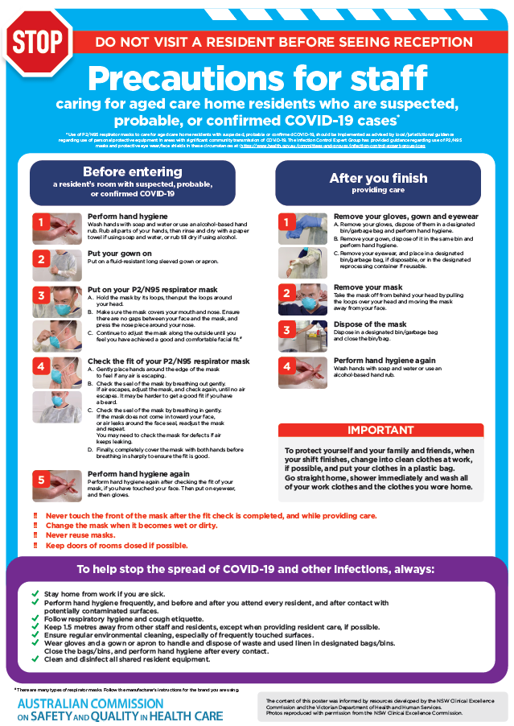](https://www.safetyandquality.gov.au/publications-and-resources/resource-library/covid-19-aged-care-staff-infection-prevention-and-control-precautions-poster)
* ***Environmental Cleaning and Infection Prevention and Control*** [www.safetyandquality.gov.au/environmental-cleaning](http://www.safetyandquality.gov.au/environmental-cleaning)
* ***Infection prevention and control Covid-19 PPE*** poster <https://www.safetyandquality.gov.au/publications-and-resources/resource-library/infection-prevention-and-control-covid-19-personal-protective-equipment>
* ***Special precautions for Covid-19 designated zones*** poster <https://www.safetyandquality.gov.au/publications-and-resources/resource-library/special-precautions-covid-19-designated-zones>
* ***COVID-19 infection prevention and control risk management – Guidance*** <https://www.safetyandquality.gov.au/publications-and-resources/resource-library/covid-19-infection-prevention-and-control-risk-management-guidance> The Commission has prepared this guidance to support health service organisations to undertake COVID-19 risk assessment and develop a comprehensive Risk Management Plan. The guidance acknowledges the ongoing risks associated with COVID-19 in Australia. Health service organisations are required to prepare and implement an organisation-wide Risk Management Plan to manage and reduce the risks related to the transmission of COVID-19.
* ***Safe care for people with cognitive impairment during COVID-19***<https://www.safetyandquality.gov.au/our-work/cognitive-impairment/cognitive-impairment-and-covid-19>
* **Medicines Management COVID-19** <https://www.safetyandquality.gov.au/our-work/medication-safety/medicines-management-covid-19>, including position statements on medicine-related issues
  + ***Managing fever associated with COVID-19***
  + ***Managing a sore throat associated with COVID-19***
  + ***ACE inhibitors and ARBs in COVID-19***
  + ***Clozapine in COVID-19***
  + ***Management of patients on oral anticoagulants during COVID-19***
  + ***Ascorbic Acid: Intravenous high dose in COVID-19***
  + ***Treatment in acute care, including oxygen therapy and medicines to support intubation***
  + ***Nebulisation and COVID-19***
  + ***Managing intranasal administration of medicines during COVID-19***
  + ***Ongoing medicines management in high-risk patients***
  + ***Medicines shortages***
* ***Potential medicines to treat COVID-19***   
  <https://www.safetyandquality.gov.au/publications-and-resources/resource-library/potential-medicines-treat-covid-19>
* ***Break the chain of infection: Stopping COVID-19*** poster<https://www.safetyandquality.gov.au/publications-and-resources/resource-library/break-chain-poster-a3>  
  **[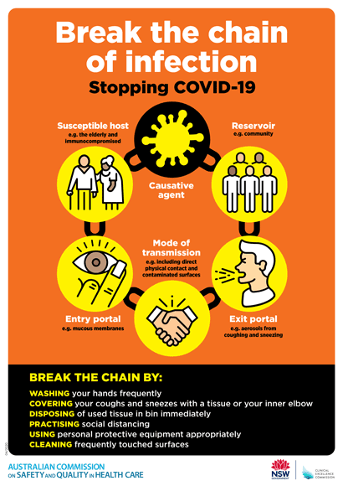](https://www.safetyandquality.gov.au/publications-and-resources/resource-library/break-chain-poster-a3https:/www.safetyandquality.gov.au/publications-and-resources/resource-library/break-chain-poster-a3)**
* ***COVID-19: Elective surgery and infection prevention and control precautions*** <https://www.safetyandquality.gov.au/publications-and-resources/resource-library/covid-19-elective-surgery-and-infection-prevention-and-control-precautions>
* ***FAQs for clinicians on elective surgery*** <https://www.safetyandquality.gov.au/node/5724>
* ***FAQs for consumers on elective surgery*** <https://www.safetyandquality.gov.au/node/5725>
* ***FAQs on community use of face masks***   
  <https://www.safetyandquality.gov.au/faqs-community-use-face-masks>
* ***COVID-19 and face masks – Information for consumers*** <https://www.safetyandquality.gov.au/publications-and-resources/resource-library/covid-19-and-face-masks-information-consumers>

[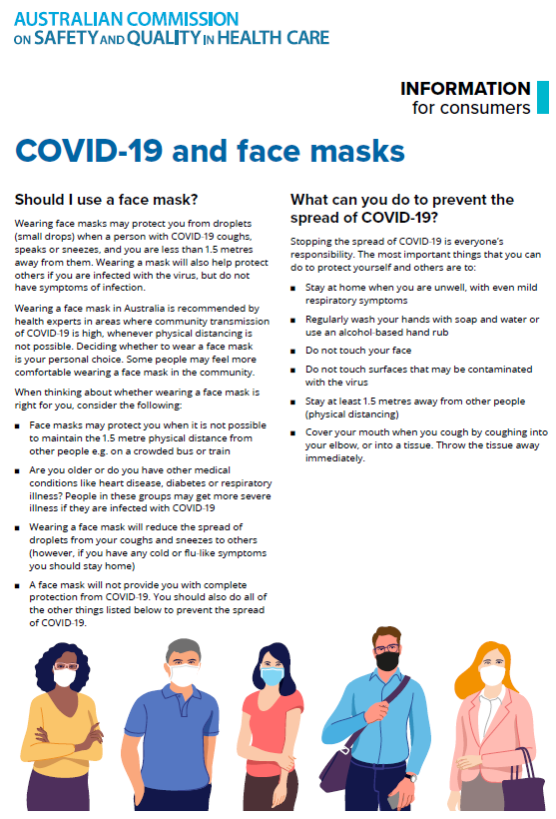](https://www.safetyandquality.gov.au/sites/default/files/2020-07/covid-19_and_face_masks_-_information_for_consumers.pdf)

**National Safety and Quality Health Service Standards: User guide for the review of clinical variation in health care**

Australian Commission on Safety and Quality in Health Care

Sydney: ACSQHC; 2020.

<https://www.safetyandquality.gov.au/publications-and-resources/resource-library/nsqhs-standards-user-guide-review-clinical-variation-health-care>

**[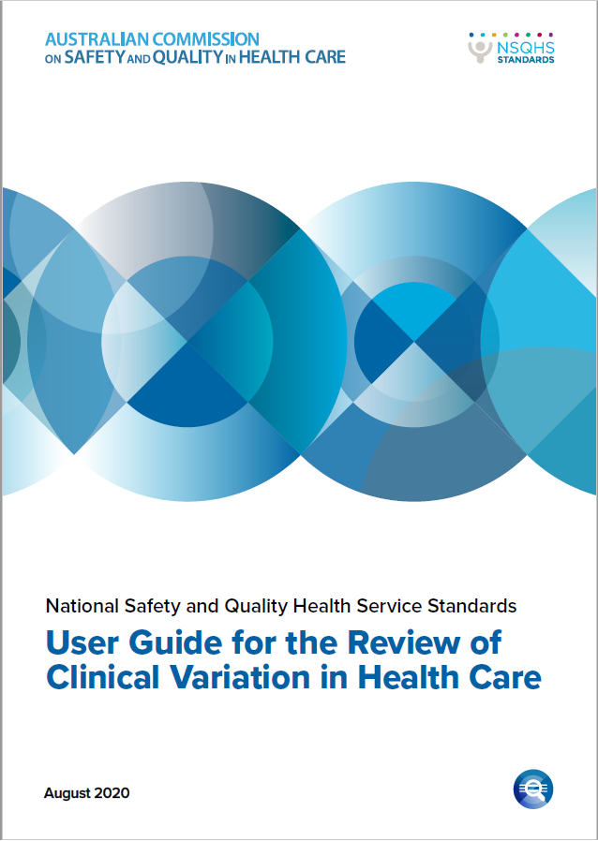](https://www.safetyandquality.gov.au/publications-and-resources/resource-library/nsqhs-standards-user-guide-review-clinical-variation-health-care)**

The Australian Commission on Safety and Quality in Health Care has released a guide to support health service organisations to review clinical variation.

The *User Guide for the Review of Clinical Variation in Health Care* explains how organisations can implement Action 1.28 of the Clinical Governance Standard in the National Safety and Quality Health Service (NSQHS) Standards.

Action 1.28 aims to ensure that health services work with their clinicians to regularly review data collected on clinical care processes and outcomes to identify unwarranted variation. Examining variation in clinical care is one way of identifying if people are being offered appropriate care.

Health services can use available data to identify potentially unwarranted variation and improve the appropriateness of care, which has widespread benefits for patients, their carers and families.

[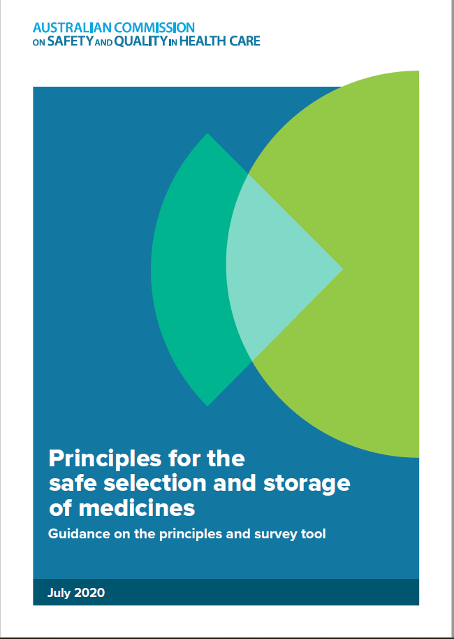](https://www.safetyandquality.gov.au/our-work/medication-safety/safer-naming-labelling-and-packaging-medicines/safe-selection-and-storage-medicines)The User Guide describes six key steps for implementing Action 1.28, and provides resources to support health services and their clinicians in reviewing clinical variation. It also includes practical case studies, and clinical topics for potential investigation.

**Safe selection and storage of medicines**

<https://www.safetyandquality.gov.au/our-work/medication-safety/safer-naming-labelling-and-packaging-medicines/safe-selection-and-storage-medicines>

The Australian Commission on Safety and Quality in Health Care has developed guidance *(Principles for the safe selection and storage of medicines: Guidance on the principles and survey tool*)to help clinicians reduce the risk of medicine selection errors. Developed for use in hospitals, the guidance will help to reduce one of the most common types of medication error - look-alike and sound-alike (LASA) medicine names. There is also a survey tool to enable health services to identify suitable risk-reduction strategies.

**Reports**

*Moving towards value-based, patient centred telehealth to support cancer care*

Deeble Institute Perspectives Brief No. 11

Slavova-Azmanova N, Millar L, Ives A, Codde J, Saunders C

Canberra: Australian Healthcare and Hospitals Association; 2020. p. 14.

|  |  |
| --- | --- |
| URL | <https://ahha.asn.au/health-policy-perspective-briefs>  <https://ahha.asn.au/sites/default/files/docs/policy-issue/perspectives_brief_no._11_moving_towards_value-based_patient_centred_telehealth_to_support_cancer_care9197_0.pdf> |
| Notes | Telehealth has become a key aspect of healthcare delivery in the COVID-19 pandemic. This Perspectives Brief from the Australian Healthcare and Hospitals Association’s Deeble Institute examines how telehealth can be implemented to enhance cancer care. The authors examine ‘the role of telehealth as a lever to enhance value in the changing value-oriented healthcare landscape…the need for an improved telehealth service model for cancer that integrates clinical and patient reported outcomes to support patients’ needs and providers’ expectations.’ |

*Telediagnosis for Acute Care: Implications for the Quality and Safety of Diagnosis*

Smith KM, Hunte HE, Graber ML

Rockville, MD: Agency for Healthcare Research and Quality; August 2020

AHRQ Publication No. 20-0040-2-EF

|  |  |
| --- | --- |
| URL | <https://www.ahrq.gov/patient-safety/reports/issue-briefs/teledx.html> |
| Notes | The US Agency for Healthcare Research and Quality (AHRQ) has released this Issue Brief that draws together the rapid uptake of telehealth and the issues of diagnostic error to focus on “telediagnosis” or the specific use of telehealth for diagnosis. The authors propose a definition of telediagnosis:  ‘…the co-production of an accurate and timely explanation of the patient’s health problem through remote interactions and transmitted data, including the clear communication of that explanation to the patient through these interactions.’  The authors assert that ‘As patients and clinicians participate in telediagnosis at scale, it is vital to consider quality and safety issues that arise when it is used for the diagnosis of acute conditions. What is known? What is not known? Given the likelihood that telehealth will become a mainstay after the current COVID-19 epidemic, we need to learn about optimizing the use of telediagnosis from the massive expansion now in progress and identify emerging research priorities.’ |

**Journal articles**

*Changes in medication administration error rates associated with the introduction of electronic medication systems in hospitals: a multisite controlled before and after study*

Westbrook JI, Sunderland NS, Woods A, Raban MZ, Gates P, Li L

BMJ Health & Care Informatics. 2020;27(3):e100170.

|  |  |
| --- | --- |
| DOI | <http://dx.doi.org/10.1136/bmjhci-2020-100170> |
| Notes | This paper reports on a study into the effects of electronic medication systems (EMS) on medication administration errors. The study was a controlled before and after study (three intervention and three control wards) at two adult teaching hospitals in which 7451 administrations were observed (4176 pre-EMS and 3275 post-EMS). The authors found that ‘Implementation of EMS was associated with a modest, but significant, reduction in overall MAE rate, but halved the proportion of MAEs rated as potentially serious. |

For information on the Commission’s work on medication safety see, <https://www.safetyandquality.gov.au/our-work/medication-safety>

For information on the Commission’s work on electronic medication management see, <https://www.safetyandquality.gov.au/our-work/medication-safety/electronic-medication-management>

*Associations between double-checking and medication administration errors: a direct observational study of paediatric inpatients*

Westbrook JI, Li L, Raban MZ, Woods A, Koyama AK, Baysari MT, et al

BMJ Quality & Safety. 2020 [epub].

|  |  |
| --- | --- |
| DOI | <http://dx.doi.org/10.1136/bmjqs-2020-011473> |
| Notes | The authors of this piece observe that while double-checking the administration of medications has been standard practice in paediatric hospitals there is little evidence of its effectiveness in reducing errors or harm. They sought to measure the association between double-checking, and the occurrence and potential severity of medication administration errors (MAEs); check duration; and factors associated with double-checking adherence through a direct observational study of 298 nurses, administering 5140 medication doses to 1523 patients, across nine wards, in a paediatric hospital in Australia. They observed that compliance with mandated double-checking was high. However, double checking seems to confer little benefit as the author’s concluded ‘Compliance with mandated double-checking was very high, but rarely independent. Primed double-checking was highly prevalent but compared with single-checking conferred no benefit in terms of reduced errors or severity.’ |

*Hospital Accreditation Impact on Healthcare Quality Dimensions: A Systematic Review*

Araujo CAS, Siqueira MM, Malikn AM

International Journal for Quality in Health Care. 2020 [epub].

|  |  |
| --- | --- |
| DOI | <https://doi.org/10.1093/intqhc/mzaa090> |
| Notes | The role and impact of accreditation in ensuring safety and quality of health care delivery has been debated for some time. This review sought to examine ‘the impact of hospital accreditation on healthcare quality indicators, as classified into seven healthcare quality dimensions.’ From the 36 studies included in the review, the authors report that ‘accreditation may have a positive impact on efficiency, safety, effectiveness, timeliness, and patient-centeredness. In turn, only one study analyzes the impact on access, and no study has investigated the impact on equity dimension yet.’ |

*Safety in Pediatric Hospice and Palliative Care: A Qualitative Study*

Pestian T, Thienprayoon R, Grossoehme D, Friebert S, Humphrey L

Pediatric Quality & Safety. 2020;5(4):e328.

|  |  |
| --- | --- |
| DOI | <https://doi.org/10.1097/pq9.0000000000000328> |
| Notes | Different healthcare settings can pose differing patient safety issues. This piece examines parental and care giver views on what constitutes safe care in the particular setting of paediatric hospice and palliative care. Based on interviews with 43 parents across 3 paediatric tertiary care hospitals. The authors report that ‘Parents of children in HPC programs describe “safe care” in novel ways’ and that ‘The use of traditional hospital safety measures for patients receiving HPC could undermine the patient’s goals or dignity, ultimately leading to harm to the patient.’ |

For information on the Commission’s work on end-of-life care, see <https://www.safetyandquality.gov.au/our-work/end-life-care>

*Effect of Treating Parents Colonized With* Staphylococcus aureus *on Transmission to Neonates in the Intensive Care Unit: A Randomized Clinical Trial*

Milstone AM, Voskertchian A, Koontz DW, Khamash DF, Ross T, Aucott SW, et al

JAMA. 2020;323(4):319-328.

|  |  |
| --- | --- |
| DOI | <https://doi.org/10.1001/jama.2019.20785> |
| Notes | It is understood that *Staphylococcus aureus* is a major cause of health care–associated infections in neonatal intensive care units (NICU) and that parents may expose neonates to *S aureus* colonization. This study sought to examine if treating colonized parents reduce the risk of *S aureus* transmission to neonates. The study was conducted in 2 tertiary NICUs in America and involved 236 neonates and their parents. The authors report that ‘treatment with intranasal mupirocin and chlorhexidine-impregnated cloths compared with placebo significantly reduced neonatal colonization’. |

For information on the Commission’s work on *Staphylococcus aureus* (SAB) prevention, see [www.safetyandquality.gov.au/sab](http://www.safetyandquality.gov.au/sab)

For information on the Commission’s work on healthcare-associated infection, see <https://www.safetyandquality.gov.au/our-work/healthcare-associated-infection>

*Healthcare Policy*

Volume 16 Number 1 August 2020

|  |  |
| --- | --- |
| URL | <https://www.longwoods.com/publications/healthcare-policy/26247/1/vol.-16-no.-1-2020> |
| Notes | A new issue of *Healthcare Policy* has been published. Articles in this issue of *Healthcare Policy* include:   * Editorial: The Changing Face of **Healthcare Delivery: Making Room for Other Disciplines** (Jason M Sutherland) * **Hospital Discharge Planning for People Experiencing Homelessness** Leaving Acute Care: A Neglected Issue (Jesse Jenkinson, Adam Wheeler, Claudia Wong and Louisa Mussells Pires) * Commentary: **Discharging the Homeless** – A Daily Issue in Acute Care (Cheryl Forchuk) * The Role of **Social Workers in Interprofessional Primary Healthcare Teams** (Vela Tadic, Rachelle Ashcroft, Judith Belle Brown and S Dahrouge) * Prioritizing and Implementing **Primary Care Performance Measures** for Ontario (Brian Hutchison, Wissam Haj-Ali, Gail Dobell, Naira Yeritsyan, Naushaba Degani and Sharon Gushue) * **Awareness and Use of Community Services among Primary Care Physicians** (Tara Kiran, Jessica J. Rodrigues, Tatiana Aratangy, Kimberly Devotta, Nathalie Sava and Patricia O’Campo) * Structural Facilitators and Barriers to **Access to and Continuity of French-Language Healthcare and Social Services** in Ontario’s Champlain Region (Jacinthe Savard, Kate Bigney, Lucy-Ann Kubina, S Savard and M Drolet) * Exploring the Results of the **Ontario Home Care Minimum Wage Change** (Alexia Olaizola, Oliver Loertscher and Arthur Sweetman) * Informing Canada’s Health System Response to **COVID-19: Priorities for Health Services and Policy Research** (Meghan McMahon, Jessica Nadigel, Erin Thompson and Richard H Glazier) |

*BMJ Quality & Safety*

July 2020 - Volume 29 - 9

|  |  |
| --- | --- |
| URL | <https://qualitysafety.bmj.com/content/29/9> |
| Notes | A new issue of *BMJ Quality & Safety* has been published. Many of the papers in this issue have been referred to in previous editions of *On the Radar* (when they were released online). Articles in this issue of *BMJ Quality & Safety* include:   * Editorial: Sounds good: the bright future of **clinical alarm management initiatives** (Halley Ruppel, Christopher P Bonafide) * Editorial: Allowing failure so trainees can thrive: the importance of **guided autonomy in medical education** (Rachel B Atkinson, Douglas S Smink) * Editorial: Leveraging electronic health record data to improve **sepsis surveillance** (Claire N Shappell, Chanu Rhee) * **Coproduction: when users define quality** (Glyn Elwyn, Eugene Nelson, Andreas Hager, Amy Price) * Time series evaluation of improvement interventions to reduce **alarm notifications in a paediatric hospital** (Colleen M Pater, Tina K Sosa, Jacquelyn Boyer, Rhonda Cable, Melinda Egan, Timothy K Knilans, Amanda C Schondelmeyer, Christine L Schuler, Nicolas L Madsen) * ‘Whatever you cut, I can fix it’: clinical supervisors’ interview accounts of allowing **trainee failure** while guarding patient safety (Jennifer M Klasen, Erik Driessen, Pim W Teunissen, Lorelei A Lingard) * Validation of **automated sepsis surveillance** based on the Sepsis-3 clinical criteria against physician record review in a general hospital population: observational study using electronic health records data (John Karlsson Valik, Logan Ward, Hideyuki Tanushi, Kajsa Müllersdorf, Anders Ternhag, Ewa Aufwerber, Anna Färnert, Anders F Johansson, Mads Lause Mogensen, Brian Pickering, Hercules Dalianis, Aron Henriksson, Vitaly Herasevich, P Nauclér) * Logic model framework for considering the inputs, processes and outcomes of a **healthcare organisation–research partnership** (Amir Alishahi Tabriz, Susan A Flocke, Deirdre Shires, Karen E Dyer, Michelle Schreiber, J E Lafata) * Applying thematic synthesis to interpretation and commentary in epidemiological studies: identifying what contributes to successful interventions to promote **hand hygiene in patient care** (Nicholas Drey, Dinah Gould, Edward Purssell, Jane Chudleigh, Donna Moralejo, Rose Gallagher, Annette Jeanes, Neil Wigglesworth, Didier Pittet) * How can **patient-held lists of medication enhance patient safety**? A mixed-methods study with a focus on user experience (Sara Garfield, Dominic Furniss, Fran Husson, Mike Etkind, Marney Williams, John Norton, Della Ogunleye, Barry Jubraj, Hanaa Lakhdari, Bryony Dean Franklin) * When do trials of **diabetes quality improvement strategies** lead to sustained change in patient care? (Emily L Kearsley-Ho, Hsin Yun Yang, Sathya Karunananthan, Celia Laur, Jeremy M Grimshaw, Noah M Ivers) |

*BMJ Quality & Safety* online first articles

|  |  |
| --- | --- |
| URL | <https://qualitysafety.bmj.com/content/early/recent> |
| Notes | *BMJ Quality &Safety* has published a number of ‘online first’ articles, including:   * **Chronic hospital nurse understaffing meets COVID-19**: an observational study (Karen B Lasater, Linda H Aiken, Douglas M Sloane, Rachel French, Brendan Martin, Kyrani Reneau, Maryann Alexander, Matthew D McHugh) * Retrospective analysis of reported **suicide deaths and attempts on veterans health administration campuses** and inpatient units (Peter D Mills, Christina Soncrant, William Gunnar) |

*International Journal for Quality in Health Care* online first articles

|  |  |
| --- | --- |
| URL | <https://academic.oup.com/intqhc/advance-articles> |
| Notes | *International Journal for Quality in Health Care* has published a number of ‘online first’ articles, including:   * The applicability of **COBIT processes representation structure** for quality improvement in healthcare: a Delphi study: Research article (Boštjan Žvanut, Milena Burnik, Tamara Štemberger Kolnik, Patrik Pucer) * From Hospital to Post-Acute Care Organisations: The Relationship Between **Patient Experience and Health Recovery** (Generosa do Nascimento, Francisco Guilherme Nunes, Janet E Anderson) * **Crisis Standards of Care in a Pandemic**: Navigating the Ethical, Clinical, Psychological, and Policy-making Maelstrom (Attila J Hertelendy, Gregory R Ciottone, Cheryl L Mitchell, Jennifer Gutberg, Frederick M Burkle) * **Ethical Frameworks for Quality Improvement Activities**: An Analysis of International Practice (Corina Naughton, Elaine Meehan, Elaine Lehane, Ciara Landers, Sarah Jane Flaherty, Aoife Lane, Margaret Landers, Caroline Kilty, Mohamad M Saab, John Goodwin, Nuala Walshe, Teresa Wills, Vera McCarthy, Siobhan Murphy, Joan McCarthy, Cummins Helen, Deirdre Madden, Josephine Hegarty) * Association of **continuity of care** with readmission, mortality, and suicide after hospital discharge among psychiatric patients (Young Choi, Chung Mo Nam, Sang Gyu Lee, Sohee Park, Hwang-Gun Ryu, Eun-Cheol Park) |

**Online resources**

*National COVID-19 Clinical Evidence Taskforce*

<https://covid19evidence.net.au/>

The National COVID-19 Clinical Evidence Taskforce is a collaboration of peak health professional bodies across Australia whose members are providing clinical care to people with COVID-19. The taskforce is undertaking continuous evidence surveillance to identify and rapidly synthesise emerging research in order to provide national, **evidence-based guidelines and clinical flowcharts for the clinical care of people with COVID-19**. The guidelines address questions that are specific to managing COVID-19 and cover the full disease course across mild, moderate, severe and critical illness. These are ‘living’ guidelines, updated with new research in near real-time in order to give reliable, up-to-the minute advice to clinicians providing frontline care in this unprecedented global health crisis.

*COVID-19 Critical Intelligence Unit*

<https://www.aci.health.nsw.gov.au/covid-19/critical-intelligence-unit>

The Agency for Clinical Innovation (ACI) in New South Wales has developed this page summarising rapid, evidence-based advice during the COVID-19 pandemic. Its operations focus on systems intelligence, clinical intelligence and evidence integration. The content includes a daily evidence digest and evidence checks on a discrete topic or question relating to the current COVID-19 pandemic. Recent evidence checks date include:

* ***Surgical masks and oxygen therapy***

*[UK] NICE Guidelines and Quality Standards*

<https://www.nice.org.uk/guidance>

The UK’s National Institute for Health and Care Excellence (NICE) has published new (or updated) guidelines and quality standards. The latest reviews or updates are:

* *NICE Guideline NG125* ***Surgical site infections****: prevention and treatment* <https://www.nice.org.uk/guidance/ng125>
* *NICE Guideline NG174* ***COVID-19 rapid guideline****:: children and young people who are* ***immunocompromised***<https://www.nice.org.uk/guidance/ng174>
* *NICE Guideline NG178* ***COVID-19 rapid guideline****::* ***renal transplantation***<https://www.nice.org.uk/guidance/ng178>
* *NICE Guideline NG180* ***Perioperative care*** *in adults* <https://www.nice.org.uk/guidance/ng180>
* *NICE Guideline NG181 Rehabilitation for adults with* ***complex psychosis***<https://www.nice.org.uk/guidance/ng181>

**Disclaimer**

On the Radar is an information resource of the Australian Commission on Safety and Quality in Health Care. The Commission is not responsible for the content of, nor does it endorse, any articles or sites listed. The Commission accepts no liability for the information or advice provided by these external links. Links are provided on the basis that users make their own decisions about the accuracy, currency and reliability of the information contained therein. Any opinions expressed are not necessarily those of the Australian Commission on Safety and Quality in Health Care.