# Australian COmmission on Safety and Quality in Health Care logo with Radar imageOn the Radar

Issue 479

31 August 2020

*On the Radar* is a summary of some of the recent publications in the areas of safety and quality in health care. Inclusion in this document is not an endorsement or recommendation of any publication or provider. Access to particular documents may depend on whether they are Open Access or not, and/or your individual or institutional access to subscription sites/services. Material that may require subscription is included as it is considered relevant.

*On the Radar* is available online, via email or as a PDF or Word document from <https://www.safetyandquality.gov.au/publications-and-resources/newsletters/radar>

If you would like to receive *On the Radar* via email, you can subscribe on our website <https://www.safetyandquality.gov.au/publications-and-resources/newsletters>   
or by emailing us at H[Umail@safetyandquality.gov.auU](mailto:mail@safetyandquality.gov.au).   
You can also send feedback and comments to H[Umail@safetyandquality.gov.auU](mailto:mail@safetyandquality.gov.au).

For information about the Commission and its programs and publications, please visit <https://www.safetyandquality.gov.au>

You can also follow us on Twitter @ACSQHC.

**On the Radar**

Editor: Dr Niall Johnson [niall.johnson@safetyandquality.gov.au](mailto:niall.johnson@safetyandquality.gov.au)

Contributors: Niall Johnson

**COVID-19 resources**

https://www.safetyandquality.gov.au/covid-19

The Australian Commission on Safety and Quality in Health Care has developed a number of resources to assist healthcare organisations, facilities and clinicians. These and other material on COVID-19 are available at <https://www.safetyandquality.gov.au/covid-19>

The latest additions include:

* ***COVID-19: Aged care staff infection prevention and control precautions*** *poster*<https://www.safetyandquality.gov.au/publications-and-resources/resource-library/covid-19-aged-care-staff-infection-prevention-and-control-precautions-poster>  
    
  [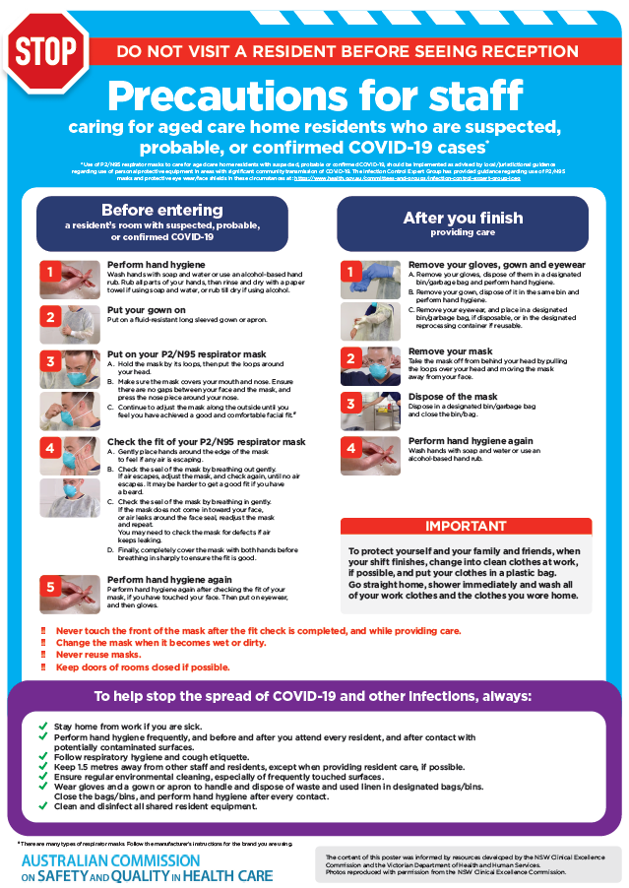](https://www.safetyandquality.gov.au/publications-and-resources/resource-library/covid-19-aged-care-staff-infection-prevention-and-control-precautions-poster)
* ***Environmental Cleaning and Infection Prevention and Control*** [www.safetyandquality.gov.au/environmental-cleaning](http://www.safetyandquality.gov.au/environmental-cleaning)
* ***Infection prevention and control Covid-19 PPE*** poster <https://www.safetyandquality.gov.au/publications-and-resources/resource-library/infection-prevention-and-control-covid-19-personal-protective-equipment>
* ***Special precautions for Covid-19 designated zones*** poster <https://www.safetyandquality.gov.au/publications-and-resources/resource-library/special-precautions-covid-19-designated-zones>
* ***COVID-19 infection prevention and control risk management – Guidance*** <https://www.safetyandquality.gov.au/publications-and-resources/resource-library/covid-19-infection-prevention-and-control-risk-management-guidance>
* ***Safe care for people with cognitive impairment during COVID-19***<https://www.safetyandquality.gov.au/our-work/cognitive-impairment/cognitive-impairment-and-covid-19>
* **Medicines Management COVID-19** <https://www.safetyandquality.gov.au/our-work/medication-safety/medicines-management-covid-19>, including position statements on medicine-related issues
  + ***Managing fever associated with COVID-19***
  + ***Managing a sore throat associated with COVID-19***
  + ***ACE inhibitors and ARBs in COVID-19***
  + ***Clozapine in COVID-19***
  + ***Management of patients on oral anticoagulants during COVID-19***
  + ***Ascorbic Acid: Intravenous high dose in COVID-19***
  + ***Treatment in acute care, including oxygen therapy and medicines to support intubation***
  + ***Nebulisation and COVID-19***
  + ***Managing intranasal administration of medicines during COVID-19***
  + ***Ongoing medicines management in high-risk patients***
  + ***Medicines shortages***
* ***Potential medicines to treat COVID-19***   
  <https://www.safetyandquality.gov.au/publications-and-resources/resource-library/potential-medicines-treat-covid-19>
* ***Break the chain of infection: Stopping COVID-19*** poster<https://www.safetyandquality.gov.au/publications-and-resources/resource-library/break-chain-poster-a3>  
  **[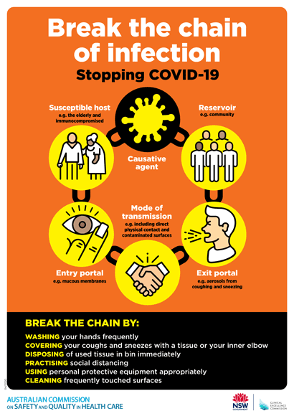](https://www.safetyandquality.gov.au/publications-and-resources/resource-library/break-chain-poster-a3https:/www.safetyandquality.gov.au/publications-and-resources/resource-library/break-chain-poster-a3)**
* ***COVID-19: Elective surgery and infection prevention and control precautions*** <https://www.safetyandquality.gov.au/publications-and-resources/resource-library/covid-19-elective-surgery-and-infection-prevention-and-control-precautions>
* ***FAQs for clinicians on elective surgery*** <https://www.safetyandquality.gov.au/node/5724>
* ***FAQs for consumers on elective surgery*** <https://www.safetyandquality.gov.au/node/5725>
* ***FAQs on community use of face masks***   
  <https://www.safetyandquality.gov.au/faqs-community-use-face-masks>
* ***COVID-19 and face masks – Information for consumers*** <https://www.safetyandquality.gov.au/publications-and-resources/resource-library/covid-19-and-face-masks-information-consumers>

[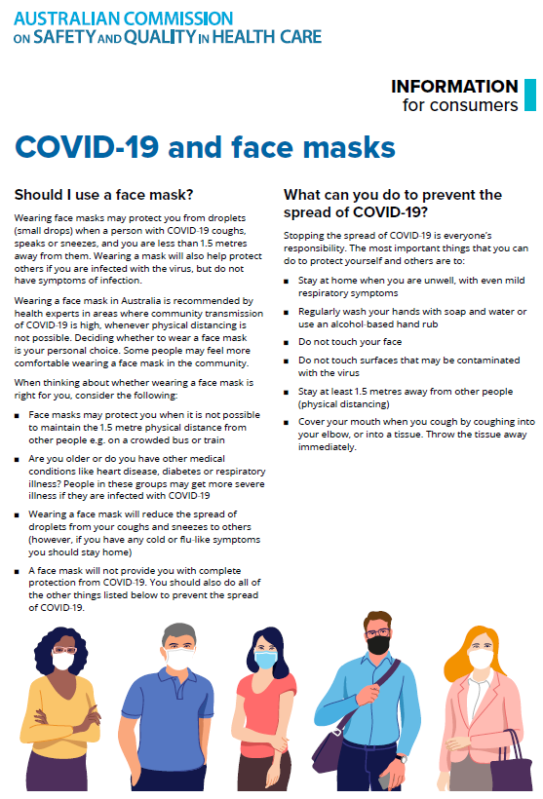](https://www.safetyandquality.gov.au/sites/default/files/2020-07/covid-19_and_face_masks_-_information_for_consumers.pdf)

**Reports**

*Measuring value in new health technology assessments: A focus on robotic surgery in public hospitals*

Deeble Institute Issues Brief No. 37

Flynn A, Verhoeven A

Canberra: Australian Healthcare and Hospitals Association; 2020. p. 26.

|  |  |
| --- | --- |
| URL | <https://ahha.asn.au/publication/health-policy-issue-briefs/deeble-issues-brief-no-37-measuring-value-new-health> |
| Notes | This Issues Brief from the Australian Healthcare and Hospitals Association’s Deeble Institute examines the processes for assessing the merits of implementing new health technology in public hospitals and how they differ across states, territories and public and private health systems. The Brief focuses on the robotic surgery program at Metro North Hospital and Health Service in Queensland. The authors suggest that   * There needs to be a clear and consistent approach to ensure that evidence to support the value of new technologies can be demonstrated in terms of both costs and patient outcomes. * Patient outcomes and experiences need to be measured and included in datasets through standardised systems or collections. * Data and evaluation need to be more coordinated with an open approach to collection and sharing. * Funding models need to enable providers to focus on outcomes that matter to patients as well as cost efficiencies * Strategies need to be undertaken to ensure that clinicians are more engaged with overall hospital objectives to identify innovative new technologies and enable access through the public hospital system. * To demonstrate value, health technology assessments must also include consideration of equity. Are the right patients receiving the right treatment? Value is only achieved across the whole health systems if everyone that needs it can access it. |

**Journal articles**

*Improving the Quality of U.S. Health Care — What Will It Take?*

McGlynn EA

New England Journal of Medicine. 2020;383(9):801-803.

|  |  |
| --- | --- |
| DOI | <https://doi.org/10.1056/NEJMp2022644> |
| Notes | The author of this piece was the lead author on a key article published in the *New England Journal of Medicine* in 2003 – *The Quality of Health Care Delivered to Adults in the United States* (<https://doi.org/10.1056/NEJMsa022615>)– in which was demonstrated that ‘on average, U.S. adults received about 55% of recommended care for the leading causes of death and disease’. In this piece she reflects on the lack of progress on improving quality of care and goes on to suggest that ‘Given the limited progress to date, the path to higher-quality care in the United States requires reconsidering approaches to measurement, financing, and organizational structures and a new emphasis on social needs. We need to **redesign for success, spread what works, and stop doing what does not work**.’ |

*Building A Better Health Care System Post-Covid-19: Steps for Reducing Low-Value and Wasteful Care*

Sorenson C, Japinga M, Crook H, McClellan M

NEJM Catalyst. 2020.

|  |  |
| --- | --- |
| URL | <https://catalyst.nejm.org/doi/full/10.1056/CAT.20.0368> |
| Notes | The adage about never wasting a crisis means we are already seeing suggestions about how to improve many aspects of society and life in the wake of the COVID-19 pandemic. While these may come up against inertia and a desire to “snap back”, many of these calls for positive change are well-intentioned and could contribute to sought after gains. This commentary piece in *NEJM Catalyst* considers that the current pandemic ‘offers an unprecedented opportunity to reduce low-value care significantly with concurrent efforts from providers and health systems, payers, policymakers, employers, and patients.’ With the pandemic necessarily disrupting much of health care delivery, including postponements and shifts to virtual, contactless and other mechanisms, the authors consider this ‘**an unprecedented opportunity to re-evaluate the necessity of services our health system provides, embracing and enhancing the ones that provide the most value and finally reducing or eliminating those that provide little or no benefit.**’ They argue that this need to be immediately as ‘force of habit and financial stresses may otherwise counteract some positive recent changes and move the health care system back toward business as usual.’ |

*Journal of Patient Safety*

Volume 16 Issue 3 Supplement September 2020

|  |  |
| --- | --- |
| URL | <https://journals.lww.com/journalpatientsafety/toc/2020/09001> |
| Notes | A new issue of the *Journal of Patient Safety* has been published. A special supplement to the September issue of the *Journal of Patient Safety* includes evidence reviews of eight of the 47 patient safety practices featured in the US Agency for Healthcare Research and Quality’s *Making Healthcare Safer III* report (available at <https://www.ahrq.gov/research/findings/making-healthcare-safer/mhs3/index.html>) Articles in this issue of the *Journal of Patient Safety* include:   * **Advancing Patient Safety**: Reviews From the Agency for Healthcare Research and Quality’s Making Healthcare Safer III Report (Shoemaker-Hunt, Sarah; Hall, Kendall; Hoffman, Lynn) * The Use of Patient Monitoring Systems to Improve **Sepsis Recognition** and Outcomes: A Systematic Review (Gale, Bryan M.; Hall, Kendall K.) * The Use of **Rapid Response Teams to Reduce Failure to Rescue Events**: A Systematic Review (Hall, Kendall K.; Lim, Andrea; Gale, Bryan) * Environmental Cleaning and Decontamination to Prevent ***Clostridioides difficile* Infection in Health Care Settings**: A Systematic Review (Schoyer, Elizabeth; Hall, Kendall) * **Chlorhexidine Bathing Strategies for Multidrug-Resistant Organisms**: A Summary of Recent Evidence (Gall, Elizabeth; Long, Anna; Hall, Kendall K.) * Using Deprescribing Practices and the Screening Tool of Older Persons’ Potentially Inappropriate Prescriptions Criteria to **Reduce Harm and Preventable Adverse Drug Events in Older Adults** (Earl, Tara R.; Katapodis, Nicole D.; Schneiderman, Stephanie R.; Shoemaker-Hunt, Sarah) * The Effect of **Opioid Stewardship** Interventions on Key Outcomes: A Systematic Review (Shoemaker-Hunt, Sarah J.; Wyant, Brandy E.) * System-Level Patient Safety Practices That Aim to Reduce **Medication Errors Associated With Infusion Pumps**: An Evidence Review (Bacon, Olivia; Hoffman, Lynn) * Improving **Team Performance and Patient Safety** on the Job Through Team Training and Performance Support Tools: A Systematic Review (Costar, Dana Milanovich; Hall, Kendall K.) |

*BMJ Quality & Safety* online first articles

|  |  |
| --- | --- |
| URL | <https://qualitysafety.bmj.com/content/early/recent> |
| Notes | *BMJ Quality &Safety* has published a number of ‘online first’ articles, including:   * Priorities to improve the **care for chronic conditions and multimorbidity**: a survey of patients and stakeholders nested within the ComPaRe e-cohort (Viet-Thi Tran, Elise Diard, Philippe Ravaud) |

*International Journal for Quality in Health Care* online first articles

|  |  |
| --- | --- |
| URL | <https://academic.oup.com/intqhc/advance-articles> |
| Notes | *International Journal for Quality in Health Care* has published a number of ‘online first’ articles, including:   * **mHealth-based person-centredness**: a key tool for the development of participatory health (Luis Fernandez-Luque) * **Human Factors/Ergonomics Work System Analysis of Patient Work**: State of the Science and Future Directions (Nicole E Werner, Siddarth Ponnala, Nadia Doutcheva, Richard J Holden) * **Tradeoff between Efficiency and Perceived Quality**: Evidence from Patient-Level Data (Saima Bashir, Muhammad Nasir) |

**Online resources**

*National COVID-19 Clinical Evidence Taskforce*

<https://covid19evidence.net.au/>

The National COVID-19 Clinical Evidence Taskforce is a collaboration of peak health professional bodies across Australia whose members are providing clinical care to people with COVID-19. The taskforce is undertaking continuous evidence surveillance to identify and rapidly synthesise emerging research in order to provide national, **evidence-based guidelines and clinical flowcharts for the clinical care of people with COVID-19**. The guidelines address questions that are specific to managing COVID-19 and cover the full disease course across mild, moderate, severe and critical illness. These are ‘living’ guidelines, updated with new research in near real-time in order to give reliable, up-to-the minute advice to clinicians providing frontline care in this unprecedented global health crisis.

*COVID-19 Critical Intelligence Unit*

<https://www.aci.health.nsw.gov.au/covid-19/critical-intelligence-unit>

The Agency for Clinical Innovation (ACI) in New South Wales has developed this page summarising rapid, evidence-based advice during the COVID-19 pandemic. Its operations focus on systems intelligence, clinical intelligence and evidence integration. The content includes a daily evidence digest and evidence checks on a discrete topic or question relating to the current COVID-19 pandemic. Recent evidence checks date include:

* ***Medium- and long-term health sequelae of COVID-19.***

*[UK] NICE Guidelines and Quality Standards*

<https://www.nice.org.uk/guidance>

The UK’s National Institute for Health and Care Excellence (NICE) has published new (or updated) guidelines and quality standards. The latest reviews or updates are:

* *NICE Guideline NG172* ***COVID-19 rapid guideline****:* ***gastrointestinal and liver conditions*** *treated with drugs affecting the immune response* <https://www.nice.org.uk/guidance/ng172>
* *Clinical Guideline CG134* ***Anaphylaxis****: assessment and referral after emergency treatment* <https://www.nice.org.uk/guidance/cg134>

*[USA] Effective Health Care Program reports*

<https://effectivehealthcare.ahrq.gov/>

The US Agency for Healthcare Research and Quality (AHRQ) has an Effective Health Care (EHC) Program. The EHC has released the following final reports and updates:

* *Strategies for Patient, Family, and Caregiver Engagement* <https://effectivehealthcare.ahrq.gov/products/family-engagement/research>

**Disclaimer**

On the Radar is an information resource of the Australian Commission on Safety and Quality in Health Care. The Commission is not responsible for the content of, nor does it endorse, any articles or sites listed. The Commission accepts no liability for the information or advice provided by these external links. Links are provided on the basis that users make their own decisions about the accuracy, currency and reliability of the information contained therein. Any opinions expressed are not necessarily those of the Australian Commission on Safety and Quality in Health Care.