# Australian COmmission on Safety and Quality in Health Care logo with Radar imageOn the Radar

Issue 480

7 September 2020

*On the Radar* is a summary of some of the recent publications in the areas of safety and quality in health care. Inclusion in this document is not an endorsement or recommendation of any publication or provider. Access to particular documents may depend on whether they are Open Access or not, and/or your individual or institutional access to subscription sites/services. Material that may require subscription is included as it is considered relevant.

*On the Radar* is available online, via email or as a PDF or Word document from <https://www.safetyandquality.gov.au/publications-and-resources/newsletters/radar>

If you would like to receive *On the Radar* via email, you can subscribe on our website <https://www.safetyandquality.gov.au/publications-and-resources/newsletters>   
or by emailing us at H[Umail@safetyandquality.gov.auU](mailto:mail@safetyandquality.gov.au).   
You can also send feedback and comments to H[Umail@safetyandquality.gov.auU](mailto:mail@safetyandquality.gov.au).

For information about the Commission and its programs and publications, please visit <https://www.safetyandquality.gov.au>

You can also follow us on Twitter @ACSQHC.

**On the Radar**

Editor: Dr Niall Johnson [niall.johnson@safetyandquality.gov.au](mailto:niall.johnson@safetyandquality.gov.au)

Contributors: Niall Johnson

**COVID-19 resources**

https://www.safetyandquality.gov.au/covid-19

The Australian Commission on Safety and Quality in Health Care has developed a number of resources to assist healthcare organisations, facilities and clinicians. These and other material on COVID-19 are available at <https://www.safetyandquality.gov.au/covid-19>

The latest additions include:

* ***COVID-19: Aged care staff infection prevention and control precautions*** *poster*<https://www.safetyandquality.gov.au/publications-and-resources/resource-library/covid-19-aged-care-staff-infection-prevention-and-control-precautions-poster>  
    
  [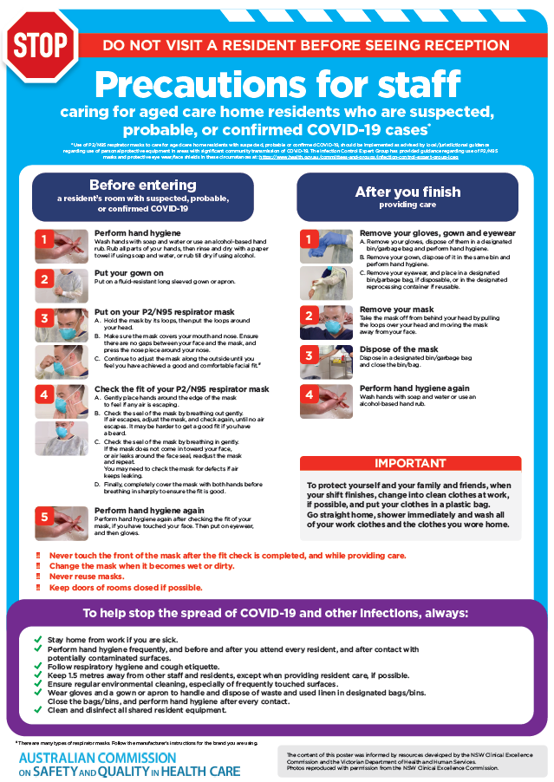](https://www.safetyandquality.gov.au/publications-and-resources/resource-library/covid-19-aged-care-staff-infection-prevention-and-control-precautions-poster)
* ***Environmental Cleaning and Infection Prevention and Control*** [www.safetyandquality.gov.au/environmental-cleaning](http://www.safetyandquality.gov.au/environmental-cleaning)
* ***Infection prevention and control Covid-19 PPE*** poster <https://www.safetyandquality.gov.au/publications-and-resources/resource-library/infection-prevention-and-control-covid-19-personal-protective-equipment>
* ***Special precautions for Covid-19 designated zones*** poster <https://www.safetyandquality.gov.au/publications-and-resources/resource-library/special-precautions-covid-19-designated-zones>
* ***COVID-19 infection prevention and control risk management – Guidance*** <https://www.safetyandquality.gov.au/publications-and-resources/resource-library/covid-19-infection-prevention-and-control-risk-management-guidance>
* ***Safe care for people with cognitive impairment during COVID-19***<https://www.safetyandquality.gov.au/our-work/cognitive-impairment/cognitive-impairment-and-covid-19>
* **Medicines Management COVID-19** <https://www.safetyandquality.gov.au/our-work/medication-safety/medicines-management-covid-19>, including position statements on medicine-related issues
  + ***Managing fever associated with COVID-19***
  + ***Managing a sore throat associated with COVID-19***
  + ***ACE inhibitors and ARBs in COVID-19***
  + ***Clozapine in COVID-19***
  + ***Management of patients on oral anticoagulants during COVID-19***
  + ***Ascorbic Acid: Intravenous high dose in COVID-19***
  + ***Treatment in acute care, including oxygen therapy and medicines to support intubation***
  + ***Nebulisation and COVID-19***
  + ***Managing intranasal administration of medicines during COVID-19***
  + ***Ongoing medicines management in high-risk patients***
  + ***Medicines shortages***
* ***Potential medicines to treat COVID-19***   
  <https://www.safetyandquality.gov.au/publications-and-resources/resource-library/potential-medicines-treat-covid-19>
* ***Break the chain of infection: Stopping COVID-19*** poster<https://www.safetyandquality.gov.au/publications-and-resources/resource-library/break-chain-poster-a3>  
  **[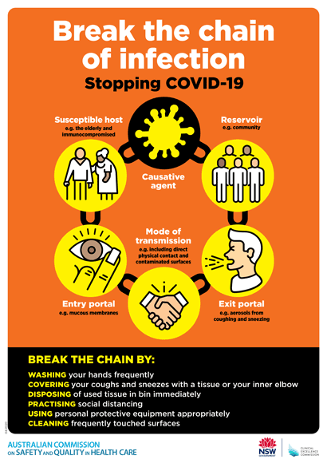](https://www.safetyandquality.gov.au/publications-and-resources/resource-library/break-chain-poster-a3https:/www.safetyandquality.gov.au/publications-and-resources/resource-library/break-chain-poster-a3)**
* ***COVID-19: Elective surgery and infection prevention and control precautions*** <https://www.safetyandquality.gov.au/publications-and-resources/resource-library/covid-19-elective-surgery-and-infection-prevention-and-control-precautions>
* ***FAQs for clinicians on elective surgery*** <https://www.safetyandquality.gov.au/node/5724>
* ***FAQs for consumers on elective surgery*** <https://www.safetyandquality.gov.au/node/5725>
* ***FAQs on community use of face masks***   
  <https://www.safetyandquality.gov.au/faqs-community-use-face-masks>
* ***COVID-19 and face masks – Information for consumers*** <https://www.safetyandquality.gov.au/publications-and-resources/resource-library/covid-19-and-face-masks-information-consumers>

[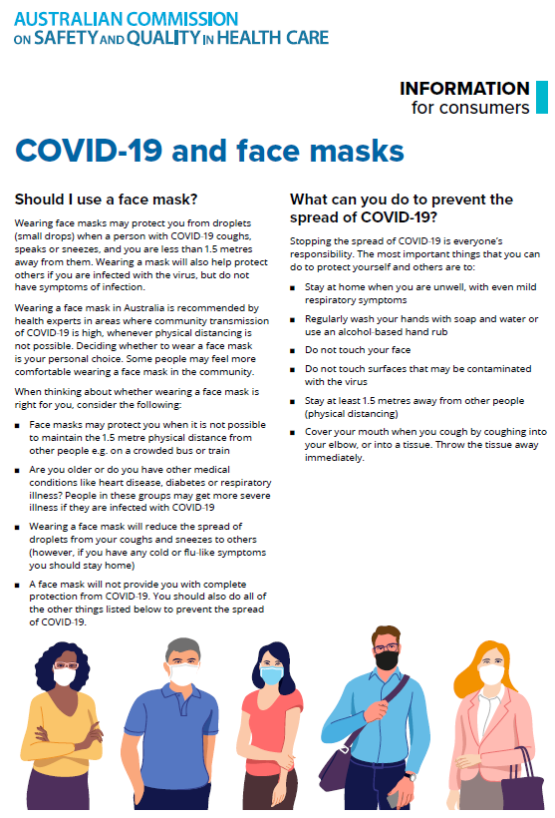](https://www.safetyandquality.gov.au/sites/default/files/2020-07/covid-19_and_face_masks_-_information_for_consumers.pdf)

**Reports**

*Australian healthcare after COVID-19: An opportunity to think differently*

Australian Healthcare and Hospitals Association

Canberra: AHHA; 2020. p. 14.

|  |  |
| --- | --- |
| URL | <https://ahha.asn.au/healthcare-after-covid-19> |
| Notes | In the last issue of *On the Radar* I had included a couple of pieces that saw the COVID-19 pandemic as an opportunity to recast our health systems. This piece, from the Australian Healthcare and Hospitals Association, makes a similar case in the Australian context. This paper paints a vision of integrated and responsive, patient-centred and outcomes-focused health care systems.  The paper also identifies 10 steps that should be taken now:   1. The direct and indirect effects of the pandemic and natural disasters on health service delivery and health outcomes are evaluated, and lessons learned inform a reimagined health system 2. Ensure greater transparency in decision making, fostering community trust and collaborative relationships amongst stakeholders 3. Empower consumers to take an engaged and active role in their health, through health literacy programs and expanded opportunities to co-design health services 4. Low and no-value health care is reduced through the prioritisation of evidence-based care and addressing inappropriate variations in care 5. Team-based care with health professionals working to the top of their scope of licence, and a greater focus on permanent employment and upskilling 6. Funding models include incentives for value and improving health outcomes 7. Patient-reported outcome data that measures what matters to patients is developed, and informs outcome-based payments and service design 8. Telehealth MBS items are continued and refined to ensure they reflect the cost of providing care, support affordable care for patients, and represent value for money for government funders 9. Cross-sector partnerships between health, aged care, disability and community services are informed by linked data, and funded to collaborate to improve health outcomes for all 10. Medical manufacturing models are responsive, cost effective, environmentally sustainable, create local jobs and advance the Australian economy.   [Australian Healthcare and Hospitals Association's vision of a Resilient Health System](https://ahha.asn.au/healthcare-after-covid-19) |

*Evaluating literature review methodologies for policymakers*

Deeble Institute Perspectives Brief No. 12

Naylor J, Jackson C, Donald M

Canberra: Australian Healthcare and Hospitals Association; 2020. p. 14.

|  |  |
| --- | --- |
| URL | <https://ahha.asn.au/deeble-institute-perspective-briefs>  <https://ahha.asn.au/sites/default/files/docs/policy-issue/perspectives_brief_no._12_evaluating_literature_review_methodologies_0.pdf> |
| Notes | This Perspectives Brief from the Australian Healthcare and Hospitals Association’s Deeble Institute examines the various form of literature review that policymakers use, commission or undertake. Various forms of review are now quite commonly found in the literature, including ‘systematic review’, ‘narrative review’, ‘scoping review’, ‘rapid review’, and ‘realist review’. The authors of this Perspectives Brief sought ‘to pragmatically ‘review’ the reviews – providing an outline of their purpose, process, strengths and limitations, and highlighting the appropriate search environment for each. It presents decision-makers with a pragmatic guide to inform resource allocation and evidence base in health care and health system research, practice and policy development.’ |

**Journal articles**

*Coproduction: when users define quality*

Elwyn G, Nelson E, Hager A, Price A

BMJ Quality & Safety. 2020;29(9):711-716.

|  |  |
| --- | --- |
| DOI | <http://dx.doi.org/10.1136/bmjqs-2019-009830> |
| Notes | Moving beyond shared decision making and patient-centred care is the coproduction of health care. Placing the patient at the centre has been a theme for some time and has seen the greater engagement of patients (and their families and carers) in various ways. This has included shared decision making, engagement in research, patient reported experience and/or outcome measures, through to participation in health service design. This piece expands the perspective and role of patients to include roles in assessing, designing, designing and delivery of care. The authors also relate coproduction to the concepts of value-based care and learning health systems.  [Coproduction cycle figure from paper: Coproduction: when users define quality](http://dx.doi.org/10.1136/bmjqs-2019-009830) |

For information on the Commission’s work on partnering with consumers, see <https://www.safetyandquality.gov.au/our-work/partnering-consumers>

For information on the Commission’s work on person-centred care, see <https://www.safetyandquality.gov.au/our-work/partnering-consumers/person-centred-care>

For information on the Commission’s work on shared decision making, see <https://www.safetyandquality.gov.au/our-work/partnering-consumers/shared-decision-making>

*A clinical pharmacist-led integrated approach for evaluation of medication errors among medical intensive care unit patients*

Aghili M, Neelathahalli Kasturirangan M

JBI Evidence Implementation. 2020 [epub].

|  |  |
| --- | --- |
| DOI | <https://doi.org/10.1097/XEB.0000000000000228> |
| Notes | In recent years there have been a number of studies that have shown that engaging a pharmacist in various contexts can prevent or ameliorate medication errors. This paper adds to that literature by showing that have a pharmacist engaging with the ICU helped critically ill patients avoid medication errors. In this approach the clinical pharmacist ‘performed a combination of medication error detection methods, which included medication chart review, patient monitoring until discharge/death, and attending medical rounds’. The authors found that the approach ‘revealed that medication errors commonly occurred among critically ill patients, and the clinical pharmacist's interventions intercepted the majority of these medication errors. The number of preventable ADEs was significantly fewer in a group of patients who received these interventions. However, medication errors formed chains of errors that adversely affected patients’ investigated outcomes in the study group with no implementation of the clinical pharmacist interventions.’ |

For information on the Commission’s work on medication safety, see <https://www.safetyandquality.gov.au/our-work/medication-safety>

*What has been the impact of Covid-19 on safety culture? A case study from a large metropolitan teaching hospital*

Denning M, Goh ET, Scott A, Martin G, Markar S, Flott K, et al

medRxiv. 2020 [epub].

|  |  |
| --- | --- |
| DOI | <https://doi.org/10.1101/2020.06.15.20129080> |
| Notes | A saying attributed to the Prussian Helmuth von Moltke is that ‘no plan survives contact with the enemy’ could perhaps be applied to health systems in the face of a pandemic. Proponents of the importance of culture in the workplace may suggest that the culture may then help drive responses to a crisis. This paper looks at how the patient safety culture in a large UK teaching hospital was evident as the COVID-19 pandemic erupted. By comparing responses to the Safety Attitudes Questionnaire (SAQ) during the pandemic with responses in 2017 the authors sought to examine the impact of COVID-19 on safety culture. The authors found differences SAQ scores ‘during Covid-19 between professional groups and compared to baseline’. Provision of training and support for redeployment in the pandemic were associated with higher SAQ scores. Reductions in incident reporting were seen in the pandemic. The authors suggest that ‘changes may reflect perception of risk, changes in volume or nature of work’. |

*Working together in Aboriginal health: a framework to guide health professional practice*

Wilson AM, Kelly J, Jones M, O’Donnell K, Wilson S, Tonkin E, et al

BMC Health Services Research. 2020;20(1):601.

|  |  |
| --- | --- |
| DOI | <https://doi.org/10.1186/s12913-020-05462-5> |
| Notes | Using interviews with 44 allied health professionals and Aboriginal health workers, along with the lived experience of working with Aboriginal communities the authors of this piece have developed a framework to guide health professional practice in Aboriginal and Torres Strait Islander health. The paper ‘describes *how* Aboriginal Health Workers and allied health professionals implemented key strategies in their practice’. The authors hope that ‘Health professionals will benefit from embracing these strategies when working in Aboriginal health to maximise working respectfully with Aboriginal people. It highlights that through commitment to the strategies identified in this paper Aboriginal and non-Aboriginal people can practice *respectfully* in Aboriginal health.’  [Framework of Strategies to guide practice in Aboriginal health](https://doi.org/10.1186/s12913-020-05462-5) |

*BMJ Quality & Safety* online first articles

|  |  |
| --- | --- |
| URL | <https://qualitysafety.bmj.com/content/early/recent> |
| Notes | *BMJ Quality &Safety* has published a number of ‘online first’ articles, including:   * The cost of improving care: a multisite economic analysis of hospital resource use for implementing **recommended postpartum contraception programmes** (Vivian B Ling, Erika E Levi, Amy R Harrington, Nikki B Zite, Saul D Rivas, Vanessa K Dalton, Roger Smith, Michelle H Moniz) |

*International Journal for Quality in Health Care* online first articles

|  |  |
| --- | --- |
| URL | <https://academic.oup.com/intqhc/advance-articles> |
| Notes | *International Journal for Quality in Health Care* has published a number of ‘online first’ articles, including:   * Case study: International **Healthcare Service Quality** - Building a Model for **Cultivating Cultural Sensitivity** (Ya-Ting Yang, Yi-Hsin Elsa Hsu, Kung-Pei Tang, Christine Wang, Stephen Timmons, Wen-Ta Chiu, Saileela Annavajjula, Jan-Show Chu) * Expanding frontiers of risk management: **care safety in nursing home during COVID-19 pandemic** (Matteo Scopetti, Alessandro Santurro, Riccardo Tartaglia, Paola Frati, Vittorio Fineschi) * The Effects of **Acupressure on Post-Cesarean Pain** and Analgesic Consumption: A Randomized Single-Blinded Placebo-Controlled Study (Mehtap Akgün, İlkay Boz) |

**Online resources**

*National COVID-19 Clinical Evidence Taskforce*

<https://covid19evidence.net.au/>

The National COVID-19 Clinical Evidence Taskforce is a collaboration of peak health professional bodies across Australia whose members are providing clinical care to people with COVID-19. The taskforce is undertaking continuous evidence surveillance to identify and rapidly synthesise emerging research in order to provide national, **evidence-based guidelines and clinical flowcharts for the clinical care of people with COVID-19**. The guidelines address questions that are specific to managing COVID-19 and cover the full disease course across mild, moderate, severe and critical illness. These are ‘living’ guidelines, updated with new research in near real-time in order to give reliable, up-to-the minute advice to clinicians providing frontline care in this unprecedented global health crisis.

*COVID-19 Critical Intelligence Unit*

<https://www.aci.health.nsw.gov.au/covid-19/critical-intelligence-unit>

The Agency for Clinical Innovation (ACI) in New South Wales has developed this page summarising rapid, evidence-based advice during the COVID-19 pandemic. Its operations focus on systems intelligence, clinical intelligence and evidence integration. The content includes a daily evidence digest and evidence checks on a discrete topic or question relating to the current COVID-19 pandemic. Recent evidence checks date include:

* ***Resuming elective surgery – Volume-outcome relationships in surgery.***

*[UK] NICE Guidelines and Quality Standards*

<https://www.nice.org.uk/guidance>

The UK’s National Institute for Health and Care Excellence (NICE) has published new (or updated) guidelines and quality standards. The latest reviews or updates are:

* *Quality Standard QS196* ***Community pharmacies****: promoting health and wellbeing* <https://www.nice.org.uk/guidance/qs196>
* *Quality Standard QS197* ***Faltering growth*** <https://www.nice.org.uk/guidance/qs197>
* *NICE Guideline NG159* ***COVID-19 rapid guideline****:* ***critical care*** *in adults* <https://www.nice.org.uk/guidance/ng159>

*[UK] NIHR Evidence alert*

<https://evidence.nihr.ac.uk/>

The UK’s National Institute for Health Research (NIHR) has posted new evidence alerts on its site. Evidence alerts are short, accessible summaries of health and care research which is funded or supported by NIHR. This is research which could influence practice and each Alert has a message for people commissioning, providing or receiving care. The latest alerts include:

* The weekly break from dialysis is harmful to patients with **kidney failure**
* **Early warning scores used in hospitals** must be based on sound science
* High rates of **delirium, persistent fatigue and post-traumatic stress disorder** were common after severe infection in previous **coronavirus** outbreaks
* Fluoxetine does not improve outcomes after **stroke**
* **Cycling** to work lowers risk of illness and death compared to driving
* New tool for assessing the severity of **type 2 diabetes** could help personalise treatment and improve outcomes
* **Lung health checks** in supermarket car parks reach older smokers in deprived communities
* Bespoke shoes and insoles could prevent **foot ulcers** in people with **diabetes**
* Damage to kidneys and eyes may start before people are diagnosed with **diabetes**.

**Disclaimer**

On the Radar is an information resource of the Australian Commission on Safety and Quality in Health Care. The Commission is not responsible for the content of, nor does it endorse, any articles or sites listed. The Commission accepts no liability for the information or advice provided by these external links. Links are provided on the basis that users make their own decisions about the accuracy, currency and reliability of the information contained therein. Any opinions expressed are not necessarily those of the Australian Commission on Safety and Quality in Health Care.