# Australian COmmission on Safety and Quality in Health Care logo with Radar imageOn the Radar

Issue 481

14 September 2020

*On the Radar* is a summary of some of the recent publications in the areas of safety and quality in health care. Inclusion in this document is not an endorsement or recommendation of any publication or provider. Access to particular documents may depend on whether they are Open Access or not, and/or your individual or institutional access to subscription sites/services. Material that may require subscription is included as it is considered relevant.

*On the Radar* is available online, via email or as a PDF or Word document from <https://www.safetyandquality.gov.au/publications-and-resources/newsletters/radar>

If you would like to receive *On the Radar* via email, you can subscribe on our website <https://www.safetyandquality.gov.au/publications-and-resources/newsletters>   
or by emailing us at H[Umail@safetyandquality.gov.auU](mailto:mail@safetyandquality.gov.au).   
You can also send feedback and comments to H[Umail@safetyandquality.gov.auU](mailto:mail@safetyandquality.gov.au).

For information about the Commission and its programs and publications, please visit <https://www.safetyandquality.gov.au>

You can also follow us on Twitter @ACSQHC.

**On the Radar**

Editor: Dr Niall Johnson [niall.johnson@safetyandquality.gov.au](mailto:niall.johnson@safetyandquality.gov.au)

Contributors: Niall Johnson

**COVID-19 resources**

https://www.safetyandquality.gov.au/covid-19

The Australian Commission on Safety and Quality in Health Care has developed a number of resources to assist healthcare organisations, facilities and clinicians. These and other material on COVID-19 are available at <https://www.safetyandquality.gov.au/covid-19>

The latest additions include:

* ***COVID-19: Aged care staff infection prevention and control precautions*** *poster*<https://www.safetyandquality.gov.au/publications-and-resources/resource-library/covid-19-aged-care-staff-infection-prevention-and-control-precautions-poster>  
    
  [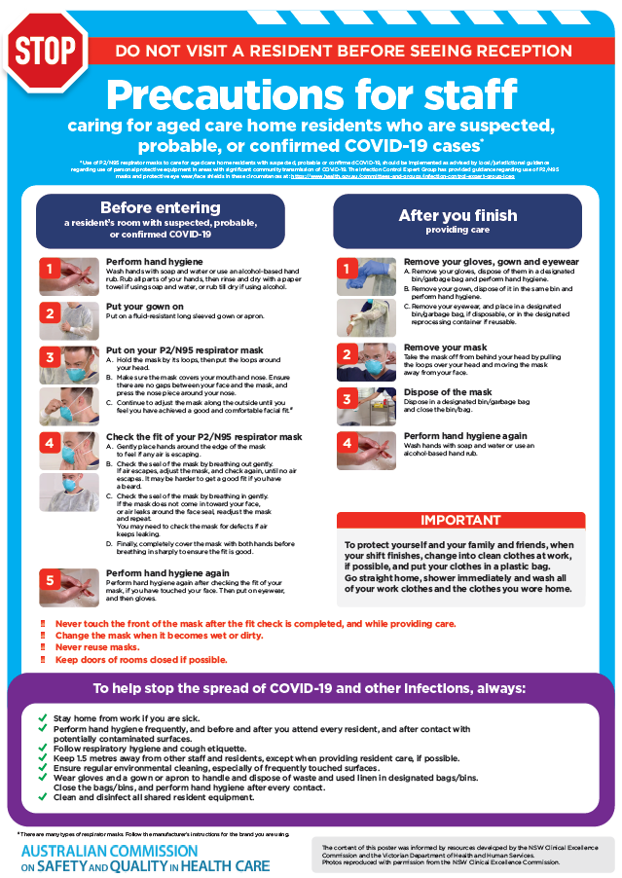](https://www.safetyandquality.gov.au/publications-and-resources/resource-library/covid-19-aged-care-staff-infection-prevention-and-control-precautions-poster)
* ***Environmental Cleaning and Infection Prevention and Control*** [www.safetyandquality.gov.au/environmental-cleaning](http://www.safetyandquality.gov.au/environmental-cleaning)
* ***Infection prevention and control Covid-19 PPE*** poster <https://www.safetyandquality.gov.au/publications-and-resources/resource-library/infection-prevention-and-control-covid-19-personal-protective-equipment>
* ***Special precautions for Covid-19 designated zones*** poster <https://www.safetyandquality.gov.au/publications-and-resources/resource-library/special-precautions-covid-19-designated-zones>
* ***COVID-19 infection prevention and control risk management – Guidance*** <https://www.safetyandquality.gov.au/publications-and-resources/resource-library/covid-19-infection-prevention-and-control-risk-management-guidance>
* ***Safe care for people with cognitive impairment during COVID-19***<https://www.safetyandquality.gov.au/our-work/cognitive-impairment/cognitive-impairment-and-covid-19>
* **Medicines Management COVID-19** <https://www.safetyandquality.gov.au/our-work/medication-safety/medicines-management-covid-19>, including position statements on medicine-related issues
  + ***Managing fever associated with COVID-19***
  + ***Managing a sore throat associated with COVID-19***
  + ***ACE inhibitors and ARBs in COVID-19***
  + ***Clozapine in COVID-19***
  + ***Management of patients on oral anticoagulants during COVID-19***
  + ***Ascorbic Acid: Intravenous high dose in COVID-19***
  + ***Treatment in acute care, including oxygen therapy and medicines to support intubation***
  + ***Nebulisation and COVID-19***
  + ***Managing intranasal administration of medicines during COVID-19***
  + ***Ongoing medicines management in high-risk patients***
  + ***Medicines shortages***
  + ***Conserving medicines***
  + ***Intravenous medicines administration in the event of an infusion pump shortage***
* ***Potential medicines to treat COVID-19***   
  <https://www.safetyandquality.gov.au/publications-and-resources/resource-library/potential-medicines-treat-covid-19>
* ***Break the chain of infection: Stopping COVID-19*** poster<https://www.safetyandquality.gov.au/publications-and-resources/resource-library/break-chain-poster-a3>  
  **[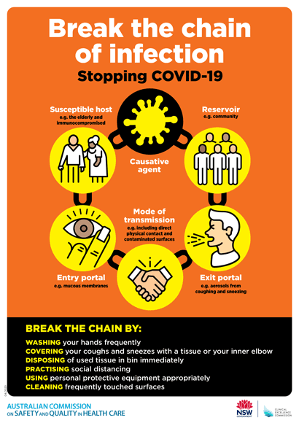](https://www.safetyandquality.gov.au/publications-and-resources/resource-library/break-chain-poster-a3https:/www.safetyandquality.gov.au/publications-and-resources/resource-library/break-chain-poster-a3)**
* ***COVID-19: Elective surgery and infection prevention and control precautions*** <https://www.safetyandquality.gov.au/publications-and-resources/resource-library/covid-19-elective-surgery-and-infection-prevention-and-control-precautions>
* ***FAQs for clinicians on elective surgery*** <https://www.safetyandquality.gov.au/node/5724>
* ***FAQs for consumers on elective surgery*** <https://www.safetyandquality.gov.au/node/5725>
* ***FAQs on community use of face masks***   
  <https://www.safetyandquality.gov.au/faqs-community-use-face-masks>
* ***COVID-19 and face masks – Information for consumers*** <https://www.safetyandquality.gov.au/publications-and-resources/resource-library/covid-19-and-face-masks-information-consumers>

[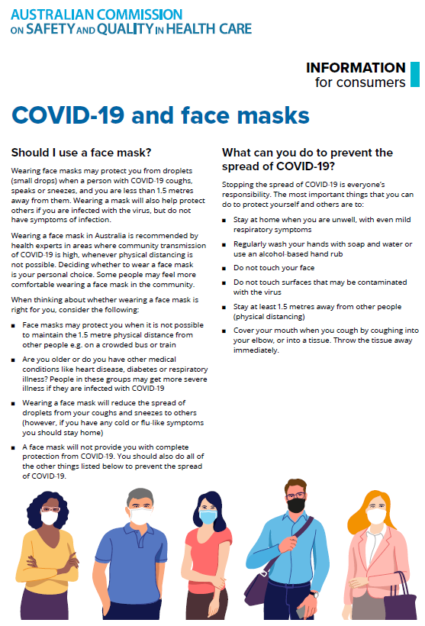](https://www.safetyandquality.gov.au/sites/default/files/2020-07/covid-19_and_face_masks_-_information_for_consumers.pdf)

*Intelligence-Based Medicine: Data Science, Artificial Intelligence, and Human Cognition in Clinical Medicine and Healthcare*

Chang AC

Amsterdam: Academic Press; 2020.

*Artificial intelligence in health care: preparing for the fifth Industrial Revolution*

Sung JJY, Stewart CL, Freedman B

Medical Journal of Australia. 2020 [epub].

*Use of artificial intelligence in skin cancer diagnosis and management*

Wada M, Ge Z, Gilmore SJ, Mar VJ

Medical Journal of Australia. 2020 [epub].

*Envisioning the future of clinical analytics: a modified Delphi process in New South Wales, Australia*

Sutherland K, Yeung W, Mak Y, Levesque J-F & the NSW Health Clinical Analytics Working Group

BMC Medical Informatics and Decision Making. 2020;20(1):210.

|  |  |
| --- | --- |
| DOI | Chang <https://doi.org/10.1016/C2020-0-00473-1>  Sung et al <https://doi.org/10.5694/mja2.50755>  Wada et al <https://doi.org/10.5694/mja2.50759>  Sutherland et al <https://doi.org/10.1186/s12911-020-01226-7> |
| Notes | The potential role and applications of technologies such as artificial intelligence (AI) in health care have been discussed for some time now. This past year or so has seen a number of substantial publications in the area. For example, a report from the US National Academy of Medicine (<https://nam.edu/artificial-intelligence-special-publication/>), another from the UK’s NHSx (<https://www.nhsx.nhs.uk/ai-lab/explore-all-resources/understand-ai/artificial-intelligence-how-get-it-right/>) and one from Australia’s CSIRO (<https://data61.csiro.au/en/Our-Research/Our-Work/AI-Roadmap>). A number of new items have appeared recently adding to the literature in this area. These include a new book (Chang) that offers an overview of artificial intelligence concepts and methodologies that have real world applications in healthcare and medicine.  Two recent pieces in the *MJA* offer briefer perspectives on the current and future role of AI. Sung et al. seek to ‘map out the current areas where AI has begun to permeate and make predictions about the kind of changes it will make to health care.’ The piece covers applications, such as AI‐assisted image interpretation, AI‐assisted diagnosis and AI‐assisted prediction and prognostication, as well as indicating some of the issues and preconditions for wider uptake. These issues include ‘data quality and ownership, transparency in governance, trust‐building in black box medicine, and legal responsibility for mishaps’.  Dermatology, particularly the automated recognition of skin lesions, has been one domain in which AI has been applied. Wada et al provide an update on the role of AI in skin cancer diagnosis and management, observing that ‘The challenge now is how to implement artificial intelligence technology safely into clinical practice.’  Sutherland et al offer a vision that is perhaps more ambitious in that it connects a number of innovations and technologies into a coherent system. This vision is not so much about AI, but rather the coordination of information, the effective and clinically relevant analysis of that information and application of the analyses in a flexible learning health system that is patient-centred. The five-year vision for clinical analytics in New South Wales is summarised as:  In five years’ time …  *Clinicians* will use patient reported measures as a part of routine care. The measures will be used for diagnosis, prognosis and clinical decision making. Clinically validated algorithms will assess case histories, diagnoses and risk profiles; and will facilitate safe and effective clinical care. Targeted and well validated alerts will highlight risk and safety issues. Aggregated, time-series data will be collected unobtrusively through the electronic medical record (eMR) and routine clinical tasks.  Clinicians will have access to relevant and timely information that highlights any unwarranted clinical variation and supports reflective and current best practice. Information will be available at the point of care on concordance of clinicians’ care with evidence-based practice; risk adjusted patient outcomes; benchmarking and peer comparisons; time-series and patient trajectories. Advanced analytics or artificial intelligence (AI) approaches will be deployed to discern novel patterns in complex and large datasets and guide the development of algorithms. Analytics-driven clinical audit processes will draw on “virtual registries” to personalise learning.  Feedback will be informed by the evidence on clinical decision making – incorporating passive ‘automated’ predictive analytics as well as peer to peer and expert feedback. Data will be discussed within clinical teams so that clinicians can collectively assess the data and identify causes of variation and plan improvements. Clinical research will be informed by timely and efficient access to linked data, big data, “virtual registries” and analytics. Efforts will be underway to secure wider data linkage to incorporate non-health sources. Clinician training will incorporate the use of analytics and address issues such as managing risk and uncertainty.  *Patients* will be assured that their data are appropriately secure and used to support clinical care and quality improvement. They will be firmly established as key informants in healthcare – providing data about their health status, experience and outcomes. Patients who chose to, will be engaged in monitoring their health using technologies that can communicate with information systems. Patients will be enabled and supported to access their own data and to use it to manage their health. With their consent, patient self-management will be prompted by algorithm enabled alerts.  *Managers* will be confident that monitoring and measurement systems are reliably and sensitively assessing healthcare services. They will be able to test models of reconfiguration and structural changes using data analytics. Real time alerts regarding impending surges in demand in acute care areas such as emergency departments, operating theatres and critical care units will be used to manage workflows, staffing and bed management.  Service level and system managers will utilise data from clinical analytics alongside administrative and other data to guide policy development and improve performance. There will be a robust mechanism and framework to identify, prioritise and support the introduction of system wide clinical analytic initiatives. |

*The General Practice and Residential Aged Care Facility Concordance of Medication (GRACEMED) study*

Makeham M, Pont L, Verdult C, Hardie R-A, Raban MZ, Mitchell R, et al.

International Journal of Medical Informatics. 2020;143:104264.

|  |  |
| --- | --- |
| DOI | <https://doi.org/10.1016/j.ijmedinf.2020.104264> |
| Notes | The state of aged care in Australia is no secret given the harsh light the pandemic and the Royal Commission have cast upon the sector. For those of who have worked in and with the sector, the variation in the use and availability of technology in the sector is little surprise. This paper focused on the lack of interoperable IT systems between residential aged care facilities (RACFs) and general practitioners (GPs) in primary care settings and how this creates the potential for medication discrepancies and other medication errors. The study undertook a cross sectional study of medication discrepancies between RACF medication orders and GP medication lists in the Sydney North Health Network involving 31 GPs and 203 RACF residents. The authors report ‘A total of 1777 discrepancies were identified giving an overall **discrepancy rate of 72.6 discrepancies for every 100 medications**. **Omissions** were the most common discrepancy type (35.2%,) followed by **dose discrepancies** (34.4%) and additions (30.4%). 48.5% of residents had a discrepancy with the potential to result in moderate harm and 9.8% had a discrepancy with the potential for severe harm. **Number of medications prescribed** was the only factor associated with medication discrepancies.’ |

*Public Health Research & Practice*

Volume 30 Issue 3 2020

|  |  |
| --- | --- |
| URL | <https://www.phrp.com.au/issues/september-2020-volume-30-issue-3/> |
| Notes | A new issue of *Public Health Research & Practice* has been published with a focus on **tobacco control**. Articles in this issue of Public Health Research & Practice include:   * Editorial: **Making tobacco control a priority** (Anita Dessaix, Becky Freeman, Matthew J Peters) * Far from ‘mission accomplished’: **time to re-energise tobacco control in Australia** (Paul Grogan, Emily Banks) * Interview with the Hon. Dr Michael Wooldridge: **tobacco control was the best buy in health then and it’s still the best buy now** (Michael Wooldridge, Paul Grogan) * The **WHO Framework Convention on Tobacco Control – time for a civil society equivalent**? (Mike Daube) * **Tackling Indigenous smoking**: a good news story in Australian tobacco control (David P Thomas, Tom Calma) * **Tobacco dependence treatment in Australia** – an untapped opportunity for reducing the smoking burden (Sarah L White, Nikki McCaffrey, Michelle M Scollo) * What are the resourcing requirements for an **Aboriginal and Torres Strait Islander primary health care research project**? (Sara Farnbach, Graham Gee, Anne-Marie Eades, John Robert Evans, Jamie Fernando, Belinda Hammond, Matty Simms, Karrina DeMasi, Nick Glozier, Maree L Hackett, on behalf of the Getting it Right Investigators) * What makes an **effective antismoking campaign** – insights from the trenches (Sarah Jane Beasley, Adam Barker, Michael Murphy, Toby Roderick, Tom Carroll) * **Smoke-free environments**: current status and remaining challenges in Australia (Alecia Brooks, Tanya Buchanan, Wendy Oakes) * Accessing the **most lethal product on the market**: community perceptions of tobacco accessibility in NSW, Australia (Christina Watts, Anita Dessaix, Alecia Brooks, Suzan Burton, Becky Freeman) |

*Journal for Healthcare Quality*

Vol. 42, No. 5, September/October 2020

|  |  |
| --- | --- |
| URL | <https://journals.lww.com/jhqonline/toc/2020/10000> |
| Notes | A new issue of the *Journal for Healthcare Quality* has been published. Articles in this issue of the *Journal for Healthcare Quality* include:   * Patient Safety Over Power Hierarchy: A Scoping Review of **Healthcare Professionals' Speaking-up Skills Training** (Kim, Sara; Appelbaum, Nital P.; Baker, Neil; Bajwa, Nadia M.; Chu, Frances; Pal, Jay D.; Cochran, Nancy E.; Bochatay, Naike) * A Novel Use of Prehospital Telemedicine to Decrease **Door to Computed Tomography Results in Acute Strokes** (Bilotta, Mary; Sigal, Adam P.; Shah, Ankit; Martin, Anthony; Schlappy, David A.; Sorensen, Greg; Barbera, C.) * Physician Practices in **Against Medical Advice Discharges** (Tummalapalli, Sri Lekha; Chang, Brian A.; Goodlev, Eric R.) * Implementation of Systematic Community Resource Referrals at Small Primary Care Practices to Promote **Cardiovascular Disease Self-Management** (Makelarski, Jennifer A.; DePumpo, Megan; Boyd, Kelly; Brown, Tiffany; Kho, Abel; Navalkha, Chenab; Lindau, Stacy T.) * **Health Information Technology Adoption and Clinical Performance** in Federally Qualified Health Centers (Davlyatov, Ganisher; Borkowski, Nancy; Feldman, Sue; Qu, Haiyan; Burke, Darrell; Bronstein, Janet; Brickman, A.) * Improving **Timeliness of Internal Medicine Consults in the Emergency Department**: A Quality Improvement Initiative (Beckerleg, Weiwei; Hasimja-Saraqini, Delvina; Kwok, Edmund S. H.; Hamdy, Noha; Battram, Erica; Wooller, Krista R.) * Implementation of a Novel **Near Visual Acuity Chart in an Emergency Department** Setting (Wu, James F.; Visotcky, Alexis; Szabo, Aniko; Eyler, Stephen; Siegmann, Peter; Griepentrog, Gregory J.; Warren, C. C.; Han, D. P.) * **Reducing Diabetic Ketoacidosis Intensive Care Unit Admissions** Through an Electronic Health Record-Driven, Standardized Care Pathway (Edholm, Karli; Lappé, Katie; Kukhareva, Polina; Hopkins, Christy; Hatton, Nathan D.; Gebhart, Benjamin; Nyman, Heather; Signor, Emily; Davis, Mikyla; Kawamoto, Kensaku; Johnson, Stacy A.) |

*Health Affairs*

Volume 39, No. 9, September 2020

|  |  |
| --- | --- |
| URL | <https://www.healthaffairs.org/toc/hlthaff/39/9> |
| Notes | A new issue of *Health Affairs* has been published with the themes of ' Medicare Payment Incentives, Medicaid & More '. Articles in this issue of *Health Affairs* include:   * Forged By AIDS, Storied NYC Residence Boosts **Aging In Place** (R Waters) * Target Prices Influence Hospital Participation And Shared Savings In **Medicare Bundled Payment Program** (Nicholas L. Berlin, Baris Gulseren, Ushapoorna Nuliyalu, and Andrew M. Ryan) * The Beneficial Effects Of **Medicare Advantage Special Needs Plans** For Patients With End-Stage Renal Disease (Brian W. Powers, Jiali Yan, Jingsan Zhu, Kristin A. Linn, Sachin H. Jain, Jennifer Kowalski, and Amol S. Navathe) * Adjustment For Social Risk Factors Does Not Meaningfully Affect Performance On **Medicare’s MIPS Clinician Cost Measures** (Alexander T. Sandhu, Jay Bhattacharya, Joyce Lam, Sam Bounds, Binglie Luo, Daniel Moran, Aimée-Sandrine Uwilingiyimana, Derek Fenson, Nirmal Choradia, Rose Do, Laurie Feinberg, Thomas MaCurdy, and Sriniketh Nagavarapu) * Clinicians With High Socially At-Risk Caseloads Received Reduced **Merit-Based Incentive Payment System Scores** (Kenton J. Johnston, Jason M. Hockenberry, Rishi K. Wadhera, and Karen E. Joynt Maddox) * High Rates Of Partial Participation In The First Year Of The **Merit-Based Incentive Payment System** (Nate C. Apathy and Jordan Everson) * **Medicaid Work Requirements** In Arkansas: Two-Year Impacts On Coverage, Employment, And Affordability Of Care (Benjamin D. Sommers, Lucy Chen, Robert J. Blendon, E. John Orav, and Arnold M. Epstein) * **Medicaid Expansion** Improved Perinatal Insurance Continuity For Low-Income Women (Jamie R. Daw, Tyler N. A. Winkelman, Vanessa K. Dalton, Katy B. Kozhimannil, and Lindsay K. Admon) * **Marketplace Premiums** Rise Faster For Tobacco Users Because Of Subsidy Design (Karina C. Manz, Teresa M. Waters, and Cameron M. Kaplan) * Contributions Of Public Health, Pharmaceuticals, And Other Medical Care To **US Life Expectancy Changes, 1990-2015** (Jason D. Buxbaum, Michael E. Chernew, A. Mark Fendrick, and David M. Cutler) * Restrictions On **US Global Health Assistance** Reduce Key Health Services In Supported Countries (Jennifer Sherwood, Matthea Roemer, Brian Honermann, Austin Jones, Greg Millett, and Michele R. Decker) * **Regulating Opioid Supply** Through Insurance Coverage (M. Christopher Auld, Jill R. Horwitz, Benjamin Lukenchuk, and Lynn McClelland) * State-Level Discrimination Policies And **HIV Pre-Exposure Prophylaxis** Adoption Efforts In The US (Stephen Bonett, Steven Meanley, Steven Elsesser, and José Bauermeister) * Characteristics Of **Biomedical Industry Payments To Teaching Hospitals** (Timothy S. Anderson, Walid F. Gellad, and Chester B. Good) * The **COVID-19 Shadow Pandemic: Meeting Social Needs For A City In Lockdown** (Jenifer Clapp, Alessandra Calvo-Friedman, Susan Cameron, Natalie Kramer, Samantha Lily Kumar, Emily Foote, Jenna Lupi, Opeyemi Osuntuyi, and Dave A. Chokshi) * **Coping With Trauma**, Celebrating Life: Reinventing Patient And Staff Support **During The COVID-19 Pandemic** (Eric Wei, Jeremy Segall, Yvette Villanueva, Linh B. Dang, Vladimir I. Gasca, M. Pilar Gonzalez, Matilde Roman, Ivelesse Mendez-Justiniano, Andrea G. Cohen, and Hyung J. Cho) * Using **Information Technology To Improve COVID-19 Care** At New York City Health + Hospitals (R. James Salway, David Silvestri, Eric K. Wei, and Michael Bouton) * **Primary Care Practice Finances** In The United States Amid The **COVID-19 Pandemic** (Sanjay Basu, Russell S. Phillips, Robert Phillips, Lars E. Peterson, and Bruce E. Landon) * **Shelter-In-Place Orders Reduced COVID-19 Mortality And Reduced The Rate Of Growth In Hospitalizations** (Wei Lyu and George L. Wehby) * **COVID-19 And Racial/Ethnic Disparities** In Health Risk, Employment, And Household Composition (Thomas M. Selden and Terceira A. Berdahl) * Designing Pull **Funding For A** **COVID-19 Vaccine** (Christopher M. Snyder, Kendall Hoyt, Dimitrios Gouglas, Thomas Johnston, and James Robinson) * Challenges In Ensuring The **Quality Of Generic Medicines** (Kevin A. Schulman) |

*BMJ Quality & Safety* online first articles

|  |  |
| --- | --- |
| URL | <https://qualitysafety.bmj.com/content/early/recent> |
| Notes | *BMJ Quality &Safety* has published a number of ‘online first’ articles, including:   * Coming to grips with seemingly conflicting results in **programme evaluation**: the devil’s in the detail (Benjamin Daniels, Sallie-Anne Pearson, Nicholas A Buckley, Claudia Bruno, Andrea Schaffer, Helga Zoega) * **Tiered daily huddles**: the power of teamwork in managing large healthcare organisations (Tomislav Mihaljevic) |

*International Journal for Quality in Health Care* online first articles

|  |  |
| --- | --- |
| URL | <https://academic.oup.com/intqhc/advance-articles> |
| Notes | *International Journal for Quality in Health Care* has published a number of ‘online first’ articles, including:   * **Frontiers in Human Factors**: Embedding Specialists in Multi-disciplinary efforts to Improve Healthcare (Ken Catchpole, Paul Bowie, Sarah Fouquet, Joy Rivera, Sue Hignett) * Risk-adjustment models for clean and colorectal surgery **surgical site infection** for the Spanish health system (Daniel Angel-García, Ismael Martínez-Nicolás, José Andrés García Marín, Victoriano Soria-Aledo) * Factors influencing family member perspectives on **safety in the intensive care unit**: a systematic review (M A Coombs, S Statton, C V Endacott, R Endacott) * **Oral Health Promotion Apps**: an assessment of message and behaviour change potential (Peter F Day, Karen Vinall-Collier, Kara A Grey-Burrows) * Correlation between **compensated patient claims and 30-day mortality** (Katrine Damgaard Skyrud, Ida Rashida Khan Bukholm) |

**Online resources**

*National COVID-19 Clinical Evidence Taskforce*

<https://covid19evidence.net.au/>

The National COVID-19 Clinical Evidence Taskforce is a collaboration of peak health professional bodies across Australia whose members are providing clinical care to people with COVID-19. The taskforce is undertaking continuous evidence surveillance to identify and rapidly synthesise emerging research in order to provide national, **evidence-based guidelines and clinical flowcharts for the clinical care of people with COVID-19**. The guidelines address questions that are specific to managing COVID-19 and cover the full disease course across mild, moderate, severe and critical illness. These are ‘living’ guidelines, updated with new research in near real-time in order to give reliable, up-to-the minute advice to clinicians providing frontline care in this unprecedented global health crisis.

*COVID-19 Critical Intelligence Unit*

<https://www.aci.health.nsw.gov.au/covid-19/critical-intelligence-unit>

The Agency for Clinical Innovation (ACI) in New South Wales has developed this page summarising rapid, evidence-based advice during the COVID-19 pandemic. Its operations focus on systems intelligence, clinical intelligence and evidence integration. The content includes a daily evidence digest and evidence checks on a discrete topic or question relating to the current COVID-19 pandemic.

**Disclaimer**

On the Radar is an information resource of the Australian Commission on Safety and Quality in Health Care. The Commission is not responsible for the content of, nor does it endorse, any articles or sites listed. The Commission accepts no liability for the information or advice provided by these external links. Links are provided on the basis that users make their own decisions about the accuracy, currency and reliability of the information contained therein. Any opinions expressed are not necessarily those of the Australian Commission on Safety and Quality in Health Care.