Activities and Events

Each year many individuals, organisations and groups come up with novel and exciting ways to engage the public and other health professionals in the important messages of World AMR Awareness Week. Ideas from the Australian Commission on Safety and Quality in Health Care (the Commission) and other groups for running activities and events during World AMR Awareness Week are described on this page.

Audit the appropriateness of local antimicrobial prescribing
Many health service organisations have local tools for assessing antimicrobial prescribing and gaining a better understand of the appropriateness of antimicrobial prescriptions. The National Centre for Antimicrobial Stewardship (NCAS), coordinates the National Antimicrobial Prescribing Survey (NAPS), which is one of those tools. Health service organisations that do not have their own tool for assessing antimicrobial prescriptions can visit the NAPS website and plan participation; results may be available during World AMR Awareness Week to enable local feedback and discussion. If your organisation’s Chief Executive would like to support participation in NAPS, you can contact your state/territory/organisational AMS lead and the NAPS team at support@naps.org.au or visit the NAPS website www.naps.org.au.

Audit the volume of local antimicrobial use
The National Antimicrobial Utilisation Surveillance Program (NAUSP), supports health service organisations to understand their antimicrobial usage. NAUSP data can be used for local discussion during World AMR Awareness Week. State, territory and peer group usage data are published regularly on the NAUSP website. If your organisation’s Chief Executive would like to support participation in NAUSP please contact the team via email at: health.nausphelp@sa.gov.au or visit the NAUSP website www.sahealth.sa.gov.au/nausp.

Use the World AMR Awareness Week logo
Promote World AMR Awareness Week on your intranet and screens. Ask your web team to place the World AMR Awareness Week web banner on your intranet page, or include an article on World AMR Awareness Week on your staff intranet homepage, linking through to more details about the week and your planned activities. You could also ask your IT Department to load a World AMR Awareness Week screensaver on to all computers.
Use the Commission’s World AMR Awareness Week logo in your email signature block, on meeting notes, and in other correspondence.

Download the World AMR Awareness Week presentation
The Commission has a PowerPoint presentation that can be used to raise health professionals’ awareness about appropriate antimicrobial use and the problem of antimicrobial resistance. You can use or adapt this presentation for grand rounds or for team, unit or departmental meetings and education sessions. You could also add some local information to your presentation, for example, ask:
- A team or department to talk about ways they have improved antimicrobial use, including the lessons learned on the improvement journey
- A surgical team or anaesthetist to discuss surgical prophylaxis
- An infectious diseases team to give a case presentation focused on management of a specific clinical condition, and how antimicrobial stewardship supported patient care
- A nurse and pharmacist to be involved in the presentation to discuss their roles in antimicrobial stewardship as members of the multidisciplinary team
- A patient story to illustrate the challenges when dealing with a complex or multi-resistant infection.

Target professional groups
Run information sessions with specific professional groups and discuss their role in the appropriate use of antimicrobials and antimicrobial stewardship. For example, organise ward-based education sessions with nurses, information session with pharmacists, or run a feedback session for prescribers (consider who is the best group to target in your facility e.g. junior doctors or consultants or visiting medical officers) detailing results of any antimicrobial prescribing audits and highlighting results against the Antimicrobial Stewardship Clinical Care Standard indicators.

Conduct consumer information sessions
Inform consumers (including patients and their carers) about the reasons why antimicrobials need to be used carefully, and how they can do so. You can use the Commission’s consumer Power Point presentation, and distribute written information to consumers about the Antimicrobial Stewardship Clinical Care Standard, and what it means for patients and consumers. You could also use the Commission’s resources on when antibiotics are needed, and information on antimicrobials for middle ear infection in children, bronchitis and a sore throat.

Create an information display
Choose a prominent area of the hospital, to display resources from the Commission as well as local resources from your hospital or jurisdictional health department. You could also:
- Hand out written material with details of where to find local policies, procedures, and local processes for seeking specialist advice or referral, as well as contact details of antimicrobial stewardship team members
- Have a range of health professionals rostered to staff the display, doctors, nurses, pharmacists, managers – to reflect the multidisciplinary nature of good antimicrobial management
- Create a display of local information relevant to antimicrobial use, for example, antimicrobial usage audit results, or local resistance and susceptibility information. The Commission has a graphic that can be printed as a large display banner.
- Be innovative! A mobile World AMR Awareness Week trolley with an entry box for the World AMR Awareness Week quiz; creative catering such as bacteria cake pops, World AMR Awareness Week fortune cookies or jelly agar treats with World AMR Awareness Week messages printed; design a game – organisations have done World AMR Awareness Week versions of Taboo™ and Poke-Biotic Go; engage your organisation with an World AMR Awareness Week poster competition
- Poke-Biotic Go was an activity originally developed by the former NSW Central Coast Local Health District. It is a game that requires its “players” (doctors, nurses, pharmacists, allied health) to find antibiotics and use them to treat bacterial infections. The antibiotics are printed, laminated cards and hidden. The bacteria are printed, laminated cards that are worn by the group of clinicians coordinating the game. The players must use the most appropriate antibiotic to treat the bacteria. Over the course of the game the bacteria that are revealed to the players can become more resistant. See the member journal of the Society of Hospital Pharmacists of Australia (SHPA) - Pharmacy Growth, Research, Innovation and Training (Pharmacy GRIT) Summer 2018-2019 Volume 2 Issue 4 on page 259 for more information.
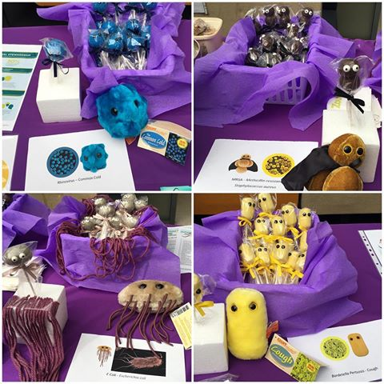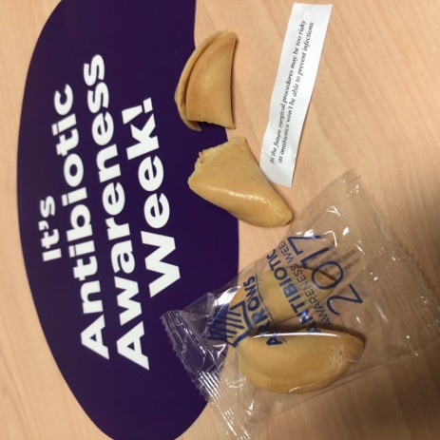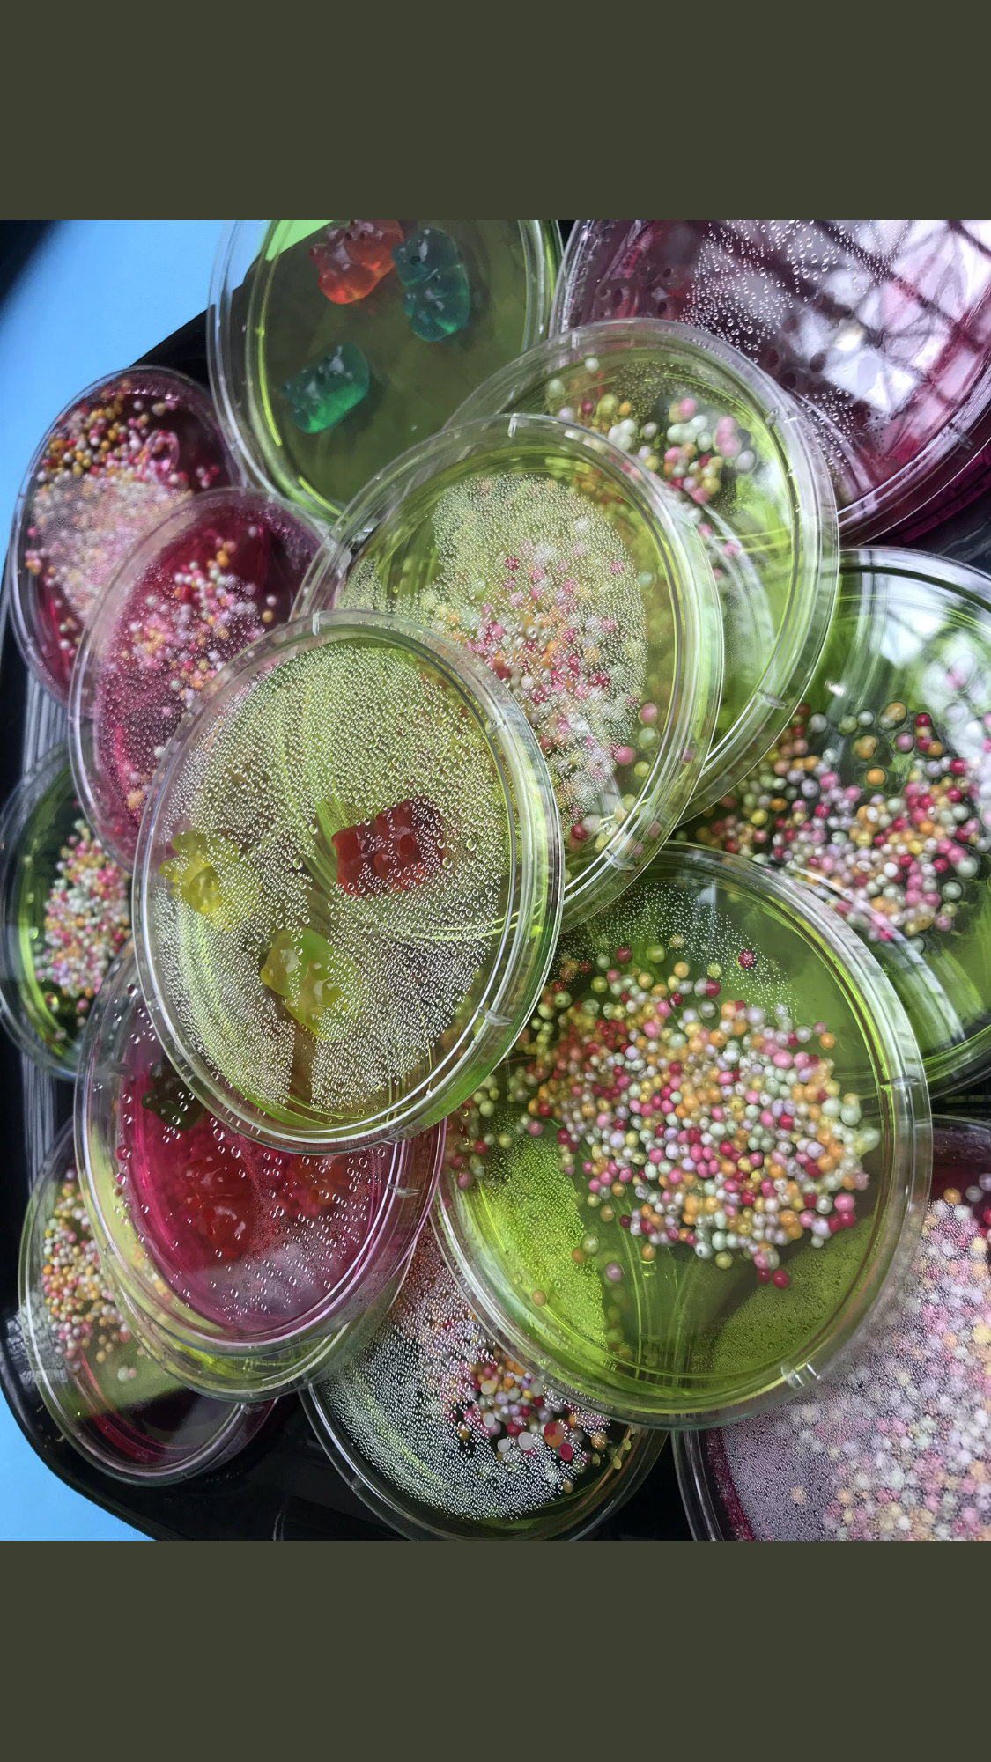

Use social media and join the discussion
If your health service organisation has a social media account, use them to promote the week and your activities. Check your organisation’s social media policy before you begin.

