# Australian COmmission on Safety and Quality in Health Care logo with Radar imageOn the Radar

Issue 484

Tuesday 6 October 2020

*On the Radar* is a summary of some of the recent publications in the areas of safety and quality in health care. Inclusion in this document is not an endorsement or recommendation of any publication or provider. Access to particular documents may depend on whether they are Open Access or not, and/or your individual or institutional access to subscription sites/services. Material that may require subscription is included as it is considered relevant.

*On the Radar* is available online, via email or as a PDF or Word document from <https://www.safetyandquality.gov.au/publications-and-resources/newsletters/radar>

If you would like to receive *On the Radar* via email, you can subscribe on our website <https://www.safetyandquality.gov.au/publications-and-resources/newsletters>   
or by emailing us at H[Umail@safetyandquality.gov.auU](mailto:mail@safetyandquality.gov.au).   
You can also send feedback and comments to H[Umail@safetyandquality.gov.auU](mailto:mail@safetyandquality.gov.au).

For information about the Commission and its programs and publications, please visit <https://www.safetyandquality.gov.au>

You can also follow us on Twitter @ACSQHC.

**On the Radar**

Editor: Dr Niall Johnson [niall.johnson@safetyandquality.gov.au](mailto:niall.johnson@safetyandquality.gov.au)

Contributors: Niall Johnson

**COVID-19 resources**

https://www.safetyandquality.gov.au/covid-19

The Australian Commission on Safety and Quality in Health Care has developed a number of resources to assist healthcare organisations, facilities and clinicians. These and other material on COVID-19 are available at <https://www.safetyandquality.gov.au/covid-19>

The latest additions include:

* ***COVID-19: Aged care staff infection prevention and control precautions*** *poster*<https://www.safetyandquality.gov.au/publications-and-resources/resource-library/covid-19-aged-care-staff-infection-prevention-and-control-precautions-poster>  
    
  [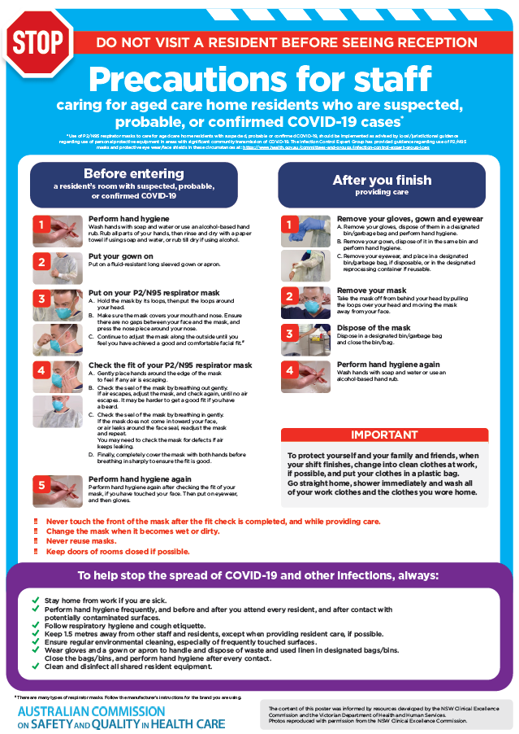](https://www.safetyandquality.gov.au/publications-and-resources/resource-library/covid-19-aged-care-staff-infection-prevention-and-control-precautions-poster)
* ***Environmental Cleaning and Infection Prevention and Control*** [www.safetyandquality.gov.au/environmental-cleaning](http://www.safetyandquality.gov.au/environmental-cleaning)
* ***Infection prevention and control Covid-19 PPE*** poster <https://www.safetyandquality.gov.au/publications-and-resources/resource-library/infection-prevention-and-control-covid-19-personal-protective-equipment>
* ***Special precautions for Covid-19 designated zones*** poster <https://www.safetyandquality.gov.au/publications-and-resources/resource-library/special-precautions-covid-19-designated-zones>
* ***COVID-19 infection prevention and control risk management – Guidance*** <https://www.safetyandquality.gov.au/publications-and-resources/resource-library/covid-19-infection-prevention-and-control-risk-management-guidance>
* ***Safe care for people with cognitive impairment during COVID-19***<https://www.safetyandquality.gov.au/our-work/cognitive-impairment/cognitive-impairment-and-covid-19>
* **Medicines Management COVID-19** <https://www.safetyandquality.gov.au/our-work/medication-safety/medicines-management-covid-19>, including position statements on medicine-related issues
  + ***Managing fever associated with COVID-19***
  + ***Managing a sore throat associated with COVID-19***
  + ***ACE inhibitors and ARBs in COVID-19***
  + ***Clozapine in COVID-19***
  + ***Management of patients on oral anticoagulants during COVID-19***
  + ***Ascorbic Acid: Intravenous high dose in COVID-19***
  + ***Treatment in acute care, including oxygen therapy and medicines to support intubation***
  + ***Nebulisation and COVID-19***
  + ***Managing intranasal administration of medicines during COVID-19***
  + ***Ongoing medicines management in high-risk patients***
  + ***Medicines shortages***
  + ***Conserving medicines***
  + ***Intravenous medicines administration in the event of an infusion pump shortage***
* ***Potential medicines to treat COVID-19***   
  <https://www.safetyandquality.gov.au/publications-and-resources/resource-library/potential-medicines-treat-covid-19>
* ***Break the chain of infection: Stopping COVID-19*** poster<https://www.safetyandquality.gov.au/publications-and-resources/resource-library/break-chain-poster-a3>  
  **[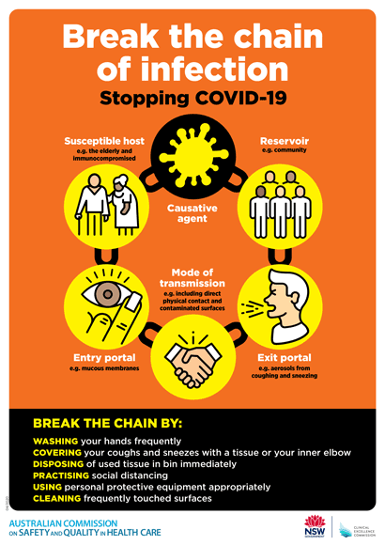](https://www.safetyandquality.gov.au/publications-and-resources/resource-library/break-chain-poster-a3https:/www.safetyandquality.gov.au/publications-and-resources/resource-library/break-chain-poster-a3)**
* ***COVID-19: Elective surgery and infection prevention and control precautions*** <https://www.safetyandquality.gov.au/publications-and-resources/resource-library/covid-19-elective-surgery-and-infection-prevention-and-control-precautions>
* ***FAQs for clinicians on elective surgery*** <https://www.safetyandquality.gov.au/node/5724>
* ***FAQs for consumers on elective surgery*** <https://www.safetyandquality.gov.au/node/5725>
* ***FAQs on community use of face masks***   
  <https://www.safetyandquality.gov.au/faqs-community-use-face-masks>
* ***COVID-19 and face masks – Information for consumers*** <https://www.safetyandquality.gov.au/publications-and-resources/resource-library/covid-19-and-face-masks-information-consumers>

[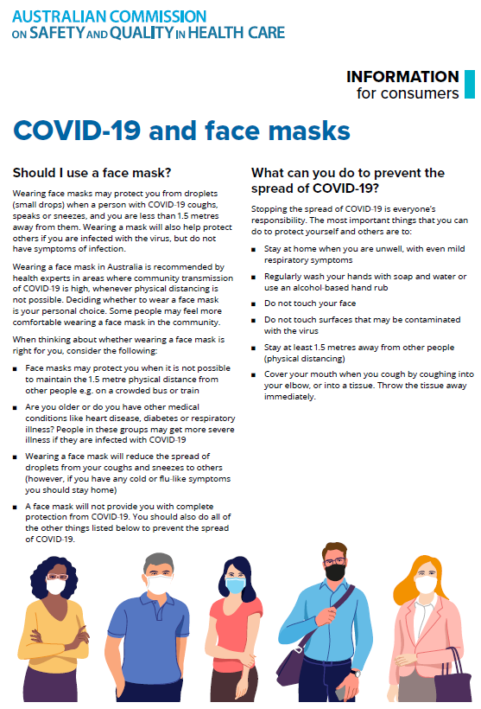](https://www.safetyandquality.gov.au/sites/default/files/2020-07/covid-19_and_face_masks_-_information_for_consumers.pdf)

**Books**

*Developing Health Literacy Skills in Children and Youth: Proceedings of a Workshop*

National Academies of Sciences, Engineering, and Medicine

Washington, DC: The National Academies Press; 2020.

|  |  |
| --- | --- |
| URL | <https://www.nationalacademies.org/our-work/developing-health-literacy-skills-in-youth-a-workshop>  <https://doi.org/10.17226/25888> |
| Notes | Health literacy is a key skill for life. Young people develop health literacy skills in a variety of environments, facing critical thinking challenges about their health from school, home and family life, peers and social life, and online. To explore the development of health literacy skills in youth, the (US) Roundtable on Health Literacy convened a workshop on 19 November 2019 in Washington, DC. Presenters at the workshop discussed factors relating to health literacy skills and ways to further develop those skills among youth from early childhood to young adulthood. This publication summarizes the presentation and discussion of the workshop. |

For information on the Commission’s work on health literacy, see <https://www.safetyandquality.gov.au/our-work/patient-and-consumer-centred-care/health-literacy>

**Reports**

*A Guide to Patient Safety Improvement: Integrating Knowledge Translation & Quality Improvement Approaches*

Canadian Patient Safety Institute

Edmonton: Canadian Patient Safety Institute 2020. p. 24.

|  |  |
| --- | --- |
| URL | <https://www.patientsafetyinstitute.ca/en/toolsResources/A-Guide-to-Patient-Safety-Improvement/Pages/default.aspx> |
| Notes | The Canadian Patient Safety Institute has produced this short (24-page) guide to support teams across all healthcare sectors in using a Knowledge Translation and Quality Improvement integrated approach to change that will impact patient safety outcomes. This guide provides high level guidance and links to references to support patient safety improvements. |

*Optimising health care through specialist referral reforms*

Deeble Institute Issues Brief No. 38

Prime S, Gardiner C, Haddock R

Canberra: Australian Healthcare and Hospitals Association; 2020. p. 43.

|  |  |
| --- | --- |
| URL | <https://ahha.asn.au/publication/health-policy-issue-briefs/deeble-brief-no-38-optimising-healthcare-through-specialist> |
| Notes | This Issues Brief from the Australian Healthcare and Hospitals Association’s Deeble Institute examines the issue of referrals to specialists. The authors observe that this specialist referral system is a key operational component of the Australian health system. They argue that it is designed to manage access to subsidised specialist services and remunerate MBS Providers at referred service rates. Further, they suggest it is also designed to affirm the central role of primary healthcare services. However, the regulatory requirement for consumers to obtain repeat referrals when already under the care of a specialist has received limited scrutiny in recent decades. The brief’s authors argue that bringing current referral rules in line with contemporary health needs and service structures will require a well-co-ordinated, effective and efficient referral system that facilitates the evidence based and linear transfer of care from one clinician to another within a highly interoperable and collaborative healthcare system.  The release of this Issues Brief instigated a robust discussion. Actually, I saw the Twitter backlash/rebuttal/argument this paper (and a related article on the Conversation website) generated before I’d seen the paper (even though I’d received a link via email). Various people, including GPs, had critiqued the piece and at least one had suggested that a law lecturer and a doctoral candidate in health policy were not qualified to comment and were in fact suggesting GPs should act unlawfully by backdating referrals. The RACGP published a response at <https://www1.racgp.org.au/newsgp/professional/report-questioning-value-of-gp-referrals-draws-rac>  The primacy of the patient and their experience and their care seemed rather lacking on some of this chatter. A referrals system that forces patients with chronic disease to spend time and money chasing multiple referrals for the various specialists they need to consult is not valuing the time and resources of either these patients or GPs. While GPs should – and often do – play an important role in coordinating the case of their patients, and the need for referrals can play a role in prompting communication between GPs and their specialist counterparts, it is questionable as to whether the current approach is the best mechanism to achieve that. Simply defending the status quo when reform is suggested may be rather missing an opportunity for improvement. |

*Improving the uptake of the Baby Friendly Health Initiative in Australian Hospitals*

Deeble Institute Issues Brief No. 39

Pramono A

Canberra: Australian Healthcare and Hospitals Association; 2020. p. 39.

|  |  |
| --- | --- |
| URL | <https://ahha.asn.au/publication/health-policy-issue-briefs/deeble-issues-brief-no-39-improving-uptake-bfhi-australian> |
| Notes | The Australian Healthcare and Hospitals Association’s Deeble Institute released two Issues Briefs this week. This one examines the Baby Friendly Health Initiative (BFHI). The BFHI, developed by the World Health Organization (WHO) and the United Nations Children’s Fund (UNICEF) in 1991, was designed to ensure that mothers receive adequate support to initiate breastfeeding and to continue doing so after discharge from the acute care service. In 1995, UNICEF passed the governance within Australia to the Australian College of Midwives (ACM). As of 2020, only 26% of Australian public hospitals have active Baby Friendly accreditation The author of the Issues Brief offers a number of recommendations, including:   * Investment in evidence based, free-from-commercial-interest education and support for breastfeeding mothers and family. * In-hospital training and preservice education aimed at increasing awareness and clinical knowledge of breastfeeding for best practice, and which are appropriately funded by government. * Integrating BFHI standards to national accreditation standards, and ensuring these are independent of influence from formula companies and their affiliates. * Continued support for breastfeeding policies in the workplace and community. * Supporting holistic relationally-based culturally-sensitive breastfeeding programs within primary health care. * Examining international models of BFHI implementation for feasibility of use in Australia. |

*The courage of compassion: Supporting nurses and midwives to deliver high-quality care*

West M, Bailey S, Williams E

London: The King's Fund; 2020. p. 156.

|  |  |
| --- | --- |
| URL | <https://www.kingsfund.org.uk/publications/courage-compassion-supporting-nurses-midwives> |
| Notes | The King’s Fund in the UK has released this report into the working lives of nurses and midwives, particularly how some aspects have been highlighted by the coronavirus pandemic. While this is focused on the UK, the report may have useful resonances elsewhere. The report’s authors make 8 recommendations to go to three core work issues: autonomy, belonging and contribution.   1. *Authority, empowerment and influence* – Introduce mechanisms for nursing and miwifery staff to shape the cultures and processes of their organisations and influence decisions about how care is structured and delivered. 2. *Justice and fairness* – Nurture and sustain just, fair and psychologically safe cultures and ensure equity, proactive and positive approaches to diversity and universal inclusion. 3. *Work conditions and working schedules* – Introduce minimum standards for facilities and working conditions for nursing and midwifery staff in all health and care organisations. 4. *Teamworking* – Develop and support effective multidisciplinary teamworking for all nursing and midwifery staff across health and care services. 5. *Culture and leadership* – Ensure health and care environments have compassionate leadership and nurturing cultures that enable both care and staff support to be high-quality, continually improving and compassionate. 6. *Workload* – Tackle chronic excessive work demands in nursing and midwifery, which exceed the capacity of nurses and midwives to sustainably lead and deliver safe, high-quality care and which damage their health and wellbeing. 7. *Management and supervision* – Ensure all nursing and midwifery staff have the effective support, professional reflection, mentorship and supervision needed to thrive in their roles. 8. *Learning, education and development* – Ensure the right systems, frameworks and processes are in place for nurses’ and midwives’ learning, education and development throughout their careers. These must promote fair and equitable outcomes. |

**Journal articles**

*Seven features of safety in maternity units: a framework based on multisite ethnography and stakeholder consultation*

Liberati EG, Tarrant C, Willars J, Draycott T, Winter C, Kuberska K, et al

BMJ Quality & Safety. 2020 [epub].

|  |  |
| --- | --- |
| DOI | <https://doi.org/10.1136/bmjqs-2020-010988> |
| Notes | The safety of mothers and babies is, understandably, a sensitive topic. In countries such as Australia there is an admirably low rate of maternal and infant mortality. Nonetheless, as the authors observe, ‘Reducing avoidable harm in maternity services is a priority globally. As well as learning from mistakes, it is important to produce rigorous descriptions of ‘what good looks like’. This British ethnographic study used 401 hours of non-participant observations 33 semi-structured interviews with staff across six maternity units, and a stakeholder consultation involving 65 semi-structured telephone interviews and one focus group from which they identified seven features of safety in maternity units and summarised them into a framework, named For Us (For Unit Safety). The seven features include:   1. commitment to safety and improvement at all levels, with everyone involved; 2. technical competence, supported by formal training and informal learning; 3. teamwork, cooperation and positive working relationships; 4. constant reinforcing of safe, ethical and respectful behaviours; 5. multiple problem-sensing systems, used as basis of action; 6. systems and processes designed for safety, and regularly reviewed and optimised; 7. effective coordination and ability to mobilise quickly. |

*The unrecognized power of health services accreditation: more than external evaluation*

Mitchell JI, Graham ID, Nicklin W

International Journal for Quality in Health Care. 2020;32(7):445-455.

*Promoting patients’ rights through hospital accreditation*

Sperling D, Pikkel RB

Israel Journal of Health Policy Research. 2020;9(1):47.

|  |  |
| --- | --- |
| DOI | Mitchell et al <https://doi.org/10.1093/intqhc/mzaa063>  Sperling and Pikkel <https://doi.org/10.1186/s13584-020-00405-1> |
| Notes | Accreditation is thought to have many benefits, including helping to drive safety and quality. Mitchell et al argue that there is a ‘unrecognized power of health services accreditation’, but the full benefits of accreditation cannot be optimised or achieved unless ‘organizations and accreditation bodies embrace the accreditation process as a knowledge to action intervention to bring about meaningful and sustained change’.  Sperling and Pikkel also find additional benefits to accreditation, in that the accreditation process can be a means by which a range of goals and concepts can be brought to have influence on the practice and delivery of health care. Focusing on the experience of accreditation in Israeli health services, the authors found that ‘accreditation process introduces and promotes the concepts of patient and family rights, increases the awareness and compliance of such concepts, and may create greater consistency in their introduction and application’. |

*Translation of evidence into policy to improve clinical practice: the development of an emergency department rapid response system*

Munroe B, Curtis K, Balzer S, Roysten K, Fetchet W, Tucker S, et al

Australasian Emergency Care. 2020 [epub].

|  |  |
| --- | --- |
| DOI | <https://doi.org/10.1016/j.auec.2020.08.003> |
| Notes | The importance of recognition and response to clinical deterioration has been understood for some years. This is lead to developments such as MET and other rapid response teams, the use of monitoring mechanisms and technologies. This paper describes the development of an emergency department rapid response system. In this example the intervention was termed the ED Clinical Emergency Response System (EDCERS). This intervention was developed from examination of the existing evidence on such interventions and then tailoring a response for the service, including an awareness of the cultural context. |

For information on the Commission’s work on recognising and responding to deterioration, see <https://www.safetyandquality.gov.au/our-work/recognising-and-responding-deterioration>

*The Riyadh Declaration: the role of digital health in fighting pandemics*

Al Knawy B, Adil M, Crooks G, Rhee K, Bates D, Jokhdar H, et al

The Lancet. 2020 [epub]

|  |  |
| --- | --- |
| DOI | <https://doi.org/10.1016/S0140-6736(20)31978-4> |
| Notes | According to a panel of 13 digital health proponents/experts there is a role for digital health in responding to pandemics. The Riyadh Declaration on Digital Health was formulated during the Riyadh Global Digital Health Summit, 11–12 August 2020, a forum that highlighted the importance of digital technology, data, and innovation for resilient global health and care systems. The Recommendations from the Riyadh Global Digital Health Summit include:   1. Implement data-driven and evidence-based protocols for clear and effective communication with common messaging to build citizens’ trust 2. Work with global stakeholders to confront propagation of misinformation or disinformation through social media platforms and mass media 3. Implement a standard global minimum dataset for public health data reporting and a data governance structure tailored to communicable diseases 4. Ensure countries prioritise digital health, particularly, improving digital health infrastructure and reaching digital maturity 5. Enable health and care organisations by providing the necessary technology to collect high-quality data in a timely way and promote sharing to create health intelligence 6. Cultivate a health and care workforce with the knowledge, skills, and training in data and digital technologies required to address current and future public health challenges 7. Ensure surveillance systems combine an effective public health response with respect for ethical and privacy principles 8. Develop digital personal tools and services to support comprehensive health programmes (in disease prevention, testing, management, and vaccination) globally 9. Maintain, continue to fund, and innovate surveillance systems as a core component of the connected global health system for rapid preparedness and optimal global responses. |

*International Journal for Quality in Health Care*

Volume 32 Issue 7, August 2020

|  |  |
| --- | --- |
| URL | <https://academic.oup.com/intqhc/issue/32/7> |
| Notes | A new issue of the *International Journal for Quality in Health* has been published. Many of the papers in this issue have been referred to in previous editions of *On the Radar* (when they were released online). Articles in this issue of the *International Journal for Quality in Health* include:   * In-hospital interventions for **reducing readmissions to acute care for adults aged 65 and over**: An umbrella review (Tiffany Conroy; Louise Heuzenroeder; Rebecca Feo) * **MRI safety management in patients with cardiac implantable electronic devices**: Utilizing failure mode and effects analysis for risk optimization (James W Ryan; Aoife S Murray; Paddy J Gilligan ; James M Bisset; Chris Nolan; Audrey Doyle; Barry Emerson; Joseph M Galvin; John G Murray) * Beyond the corrective action hierarchy: A **systems approach to organizational change** (Laura J Wood; Douglas A Wiegmann) * The unrecognized power of **health services accreditation**: more than external evaluation (Jonathan I Mitchell; Ian D Graham; Wendy Nicklin) * Development and evaluation of a **quality improvement framework for healthcare** (Samantha Hamilton; Alison Jennings; Alan J Forster) * Qualitative exploration of factors associated with **shared decision-making in diabetes management**: a health care provider’s perspective (Amena Moazzam Baig; Ayesha Humayaun; Sara Mehmood ; Muhammed Waqar Akram; Syed Abbass Raza; Tania Shakoori) * Sequential implementation of the EQUIPPED **geriatric medication safety** program as a learning health system (Ann E Vandenberg; Michelle Kegler; S Nicole Hastings ; Ula Hwang; Daniel Wu; Melissa B Stevens; Carolyn Clevenger; Stephanie Eucker; Nick Genes; Wennie Huang; Edidiong Ikpe-Ekpo; Denise Nassisi; Laura Previll; Sandra Rodriguez; Martine Sanon; David Schlientz; Debbie Vigliotti; Camille P Vaughan) * Quality in practice: applying the **patient inventory method** at a Danish psychiatric hospital (Sabina Bay Hermansen; Jens Holmskov; Søren Paaske Johnsen ; Jan Mainz; Søren Valgreen Knudsen) * **The care and keeping of clinicians in quality improvement** (Ulfat Shaikh; Peter Lachman; Andrew J Padovani ; SiobhÁn E McCarthy) |

*Journal of Patient Safety and Risk Management*

Volume: 25, Number: 4 (August 2020)

|  |  |
| --- | --- |
| URL | <https://journals.sagepub.com/toc/cric/25/4> |
| Notes | A new issue of the *Journal of Patient Safety and Risk Management* has been published. Articles in this issue of the *Journal of Patient Safety and Risk Management* include:   * Editorial: **COVID-19: The dark side and the sunny side for patient safety** (Albert W Wu, Hugo Sax, Mondher Letaief, Tomasso Bellandi, David Newman-Toker, Lori A Paine, Charles Vincent, Peter J Pronovost, Ezequiel Garcia Elorrio, Allen Kachalia, and Elliott R Haut) * **Research and data: Taking steps to improve patient safety** (Jeremy Hunt) * The mind of an academic, the voice of a patient: My field experience with **safe communication** (Annegret F Hannawa) * The cost-effectiveness of sub-epidermal moisture scanning to assess **pressure injury risk** in U.S. health systems (William V Padula, Shreena Malaviya, Ellen Hu, Sue Creehan, Barbara Delmore, and Jonothan C Tierce) * Using **event reports in real-time to identify and mitigate patient safety concerns** during the COVID-19 pandemic (Eileen Kasda, Christine Robson, Jamia Saunders, Asa Adadey, Brenna Ford, Nisha Sinha, Jonathan Teter, Nicole Warner, and Lori Paine) * **Psychological first aid to support healthcare professionals** (George S Everly, Jr) * Rapid adoption of **resilience strategies during the COVID-19 pandemic** (Florence R LeCraw) |

*Australian Health Review*

Vol. 44, No. 5, September 2020

|  |  |
| --- | --- |
| URL | <https://www.publish.csiro.au/ah/issue/9739> |
| Notes | A new issue of *Australian Health Review* has been published. Articles in this issue of *Australian Health Review* include:   * No observed reduction of **non-attendance rate in telehealth models of care** (E P Greenup, D Best, M Page and B Potts) * **Queensland Digital Health Clinical Charter**: a clinical consensus statement on priorities for digital health in hospitals (Clair Sullivan, Andrew Staib, Keith McNeil, David Rosengren and Ian Johnson) * **Digital transformation of the emergency department-inpatient interface (EDii)**: integration for future innovation (Andrew Staib, Clair Sullivan, Cara Joyce Cabilan, Rohan Cattell and Rob Eley) * Implementation pilot of a novel **electronic bedside nursing chart**: a mixed-methods case study (Kasia Bail, Rachel Davey, Marian Currie, Jo Gibson, Eamon Merrick and Bernice Redley) * **Digitising an Australian university hospital**: qualitative analysis of staff-reported impacts (Rebekah Eden, Andrew Burton-Jones, James Grant, Renea Collins, Andrew Staib and Clair Sullivan) * Surveying perceptions of the early impacts of an **integrated electronic medical record across a hospital and healthcare service** (Rebekah Eden, Andrew Burton-Jones, Andrew Staib and Clair Sullivan) * Review of **electronic discharge summaries** from the general medicine, general surgery and mental health streams at a tertiary hospital: retrospective analysis of timeliness, brevity and completeness (Keith Potent, Benjamin Levy and Andrew Porritt) * From **benefits idealisation to value optimisation: application in the digital health context** (Natalie Smith, Andrew Burton-Jones and C Sullivan) * Documenting **COVID-19 screening before surgery** during lockdown (COVID Screen): an audit with routinely collected health data (David Story, Elizabeth Coyle, Abarna Devapalasundaram, Sofia Sidiropoulos, Bobby Ou Yang and Tim Coulson) * Should Australian states and territories have **designated COVID hospitals** in low community transmission? Case study for Western Australia (Chantal Ferguson, Robert Fletcher, Portia Ho and Elizabeth MacLeod) * **General practice's early response to the COVID-19 pandemic** (Michael Wright, Roald Versteeg and Jane Hall) * **Telehealth uptake in general practice as a result of the coronavirus** (COVID-19) pandemic (Centaine L Snoswell, Liam J Caffery, Helen M Haydon, Emma E Thomas and Anthony C Smith) * Description of the effect of patient flow, junior doctor supervision and pandemic preparation on the **ability of emergency physicians to provide direct patient care** (Andy Lim, Namankit Gupta, Alvin Lim, Wei Hong and Katie Walker) * 'I just hope they take it seriously': **homeless men talk about their health care** (Nancy Sturman and Don Matheson) * Factors affecting **hepatitis C treatment intentions among Aboriginal people** in Western Australia: a mixed-methods study (Amineh Rashidi, Peter Higgs and Susan Carruthers) * **How general practitioners perceive access needs of vulnerable patients and act** to address these needs: a mixed-methods study in south-east Melbourne, Australia (Marina Kunin, Jenny Advocat, Suhashi M Wickramasinghe, Emilie Dionne and Grant Russell) * **The 'Surgical Time'**: a myth or reality? Surgeons' prediction of operating time and its effect on theatre scheduling (Raghav Goel, Harsh Kanhere and Markus Trochsler) * Mapping **non-malignant respiratory palliative care services** in Australia and New Zealand (Jennifer Philip, Rachel Wiseman, Peter Eastman, Chi Li and Natasha Smallwood) * Welcome to The Lucky Country: the **Royal Australian College of General Practitioners deters overseas-trained academic general practitioners** (Katharine A Wallis) * Characteristics and predictors of **regulatory immediate action imposed on registered health practitioners** in Australia: a retrospective cohort study (Owen M Bradfield, Marie M Bismark, David M Studdert and M J Spittal) * Economic and clinical outcomes of the **nurse practitioner-led Sydney Adventist Hospital Community Palliative Care Service** (Sam G Moreton, Emily Saurman, Glenn Salkeld, Julie Edwards, Dawn Hooper, Kerrie Kneen, Gillian Rothwell and John Watson) * Challenges in obtaining **research ethics and governance approvals for an Australian national intersector, multisite audit study** (Kimberly Buck, Linda Nolte, Helana Kelly, K Detering, C Sinclair, B P White and M Sellars) * **Engaging consumers in health research**: a narrative review (Ania Anderst, Karena Conroy, Greg Fairbrother, Laila Hallam, Alan McPhail and V Taylor) |

*BMJ Quality & Safety* online first articles

|  |  |
| --- | --- |
| URL | <https://qualitysafety.bmj.com/content/early/recent> |
| Notes | *BMJ Quality &Safety* has published a number of ‘online first’ articles, including:   * Editorial: Addressing the ignored complication: **chronic opioid use after surgery** (Scott G Weiner) * Editorial: What current and missing data can teach us about **medication errors** (William V Padula, Irving Steinberg) * Seven features of **safety in maternity units**: a framework based on multisite ethnography and stakeholder consultation (Elisa Giulia Liberati, Carolyn Tarrant, Janet Willars, Tim Draycott, Cathy Winter, Karolina Kuberska, Alexis Paton, Sonja Marjanovic, Brandi Leach, Catherine Lichten, Lucy Hocking, Sarah Ball, Mary Dixon-Woods The SCALING Authorship Group) * Differences in **transitional care processes among high-performing and low-performing hospital-SNF pairs**: a rapid ethnographic approach (Kirstin A Manges, Roman Ayele, Chelsea Leonard, Marcie Lee, Emily Galenbeck, Robert E Burke) |

*International Journal for Quality in Health Care* online first articles

|  |  |
| --- | --- |
| URL | <https://academic.oup.com/intqhc/advance-articles> |
| Notes | *International Journal for Quality in Health Care* has published a number of ‘online first’ articles, including:   * “**Heroes in Healthcare**; what’s wrong with that?” (John Brennan) * The **40 health systems, COVID-19** (40HS, C-19) study (Jeffrey Braithwaite, Yvonne Tran, Louise A Ellis, Johanna Westbrook) * Dealing with the **impact of the COVID-19 pandemic on a Rapid Response Team** operation in Brazil: Quality in practice (Hermano Alexandre Lima Rocha, Antonia Célia de Castro Alcântara, Fernanda Colares de Borba Netto, Flavio Lucio Pontes Ibiapina, Livia Amaral Lopes) * Human factors: the **pharmaceutical supply chain** as a complex sociotechnical system (Brian Edwards, Charles A Gloor, Franck Toussaint, Chaofeng Guan, Dominic Furniss) * A Novel Method of **Assessing Clinical Preparedness for COVID-19 and Other Disasters** (Harriet Fisher, Cherilyn Re, Jeffery Wilhite, Kathleen Hanley, Lisa Altshuler, James Schmidtburger, Morris Gagliardi, Sondra Zabar) * **Human factors engineering for medical devices**: European regulation and current issues (Sylvia Pelayo, Romaric Marcilly, Tommaso Bellandi) * **Human Factors and Ergonomics Systems Approach to the COVID-19** Healthcare Crisis (Pascale Carayon, Shawna Perry) * **Healthcare Cyber-Attacks and the COVID-19 Pandemic**: An Urgent Threat to Global Health (Menaka Muthuppalaniappan, Kerrie Stevenson) * Deciding Without Data: **Clinical Decision Making in Pediatric Orthopaedic Surgery** (Karthik Nathan, Maechi Uzosike, Uriel Sanchez, Alexander Karius, Jacinta Leyden, Segovia Nicole, Eppler Sara, Katherine G Hastings, Robin Kamal,.D, Steven Frick) |

**Online resources**

*National COVID-19 Clinical Evidence Taskforce*

<https://covid19evidence.net.au/>

The National COVID-19 Clinical Evidence Taskforce is a collaboration of peak health professional bodies across Australia whose members are providing clinical care to people with COVID-19. The taskforce is undertaking continuous evidence surveillance to identify and rapidly synthesise emerging research in order to provide national, **evidence-based guidelines and clinical flowcharts for the clinical care of people with COVID-19**. The guidelines address questions that are specific to managing COVID-19 and cover the full disease course across mild, moderate, severe and critical illness. These are ‘living’ guidelines, updated with new research in near real-time in order to give reliable, up-to-the minute advice to clinicians providing frontline care in this unprecedented global health crisis.

*COVID-19 Critical Intelligence Unit*

<https://www.aci.health.nsw.gov.au/covid-19/critical-intelligence-unit>

The Agency for Clinical Innovation (ACI) in New South Wales has developed this page summarising rapid, evidence-based advice during the COVID-19 pandemic. Its operations focus on systems intelligence, clinical intelligence and evidence integration. The content includes a daily evidence digest and evidence checks on a discrete topic or question relating to the current COVID-19 pandemic. Recent evidence checks include:

* ***Cardiopulmonary resuscitation (CPR)***

*[UK] NIHR Evidence alert*

<https://evidence.nihr.ac.uk/>

The UK’s National Institute for Health Research (NIHR) has posted new evidence alerts on its site. Evidence alerts are short, accessible summaries of health and care research which is funded or supported by NIHR. This is research which could influence practice and each Alert has a message for people commissioning, providing or receiving care. The latest alerts include:

* Anti-inflammatory drugs do not lift depression in **bipolar disorder**

• **Psychiatric drugs given to children and adolescents** have been ranked in order of safety

* Teams of healthcare professionals from a wide range of disciplines and pay grades are most effective at delivering **improvements in patients’ experiences**
* **Adopted children** can experience lasting mental health problems
* Screening for **lymphoedema after breast cancer surgery** could identify women likely to benefit from compression sleeves
* **Male prisoners** develop unhealthy hearts at younger ages than people on the outside
* Most patients welcome advice from GPs on **changing their behaviour to improve health**
* Parents-to-be need to be prepared for receiving **uncertain results from genetic tests**
* Community-based medicine collection improves access to lifesaving **HIV treatment** in South Africa
* **Cultural and language barriers** need to be addressed for British-Pakistani women to benefit fully from breast screening
* More **health research** should take place in the areas and populations with most disease
* **Terminally ill patients and their families** often need more help to manage their medicines
* With the right training, **people with** **learning disabilities** can become partners in research
* New research provides insights into the distress experienced by **transgender adults**
* More precise classification of risk in **prostate cancer** reveals a huge variation in treatment.

**Disclaimer**

On the Radar is an information resource of the Australian Commission on Safety and Quality in Health Care. The Commission is not responsible for the content of, nor does it endorse, any articles or sites listed. The Commission accepts no liability for the information or advice provided by these external links. Links are provided on the basis that users make their own decisions about the accuracy, currency and reliability of the information contained therein. Any opinions expressed are not necessarily those of the Australian Commission on Safety and Quality in Health Care.