# Australian COmmission on Safety and Quality in Health Care logo with Radar imageOn the Radar

Issue 486

19 October 2020

*On the Radar* is a summary of some of the recent publications in the areas of safety and quality in health care. Inclusion in this document is not an endorsement or recommendation of any publication or provider. Access to particular documents may depend on whether they are Open Access or not, and/or your individual or institutional access to subscription sites/services. Material that may require subscription is included as it is considered relevant.

*On the Radar* is available online, via email or as a PDF or Word document from <https://www.safetyandquality.gov.au/publications-and-resources/newsletters/radar>

If you would like to receive *On the Radar* via email, you can subscribe on our website <https://www.safetyandquality.gov.au/publications-and-resources/newsletters>   
or by emailing us at H[Umail@safetyandquality.gov.auU](mailto:mail@safetyandquality.gov.au).   
You can also send feedback and comments to H[Umail@safetyandquality.gov.auU](mailto:mail@safetyandquality.gov.au).

For information about the Commission and its programs and publications, please visit <https://www.safetyandquality.gov.au>

You can also follow us on Twitter @ACSQHC.

**On the Radar**

Editor: Dr Niall Johnson [niall.johnson@safetyandquality.gov.au](mailto:niall.johnson@safetyandquality.gov.au)

Contributors: Niall Johnson, Kim Packham

**COVID-19 resources**

https://www.safetyandquality.gov.au/covid-19

The Australian Commission on Safety and Quality in Health Care has developed a number of resources to assist healthcare organisations, facilities and clinicians. These and other material on COVID-19 are available at <https://www.safetyandquality.gov.au/covid-19>

The latest additions include:

* ***COVID-19: Aged care staff infection prevention and control precautions*** *poster*<https://www.safetyandquality.gov.au/publications-and-resources/resource-library/covid-19-aged-care-staff-infection-prevention-and-control-precautions-poster>  
    
  [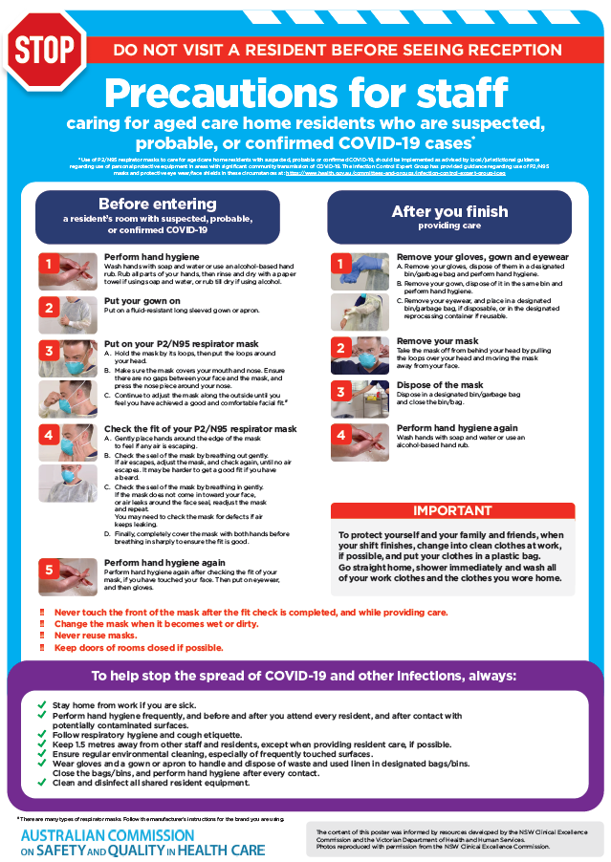](https://www.safetyandquality.gov.au/publications-and-resources/resource-library/covid-19-aged-care-staff-infection-prevention-and-control-precautions-poster)
* ***Environmental Cleaning and Infection Prevention and Control*** [www.safetyandquality.gov.au/environmental-cleaning](http://www.safetyandquality.gov.au/environmental-cleaning)
* ***Infection prevention and control Covid-19 PPE*** poster <https://www.safetyandquality.gov.au/publications-and-resources/resource-library/infection-prevention-and-control-covid-19-personal-protective-equipment>
* ***Special precautions for Covid-19 designated zones*** poster <https://www.safetyandquality.gov.au/publications-and-resources/resource-library/special-precautions-covid-19-designated-zones>
* ***COVID-19 infection prevention and control risk management – Guidance*** <https://www.safetyandquality.gov.au/publications-and-resources/resource-library/covid-19-infection-prevention-and-control-risk-management-guidance>
* ***Safe care for people with cognitive impairment during COVID-19***<https://www.safetyandquality.gov.au/our-work/cognitive-impairment/cognitive-impairment-and-covid-19>
* **Medicines Management COVID-19** <https://www.safetyandquality.gov.au/our-work/medication-safety/medicines-management-covid-19>, including position statements on medicine-related issues
  + ***Managing fever associated with COVID-19***
  + ***Managing a sore throat associated with COVID-19***
  + ***ACE inhibitors and ARBs in COVID-19***
  + ***Clozapine in COVID-19***
  + ***Management of patients on oral anticoagulants during COVID-19***
  + ***Ascorbic Acid: Intravenous high dose in COVID-19***
  + ***Treatment in acute care, including oxygen therapy and medicines to support intubation***
  + ***Nebulisation and COVID-19***
  + ***Managing intranasal administration of medicines during COVID-19***
  + ***Ongoing medicines management in high-risk patients***
  + ***Medicines shortages***
  + ***Conserving medicines***
  + ***Intravenous medicines administration in the event of an infusion pump shortage***
* ***Potential medicines to treat COVID-19***   
  <https://www.safetyandquality.gov.au/publications-and-resources/resource-library/potential-medicines-treat-covid-19>
* ***Break the chain of infection: Stopping COVID-19*** poster<https://www.safetyandquality.gov.au/publications-and-resources/resource-library/break-chain-poster-a3>  
  **[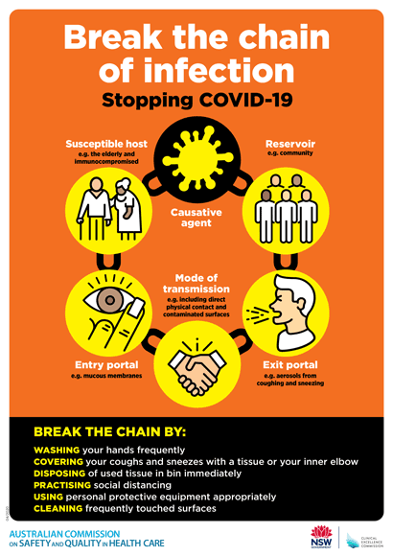](https://www.safetyandquality.gov.au/publications-and-resources/resource-library/break-chain-poster-a3https:/www.safetyandquality.gov.au/publications-and-resources/resource-library/break-chain-poster-a3)**
* ***COVID-19: Elective surgery and infection prevention and control precautions*** <https://www.safetyandquality.gov.au/publications-and-resources/resource-library/covid-19-elective-surgery-and-infection-prevention-and-control-precautions>
* ***FAQs for clinicians on elective surgery*** <https://www.safetyandquality.gov.au/node/5724>
* ***FAQs for consumers on elective surgery*** <https://www.safetyandquality.gov.au/node/5725>
* ***FAQs on community use of face masks***   
   <https://www.safetyandquality.gov.au/faqs-community-use-face-masks>
* ***COVID-19 and face masks – Information for consumers*** <https://www.safetyandquality.gov.au/publications-and-resources/resource-library/covid-19-and-face-masks-information-consumers>

[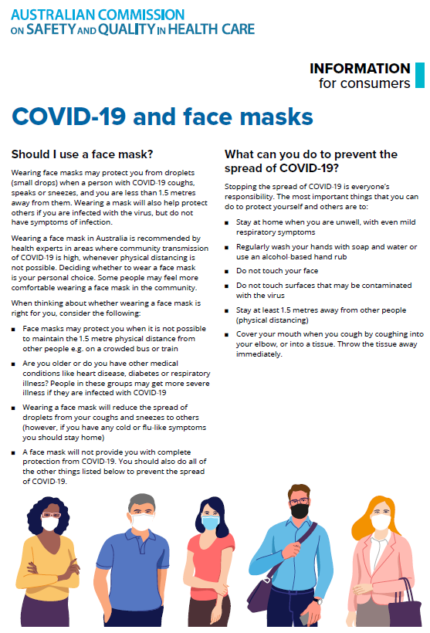](https://www.safetyandquality.gov.au/sites/default/files/2020-07/covid-19_and_face_masks_-_information_for_consumers.pdf)

**National Safety and Quality Primary Healthcare Standards Consultation**

<https://www.safetyandquality.gov.au/standards/national-safety-and-quality-primary-healthcare-nsqph-standards>

The Australian Commission on Safety and Quality in Health Care is developing safety and quality standards for primary healthcare services. The draft *National Safety and Quality Primary Healthcare (NSQPH) Standards* address key safety and quality issues for primary healthcare services and highlight the importance of clinical governance and consumer partnerships in effective safe and high-quality care.

The NSQPH Standards are now available and open for comment until close of business, Friday 27 November 2020. Visit the Commission’s [website](https://www.safetyandquality.gov.au/standards/national-safety-and-quality-primary-healthcare-nsqph-standards) to review the draft standards, and to submit your feedback or register to participate in an online consultation forum.

**Reports**

*rpavirtual: A new way of caring*

Deeble Institute Perspectives Brief No. 13

Shaw M, Anderson T, Sinclair T, Raffan F, Dearing C, Hutchings O, et al

Canberra: Australian Healthcare and Hospitals Association; 2020. p. 7.

|  |  |
| --- | --- |
| URL | <https://ahha.asn.au/health-policy-perspective-briefs>  <https://ahha.asn.au/sites/default/files/docs/policy-issue/deeble_perspectives_brief_no._13_-_rpavirtual_-_a_new_way_of_caring.pdf> |
| Notes | The Australian Healthcare and Hospitals Association’s Deeble Institute has released two new Perspective Briefs. This brief recounts the development, implementation and then rapid scaling up in the face of a pandemic of the RPA Virtual Hospital (known as rpavirtual). Rpavirtual, is a new model of care which combines Sydney Local Health District's integrated hospital and community care with digital solutions. Rpavirtual was able to rapidly scale-up to provide virtual care for over 2,000 COVID-19 patients in quarantine. In addition, rpavirtual has also implemented the following models of care:   * care for patients in health hotel quarantine * medication monitoring for immune-supressed patients * mental health medication monitoring and wellbeing surveys * residential aged care facilities triage line and ambulance board monitoring, and * a virtual fracture clinic.   The brief also notes the importance of the patient experience. The authors observe that ‘The patient experience data demonstrates that clinician assessment, monitoring and treatment within the hospital context can be delivered safely via technology in the community environment; and, patients accept and respond well to comprehensive, supportive care delivered through virtual technologies.’  The development of rpavirtual and its role earlier in the COVID-19 pandemic was the subject of an earlier issue of *On the Radar* (Issue 472) including a rapid evidence scan on the effectiveness of Virtual Hospital models of care (<https://www.saxinstitute.org.au/news/virtual-hospitals-a-new-way-to-ease-healthcare-burdens/>) and a podcast featuring the Chief Executive of Sydney Local Health District, Teresa Anderson, discussing the RPA Virtual Hospital and the COVID-19 pandemic (<https://soundcloud.com/ahhapodcast/rpa-virtual-hospital-care-during-the-pandemic>) |

*The Value Based Health Care landscape*

Deeble Institute Perspectives Brief No. 14

Shadbolt B, Angeles MR, Kapoor T, Low C, McCrossin R, Shadbolt T, et al

Canberra: Australian Healthcare and Hospitals Association; 2020. p. 19.

|  |  |
| --- | --- |
| URL | <https://ahha.asn.au/health-policy-perspective-briefs>  <https://ahha.asn.au/sites/default/files/docs/policy-issue/deeble_perspectives_brief_no._14_-_the_value_based_health_care_landscape.pdf> |
| Notes | The second Perspectives Brief from the Australian Healthcare and Hospitals Association’s Deeble Institute examines the factors that are likely to contribute to the success of value based health care in Australia. According to the Brief, the key success factors to implementing value based health care have been identified as falling into the themes of:   * Defining value and effective data collection * Development and structuring effective information and computing technologies * Development and structuring integrated practice units and care pathways * Economics and finance * Policy, planning and reforms * Behavioural change. |

*Developmental Language Disorder and the National Disability Insurance Scheme (NDIS)*

Deeble Institute Evidence Brief No. 21

Walker C, Haddock R

Canberra: Australian Healthcare and Hospitals Association; 2020. p. 18.

|  |  |
| --- | --- |
| URL | <https://ahha.asn.au/publication/health-policy-evidence-briefs/deeble-evidence-brief-no-21-developmental-language> |
| Notes | This Evidence Brief from the Australian Healthcare and Hospitals Association’s Deeble Institute follows an earlier one that provided an overview of the issue of developmental language disorder (DLD) in Australia (<https://ahha.asn.au/publication/health-policy-evidence-briefs/evidence-brief-no-20-developmental-language-disorder>).  Developmental language disorder (DLD) is diagnosed when a child has language difficulties that continue into school age and beyond. Children with DLD require early and targeted intervention support to reduce the risk (and related costs) of poor social, education, emotional and mental health outcomes.  This Evidence Brief contends that it can be difficult for Australian children with DLD to access the services that they need in a timely and effective manner. Many factors contribute towards this including poor awareness of DLD, inequitable and inaccessible health services and unclear navigation of health and disability services. Further, it is stated that children with DLD are being inconsistently excluded from NDIS funding support due to subjective assessment criteria, length waiting periods and unclear exclusion criteria. |

**Journal articles**

*Catheter-Associated Urinary Tract Infection Reduction in a Pediatric Safety Engagement Network*

Foster CB, Ackerman K, Hupertz V, Mustin L, Sanders J, Sisson P, et al

Pediatrics. 2020;146(4):e20192057.

|  |  |
| --- | --- |
| DOI | <http://doi.org/10.1542/peds.2019-2057> |
| Notes | Paper describing the implementation and impact of catheter-associated urinary tract infection (CAUTI) prevention in a network of children’s hospitals between 2011 and 2017 (eventually reaching 128 participating centres). The interventions included catheter insertion bundles and maintenance bundles. The paper reports that ‘CAUTI rates across the network decreased 61.6%, from 2.55 to 0.98 infections per 1000 catheter-line days’. |

For information on the Commission’s work on healthcare-associated infection, see <https://www.safetyandquality.gov.au/our-work/healthcare-associated-infection>

*Impact of pharmacist interventions on medication errors in hospitalized pediatric patients: a systematic review and meta-analysis*

Naseralallah LM, Hussain TA, Jaam M, Pawluk SA

International Journal of Clinical Pharmacy. 2020;42(4):979-994.

|  |  |
| --- | --- |
| DOI | <http://doi.org/10.1007/s11096-020-01034-z> |
| Notes | A further addition to the literature indicating that involving pharmacists has value when it comes to reducing medication errors. In this case a systematic review and meta-analysis of the literature around medication errors among hospitalised children that saw 19 studies systematically reviewed and 6 studies (29,291 patients) included in the meta-analysis. The findings include:   * Pharmacist interventions involved delivering educational sessions, reviewing prescriptions, attending rounds and implementing a unit-based clinical pharmacist. * The systematic review indicated that the most common trigger for pharmacist interventions was inappropriate dosing. * Pharmacist involvement was associated with significant reductions in the overall rate of medication errors occurrence (OR 0.27; 95% CI 0.15 to 0.49). |

For information on the Commission’s work on medication safety, see <https://www.safetyandquality.gov.au/our-work/medication-safety>

*Australian Journal of Primary Health*

Volume 26, No. 5 2020

|  |  |
| --- | --- |
| URL | <https://www.publish.csiro.au/py/issue/9751> |
| Notes | A new issue of the *Australian Journal of Primary Health* has been published. Articles in this issue of the *Australian Journal of Primary Health* include:   * Priorities for **primary health care policy implementation**: recommendations from the combined experience of six countries in the Asia–Pacific (Ryuki Kassai, Chris van Weel, Karen Flegg, Seng Fah Tong, Tin Myo Han, Sairat Noknoy, Myagmartseren Dashtseren, Pham Le An, Chirk Jenn Ng, Ee Ming Khoo, Kamaliah Mohd Noh, Meng-Chih Lee, Amanda Howe and Felicity Goodyear-Smith) * Does point-of-care testing in general practice for leucocyte and differential count change **use of antimicrobial medicines**? A pilot study (Oliver Frank, Nigel Stocks and Chris Del Mar) * **Obesity**: a sociological guide for health practitioners (Samuel G Grace) * The Rohingya Little Local: exploring **innovative models of refugee engagement** in Sydney, Australia (Amy Bestman, Jane Lloyd, Barbara Hawkshaw, Jawat Kabir and Elizabeth Harris) * Program description and implementation findings of **MyCare: enhancing community mental health care** in Tasmania, Australia (Renee O'Donnell, Darshini Ayton, Bengianni Pizzirani, Melissa Savaglio, Debra Fast, Dave Vicary and Helen Skouteris) * The **Medical Treatment Planning and Decisions Act 2016**: what is the role for **allied health professionals**? (Aidan Borthwick and Peter Higgs) * Whose role is it? Primary care and the provision of **emotional support for women experiencing miscarriage**: a pilot qualitative Australian study (Vellyna Sumarno, Meredith J. Temple-Smith and Jade E. Bilardi) * The **ED2GP (emergency department to general practice) for Women study**: understanding lower follow-up rates among older women (Shaddy Hanna, Chun Wah Michael Tam, Andrew Knight, Linheng Zhao, Lucille Ban, Belinda Pellizzon and James Parks) * Effect of an intelligent family physician-optimised coordination model program on **hypertension management** in a Beijing community (Dan Li, Xuejuan Wei, Hao Wu, Xinying Liu, Caiying Ge and Wenjuan Gao) * **National Cervical Screening Program** renewal in Australia: survey of clinician views and attitudes (Sally Sweeney, Yan Cheng, Jessica R Botfield and Deborah Bateson) * Australian **osteopaths as non-medical prescribers**: comparison of healthcare practitioner characteristics from a nationally representative survey (Brett Vaughan, Michael Fleischmann, Kylie Fitzgerald, Sandra Grace, Paul Orrock and Amie Steel) * Current status of **pharmacy services in primary healthcare institutions in Jiangsu Province, China** (Yuankai Huang, Dongning Yao, Xiaoyu Xi, Yitao Wang and Wenbing Yao) |

*BMJ Quality & Safety* online first articles

|  |  |
| --- | --- |
| URL | <https://qualitysafety.bmj.com/content/early/recent> |
| Notes | *BMJ Quality &Safety* has published a number of ‘online first’ articles, including:   * A realist synthesis of **quality improvement curricula** in undergraduate and postgraduate medical education: what works, for whom, and in what contexts? (Allison Brown, Kyle Lafreniere, David Freedman, Aditya Nidumolu, Matthew Mancuso, Kent Hecker, Aliya Kassam) * Use of **telecritical care for family visitation to ICU** during the COVID-19 pandemic: an interview study and sentiment analysis (Farzan Sasangohar, Atiya Dhala, Feibi Zheng, Nima Ahmadi, Bita Kash, Faisal Masud) * Standardised approach to **measuring goal-based outcomes among older disabled adults**: results from a multisite pilot (Erin R Giovannetti, Catherine A Clair, Lee A Jennings, Shana F Sandberg, Angelia Bowman, David B Reuben, Sarah H Scholle) * **Mortality and pulmonary complications in patients undergoing upper extremity surgery at the peak of the SARS-CoV-2 pandemic** in the UK: a national cohort study (Benjamin John Floyd Dean The Corona Hands Collaborative) |

*International Journal for Quality in Health Care* online first articles

|  |  |
| --- | --- |
| URL | <https://academic.oup.com/intqhc/advance-articles> |
| Notes | *International Journal for Quality in Health Care* has published a number of ‘online first’ articles, including:   * **Reengineer Health Care: A Human Factors and Ergonomics Framework** to Improve the Socio-Technical System (Raquel Santos) * **Trauma system accreditation and patient outcomes** in British Columbia: An interrupted time series analysis. (Brice Batomen, Lynne Moore, Erin Strumpf, Natalie L Yanchar, Jaimini Thakore) * Perspectives on implementing a quality improvement collaborative to improve **person-centered care for maternal and reproductive health** in Kenya (Katie Giessler, Avery Seefeld, Dominic Montagu, Beth Phillips, James Mwangi, Meghan Munson, Cathy Green, James Opot, Ginger Golub) * The effect of electronic **audits and feedback in primary care** and factors that contribute to their effectiveness: a systematic review (Steve Van den Bulck, David Spitaels, Bert Vaes, Geert Goderis, Rosella Hermens, Patrik Vankrunkelsven) * Evaluation of **clinical practice guideline quality**: Comparison of two appraisal tools (Meltem Esra Koc, Hilal Aksoy, Duygu Ayhan Baser, Aylin Baydar Artantas, Rabia Kahveci, Fatma Goksin Cihan) * Development and Psychometric Properties of the **Caring Behaviors Assessment Tool Nursing Version-Short Form** (Mehtap Akgün, Turan Selma Kavradim, İlkay Boz, Zeynep Özer) |

**Online resources**

*National COVID-19 Clinical Evidence Taskforce*

<https://covid19evidence.net.au/>

The National COVID-19 Clinical Evidence Taskforce is a collaboration of peak health professional bodies across Australia whose members are providing clinical care to people with COVID-19. The taskforce is undertaking continuous evidence surveillance to identify and rapidly synthesise emerging research in order to provide national, **evidence-based guidelines and clinical flowcharts for the clinical care of people with COVID-19**. The guidelines address questions that are specific to managing COVID-19 and cover the full disease course across mild, moderate, severe and critical illness. These are ‘living’ guidelines, updated with new research in near real-time in order to give reliable, up-to-the minute advice to clinicians providing frontline care in this unprecedented global health crisis.

*COVID-19 Critical Intelligence Unit*

<https://www.aci.health.nsw.gov.au/covid-19/critical-intelligence-unit>

The Agency for Clinical Innovation (ACI) in New South Wales has developed this page summarising rapid, evidence-based advice during the COVID-19 pandemic. Its operations focus on systems intelligence, clinical intelligence and evidence integration. The content includes a daily evidence digest and evidence checks on a discrete topic or question relating to the current COVID-19 pandemic.

[*UK] NICE Guidelines and Quality Standards*

<https://www.nice.org.uk/guidance>

The UK’s National Institute for Health and Care Excellence (NICE) has published new (or updated) guidelines and quality standards. The latest reviews or updates are:

* NICE Guideline NG100 ***Rheumatoid arthritis*** *in adults: management* <https://www.nice.org.uk/guidance/ng100>
* NICE Guideline NG163 *COVID-19 rapid guideline:* ***managing symptoms (including at the end of life) in the community*** <https://www.nice.org.uk/guidance/ng163>
* NICE Guideline NG173 *COVID-19 rapid guideline:* ***antibiotics for pneumonia*** *in adults in hospital*<https://www.nice.org.uk/guidance/ng173>

*[USA] Effective Health Care Program reports*

<https://effectivehealthcare.ahrq.gov/>

The US Agency for Healthcare Research and Quality (AHRQ) has an Effective Health Care (EHC) Program. The EHC has released the following final reports and updates:

* *Management of* ***Colonic Diverticulitis*** <https://effectivehealthcare.ahrq.gov/products/diverticulitis/research>

**Disclaimer**

On the Radar is an information resource of the Australian Commission on Safety and Quality in Health Care. The Commission is not responsible for the content of, nor does it endorse, any articles or sites listed. The Commission accepts no liability for the information or advice provided by these external links. Links are provided on the basis that users make their own decisions about the accuracy, currency and reliability of the information contained therein. Any opinions expressed are not necessarily those of the Australian Commission on Safety and Quality in Health Care.