# Australian COmmission on Safety and Quality in Health Care logo with Radar imageOn the Radar

Issue 487

26 October 2020

*On the Radar* is a summary of some of the recent publications in the areas of safety and quality in health care. Inclusion in this document is not an endorsement or recommendation of any publication or provider. Access to particular documents may depend on whether they are Open Access or not, and/or your individual or institutional access to subscription sites/services. Material that may require subscription is included as it is considered relevant.

*On the Radar* is available online, via email or as a PDF or Word document from <https://www.safetyandquality.gov.au/publications-and-resources/newsletters/radar>

If you would like to receive *On the Radar* via email, you can subscribe on our website <https://www.safetyandquality.gov.au/publications-and-resources/newsletters>   
or by emailing us at H[Umail@safetyandquality.gov.auU](mailto:mail@safetyandquality.gov.au).   
You can also send feedback and comments to H[Umail@safetyandquality.gov.auU](mailto:mail@safetyandquality.gov.au).

For information about the Commission and its programs and publications, please visit <https://www.safetyandquality.gov.au>

You can also follow us on Twitter @ACSQHC.

**On the Radar**

Editor: Dr Niall Johnson [niall.johnson@safetyandquality.gov.au](mailto:niall.johnson@safetyandquality.gov.au)

Contributors: Niall Johnson, Kim Stewart, Jennifer Caldwell

**COVID-19 resources**

https://www.safetyandquality.gov.au/covid-19

The Australian Commission on Safety and Quality in Health Care has developed a number of resources to assist healthcare organisations, facilities and clinicians. These and other material on COVID-19 are available at <https://www.safetyandquality.gov.au/covid-19>

The latest additions include:

* ***COVID-19: Aged care staff infection prevention and control precautions*** *poster*<https://www.safetyandquality.gov.au/publications-and-resources/resource-library/covid-19-aged-care-staff-infection-prevention-and-control-precautions-poster>  
    
  [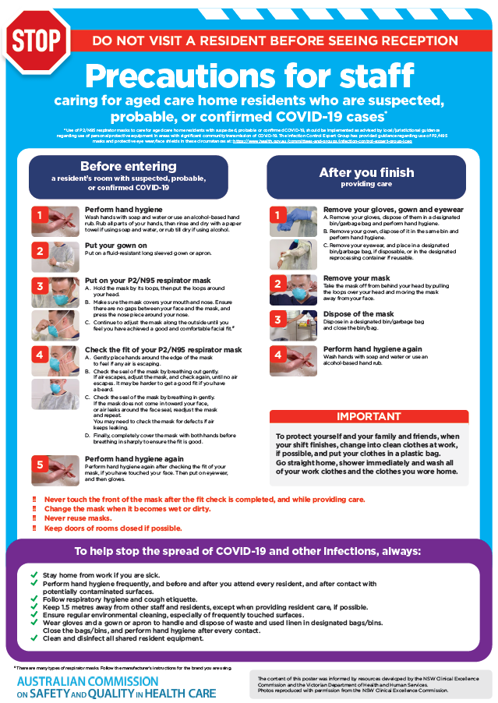](https://www.safetyandquality.gov.au/publications-and-resources/resource-library/covid-19-aged-care-staff-infection-prevention-and-control-precautions-poster)
* ***Environmental Cleaning and Infection Prevention and Control*** [www.safetyandquality.gov.au/environmental-cleaning](http://www.safetyandquality.gov.au/environmental-cleaning)
* ***Infection prevention and control Covid-19 PPE*** poster <https://www.safetyandquality.gov.au/publications-and-resources/resource-library/infection-prevention-and-control-covid-19-personal-protective-equipment>
* ***Special precautions for Covid-19 designated zones*** poster <https://www.safetyandquality.gov.au/publications-and-resources/resource-library/special-precautions-covid-19-designated-zones>
* ***COVID-19 infection prevention and control risk management – Guidance*** <https://www.safetyandquality.gov.au/publications-and-resources/resource-library/covid-19-infection-prevention-and-control-risk-management-guidance>
* ***Safe care for people with cognitive impairment during COVID-19***<https://www.safetyandquality.gov.au/our-work/cognitive-impairment/cognitive-impairment-and-covid-19>
* **Medicines Management COVID-19** <https://www.safetyandquality.gov.au/our-work/medication-safety/medicines-management-covid-19>, including position statements on medicine-related issues
  + ***Managing fever associated with COVID-19***
  + ***Managing a sore throat associated with COVID-19***
  + ***ACE inhibitors and ARBs in COVID-19***
  + ***Clozapine in COVID-19***
  + ***Management of patients on oral anticoagulants during COVID-19***
  + ***Ascorbic Acid: Intravenous high dose in COVID-19***
  + ***Treatment in acute care, including oxygen therapy and medicines to support intubation***
  + ***Nebulisation and COVID-19***
  + ***Managing intranasal administration of medicines during COVID-19***
  + ***Ongoing medicines management in high-risk patients***
  + ***Medicines shortages***
  + ***Conserving medicines***
  + ***Intravenous medicines administration in the event of an infusion pump shortage***
* ***Potential medicines to treat COVID-19***   
  <https://www.safetyandquality.gov.au/publications-and-resources/resource-library/potential-medicines-treat-covid-19>
* ***Break the chain of infection: Stopping COVID-19*** poster<https://www.safetyandquality.gov.au/publications-and-resources/resource-library/break-chain-poster-a3>  
  **[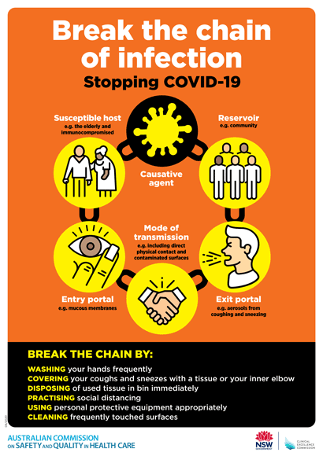](https://www.safetyandquality.gov.au/publications-and-resources/resource-library/break-chain-poster-a3https:/www.safetyandquality.gov.au/publications-and-resources/resource-library/break-chain-poster-a3)**
* ***COVID-19: Elective surgery and infection prevention and control precautions*** <https://www.safetyandquality.gov.au/publications-and-resources/resource-library/covid-19-elective-surgery-and-infection-prevention-and-control-precautions>
* ***FAQs for clinicians on elective surgery*** <https://www.safetyandquality.gov.au/node/5724>
* ***FAQs for consumers on elective surgery*** <https://www.safetyandquality.gov.au/node/5725>
* ***FAQs on community use of face masks***   
   <https://www.safetyandquality.gov.au/faqs-community-use-face-masks>
* ***COVID-19 and face masks – Information for consumers*** <https://www.safetyandquality.gov.au/publications-and-resources/resource-library/covid-19-and-face-masks-information-consumers>  
  The Commission’s fact sheet on use of face masks in the community to reduce the spread of COVID-19 is now available in Easy English and 10 other community languages from <https://www.safetyandquality.gov.au/wearing-face-masks-community>.  
  The factsheet was developed to help people understand when it is important to wear a mask to reduce the risk of the spread of COVID-19, and to explain how to safely put on and remove face masks. It also reinforces the importance of staying home if you have symptoms, physical distancing, hand hygiene and cough etiquette.

[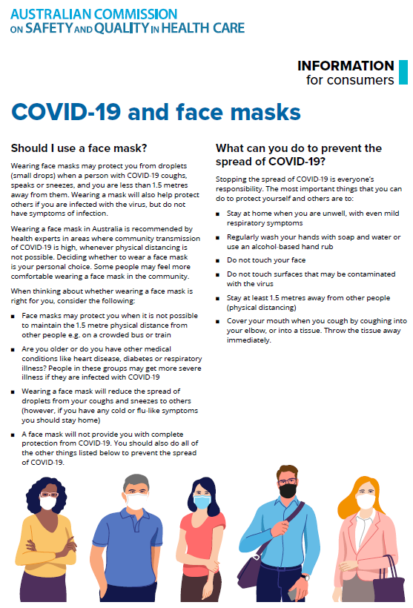](https://www.safetyandquality.gov.au/sites/default/files/2020-07/covid-19_and_face_masks_-_information_for_consumers.pdf)

***Clostridioides difficile* infection 2018 Data Snapshot**

Australian Commission on Safety and Quality in Health Care

Sydney: ACSQHC; 2020. p. 14.

<https://www.safetyandquality.gov.au/publications-and-resources/resource-library/clostridium-difficile-infection-2018-data-snapshot>

The third data snapshot report on the prevalence of *Clostridioides difficile* infection (CDI) in Australian public hospitals has been published on the Commission’s website, along with an infographic to highlight the key findings from the report (<https://www.safetyandquality.gov.au/publications-and-resources/resource-library/clostridium-difficile-infographic>)

This report provides an overview of the burden of CDI in Australian public hospitals in 2018.

The report’s analyses support review and assessment of the CDI burden nationally. State and territory health authorities and health service organisations should consider the use of timely local patient administrative data, such as the model presented in this report, in conjunction with other relevant surveillance information to evaluate the local epidemiology of CDI and inform local strategies for the control of potential CDI outbreaks.

In 2018, the average rate for all CDI diagnoses (principal and non-principal combined) was 4.05 diagnoses per 10,000 patient bed days. From 2016 to 2018, there was an upward trend in the average yearly rate for all CDI diagnoses.

An amalgam report that summarises the findings from the three CDI data snapshot reports from 2016, 2017 and 2018, as well as discussion on the case validation used for CDI surveillance and the future directions for CDI surveillance in Australia will be released later 2020.

**[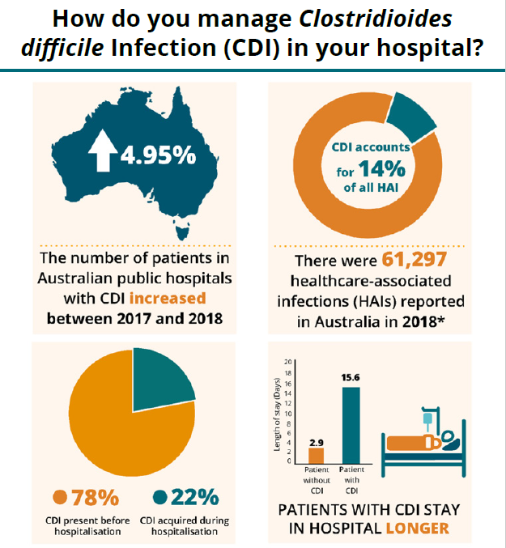](https://www.safetyandquality.gov.au/publications-and-resources/resource-library/clostridium-difficile-infographic)**

**Reports**

*Aboriginal Community Controlled Health Organisations in practice: sharing ways of working from the ACCHO sector*

The Centre of Research Excellence in Aboriginal Chronic Disease Knowledge Translation and Exchange

Adelaide: Wardliparingga Aboriginal Health Equity Theme and the South Australian Health and Medical Research Institute.; 2020.

|  |  |
| --- | --- |
| URL | <https://create.sahmri.org/> |
| Notes | This resource showcases the Aboriginal Community Controlled Health Organisation (ACCHO) sector. It highlights ACCHO ways of working and has been developed for workforce within ACCHOs and other Indigenous primary health care organisations. The resource may be used to support evaluation of existing programs and service delivery models, induction of new staff, workforce capacity building, strategic planning processes, funding applications or future research endeavours.  The resource contains ten chapters that each describe ACCHO practices in one domain. Policy briefs have also been developed to summarise the challenges and policy implications related to each chapter of the resource, with the exception of Chapter 2 (Governance chapter). The chapters include:   1. Characteristics of ACCHO Comprehensive Primary Health Care Service Delivery 2. Doing it Our Way: Governance in ACCHOs 3. Strengthening ACCHO Workforce 4. Addressing the Social Determinants of Health: ACCHO practices and principles 5. ACCHO Comprehensive Health Promotion 6. Caring for Elders in practice: Aged Care in ACCHOs 7. Approaches to Funding in newly established ACCHOs 8. A Health Check for the service: ACCHO approaches to accreditation 9. It’s everyone’s business: Continuous Quality Improvement in ACCHOs 10. National Key Performance Indicators and ACCHOs. |

**Journal articles**

*Leadership during the COVID-19 pandemic: building and sustaining trust in times of uncertainty*

Ahern S, Loh E

BMJ Leader. 2020:leader-2020-000271.

|  |  |
| --- | --- |
| DOI | <https://dx.doi.org/10.1136/leader-2020-000271> |
| Notes | The(SARS-CoV-2/COVID-19 pandemic has brought many things, including a literature reflecting on many aspects of life in a pandemic. This commentary piece reflects on the importance of trust as it applies to healthcare. This include trust at various levels including the system, organisational and individual. The authors reflect on developing and sustaining trust through preparedness, planning, action, being adaptive, responsibility, accountability, connection, authenticity, etc. They also suggest that ‘As COVID-19 continues to play out over the globe, it is becoming clear that trust ultimately also requires leaders to offer hope, a credible vision of our lives for the future and guidance on how it can be achieved.’  It could be said that perhaps this is not just true of leading in a pandemic but simply trust is central to leadership. |

*What safety events are reported for ambulatory care? Analysis of incident reports from a patient safety organization*

Sharma AE, Yang J, Del Rosario JB, Hoskote M, Rivadeneira NA, Stakeholder Research Advisory Council, et al

The Joint Commission Journal on Quality and Patient Safety. 2020 [epub].

|  |  |
| --- | --- |
| DOI | <https://doi.org/10.1016/j.jcjq.2020.08.010> |
| Notes | Paper reporting on a study of patient safety reports in ambulatory care settings collected from a ‘patient safety organization’ covering 400 hospitals in 10 US states in the period May 2012 to October 2018. The 2,071 events analysed included 51 deaths, 159 severe harm events, 1,180 moderate harm, 926 mild harm, 384 no harm events. The findings include:   * Most were from outpatient subspecialty care, while 5.2% were from home/community, and 2.1% were from primary care * Medication-related events were most common (45.3%) * Diagnostic errors, patient/caregiver challenges, and events in the home/community and in psychiatric settings were associated with higher harm. |

*Nursing Leadership*

Volume 33, Number 3, 2020

|  |  |
| --- | --- |
| URL | <https://www.longwoods.com/publications/nursing-leadership/26318/1/vol.-33-no.-3-2020> |
| Notes | A new issue of *Nursing Leadership* has been published with a special focus on Introduction To Crisis Leadership. Articles in this issue of *Nursing Leadership* include:   * Editorial: A **Cockeyed Optimist** (Lynn M Nagle) * Letter to the Editor: Re: CJNL 32.4 - Special Focus on the **NCLEX-RN Experience in Canada** (David Byres, Natasha Prodan-Bhalla and R Lynn Stevenson) * Weathering **Pandemic Turbulence**: It’s All about Relationships (Mary McAllister) * The Impact of **COVID-19 within Academic Settings**: A High-Speed Pivot (Joan Almost) * **Community Care and COVID-19**: A Case Study (Barbara Mildon) * Using the Synergy Tool to Determine Regina **Emergency Department Staffing Needs** (Maura MacPhee, Joan Wagner, Sonia A Udod, Lois Berry, Glen Perchie and Aidan Conway) * Implementation of a Preparedness Program to Address **Violent Situations in Healthcare** (Jacqueline J Johnson-Howell and Della J Derscheid) * Book Review: A Knapsack Full of Dreams: **Memoirs of a Street Nurse** (Natalie Stake-Doucet) |

*BMJ Quality & Safety*

November 2020 - Volume 29 - 11

|  |  |
| --- | --- |
| URL | <https://qualitysafety.bmj.com/content/29/11> |
| Notes | A new issue of *BMJ Quality & Safety* has been published. Many of the papers in this issue have been referred to in previous editions of *On the Radar* (when they were released online). Articles in this issue of *BMJ Quality & Safety* include:   * Editorial: Making **communication and resolution programmes mission critical** in healthcare organisations (Thomas H Gallagher, Richard C Boothman, Leilani Schweitzer, Evan M Benjamin) * Editorial: Making MAGIC: how to improve the use of **peripherally inserted central catheters** (Vineet Chopra) * Association of **open communication and the emotional and behavioural impact of medical error** on patients and families: state-wide cross-sectional survey (Julia C Prentice, Sigall K Bell, Eric J Thomas, Eric C Schneider, Saul N Weingart, Joel S Weissman, Mark J Schlesinger) * Ensuring successful implementation of **communication-and-resolution programmes** (Michelle M Mello, Stephanie Roche, Yelena Greenberg, Patricia Henry Folcarelli, Melinda Biocchi Van Niel, Allen Kachalia) * Appropriateness of **peripherally inserted central catheter** use among general medical inpatients: an observational study using routinely collected data (Amol A Verma, Alexander Kumachev, Sonam Shah, Yishan Guo, Hae Young Jung, Shail Rawal, Lauren Lapointe-Shaw, Janice L Kwan, Adina Weinerman, Terence Tang, Fahad Razak) * Reduction of **paediatric head CT utilisation** at a rural general hospital emergency department (Jeffrey Paul Louie, Joseph Alfano, Thuy Nguyen-Tran, Hai Nguyen-Tran, Ryan Shanley, Tara Holm, Ronald A Furnival) * Cluster randomised controlled trial evaluating the clinical and humanistic impact of a **pharmacist-led minor ailment service** (Sarah Dineen-Griffin, Shalom I Benrimoj, Kris Rogers, Kylie A Williams, Victoria Garcia-Cardenas) * Out of sight, out of mind: a prospective observational study to estimate the duration of the **Hawthorne effect on hand hygiene events** (Alon Vaisman, Grace Bannerman, John Matelski, Kathryn Tinckam, Susy S Hota) * CODE: a practical framework for advancing **patient-centred code status discussions** (Alec Petersen, James A Tulsky, Mallika Mendu) * **To improve quality, keep your eyes on the road** (Marc Philip T Pimentel, John Matthew Austin, Allen Kachalia) * **Improving access in a VA primary care clinic** using an innovative Panel Retention Tool: a quality improvement report (Andrew T Harris, Catherine Hoover, Brendan Cmolik, Mariel Zaun, Corinna Falck-Ytter, Mamta K Singh) |

*Pediatric Quality & Safety*

Vol. 5, No. 5, September/October 2020

|  |  |
| --- | --- |
| URL | <https://journals.lww.com/pqs/toc/2020/09000> |
| Notes | A new issue of *Pediatric Quality & Safety* has been published. Articles in this issue of *Pediatric Quality & Safety* include:   * **Physician Burnout at a Children’s Hospital**: Incidence, Interventions, and Impact (Gogi Kumar, Adam Mezoff) * A Quality Improvement Initiative to Improve **Perioperative Hypothermia Rates in the NICU** Utilizing Checklists (Morcos Hanna, Zeyar Htun, Shahidul Islam, Nazeeh Hanna, Ulka Kothari, Amrita Nayak) * Plan-Do-Study-Act Methodology: Refining an **Inpatient Pediatric Sepsis Screening Process** (Kathryn E Nuss, Jillian S Kunar, Erin A. Ahrens) * Diurnal Variation in **Medical Emergency Team Calls at a Tertiary Care Children’s Hospital** (Susan R Conway, Ken Tegtmeyer, Derek S Wheeler, Allison Loechtenfeldt, Erika L Stalets, Patrick W Brady) * Nurse-driven Clinical Pathway Based on an Innovative **Asthma Score Reduces Admission Time** for Children (Machtelt H Sjoerdsma, Thom H G Bongaerts, Lidy van Lente, Arvid W A Kamps) * Learning by Doing: Design and Evaluation of a **Quality Improvement Curriculum for Pediatric Hospitalists** (John Szymusiak, A McCormick) * Prospective Evaluation of the Safety and Efficacy of THRIVE for **Children Undergoing Airway Evaluation** (Tyler S Okland, George S Liu, Thomas J Caruso, Douglas R Sidell) * Quality Improvement Analyses Revealed a Hidden Shift Following a Retrospective Study on **Breastfeeding Rates** (Jennifer Sedler, I Sheevaun Khaki, Carrie A Phillipi, Dmitry Dukhovny, Kenneth DeVane, L Gievers) * Transitions to Postsecondary Education in **Young Adults with Hemoglobinopathies**: Perceptions of Patients and Staff (Brooke A Allemang, James Bradley, Rosemary Leone, Megan Henze) * A Quality Improvement Approach to Reduce **Unplanned Extubation in the NICU** While Avoiding Sedation and Restraints (C Briana Bertoni, Thomas Bartman, Gregory Ryshen, Brandon Kuehne, Marissa Larouere, Leslie Thomas, Erin Wishloff, Edward Shepherd, J Dillard, L R Pavlek, M Moallem) * **Perioperative Temperature Management in Children**: What Matters? (Shu Ying Lee, Sharon Yuan Kwan Wan, Chin Lin Tay, Zi Hui Tan, Irene Wong, Maureen Chua, John C Allen) * Seventy-two-hour Return Initiative: Improving **Emergency Department Discharge** to Decrease Returns (Nidhya Navanandan, Sarah K Schmidt, Natasha Cabrera, Irina Topoz, Michael C DiStefano, Rakesh D Mistry) * The **Type 1 Diabetes Composite Score**: An Innovative Metric for Measuring Patient Care Outcomes Beyond Hemoglobin A1c (Justin A Indyk, Don Buckingham, K S Obrynba, C Servick, K K Gandhi, A Kramer, M K Kamboj) * Optimizing **Rapid Sequence Intubation** for Medical and Trauma Patients in the Pediatric Emergency Department (Berkeley L Bennett, Daniel Scherzer, Delia Gold, Don Buckingham, Andrew McClain, Elaise Hill, Adjoa Andoh, Joseph Christman, Andrew Shonk, Sandra P Spencer) * **Screening Social Determinants of Health** in a Multidisciplinary Severe Asthma Clinical Program (Sydney Leibel, Bob Geng, Wanda Phipatanakul, Euyhyun Lee, Phyllis Hartigan) |

*BMJ Quality & Safety* online first articles

|  |  |
| --- | --- |
| URL | <https://qualitysafety.bmj.com/content/early/recent> |
| Notes | *BMJ Quality &Safety* has published a number of ‘online first’ articles, including:   * Variation in the design of **Do Not Resuscitate orders and other code status options**: a multi-institutional qualitative study (Jason N Batten, Jacob A Blythe, Sarah Wieten, Miriam Piven Cotler, Joshua B Kayser, Karin Porter-Williamson, Stephanie Harman, Elizabeth Dzeng, David Magnus) * Work systems analysis of **sterile processing**: assembly (Myrtede Alfred, Ken Catchpole, Emily Huffer, Larry Fredendall, Kevin M Taaffe) |

*International Journal for Quality in Health Care* online first articles

|  |  |
| --- | --- |
| URL | <https://academic.oup.com/intqhc/advance-articles> |
| Notes | *International Journal for Quality in Health Care* has published a number of ‘online first’ articles, including:   * Innovating Health Care: Key Characteristics of **Human-Centered Design** (Marijke Melles, Armagan Albayrak, Richard Goossens) * **Hospital medication errors**: a cross sectional study (Anton N Isaacs, Kenneth Ch’ng, Naaz Delhiwale, Kieran Taylor, Bethany Kent, Anita Raymond) * The efficiency-thoroughness trade-off after **implementation of electronic medication management**: a qualitative study in pediatric oncology (Melissa T Baysari, Bethany A Van Dort, Mirela Prgomet, Wu Yi Zheng, Magdalena Z Raban) |

**Online resources**

*National COVID-19 Clinical Evidence Taskforce*

<https://covid19evidence.net.au/>

The National COVID-19 Clinical Evidence Taskforce is a collaboration of peak health professional bodies across Australia whose members are providing clinical care to people with COVID-19. The taskforce is undertaking continuous evidence surveillance to identify and rapidly synthesise emerging research in order to provide national, **evidence-based guidelines and clinical flowcharts for the clinical care of people with COVID-19**. The guidelines address questions that are specific to managing COVID-19 and cover the full disease course across mild, moderate, severe and critical illness. These are ‘living’ guidelines, updated with new research in near real-time in order to give reliable, up-to-the minute advice to clinicians providing frontline care in this unprecedented global health crisis.

*COVID-19 Critical Intelligence Unit*

<https://www.aci.health.nsw.gov.au/covid-19/critical-intelligence-unit>

The Agency for Clinical Innovation (ACI) in New South Wales has developed this page summarising rapid, evidence-based advice during the COVID-19 pandemic. Its operations focus on systems intelligence, clinical intelligence and evidence integration. The content includes a daily evidence digest and evidence checks on a discrete topic or question relating to the current COVID-19 pandemic.

[*UK] NICE Guidelines and Quality Standards*

<https://www.nice.org.uk/guidance>

The UK’s National Institute for Health and Care Excellence (NICE) has published new (or updated) guidelines and quality standards. The latest reviews or updates are:

* Quality Standard QS47 ***Heavy menstrual bleeding*** <https://www.nice.org.uk/guidance/qs47>

**Disclaimer**

On the Radar is an information resource of the Australian Commission on Safety and Quality in Health Care. The Commission is not responsible for the content of, nor does it endorse, any articles or sites listed. The Commission accepts no liability for the information or advice provided by these external links. Links are provided on the basis that users make their own decisions about the accuracy, currency and reliability of the information contained therein. Any opinions expressed are not necessarily those of the Australian Commission on Safety and Quality in Health Care.