# Australian COmmission on Safety and Quality in Health Care logo with Radar imageOn the Radar

Issue 488

2 November 2020

*On the Radar* is a summary of some of the recent publications in the areas of safety and quality in health care. Inclusion in this document is not an endorsement or recommendation of any publication or provider. Access to particular documents may depend on whether they are Open Access or not, and/or your individual or institutional access to subscription sites/services. Material that may require subscription is included as it is considered relevant.

*On the Radar* is available online, via email or as a PDF or Word document from <https://www.safetyandquality.gov.au/publications-and-resources/newsletters/radar>

If you would like to receive *On the Radar* via email, you can subscribe on our website <https://www.safetyandquality.gov.au/publications-and-resources/newsletters>   
or by emailing us at H[Umail@safetyandquality.gov.auU](mailto:mail@safetyandquality.gov.au).   
You can also send feedback and comments to H[Umail@safetyandquality.gov.auU](mailto:mail@safetyandquality.gov.au).

For information about the Commission and its programs and publications, please visit <https://www.safetyandquality.gov.au>

You can also follow us on Twitter @ACSQHC.

**On the Radar**

Editor: Dr Niall Johnson [niall.johnson@safetyandquality.gov.au](mailto:niall.johnson@safetyandquality.gov.au)

Contributors: Niall Johnson, Kristin Xenos, Luke Slawomirski

**COVID-19 resources**

https://www.safetyandquality.gov.au/covid-19

The Australian Commission on Safety and Quality in Health Care has developed a number of resources to assist healthcare organisations, facilities and clinicians. These and other material on COVID-19 are available at <https://www.safetyandquality.gov.au/covid-19>

The latest additions include:

* ***COVID-19: Aged care staff infection prevention and control precautions*** *poster*<https://www.safetyandquality.gov.au/publications-and-resources/resource-library/covid-19-aged-care-staff-infection-prevention-and-control-precautions-poster>  
    
  [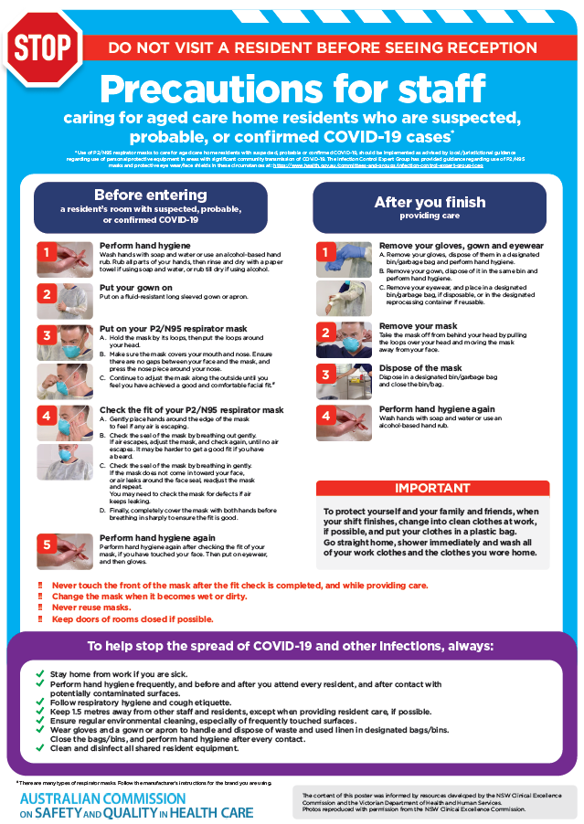](https://www.safetyandquality.gov.au/publications-and-resources/resource-library/covid-19-aged-care-staff-infection-prevention-and-control-precautions-poster)
* ***Environmental Cleaning and Infection Prevention and Control*** [www.safetyandquality.gov.au/environmental-cleaning](http://www.safetyandquality.gov.au/environmental-cleaning)
* ***Infection prevention and control Covid-19 PPE*** poster <https://www.safetyandquality.gov.au/publications-and-resources/resource-library/infection-prevention-and-control-covid-19-personal-protective-equipment>
* ***Special precautions for Covid-19 designated zones*** poster <https://www.safetyandquality.gov.au/publications-and-resources/resource-library/special-precautions-covid-19-designated-zones>
* ***COVID-19 infection prevention and control risk management – Guidance*** <https://www.safetyandquality.gov.au/publications-and-resources/resource-library/covid-19-infection-prevention-and-control-risk-management-guidance>
* ***Safe care for people with cognitive impairment during COVID-19***<https://www.safetyandquality.gov.au/our-work/cognitive-impairment/cognitive-impairment-and-covid-19>
* **Medicines Management COVID-19** <https://www.safetyandquality.gov.au/our-work/medication-safety/medicines-management-covid-19>, including position statements on medicine-related issues
  + ***Managing fever associated with COVID-19***
  + ***Managing a sore throat associated with COVID-19***
  + ***ACE inhibitors and ARBs in COVID-19***
  + ***Clozapine in COVID-19***
  + ***Management of patients on oral anticoagulants during COVID-19***
  + ***Ascorbic Acid: Intravenous high dose in COVID-19***
  + ***Treatment in acute care, including oxygen therapy and medicines to support intubation***
  + ***Nebulisation and COVID-19***
  + ***Managing intranasal administration of medicines during COVID-19***
  + ***Ongoing medicines management in high-risk patients***
  + ***Medicines shortages***
  + ***Conserving medicines***
  + ***Intravenous medicines administration in the event of an infusion pump shortage***
* ***Potential medicines to treat COVID-19***   
  <https://www.safetyandquality.gov.au/publications-and-resources/resource-library/potential-medicines-treat-covid-19>
* ***Break the chain of infection: Stopping COVID-19*** poster<https://www.safetyandquality.gov.au/publications-and-resources/resource-library/break-chain-poster-a3>  
  **[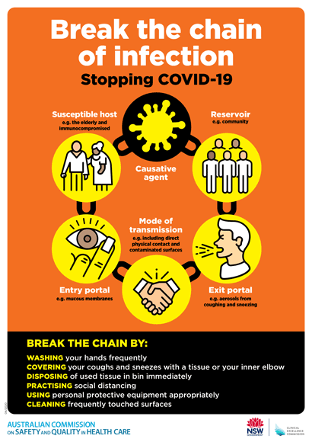](https://www.safetyandquality.gov.au/publications-and-resources/resource-library/break-chain-poster-a3https:/www.safetyandquality.gov.au/publications-and-resources/resource-library/break-chain-poster-a3)**
* ***COVID-19: Elective surgery and infection prevention and control precautions*** <https://www.safetyandquality.gov.au/publications-and-resources/resource-library/covid-19-elective-surgery-and-infection-prevention-and-control-precautions>
* ***FAQs for clinicians on elective surgery*** <https://www.safetyandquality.gov.au/node/5724>
* ***FAQs for consumers on elective surgery*** <https://www.safetyandquality.gov.au/node/5725>
* ***FAQs on community use of face masks***   
   <https://www.safetyandquality.gov.au/faqs-community-use-face-masks>
* ***COVID-19 and face masks – Information for consumers*** <https://www.safetyandquality.gov.au/publications-and-resources/resource-library/covid-19-and-face-masks-information-consumers>  
  The Commission’s fact sheet on use of face masks in the community to reduce the spread of COVID-19 is now available in Easy English and 10 other community languages from <https://www.safetyandquality.gov.au/wearing-face-masks-community>.  
  The factsheet was developed to help people understand when it is important to wear a mask to reduce the risk of the spread of COVID-19, and to explain how to safely put on and remove face masks. It also reinforces the importance of staying home if you have symptoms, physical distancing, hand hygiene and cough etiquette.

[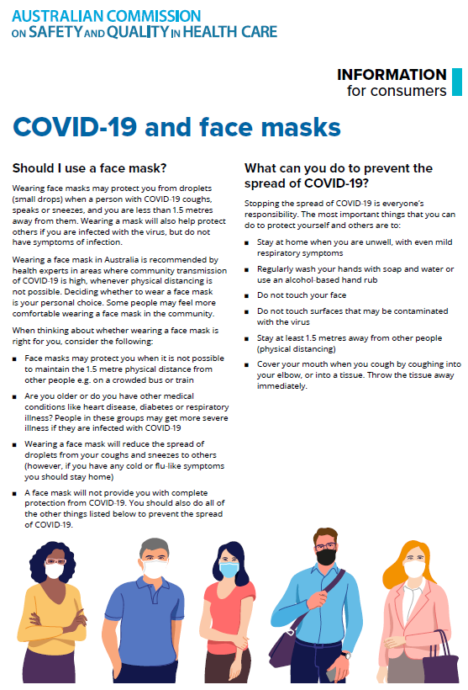](https://www.safetyandquality.gov.au/sites/default/files/2020-07/covid-19_and_face_masks_-_information_for_consumers.pdf)

**Antimicrobial Stewardship in Australian Health Care Book – Antimicrobial Stewardship in the Care of Children – Chapter 14**

<https://www.safetyandquality.gov.au/publications-and-resources/resource-library/antimicrobial-stewardship-australian-health-care-2018>

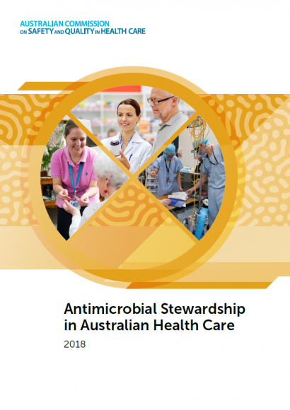

Australian Commission on Safety and Quality in Health Care

Role of general practice in antimicrobial stewardship

*Antimicrobial Stewardship in Australian Health Care*

Sydney: ACSQHC; 2020.

A new chapter has been added to *Antimicrobial Stewardship in Australian Health Care*. The new chapter, *Antimicrobial Stewardship in the Care of Children,* deals with antimicrobial stewardship (AMS) and the care of children. Key elements include:

* An overview of antimicrobial use, resistance and stewardship for children and young people
* Factors that influence antimicrobial prescribing for children and young people
* Details to support antimicrobial stewardship strategies in paediatric settings
* Implementing and leading antimicrobial stewardship in paediatric care
* Measuring AMS performance.

The chapter is available from the Commission’s web page at <https://www.safetyandquality.gov.au/publications-and-resources/resource-library/antimicrobial-stewardship-australian-health-care-2018>

**Reports**

*The Economics of Patient Safety: From analysis to action*

Slawomirski L, Klazinga NS

Paris: OECD; 2020. p. 77.

|  |  |
| --- | --- |
| URL | <https://www.oecd.org/health/health-systems/Economics-of-Patient-Safety-October-2020.pdf> |
| Notes | *From Analysis to Action*, the latest addition to the OECD’s Economics of Patient Safety reports, provides further evidence about the high cost of patient harm and the best way to address it across an entire healthcare system. Globally, unsafe care claims over 3 million lives each year. The mortality burden exceeds that of malaria, TB and diabetes and is just below HIV/AIDS. Most of this is felt in the developing world, but adverse events continue to be a significant problem in high-income countries.  The report suggests that 12.6% of all health expenditure is consumed by managing the clinical effects of unsafe care. Factoring in preventability of adverse events reduces this figure to 8.6%. This amounts to over USD 600billion per annum across OECD countries; in Australia it represents AUD 16.5 billion a year. The indirect costs are also considerable. The report estimates that the consequences of patient harm slow global economic growth by 0.76%. This amounts to trillions of dollars every year.  The report suggests that investing in safety can deliver high returns because it improves outcomes while, at the same time, reducing costs. For example, interventions targeting healthcare-associated infections can deliver a 7-fold return on investment, even in developed-world health systems. Also, evidence for the role of digital technologies in reducing harms such as adverse drug events and diagnostic error has grown considerably. But interventions aimed at minimising harm in the clinical microsystem are more effective if implemented within an overarching framework comprising *inter alia*: good governance, 21st century information infrastructure and data collection, appropriate staffing, education and training, aligned risks and incentives and a culture that puts patient welfare and outcomes at the heart of everything a health service or organisation does. |

*Investigation into the Role of Clinical Pharmacy Services in Helping to Identify and Reduce High-risk Prescribing Errors in Hospital*

Healthcare Safety Investigation I2018/019

Healthcare Safety Investigation Branch

Farnborough: HSIB; 2020. p. 78.

|  |  |
| --- | --- |
| URL | <https://www.hsib.org.uk/investigations-cases/high-risk-prescribing-errors-hospital/> |
| Notes | This is the latest report from the UK’s Healthcare Safety Investigation Branch (HSIB) and examines how clinical pharmacy services could be engaged in preventing prescribing errors in the hospital setting. The investigation was spurred by an incident where a hospital inpatient was administered repeated doses of warfarin in error and suffered significant harm as a result. The investigation examined:   * Systems and processes which underpin the identification, prescribing and administration of warfarin for older inpatients. * Main patient safety risks arising from the prescribing and administration of warfarin and other high-risk drugs. * Main patient safety defences that act to protect people from medication errors with high-risk medicines.   The report offers a number of findings, observations and recommendations, including   * Ward-based clinical pharmacy services can play an important role in helping the multidisciplinary team to identify and reduce high-risk medication errors. * The impact of a complex patient caseload or operational pressures on the ability of ward-based clinical pharmacy services to operate and adapt effectively is not well studied. * Pharmaceutical care of older people is a complex and increasingly demanding specialty that involves caring for patients at the greatest risk of medicine-related harm. * Effective clinical pharmacy services have been evidenced to improve a range of measures linked to efficiency and patient safety in acute hospitals. * Further integration of clinical pharmacy services within the MDT and within strategic decision making may improve a shared understanding of which medicines and situations place patients at greater risk of serious medication errors occurring. * Clinical pharmacy services should consider using validated tools to assist in prioritising pharmacy care and identifying high-risk medicines and high-risk situations for medication error. Where electronic medical record systems are used, such tools could be integrated into these systems to aid prioritisation. * Caring for older patients in hospital often presents a high-risk situation for medication errors occurring. Further efforts should be made to learn from technological developments and the organisation of pharmacy services in other high-risk areas of care that may improve system resilience in older persons care.   A summary report is also available. |

For information on the Commission’s work on medication safety, see <https://www.safetyandquality.gov.au/our-work/medication-safety>

**Journal articles**

*Medical Care of Adults With Down Syndrome: A Clinical Guideline*

Tsou AY, Bulova P, Capone G, Chicoine B, Gelaro B, Harville TO, et al

JAMA. 2020;324(15):1543-1556.

|  |  |
| --- | --- |
| DOI | <https://doi.org/10.1001/jama.2020.17024> |
| Notes | The authors of this piece observe that ‘Down syndrome is the most common chromosomal condition’. However, they also note that ‘Despite the unique clinical comorbidities among adults with Down syndrome, there are no clinical guidelines for the (primary) care of these patients.’ This has led to the development of this guideline providing evidence-based recommendations across behavioural health, dementia, diabetes, cardiovascular disease prevention, stroke prevention, obesity, atlantoaxial instability, osteoporosis, thyroid disease, and celiac disease. |

*Identifying Recommendations for Stopping or Scaling Back Unnecessary Routine Services in Primary Care*

Kerr EA, Klamerus ML, Markovitz AA, Sussman JB, Bernstein SJ, Caverly TJ, et al

JAMA Internal Medicine. 2020 [epub].

*De-adopting Low-Value Care: Evidence, Eminence, and Economics*

Powers BW, Jain SH, Shrank WH.

Journal of the American Medical Association. 2020;324(16):1603-1604.

|  |  |
| --- | --- |
| DOI | Kerr et al <https://doi.org/10.1001/jamainternmed.2020.4001>  Powers et al <https://doi.org/10.1001/jama.2020.17534> |
| Notes | A pair of articles looking at how to reduce (stopping, scaling back or de-adopting) the use of low value or unnecessary activity.  Kerr at el sought to determine if a systematic, transparent, and reproducible approach could be developed to identify, specify, and validate ‘deintensification recommendations’ associated with routine adult primary care. Using a focused review of existing guidelines and recommendations the authors report that 178 recommendations that ‘represented unique opportunities to stop or scale back routine services were identified from a set of established guidelines, measures, and Choosing Wisely recommendations.’ Expert panels reviewed the evidence and suggested modifications, resulting in 37 being validated as high-priority deintensification recommendations.  Powers et al observe that while innovation can be slow to be adopted, medicine can also ‘slow to abandon practices that provide little or no benefit to patients’. The authors of this piece offer a trio of ‘forces that govern the de-adoption of low-value care—evidence, eminence, and economics’ and provide some case examples to illustrate their point and discuss the policy implications.  In locations where there is a single or dominant payer, often a government, the decision to not fund low value or unnecessary activity or limit the circumstances in which it will be funded or reimbursed has the potential to be quite a strong lever – when it is used. |

*Journal of Patient Safety and Risk Management*

Volume: 25, Number: 5 (October 2020)

|  |  |
| --- | --- |
| URL | <https://journals.sagepub.com/toc/cric/25/5> |
| Notes | A new issue of the *Journal of Patient Safety and Risk Management* has been published. Articles in this issue of the *Journal of Patient Safety and Risk Management* include:   * Editorial: **Health worker well-being and resilience**: A Red Ball issue for the COVID-19 response (Albert W Wu) * **World patient safety day**: A call for action on **health worker safety** (Liam J Donaldson and Dhingra Neelam) * **Lessons learned after six months at war with COVID-19** (Jennifer Milesky) * **Hand hygiene compliance among healthcare workers** in Ghana’s health care institutions: An observational study (Aaron Asibi Abuosi, Samuel Kaba Akoriyea, Gloria Ntow-Kummi, Joseph Akanuwe, Patience Aseweh Abor, Anita Anima Daniels, and Robert Kaba Alhassan) * **Informed consent**, Montgomery and the duty to discuss alternative treatments in England and Australia (Tracey Carver) * **No liability for rare complication** – Nicholas Collyer v. Mid Essex Hospital Services NHS Trust (High Court, 20 December 2019 – Judge Coe QC) (John Mead) * **Communication science lessons for patient safety and quality care** (Annegret F Hannawa, Brian H Spitzberg, Marcia D Childress, Richard Frankel, Julius C Pham, and Albert W Wu) * **Occupational risk prevention, education and support** in black, Asian and ethnic minority health worker in the COVID-19 pandemic (Nicholas H Morris, Sohier Elneil, David Morris, Peter Ellis, and Sabaratnam Arulkumaran) |

*Healthcare Quarterly*

Volume 23, Number 3, 2020

|  |  |
| --- | --- |
| URL | <https://www.longwoods.com/publications/healthcare-quarterly/26331/1/vol.-23-no.-3-2020> |
| Notes | A new issue of *Healthcare Quarterly* has been published. Articles in this issue of *Healthcare Quarterly* include:   * **Mental Health and Addictions System Performance** in Ontario: An Updated Scorecard, 2009–2017 (Maria Chiu, Astrid Guttmann and P Kurdyak) * **Hospital Stays for Harm Caused by Substance Use among Youth** in Canada (Erin Pichora, Alexey Dudevich, Geoffrey Hynes and Christina Catley) * Responding To The Covid-19 Pandemic: Mobilizing a Whole Community: Policy and Strategy Implications of an **Integrated Local System Response to a Global Health Crisis** (Anne Wojtak, Jason Altenberg, Carol Annett, Anne Babcock, Keith Chung, Sarah Downey, Mark Fam, Ian Fraser, Kate Mason, Thuy-Nga (Tia) Pham, Jeff Powis, Ashnoor Rahim, Jarred Rosenberg and Catherine Yu) * Responding To The Covid-19 Pandemic: Finding a New Normal: **Hospital Governance Best Practices during COVID-19** (Nyranne Martin) * Responding To The Covid-19 Pandemic: A **Rapid Primary Healthcare Response to COVID-19**: An Equity-Based and Systems- Thinking Approach to Care Ensuring that No One Is Left Behind (Sara Bhatti, Elana Commisso and Jennifer Rayner) * Innovation in Health Services: Cost Impact of a **Pharmacist-Driven Medication Reconciliation Program during Transitions to Long-Term Care** and Retirement Homes (Denis O’Donnell, Carla Beaton, June Liang, Kisalaya Basu, Michael Hum, Amanda Propp, Liz Yanni, Yannan Chen and Parnian Ghafari) * Healthcare Governance: **Measuring Boards** Using Quantitative Tools from Natural Language Processing (Lewis Hooper) * Quality Improvement: **Physician Initial Assessment Times** Based on CTAS Scores: Are We Meeting the Recommendations? (Mazen El-Baba, Ryan Ramos, Leila Salehi, Qamar Amin, Shira Brown, Suneel Upadhye and Rahim Valani) * Digital Health: **Electronic Health Record-Related Burnout** among Clinicians: Practical Recommendations for Canadian Healthcare Organizations (Brian Lo, Jessica Kemp, Clare Cullen, Tania Tajirian, Damian Jankowicz and Gillian Strudwick) |

*BMJ Quality & Safety* online first articles

|  |  |
| --- | --- |
| URL | <https://qualitysafety.bmj.com/content/early/recent> |
| Notes | *BMJ Quality &Safety* has published a number of ‘online first’ articles, including:   * **Trauma Resuscitation Using in situ Simulation Team Training** (TRUST) study: latent safety threat evaluation using framework analysis and video review (Andrew Petrosoniak, Mark Fan, Christopher M Hicks, Kari White, Melissa McGowan, Doug Campbell, Patricia Trbovich) * **Inpatient patient safety events in vulnerable populations**: a retrospective cohort study (Lucy B Schulson, Victor Novack, Patricia H Folcarelli, Jennifer P Stevens, Bruce E Landon) * Changes in **weekend and weekday care quality of emergency medical admissions** to 20 hospitals in England during implementation of the 7-day services national health policy (Julian Bion, Cassie Aldridge, Alan J Girling, Gavin Rudge, Jianxia Sun, Carolyn Tarrant, Elizabeth Sutton, Janet Willars, Chris Beet, Amunpreet Boyal, Peter Rees, Chris Roseveare, Mark Temple, Samuel Ian Watson, Yen-Fu Chen, Mike Clancy, Louise Rowan, Joanne Lord, Russell Mannion, Timothy Hofer, Richard Lilford) * Editorial: **Achieving patient priorities**: an alternative to patient-reported outcome measures (PROMs) for promoting patient-centred care (Aanand D Naik, Angela Catic) * Role of practices and Clinical Commissioning Groups in **measures of patient experience**: analysis of routine data (Mayam Gomez-Cano, Emily Fletcher, John L Campbell, Marc Elliott, Jenni Burt, Gary Abel) * Editorial: Unravelling the magic of **latent safety threats** (Yadin David) |

*International Journal for Quality in Health Care* online first articles

|  |  |
| --- | --- |
| URL | <https://academic.oup.com/intqhc/advance-articles> |
| Notes | *International Journal for Quality in Health Care* has published a number of ‘online first’ articles, including:   * A Novel Method of **Assessing Clinical Preparedness** for COVID-19 and Other Disasters (Harriet Fisher, Cherilyn Re, Jeffrey A Wilhite, Kathleen Hanley, Lisa Altshuler, James Schmidtberger, Morris Gagliardi, Sondra Zabar) * **30-Day Readmission Rate Of Covid-19 Patients Discharged** From A Tertiary Care University Hospital In Turkey; An Observational, Single-Center Study (Oğuz Abdullah Uyaroğlu, Nursel Çalık Başaran, Lale Özişik, Gülçin Telli Dizman, İmdat Eroğlu, Taha Koray Şahin, Zahit Taş, Ahmet Çağkan Inkaya, Mine Durusu Tanriover, Gökhan Metan, Gülay Sain Güven, Serhat Ünal) |

**Online resources**

*Future Leaders Communiqué*

<https://www.thecommuniques.com/post/future-leaders-communiqu%C3%A9-volume-5-issue-4-october-2020>

Volume 5, Issue 4, October 2020

This issue of the *Future Leaders Communiqué* focuses on **clinical documentation** and **handover** with an illustrative case and two expert commentaries. The case examines the tragic death of a 6-year-old boy following delays in the diagnosis and management of bacterial sepsis. This case highlights the importance of clinical handover and documentation. The two expert commentaries focus on the importance of the medical record and provide a reflection on the art of clinical communication and record-keeping.

*National COVID-19 Clinical Evidence Taskforce*

<https://covid19evidence.net.au/>

The National COVID-19 Clinical Evidence Taskforce is a collaboration of peak health professional bodies across Australia whose members are providing clinical care to people with COVID-19. The taskforce is undertaking continuous evidence surveillance to identify and rapidly synthesise emerging research in order to provide national, **evidence-based guidelines and clinical flowcharts for the clinical care of people with COVID-19**. The guidelines address questions that are specific to managing COVID-19 and cover the full disease course across mild, moderate, severe and critical illness. These are ‘living’ guidelines, updated with new research in near real-time in order to give reliable, up-to-the minute advice to clinicians providing frontline care in this unprecedented global health crisis.

*COVID-19 Critical Intelligence Unit*

<https://www.aci.health.nsw.gov.au/covid-19/critical-intelligence-unit>

The Agency for Clinical Innovation (ACI) in New South Wales has developed this page summarising rapid, evidence-based advice during the COVID-19 pandemic. Its operations focus on systems intelligence, clinical intelligence and evidence integration. The content includes a daily evidence digest and evidence checks on a discrete topic or question relating to the current COVID-19 pandemic.

[*UK] NICE Guidelines and Quality Standards*

<https://www.nice.org.uk/guidance>

The UK’s National Institute for Health and Care Excellence (NICE) has published new (or updated) guidelines and quality standards. The latest reviews or updates are:

* Diagnostics Guideline DG42 *Testing strategies for Lynch syndrome in people with* ***endometrial cancer*** <https://www.nice.org.uk/guidance/dg42>

*[UK] NIHR Evidence alert*

<https://evidence.nihr.ac.uk/>

The UK’s National Institute for Health Research (NIHR) has posted new evidence alerts on its site. Evidence alerts are short, accessible summaries of health and care research which is funded or supported by NIHR. This is research which could influence practice and each Alert has a message for people commissioning, providing or receiving care. The latest alerts include:

* People with **anorectal melanoma** may not benefit from radical surgery
* A new technique could make more **livers available for transplant**
* Tackling fear and misinformation may help increase **hepatitis C testing** in prison
* Tranexamic acid should not be used for patients with **severe gastrointestinal bleeding**
* A **decision aid** may help people with newly-diagnosed **multiple sclerosis** consider their options for treatment
* Working may improve quality of life for carers of people with **dementia**
* Play and social skills may protect **children who have difficulties with spoken language**
* Prozac may be the best treatment for **young people with depression** – but more research is needed
* Brain and nerve complications are more common than expected in younger patients with **severe COVID-19**
* Results from a routine blood test could help in **early detection of cancer**
* Recommendations from **male students** help shape **mental health** support for this high-risk group
* Sharing electronic records with patients led to improved control of type two **diabetes**
* **People with mild memory problems** are left in limbo between health and dementia, and need help to make lifestyle changes
* **Stroke survivors with vision impairments** need personalised rehabilitation and greater support.

**Disclaimer**

On the Radar is an information resource of the Australian Commission on Safety and Quality in Health Care. The Commission is not responsible for the content of, nor does it endorse, any articles or sites listed. The Commission accepts no liability for the information or advice provided by these external links. Links are provided on the basis that users make their own decisions about the accuracy, currency and reliability of the information contained therein. Any opinions expressed are not necessarily those of the Australian Commission on Safety and Quality in Health Care.