# Australian COmmission on Safety and Quality in Health Care logo with Radar imageOn the Radar

Issue 490

16 November 2020

*On the Radar* is a summary of some of the recent publications in the areas of safety and quality in health care. Inclusion in this document is not an endorsement or recommendation of any publication or provider. Access to particular documents may depend on whether they are Open Access or not, and/or your individual or institutional access to subscription sites/services. Material that may require subscription is included as it is considered relevant.

*On the Radar* is available online, via email or as a PDF or Word document from <https://www.safetyandquality.gov.au/publications-and-resources/newsletters/radar>

If you would like to receive *On the Radar* via email, you can subscribe on our website <https://www.safetyandquality.gov.au/publications-and-resources/newsletters>   
or by emailing us at H[Umail@safetyandquality.gov.auU](mailto:mail@safetyandquality.gov.au).   
You can also send feedback and comments to H[Umail@safetyandquality.gov.auU](mailto:mail@safetyandquality.gov.au).

For information about the Commission and its programs and publications, please visit <https://www.safetyandquality.gov.au>

You can also follow us on Twitter @ACSQHC.

**On the Radar**

Editor: Dr Niall Johnson [niall.johnson@safetyandquality.gov.au](mailto:niall.johnson@safetyandquality.gov.au)

Contributors: Niall Johnson, Kim Stewart

**COVID-19 resources**

https://www.safetyandquality.gov.au/covid-19

The Australian Commission on Safety and Quality in Health Care has developed a number of resources to assist healthcare organisations, facilities and clinicians. These and other material on COVID-19 are available at <https://www.safetyandquality.gov.au/covid-19>

The latest additions include:

* ***COVID-19: Aged care staff infection prevention and control precautions*** *poster*<https://www.safetyandquality.gov.au/publications-and-resources/resource-library/covid-19-aged-care-staff-infection-prevention-and-control-precautions-poster>  
    
  [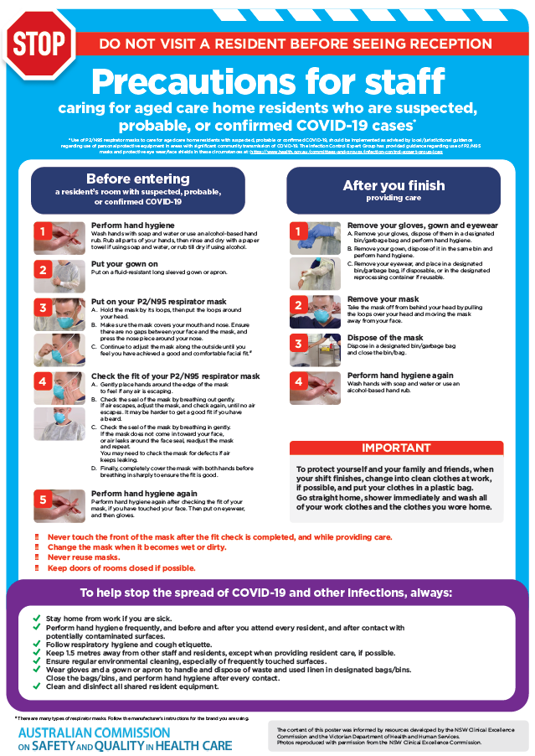](https://www.safetyandquality.gov.au/publications-and-resources/resource-library/covid-19-aged-care-staff-infection-prevention-and-control-precautions-poster)
* ***Environmental Cleaning and Infection Prevention and Control*** [www.safetyandquality.gov.au/environmental-cleaning](http://www.safetyandquality.gov.au/environmental-cleaning)
* ***Infection prevention and control Covid-19 PPE*** poster <https://www.safetyandquality.gov.au/publications-and-resources/resource-library/infection-prevention-and-control-covid-19-personal-protective-equipment>
* ***Special precautions for Covid-19 designated zones*** poster <https://www.safetyandquality.gov.au/publications-and-resources/resource-library/special-precautions-covid-19-designated-zones>
* ***COVID-19 infection prevention and control risk management – Guidance*** <https://www.safetyandquality.gov.au/publications-and-resources/resource-library/covid-19-infection-prevention-and-control-risk-management-guidance>
* ***Safe care for people with cognitive impairment during COVID-19***<https://www.safetyandquality.gov.au/our-work/cognitive-impairment/cognitive-impairment-and-covid-19>
* **Medicines Management COVID-19** <https://www.safetyandquality.gov.au/our-work/medication-safety/medicines-management-covid-19>, including position statements on medicine-related issues
  + ***Managing fever associated with COVID-19***
  + ***Managing a sore throat associated with COVID-19***
  + ***ACE inhibitors and ARBs in COVID-19***
  + ***Clozapine in COVID-19***
  + ***Management of patients on oral anticoagulants during COVID-19***
  + ***Ascorbic Acid: Intravenous high dose in COVID-19***
  + ***Treatment in acute care, including oxygen therapy and medicines to support intubation***
  + ***Nebulisation and COVID-19***
  + ***Managing intranasal administration of medicines during COVID-19***
  + ***Ongoing medicines management in high-risk patients***
  + ***Medicines shortages***
  + ***Conserving medicines***
  + ***Intravenous medicines administration in the event of an infusion pump shortage***
* ***Potential medicines to treat COVID-19***   
  <https://www.safetyandquality.gov.au/publications-and-resources/resource-library/potential-medicines-treat-covid-19>
* ***Break the chain of infection: Stopping COVID-19*** poster<https://www.safetyandquality.gov.au/publications-and-resources/resource-library/break-chain-poster-a3>  
  **[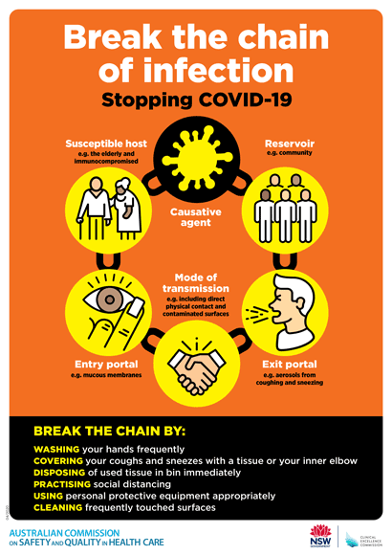](https://www.safetyandquality.gov.au/publications-and-resources/resource-library/break-chain-poster-a3https:/www.safetyandquality.gov.au/publications-and-resources/resource-library/break-chain-poster-a3)**
* ***COVID-19: Elective surgery and infection prevention and control precautions*** <https://www.safetyandquality.gov.au/publications-and-resources/resource-library/covid-19-elective-surgery-and-infection-prevention-and-control-precautions>
* ***FAQs for clinicians on elective surgery*** <https://www.safetyandquality.gov.au/node/5724>
* ***FAQs for consumers on elective surgery*** <https://www.safetyandquality.gov.au/node/5725>
* ***FAQs on community use of face masks***   
   <https://www.safetyandquality.gov.au/faqs-community-use-face-masks>
* ***COVID-19 and face masks – Information for consumers*** <https://www.safetyandquality.gov.au/publications-and-resources/resource-library/covid-19-and-face-masks-information-consumers>  
  The Commission’s fact sheet on use of face masks in the community to reduce the spread of COVID-19 is now available in Easy English and 10 other community languages from <https://www.safetyandquality.gov.au/wearing-face-masks-community>.  
  The factsheet was developed to help people understand when it is important to wear a mask to reduce the risk of the spread of COVID-19, and to explain how to safely put on and remove face masks. It also reinforces the importance of staying home if you have symptoms, physical distancing, hand hygiene and cough etiquette.

[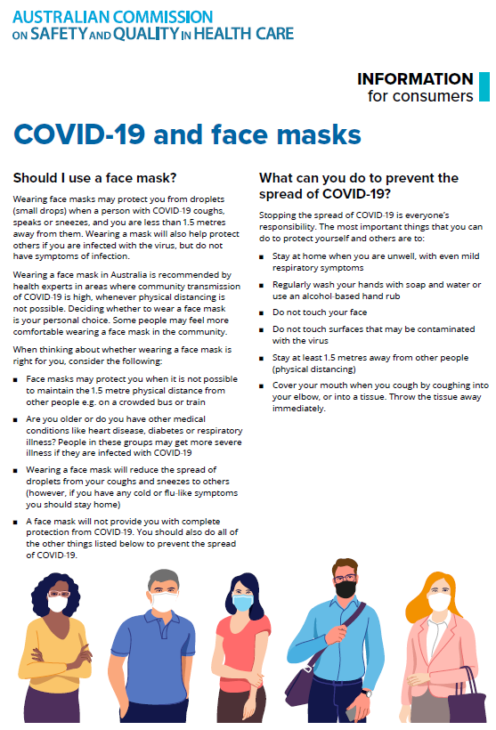](https://www.safetyandquality.gov.au/sites/default/files/2020-07/covid-19_and_face_masks_-_information_for_consumers.pdf)

***Surgical prophylaxis prescribing in Australian Hospitals Results of the 2019 Surgical National Antimicrobial Prescribing Survey***

<https://www.safetyandquality.gov.au/publications-and-resources/resource-library/surgical-national-antimicrobial-prescribing-survey-results-2019-survey>

National Centre for Antimicrobial Stewardship and Australian Commission on Safety and Quality in Health Care

Sydney: ACSQHC; 2020. p. 75.

The results of the 2019 Surgical National Antimicrobial Prescribing Survey (NAPS), which reports on appropriateness of surgical prophylaxis prescribing in Australian hospitals, have been published by the Australian Commission on Safety and Quality in Health Care.

The Surgical NAPS is a standardised audit that Australian health service organisations can use to monitor and report on the appropriateness of antimicrobial use for surgical prophylaxis. In 2019, 144 public and private facilities contributed data for the Surgical NAPS. Over the four years that the Surgical NAPS has been conducted, there has been an increase in the appropriateness of procedural prescribing, which may be due to improved timing of administration and dosage of antimicrobials. The Hospital NAPS has also identified an improvement in the proportion of surgical prophylaxis given for greater than 24 hours from 41.0% in 2013 down to 30.0% in 2019.

However, consistent with findings from previous surveys, the 2019 Surgical NAPS identified ongoing concerning inappropriate use of surgical prophylaxis in contributor hospitals. These issues, which require urgent and specific attention, include:

* Sub-optimal documentation of the time of antimicrobial administration (77.4%) and incision time (66.1%)
* Low rates of compliance with prescribing guidelines for procedural (62.7%) and post-procedural (31.4%) antimicrobial prophylaxis in relation to timing, dosage and duration of use
* Inappropriate procedural prescribing for orthopaedic surgery, urological surgery, abdominal surgery, and plastic and reconstructive surgery, in particular
* Inappropriate post-procedural prescribing for orthopaedic surgery, plastic and reconstructive surgery, and head and neck surgery, in particular.

For the first time the report includes snapshots for 14 procedural specialty groups. These reports will assist the development of targeted improvement programs by these specialties.

**CARAlert Data Update 19: 1 July 2020 – 31 August 2020**

<https://www.safetyandquality.gov.au/publications-and-resources/resource-library/caralert-data-update-19-1-july-2020-31-august-2020>

Australian Commission on Safety and Quality in Health Care

Sydney: ACSQHC; 2020. p. 26.

This report is the nineteenth in the series of bimonthly reports summarising data submitted to the National Alert System for Critical Antimicrobial Resistances (CARAlert) (<https://www.safetyandquality.gov.au/our-work/antimicrobial-resistance/antimicrobial-use-and-resistance-australia-surveillance-system/national-alert-system-critical-antimicrobial-resistances-caralert>).

The report presents data submitted to CARAlert for the reporting period 1 July 2020 to 31 August 2020, and complements previous analyses of and updates on CARAlert data.

There was little change in the number of critical antimicrobial resistances (CARs) reported compared to the previous two-month reporting period. Carbapenemase-producing Enterobacterales (CPE) remains the most frequently reported critical antimicrobial resistance (CAR), followed by azithromycin non-susceptible (low-level resistance, MIC ≤ 256 mg/L) *Neisseria gonorrhoeae* (n = 42, 18.2%). The total number of CPE (either alone or in combination with other CARs) reported this year to date, compared to the same period last year, decreased by 25.6% (n = 444 versus n = 597). The first AIM carbapenemase type submitted to CARAlert was reported from a *Pseudomonas aeruginosa*. The AIM carbapenemase was first reported from *P. aeruginosa* in 2012. It appears to be unique to Australia, with sporadic cases reported from Adelaide since 2006. The last known case was reported in 2016.

The majority of CARs, excluding those from *N. gonorrhoeae*, were reported from public hospitals (n = 106, 66% where setting known). There were 36 reports from community settings, 9 from aged care homes and 10 from private hospitals.

**Reports**

*A Global Inquiry on Excellence in the Diagnostic Journey: The Power of Human Experience in Healthcare*

Wolf JA

Nashville: The Beryl Institute; 2020. p. 23.

|  |  |
| --- | --- |
| URL | <https://www.theberylinstitute.org/store/viewproduct.aspx?id=17422197> |
| Notes | The Beryl Institute in the USA are a patient experience advocate (and the publisher of the *Patient Experience Journal*). They have released this report on what they are terming the ‘diagnostic experience’. Here they define the ‘diagnostic experience’ as ‘the journey from experiencing a health issue, to a referral to a physician including a formal examination and/or testing, to the sharing and discussion of results, to the development of a plan of care, to the outcomes achieved’. This appears to be a rebranding of ‘patient journey’ into ‘diagnostic experience’. Such a rebranding of a term that (seems) well understood into one that the report itself deems ‘a healthcare-centric term’ seems counterintuitive to being more person/patient/consumer focussed. It could also seem that terming the whole patient journey/experience as a ‘diagnostic experience’ may expand the diagnostic from the clinical space. It’s conceivable that many participants (clinician and patient) would categorise the diagnostic phase as that phase between disease/condition onset and definitive diagnosis and that thereafter it is a treatment phase. So while the report does capture much that is useful to consider about the patient journey or patient experience, the term ‘diagnostic experience’ may not be actually that useful. |

For information on the Commission’s work on partnering with consumers, including person-centred care, see <https://www.safetyandquality.gov.au/our-work/partnering-consumers>

**Journal articles**

*Increased risk of 2-year death in patients who discontinued their use of statins*

Seaman K, Sanfilippo F, Bulsara M, Roughead E, Kemp-Casey A, Bulsara C, et al

Journal of Health Services Research & Policy. 2020:1355819620965610.

|  |  |
| --- | --- |
| DOI | <https://doi.org/10.1177/1355819620965610> |
| Notes | On occasion the widespread use of statins has been a topic of (rather heated) contention. The mass of the evidence has suggested that it is generally better for patients to continue their use of statins. This study in Western Australia sought to determine the mortality risk for patients who stopped (or discontinued) taking statin medication. This was a retrospective observational study using linked administrative Commonwealth Pharmaceutical Benefits Scheme (PBS) data and State hospital inpatient and death data to examine the association between statin usage (discontinued, reduced or continued) and two-year death following a 21% increase in the PBS consumer co-payment in Western Australia. The study found that in the first six months after the change, 3.3% discontinued, 12.5% reduced and 84.2% continued statin therapy. It was also observed that ‘those who discontinued statins were also likely to discontinue at least two other medicines compared to those who continued therapy.’  The authors conclude that ‘Patients who discontinued their statin therapy had a significantly increased risk of IHD [ischemic heart disease] and stroke death. Health professionals should be aware that large co-payment changes may be associated with patients discontinuing or reducing medicines to their health detriment. Factors that lead to such changes in patient medication-taking behaviour need to be considered and addressed at the clinical and policy levels.’ |

*Hospital medication errors: a cross sectional study*

Isaacs AN, Ch’ng K, Delhiwale N, Taylor K, Kent B, Raymond A

International Journal for Quality in Health Care. 2020 [epub].

|  |  |
| --- | --- |
| DOI | <https://doi.org/10.1093/intqhc/mzaa136> |
| Notes | Paper reporting on an Australian study reporting on the incidence, time trends, types and factors associated factors with medication errors in a large regional hospital. Undertaken as a 5-year cross-sectional study, the findings included:   * The incidence of medication errors was 1.05 per 100 admitted patients. * The highest frequency of errors was observed during the colder months of May to August. * When distributed by day, Mondays and Tuesdays had the highest frequency of errors. * When distributed by hour of the day, time intervals from 7am to 8am and 7 pm to 8pm showed a sharp increase in the frequency of errors. * 1088 (57.8%) MEs belonged to Incidence Severity Rating (ISR) 4 and 787 (41.8%) belonged to ISR 3. There were 6 incidents of ISR level 2 and only 1 incident of ISR level 1 reported in the last 5 years. * Administration-only errors were the most common accounting for 1070 (56.8%) followed by prescribing-only errors (433, 23%). * High risk medications were associated with half the number of errors, the most common of which were narcotics (17.9%) and anti-microbials (13.2%). |

For information on the Commission’s work on medication safety, see <https://www.safetyandquality.gov.au/our-work/medication-safety>

*“We’re very much part of the team here”: A culture of respect for Indigenous health workforce transforms Indigenous health care*

Taylor EV, Lyford M, Parsons L, Mason T, Sabesan S, Thompson SC

PLOS ONE. 2020;15(9):e0239207.

|  |  |
| --- | --- |
| DOI | <https://doi.org/10.1371/journal.pone.0239207> |
| Notes | There is an appreciation that cultural safety and appropriateness can be important in the therapeutic environment and relationship. This applies to all participants, including the health workforce. This article examined the Indigenous workforce policies and strategies from two Australian health services, as well as cancer-service specific strategies. The authors consider that the ‘two cancer services and their affiliated hospitals show how positive patient outcomes and a strong Indigenous health workforce can be achieved when a health service has strong leadership, commits to an inclusive and enabling culture, facilitates two-way learning and develops specific support structures appropriate for Indigenous staff.’ |

*Time to reality check the promises of machine learning-powered precision medicine*

Wilkinson J, Arnold KF, Murray EJ, van Smeden M, Carr K, Sippy R, et al

The Lancet Digital Health. 2020 [epub].

|  |  |
| --- | --- |
| DOI | <https://doi.org/10.1016/S2589-7500(20)30200-4> |
| Notes | Machine learning, artificial intelligence, ‘big data’ and the like have all been held out as offering the potential for significant changes in the delivery of health care. This piece seeks to offer something of a corrective to some of the hype and puffery. The authors of this piece recognise that ‘Machine learning methods, combined with large electronic health databases, could enable a personalised approach to medicine through improved diagnosis and prediction of individual responses to therapies’ and that ‘. If successful, this strategy would represent a revolution in clinical research and practice.’ However, there is ‘a need to distinguish genuine potential from hype’ and ‘call for collaboration between traditional methodologists and experts in medical machine learning to avoid extensive research waste.’ |

*Avoiding unnecessary hospitalisation for patients with chronic conditions: a systematic review of implementation determinants for hospital avoidance programmes*

Sarkies M, Long JC, Pomare C, Wu W, Clay-Williams R, Nguyen HM, et al

Implementation Science. 2020;15(1):91.

|  |  |
| --- | --- |
| DOI | <https://doi.org/10.1186/s13012-020-01049-0> |
| Notes | The issues of avoidable or ‘potentially preventable’ hospitalisations has interested many, particularly policymakers. If only there was a way of identifying and then reducing these hospitalisations, then the costs of operating hospitals could be curtailed (apparently). A glib answer may be to enable better provision and access to primary care. This study sought to examine the implementation of those programmes that have been attempted to reduce ‘unnecessary hospitalisations’. The systematic review focused on 13 articles covering 14 studies with thematic synthesis identifying 23 determinants of implementation. The authors found that ‘Availability of resources’, ‘compatibility and fit’, and ‘engagement of interprofessional team’ were the most prominent determinants and that the most interconnected implementation determinants were the ‘compatibility and fit’ of interventions and ‘leadership influence’ factors. |

*International Journal for Quality in Health Care*

Volume 32, Issue 8, October 2020

|  |  |
| --- | --- |
| URL | <https://academic.oup.com/intqhc/issue/32/8> |
| Notes | A new issue of the *International Journal for Quality in Health* has been published. Many of the papers in this issue have been referred to in previous editions of *On the Radar* (when they were released online). Articles in this issue of the *International Journal for Quality in Health* include:   * **Improving knowledge and confidence in foundation doctors** during specialty changeover (Madhav Sanatkumar Dave, Shahd Mobarak, Harry V M Spiers, Munir Tarazi, Saurabh Jamdar) * Variation between hospitals and reviewers in **detection of adverse events** identified through medical record review in Korea (Sukyeong Kim, Ho Gyun Shin, A E Jeong Jo, Ari Min, Minsu Ock, Jee-In Hwang, Youngjin Jeong, Moon Sung Park, Jong Bouk Lee, Tae I K Chang, Eunhyang Song, Heungseon Kim, Sang-Il Lee) * The **Registry of Senior Australians outcome monitoring system**: quality and safety indicators for residential aged care (Maria C Inacio, Catherine Lang, Gillian E Caughey, Sarah C E Bray, Stephanie L Harrison, Craig Whitehead, Renuka Visvanathan, Keith Evans, Megan Corlis, V Cornell, S Wesselingh) * The efficiency–thoroughness trade-off after implementation of **electronic medication management**: a qualitative study in paediatric oncology (Melissa T Baysari, Bethany A van Dort, Mirela Prgomet, Wu Yi Zheng, Magdalena Z Raban, Luciano Dalla-Pozza, Cheryl Mccullagh, Johanna Westbrook) * Improving the quality of **mortality review equity reporting**: Development of an indigenous Māori responsiveness rubric (Denise Wilson, Sue Crengle, Fiona Cram) * **Bundle interventions including nontechnical skills for surgeons** can reduce operative time and improve patient safety (Daisuke Koike, Yukihiro Nomura, Motoki Nagai, Takashi Matsunaga, Ayuko Yasuda) * **Hospital accreditation impact on healthcare quality dimensions**: a systematic review (Claudia A S Araujo, Marina Martins Siqueira, Ana M Malik) * Psychometric evaluation of instruments measuring the **work environment of healthcare professionals in hospitals**: a systematic literature review (Susanne M Maassen, Anne Marie J W Weggelaar Jansen, Gerard Brekelmans, Hester Vermeulen, Catharina J van Oostveen) * **Ethical frameworks for quality improvement activities**: an analysis of international practice (Corina Naughton, Elaine Meehan, Elaine Lehane, Ciara Landers, Sarah Jane Flaherty, Aoife Lane, Margaret Landers, Caroline Kilty, Mohamad Saab, John Goodwin, Nuala Walshe, Teresa Wills, Vera Mccarthy, Siobhan Murphy, Joan Mccarthy, Helen Cummins, D Madden, J Hegarty) |

*American Journal of Medical Quality*

Volume: 35, Number: 6 (December 2020)

|  |  |
| --- | --- |
| URL | <https://journals.sagepub.com/toc/ajmb/35/6> |
| Notes | A new issue of the *American Journal of Medical Quality* has been published. Articles in this issue of the *American Journal of Medical Quality* include:   * Responding to the COVID-19 Pandemic: A New **Surgical Patient Flow Utilizing the Preoperative Evaluation Clinic** (Sher-Lu Pai, Joan M Irizarry-Alvarado, Nancy E. Pitruzzello, Wendelyn Bosch, and S Aniskevich, III) * **COVID-19 Intubation Safety**: A Multidisciplinary, Rapid-Cycle Model of Improvement (Amy Tronnier, Collin F Mulcahy, Ayal Pierce, Ivy Benjenk, M Sherman, E R Heinz, S Honeychurch, G Ho, K Talton, and D Yamane) * The NQF Scientific Methods Panel: Enhancing the Review and Endorsement Process for **Performance Measures** (David R Nerenz, David Cella, Lacy Fabian, E Nuccio, J Bott, J M Austin, S Simon, J Needleman, and K Johnson) * Quality in the Context of Value: Reliability of **Quality Metrics** in an Academic Health System Shifting Toward **Value-Based Payments** (Linnaea Schuttner, Ashok Reddy, Andrew A White, Edwin S Wong, and J M Liao) * Impact of Simulation-Based Closed-Loop Communication Training on **Medical Errors in a Pediatric Emergency Department** (Maria Carmen G Diaz and Kimberly Dawson) * Application of Forcing Functions to Electronic Health Records Is Associated With Improved **Pain Control for Patients Undergoing Radiation Therapy** for Bone Metastases (D Huang, I Chervoneva, L Babinsky, and M D Hurwitz) * **Hypertension and Diabetes Quality Improvement** in a Practice Transformation Network (N Khanna, E Klyushnenkova, and R Montgomery) * Improving **Ambulatory Health Care Proxy Completion Rates**: Implementing an Interdisciplinary Clinic-Based Process (Lauge Sokol-Hessner, Griffen Allen, and Jennifer Cluett) * Why Many **Quality Improvement Initiatives Die a Quick Death** (Dinesh K Arya) * Improving **Breast Cancer Screening Rates** in a Resident Clinic in Eastern North Carolina (Jennifer Newcome, Ashley Choe, Lacy Hobgood, Mary Catherine Brake Turner, and Ashley Lundberg) * **Is My Quality Improvement Initiative Also Research?** A Primer on Making This Distinction and the Ethical Considerations for Graduate Trainees (Tyrone G Harrison, Sadia Ahmed, Sumedh Bele, Nicola Cavanagh, Brenda R Hemmelgarn, and Deirdre McCaughey) * EMR-Based Intervention Improves **Cervical Cancer Screening Rate** in a Primary Care Office (Miranda Aragón, Sunny Lai, Jessica Deffler, Anna Woods, Barbara Cymring, Kali Graham, Amy Cunningham, and G Mills) * **Improved Physical Exam Documentation** in a Pediatric After-Hours Clinic (Shannon Kinlaw, M Dailey, D Scott, S Hanchey, D Tumin, and A Higginson) * **Human Factor** Consideration in Routine **Root Cause Analysis** (Yu-Hsun Cheng, Sheng-Hui Hung, Tung-Wen Ko, and Pa-Chun Wang) * Improving **Intraoperative Ophthalmic Surgery Communication** (Obanor Osamudiamen, Hussain Samnani, Jordan Burgess, and Joseph M Hendrix) * The ACMQ Value Proposition (Donald E Casey, Jr) |

*Journal for Healthcare Quality*

Vol. 42, No. 6, November/December 2020

|  |  |
| --- | --- |
| URL | <https://journals.lww.com/jhqonline/toc/2020/12000> |
| Notes | A new issue of the *Journal for Healthcare Quality* (JHQ) has been published. Articles in this issue of the *Journal for Healthcare Quality* include:   * Factors to Consider When Evaluating Rates of **Pharmacologic Venous Thromboembolism Prophylaxis Administration** Among Trauma Patients (Erica Sercy, Matthew M. Carrick, Alessandro Orlando, David Bar-Or) * Using a Social Worker Transition Coach to Improve **Hospital-to-Home Transitions for High-Risk Nonelderly Patients** (Richard Balaban, Maren Batalden, Dennis Ross-Degnan, Benjamin Le Cook) * **Emergency Department Ergonomic Redesign** Improves Team Satisfaction in Cardiopulmonary Resuscitation Delivery: A Simulation-Based Quality Improvement Approach (Michael R. Ehmann, Erin M. Kane, Zakk Arciaga, Jordan Duval-Arnould, Mustapha Saheed) * Measured Performance and Vaccine Administration After Decision Support and Office Workflow Changes for **Influenza Vaccination** (Stephen D. Persell, Nora Lewin, Banu Yagci, Ji Young Lee, Sonali K. Oberoi, Erik Orelind, Phillip Roemer, Michael A. Schachter, Kathryn Thomas) * Pull the Foley: Improved Quality for Middle-Aged and Geriatric Trauma Patients Without **Indwelling Catheters** (Sanjit R. Konda, Joseph R. Johnson, Erin A. Kelly, Kenneth A. Egol) * Voluntary **Hospital Reporting of Performance** in Cancer Care: Does Volume Make a Difference? (Bonnie Jin, Ingrid M. Nembhard) * An Imaging Stewardship Initiative to Reduce **Low-Value Positron Emission Tomography-Computed Tomography** Use in Hospitalized Patients (Richard M. Elias, Deanne Kashiwagi, Christopher Lau, Stephanie L. Hansel) |

*Patient Experience Journal*

Volume 7, Number 3

|  |  |
| --- | --- |
| URL | <https://pxjournal.org/journal/vol7/iss3/> |
| Notes | A new issue of the *Patient Experience Journal (PXJ)* has been published. Articles in this issue of the *Patient Experience Journal* include:   * Editorial: Moving forward to the **future of healthcare** (Jason A Wolf) * Patient-centric culture and implications for **patient engagement during the COVID-19 pandemic** (Umair Majid and Aghna Wasim) * **Solitude and fear** during the great coronavirus war (Chiara Catania, Ester Del Signore, and letizia gianoncelli) * A student's lesson in **healthcare disparities** (Daniel Oluwatimilehin Macaulay, Christine Khandelwal, and Leah Rosen) * A home for us and a womb for her: **Living the Family Integrated Care model in a Danish NICU** (Ann Katrine B Miranda) * **Cancer patient perspectives during the COVID-19 pandemic**: A thematic analysis of cancer blog posts (Matthew A Hintermayer, Mark Sorin, Joan M Romero, Sarah M Maritan, Owen J Chen, and Surabhi Rawal) * The impact of **parental presence in the NICU** on hospital alienation and other distress measures (Katherine D Taylor, Lindsey McLaughlin, Devon Kuehn, Justin Campbell, John Kohler Sr, and Jason Higginson) * Patient reported experience of **inpatient rehabilitation in Australia** (Jacquelin T Capell, Tara Alexander, Julie Pryor, and Murray Fisher) * Collecting **child-patient feedback**: A systematic review on the patient-reported outcome measures for hospitalized children (Haneen Ali, Astin Cole, Adam Sienkiewicz, Steffie Rosene, Reagan Shaffer, and Robert Thames) * Exploring peer mentoring in **pediatric transition**: Perspectives of different stakeholders about accompanying patients in gastroenterology (Guillaume Dumais-Lévesque and Marie-Pascale Pomey) * **Living with cardiovascular disease (CVD)**: Exploring the biggest challenges for people affected by CVD in the UK, and their use (or not) of online resources (Sarah-Ann Burger, Alan J Poots, Anna Perris, Helen Crump, Helen Thorne, Sally Hughes, and Jacob West) * **Consumer experiences of Chronic Obstructive Pulmonary Disease in regional Australia**: A mixed methods study and logic model to identify consumer-experience mechanisms to avoid hospital and enhance outcomes (Anna Moran, Glenda Chapman, Ron Picard, Janet Chapman, Sally Squire, Guinever Threlkeld, and Irene Blackberry) * How information sharing can improve **patient and family experience in critical care**: A focus group study (Jayne Garner, Sioban Kelly, Girendra Sadera, and Victoria Treadway) * Enhancing **patient involvement in quality improvement**: How complaint managers see their roles and limitations (Nathalie Clavel and M-P Pomey) * **Patient participation** strategies: The nursing bedside handover (Irene DeCelie) * **Utilising co-design** to improve outpatient neurological care in a rural setting (Andrew J Butler, Sarah J Prior, Sajina Mathew, David Carter, and Brad Ellem) * **Patient engagement in action**: Timing and intensity of strategies used to engage low income depressed mothers of infants and toddlers (Maureen J Baker, Beth Perry Black, and Linda S Beeber) * **Responsiveness of primary health care services** in Nigeria: The patients’ perspective (Daprim S Ogaji, Brian C Egu, Michael Nwakor-osaji, Amala C Smart, Emeka F Anyiam, and Faith C Diorgu) * **Patients’ experience in Hong Kong hospitals**: A comparison between south Asian and Chinese people (Nimisha Vandan, Janet Yuen-Ha Wong., Paul Siu-Fai Yip, and Daniel Yee-Tak Fong) * **Patient experience in outpatient clinics**: Does appointment time impact satisfaction? (Shikha Shah Modi, J B Costigan, M Lemak, and S Feldman) * **Management of frequent ED users by community paramedics** improves patient experiences and reduces EMS utilization (Oluwakemi Aiyedun Adio, Laura Ikuma, and Sonja Wiley) * Addressing social disconnection among **frequent users of community hospital emergency departments**: A statewide implementation evaluation (A Rani Elwy, Elisa Koppelman, Victoria Parker, and Chris Louis) * Does an empathic pre-visit conversation with another team member improve perceived **surgeon empathy**? (Lindy Derkzen, Janna S E Ottenhoff, Carrie Barron, and David Ring) * Factors associated with **patient rating of physician communication effectiveness and satisfaction** in musculoskeletal care (Amirreza Fatehi, Amanda Gonzalez, David Bandell, Joost Kortlever, Léon Rijk, and D Ring) * **Perceptions of care & patient-provider communication** by varying identity groups in a collegiate health clinic (Yewande O Addie, Tatiana Maser, Cecilia Luna, Casey Rayfield, and Kelli R Agrawal) * PANDA: A case-study examining a successful **Audiology and Otology Patient and Public Involvement and Engagement research group** (Laura Boddy, Richard Allen, Rosalyn Parker, Margaret E O'Hara, and A V Gosling) * A systems thinking framework to improve **care of the terminally ill**: An Australian case study (Elizabeth Summerfield) * **Patient Experience Rounds (PER)**: Real-time feedback to improve the patient experience and quality of care (Amber Moore, Caroline Moore, Lydia Bunker, and Barbara Sarnoff) * The use of organizational assessments in **improving patient and staff experiences in the ambulatory care setting** (Linda C Lombardi, Andrew B Wallach, and Paula A Wilson) |

*BMJ Quality & Safety* online first articles

|  |  |
| --- | --- |
| URL | <https://qualitysafety.bmj.com/content/early/recent> |
| Notes | *BMJ Quality &Safety* has published a number of ‘online first’ articles, including:   * Incidence, nature and causes of **avoidable significant harm in primary care** in England: retrospective case note review (Anthony J Avery, Christina Sheehan, Brian Bell, Sarah Armstrong, Darren M Ashcroft, Matthew J Boyd, Antony Chuter, Alison Cooper, Ailsa Donnelly, Adrian Edwards, Huw Prosser Evans, Stuart Hellard, Joanne Lymn, Rajnikant Mehta, Sarah Rodgers, Aziz Sheikh, Pam Smith, Huw Williams, Stephen M Campbell, Andrew Carson-Stevens) * Factors influencing **physician responsiveness to nurse-initiated communication**: a qualitative study (Milisa Manojlovich, Molly Harrod, Timothy Hofer, Megan Lafferty, Michaella McBratnie, Sarah L Krein) * Changes in **weekend and weekday care quality of emergency medical admissions** to 20 hospitals in England during implementation of the 7-day services national health policy (Julian Bion, Cassie Aldridge, Alan J Girling, Gavin Rudge, Jianxia Sun, Carolyn Tarrant, Elizabeth Sutton, Janet Willars, Chris Beet, Amunpreet Boyal, Peter Rees, Chris Roseveare, Mark Temple, Samuel Ian Watson, Yen-Fu Chen, Mike Clancy, Louise Rowan, Joanne Lord, Russell Mannion, Timothy Hofer, Richard Lilford) |

*International Journal for Quality in Health Care* online first articles

|  |  |
| --- | --- |
| URL | <https://academic.oup.com/intqhc/advance-articles> |
| Notes | *International Journal for Quality in Health Care* has published a number of ‘online first’ articles, including:   * **Trauma system accreditation and patient outcomes** in British Columbia: an interrupted time series analysis (Brice Batomen, Lynne Moore, Erin Strumpf, Natalie L Yanchar, Jaimini Thakore, Arijit Nandi) * The **40 health systems, COVID-19** (40HS, C-19) study (Jeffrey Braithwaite, Yvonne Tran, Louise A Ellis, Johanna Westbrook) * An In Situ Simulation Program: A Quantitative And Qualitative Prospective Study Identifying **Latent Safety Threats** And Examining Participant Experiences (Gunhild Kjærgaard-Andersen, Pernille Ibsgaard, Charlotte Paltved, Hanne Irene Jensen) |

**Online resources**

*National COVID-19 Clinical Evidence Taskforce*

<https://covid19evidence.net.au/>

The National COVID-19 Clinical Evidence Taskforce is a collaboration of peak health professional bodies across Australia whose members are providing clinical care to people with COVID-19. The taskforce is undertaking continuous evidence surveillance to identify and rapidly synthesise emerging research in order to provide national, **evidence-based guidelines and clinical flowcharts for the clinical care of people with COVID-19**. The guidelines address questions that are specific to managing COVID-19 and cover the full disease course across mild, moderate, severe and critical illness. These are ‘living’ guidelines, updated with new research in near real-time in order to give reliable, up-to-the minute advice to clinicians providing frontline care in this unprecedented global health crisis.

*COVID-19 Critical Intelligence Unit*

<https://www.aci.health.nsw.gov.au/covid-19/critical-intelligence-unit>

The Agency for Clinical Innovation (ACI) in New South Wales has developed this page summarising rapid, evidence-based advice during the COVID-19 pandemic. Its operations focus on systems intelligence, clinical intelligence and evidence integration. The content includes a daily evidence digest and evidence checks on a discrete topic or question relating to the current COVID-19 pandemic. . Recent evidence checks include:

* ***Wastewater surveillance for COVID-19.***

[*UK] NICE Guidelines and Quality Standards*

<https://www.nice.org.uk/guidance>

The UK’s National Institute for Health and Care Excellence (NICE) has published new (or updated) guidelines and quality standards. The latest reviews or updates are:

* NICE Guideline NG161 ***COVID-19*** *rapid guideline: delivery of* ***systemic anticancer treatments*** <https://www.nice.org.uk/guidance/ng161>

*[USA] Effective Health Care Program reports*

<https://effectivehealthcare.ahrq.gov/>

The US Agency for Healthcare Research and Quality (AHRQ) has an Effective Health Care (EHC) Program. The EHC has released the following final reports and updates:

* *Management of* ***Primary Headaches in Pregnancy*** <https://effectivehealthcare.ahrq.gov/products/headaches-pregnancy/research>

**Disclaimer**

On the Radar is an information resource of the Australian Commission on Safety and Quality in Health Care. The Commission is not responsible for the content of, nor does it endorse, any articles or sites listed. The Commission accepts no liability for the information or advice provided by these external links. Links are provided on the basis that users make their own decisions about the accuracy, currency and reliability of the information contained therein. Any opinions expressed are not necessarily those of the Australian Commission on Safety and Quality in Health Care.