# Australian COmmission on Safety and Quality in Health Care logo with Radar imageOn the Radar

Issue 491

23 November 2020

*On the Radar* is a summary of some of the recent publications in the areas of safety and quality in health care. Inclusion in this document is not an endorsement or recommendation of any publication or provider. Access to particular documents may depend on whether they are Open Access or not, and/or your individual or institutional access to subscription sites/services. Material that may require subscription is included as it is considered relevant.

*On the Radar* is available online, via email or as a PDF or Word document from <https://www.safetyandquality.gov.au/publications-and-resources/newsletters/radar>

If you would like to receive *On the Radar* via email, you can subscribe on our website <https://www.safetyandquality.gov.au/publications-and-resources/newsletters>   
or by emailing us at H[Umail@safetyandquality.gov.auU](mailto:mail@safetyandquality.gov.au).   
You can also send feedback and comments to H[Umail@safetyandquality.gov.auU](mailto:mail@safetyandquality.gov.au).

For information about the Commission and its programs and publications, please visit <https://www.safetyandquality.gov.au>

You can also follow us on Twitter @ACSQHC.

**On the Radar**

Editor: Dr Niall Johnson [niall.johnson@safetyandquality.gov.au](mailto:niall.johnson@safetyandquality.gov.au)

Contributors: Niall Johnson

**COVID-19 resources**

https://www.safetyandquality.gov.au/covid-19

The Australian Commission on Safety and Quality in Health Care has developed a number of resources to assist healthcare organisations, facilities and clinicians. These and other material on COVID-19 are available at <https://www.safetyandquality.gov.au/covid-19>

The latest additions include:

* ***COVID-19: Aged care staff infection prevention and control precautions*** *poster*<https://www.safetyandquality.gov.au/publications-and-resources/resource-library/covid-19-aged-care-staff-infection-prevention-and-control-precautions-poster>  
    
  [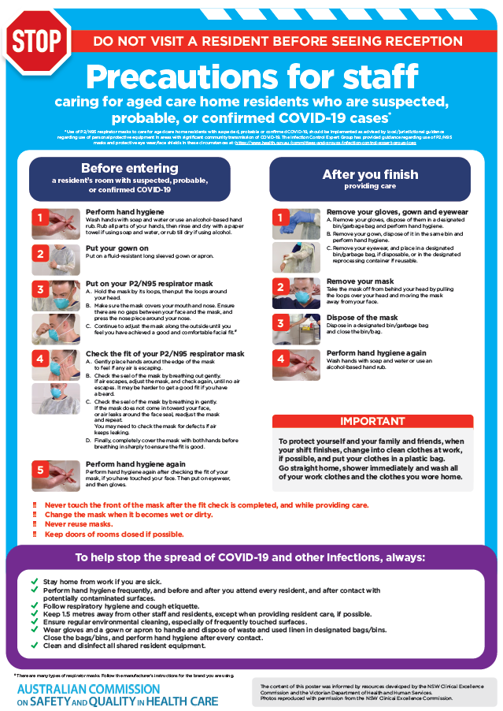](https://www.safetyandquality.gov.au/publications-and-resources/resource-library/covid-19-aged-care-staff-infection-prevention-and-control-precautions-poster)
* ***Environmental Cleaning and Infection Prevention and Control*** [www.safetyandquality.gov.au/environmental-cleaning](http://www.safetyandquality.gov.au/environmental-cleaning)
* ***Infection prevention and control Covid-19 PPE*** poster <https://www.safetyandquality.gov.au/publications-and-resources/resource-library/infection-prevention-and-control-covid-19-personal-protective-equipment>
* ***Special precautions for Covid-19 designated zones*** poster <https://www.safetyandquality.gov.au/publications-and-resources/resource-library/special-precautions-covid-19-designated-zones>
* ***COVID-19 infection prevention and control risk management – Guidance*** <https://www.safetyandquality.gov.au/publications-and-resources/resource-library/covid-19-infection-prevention-and-control-risk-management-guidance>
* ***Safe care for people with cognitive impairment during COVID-19***<https://www.safetyandquality.gov.au/our-work/cognitive-impairment/cognitive-impairment-and-covid-19>
* **Medicines Management COVID-19** <https://www.safetyandquality.gov.au/our-work/medication-safety/medicines-management-covid-19>, including position statements on medicine-related issues
  + ***Managing fever associated with COVID-19***
  + ***Managing a sore throat associated with COVID-19***
  + ***ACE inhibitors and ARBs in COVID-19***
  + ***Clozapine in COVID-19***
  + ***Management of patients on oral anticoagulants during COVID-19***
  + ***Ascorbic Acid: Intravenous high dose in COVID-19***
  + ***Treatment in acute care, including oxygen therapy and medicines to support intubation***
  + ***Nebulisation and COVID-19***
  + ***Managing intranasal administration of medicines during COVID-19***
  + ***Ongoing medicines management in high-risk patients***
  + ***Medicines shortages***
  + ***Conserving medicines***
  + ***Intravenous medicines administration in the event of an infusion pump shortage***
* ***Potential medicines to treat COVID-19***   
  <https://www.safetyandquality.gov.au/publications-and-resources/resource-library/potential-medicines-treat-covid-19>
* ***Break the chain of infection: Stopping COVID-19*** poster<https://www.safetyandquality.gov.au/publications-and-resources/resource-library/break-chain-poster-a3>  
  **[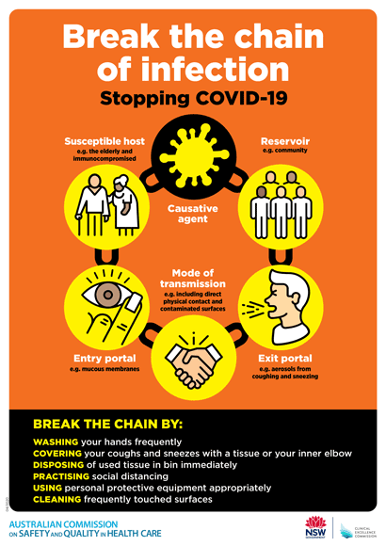](https://www.safetyandquality.gov.au/publications-and-resources/resource-library/break-chain-poster-a3https:/www.safetyandquality.gov.au/publications-and-resources/resource-library/break-chain-poster-a3)**
* ***COVID-19: Elective surgery and infection prevention and control precautions*** <https://www.safetyandquality.gov.au/publications-and-resources/resource-library/covid-19-elective-surgery-and-infection-prevention-and-control-precautions>
* ***FAQs for clinicians on elective surgery*** <https://www.safetyandquality.gov.au/node/5724>
* ***FAQs for consumers on elective surgery*** <https://www.safetyandquality.gov.au/node/5725>
* ***FAQs on community use of face masks***   
   <https://www.safetyandquality.gov.au/faqs-community-use-face-masks>
* ***COVID-19 and face masks – Information for consumers*** <https://www.safetyandquality.gov.au/publications-and-resources/resource-library/covid-19-and-face-masks-information-consumers>  
  The Commission’s fact sheet on use of face masks in the community to reduce the spread of COVID-19 is now available in Easy English and 10 other community languages from <https://www.safetyandquality.gov.au/wearing-face-masks-community>.  
  The factsheet was developed to help people understand when it is important to wear a mask to reduce the risk of the spread of COVID-19, and to explain how to safely put on and remove face masks. It also reinforces the importance of staying home if you have symptoms, physical distancing, hand hygiene and cough etiquette.

[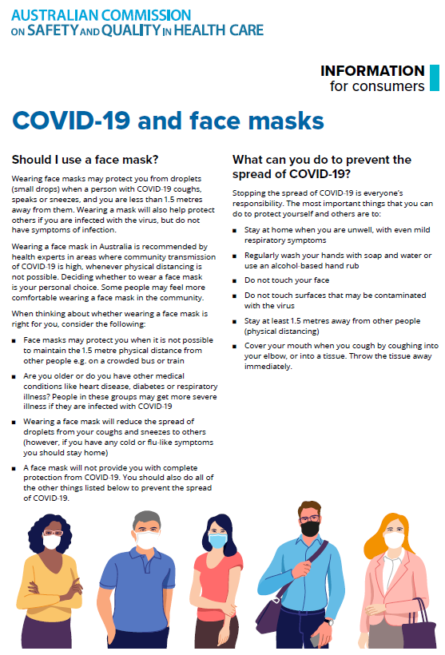](https://www.safetyandquality.gov.au/sites/default/files/2020-07/covid-19_and_face_masks_-_information_for_consumers.pdf)

**Journal articles**

*Incidence, nature and causes of avoidable significant harm in primary care in England: retrospective case note review*

Avery AJ, Sheehan C, Bell B, Armstrong S, Ashcroft DM, Boyd MJ, et al

BMJ Quality & Safety. 2020 [epub].

|  |  |
| --- | --- |
| DOI | <https://doi.org/10.1136/bmjqs-2020-011405> |
| Notes | The true extent of patient safety issues in primary care is something of an unknown. This study sought to estimate the incidence of avoidable significant harm in primary care in England. This was a retrospective case note review of a sample of 14 407 primary care patients registered with 12 randomly selected general practices from three regions in England hat was undertaken by 13 general practitioners (GPs). The reviewers identified patients with significant health problems and clinical judgements were made on avoidability and severity of harm. Factors contributing to avoidable harm were identified and recorded.  The review found:   * 74 cases of avoidable harm were detected, involving 72 patients (from the 14 407 patients in the sample). * The rate of significant harm considered at least probably avoidable was 35.6 (95% CI 23.3 to 48.0) per 100 000 patient-years (57.9, 95% CI 42.2 to 73.7, per 100 000 based on a sensitivity analysis). * Three types of incident accounted for more than 90% of the problems: problems with **diagnosis** accounted for 45/74 (60.8%) primary incidents, followed by **medication-related** problems (n=19, 25.7%) and **delayed referrals** (n=8, 10.8%). * In 59 (79.7%) cases, the significant harm could have been identified sooner (n=48) or prevented (n=11) if the GP had taken actions aligned with evidence-based guidelines.   The authors suggest that ‘improvements could be made through more effective implementation of existing **information technology**, enhanced **team coordination and communication**, and greater personal and informational **continuity of care**.’ |

For information on the Commission’s work on primary health care, see <https://www.safetyandquality.gov.au/our-work/primary-health-care>

*Evaluation of a Patient-Centered Fall-Prevention Tool Kit to Reduce Falls and Injuries: A Nonrandomized Controlled Trial*

Dykes PC, Burns Z, Adelman J, Benneyan J, Bogaisky M, Carter E, et al

JAMA Network Open. 2020;3(11):e2025889-e2025889.

|  |  |
| --- | --- |
| DOI | <https://doi.org/10.1001/jamanetworkopen.2020.25889> |
| Notes | Falls remain a major safety and quality risk in health service organisations. Falls prevention and harm minimisation plans based on best practice and evidence can improve patient outcomes. This study reports on the implementation of a nurse-led fall-prevention tool kit in n 14 medical units within 3 hospitals in the USA that involved 37,231 patients over 3 years. The authors report that ‘implementation of a fall-prevention tool kit was associated with a statistically significant 15% reduction in overall inpatient falls and a 34% reduction in injurious falls.’ |

For information on the Commission’s work on falls prevention, see <https://www.safetyandquality.gov.au/our-work/comprehensive-care/related-topics/falls-prevention>

*Speaking truth to power: why leaders cannot hear what they need to hear*

Reitz M, Higgins J

BMJ Leader. 2020 [epub]

|  |  |
| --- | --- |
| DOI | <http://dx.doi.org/10.1136/leader-2020-000394> |
| Notes | The importance of speaking up and its impact on safety and quality –and the need to create a culture that encourages it– is widely accepted. However, as is also well understood, speaking up is not easy. This commentary piece reflects on the difficulties of ‘speaking truth to power’ and how it can be encouraged. The imperative to speak up and the costs of silence, and why so many of us stay silent, are canvassed, along with issues of who speaks, who listens and ‘advantage blindness’. The authors offer some advice as to how leaders may ‘become more adept at inviting others to speak up and then listening up’. These include:   * Assume you are scarier than you think * Question your ‘little list’ of whose opinion counts * Send ‘speak up’ rather than ‘shut up’ signals and responses.   However, as is also observed, ‘Most fundamentally it requires leaders to *want* to listen’. |

**Online resources**

*National COVID-19 Clinical Evidence Taskforce*

<https://covid19evidence.net.au/>

The National COVID-19 Clinical Evidence Taskforce is a collaboration of peak health professional bodies across Australia whose members are providing clinical care to people with COVID-19. The taskforce is undertaking continuous evidence surveillance to identify and rapidly synthesise emerging research in order to provide national, **evidence-based guidelines and clinical flowcharts for the clinical care of people with COVID-19**. The guidelines address questions that are specific to managing COVID-19 and cover the full disease course across mild, moderate, severe and critical illness. These are ‘living’ guidelines, updated with new research in near real-time in order to give reliable, up-to-the minute advice to clinicians providing frontline care in this unprecedented global health crisis.

*COVID-19 Critical Intelligence Unit*

<https://www.aci.health.nsw.gov.au/covid-19/critical-intelligence-unit>

The Agency for Clinical Innovation (ACI) in New South Wales has developed this page summarising rapid, evidence-based advice during the COVID-19 pandemic. Its operations focus on systems intelligence, clinical intelligence and evidence integration. The content includes a daily evidence digest and evidence checks on a discrete topic or question relating to the current COVID-19 pandemic. . Recent evidence checks include:

* ***High-risk settings for transmission of COVID-19.***

[*UK] NICE Guidelines and Quality Standards*

<https://www.nice.org.uk/guidance>

The UK’s National Institute for Health and Care Excellence (NICE) has published new (or updated) guidelines and quality standards. The latest reviews or updates are:

* NICE Guideline NG185 ***Acute coronary syndromes*** <https://www.nice.org.uk/guidance/ng185>
* Quality Standard QS68 ***Acute coronary syndromes*** *in adults* <https://www.nice.org.uk/guidance/qs68>

**Disclaimer**

On the Radar is an information resource of the Australian Commission on Safety and Quality in Health Care. The Commission is not responsible for the content of, nor does it endorse, any articles or sites listed. The Commission accepts no liability for the information or advice provided by these external links. Links are provided on the basis that users make their own decisions about the accuracy, currency and reliability of the information contained therein. Any opinions expressed are not necessarily those of the Australian Commission on Safety and Quality in Health Care.