# Australian COmmission on Safety and Quality in Health Care logo with Radar imageOn the Radar

Issue 492

30 November 2020

*On the Radar* is a summary of some of the recent publications in the areas of safety and quality in health care. Inclusion in this document is not an endorsement or recommendation of any publication or provider. Access to particular documents may depend on whether they are Open Access or not, and/or your individual or institutional access to subscription sites/services. Material that may require subscription is included as it is considered relevant.

*On the Radar* is available online, via email or as a PDF or Word document from <https://www.safetyandquality.gov.au/publications-and-resources/newsletters/radar>

If you would like to receive *On the Radar* via email, you can subscribe on our website <https://www.safetyandquality.gov.au/publications-and-resources/newsletters>   
or by emailing us at H[Umail@safetyandquality.gov.auU](mailto:mail@safetyandquality.gov.au).   
You can also send feedback and comments to H[Umail@safetyandquality.gov.auU](mailto:mail@safetyandquality.gov.au).

For information about the Commission and its programs and publications, please visit <https://www.safetyandquality.gov.au>

You can also follow us on Twitter @ACSQHC.

**On the Radar**

Editor: Dr Niall Johnson [niall.johnson@safetyandquality.gov.au](mailto:niall.johnson@safetyandquality.gov.au)

Contributors: Niall Johnson, Fiona Doukas, Kim Packham

**COVID-19 resources**

https://www.safetyandquality.gov.au/covid-19

The Australian Commission on Safety and Quality in Health Care has developed a number of resources to assist healthcare organisations, facilities and clinicians. These and other material on COVID-19 are available at <https://www.safetyandquality.gov.au/covid-19>

The latest additions include:

* ***COVID-19: Aged care staff infection prevention and control precautions*** *poster*<https://www.safetyandquality.gov.au/publications-and-resources/resource-library/covid-19-aged-care-staff-infection-prevention-and-control-precautions-poster>  
    
  [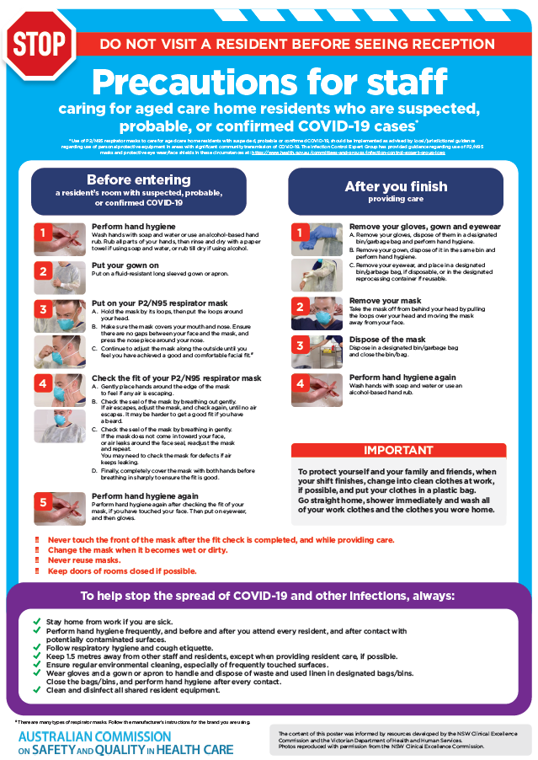](https://www.safetyandquality.gov.au/publications-and-resources/resource-library/covid-19-aged-care-staff-infection-prevention-and-control-precautions-poster)
* ***Environmental Cleaning and Infection Prevention and Control*** [www.safetyandquality.gov.au/environmental-cleaning](http://www.safetyandquality.gov.au/environmental-cleaning)
* ***Infection prevention and control Covid-19 PPE*** poster <https://www.safetyandquality.gov.au/publications-and-resources/resource-library/infection-prevention-and-control-covid-19-personal-protective-equipment>
* ***Special precautions for Covid-19 designated zones*** poster <https://www.safetyandquality.gov.au/publications-and-resources/resource-library/special-precautions-covid-19-designated-zones>
* ***COVID-19 infection prevention and control risk management – Guidance*** <https://www.safetyandquality.gov.au/publications-and-resources/resource-library/covid-19-infection-prevention-and-control-risk-management-guidance>
* ***Safe care for people with cognitive impairment during COVID-19***<https://www.safetyandquality.gov.au/our-work/cognitive-impairment/cognitive-impairment-and-covid-19>
* **Medicines Management COVID-19** <https://www.safetyandquality.gov.au/our-work/medication-safety/medicines-management-covid-19>, including position statements on medicine-related issues
  + ***Managing fever associated with COVID-19***
  + ***Managing a sore throat associated with COVID-19***
  + ***ACE inhibitors and ARBs in COVID-19***
  + ***Clozapine in COVID-19***
  + ***Management of patients on oral anticoagulants during COVID-19***
  + ***Ascorbic Acid: Intravenous high dose in COVID-19***
  + ***Treatment in acute care, including oxygen therapy and medicines to support intubation***
  + ***Nebulisation and COVID-19***
  + ***Managing intranasal administration of medicines during COVID-19***
  + ***Ongoing medicines management in high-risk patients***
  + ***Medicines shortages***
  + ***Conserving medicines***
  + ***Intravenous medicines administration in the event of an infusion pump shortage***
* ***Potential medicines to treat COVID-19***   
  <https://www.safetyandquality.gov.au/publications-and-resources/resource-library/potential-medicines-treat-covid-19>
* ***Break the chain of infection: Stopping COVID-19*** poster<https://www.safetyandquality.gov.au/publications-and-resources/resource-library/break-chain-poster-a3>  
  **[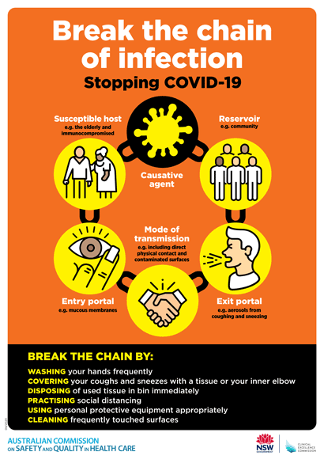](https://www.safetyandquality.gov.au/publications-and-resources/resource-library/break-chain-poster-a3https:/www.safetyandquality.gov.au/publications-and-resources/resource-library/break-chain-poster-a3)**
* ***COVID-19: Elective surgery and infection prevention and control precautions*** <https://www.safetyandquality.gov.au/publications-and-resources/resource-library/covid-19-elective-surgery-and-infection-prevention-and-control-precautions>
* ***FAQs for clinicians on elective surgery*** <https://www.safetyandquality.gov.au/node/5724>
* ***FAQs for consumers on elective surgery*** <https://www.safetyandquality.gov.au/node/5725>
* ***FAQs on community use of face masks***   
   <https://www.safetyandquality.gov.au/faqs-community-use-face-masks>
* ***COVID-19 and face masks – Information for consumers*** <https://www.safetyandquality.gov.au/publications-and-resources/resource-library/covid-19-and-face-masks-information-consumers>  
  The Commission’s fact sheet on use of face masks in the community to reduce the spread of COVID-19 is now available in Easy English and 10 other community languages from <https://www.safetyandquality.gov.au/wearing-face-masks-community>.  
  The factsheet was developed to help people understand when it is important to wear a mask to reduce the risk of the spread of COVID-19, and to explain how to safely put on and remove face masks. It also reinforces the importance of staying home if you have symptoms, physical distancing, hand hygiene and cough etiquette.

[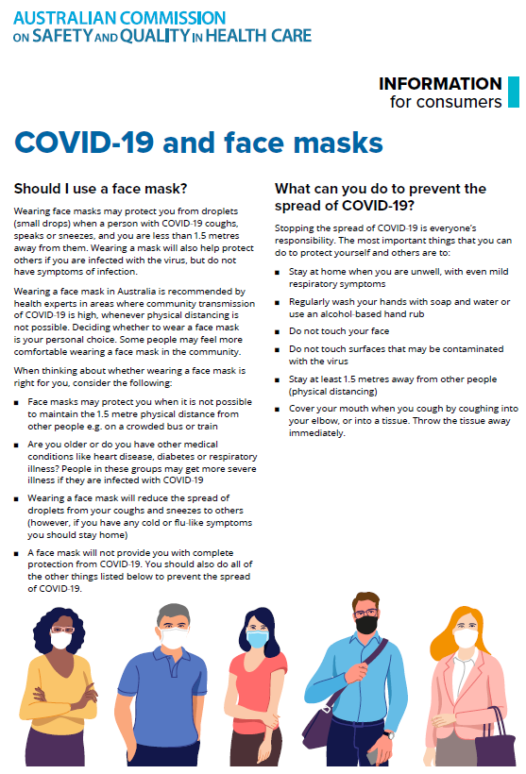](https://www.safetyandquality.gov.au/sites/default/files/2020-07/covid-19_and_face_masks_-_information_for_consumers.pdf)

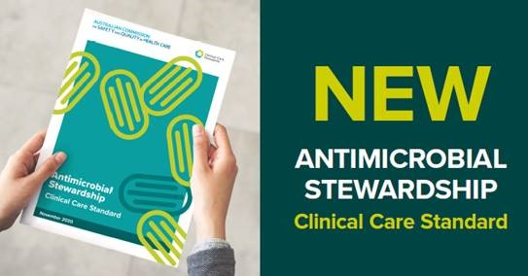

***Antimicrobial Stewardship Clinical Care Standard***

Australian Commission on Safety and Quality in Health Care

Sydney: ACSQHC; 2020. p. 48.

<https://www.safetyandquality.gov.au/our-work/clinical-care-standards/antimicrobial-stewardship-clinical-care-standard>

The 2020 *Antimicrobial Stewardship Clinical Care Standard* was launched by the Australian Commission on Safety and Quality in Health Care on the last day of World Antimicrobial Awareness Week – 24 November 2020. First published in 2014, this clinical care standard describes the care patients should receive when they have (or are at risk of) an infection.

Following a comprehensive review, the updated standard includes strengthened recommendations regarding surgical prophylaxis and a new statement about assessing adverse reactions to antimicrobials (including allergies).



**National Safety and Quality Primary Healthcare Standards Consultation**

<https://www.safetyandquality.gov.au/standards/national-safety-and-quality-primary-healthcare-nsqph-standards>

The Australian Commission on Safety and Quality in Health Care has extended the consultation on the draft *National Safety and Quality Primary Healthcare (NSQPH) Standards* until **Friday 29 January 2021**.

This is to ensure those wanting to contribute to the Australia’s first nationally consistent safety and quality standards for the primary healthcare sector are able to do so.

Written for services that deliver health care to people in a primary healthcare setting, the draft NSQPH Standards provide a national framework to support safety and quality improvements, with a focus on delivering consumer-centred care.

Visit the Commission’s website at <https://www.safetyandquality.gov.au/standards/national-safety-and-quality-primary-healthcare-nsqph-standards> before 29 January 2021 to review the draft standards and have your say by:

* Completing a short online voting poll, or
* Providing a written submission.

To stay updated on the progress of the NSQPH Standards, subscribe to our Primary Care newsletter at <https://www.safetyandquality.gov.au/publications-and-resources/newsletters>, or follow us on [LinkedIn](https://www.linkedin.com/company/acsqhc/) or [Twitter](https://twitter.com/ACSQHC).

**Journal articles**

*The prevalence and impact of unprofessional behaviour among hospital workers: a survey in seven Australian hospitals*

Westbrook J, Sunderland N, Li L, Koyama A, McMullan R, Urwin R, et al

Medical Journal of Australia. 2020 [epub].

|  |  |
| --- | --- |
| DOI | <https://doi.org/10.5694/mja2.50849> |
| Notes | Paper reporting on a study that surveyed hospital workers at 7 Australian hospitals about their experience of “unprofessional behaviours” and the impact on personal wellbeing, teamwork and care quality. Using responses from more than 5,000, the authors report:   * 4846 respondents (**93.6%**; 95% CI, 92.9–94.2%) reported experiencing **at least one unprofessional behaviour during the preceding year**, * including 2009 (**38.8%;** 95% CI, 37.5–40.1%) who **reported weekly or more frequent incivility or bullying**; * 753 (**14.5%**; 95% CI, 13.6–15.5%) **reported** **extreme unprofessional behaviour**. * Nurses and non‐clinical staff members aged 25–34 years reported incivility/bullying and extreme behaviour more often than other staff and age groups respectively. * Staff with self‐reported speaking‐up skills experienced less incivility/bullying (odds ratio [OR], 0.53; 95% CI, 0.46–0.61) and extreme behaviour (OR, 0.80; 95% CI, 0.67–0.97), and also less frequently an impact on their personal wellbeing (OR, 0.44; 95% CI, 0.38–0.51).   The authors concluded ‘Unprofessional behaviour is common among hospital workers. Tolerance for low level poor behaviour may be an enabler for more serious misbehaviour that endangers staff wellbeing and patient safety. Training staff about speaking up is required, together with organisational processes for effectively eliminating unprofessional behaviour.’ |

*Changes in public perceptions and experiences of the Australian health‐care system: A decade of change*

Ellis LA, Pomare C, Gillespie JA, Root J, Ansell J, Holt J, et al.

Health Expectations. 2020 [epub].

|  |  |
| --- | --- |
| DOI | <https://doi.org/10.1111/hex.13154> |
| Notes | The experience of and perceptions about the health “system” by the users of the system have attracted growing interest in recent years. This paper reports on a study that sought the views of Australians in 2018 (and compared them with previous surveys in 2008, 2010 and 2012. The population‐based online survey gathered responses form 1,024 individuals. The survey included questions consistent with previous surveys regarding self‐reported health status, and questions about use, opinions and experiences of the health system. The authors found that ‘Overall, there are predominantly positive views towards the Australian health system and these have improved over the past decade. Almost half of Australians view their health‐care system positively, and this is a significant improvement from only 30% in 2012. In 2018, public sentiment was significantly more favourable towards public hospitals, GPs, and dental services than previously reported, reflecting improved satisfaction with these services.’ However, it was also noted that ‘Problem areas have been identified across the surveys, including the need for more doctors, nurses and other health workers. Cost barriers have become more of an issue across the decade, particularly barriers to access to care and medicines, along with rising concern over the quality of residential aged care services.’ |

*BMJ Quality & Safety*

December 2020 - Volume 29 - 12

|  |  |
| --- | --- |
| URL | <https://qualitysafety.bmj.com/content/29/12> |
| Notes | A new issue of *BMJ Quality & Safety* has been published. Many of the papers in this issue have been referred to in previous editions of *On the Radar* (when they were released online). Articles in this issue of *BMJ Quality & Safety* include:   * Editorial: **Diagnostic error in hospitals**: finding forests not just the big trees (Laura Zwaan, Hardeep Singh) * Editorial: Devil in the details: understanding the effects of **providing electronic health record access to patients and families** (Urmimala Sarkar, Courtney Lyles) * Editorial: **Home care after elective vascular surgery**: still more questions than answers (Christine D Jones, Rebecca S Boxer) * Prevalence and characterisation of **diagnostic error among 7-day all-cause hospital medicine readmissions**: a retrospective cohort study (Katie E Raffel, Molly A Kantor, Peter Barish, A Esmaili, H Lim, F Xue, S R Ranji) * Going the extra mile — **cross-border patient handover** in a European border region: qualitative study of healthcare professionals’ perspectives (Juliëtte A Beuken, Daniëlle M L Verstegen, Diana H J M Dolmans, Laura Van Kersbergen, Xavier Losfeld, Saša Sopka, Lina Vogt, Mara E J Bouwmans) * **Identical or similar brand names used in different countries for medications with different active ingredients**: a descriptive analysis (Lubna Merchant, Randall Lutter, Sherry Chang) * Estimating misclassification error in a binary performance indicator: case study of **low value care in Australian hospitals** (Tim Badgery-Parker, Sallie-Anne Pearson, Adam G Elshaug) * **Fall prevention implementation strategies** in use at 60 United States hospitals: a descriptive study (Kea Turner, Vincent Staggs, Catima Potter, Emily Cramer, Ronald Shorr, Lorraine C Mion) * Prevalence of **harmful diagnostic errors in hospitalised adults**: a systematic review and meta-analysis (Craig G Gunderson, Victor P Bilan, Jurgen L Holleck, Phillip Nickerson, Benjamin M Cherry, Philip Chui, Lori A Bastian, Alyssa A Grimshaw, Benjamin A Rodwin) * Impact of **providing patients access to electronic health records** on quality and safety of care: a systematic review and meta-analysis (Ana Luisa Neves, Lisa Freise, Liliana Laranjo, Alexander W Carter, Ara Darzi, Erik Mayer) * Associations of **workflow disruptions in the operating room with surgical outcomes**: a systematic review and narrative synthesis (Amelie Koch, Jacob Burns, Ken Catchpole, Matthias Weigl) * Overly optimistic picture of current state of **cross-border patient care** in ‘Going the extra mile’ study (Dionne SKringos, Femke Jansen, Tessa Jansen) * Response to: Overly optimistic picture of current state of **cross-border patient care** in ‘Going the extra mile’ by Beuken JA, Verstegen DML, Dolmans D, et al (Juliëtte A Beuken, Daniëlle M L Verstegen, Diana Dolmans, Laura Van Kersbergen, Xavier Losfeld, S Sopka, L Vogt, M E J Bouwmans) * **Tiered daily huddles**: the power of teamwork in managing large healthcare organisations (Tomislav Mihaljevic) |

*International Journal for Quality in Health Care*

Volume 32, Issue 9, November 2020

|  |  |
| --- | --- |
| URL | <https://academic.oup.com/intqhc/issue/32/9> |
| Notes | A new issue of the *International Journal for Quality in Health* has been published. Many of the papers in this issue have been referred to in previous editions of *On the Radar* (when they were released online). Articles in this issue of the *International Journal for Quality in Health* include:   * ‘**Heroes in healthcare**; what’s wrong with that?’ (John Brennan) * Association of **continuity of care** with readmission, mortality and suicide after hospital discharge among psychiatric patients (Young Choi, Chung Mo Nam, Sang Gyu Lee, Sohee Park, Hwang-Gun Ryu, Eun-Cheol Park) * The applicability of COBIT processes representation structure for **quality improvement in healthcare**: a Delphi study (Boştjan Žvanut, Milena Burnik, Tamara Štemberger Kolnik, Patrik Pucer) * **From hospital to post-acute care organizations**: the relationship between patient experience and health recovery (Generosa Do Nascimento, Francisco Guilherme Nunes, Janet E Anderson) * **Tradeoff between efficiency and perceived quality**: evidence from patient-level data (Saima Bashir, Muhammad Nasir) * Risk-adjustment models for clean and colorectal surgery **surgical site infection** for the Spanish health system (Daniel Angel García, Ismael Martínez Nicolás, José Andrés García Marín, Victoriano Soria Aledo) * The effects of acupressure on **post-cesarean pain and analgesic consumption**: a randomized single-blinded placebo-controlled study (Mehtap Akgün, İlkay Boz) * Impact of **TeamSTEPPS on patient safety culture** in a Swiss maternity ward (Anthony Staines, Estelle Lécureux, Pascal Rubin, C Baralon, A Farin) * Factors influencing family member perspectives on **safety in the intensive care unit**: a systematic review (M A Coombs, S Statton, C V Endacott, R Endacott) * Case study: international healthcare service quality, building a model for **cultivating cultural sensitivity** (Ya-Ting Yang, Yi-Hsin Elsa Hsu, Kung-Pei Tang, Christine Wang, Stephen Timmon, W-T Chiu, S Annavajjula, J-S Chu) |

*Journal of Patient Safety*

Vol. 16, No. 4, December 2020

|  |  |
| --- | --- |
| URL | <https://journals.lww.com/journalpatientsafety/toc/2020/12000> |
| Notes | A new issue of the *Journal of Patient Safety* has been published. Articles in this issue of the *Journal of Patient Safety* include:   * Using **Simulation to Prepare Healthcare Teams During the COVID-19** Pandemic (Maria Carmen G Diaz, Kimberly Dawson, Heather Sobolewski) * **Keeping Patients and Hospital Health Care Workers Safe During the COVID-19 Pandemic**: Pneumonia Epidemic Prevention Ward (Jung-Yueh Chen, Hui-Wen Tsai, Chun-Kai Huang, Shu-Ching Chi, Tzu-Ling Lin * The Impact of Surgical Count Technology on **Retained Surgical Items Rates** in the Veterans Health Administration (William Gunnar, Christina Soncrant, Marilyn M. Lynn, Julia Neily, Yohannes Tesema, William Nylander) * Effect of Implementing a **Standardized Shoulder Dystocia Documentation** Form on Quality of Delivery Notes (Lisa C. Zuckerwise, Madison M. Hustedt, Heather S. Lipkind, Edmund F. Funai, Cheryl A. Raab, Christian M. Pettker) * **Learning From Incident Reporting**? Analysis of Incidents Resulting in Patient Injuries in a Web-Based System in Swedish Health Care (Eva-Lena Ahlberg, Johan Elfström, Madeleine Risberg Borgstedt, Annica Öhrn, Christer Andersson, Rune Sjödahl, Per Nilsen) * **Adverse Events** at Baseline in a Chinese General Hospital: A Pilot Study of the Global Trigger Tool (Xiao-Di Xu, Yi-Jie Yuan, Li-Ming Zhao, Yang Li, Hui-Zhen Zhang, Hua Wu) * The Detection, Analysis, and Significance of **Physician Clustering in Medical Malpractice Lawsuit Payouts** (Robert E. Oshel, Philip Levitt) * Is Communication Improved With the Implementation of an **Obstetrical** Version of the World Health Organization **Safe Surgery Checklist**? (Shravya Govindappagari, Amanda Guardado, Dena Goffman, Jeffrey Bernstein, Colleen Lee, Sara Schonfeld, Robert Angert, Andrea McGowan, P S Bernstein) * Identifying Patient Characteristics Associated With **Deficits in Surgical Decision Making** (Zara Cooper, N Hevelone, M Sarhan, T Quinn, A Bader) * How Differences Between Manager and Clinician Perceptions of **Safety Culture Impact Hospital Processes of Care** (Jason Richter, Olena Mazurenko, Abby Swanson Kazley, Eric W Ford) * **Adverse Event Reporting**: Harnessing Residents to Improve Patient Safety (Sarah E Tevis, Ryan K Schmocker, Tosha B Wetterneck) * A Prospective Assessment of **Adverse Events in 3 Digestive Surgery Departments** From Central Tunisia (Mondher Letaief, Sana El Mhamdi, Sameen Siddiqi, Rached Letaief, Abdelwaheb Morjane, Abdelaziz Hamdi) * The Impact of Environmental Context on **Intern Sign-Out Quality** (Soo-Hoon Lee, Christopher Terndrup, Phillip H Phan, Sandra E Zaeh, Kwame Atsina, Nicole Minkove, Sanjay V Desai) * **Essential and Nonessential Blood Testing** in the Clinical Teaching Unit (Cody Sherren, Andrew Day, Roy Ilan) * Prevalence and Seriousness of **Analgesic-Induced Adverse Events in Korea**: A 10-Year Nationwide Surveillance (Yeo Jin Choi, Myoung-Hee Kim, Eun Kyoung Chung, Jun Kyu Lee, Jimin Yoon, Ji Seob Yug, Dong Kee Jang) * The **Impact of** **Incident Disclosure Behaviors on Medical Malpractice Claims** (Priscila Giraldo, Luke Sato, Xavier Castells) * **Barriers to Speaking Up** About Patient Safety Concerns (Jason M Etchegaray, Madelene J Ottosen, Theresa Dancsak, Eric J Thomas) * **Race Differences in Reported Harmful Patient Safety Events** in Healthcare System High Reliability Organizations (Angela D Thomas, Chinmay Pandit, Seth A Krevat) * **Dentists Survey on Adverse Events** During Their Clinical Training (Alfredo Alan Osegueda-Espinosa, Leonor Sánchez-Pérez, Bernardo Perea-Pérez, Elena Labajo-González, A. Enrique Acosta-Gio) * Description and Yield of Current **Quality and Safety Review in Selected US Academic Emergency Departments** (Richard Thomas Griffey, Ryan M Schneider, Brian R Sharp, Jeffrey J Pothof, S Hodkins, R Capp, J L Wiler, N Sreshta, J E Sather, C S Sampson, J T Powell, K Y Groner, L M Adler) * Cost-Benefit Analysis of a **Support Program for Nursing Staff** (Dane Moran, Albert W Wu, Cheryl Connors, Meera R Chappidi, Sushama K Sreedhara, Jessica H Selter, William V Padula) * Impact of a Nurse-Driven **Diabetic Ketoacidosis Insulin Infusion Calculator** on the Rate of Hypoglycemia (Cynthia Lee, Jennifer Austin Szwak, Samantha Bastow, Sarah McCarthy) * The Protagonism of the **Brazilian Health Regulatory System in the Evolution of Patient Safety** in the Country: History, Dilemmas, and Current Challenges (Heiko T Santana, Magda M M Costa, Maria Dolores S P Nogueira, Ana Clara R B dos Santos, André A Carvalho, Luana T Morelo, Cleide F M Ribeiro, Fabiana C de Sousa, Humberto L C A de Moura, Lilian de S Barros, Luciana S C de Oliveira, Mara R S Gonçalves) * Psychometric Design and Validation of an **Adverse Event Vulnerability Scale in Prehospital Emergency Care** (Antonio Montero García, Olga Patricia Jiménez Guerrero, Esther Caravias Chaves, Lázaro González Aranda, Silvia García Mayor, José Miguel Morales Asencio) * Criticality of **Maternal Complications During Childbirths** (Jean Guglielminotti, Ruth Landau, Cynthia A Wong, Guohua Li) * Exploring the **Impact of Primary Care Physician Burnout and Well-Being on Patient Care**: A Focus Group Study (Louise H Hall, Judith Johnson, Jane Heyhoe, Ian Watt, Kevin Anderson, Daryl B O’Connor) * Multilevel Analysis of Individual, Organizational, and Regional Factors Associated With **Patient Safety Culture**: A Cross-Sectional Study of Maternal and Child Health Institutions in China (Yuanyuan Wang, Yanjun Fan, Xiaoli Wang, Yuanying Ma, Chunmei Wu, Huifeng Shi, Hui Han, Weiwei Liu, C Liu) * Returning to **Elective Orthopedic Surgery During the COVID-19 Pandemic:** A Multidisciplinary and Pragmatic Strategy for Initial Patient Selection (Georges F Vles, Stijn Ghijselings, Iris De Ryck, Geert Meyfroidt, Nicola A Sweeney, Wouter Oosterlinck, Minne Casteels, Lieven Moke) * **Liability of Health Care Professionals and Institutions During COVID-19** Pandemic in Italy: Symposium Proceedings and Position Statement (Antonio Oliva, Matteo Caputo, Simone Grassi, G Vetrugno, M Marazza, G Ponzanelli, R Cauda, G Scambia, G Forti, R Bellantone, V L Pascali) * Associated Factors With **Acute Transfusion Reaction** From Hospital Online Reporting Events: A Retrospective Cohort Study (Chao-Yuan Yao, Ju-Huei Chien, Hsun-Yang Chuang, Tsing-Fen Ho) * The Correlation Between **Neonatal Intensive Care Unit Safety Culture and Quality of Care** (Jochen Profit, Paul J Sharek, Xin Cui, Courtney C Nisbet, Eric J Thomas, Daniel S Tawfik, Henry C Lee, David Draper, J Bryan Sexton) * **Miscarriage Treatment–Related Morbidities and Adverse Events** in Hospitals, Ambulatory Surgery Centers, and Office-Based Settings (Sarah C M Roberts, Nancy Beam, G Liu, U D Upadhyay, D L Leslie, D Ba, J L Kerns) * Capturing **Patients' Perspectives on Medication Safety**: The Development of a Patient-Centered Medication Safety Framework (Sally J Giles, Penny J Lewis, Denham L Phipps, Faith Mann, Anthony J Avery, Darren M Ashcroft * Applying the **Global Trigger Tool in German Hospitals**: A Pilot in Surgery and Neurosurgery (Mareen Brösterhaus, Antje Hammer, S Kalina, S Grau, A A Roeth, H Ashmawy, T Groß, M Binnebösel, W T Knoefel, T Manser) * Comparing the Evolution of **Risk Culture in Radiation Oncology, Aviation, and Nuclear Power** (Ahmed Abdulla, K R Schell, M C Schell) * A Safety Evaluation of the Impact of Maternity-Orientated Human Factors Training on **Safety Culture in a Tertiary Maternity Unit** (Sophia P Ansari, Malissa E Rayfield, V A Wallis, J E Jardine, E P Morris, E Prosser-Snelling) * Supplying Pharmacist Home Visit and Anticoagulation Professional Consultation During **Transition of Care for Patients With Venous Thromboembolism** (Alok Kapoor, Valentina Landyn, Joann Wagner, Pamela Burgwinkle, Wei Huang, Joel Gore, Frederick A Spencer, Robert Goldberg, David D McManus, Chad Darling, Edwin Boudreaux, B Barton, K M Mazor) * Factors Influencing **Falls in High- and Low-Risk Patients in a Tertiary Hospital** in Korea (Young-Shin Lee, Eun-Ju Choi, Yeon-Hee Kim, H-A Park) * When **One Patient’s Cancer Specimen Becomes Accidently Swapped With Another’s** Specimen (Sam Atallah, Sergio W Larach) * Engagement in **Eliminating Overuse**: The Argument for Safety and Beyond (Sara Pasik, Deborah Korenstein, Sigal Israilov, Hyung J Cho) * Preventing **Dental Surgical Fires**: Characterizing Nasal-Cannulated Supplemental Oxygen Pooling in an In Situ Dental Procedure (Bradley W Cox, James E Jones, Mark A Saxen, Juan F Yepes) * Lessons Learned From the TRIAD Research Opportunities to Improve **Patient Safety in Emergency Care Near End of Life** (Ferdinando L Mirarchi, Donald M Yealy) |

*Healthcare Policy*

Volume 16, Number 2, 2020

|  |  |
| --- | --- |
| URL | <https://www.longwoods.com/publications/healthcare-policy/26348/1/vol.-16-no.-2-2020> |
| Notes | A new issue of *Healthcare Policy* has been published. Articles in this issue of *Healthcare Policy* include:   * Editorial: **Health Services Research and Government’s Spending** on Healthcare Programs: A Welcome Misalignment? (Jason M Sutherland) * Eliminating Religious and Philosophical Exemptions: The Next Step in Ontario’s Campaign against **Vaccine Hesitancy** (B Thomas and C M Flood) * Commentary: Cautionary Notes on **Exemption Elimination** (L G Beaman) * Transitions in **Labour Force Participation over the Palliative Care Trajectory** (Denise Guerriere, Amna Husain, Denise Marshall, Brandon Zagorski, Julia Kennedy and Peter C Coyte) * **Reallocating Cancer Surgery Payments for Alternate Level of Care** in Ontario: What Are the Options? (Judith Wong, Shannon Milroy, Katherine Sun, Pierre Iorio, May Seto, Julia Monakova and Jason M Sutherland) * Catalyzing **Digital Health Innovation** in Ontario: The Role of an Academic Medical Centre (Laura Desveaux, Leah T Kelley, R S Bhatia and T Jamieson) * **Co-locating Older Retirement Home Residents**: Uncovering an Under-Researched Population via Postal Code (Hana Brath, Sanghun J Kim, Susan E Bronskill, Paula A Rochon and Nathan M Stall) * The **Impact of Prescription Medication Cost Coverage on Oral Medication Use** for Hypertension and Type 2 Diabetes Mellitus (Razan Amoud, Kelly Grindrod, Martin Cooke and Mhd Wasem Alsabbagh) * Rheumatologists’ Acceptance of **Patient Referrals from Physical Therapists** (Debbie Ehrmann Feldman, Michel Zummer, Tatiana Orozco, Jonathan El-Khoury, François Desmeules, Maude Laliberté, Kadija Perreault, Roland Grad, Linda Woodhouse and Sasha Bernatsky) * The Ontario Public Does Not Understand the **Difference Between Registered Dietitians and Unregulated "Nutritionists”**: Results from a Cross-Sectional Mixed Methods Study (Deanna Veloce, Marley Fisher, Colleen O’Connor, Brenda Hartman and Justine R Horne) |

*BMJ Quality & Safety* online first articles

|  |  |
| --- | --- |
| URL | <https://qualitysafety.bmj.com/content/early/recent> |
| Notes | *BMJ Quality &Safety* has published a number of ‘online first’ articles, including:   * Editorial: Can we safely continue to offer **surgical treatments during the COVID-19 pandemic**? (Alex Fowler, Tom E F Abbott, Rupert M Pearse) * Reporting incidents involving the **use of advanced medical technologies by nurses in home care**: a cross-sectional survey and an analysis of registration data (Ingrid ten Haken, Somaya Ben Allouch, Wim H van Harten) * How sensitive are **avoidable emergency department attendances** to primary care quality? Retrospective observational study (Beth Parkinson, Rachel Meacock, Kath Checkland, Matt Sutton) |

**Online resources**

*National COVID-19 Clinical Evidence Taskforce*

<https://covid19evidence.net.au/>

The National COVID-19 Clinical Evidence Taskforce is a collaboration of peak health professional bodies across Australia whose members are providing clinical care to people with COVID-19. The taskforce is undertaking continuous evidence surveillance to identify and rapidly synthesise emerging research in order to provide national, **evidence-based guidelines and clinical flowcharts for the clinical care of people with COVID-19**. The guidelines address questions that are specific to managing COVID-19 and cover the full disease course across mild, moderate, severe and critical illness. These are ‘living’ guidelines, updated with new research in near real-time in order to give reliable, up-to-the minute advice to clinicians providing frontline care in this unprecedented global health crisis.

*COVID-19 Critical Intelligence Unit*

<https://www.aci.health.nsw.gov.au/covid-19/critical-intelligence-unit>

The Agency for Clinical Innovation (ACI) in New South Wales has developed this page summarising rapid, evidence-based advice during the COVID-19 pandemic. Its operations focus on systems intelligence, clinical intelligence and evidence integration. The content includes a daily evidence digest and evidence checks on a discrete topic or question relating to the current COVID-19 pandemic.

*[WHO] Augmented reality PPE course*

<https://www.who.int/about/who-academy/the-who-academy-s-covid-19-mobile-learning-app>

The World Health Organization developed the WHO Academy’s mobile learning app specifically for health workers. The app is designed to enable health workers to expand their life-saving skills to battle COVID-19. It delivers mobile access to a wealth of COVID-19 knowledge resources developed by WHO with content in seven languages: Arabic, Chinese, English, French, Portuguese, Russian and Spanish. The app has a feature that uses augmented reality (AR) technology to help health workers use personal protective equipment (PPE) appropriately. This 20-minute course demonstrates the proper techniques and sequence to put on and remove PPE.

[*UK] NICE Guidelines and Quality Standards*

<https://www.nice.org.uk/guidance>

The UK’s National Institute for Health and Care Excellence (NICE) has published new (or updated) guidelines and quality standards. The latest reviews or updates are:

* NICE Guideline NG186 ***COVID-19 rapid guideline****: reducing the risk of* ***venous thromboembolism*** *in over 16s with COVID-19* <https://www.nice.org.uk/guidance/ng186>

*[USA] Effective Health Care Program reports*

<https://effectivehealthcare.ahrq.gov/>

The US Agency for Healthcare Research and Quality (AHRQ) has an Effective Health Care (EHC) Program. The EHC has released the following final reports and updates:

* *Interventions for* ***Breathlessness in Patients With Advanced Cancer*** <https://effectivehealthcare.ahrq.gov/products/dyspnea-advanced-cancer/report>

*[UK] Deafness and Hearing Loss Toolkit*

<https://www.rcgp.org.uk/clinical-and-research/resources/toolkits/deafness-and-hearing-loss-toolkit.aspx>

The UK’s Royal College of General Practitioners and The Royal National Institute for Deaf People (RNID) and NHS England and Improvement have developed a toolkit to support GPs to deliver care for patients with hearing loss and aims to encourage deaf patients to access primary care. The toolkit aims to support GPs to consult effectively with deaf patients by offering tips on how to communicate during face to face and remote appointments. It also offers guidelines on how to recognise early symptoms of hearing loss and how to refer patients for a hearing assessment.

**Disclaimer**

On the Radar is an information resource of the Australian Commission on Safety and Quality in Health Care. The Commission is not responsible for the content of, nor does it endorse, any articles or sites listed. The Commission accepts no liability for the information or advice provided by these external links. Links are provided on the basis that users make their own decisions about the accuracy, currency and reliability of the information contained therein. Any opinions expressed are not necessarily those of the Australian Commission on Safety and Quality in Health Care.