# Australian COmmission on Safety and Quality in Health Care logo with Radar imageOn the Radar

Issue 497

1 February 2021

*On the Radar* is a summary of some of the recent publications in the areas of safety and quality in health care. Inclusion in this document is not an endorsement or recommendation of any publication or provider. Access to particular documents may depend on whether they are Open Access or not, and/or your individual or institutional access to subscription sites/services. Material that may require subscription is included as it is considered relevant.

*On the Radar* is available online, via email or as a PDF or Word document from <https://www.safetyandquality.gov.au/publications-and-resources/newsletters/radar>

If you would like to receive *On the Radar* via email, you can subscribe on our website <https://www.safetyandquality.gov.au/publications-and-resources/newsletters>   
or by emailing us at H[Umail@safetyandquality.gov.auU](mailto:mail@safetyandquality.gov.au).   
You can also send feedback and comments to H[Umail@safetyandquality.gov.auU](mailto:mail@safetyandquality.gov.au).

For information about the Commission and its programs and publications, please visit <https://www.safetyandquality.gov.au>

You can also follow us on Twitter @ACSQHC.

**On the Radar**

Editor: Dr Niall Johnson [niall.johnson@safetyandquality.gov.au](mailto:niall.johnson@safetyandquality.gov.au)

Contributors: Niall Johnson

**COVID-19 resources**

https://www.safetyandquality.gov.au/covid-19

The Australian Commission on Safety and Quality in Health Care has developed a number of resources to assist healthcare organisations, facilities and clinicians. These and other material on COVID-19 are available at <https://www.safetyandquality.gov.au/covid-19>

These resource include:

* ***COVID-19: Aged care staff infection prevention and control precautions*** *poster*<https://www.safetyandquality.gov.au/publications-and-resources/resource-library/covid-19-aged-care-staff-infection-prevention-and-control-precautions-poster>  
    
  [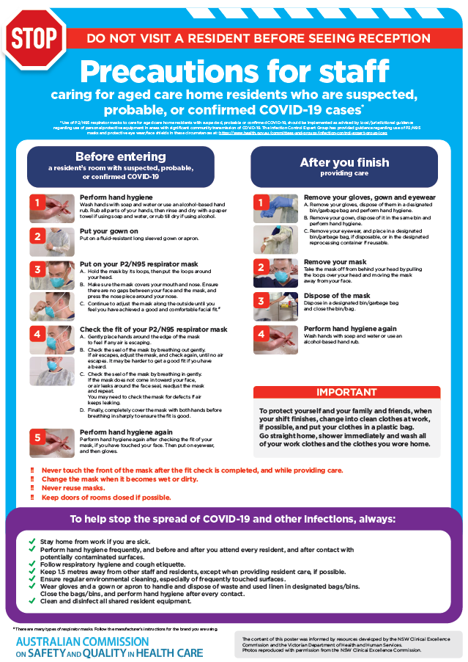](https://www.safetyandquality.gov.au/publications-and-resources/resource-library/covid-19-aged-care-staff-infection-prevention-and-control-precautions-poster)
* ***Environmental Cleaning and Infection Prevention and Control*** [www.safetyandquality.gov.au/environmental-cleaning](http://www.safetyandquality.gov.au/environmental-cleaning)
* ***Infection prevention and control Covid-19 PPE*** poster <https://www.safetyandquality.gov.au/publications-and-resources/resource-library/infection-prevention-and-control-covid-19-personal-protective-equipment>
* ***Special precautions for Covid-19 designated zones*** poster <https://www.safetyandquality.gov.au/publications-and-resources/resource-library/special-precautions-covid-19-designated-zones>
* ***COVID-19 infection prevention and control risk management – Guidance*** <https://www.safetyandquality.gov.au/publications-and-resources/resource-library/covid-19-infection-prevention-and-control-risk-management-guidance>
* ***Safe care for people with cognitive impairment during COVID-19***<https://www.safetyandquality.gov.au/our-work/cognitive-impairment/cognitive-impairment-and-covid-19>
* **Medicines Management COVID-19** <https://www.safetyandquality.gov.au/our-work/medication-safety/medicines-management-covid-19>, including position statements on medicine-related issues
  + ***Managing fever associated with COVID-19***
  + ***Managing a sore throat associated with COVID-19***
  + ***ACE inhibitors and ARBs in COVID-19***
  + ***Clozapine in COVID-19***
  + ***Management of patients on oral anticoagulants during COVID-19***
  + ***Ascorbic Acid: Intravenous high dose in COVID-19***
  + ***Treatment in acute care, including oxygen therapy and medicines to support intubation***
  + ***Nebulisation and COVID-19***
  + ***Managing intranasal administration of medicines during COVID-19***
  + ***Ongoing medicines management in high-risk patients***
  + ***Medicines shortages***
  + ***Conserving medicines***
  + ***Intravenous medicines administration in the event of an infusion pump shortage***
* ***Potential medicines to treat COVID-19***   
  <https://www.safetyandquality.gov.au/publications-and-resources/resource-library/potential-medicines-treat-covid-19>
* ***Break the chain of infection: Stopping COVID-19*** poster<https://www.safetyandquality.gov.au/publications-and-resources/resource-library/break-chain-poster-a3>  
  **[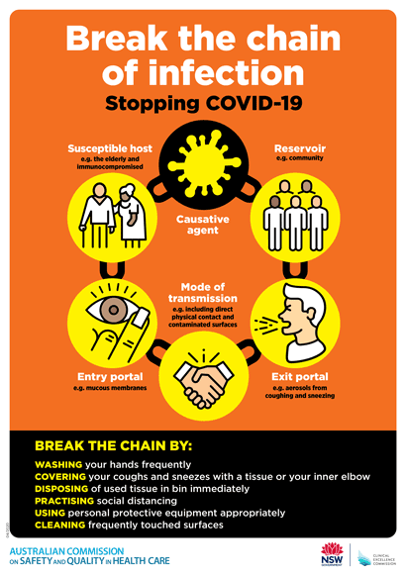](https://www.safetyandquality.gov.au/publications-and-resources/resource-library/break-chain-poster-a3https:/www.safetyandquality.gov.au/publications-and-resources/resource-library/break-chain-poster-a3)**
* ***COVID-19: Elective surgery and infection prevention and control precautions*** <https://www.safetyandquality.gov.au/publications-and-resources/resource-library/covid-19-elective-surgery-and-infection-prevention-and-control-precautions>
* ***FAQs for clinicians on elective surgery*** <https://www.safetyandquality.gov.au/node/5724>
* ***FAQs for consumers on elective surgery*** <https://www.safetyandquality.gov.au/node/5725>
* ***FAQs on community use of face masks***   
   <https://www.safetyandquality.gov.au/faqs-community-use-face-masks>
* ***COVID-19 and face masks – Information for consumers*** <https://www.safetyandquality.gov.au/publications-and-resources/resource-library/covid-19-and-face-masks-information-consumers>  
  The Commission’s fact sheet on use of face masks in the community to reduce the spread of COVID-19 is now available in Easy English and 10 other community languages from <https://www.safetyandquality.gov.au/wearing-face-masks-community>.  
  The factsheet was developed to help people understand when it is important to wear a mask to reduce the risk of the spread of COVID-19, and to explain how to safely put on and remove face masks. It also reinforces the importance of staying home if you have symptoms, physical distancing, hand hygiene and cough etiquette.

[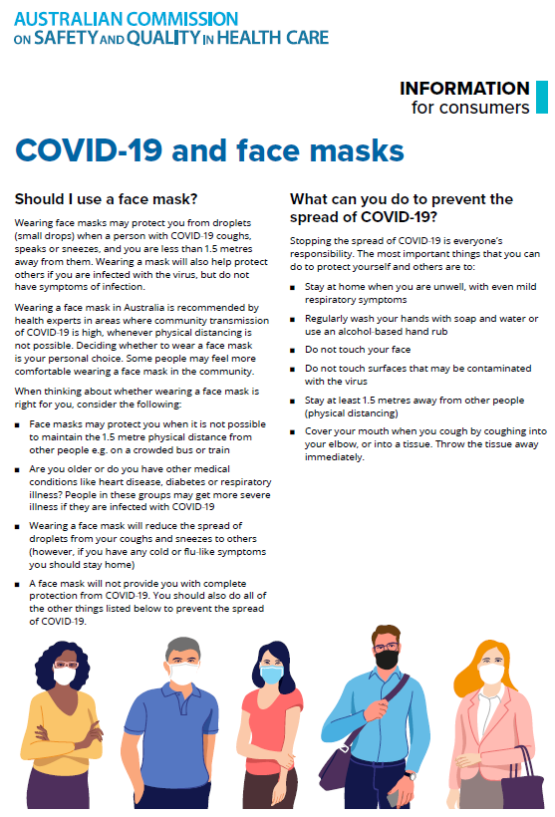](https://www.safetyandquality.gov.au/sites/default/files/2020-07/covid-19_and_face_masks_-_information_for_consumers.pdf)

*National COVID-19 Clinical Evidence Taskforce*

<https://covid19evidence.net.au/>

The National COVID-19 Clinical Evidence Taskforce is a collaboration of peak health professional bodies across Australia whose members are providing clinical care to people with COVID-19. The taskforce is undertaking continuous evidence surveillance to identify and rapidly synthesise emerging research in order to provide national, **evidence-based guidelines and clinical flowcharts for the clinical care of people with COVID-19**. The guidelines address questions that are specific to managing COVID-19 and cover the full disease course across mild, moderate, severe and critical illness. These are ‘living’ guidelines, updated with new research in near real-time in order to give reliable, up-to-the minute advice to clinicians providing frontline care in this unprecedented global health crisis.

*COVID-19 Critical Intelligence Unit*

<https://www.aci.health.nsw.gov.au/covid-19/critical-intelligence-unit>

The Agency for Clinical Innovation (ACI) in New South Wales has developed this page summarising rapid, evidence-based advice during the COVID-19 pandemic. Its operations focus on systems intelligence, clinical intelligence and evidence integration. The content includes a daily evidence digest and evidence checks on a discrete topic or question relating to the current COVID-19 pandemic. The latest updates include:

* ***Emerging evidence about COVID-19 vaccines***
* ***SARS-CoV-2 variants.***

**Reports**

*National Learning Report: Never Events: analysis of HSIB's national investigations*

Healthcare Safety Investigation Branch

Farnborough: HSIB; 2021. p. 75.

|  |  |
| --- | --- |
| URL | <https://www.hsib.org.uk/investigations-cases/never-events/> |
| Notes | The UK’s Healthcare Safety Investigation Branch (HSIB) has released this report examining “never events”. The HSIB considers that Never events are ‘patient safety incidents that are defined as being wholly preventable. They are considered wholly preventable because guidance or safety recommendations are in place at a national level and should have been implemented by all providers in the healthcare system. This should act as a strong systemic barrier to prevent the serious incident from happening.’ This report analyses 10 investigations carried out by HSIB into Never Events. The HSIB challenges some of the assumptions and events deemed to be never events. They also suggest that work to identify strong and systemic safety barriers for specific incidents to aid in their prevention. |

**Journal articles**

*COVID-19 and residential aged care: priorities for optimising preparation and management of outbreaks*

Aitken GE, Holmes AL, Ibrahim JE

Medical Journal of Australia. 2021;214(1):6-8.e1.

|  |  |
| --- | --- |
| DOI | <https://doi.org/10.5694/mja2.50892> |
| Notes | During the SAR-CoV2/COVID-19 pandemic aged care facilities have borne the brunt of much of the morbidity and mortality. This Perspectives piece in the *Medical Journal of Australia* offers a number of recommendations to guide residential aged care facilities in preparing for and managing infectious disease outbreaks. The piece focuses on **outbreak management plans**, **training of staff**, and **maintaining an adequate workforce**. |

*PPE for your mind: a peer support initiative for health care workers*

Bridson TL, Jenkins K, Allen KG, McDermott BM

Medical Journal of Australia. 2021;214(1):8-11.e11.

|  |  |
| --- | --- |
| DOI | <https://doi.org/10.5694/mja2.50886> |
| Notes | Whilst Australia has by-and-large escaped the worst of the SAR-CoV2/COVID-19 pandemic, that is not to say it has not had an effect on Australia, Australians and, perhaps most particularly, Australian health workers. In light of this is this piece in the *Medical Journal of Australia* describing peer support initiatives aimed at aiding Australian health care workers. |

*Healthcare Quarterly*

Volume 23, No. 4

|  |  |
| --- | --- |
| URL | <https://www.longwoods.com/publications/healthcare-quarterly/26363> |
| Notes | A new issue of *Healthcare Quarterly* has been published, with the theme of ‘Responding to the COVID-19 pandemic’. Articles in this issue of *Healthcare Quarterly* include:   * Were Snowbirds **Disproportionally Impacted by COVID-19?** An Ontario Analysis (Salimah Z. Shariff, Lucie Richard, Stephanie Dixon and Kristin K. Clemens) * New Data on **Access to Mental Health and Addictions Services and Home and Community Care** (Maria Zaccaria Cho, Jennifer Frood, Liudmila Husak, Jeanie Lacroix, Norma Hall and Luke Andrew Turcotte) * “Flying Blind”: **Canada’s Supply Chain Infrastructure and the COVID-19 Pandemic** (Anne W Snowdon and Pierre-Gerlier Forest) * Shortages of **Palliative Care Medications in Canada during the COVID-19** Pandemic: Gambling with Suffering (Amit Arya, James Downar, Patty Rice, Susan MacDonald, Ed Osborne, Salmaan Kanji and Robert Sauls) * **Crowdsourcing Health Policy** with the Provider Community during a Crisis (Emma Jowett, Vicki Alexopoulos, Cathy Cattaruzza and Graham Woodward) * **Leading a Long-Term Care Facility through the COVID-19 Crisis**: Successes, Barriers and Lessons Learned (Farinaz Havaei, Maura MacPhee, David Keselman and Sabina Staempfli) * **Decontaminating N95 Respirators for Reuse** in a Hospital Setting (Tabitha A Chiu, Jennifer Jeon, Betty-Jo Edgell and Garry Bassi) * Environmental Sustainability in Canadian Critical Care: A Nationwide Survey Study on **Medical Waste Management** (Alec Yu and Iman Baharmand) * Use of High-Reliability Principles in the Evolution of a **Hospital Command Centre** (Barbara E Collins) * Developing and Implementing a **Patient Behaviour Risk Screening, Communication and Care Planning Intervention** for Hospital Settings (Marija Corovic, Susan Fuciarelli, Denise Johnson, Erika Caspersen, Tony DeBono, Karen Spithoff, Elaine Principi, Melissa Brouwers and Jon-David Schwalm) * “Call Me by My Name”: **Improving Communication with Family Members** at the Bedside via the Caregiver Identification Badge (Lucy Duan, Aris Hadjinicolaou, Raphaël Kraus, Marie-Pier Lirette, Carolyn E. Beck and Michael Gardam) |

*BMJ Quality & Safety* online first articles

|  |  |
| --- | --- |
| URL | <https://qualitysafety.bmj.com/content/early/recent> |
| Notes | *BMJ Quality &Safety* has published a number of ‘online first’ articles, including:   * Association between **intrahospital transfer and hospital-acquired infection in the elderly**: a retrospective case–control study in a UK hospital network (Emanuela Estera Boncea, Paul Expert, Kate Honeyford, Anne Kinderlerer, Colin Mitchell, Graham S Cooke, Luca Mercuri, Céire E Costelloe) |

*International Journal for Quality in Health Care* online first articles

|  |  |
| --- | --- |
| URL | <https://academic.oup.com/intqhc/advance-articles> |
| Notes | *International Journal for Quality in Health Care* has published a number of ‘online first’ articles, including:   * Measuring the impact of **delayed access to elective cholecystectomy** through patient’s cost-utility: An observational cohort study (Ahmer Karimuddin, Carmela Melina Albanese, Trafford Crump, Guiping Liu, Jason M Sutherland) * Healthcare Utilisation Associated with Adherence to **Antibiotics for Abdominal Surgeries** in Japan: Cross-Sectional Analysis of Administrative Database (Shinobu Imai, Anna Kiyomi, Munetoshi Sugiura, Kiyohide Fushimi) |

**Online resources**

*Program of Experience in the Palliative Approach*

<https://pepaeducation.com/>

The Program of Experience in the Palliative Approach (PEPA) forms part of the Palliative Care Education and Training Collaborative. , PEPA aims to enhance the capacity of health professionals to deliver a palliative care approach through their participation in either clinical placements in specialist palliative care services or interactive workshops. PEPA provides opportunities to develop confidence, knowledge and skills in the palliative approach to care through:

* funded clinical workforce placements or workshops
* integration of learning into your workplace
* establishing networks of support.

The PEPA website includes support and education resources, including general resources and information, online learning, learning guides, case studies, etc.

*Taking care: A podcast of conversations about public safety and health care*

<https://www.ahpra.gov.au/Publications/Podcasts.aspx>

The Australian Health Practitioner Regulation Agency (AHPRA) hosts conversations and interviews with people to discuss current issues, address myths and common questions, and think about what we can do to best protect the public and support the safe delivery of health care in Australia. Podcasts available include:

* Continuing the telehealth conversation
* Dental practice in a pandemic
* When protecting the public is your focus
* Responsible advertising by regulated health services
* Mental health of nurses, midwives and the people they care for
* Collaboration across professions: Aboriginal and Torres Strait Islander Health Practitioners
* Sexual misconduct in the health professions
* How the pandemic is changing mental healthcare.

[*UK] NICE Guidelines and Quality Standards*

<https://www.nice.org.uk/guidance>

The UK’s National Institute for Health and Care Excellence (NICE) has published new (or updated) guidelines and quality standards. The latest reviews or updates are:

* Quality Standard QS29 ***Venous thromboembolism*** *in adults: diagnosis and management* <https://www.nice.org.uk/guidance/qs29>
* Quality Standard QS199 ***Abortion care*** <https://www.nice.org.uk/guidance/qs199>

*[USA] Effective Health Care Program reports*

<https://effectivehealthcare.ahrq.gov/>

The US Agency for Healthcare Research and Quality (AHRQ) has an Effective Health Care (EHC) Program. The EHC has released the following final reports and updates:

* *Living Systematic Review on* ***Cannabis and Other Plant-Based Treatments for Chronic Pain*** <https://effectivehealthcare.ahrq.gov/products/plant-based-chronic-pain-treatment/living-review>

*[UK] NIHR Evidence alert*

<https://evidence.nihr.ac.uk/>alerts/

The UK’s National Institute for Health Research (NIHR) has posted new evidence alerts on its site. Evidence alerts are short, accessible summaries of health and care research which is funded or supported by NIHR. This is research which could influence practice and each Alert has a message for people commissioning, providing or receiving care. The latest alerts include:

* *Cardiovascular disorders*
* Spironolactone is not an effective treatment for one type of **irregular heartbeat**, research shows
* *Social care*
* **Informal dementia carers** had to make difficult decisions about paid care during COVID-19
* People who fund their own **social care** receive little help to navigate the system
* Older people move safely **from hospital to home** when staff communicate widely and bridge gaps in the system
* *Mental Health*
* Lockdown raised anxiety in people with **anorexia** and their carers, but online resources helped
* *Injuries and accidents*
* Plaster cast is as good as surgery for a broken **scaphoid** bone in the wrist, SWIFFT trial finds.

**Disclaimer**

On the Radar is an information resource of the Australian Commission on Safety and Quality in Health Care. The Commission is not responsible for the content of, nor does it endorse, any articles or sites listed. The Commission accepts no liability for the information or advice provided by these external links. Links are provided on the basis that users make their own decisions about the accuracy, currency and reliability of the information contained therein. Any opinions expressed are not necessarily those of the Australian Commission on Safety and Quality in Health Care.