

# D20-37896

# OrgTRx Quick Reference Guide – Creating a Formatted Cumulative Antibiogram

### Introduction

A cumulative antibiogram supports health services in achieving compliance with the Australian Commission on Safety and Quality in Health Care’s (the Commission’s) National Safety and Quality Health Service (NSQHS) Standard,Preventing and Controlling Healthcare-Associated Infection, specifically Action 3.16. Antibiograms are useful to the local hospital Antimicrobial Stewardship (AMS) teams who are responsible for AMS programs. These programs work to establish antimicrobial prescribing guidelines to inform local empirical therapy recommendations and formulary management.

This document is designed for clinical microbiologists to be able to create their own antibiograms with the relevant formatting already in place enabling them to export an image that can be published for their facility.

The Commission’s website provides more information regarding the [Specification for a Hospital Cumulative Antibiogram](https://www.safetyandquality.gov.au/search?keys=antibiogram).

The format and structure of the published antibiogram work board was originally designed for Queensland Health, but can be adapted to suit other jurisdictions as required.

Please contact [orgtrx-support@health.qld.gov.au](mailto:orgtrx-support@health.qld.gov.au) to discuss options.

Antibiograms can be created to display the organisms as required by each jurisdiction or organisms ordered by the maximum count antimicrobial.

The antibiograms can be based on the CLSI or EUCAST interpretive criteria.

As of 2022, most of the laboratories contributing to APAS have either converted to EUCAST interpretive criteria in their laboratories or are in the process of converting to EUCAST criteria. We have developed two Formatted Antibiograms one for EUCAST and the other for CLSI interpretive criteria.

### The first Isolate rule

When data is sent through to OrgTRx from a Pathology Service all data is incorporated. However, if the first isolate rule is applied then the data is restricted to what the rule stipulates.

For example, if all the data that comes into the data cube for a Pathology Service is reviewed as demonstrated by the example below all isolates for all patients will be included.



For the Facility selected the total number of *Escherichia. coli* isolates tested for ampicillin in 2021 is 2,806.

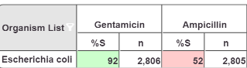

#### Year Isolate

If **First Isolate** is selected as below in the **Year isolate** slicer, this will select the **first isolate** for that **Jurisdiction code** (eg. Alfred Health)for a specific **collection date** for a unique **patient code** and a specific **organism code**.



Applying this rule, the number of *E. coli* isolates tested for ampicillin in 2021 is 2,129 (less 677). There will be no duplicates in the data for the combination above.

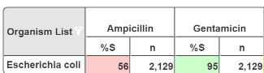

#### Facility Year Isolate

You can also select the data as Facility year isolate by selecting the slicer below



The data is then sliced by the **first isolate** for that **Jurisdiction code** and the specific f**acility code** and **collection date** for a unique **patient code** and a specific **organism code**.

Note that when Facility Year Isolate is selected the data has already been screened for the first isolate for that facility which means that if a patient has visited multiple facilities in that Jurisdiction the first isolate might have been at a facility different to the one selected and as such not included (assuming the patient code is the same for each individual patient).

Antibiograms are designed with **Specimen Year Isolate** as the default setting ensuring all duplication is removed from the antibiogram. Using the **Specimen Category Hierarchy** slicer. You can select the specimen category you would like to display in your antibiogram. The Specimen category selected as a default will be **All excluding infection control screens** as demonstrated below. From here you can select the facility of interest.



### Creating your facility specific antibiogram

Step 1 Click on Public work boards and select **Antibiograms** and then select **Formatted** as below:

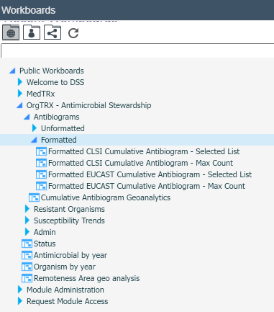

Formatted Antibiograms display the cumulative antibiogram with relevant organism-antimicrobial combinations formatted with < 70% susceptible highlighted in pink, 70-90% susceptible highlighted in yellow and green for where >90% are susceptible. Antimicrobials not tested will be shaded grey and antimicrobials not recommended for use in children shaded blue.

### Difference between CLSI and EUCAST antibiograms

The CLSI antibiogram display %S as isolates with a susceptibility code of 'S'. However, the EUCAST antibiogram includes both susceptible, increased exposure (I) and S as susceptible.

### Formatted EUCAST cumulative antibiogram - Max Count

In this format the organisms are ordered by the Max Count Antimicrobial. What this means is that regardless of the hierarchy of the organisms the ones with the highest counts will appear in the list.

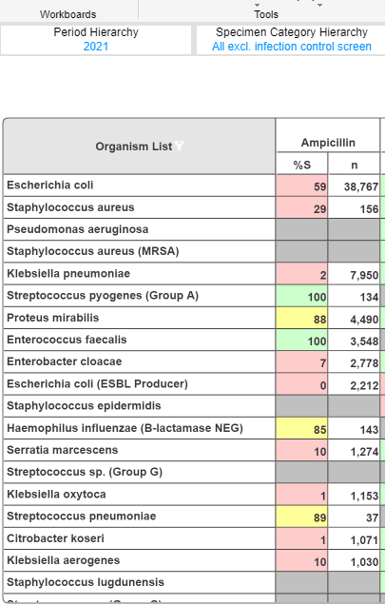

As can be seen above *E. coli* and *E. coli* (ESBL Producer); *S. aureus* and *S. aureus* MRSA are listed separately based on the max count antimicrobial.

### Formatted EUCAST cumulative antibiogram – Selected List

In this format the organisms are selected as ones of interest by the clinical microbiologist at the specific facility.

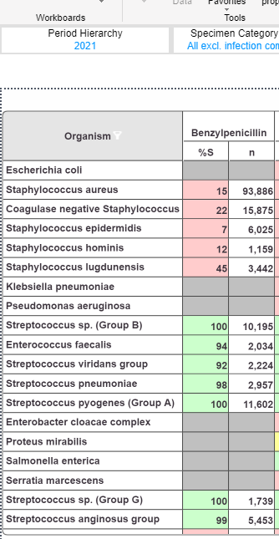

This list can be modified by right clicking on the organism header and selecting organisms of interest.

2

Select the year by right clicking on the [Period Hierarchy] slicer and a list of the available years of data will appear. Select the year of interest as below and click OK. Now the workboard will only contain data for the selected year.

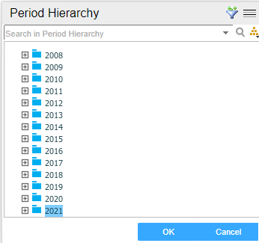

3

Select the Facility by right clicking on the [Facility Ward Hierarchy] slicer and select the Facility you wish to display data for by clicking on it and selecting OK as below.

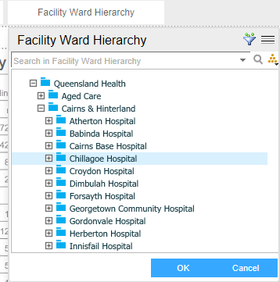

Data displayed in the antibiogram will now be for the selected facility and year.

Once the work board is populated with the data for your facility for the chosen year, you may wish to select the five most commonly isolated species relevant to your facility and patient case mix.

You may select 'Blood', 'Urine' or 'not Blood or Urine' as a specimen type, depending on the relevance to your hospital population.

The work board will be automatically updated when the data cube is built with the previous months’ data (second Tuesday of each month). The workboard is dynamic and by using **select highlighted member** by right clicking on the organism or antimicrobial you are able to make specific selections of interest.

Refer to the **Specification for a Hospital Cumulative Antibiogram** published on the ACSQHC website [Specification for a Hospital Cumulative Antibiogram 2019 | Australian Commission on Safety and Quality in Health Care](https://www.safetyandquality.gov.au/publications-and-resources/resource-library/specification-hospital-cumulative-antibiogram-2019) for guidance in creating your antibiogram.

When you scroll down on the antibiogram page, signal resistances relevant to your facility for the organisms listed below will be displayed.

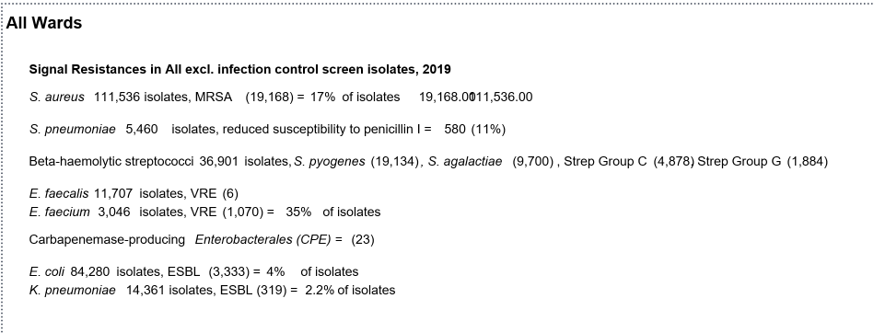

Notes:

1. These values will only appear on your antibiogram if the phenotype is reported with an additional descriptor such as MRSA, VRE, ESBL or CPE for the organism (e.g. *Staphylococcus aureus* (MRSA). If the phenotype is not reported then a “0” will be returned for the % susceptibility and count.
2. While beta-haemolytic streptococci appear on the report it is noted that they are not signal resistances but of interest to Queensland Health users.
3. *Streptococcus pneumoniae* with a penicillin MIC >0.06 mg/L; these are categorised as I (CLSI, or susceptible, increased exposure (EUCAST) and R (MIC >2 mg/L) making reference in the commentary that breakpoints for meningitis and infections other than meningitis differ)

4 To export this image click on the cloud symbol on the application bar:

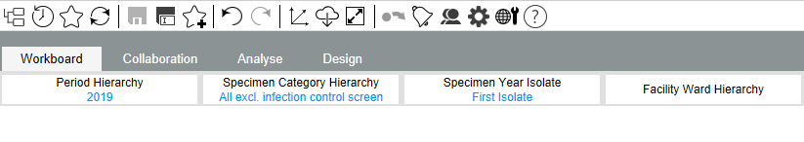

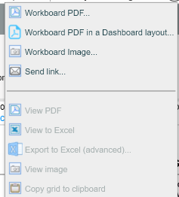

Using the option **Workboard PDF in a Dashboard layout** above it is possible to copy and paste this image into a report or a PowerPoint presentation as required.

It is also possible to capture this view using the **Workboard PDF** option, however the image is split between several page and not as easy to include in a PowerPoint presentation but maybe more appropriate for a report.