# Australian COmmission on Safety and Quality in Health Care logo with Radar imageOn the Radar

**Issue 500**

22 February 2021

*On the Radar* is a summary of some of the recent publications in the areas of safety and quality in health care. Inclusion in this document is not an endorsement or recommendation of any publication or provider. Access to particular documents may depend on whether they are Open Access or not, and/or your individual or institutional access to subscription sites/services. Material that may require subscription is included as it is considered relevant.

*On the Radar* is available online, via email or as a PDF or Word document from <https://www.safetyandquality.gov.au/publications-and-resources/newsletters/radar>

If you would like to receive *On the Radar* via email, you can subscribe on our website <https://www.safetyandquality.gov.au/publications-and-resources/newsletters>   
or by emailing us at H[Umail@safetyandquality.gov.auU](mailto:mail@safetyandquality.gov.au).   
You can also send feedback and comments to H[Umail@safetyandquality.gov.auU](mailto:mail@safetyandquality.gov.au).

For information about the Commission and its programs and publications, please visit <https://www.safetyandquality.gov.au>

You can also follow us on Twitter @ACSQHC.

**On the Radar**

Editor: Dr Niall Johnson [niall.johnson@safetyandquality.gov.au](mailto:niall.johnson@safetyandquality.gov.au)

Contributors: Niall Johnson, Professor Chris Baggoley AO, Leanne Vidler

**Foreword by Professor Chris Baggoley AO**

It is with great pleasure that I am taking up an offer to mark the 500th edition of *On the radar*. I have received and read each and every edition since it was first published on 5 July 2010.

In 2010, as Chief Executive of the Australian Commission on Safety and Quality on Health Care, I felt that the Commission staff, at the very least, should be abreast of the current literature. I approached Dr Niall Johnson, Senior Project Officer at the Commission, and author of what is now a very topical book, *Britain and the 1918-19 Influenza Pandemic: A Dark Epilogue*, to undertake this role. *On the radar* was thus born, on 5 July 2010. This he has continued to produce with great constancy, resolve and excellent results, thereby providing what I think of as a key plank in the reputation the Commission enjoys.

The Commission is now, and has been for quite some time, a sapiential authority for safety and quality matters for Australia. While *On the radar* was originally intended for internal consumption by Commission staff it soon became a resource for all involved in the delivery of safe and high quality health care. Niall has reasonably estimated that it now has a readership of 70,000 people each week.

I have had a number of roles since my time at the Commission but through all these roles, whether they be at a national level, in the public hospital system or in the private hospital system, or, indeed as a patient, I have always found there to be references which resonate and which assist my understanding and planning.

In planning this foreword I compared the contents of the first edition with the 499th. One aspect is totally new, the focus on COVID-19. I do wonder if *On the radar* had been produced in 2009 whether there would have been a plethora of articles on the H1N1 influenza pandemic? I imagine so.

Some things remain eerily similar. Thus in the first edition there were two consecutive articles:

* *Devastatingly Human: An Analysis of Registered Nurses' Medication Error Accounts*. Qualitative Health Research 2010.
* *Adherence to Surgical Care Improvement Project Measures and the Association With Postoperative Infections*. JAMA 2010;303:2479-85.

In edition 499 these consecutive articles appeared:

* *The impact of critical incidents on nurses and midwives: a systematic review*. Journal of Clinical Nursing. 2021 [epub].
* *Supporting recovery after adverse events: an essential component of surgeon well-being*. Journal of Pediatric Surgery. 2021 [epub].

What is new in the latter articles is their method of publication. I don’t recall seeing the reference to “epub” in the first edition!

Congratulations to Niall and to all at the Commission on providing this enduring resource for well over 10 years and, of course, for the totality of its work. One aspect of the Commission’s work which I, and countless others, are reminded of on a daily basis, as we work to ensure that the highest levels of safety and quality of health care in our environments are being provided, are the National Safety and Quality Health Service Standards. Thank goodness for all the assisting publications from the Commission to help in that process.

I just hope that I’m around to write a foreword to the 1,000th edition!

Chris Baggoley

**COVID-19 resources**

https://www.safetyandquality.gov.au/covid-19

The Australian Commission on Safety and Quality in Health Care has developed a number of resources to assist healthcare organisations, facilities and clinicians. These and other material on COVID-19 are available at <https://www.safetyandquality.gov.au/covid-19>

These resource include:

* ***COVID-19: Aged care staff infection prevention and control precautions*** *poster*<https://www.safetyandquality.gov.au/publications-and-resources/resource-library/covid-19-aged-care-staff-infection-prevention-and-control-precautions-poster>  
    
  [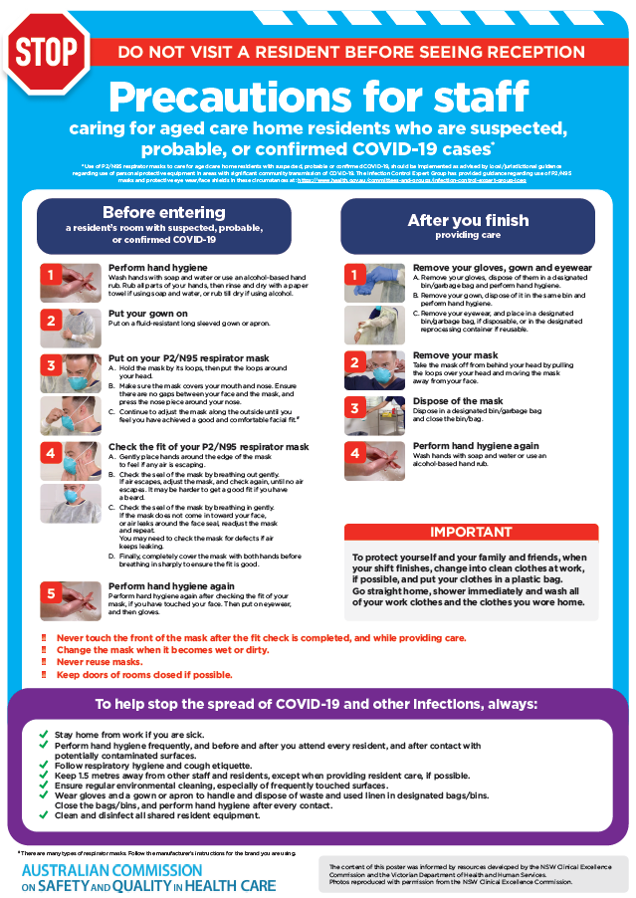](https://www.safetyandquality.gov.au/publications-and-resources/resource-library/covid-19-aged-care-staff-infection-prevention-and-control-precautions-poster)
* ***Environmental Cleaning and Infection Prevention and Control*** [www.safetyandquality.gov.au/environmental-cleaning](http://www.safetyandquality.gov.au/environmental-cleaning)
* ***Infection prevention and control Covid-19 PPE*** poster <https://www.safetyandquality.gov.au/publications-and-resources/resource-library/infection-prevention-and-control-covid-19-personal-protective-equipment>
* ***Special precautions for Covid-19 designated zones*** poster <https://www.safetyandquality.gov.au/publications-and-resources/resource-library/special-precautions-covid-19-designated-zones>
* ***COVID-19 infection prevention and control risk management – Guidance*** <https://www.safetyandquality.gov.au/publications-and-resources/resource-library/covid-19-infection-prevention-and-control-risk-management-guidance>
* ***Safe care for people with cognitive impairment during COVID-19***<https://www.safetyandquality.gov.au/our-work/cognitive-impairment/cognitive-impairment-and-covid-19>
* **Medicines Management COVID-19** <https://www.safetyandquality.gov.au/our-work/medication-safety/medicines-management-covid-19>, including position statements on medicine-related issues
  + ***Managing fever associated with COVID-19***
  + ***Managing a sore throat associated with COVID-19***
  + ***ACE inhibitors and ARBs in COVID-19***
  + ***Clozapine in COVID-19***
  + ***Management of patients on oral anticoagulants during COVID-19***
  + ***Ascorbic Acid: Intravenous high dose in COVID-19***
  + ***Treatment in acute care, including oxygen therapy and medicines to support intubation***
  + ***Nebulisation and COVID-19***
  + ***Managing intranasal administration of medicines during COVID-19***
  + ***Ongoing medicines management in high-risk patients***
  + ***Medicines shortages***
  + ***Conserving medicines***
  + ***Intravenous medicines administration in the event of an infusion pump shortage***
* ***Potential medicines to treat COVID-19***  
  <https://www.safetyandquality.gov.au/publications-and-resources/resource-library/potential-medicines-treat-covid-19>
* ***Break the chain of infection: Stopping COVID-19*** poster<https://www.safetyandquality.gov.au/publications-and-resources/resource-library/break-chain-poster-a3>  
  **[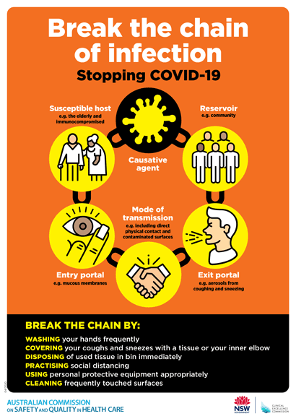](https://www.safetyandquality.gov.au/publications-and-resources/resource-library/break-chain-poster-a3https:/www.safetyandquality.gov.au/publications-and-resources/resource-library/break-chain-poster-a3)**
* ***COVID-19: Elective surgery and infection prevention and control precautions*** <https://www.safetyandquality.gov.au/publications-and-resources/resource-library/covid-19-elective-surgery-and-infection-prevention-and-control-precautions>
* ***FAQs for clinicians on elective surgery*** <https://www.safetyandquality.gov.au/node/5724>
* ***FAQs for consumers on elective surgery*** <https://www.safetyandquality.gov.au/node/5725>
* ***FAQs on community use of face masks***   
   <https://www.safetyandquality.gov.au/faqs-community-use-face-masks>
* ***COVID-19 and face masks – Information for consumers*** <https://www.safetyandquality.gov.au/publications-and-resources/resource-library/covid-19-and-face-masks-information-consumers>  
  The Commission’s fact sheet on use of face masks in the community to reduce the spread of COVID-19 is now available in Easy English and 10 other community languages from <https://www.safetyandquality.gov.au/wearing-face-masks-community>.  
  The factsheet was developed to help people understand when it is important to wear a mask to reduce the risk of the spread of COVID-19, and to explain how to safely put on and remove face masks. It also reinforces the importance of staying home if you have symptoms, physical distancing, hand hygiene and cough etiquette.

[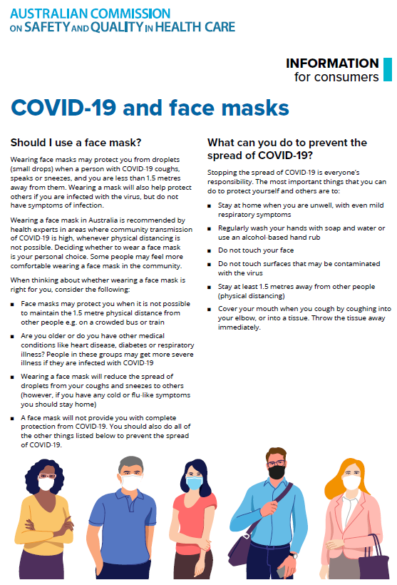](https://www.safetyandquality.gov.au/sites/default/files/2020-07/covid-19_and_face_masks_-_information_for_consumers.pdf)

*National COVID-19 Clinical Evidence Taskforce*

<https://covid19evidence.net.au/>

The National COVID-19 Clinical Evidence Taskforce is a collaboration of peak health professional bodies across Australia whose members are providing clinical care to people with COVID-19. The taskforce is undertaking continuous evidence surveillance to identify and rapidly synthesise emerging research in order to provide national, **evidence-based guidelines and clinical flowcharts for the clinical care of people with COVID-19**. The guidelines address questions that are specific to managing COVID-19 and cover the full disease course across mild, moderate, severe and critical illness. These are ‘living’ guidelines, updated with new research in near real-time in order to give reliable, up-to-the minute advice to clinicians providing frontline care in this unprecedented global health crisis.

*COVID-19 Critical Intelligence Unit*

<https://www.aci.health.nsw.gov.au/covid-19/critical-intelligence-unit>

The Agency for Clinical Innovation (ACI) in New South Wales has developed this page summarising rapid, evidence-based advice during the COVID-19 pandemic. Its operations focus on systems intelligence, clinical intelligence and evidence integration. The content includes a daily evidence digest and evidence checks on a discrete topic or question relating to the current COVID-19 pandemic. There is also a ‘Living evidence’ section summarising key studies and emerging evidence on **COVID-19 vaccines** and **SARS-CoV-2 variants**.

**How to analyse *Staphylococcus aureus* bloodstream infection (SABSI) data for quality improvement**

Australian Commission on Safety and Quality in Health Care

Sydney: ACSQHC; 2021. p. 4.

<https://www.safetyandquality.gov.au/publications-and-resources/resource-library/staphylococcus-aureus-bloodstream-infection-data-analysis-information-sheet>

The Australian Health Ministers Advisory Council (AHMAC) previously endorsed a revised national benchmark for healthcare-associated *Staphylococcus aureus bacteraemia* (SAB) of 1.0 per 10,000 patient days for public hospitals, for the purpose of national reporting. The revised benchmark was implemented from 1 July 2020 to promote ongoing and sustained local safety and quality improvements.

To support the implementation of the revised benchmark, the Australian Commission on Safety and Quality in Health Care has recently published a new [Information Sheet](https://www.safetyandquality.gov.au/publications-and-resources/resource-library/staphylococcus-aureus-bloodstream-infection-data-analysis-information-sheet) to assist hospitals on how to better analyse and use their SAB surveillance data as part of a quality improvement approach. Understanding where and why these infections occur in a hospital should be an essential part of every hospital’s infection prevention and control strategy. [SAB surveillance](https://www.safetyandquality.gov.au/publications-and-resources/resource-library/implementation-guide-surveillance-staphylococcus-aureus-bacteraemia-0) should be complemented with robust data analysis that breaks down data in a meaningful way and allows for hospitals to pinpoint where there have been wins and improvements in SAB prevention as well as areas where additional resources, different strategies and further efforts are needed. This new resource was developed in consultation with the Commission’s HAI Advisory Committee and jurisdictional infection prevention and control programs.

This new Information Sheet is featured on the Commission’s website as part of the Commission’s online SAB prevention compendium at <https://www.safetyandquality.gov.au/sab> and SAB surveillance resources at <https://www.safetyandquality.gov.au/our-work/healthcare-associated-infection/national-hai-surveillance-initiative/myhospitals-staphylococcus-aureus-bacteraemia-data>

**Reports**

*Australia’s aged care system: the quality of care experience and community expectations*

A research study for the Royal Commission into Aged Care Quality and Safety

Ratcliffe J, Chen G, Khadka J, Kumaran S, Hutchinson C, Milte R, et al

Adelaide: Caring Futures Institute, Flinders University; 2020.

*A new measure of quality of care experience in aged care: psychometric assessment and validation of the Quality of Care Experience (QCE) questionnaire*

Ratcliffe J, Chen G, Khadka J, Kumaran S, Hutchinson C, Milte R, et al

Adelaide: Caring Futures Institute, Flinders University; 2020.

|  |  |
| --- | --- |
| URL | <https://agedcare.royalcommission.gov.au/publications/research-paper-20-quality-care-experience-and-community-expectations> |
| Notes | The Royal Commission into Aged Care Quality and Safety has commissioned a number of research projects and reports. This research paper, produced by the Caring Futures Institute at Flinders University, is the most recent release. A number of the research projects have utilised a large-scale general public survey of Australians and two surveys of older people receiving home care and residential care in Australia (or their family carer as a proxy). The surveys of people receiving care used a new questionnaire that measures the Quality of Care Experience (QCE) in aged care containing 6 attributes rated on a 5-point Likert response scale. The attributes were:   * I am treated with respect and dignity * I am supported to make my own decisions about the care and services I receive * I receive care and support from aged care staff who have the appropriate skills and training * I receive services and support for daily living that are important for my health and wellbeing * I am supported to maintain my social relationships and connections with the community * I am comfortable lodging complaints, with confidence that appropriate action will be taken.   The authors of this report observe that ‘Results from the national surveys of care recipients were alarming. Only 24% of people receiving residential care, and 20% of people in home care, felt their care needs were always met across all quality of care experience attributes (including the amalgamated complaints attribute).’  They go on to state that ‘These surveys provide Australia with an important set of baseline data from which to evaluate aged care reform and public expectations in the future. Importantly, they also enabled the development and validation of the QCE which has filled the gap in the research toolkit needed to measure the overall quality of care experience from the care recipient’s perspective.  Routine measurement and public reporting of quality of care experience, as well as quality of life, are essential to understanding the effectiveness of aged care in Australia and internationally. By repeating the surveys at regular intervals, it will be possible to monitor the progress of Australian aged care, promote continuous quality improvement among service providers, and move more quickly to address problems within the system.’ |

*Aged health services in NSW*

NSW Agency for Clinical Innovation

Sydney: ACI; 2021.

|  |  |
| --- | --- |
| URL | <https://aci.health.nsw.gov.au/networks/aged-health/resources/aged-health-services-in-nsw> |
| Notes | The Agency for Clinical Innovation at NSW Health has produced this document in order to ‘develop an ideal model for NSW Health to deliver aged health services, with the aim of improving the care of older people.’ In the document, three different service models are presented that reflect different aspects of aged health services in NSW. The service models in this document are:   * intended as a practical tool to demonstrate the current and ideal aged health services requirements for care of the older person in NSW * accompanied by a decision support tool to assist in identifying the impact on patient care, service and the aged health system, if services are transferred, reduced, changed or enhanced. |

*Advance Care Yarning Guide: Decision Making for End of Life For Aboriginal People in Iutruwita/Tasmania*

Palliative Care Tasmania

Hobart: Palliative Care Tasmania; 2020. p. 12.u

|  |  |
| --- | --- |
| URL | <https://www.pallcaretas.org.au/advance-care-yarning-guide/> |
| Notes | Palliative Care Tasmania has developed this resource as a guide for Aboriginal people, their families and their community, who live in lutruwita/Tasmania, to better understand their choices at end of life and how to explain these choices to medical and health professionals through Advance Care Planning (Yarning). |

**Journal articles**

*Development and Validation of a Tool to Measure Patient Assessment of Clinical Compassion*

Roberts BW, Roberts MB, Yao J, Bosire J, Mazzarelli A, Trzeciak S

JAMA Network Open. 2019;2(5):e193976.

*Curricula for empathy and compassion training in medical education: A systematic review*

Patel S, Pelletier-Bui A, Smith S, Roberts MB, Kilgannon H, et al. (2019) Curricula for empathy and compassion training in medical education: A systematic review. PLOS ONE 14(8): e0221412.

|  |  |
| --- | --- |
| DOI | Roberts et al <https://doi.org/10.1001/jamanetworkopen.2019.3976>  Patel et al <https://doi.org/10.1371/journal.pone.0221412> |
| Notes | The measure for aged care quality experience (above) has some similarities to this measure of compassionate care described by Roberts et al. This paper reports on a cohort study of 6493 that sought to validate a 5-item compassion measure that had been developed to measure patient assessment of clinician compassion. This 3-month cohort study found that the measure ‘demonstrated good internal consistency and convergent validity’. The items in the compassion measure were:   1. How often do you feel your provider cares about your emotional or psychological well-being? 2. How often do you feel your provider is interested in you as a whole person? 3. How often do you feel your provider is considerate of your personal needs? 4. How often do you feel your provider is able to gain your trust? 5. How often do you feel your provider shows you care and compassion?   Furthermore, not only is compassionate care measurable, it is teachable. Patel et al provide a systematic review of the literature on empathy and compassion training in medicine. The review focused on 52 studies looking for specific curricula components (skills and behaviours) demonstrated to be effective. The review ‘identified the following key behaviors to be effective:   1. sitting (versus standing) during the interview; 2. detecting patients’ non-verbal cues of emotion; 3. recognizing and responding to opportunities for compassion; 4. non-verbal communication of caring (e.g. eye contact); and 5. verbal statements of acknowledgement, validation, and support.   These behaviors were found to improve patient perception of physician empathy and/or compassion.’  A recent No Harm Done podcast (<http://noharmdonepodcast.com/>) focused on compassionate care and the safety and quality benefits (to providers and patients). The podcast discussed these two papers and a number of other resources. |

*Cultural Humility: A Proposed Model for a Continuing Professional Development Program*

Cox JL, Simpson MD

Pharmacy. 2020;8(4).

*Cultural respect in midwifery service provision for Aboriginal women: longitudinal follow-up reveals the enduring legacy of targeted program initiatives*

Thackrah RD, Wood J, Thompson SC

International Journal for Equity in Health. 2020;19(1):210.

|  |  |
| --- | --- |
| DOI | Cox and Simpson <https://doi.org/10.3390/pharmacy8040214>  Thackrah et al <https://doi.org/10.1186/s12939-020-01325-x> |
| Notes | Recent years have seen an increasing awareness of the need for culturally appropriate and safe care delivery. This has been accompanied by the development of training in “cultural safety”. Cox and Simpson describes a model for a continuing professional development program on “cultural humility’. The proposed model program for a cultural humility CPD activity incorporates pre-work, online modules, interactive workshop, reflection on professional practice and a post-workshop evaluation.  Thackrah et al provide an example of how cultural respect or cultural safety can have an impact on care. Based on interviews with 14 non-Indigenous midwives who had core Indigenous content and community placements in their training in 2012–14. The interviews revealed that ‘Exposure to Indigenous content and settings during training had an enduring impact on participants’ midwifery practice; most felt better prepared to provide culturally safe care, build respectful relationships and advocate for improved services for Aboriginal women.’ They also recognised some apprehension about causing offence and recognised their own knowledge deficits with regard to Aboriginal cultural practices, and that organisational constraints also existed. The authors conclude that ‘well-designed and delivered Indigenous content and community placement opportunities in midwifery programs can have a lasting impact on service provision to Aboriginal women, contribute to a more informed, empathetic and culturally competent maternity workforce and help catalyse health service changes towards more culturally safe care.’ |

*Preventable medication harm across health care settings: a systematic review and meta-analysis*

Hodkinson A, Tyler N, Ashcroft DM, Keers RN, Khan K, Phipps D, et al

BMC Medicine. 2020;18(1):313.

|  |  |
| --- | --- |
| DOI | <http://doi.org/10.1186/s12916-020-01774-9> |
| Notes | Medication errors are among the most common forms of error in health. This paper reports on a review and meta-analysis to examine the prevalence of preventable medication harm. Based on 81 studies involving 285,687 patients, the authors report that ‘**around one in 30 patients are exposed to preventable medication harm in medical care, and more than a quarter of this harm is considered severe or life-threatening.**’  The authors also report that   * the highest rates of preventable medication harm were seen in elderly patient care settings, intensive care, highly specialised or surgical care and emergency medicine * the proportion of mild preventable medication harm was 39%, moderate preventable harm 40% and clinically severe or life-threatening preventable harm 26%. * the source of the highest prevalence rates of preventable harm were at the prescribing and monitoring stages of medication use. |

For information on the Commission’s work on medication safety, see <https://www.safetyandquality.gov.au/our-work/medication-safety>

*The I-READI quality and safety framework: a health system’s response to airway complications in mechanically ventilated patients with Covid-19*

Ginestra Jennifer C, Atkins J, Mikkelsen M, Mitchell Oscar JL, Gutsche J, Jablonski J, et al

NEJM Catalyst.2(1).

|  |  |
| --- | --- |
| DOI | <http://doi.org/10.1056/CAT.20.0305> |
| Notes | Item reporting on the development of the I-READI (integration, root cause analysis, evidence review, adaptation, dissemination, and implementation) conceptual framework to assist hospitals in preparing for and responding to safety and quality challenges during times of crisis, such as the COVID-19 pandemic. The I-READI approach is intended to streamline communication of clinical concerns, enrich collaboration on solutions, and coordinate rapid change through the use of daily safety huddles, root cause analysis and evidence review, and technology that enables standardised implementation, goal setting, and real-time performance feedback to support practice improvements. |

*Implementing patient and family involvement interventions for promoting patient safety: a systematic review and meta-analysis*

Giap T-T-T, Park M

Journal of Patient Safety. 2021 [epub].

|  |  |
| --- | --- |
| DOI | <http://doi.org/10.1097/PTS.0000000000000714> |
| Notes | The engagement of patients, families, carers and advocates in patient safety has been happening at various levels and to varying degrees for some time. This paper reports a review and meta-analysis that sought to evaluate and to quantify the effects of **patient and family involvement (PFI) interventions on patient safety**. Based on just 22 studies, the meta-analysis found that such interventions were **beneficial in significantly reducing adverse events**, **decreasing the length of hospital stay**, **increasing patient safety experiences**, and **improving patient satisfaction**, but did not significantly enhance the perception of patient safety or the quality of life. |

For information on the Commission’s work on partnering with consumers, see <https://www.safetyandquality.gov.au/our-work/partnering-consumers>

*Association between intrahospital transfer and hospital-acquired infection in the elderly: a retrospective case–control study in a UK hospital network*

Boncea EE, Expert P, Honeyford K, Kinderlerer A, Mitchell C, Cooke GS, et al

BMJ Quality & Safety. 2021 [epub].

*High delayed and missed injury rate after inter-hospital transfer of severely injured trauma patients*

Hensgens RL, El Moumni M, Ijpma FFA, Harbers JS, Duis Kt, Wendt KW, et al

European Journal of Trauma and Emergency Surgery. 2020;46(6):1367-74.

|  |  |
| --- | --- |
| DOI | Boncea et al <https://doi.org/10.1136/bmjqs-2020-012124>  Hensgens et al <http://doi.org/10.1007/s00068-019-01195-1> |
| Notes | The risk during clinical handoff or handovers has been well-known for many years, particularly around the communication of clinically relevant information. These two pieces look at aspects of transfers/movements of patients between and within hospitals.  Boncea et al report looked at intrahospital transfers and the association with hospital-acquired infection (HAI). This was a retrospective case–control study using data extracted from electronic health records and microbiology cultures of non-elective, medical admissions to a large urban hospital network of three hospital sites between 2015 and 2018 in the UK (n=24 240). The analysis focused on older patients (aged 65 and over) as ‘elderly patients comprise a large proportion of hospital users and are a high-risk population for HAIs’. The analysis found that ‘each additional intrahospital transfer increased the odds of acquiring an HAI by 9% (OR=1.09; 95% CI 1.05 to 1.13).’ These findings led the authors to conclude that ‘Intrahospital transfers are associated with increased odds of developing an HAI. Strategies for minimising intrahospital transfers should be considered, and further research is needed to identify unnecessary transfers. Their reduction may diminish spread of contagious pathogens in the hospital environment.’  Hensgens et al report on a Dutch study that sought to establish the incidence and clinical relevance of missed injuries in severely injured patients who require inter-hospital transfer to a level 1 trauma centre. The study included all 251 patients who had been transferred to the University Medical Center Groningen (UMCG) between January 2010 and July 2015 with an Injury Severity Score (ISS)  ≥ 16. The authors report that ‘Inter-hospital transfer of severely injured patients increases the risk of a delayed detection of injuries. We found that 35% of all transferred patients with an ISS ≥ 16 have at least new diagnoses, with over half of these diagnoses requiring a change of management. Given these findings, clinicians should maintain a high index of suspicion when receiving a transferred severely injured trauma patient.’ |

For information on the Commission’s work on clinical handover, see <https://www.safetyandquality.gov.au/our-work/communicating-safety/clinical-handover>

*Australian Journal of Primary Health*

Volume 27 Number 1 2021

|  |  |
| --- | --- |
| URL | <https://www.publish.csiro.au/py/issue/10181> |
| Notes | A new issue of the *Australian Journal of Primary Health* has been published with the theme “**Primary Health Care Nursing**: A celebration of the Year of the Nurse and Midwife”. Articles in this issue of the *Australian Journal of Primary Health* include:   * Editorial: Celebrating the **Year of the Nurse and Midwife in primary health care** (Elizabeth Halcomb, Anna Williams and Susan McInnes) * **Nurse practitioner locums**: a plausible solution for augmenting health care access for rural communities (Natasha Jennings, Grainne Lowe and K Tori) * Mobile memory clinic: implementing a **nurse practitioner-led, collaborative dementia model of care** within general practice (Dimity Pond, Isabel Higgins, Karen Mate, Helga Merl, Dianne Mills and Karen McNeil) * Practice nurses and **providing preconception care to women** in Australia: a qualitative study (Ruth Walker, Pragya Kandel, Briony Hill, Sharon Hills, James Dunbar and Helen Skouteris) * Understanding the **general practice nursing workforce in New Zealand**: an overview of characteristics 2015–19 (Sarah L Hewitt, Nicolette F Sheridan, Karen Hoare and Jane E Mills) * Barriers and facilitators to **lifestyle risk communication** by Australian general practice nurses (Sharon James, Elizabeth Halcomb, Jane Desborough and Susan McInnes) * A chlamydia education and training program for general practice nurses: reporting the effect on **chlamydia testing uptake** (Anna Wood, Sabine Braat, Meredith Temple-Smith, Rebecca Lorch, Alaina Vaisey, R Guy and J Hocking) * Victorian **maternal and child health nurses’ family violence practices and training needs**: a cross-sectional analysis of routine data (Leesa Hooker, Jan Nicholson, Kelsey Hegarty, Lael Ridgway and Angela Taft) * New to the community setting: **nurses’ experiences and the importance of orientation** (Linda Foley, Panagiota Avramidis and Sue Randall) * **Community midwifery**: a primary health care approach to care during pregnancy for Aboriginal and Torres Strait Islander women (Ailsa Munns) * **Remote area nursing**: best practice or paternalism in action? The importance of consumer perspectives on primary health care nursing practice in remote communities (Kylie McCullough, Lisa Whitehead, Sara Bayes and R Schultz) |

*Health Expectations*

Volume 24, Issue 1, February 2021

|  |  |
| --- | --- |
| URL | <https://onlinelibrary.wiley.com/toc/13697625/2021/24/1> |
| Notes | A new issue of *Health Expectations* has been published. Articles in this issue of *Health Expectations* include:   * ‘I think I will need help’: A systematic review of who facilitates the **recovery from gender‐based violence** and how they do so (Patricia Melgar Alcantud, Roger Campdepadrós‐Cullell, Concepció Fuentes‐Pumarola, E Mut‐Montalvà) * Exploring disconnected discourses about **Patient and Public Involvement and Volunteer Involvement** in English health and social care (Jurgen Grotz, Linda Birt, Heather Edwards, Michael Locke, Fiona Poland) * Enhancing **shared and surrogate decision making for people living with dementia**: A systematic review of the effectiveness of interventions (Andrew Geddis‐Regan, Linda Errington, Clare Abley, Rebecca Wassall, Catherine Exley, Richard Thomson) * Cross‐cultural validation of the **patient‐practitioner orientation scale** among primary care professionals in Spain (Lilisbeth Perestelo‐Pérez, Amado Rivero‐Santana, Ana Isabel González‐González, Carlos Jesús Bermejo‐Caja, Vanesa Ramos‐García, Débora Koatz, Alezandra Torres‐Castaño, Marta Ballester, Marcos Muñoz‐Balsa, Yolanda del Rey‐Granado, Francisco Javier Pérez‐Rivas, Yolanda Canellas‐Criado, A B Ramírez‐Puerta, V Pacheco‐Huergo, C Orrego) * Developing a **patient safety guide for primary care**: A co‐design approach involving patients, carers and clinicians (Rebecca L Morris, Angela Ruddock Kay Gallacher, Carly Rolfe, Sally Giles, Stephen Campbell) * Stakeholder engagement from problem analysis to implementation strategies for a **patient‐reported experience measure in disability care**: A qualitative study on the process and experiences (Marjolein van Rooijen, Stephanie Lenzen, Ruth Dalemans, Anna Beurskens, Albine Moser) * Can you see me? **Participant experience of accessing a weight management programme via group videoconference** to overcome barriers to engagement (Marion Cliffe, Enzo Di Battista, Simon Bishop) * **Introducing physician associates to hospital patients**: Development and feasibility testing of a patient experience‐based intervention (Francesca Taylor, Jonathan Ogidi, Rakhee Chauhan, Zeena Ladva, Sally Brearley, V M Drennan) * A patient and public involvement workshop using visual art and priority setting to provide **patients with a voice to describe quality and safety concerns:** Vitamin B12 deficiency and pernicious anaemia (Natasha Tyler, Sally Giles, Gavin Daker‐White, Beth Clare McManus, Maria Panagioti) * **Changes in public perceptions and experiences of the Australian health‐care system**: A decade of change (Louise A Ellis, Chiara Pomare, James A Gillespie, Jo Root, James Ansell, Joanna Holt, Leanne Wells, Yvonne Tran, Jeffrey Braithwaite, Yvonne Zurynski) * **Responsibilities and capabilities of health engagement professionals (HEPs)**: Perspectives from HEPs and health consumers in Australia (Lisa Tam, Kara Burns, Katherine Barnes) * **Perceptions of patients** undergoing percutaneous coronary intervention **on pre‐operative education** in China: A qualitative study (Qiqi Zhuo, Hongmin Liang, Yangjuan Bai, Qiulan Hu, Ardani Latifah Hanum, Mingfang Yang, Yanjiao Wang, Wei Wei, Lan Ding, Fang Ma) * Mapping the **experiences of people with achalasia** from initial symptoms to long‐term management (Melika Kalantari, A Hollywood, R Lim, M Hashemi) * What are the underlying reasons behind **socioeconomic differences in doctor‐patient communication in head and neck oncology review clinics**? (Sarah Allen, Simon N Rogers, Steven Brown, Rebecca V Harris) * **Inclusion under the Mental Capacity Act** (2005): A review of research policy guidance and governance structures in England and Wales (Hayley Ryan, Rob Heywood, Oluseyi Jimoh, Anne Killett, Peter E Langdon, Ciara Shiggins, Karen Bunning) * Mediated roles of generalized trust and perceived social support in the effects of **problematic social media use on mental health**: A cross‐sectional study (Chung‐Ying Lin, Peyman Namdar, Mark D Griffiths, Amir H Pakpour) |

*BMJ Quality & Safety* online first articles

|  |  |
| --- | --- |
| URL | <https://qualitysafety.bmj.com/content/early/recent> |
| Notes | *BMJ Quality &Safety* has published a number of ‘online first’ articles, including:   * **Medical crisis checklists in the emergency department**: a simulation-based multi-institutional randomised controlled trial (Eric Dryver, Jakob Lundager Forberg, Caroline Hård af Segerstad, William D Dupont, Anders Bergenfelz, Ulf Ekelund) * Use of **patient complaints to identify diagnosis-related safety concerns**: a mixed-method evaluation (Traber D Giardina, Saritha Korukonda, Umber Shahid, Viralkumar Vaghani, Divvy K Upadhyay, Greg F Burke, Hardeep Singh) |

*International Journal for Quality in Health Care* online first articles

|  |  |
| --- | --- |
| URL | <https://academic.oup.com/intqhc/advance-articles> |
| Notes | *International Journal for Quality in Health Care* has published a number of ‘online first’ articles, including:   * **Measuring patient voice matters**: setting the scene for patient-reported indicators (Katherine de Bienassis, Solvejg Kristensen, Emily Hewlett, David Roe, Jan Mainz, Niek Klazinga) * Top Four Types of **Sentinel Events in Saudi Arabia** During the Period 2016–2019 (Nasser Altalhi, Haifa Alnaimi, Mafaten Chaouali, Falaa Alahmari, Noor Alabdulkareem, Tareef Alaama) |

**Online resources**

[*UK] NICE Guidelines and Quality Standards*

<https://www.nice.org.uk/guidance>

The UK’s National Institute for Health and Care Excellence (NICE) has published new (or updated) guidelines and quality standards. The latest reviews or updates are:

* NICE Guideline NG159 ***COVID-19*** *rapid guideline:* ***critical care in adults*** <https://www.nice.org.uk/guidance/ng159>
* NICE Guideline NG161 ***COVID-19*** *rapid guideline: delivery of* ***systemic anticancer treatments*** <https://www.nice.org.uk/guidance/ng161>
* NICE Guideline NG162 ***COVID-19*** *rapid guideline: delivery of* ***radiotherapy***<https://www.nice.org.uk/guidance/ng162>

*[USA] Effective Health Care Program reports*

<https://effectivehealthcare.ahrq.gov/>

The US Agency for Healthcare Research and Quality (AHRQ) has an Effective Health Care (EHC) Program. The EHC has released the following final reports and updates:

* *Integrating* ***Palliative Care*** *in Ambulatory Care of Noncancer Serious Chronic Illness: A Systematic Review*   
  <https://effectivehealthcare.ahrq.gov/products/palliative-care-integration/research>

**Disclaimer**

On the Radar is an information resource of the Australian Commission on Safety and Quality in Health Care. The Commission is not responsible for the content of, nor does it endorse, any articles or sites listed. The Commission accepts no liability for the information or advice provided by these external links. Links are provided on the basis that users make their own decisions about the accuracy, currency and reliability of the information contained therein. Any opinions expressed are not necessarily those of the Australian Commission on Safety and Quality in Health Care.