# Australian COmmission on Safety and Quality in Health Care logo with Radar imageOn the Radar

Issue 501

1 March 2021

*On the Radar* is a summary of some of the recent publications in the areas of safety and quality in health care. Inclusion in this document is not an endorsement or recommendation of any publication or provider. Access to particular documents may depend on whether they are Open Access or not, and/or your individual or institutional access to subscription sites/services. Material that may require subscription is included as it is considered relevant.

*On the Radar* is available online, via email or as a PDF or Word document from <https://www.safetyandquality.gov.au/publications-and-resources/newsletters/radar>

If you would like to receive *On the Radar* via email, you can subscribe on our website <https://www.safetyandquality.gov.au/publications-and-resources/newsletters>   
or by emailing us at H[Umail@safetyandquality.gov.auU](mailto:mail@safetyandquality.gov.au).   
You can also send feedback and comments to H[Umail@safetyandquality.gov.auU](mailto:mail@safetyandquality.gov.au).

For information about the Commission and its programs and publications, please visit <https://www.safetyandquality.gov.au>

You can also follow us on Twitter @ACSQHC.

**On the Radar**

Editor: Dr Niall Johnson [niall.johnson@safetyandquality.gov.au](mailto:niall.johnson@safetyandquality.gov.au)

Contributors: Niall Johnson

**COVID-19 resources**

https://www.safetyandquality.gov.au/covid-19

The Australian Commission on Safety and Quality in Health Care has developed a number of resources to assist healthcare organisations, facilities and clinicians. These and other material on COVID-19 are available at <https://www.safetyandquality.gov.au/covid-19>

These resource include:

* ***COVID-19: Aged care staff infection prevention and control precautions*** *poster*<https://www.safetyandquality.gov.au/publications-and-resources/resource-library/covid-19-aged-care-staff-infection-prevention-and-control-precautions-poster>  
    
  [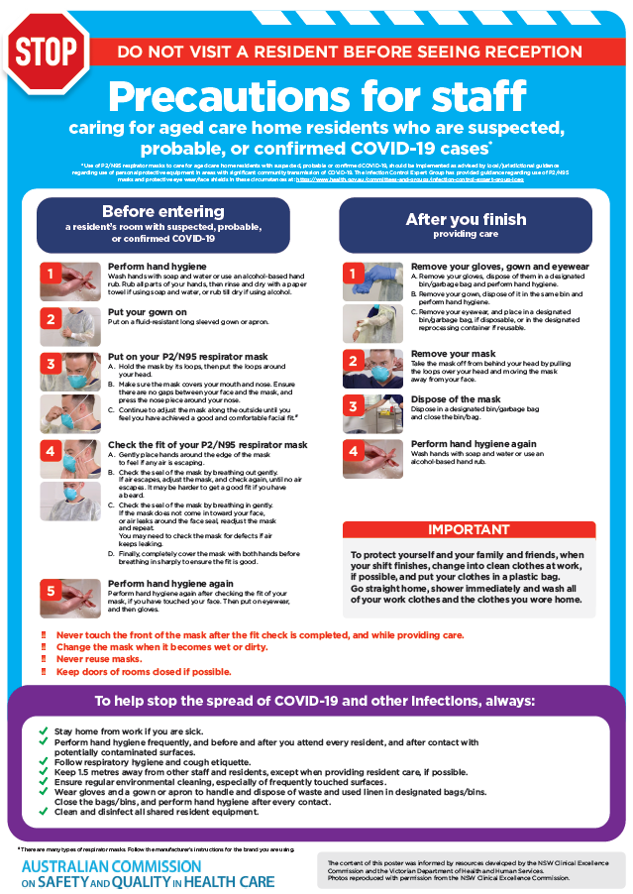](https://www.safetyandquality.gov.au/publications-and-resources/resource-library/covid-19-aged-care-staff-infection-prevention-and-control-precautions-poster)
* ***Environmental Cleaning and Infection Prevention and Control*** [www.safetyandquality.gov.au/environmental-cleaning](http://www.safetyandquality.gov.au/environmental-cleaning)
* ***Infection prevention and control Covid-19 PPE*** poster <https://www.safetyandquality.gov.au/publications-and-resources/resource-library/infection-prevention-and-control-covid-19-personal-protective-equipment>
* ***Special precautions for Covid-19 designated zones*** poster <https://www.safetyandquality.gov.au/publications-and-resources/resource-library/special-precautions-covid-19-designated-zones>
* ***COVID-19 infection prevention and control risk management – Guidance*** <https://www.safetyandquality.gov.au/publications-and-resources/resource-library/covid-19-infection-prevention-and-control-risk-management-guidance>
* ***Safe care for people with cognitive impairment during COVID-19***<https://www.safetyandquality.gov.au/our-work/cognitive-impairment/cognitive-impairment-and-covid-19>
* **Medicines Management COVID-19** <https://www.safetyandquality.gov.au/our-work/medication-safety/medicines-management-covid-19>, including position statements on medicine-related issues
  + ***Managing fever associated with COVID-19***
  + ***Managing a sore throat associated with COVID-19***
  + ***ACE inhibitors and ARBs in COVID-19***
  + ***Clozapine in COVID-19***
  + ***Management of patients on oral anticoagulants during COVID-19***
  + ***Ascorbic Acid: Intravenous high dose in COVID-19***
  + ***Treatment in acute care, including oxygen therapy and medicines to support intubation***
  + ***Nebulisation and COVID-19***
  + ***Managing intranasal administration of medicines during COVID-19***
  + ***Ongoing medicines management in high-risk patients***
  + ***Medicines shortages***
  + ***Conserving medicines***
  + ***Intravenous medicines administration in the event of an infusion pump shortage***
* ***Break the chain of infection: Stopping COVID-19*** poster<https://www.safetyandquality.gov.au/publications-and-resources/resource-library/break-chain-poster-a3>  
  **[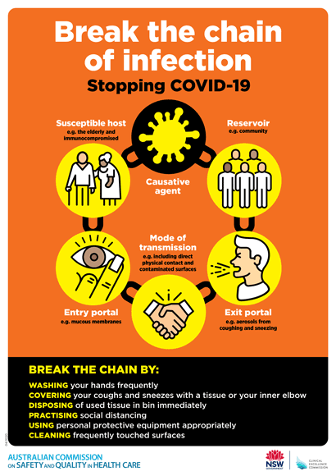](https://www.safetyandquality.gov.au/publications-and-resources/resource-library/break-chain-poster-a3https:/www.safetyandquality.gov.au/publications-and-resources/resource-library/break-chain-poster-a3)**
* ***COVID-19: Elective surgery and infection prevention and control precautions*** <https://www.safetyandquality.gov.au/publications-and-resources/resource-library/covid-19-elective-surgery-and-infection-prevention-and-control-precautions>
* ***FAQs for clinicians on elective surgery*** <https://www.safetyandquality.gov.au/node/5724>
* ***FAQs for consumers on elective surgery*** <https://www.safetyandquality.gov.au/node/5725>
* ***FAQs on community use of face masks***   
   <https://www.safetyandquality.gov.au/faqs-community-use-face-masks>
* ***COVID-19 and face masks – Information for consumers*** <https://www.safetyandquality.gov.au/publications-and-resources/resource-library/covid-19-and-face-masks-information-consumers>  
  The Commission’s fact sheet on use of face masks in the community to reduce the spread of COVID-19 is now available in Easy English and 10 other community languages from <https://www.safetyandquality.gov.au/wearing-face-masks-community>.  
  The factsheet was developed to help people understand when it is important to wear a mask to reduce the risk of the spread of COVID-19, and to explain how to safely put on and remove face masks. It also reinforces the importance of staying home if you have symptoms, physical distancing, hand hygiene and cough etiquette.

[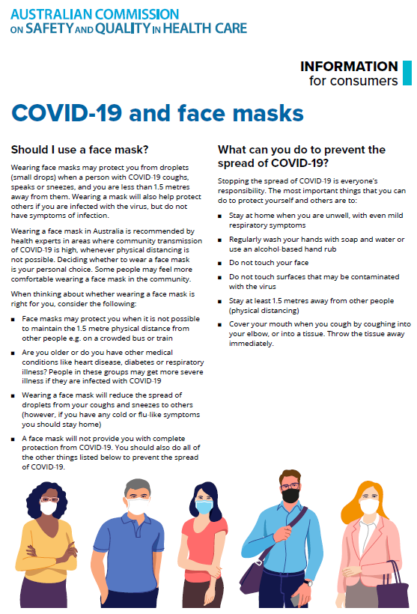](https://www.safetyandquality.gov.au/sites/default/files/2020-07/covid-19_and_face_masks_-_information_for_consumers.pdf)

*National COVID-19 Clinical Evidence Taskforce*

<https://covid19evidence.net.au/>

The National COVID-19 Clinical Evidence Taskforce is a collaboration of peak health professional bodies across Australia whose members are providing clinical care to people with COVID-19. The taskforce is undertaking continuous evidence surveillance to identify and rapidly synthesise emerging research in order to provide national, **evidence-based guidelines and clinical flowcharts for the clinical care of people with COVID-19**. The guidelines address questions that are specific to managing COVID-19 and cover the full disease course across mild, moderate, severe and critical illness. These are ‘living’ guidelines, updated with new research in near real-time in order to give reliable, up-to-the minute advice to clinicians providing frontline care in this unprecedented global health crisis.

*COVID-19 Critical Intelligence Unit*

<https://www.aci.health.nsw.gov.au/covid-19/critical-intelligence-unit>

The Agency for Clinical Innovation (ACI) in New South Wales has developed this page summarising rapid, evidence-based advice during the COVID-19 pandemic. Its operations focus on systems intelligence, clinical intelligence and evidence integration. The content includes a daily evidence digest and evidence checks on a discrete topic or question relating to the current COVID-19 pandemic. There is also a ‘Living evidence’ section summarising key studies and emerging evidence on **COVID-19 vaccines** and **SARS-CoV-2 variants**.

**Reports**

*Supporting patient safety: learning from sentinel events. Annual report 2019–20*

Safer Care Victoria

Melbourne: Safer Care Victoria; 2021:54.

|  |  |
| --- | --- |
| URL | <https://www.bettersafercare.vic.gov.au/publications/sentinel-events-annual-report-2019-20> |
| Notes | Safer Care Victoria (SCV) has published this report on the most serious adverse events reported in Victorian public and private hospitals, and ambulance services in 2019–20. Victorian public and private health services notified 186 sentinel events in 2019–20.  The report pays particular attention to sentinel events in maternity and newborn care, patient falls and medication safety as they are among the most common types of sentinel event.  It’s not enough to simply identify and report on the incidence of sentinel events. As SCV stress, it’s important to learn from and take action. Consequently, the report also looks the root causes, critical events and recommendations identified by health services during root cause analysis (RCA) reviews. The report identifies that recommendations are often not as strong as they might be. It also observes that ‘Open disclosure must occur after an adverse event. But in nearly 10 per cent of 2019–20 sentinel events, open disclosure had not occurred when the event was notified.’  This report sees an increase in reported events. This increase may not reflect an actual increase in incidence but a greater willingness to report and act upon them.  Many such reports tend to only cover public facilities. This report covers some private facilities in Victoria, but does not appear to identify the proportion of facilities or beds covered. An earlier attempt at national reporting of sentinel events managed to cover about 80% of private hospital beds in Australia (<https://www.safetyandquality.gov.au/publications-and-resources/resource-library/windows-safety-and-quality-health-care-2009> ). Ideally such reports would cover all facilities so there is a true sense of the scale and nature of the issue. |

**Journal articles**

*The Collective Leadership for Safety Culture (Co-Lead) Team Intervention to Promote Teamwork and Patient Safety*

De Brún A, Anjara S, Cunningham U, Khurshid Z, Macdonald S, O’Donovan R, et al

International Journal of Environmental Research and Public Health 2020;17(22):8673.

|  |  |
| --- | --- |
| DOI | <https://doi.org/10.3390/ijerph17228673> |
| Notes | Good culture and leadership are seen a crucial precursors for safety and quality (improvement). The article describes the design, pilot testing, and refinement of the Collective Leadership for Safety Culture (Co-Lead) programme, along with key early findings from the evaluation. The Collective Leadership for Safety Cultures (Co-Lead) programme is described as ‘a co-designed intervention for multidisciplinary healthcare teams. It is an open-source resource that offers teams a systematic approach to the development of collective leadership behaviours to promote effective teamworking and enhance patient safety cultures.’ The paper offers a definition of a collective leadership approach as ‘as one that recognises leadership is not necessarily the sole responsibility of one individual, but may be considered a team property, where roles and responsibilities are shared as the task demands’.  The full collective leadership intervention is available to be downloaded as an open access resource from [www.ucd.ie/collectiveleadership](http://www.ucd.ie/collectiveleadership)  [Collective Leadership for Safety Culture programme modules](https://doi.org/10.3390/ijerph17228673) |

*Paving the PICC journey: building structures, process and engagement to improve outcomes*

Fakih M, Sturm L

BMJ Quality & Safety 2021 [epub].

|  |  |
| --- | --- |
| DOI | <https://doi.org/10.1136/bmjqs-2020-012910> |
| Notes | In this editorial, Fakih and Sturm discuss the importance and utility of peripherally inserted central venous catheters (PICC), but also observe that ‘With up to one in five patients at risk for developing complications, it is incumbent on us to ensure that these devices are properly used and maintained.’ To help ensure that PICCs are used safely and appropriately, they ‘propose an approach to improve the appropriate and safe use of PICCs by focusing on three elements …: establishing a structure powered by a VAT [Vascular Access Team]; anchoring a standardised process for line selection, insertion and care; and promoting adoption by engagement with the key stakeholders.’ |

*Use of patient complaints to identify diagnosis-related safety concerns: a mixed-method evaluation*

Giardina TD, Korukonda S, Shahid U, Vaghani V, Upadhyay DK, Burke GF, et al

BMJ Quality & Safety 2021 [epub].

|  |  |
| --- | --- |
| DOI | <https://doi.org/10.1136/bmjqs-2020-011593> |
| Notes | Complaints (and other forms of feedback) from patients, carers and families can be an important source of intelligence about the safety and quality of care. This study examined whether complaints could usefully be used to better understand issues around diagnosis. The study examined two cohorts of patient complaints in a US healthcare organisation, with the cohorts containing 1,865 and 2,423 complaint summaries. From the first cohort, they identified 177 (9.5%) ‘concerning reports’ and review and analysis identified 39 diagnostic errors. In the second cohort, .they identified 310 (12.8%) concerning reports and a 10% sample (n=31 cases) contained five diagnostic errors. These led the authors to conclude ‘Analysis of patient complaint data and corresponding medical record review identifies patterns of failures in the diagnostic process reported by patients and families. Health systems could systematically analyse available data on patient complaints to monitor diagnostic safety concerns and identify opportunities for learning and improvement. |

*Why do healthcare professionals fail to escalate as per the early warning system (EWS) protocol? A qualitative evidence synthesis of the barriers and facilitators of escalation*

O’Neill SM, Clyne B, Bell M, Casey A, Leen B, Smith SM, et al

BMC Emergency Medicine 2021;21(1):15.

|  |  |
| --- | --- |
| DOI | <https://doi.org/10.1186/s12873-021-00403-9> |
| Notes | Considerable effort has gone into the development of early warning systems or systems to recognise and respond to clinical deterioration as it is thought that early responses to deterioration can prevent morbidity and mortality. However, health care workers may not always escalate situations. This paper sought to examine the factors that may influence this behaviour. From 18 studies across 7 countries, the authors identified five overarching themes: Governance, Rapid Response Team (RRT) Response, Professional Boundaries, Clinical Experience, and Early Warning System parameters.  Barriers to escalation included: Lack of Standardisation, Resources, Lack of accountability, RRT behaviours, Fear, Hierarchy, Increased Conflict, Over confidence, Lack of confidence, and Patient variability.  Facilitators included: Accountability, Standardisation, Resources, RRT behaviours, Expertise, Additional support, License to escalate, Bridge across boundaries, Clinical confidence, empowerment, Clinical judgment, and a tool for detecting deterioration. |

For information on the Commission’s work on recognising and responding to deterioration, see <https://www.safetyandquality.gov.au/our-work/recognising-and-responding-deterioration>

*Assessment of a quality improvement intervention to decrease opioid prescribing in a regional health system*

Brown CS, Vu JV, Howard RA, Gunaseelan V, Brummett CM, Waljee J, et al

BMJ Quality & Safety 2021;30(3):251-9.

*Addressing the ignored complication: chronic opioid use after surgery*

Weiner SG

BMJ Quality & Safety 2021;30(3):180-2.

|  |  |
| --- | --- |
| DOI | Brown et al <http://dx.doi.org/10.1136/bmjqs-2020-011295>  Weiner <http://dx.doi.org/10.1136/bmjqs-2020-011841> |
| Notes | The use (and misuse and abuse) of opioids has garnered much attention in recent years, particularly given the “opioid crisis” in the USA. This has also led to efforts to try and ensure more appropriate use of opioids to avoid patients becoming dependent upon them. This piece (Brown et al) and an accompanying editorial (Weiner) look at the issue and one approach to addressing the possible over-prescribing of opioids following surgery that has been undertaken in a 70-hospital collaborative in the USA. Winer observes that ‘Only recently, we have recognised that prescribing excess opioids to previously naïve patients who undergo surgery and subsequently become chronic users is a ‘never event’ that we must strive to avoid.’ Further, he recognises ‘Prolonged opioid use after surgery is one of the most common surgical complications’.  Brown et al describe the development and implementation of a series of opioid prescribing guidelines. The intervention saw ‘mean (SD) prescription size decreased from 25 (17) tablets of 5 mg oxycodone to 12 (8) tablets. Opioid consumption also decreased from 11 (16) to 5 (7) tablets (p<0.001), while satisfaction and postoperative pain remained unchanged.’ Weiner emphasises this last point by observing that ‘that patient satisfaction with care *increased* [emphasis in the original] as opioid quantities decreased, and postoperative pain scores were unchanged. This finding should put to rest, once and for all, the myth that decreasing opioid prescribing will lead to increased patient suffering and decreased patient satisfaction.’ |

For information on the Commission’s work on medication safety, see <https://www.safetyandquality.gov.au/our-work/medication-safety>

*BMJ Quality & Safety*

March 2021 - Volume 30 - 3

|  |  |
| --- | --- |
| URL | <https://qualitysafety.bmj.com/content/30/3> |
| Notes | A new issue of *BMJ Quality & Safety* has been published. Many of the papers in this issue have been referred to in previous editions of *On the Radar* (when they were released online). Articles in this issue of *BMJ Quality & Safety* include:   * Editorial: **Well spotted: but now you need to do something** (Richard Hamblin, Carl Shuker) * Editorial: Addressing the ignored complication: **chronic opioid use after surgery** (Scott G Weiner) * Editorial: Leveraging natural experiments to **evaluate interventions in learning health systems** (Sunita Desai, Eric Roberts) * Preventing critical failure. Can routinely collected data be repurposed to predict **avoidable patient harm**? A quantitative descriptive study (Benjamin Michael Nowotny, Miranda Davies-Tuck, Belinda Scott, Michael Stewart, Elizabeth Cox, Karen Cusack, Martin Fletcher, Eva Saar, Tanya Farrell, Shirin Anil, Louise McKinlay, Euan M Wallace) * Relative contributions of **hospital versus skilled nursing facility quality on patient outcomes** (Paula Chatterjee, Mingyu Qi, Rachel Werner) * Evaluating the **influence of data collector training for predictive risk of death models**: an observational study (Arvind Rajamani, Stephen Huang, Ashwin Subramaniam, Michele Thomson, Jinghang Luo, Andrew Simpson, Anthony McLean, Anders Aneman, Thodur Vinodh Madapusi, Ramanathan Lakshmanan, Gordon Flynn, Latesh Poojara, Jonathan Gatward, Raju Pusapati, Adam Howard, Debbie Odlum) * Implementing **receiver-driven handoffs to the emergency department** to reduce miscommunication (Kathleen Huth, Anne M Stack, Jonathan Hatoun, Grace Chi, Robert Blake, Robert Shields, Patrice Melvin, Daniel C West, Nancy D Spector, Amy J Starmer) * **Adverse events in the paediatric emergency department**: a prospective cohort study (Amy C Plint, Antonia Stang, Amanda S Newton, Dale Dalgleish, Mary Aglipay, Nick Barrowman, Sandy Tse, Gina Neto, Ken Farion, Walter David Creery, David W Johnson, Terry P Klassen, Lisa A Calder) * Effect of preoperative education and ICU tour on **patient and family satisfaction and anxiety in the intensive care unit** after elective cardiac surgery: a randomised controlled trial (Veronica Ka Wai Lai, Ka Man Ho, Wai Tat Wong, Patricia Leung, Charles David Gomersall, Malcolm John Underwood, Gavin Matthew Joynt, Anna Lee) * Cost of contact: **redesigning healthcare in the age of COVID** (R Sacha Bhatia, Kaveh G Shojania, Wendy Levinson) * **Continuous quality improvement in statistical code**: avoiding errors and improving transparency (Thomas S Valley, Neil Kamdar, Wyndy L Wiitala, Andrew M Ryan, Sarah M Seelye, Akbar K Waljee, Brahmajee K Nallamothu) * Cutting edge or blunt instrument: how to decide if a **stepped wedge design** is right for you (Richard Hooper, Sandra M Eldridge) * Assessment of a quality improvement intervention to **decrease opioid prescribing in a regional health system** (Craig S Brown, Joceline V Vu, Ryan A Howard, Vidhya Gunaseelan, Chad M Brummett, Jennifer Waljee, Michael Englesbe) |

*Nursing Leadership*

Volume 33 Number 4 2020

|  |  |
| --- | --- |
| URL | <https://www.longwoods.com/publications/nursing-leadership/26418/1/vol.-33-no.-4-2020> |
| Notes | A new issue of *Nursing Leadership* has been published with a theme of Lessons in Crisis Leadership. Articles in this issue of *Nursing Leadership* include:   * Editorial: Creating a **Silver Linings Playbook** (Lynn M Nagle) * **Balancing Resiliency and New Accountabilities**: Insights from Chief Nurse Executives amid the COVID-19 Pandemic (Lianne Jeffs, Jane Merkley, Sonya Canzian, Ru Taggart, Irene Andress and Alexandra Harris) * **Safeguarding and Inspiring**: In-Patient Nurse Managers’ Dual Roles during COVID-19 (Sue Bookey-Bassett, Nancy Purdy and Anne van Deursen) * **Crisis Leadership**: Lessons from the Front Line (Raman Nijjar) * **Enhancing Nursing Capacity** to Provide Patient Care in a Pandemic (Lorraine Montoya, Trishia Jonathan, Ann Mitchell, Lori Delaney, Lisa Freeman, Meghan Kelly, Charles Mann and Debra A. Bournes) * Why Do We Need **Wobble Rooms** during COVID-19? (Lara Gurney, Julie Lockington, Lori Quinn and Maura MacPhee) * **Lessons on COVID-19 from Home and Community**: Perspectives of Nursing Leaders at All Levels (Nancy Lefebre, Shirlee Sharkey, Tazim Virani, Kaiyan Fu, Melanie Brown and Mary Lou Ackerman) * Navigating Turbulent Waters: **Leading Home and Community Care Practice Change** during the COVID-19 Pandemic (Barbara Jones, Shari Comerford, Karen Curry and Irene Holubiec) |

*BMJ Quality & Safety* online first articles

|  |  |
| --- | --- |
| URL | <https://qualitysafety.bmj.com/content/early/recent> |
| Notes | *BMJ Quality &Safety* has published a number of ‘online first’ articles, including:   * **Timeout procedure in paediatric surgery**: effective tool or lip service? A randomised prospective observational study (Oliver J Muensterer, Hendrik Kreutz, Alicia Poplawski, Jan Goedeke) * mHOMR: the acceptability of an **automated mortality prediction model for timely identification of patients for palliative care** (Stephanie Saunders, James Downar, Saranjah Subramaniam, Gaya Embuldeniya, Carl van Walraven, Pete Wegier) |

*International Journal for Quality in Health Care* online first articles

|  |  |
| --- | --- |
| URL | <https://academic.oup.com/intqhc/advance-articles> |
| Notes | *International Journal for Quality in Health Care* has published a number of ‘online first’ articles, including:   * **Hospital Nurses’ Intention to Report Near Misses, Patient Safety Culture and Professional Seniority** (Orly Toren, Dokhi Mohanad, Freda DeKeyser Ganz) * Impact of a Prolonged **COVID-19 Lockdown on Patterns of Admission, Mortality and Performance Indicators in a Cardiovascular Intensive Care Unit** (Jorge Luis Szarfer, Luciana Puente, Leandro Bono, María Laura Estrella, Eugenia Doppler, Mariano Napoli Llobera, María Patricia Arce, Karina Alejandra Borri, Mariana Elisa Fiandesio, Marta Josefina Ferraris, Juan Gagliardi) * **Quality of Maternal and Newborn Hospital Care in Brazil**: A Quality Improvement Cycle Using the WHO Assessment and Quality Tool (Emanuelle Pessa Valente, Fabio Barbone, Tereza Rebecca de Melo e Lima, Paula Ferdinanda Conceição de Mascena Diniz Maia, Francesca Vezzini, Giorgio Tamburlini) * Uniform Criteria for Total Hip Replacement Surgery in Patients With **Hip Osteoarthritis**; a Decision Tool to Guide Treatment Decisions (Femke Atsma, Olivier Molenkamp, Heinse Bouma, Stefan B Bolder, Stef Groenewoud, Gert P Westert) |

**Online resources**

*Digital Health Specialist Toolkit*

<https://specialist-toolkit.digitalhealth.gov.au/>

The Australian Digital Health Agency has developed this toolkit to support the adoption of digital health by specialists and their teams in private practice. This includes fact sheets, user and implementation guides, FAQ sheets and Continuing Professional Development (CPD) modules. The toolkit includes resources on telehealth consultations, electronic prescriptions, secure messaging and My Health Record.

[*UK] NICE Guidelines and Quality Standards*

<https://www.nice.org.uk/guidance>

The UK’s National Institute for Health and Care Excellence (NICE) has published new (or updated) guidelines and quality standards. The latest reviews or updates are:

* NICE Guideline NG189 ***Safeguarding adults in care homes*** <https://www.nice.org.uk/guidance/ng189>

**Disclaimer**

On the Radar is an information resource of the Australian Commission on Safety and Quality in Health Care. The Commission is not responsible for the content of, nor does it endorse, any articles or sites listed. The Commission accepts no liability for the information or advice provided by these external links. Links are provided on the basis that users make their own decisions about the accuracy, currency and reliability of the information contained therein. Any opinions expressed are not necessarily those of the Australian Commission on Safety and Quality in Health Care.