# Australian COmmission on Safety and Quality in Health Care logo with Radar imageOn the Radar

Issue 503

15 March 2021

*On the Radar* is a summary of some of the recent publications in the areas of safety and quality in health care. Inclusion in this document is not an endorsement or recommendation of any publication or provider. Access to particular documents may depend on whether they are Open Access or not, and/or your individual or institutional access to subscription sites/services. Material that may require subscription is included as it is considered relevant.

*On the Radar* is available online, via email or as a PDF or Word document from <https://www.safetyandquality.gov.au/publications-and-resources/newsletters/radar>

If you would like to receive *On the Radar* via email, you can subscribe on our website <https://www.safetyandquality.gov.au/publications-and-resources/newsletters>   
or by emailing us at H[Umail@safetyandquality.gov.auU](mailto:mail@safetyandquality.gov.au).   
You can also send feedback and comments to H[Umail@safetyandquality.gov.auU](mailto:mail@safetyandquality.gov.au).

For information about the Commission and its programs and publications, please visit <https://www.safetyandquality.gov.au>

You can also follow us on Twitter @ACSQHC.

**On the Radar**

Editor: Dr Niall Johnson [niall.johnson@safetyandquality.gov.au](mailto:niall.johnson@safetyandquality.gov.au)

Contributors: Niall Johnson

**COVID-19 resources**

https://www.safetyandquality.gov.au/covid-19

The Australian Commission on Safety and Quality in Health Care has developed a number of resources to assist healthcare organisations, facilities and clinicians. These and other material on COVID-19 are available at <https://www.safetyandquality.gov.au/covid-19>

These resource include:

* ***COVID-19: Aged care staff infection prevention and control precautions*** *poster*<https://www.safetyandquality.gov.au/publications-and-resources/resource-library/covid-19-aged-care-staff-infection-prevention-and-control-precautions-poster>  
    
  [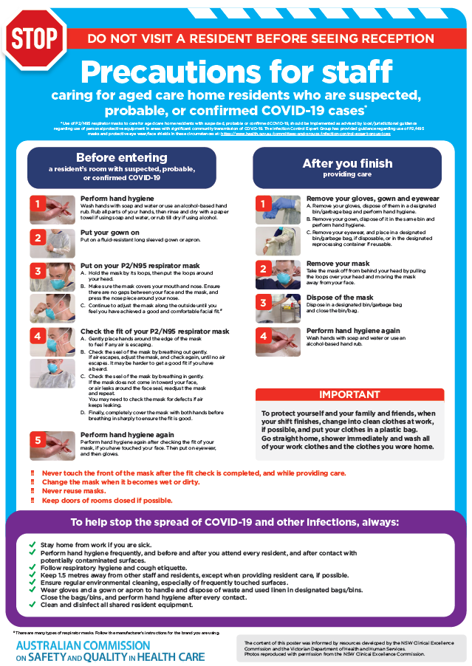](https://www.safetyandquality.gov.au/publications-and-resources/resource-library/covid-19-aged-care-staff-infection-prevention-and-control-precautions-poster)
* ***Environmental Cleaning and Infection Prevention and Control*** [www.safetyandquality.gov.au/environmental-cleaning](http://www.safetyandquality.gov.au/environmental-cleaning)
* ***Infection prevention and control Covid-19 PPE*** poster <https://www.safetyandquality.gov.au/publications-and-resources/resource-library/infection-prevention-and-control-covid-19-personal-protective-equipment>
* ***Special precautions for Covid-19 designated zones*** poster <https://www.safetyandquality.gov.au/publications-and-resources/resource-library/special-precautions-covid-19-designated-zones>
* ***COVID-19 infection prevention and control risk management – Guidance*** <https://www.safetyandquality.gov.au/publications-and-resources/resource-library/covid-19-infection-prevention-and-control-risk-management-guidance>
* ***Safe care for people with cognitive impairment during COVID-19***<https://www.safetyandquality.gov.au/our-work/cognitive-impairment/cognitive-impairment-and-covid-19>
* **Medicines Management COVID-19** <https://www.safetyandquality.gov.au/our-work/medication-safety/medicines-management-covid-19>, including position statements on medicine-related issues
  + ***Managing fever associated with COVID-19***
  + ***Managing a sore throat associated with COVID-19***
  + ***ACE inhibitors and ARBs in COVID-19***
  + ***Clozapine in COVID-19***
  + ***Management of patients on oral anticoagulants during COVID-19***
  + ***Ascorbic Acid: Intravenous high dose in COVID-19***
  + ***Treatment in acute care, including oxygen therapy and medicines to support intubation***
  + ***Nebulisation and COVID-19***
  + ***Managing intranasal administration of medicines during COVID-19***
  + ***Ongoing medicines management in high-risk patients***
  + ***Medicines shortages***
  + ***Conserving medicines***
  + ***Intravenous medicines administration in the event of an infusion pump shortage***
* ***Break the chain of infection: Stopping COVID-19*** poster<https://www.safetyandquality.gov.au/publications-and-resources/resource-library/break-chain-poster-a3>  
  **[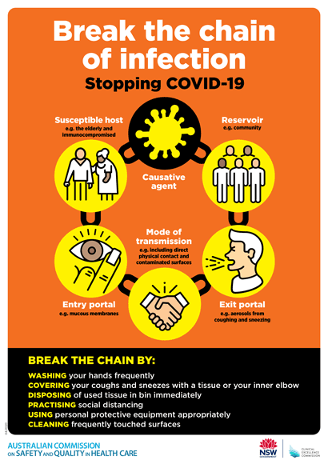](https://www.safetyandquality.gov.au/publications-and-resources/resource-library/break-chain-poster-a3https:/www.safetyandquality.gov.au/publications-and-resources/resource-library/break-chain-poster-a3)**
* ***COVID-19: Elective surgery and infection prevention and control precautions*** <https://www.safetyandquality.gov.au/publications-and-resources/resource-library/covid-19-elective-surgery-and-infection-prevention-and-control-precautions>
* ***FAQs for clinicians on elective surgery*** <https://www.safetyandquality.gov.au/node/5724>
* ***FAQs for consumers on elective surgery*** <https://www.safetyandquality.gov.au/node/5725>
* ***FAQs on community use of face masks***   
   <https://www.safetyandquality.gov.au/faqs-community-use-face-masks>
* ***COVID-19 and face masks – Information for consumers*** <https://www.safetyandquality.gov.au/publications-and-resources/resource-library/covid-19-and-face-masks-information-consumers>  
  The Commission’s fact sheet on use of face masks in the community to reduce the spread of COVID-19 is now available in Easy English and 10 other community languages from <https://www.safetyandquality.gov.au/wearing-face-masks-community>.  
  The factsheet was developed to help people understand when it is important to wear a mask to reduce the risk of the spread of COVID-19, and to explain how to safely put on and remove face masks. It also reinforces the importance of staying home if you have symptoms, physical distancing, hand hygiene and cough etiquette.

[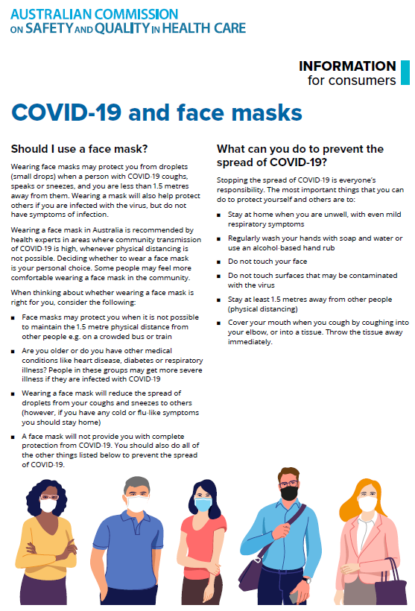](https://www.safetyandquality.gov.au/sites/default/files/2020-07/covid-19_and_face_masks_-_information_for_consumers.pdf)

*National COVID-19 Clinical Evidence Taskforce*

<https://covid19evidence.net.au/>

The National COVID-19 Clinical Evidence Taskforce is a collaboration of peak health professional bodies across Australia whose members are providing clinical care to people with COVID-19. The taskforce is undertaking continuous evidence surveillance to identify and rapidly synthesise emerging research in order to provide national, **evidence-based guidelines and clinical flowcharts for the clinical care of people with COVID-19**. The guidelines address questions that are specific to managing COVID-19 and cover the full disease course across mild, moderate, severe and critical illness. These are ‘living’ guidelines, updated with new research in near real-time in order to give reliable, up-to-the minute advice to clinicians providing frontline care in this unprecedented global health crisis.

*COVID-19 Critical Intelligence Unit*

<https://www.aci.health.nsw.gov.au/covid-19/critical-intelligence-unit>

The Agency for Clinical Innovation (ACI) in New South Wales has developed this page summarising rapid, evidence-based advice during the COVID-19 pandemic. Its operations focus on systems intelligence, clinical intelligence and evidence integration. The content includes a daily evidence digest and evidence checks on a discrete topic or question relating to the current COVID-19 pandemic. There is also a ‘Living evidence’ section summarising key studies and emerging evidence on **COVID-19 vaccines** and **SARS-CoV-2 variants**. Recent evidence check updates include:

* **Evidence on AstraZeneca vaccine rollout**
* **COVID-19 pre-peer review articles.**

**Journal articles**

*Provider Teams Outperform Solo Providers In Managing Chronic Diseases And Could Improve The Value Of Care*

Pany MJ, Chen L, Sheridan B, Huckman RS

Health Affairs. 2021;40(3):435-444.

|  |  |
| --- | --- |
| DOI | <https://doi.org/10.1377/hlthaff.2020.01580> |
| Notes | Health care is a team sport and this paper seems to bear that out. The paper reports on a US study that ‘examined how care management and biomarker outcomes after the onset of three chronic diseases differed both by team-based versus solo care and by physician versus nonphysician (that is, nurse practitioner and physician assistant) care.’ Using deidentified electronic health record data from US primary care practices over the period 2013–18 with ‘detailed visit-level information on more than twelve million primary care visits for more than one million patients’ from 2028 primary providers. The ‘main outcome measure was disease control within one year of disease onset. We defined disease control as HbA1c of 7.0 percent or less for type 2 diabetes mellitus, LDL of 100 mg/dL or less for hyperlipidemia, and a systolic blood pressure of less than 140 or 130 mmHg for hypertension.’ The authors report that ‘. For all three chronic diseases, teams were more likely than solo providers to have patients whose disease was brought under control. For example, patients seen by teams were 9.2 percentage points more likely to have their type 2 diabetes mellitus brought under control (63.9 percent versus 54.7 percent; p<0.001); for hyperlipidemia and hypertension, patients seen by teams were, respectively, 2.3 percentage points (9.1 percent versus 6.8 percent; p<0.001) and 6.1 percentage points (71.0 percent versus 64.9 percent; p<0.001) more likely to have their disease brought under control.’ |

*Effectiveness of a multifaceted intervention to improve emergency department care of low back pain: a stepped-wedge, cluster-randomised trial*

Coombs DM, Machado GC, Richards B, Needs C, Buchbinder R, Harris IA, et al

BMJ Quality & Safety. 2021 [epub].

|  |  |
| --- | --- |
| DOI | <http://dx.doi.org/10.1136/bmjqs-2020-012337> |
| Notes | Lower back pain is a very common complaint and the treatment of it has been debatable leading it to be something of a focus for targeting low value care. This study looked at an intervention aimed at improving the treatment of low back pain in the emergency department (ED) setting.  National Health and Medical Research Council guidelines recommend that imaging is unnecessary for acute low back pain unless there are signs suggestive of a serious condition. However, approximately a quarter of patients are referred for imaging after their first consultation, resulting in unnecessary Medicare expenditure. The NSW  Agency for Clinical Innovation produced their *Clinical Model of Care Management of people with acute low back pain*. he clinical model of care highlights three important areas for improvement:   * more appropriate clinical examination and use of radiological imaging only as necessary * better use of appropriate analgesia * enhanced patient education.   The model of care is designed for people presenting to health practitioners in primary care settings but will also be the guide for care in settings such as emergency departments.  Coombs et al report on the implementation of this model in 4 EDs. The study saw a stepped-wedge, cluster-randomised trial involving a total of 269 ED clinicians and 4625 episodes of care for low back pain (4491 patients). This study **did not find ‘clear evidence that the intervention reduced lumbar imaging** (OR 0.77; 95% CI 0.47 to 1.26; p=0.29)’. However, it ‘**did reduce opioid use** (OR 0.57; 95% CI 0.38 to 0.85; p=0.006) and improved clinicians’ beliefs (mean difference (MD), 2.85; 95% CI 1.85 to 3.85; p<0.001; on a scale from 9 to 45) and knowledge about low back pain care’. Further, the reduction in opioid use was not associated with a difference in pain scores at 1-week follow-up. The authors concluded that ‘It is uncertain if a multifaceted intervention to implement guideline recommendations for low back pain care decreased lumbar imaging in the ED; however, it did reduce opioid prescriptions without adversely affecting patient outcomes’  The clinical model of care and accompanying consumer information (booklet and handout) are available from <https://aci.health.nsw.gov.au/resources/musculoskeletal/management-of-people-with-acute-low-back-pain/albp-model> |

*Categorizing and Rating Patient Complaints: An Innovative Approach to Improve Patient Experience*

Bayer S, Kuzmickas P, Boissy A, Rose SL, Mercer MB

Journal of Patient Experience. 2021;8:2374373521998624.

|  |  |
| --- | --- |
| DOI | <https://doi.org/10.1177%2F2374373521998624> |
| Notes | The examination of complaints for quality improvement and understanding the delivery of care has become more commonplace. This paper describes how one health service, the Cleveland Clinic, devised and implemented an approach to organise and interrogate patient complaints and grievances. |

For information on the Commission’s work on partnering with consumers, see <https://www.safetyandquality.gov.au/our-work/partnering-consumers>

*Public Preferences for Allocating Ventilators in an Intensive Care Unit: A Discrete Choice Experiment*

Norman R, Robinson S, Dickinson H, Williams I, Meshcheriakova E, Manipis K, et al

The Patient - Patient-Centered Outcomes Research. 2021.

|  |  |
| --- | --- |
| DOI | <https://doi.org/10.1007/s40271-021-00498-z> |
| Notes | One of the most difficult challenges of the COVID-19 pandemic has been in those situations where decisions have had to be made about who gets potentially life-saving treatment and who does not. Australia has largely been spared such difficult situations. However, that does mean that Australian clinicians have not contemplated such decisions. This paper reports on a study that engaged 1050 Australians in a community survey to gauge their views on how intensive care unit (ICU) resources could be allocated in circumstances where there may not be enough resources to treat all those who might benefit. In these discrete choice experiments, the dimensions that respondents ‘considered most important were age, likely effectiveness, smoking status, whether the person has dependents, whether they are a healthcare worker, and whether they have a disability or not’. However, as the authors observe, ‘The use of such information should be treated with some caution as the underlying reason for such preferences are unclear, and respondents themselves preferred the decision to be made by others’, particularly medical professionals. |

*Implementing a human factors approach to RCA2: Tools, processes and strategies*Wiegmann DA, Wood LJ, Solomon DB, Shappell SA

Journal of Healthcare Risk Management. 2020 [epub].

|  |  |
| --- | --- |
| DOI | <http://doi.org/10.1002/jhrm.21454> |
| Notes | Root case analysis (RCA) is a commonly used method for investigating serious incidents. A few years a revised method, Root Cause Analysis and Action (RCA2), was proposed. This paper examines a number of human factors tools may be used with the RCA2 framework. The paper covers the Human Factors Analysis and Classification System (HFACS), the Human Factors Intervention Matrix (HFIX), and the FACES decision tool. The paper discusses the experience of an 18-month implementation of these tools in a US teaching hospital. The authors asset that the results ‘demonstrate how HFACS‐RCA2 can foster a more comprehensive, human factors analysis of serious patient harm events and the identification of broader system interventions.’ They also argue that ‘RCA team members (risk managers and quality improvement advisors) also experienced greater satisfaction in their work, leadership gained more trust in RCA findings and recommendations, and the transparency of the RCA process increased.’ |

*Common General Surgical Never Events: Analysis of NHS England Never Events Data*

Omar I, Singhal R, Wilson M, Parmar C, Khan O, Mahawar K

International Journal for Quality in Health Care. 2021 [epub].

|  |  |
| --- | --- |
| DOI | <https://doi.org/10.1093/intqhc/mzab045> |
| Notes | Paper reporting on a study that examined NHS England data from April 2012 to February 2020 to identify common general surgical never events (NE). The authors report that:   * There was a total of 797 general surgical NE identified under three main categories of **Wrong-Site Surgery** (n=427;**53.58%**), **Retained Items Post-Procedure** (n=355; **44.54%**), and **Wrong Implant/Prosthesis** and (n=15; **1.88%**). * A total of 56 common general surgical themes were identified – 25 each in the Wrong-Site Surgery and Retained Foreign Body category and 6 in wrong implants. * **Wrong skin condition surgery** was the commonest wrong-site surgery (n=117; 27.4%). There were 18 **wrong side chest drains** (4.2%) and 18 (4.2%) **wrong side angioplasty/angiogram**. There were 7 (1.6%) instances of **confusion in pilonidal/perianal/perineal surgeries** and 6 (1.4%) instances of **biopsy of cervix rather than colon or rectum**. * **Retained surgical swabs** were the most common retained items (n=165;46.5%). There were 28 (7.9%) **laparoscopic retrieval bags** with or without the specimen, 26 (7.3%) **chest drain guidewires**, 26 (7.3%) **surgical needles**; and 9 (2.5%) **surgical drains**. * **Wrong stents** were most common (n=9;60%) wrong implant followed by **wrong breast implants** (n=2;13.3%). |

*A thematic analysis of the prevention of future deaths reports in healthcare from HM coroners in England and Wales 2016–2019*

Leary A, Bushe D, Oldman C, Lawler J, Punshon G.

Journal of Patient Safety and Risk Management. 2021;26(1):14-21.

|  |  |
| --- | --- |
| DOI | <https://doi.org/10.1177%2F2516043521992651> |
| Notes | Coroner’s reports, and their findings, can be instructive for improving the safety and quality of care. For example, the Communiqué series of reports from the Victorian Institute of Forensic Medicine (<https://www.thecommuniques.com/>) draw heavily from coronial inquests and reports to inform them. This paper reports on a study that examined coroner’s reports in England and Wales, with particular attention to the Prevention of Future Death (PFD) report that coroners may issue. The study looked at 710 reports from 2016–2019 that had examined deaths in hospitals, care homes and the community in England and Wales. The authors report that their thematic analysis revealed ‘five emerging primary themes: **deficit in skill or knowledge**, **missed, delayed or uncoordinated care**, **communication and cultural issues**, **systems issues** and **lack of resources**.’ |

*The Journal for Healthcare Quality*

Vol. 43, No. 2, March/April 2021

|  |  |
| --- | --- |
| URL | <https://journals.lww.com/jhqonline/toc/2021/04000> |
| Notes | A new issue of *The Journal for Healthcare Quality* has been published. Articles in this issue of *The Journal for Healthcare Quality* include:   * Reducing **Caesarean Section Surgical Site Infection** (SSI) by 50%: A Collaborative Approach (Corbett, Gillian A; O'Shea, Evelyn; Nazir, Syeda Farah; Hanniffy, Rosena; Chawke, Geraldine; Rothwell, Alison; Gilsenan, Fiona; MacIntyre, Anne; Meenan, Anne Marie; O'Sullivan, Niamh; Maher, Niamh; Tan, Terry; Sheehan, Sharon R) * Comparison of Outcomes Between the **National Surgical Quality Improvement Program and an Emergency General Surgery Registry** (DesPain, Robert W; Parker, William J; Kindvall, Angela T; Learn, Peter A; Elster, Eric A; Jessie, Elliot M; Rodriguez, Carlos J; Bradley, Matthew J) * Improving **Emergency Access to Human Immunodeficiency Virus Prophylaxis** for Patients Evaluated After Sexual Assault (Saadatzadeh, Tirajeh; Salas, Natalie M; Walraven, Carla; Sarangarm, Preeyaporn; Crandall, Cameron S; Crook, Joy; Sarangarm, Dusadee; Yaple, Charles; Stafford, Amanda; Wilson, Christopher G; Page, Kimberly; Carvour, Martha L) * Implementation and Feasibility of the **Re-Engineered Discharge for Surgery (RED-S) Intervention**: A Pilot Study (Du, Rebecca Y; Shelton, George; Ledet, Celia R; Mills, Whitney L; Neal-Herman, Levi; Horstman, Molly; Trautner, Barbara; Awad, Samir; Berger, David; Naik, Aanand D) * The **Effects of Harm Events on 30-Day Readmission in Surgical Patients** (Kandagatla, Pridvi; Su, Wan-Ting K; Adrianto, Indra; Jordan, Jack; Haeusler, Jessica; Rubinfeld, Ilan) * Implementing a **Heart Failure Transition Program to Reduce 30-Day Readmissions** (Hinch, Barbara K.; Staffileno, Beth A) * Measuring Adherence to U.S. Preventive Services Task Force **Diabetes Prevention Guidelines** Within Two Healthcare Systems (Brunisholz, Kimberly D; Conroy, Molly B; Belnap, Thomas; Joy, E A; Srivastava, R) * Improving **Diabetic Retinopathy Screening** Among Patients With Diabetes Mellitus Using the Define, Measure, Analyze, Improve, and Control Process Improvement Methodology (Kollipara, Usha; Varghese, Shilu; Mutz, Jackie; Putra, Joseph; Bajaj, Puneet; Mirfakhraee, Sasan; Tessnow, Alex; Fish, J; Ali, S) * Improving Management of **Type 2 Diabetes Mellitus in Hospitalized Adults**: A Quality Initiative (Wahlberg, Elizabeth A.; Muthukrishnan, Preetika; Burnett, Maria; Barrett, Kaitlyn V; Gilbert, Matthew; Repp, Allen B) * Assessing the Impact of a **Pharmacist-Managed Discharge Medication Reconciliation** Pilot at a Community Hospital System (Petrovich, Betty; Sweet, Michelle; Gillian, Sarah; Copenhaver, Jennifer) |

*Journal of Patient Safety and Risk Management*

Volume 26, Number 1 (February 2021)

|  |  |
| --- | --- |
| URL | <https://journals.sagepub.com/toc/cric/26/1> |
| Notes | A new issue of the *Journal of Patient Safety and Risk Management* has been published. Articles in this issue of the *Journal of Patient Safety and Risk Management* include:   * Editorial: Who are **essential workers for patient safety**? (Albert W Wu) * **Cybersecurity in health** is an urgent patient safety concern: We can learn from existing patient safety improvement strategies to address it (Niki O’Brien, Saira Ghafur, Mike Durkin) * Pitfalls in the use of **personal protective equipment during aerosol-generating operations on COVID-19 patients** (Anirudh Saraswathula, Clare Rock, Melanie Curless, Shumon I Dhar) * A thematic analysis of the **prevention of future deaths reports in healthcare** from HM coroners in England and Wales 2016–2019 (Alison Leary, David Bushe, Crystal Oldman, Jessica Lawler, Geoffrey Punshon) * Disseminating a patient-centered education bundle to reduce missed doses of **pharmacologic venous thromboembolism (VTE) prophylaxis** to a community hospital (Oluwafemi P Owodunni, Brandyn D Lau, Dauryne L Shaffer, Danielle McQuigg, Deborah Samuel, Mindy Kantsiper, James E Harris, Jr, Deborah B Hobson, Peggy S Kraus, Kristen LW Webster, Christine G Holzmueller, Mujan Varasteh Kia, Michael B Streiff, Elliott R Haut) * A Likert-Type scale for **evaluating the “bottom line” of patient safety** (Sarit Rashkovits) * How U.S. teams advanced **communication and resolution program adoption** at local, state and national levels (Florence R LeCraw, Sally C Stearns, Michael J McCoy) * Skilled nursing resident adherence with **wearable technology** to offer safer mobility and decreased **fall injuries** (Rebecca J Tarbert, Wamis Singhatat) |

*Public Health Research & Practice*

Volume 31, Issue 1, March 2021

|  |  |
| --- | --- |
| URL | <https://www.phrp.com.au/issues/march-2021-volume-31-issue-1/> |
| Notes | A new issue of *Public Health Research & Practice* has been published. Articles in this issue of *Public Health Research & Practice* include:   * Editorial: The vital role of **meaningful community engagement in responding to the COVID-19 pandemic** (Don Nutbeam) * Talking about the ‘r’ word: **a right to a health system that is free of racism** (Carmen Parter, Donna Murray, Janine Mohamed, Boe Rambaldini, Tom Calma, Shawn Wilson, Donna Hartz, Josephine Gwynn, John Skinner) * Addressing health and social care during and beyond COVID-19: the importance of **implementation science** (Helen Skouteris) * Impact of funding on **influenza vaccine uptake** in Australian children (Zachary L Howard, Craig B Dalton, Sandra Carlson, Zoe Baldwin, David N Durrheim) * The impact of **vicarious trauma on Aboriginal and/or Torres Strait Islander health researchers** (Anne-Marie Eades, Maree Hackett, Margaret Raven, Hueiming Liu, Alan Cass) * Exploring the impact of a **large gender-sensitised health promotion program: the Sons of the West program** (Carolyn L Deans) * **Fall prevention behaviour** after participation in the Stepping On program: a pre–post study (Anne Tiedemann, Kate Purcell, Lindy Clemson, Stephen R Lord, Catherine Sherrington) * **Communicating COVID-19 health information to culturally and linguistically diverse communities**: insights from a participatory research collaboration (Abigail Wild, Breanne Kunstler, Denise Goodwin, Saturnino Onyala, Li Zhang, Marama Kufi, Wudad Salim, Faduma Musse, Mohamed Mohideen, Molina Asthana, Mohammad Al-Khafaji, Mary Ann Geronimo, Daniel Coase, Erin Chew, Eddie Micallef, Helen Skouteris) * **Meal replacement soups and shakes**: do they have a place in public health practice to manage weight loss? (Bronwyn McGill, Anne C Grunseit, Philayrath Phongsavan, Claudia Harper, Blythe J O'Hara) * Young people’s needs and preferences for **health resources focused on pornography and sharing of sexually explicit imagery** (Cassandra JC Wright, Angela Davis, Alyce M Vella, Ruby McGrath-Lester, Megan SC Lim) |

*Healthcare Policy*

Volume 16, No. 3, 2021

|  |  |
| --- | --- |
| URL | <https://www.longwoods.com/publications/healthcare-policy/26427/1/vol.-16-no.-3-2021> |
| Notes | A new issue of *Healthcare Policy* has been published. Articles in this issue of *Healthcare Policy* include:   * Editorial: The Mounting Opportunity **Cost of Pivoting to COVID-19-Related Health Systems and Services Research** (Jason M Sutherland) * Public Funding of **Evidence-Based Psychotherapy for Common Mental Disorders**: Increasing Calls for Action in Canadian Provinces (Helen-Maria Vasiliadis, Jessica Spagnolo and Alain Lesage) * Commentary: Time to Improve **Access to Psychotherapies** – A Family Medicine Perspective (Francine Lemire and Marie-Hélène Chomienne) * Increased **Private Healthcare for Canada**: Is That the Right Solution? (Shoo K Lee, Brian H Rowe and Sukhy K Mahl) * Commentary: **Improving the Sustainability of Healthcare** in Canada through **Physician-Engaged Delivery System Reforms** (Amity E Quinn and Braden J Manns) * Estimating **Population Benefits of Prevention Approaches** Using a Risk Tool: High Resource Users in Ontario, Canada (Meghan O’Neill, Kathy Kornas, Walter P Wodchis and Laura C Rosella) * Paramedics Have Untapped Potential to Address **Social Determinants of Health** in Canada (Amir Allana and Andrew D Pinto) * What Factors Impact Implementation of **Critical Incident Disclosure** in Ontario Hospitals: A Multiple-Case Study (Michael Heenan and Gillian Mulvale) * Understanding the Feasibility of **Implementing Car T-Cell Therapies** from a Canadian Perspective (Kristina Ellis, Kelly Grindrod, Stephen Tully, Tom Mcfarlane, Kelvin K W Chan and William W L Wong) * The Allocation of **Medical School Spaces in Canada** by Province and Territory: The Need for Evidence-Based Health Workforce Policy (Lawrence Grierson and Meredith Vanstone) * Evaluation of **Rheumatology Workforce** Supply Changes in Ontario, Canada, from 2000 to 2030 (Jessica Widdifield, Sasha Bernatsky, Janet E Pope, Bindee Kuriya, Claire E H Barber, Lihi Eder, Vandana Ahluwalia, Vicki Ling, Peter Gozdyra, Catherine Hofstetter, Anne Lyddiatt, J Michael Paterson and Carter Thorne) |

*BMJ Quality & Safety* online first articles

|  |  |
| --- | --- |
| URL | <https://qualitysafety.bmj.com/content/early/recent> |
| Notes | *BMJ Quality &Safety* has published a number of ‘online first’ articles, including:   * Smart agent system for **insulin infusion protocol management**: a simulation-based human factors evaluation study (Michael A Rosen, Mark Romig, Zoe Demko, Noah Barasch, Cynthia Dwyer, Peter J Pronovost, Adam Sapirstein) * Effectiveness of a multifaceted intervention to improve **emergency department care of low back pain**: a stepped-wedge, cluster-randomised trial (Danielle M Coombs, Gustavo C Machado, Bethan Richards, Chris Needs, Rachelle Buchbinder, Ian A Harris, Kirsten Howard, Kirsten McCaffery, Laurent Billot, James Edwards, Eileen Rogan, Rochelle Facer, Qiang Li, Christopher G Maher) |

*International Journal for Quality in Health Care* online first articles

|  |  |
| --- | --- |
| URL | <https://academic.oup.com/intqhc/advance-articles> |
| Notes | *International Journal for Quality in Health Care* has published a number of ‘online first’ articles, including:   * **Common General Surgical Never Events**: Analysis of NHS England Never Events Data (Islam Omar, Rishi Singhal, Michael Wilson, Chetan Parmar, Omar Khan, Kamal Mahawar) * Feasibility of Modifying the Hospital Environment to Reduce Length of **Amnesia after Traumatic Brain Injury**: a Pilot Randomised Controlled Trial (Natasha A Lannin, Claire Galea, Megan Coulter, Russell Gruen, Laura Jolliffe, Tamara Ownsworth, Julia Schmidt, Carolyn Unsworth) * Accuracy and Reliability of **Injury Coding in the National Dutch Trauma Registry** (Eric Twiss, Pieta Krijnen, Inger Schipper) |

**Disclaimer**

On the Radar is an information resource of the Australian Commission on Safety and Quality in Health Care. The Commission is not responsible for the content of, nor does it endorse, any articles or sites listed. The Commission accepts no liability for the information or advice provided by these external links. Links are provided on the basis that users make their own decisions about the accuracy, currency and reliability of the information contained therein. Any opinions expressed are not necessarily those of the Australian Commission on Safety and Quality in Health Care.