# Australian COmmission on Safety and Quality in Health Care logo with Radar imageOn the Radar

Issue 506

12 April 2021

*On the Radar* is a summary of some of the recent publications in the areas of safety and quality in health care. Inclusion in this document is not an endorsement or recommendation of any publication or provider. Access to particular documents may depend on whether they are Open Access or not, and/or your individual or institutional access to subscription sites/services. Material that may require subscription is included as it is considered relevant.

*On the Radar* is available online, via email or as a PDF or Word document from <https://www.safetyandquality.gov.au/publications-and-resources/newsletters/radar>

If you would like to receive *On the Radar* via email, you can subscribe on our website <https://www.safetyandquality.gov.au/publications-and-resources/newsletters>   
or by emailing us at H[Umail@safetyandquality.gov.auU](mailto:mail@safetyandquality.gov.au).   
You can also send feedback and comments to H[Umail@safetyandquality.gov.auU](mailto:mail@safetyandquality.gov.au).

For information about the Commission and its programs and publications, please visit <https://www.safetyandquality.gov.au>

You can also follow us on Twitter @ACSQHC.

**On the Radar**

Editor: Dr Niall Johnson [niall.johnson@safetyandquality.gov.au](mailto:niall.johnson@safetyandquality.gov.au)

Contributors: Niall Johnson, Chris Boyd-Skinner, Rebecca Peters, Meredith Page, Robyn Davies, Helen Francombe, Jennifer Caldwell

[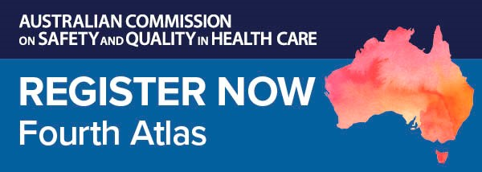](https://kapara.rdbk.com.au/landers/539292.html)

**Fourth Australian Atlas of Healthcare Variation launch**

Do all Australians receive the same evidence-based health care, no matter where they live? If not, where does it vary, and why?

Join us for the online launch of our *Fourth Australian Atlas of Healthcare Variation*.

Mapping healthcare use across the country, the new Atlas highlights variation across six clinical topics including early planned births and chronic disease and infection.

National healthcare leaders including Professor John Newnham AM, 2020 Senior Australian of the Year and Professor in Obstetrics & Gynaecology at The University of Western Australia, will share important findings from the new Atlas and what they reveal about the appropriateness and equity of healthcare delivery in Australia.

Date: Wednesday **28 April 2021**

Time: **12.00–1.00pm** (AEST)

Location: Online

Click [here](https://kapara.rdbk.com.au/landers/539292.html) to register.

Produced in partnership with the Australian Institute of Health and Welfare, our Atlas series identifies variation for a range of procedures, investigations, treatments and hospitalisations. With recommendations to reduce unwarranted variation, it provides opportunities to minimise low value care, improve the equity of care and improve patient outcomes.

Find out more about the Atlas series and healthcare variation on our website or email us at [atlas@safetyandquality.gov.au](mailto:atlas@safetyandquality.gov.au)

[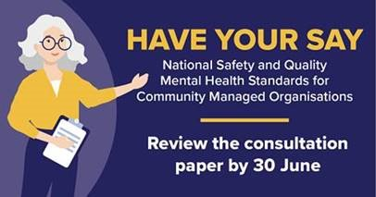](https://www.safetyandquality.gov.au/our-work/mental-health/national-safety-and-quality-mental-health-standards-community-managed-organisations)

**National Safety and Quality Mental Health Standards for Community Managed Organisations – consultation paper**

Australian Commission on Safety and Quality in Health Care

Sydney: ACSQHC; 2021. p. 24.

<https://www.safetyandquality.gov.au/our-work/mental-health/national-safety-and-quality-mental-health-standards-community-managed-organisations>

The Australian Commission on Safety and Quality in Health Care has released the *National Safety and Quality Mental Health (NSQHS) Standards for Community Managed Organisations (CMOs) – consultation paper*.

The Commission is seeking input from community managed organisations, consumers, carers, clinicians, service providers and other stakeholders working in this area to inform the most appropriate approach to develop the NSQMH Standards for CMOs.

Feedback can be provided via an online survey, written submission or participation in a focus group.

The Commission is holding a series of information webinars and online focus groups between April and June 2021. The focus groups will be facilitated by Dr Peggy Brown AO, Senior Clinical Advisor, and David McGrath, Executive Lead, Mental Health Standards, and will give stakeholders an opportunity to discuss the consultation paper, provide feedback and ask questions.

Find out more and register to attend an information webinar or focus group at <https://www.eventbrite.com.au/o/australian-commission-on-safety-and-quality-in-health-care-32829455729>

The consultation is open until midnight (AEST) on Wednesday **30 June 2021**.

**Sepsis survivorship: A review of the impacts of surviving sepsis for Australian patients**

Australian Commission on Safety and Quality in Health Care.

Sydney: ACSQHC; 2021.

<https://www.safetyandquality.gov.au/publications-and-resources/resource-library/sepsis-survivorship-report>

The Australian Commission on Safety and Quality in Health Care (the Commission) engaged KP Health to undertake a literature review regarding the impacts of sepsis on people who survive sepsis in the Australian population. Evidence for interventions to improve recovery and reduce sepsis morbidity are also described.

The review addressed the following questions:

1. How many people survive sepsis each year by age and by sex in Australia?
2. Does Australia have better or worse outcomes for people who survive sepsis by age and sex than countries with similar health systems?
3. What complications do survivors of sepsis face after discharge from hospital?
4. How frequently are survivors readmitted to hospital?
5. What interventions improve recovery after discharge and reduce ongoing morbidity?
6. How have these interventions been evaluated and which ones were successful?
7. What measures were used to demonstrate success?
8. Which of these interventions could work in the Australian context?

The authors found that there is very little evidence for specific interventions – developed, trialled or implemented – to improve mortality, morbidity or quality of life in patients after hospital discharge for sepsis. Numerous opportunities exist to address knowledge gaps and improve post-hospital discharge sepsis support services. This includes conducting further research to identify effective strategies that improve survival, quality of life and cognitive and physical function in people who have survived sepsis.

In response to the findings and recommendation from the literature review, the Commission is undertaking a qualitative investigation to examine the lived experiences of sepsis survivors and their families or carers. It is expected that this study will provide further evidence toward developing a post-sepsis support care model for Australian patients in consultation with consumers, clinicians and state and territory health departments.

**Environmental Cleaning and Infection Prevention and Control**

[www.safetyandquality.gov.au/environmental-cleaning](http://www.safetyandquality.gov.au/environmental-cleaning)

Environmental cleaning is a critical element of standard precautions and should be a feature of every health service organisation’s infection prevention and control program.

The Australian Commission on Safety and Quality in Health Care (the Commission) has produced a suite of environmental cleaning factsheets to support health service organisations in this important infection prevention and control activity, particularly during the response to COVID-19. These factsheets support the actions relating to environmental cleaning in [National Safety and Quality Health Service Standards](https://www.safetyandquality.gov.au/standards/nsqhs-standards/partnering-consumers-standard) and the implementation of the environmental cleaning requirements of the [*Australian Guidelines for the Prevention and Control of Infection in Healthcare*](https://www.nhmrc.gov.au/about-us/publications/australian-guidelines-prevention-and-control-infection-healthcare-2019).

The latest factsheet, *Environmental cleaning: Emerging environmental cleaning technologies,* provides guidance on the appropriate use of novel environmental cleaning technologies and complements the *Australian Guidelines for the Prevention and Control of Infection in Healthcare* regarding the use of emerging environmental cleaning technologies in the healthcare setting. The new *Environmental cleaning: Emerging environmental cleaning technologies* factsheet is available on the Commission’s website at [www.safetyandquality.gov.au/environmental-cleaning](http://www.safetyandquality.gov.au/environmental-cleaning)

**Workforce Immunisation Risk Matrix**

<https://www.safetyandquality.gov.au/sites/default/files/migrated/Workforce-immunisation-risk-matrix1.pdf>

The Workforce Immunisation Risk Matrix has been revised to better support actions relating to workforce immunisation in the National Safety and Quality Health Service (NSQHS) standards.

The Workforce Immunisation Risk Matrix helps health service organisations to identify and address risks that are relevant to the scope of the role and function of members of the workforce, and assists organisations in meeting the requirements of the NSQHS Standards.

The risk matrix was revised to simplify the complex topic of workforce immunisation in consultation with the Healthcare-Associated Infection Advisory Committee and state and territory infection prevention and control programs. The updated Workforce Immunisation Risk Matrix has been published on the Commission’s website and is available from <https://www.safetyandquality.gov.au/sites/default/files/migrated/Workforce-immunisation-risk-matrix1.pdf>

[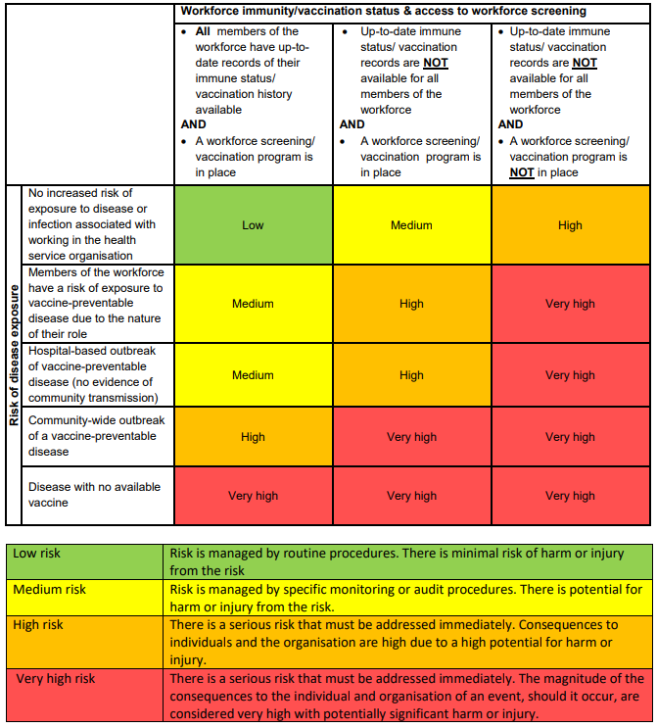](https://www.safetyandquality.gov.au/sites/default/files/migrated/Workforce-immunisation-risk-matrix1.pdf)

**Reports**

*Translating aged care reform recommendations to action*

Deeble Institute Perspectives Brief No 16

Bourke C, Verhoeven A

Canberra: Australian Healthcare and Hospitals Association; 2021:8

|  |  |
| --- | --- |
| URL | <https://ahha.asn.au/deeble-institute-perspective-briefs> |
| Notes | This Perspectives Brief from the Australian Healthcare and Hospitals Association’s Deeble Institute offers a review of the Final Report of the Royal Commission into Aged Care Quality and Safety. That report which stretched across more than 4000 pages in its multiple volumes included 148 recommendations. The Perspectives Brief reviews the recommendations, particularly those pertaining to the Australian government and indicates a way forward, and one that needs to be seized with some urgency. The authors suggest that ‘The May 2021 Commonwealth budget is an opportunity to start the shift from a market-oriented approach to aged care to the human rights approach advocated by the Royal Commission. The safety and wellbeing of older Australians depends on positive decision-making now; we cannot continue to perpetuate 20 years of policy failure any longer.’ |

**Journal articles**

*Conversion of a Colorectal Cancer Guideline into Clinical Decision Trees with Assessment of Validity*

Keikes L, Kos M, Verbeek XAAM, van Vegchel T, Nagtegaal ID, Lahaye MJ, et al

International Journal for Quality in Health Care. 2021.

|  |  |
| --- | --- |
| DOI | <https://doi.org/10.1093/intqhc/mzab051> |
| Notes | The term ‘guidelines’ may conjure images of voluminous tomes on a shelf, unread and of limited impact. However, recent years have seen a move towards ‘guidance’, include a range of tools and other forms of providing the guidance from guidelines to practicing clinicians. These have included apps and other tools, such as the clinical decision trees that are the focus of this article. This article describes the development and testing of clinical decision trees that used the Dutch colorectal cancer guidelines as their underpinning. The authors suggest that the decision trees may contribute to future strategies to optimize quality of care for colorectal cancer patients. |

*Benefits and Risks of Non-Slip Socks in Hospitals: A Rapid Review*

Jazayeri D, Heng H, Slade SC, Seymour B, Lui R, Volpe D, et al

International Journal for Quality in Health Care. 2021.

|  |  |
| --- | --- |
| DOI | <https://doi.org/10.1093/intqhc/mzab057> |
| Notes | Falls are one of the more common – and apparently intractable – forms of harm that can occur in hospitals. Various interventions have been proposed over the years. One of these that gained some traction, has been the use of non-slip socks. This study sought to examine the literature on the value and efficacy of non-slip socks. Based on 14 articles, of which 9 used non-slip socks as an intervention in hospitals, the reviewers found that:   * Non-slip socks carry an infection control risk that requires careful management * There was no strong or conclusive evidence that they prevent hospital falls. |

For information on the Commission’s work on falls prevention, see <https://www.safetyandquality.gov.au/our-work/comprehensive-care/related-topics/falls-prevention>

*Australian Health Review*

Volume 45 Number 2 2021

|  |  |
| --- | --- |
| URL | <https://www.publish.csiro.au/ah/issue/10147> |
| Notes | A new issue of the *Australian Health Review* has been published. Articles in this issue of the *Australian Health Review* include:   * Achieving greater **value and equity in health care** (Alison Verhoeven) * Measuring the **economic impact of hospital-acquired complications** on an acute health service (Liam Fernando-Canavan, Anthony Gust, Arthur Hsueh, An Tran-Duy, Michael Kirk, Peter Brooks and Josh Knight) * Implementing a **hip fracture registry** and financial incentive program to enhance **best practice in hip fracture care** in Western Australia (Hannah Seymour, Diana Fajardo Pulido, Amanda Ling and Rebecca Mitchell) * A cross-sectional analysis of **out-of-pocket expenses for people living with a cancer** in rural and outer metropolitan Western Australia (Neli S Slavova-Azmanova, Jade C Newton, Claire E Johnson, Harry Hohnen, Angela Ives, Sandy McKiernan, Violet Platt, Max Bulsara and Christobel Saunders) * Is there **unwarranted variation in obstetric practice** in Australia? Obstetric intervention trends in Queensland hospitals (Haylee Fox, Emily Callander, Daniel Lindsay and Stephanie M Topp) * Financial contributions made by patients towards **dispensed medicines prescribed by Australian dentists** from 2006 to 2018: a cost-analysis study (Joon Soo Park, Estie Kruger and Marc Tennant) * Sociocognitive approach to behaviour change for reducing **low-value care** (Ian A Scott and Steven M McPhail) * Identifying the **gaps in public dental services locations** for people living with a disability in metropolitan Australia: a geographic information system (GIS)-based approach (Nicholas Liu, Estie Kruger and Marc Tennant) * Review of current pathways to **wait-listing for kidney transplantation** for Aboriginal and Torres Strait Islander peoples with end-stage kidney disease in the Top End of Northern Australia (Sandawana W Majoni, Kerry Dole, Jaquelyne T Hughes and Charles Pain) * Lessons learned from a **subsidised spectacles scheme** aiming to improve eye health in Aboriginal people in Victoria, Australia (Timothy R Fricke, Chelsea Brand, Levi Lovett, Neville W Turner, M D Anjou and S A Bentley) * **Integrating patient complexity into health policy**: a conceptual framework (Peter Maree, Roger Hughes, Jan Radford, Jim Stankovich and P J Van Dam) * **South Australian Medicines Evaluation Panel** in review: providing evidence-based guidance on the use of high-cost medicines in the South Australian public health system (Robyn Lambert, Naomi Burgess, Nadine Hillock, Joy Gailer, Pravin Hissaria, Tracy Merlin, Chris Pearson, Benjamin Reddi, Michael Ward and Catherine Hill) * **Biobank networking and globalisation**: perspectives and practices of Australian biobanks (Edwina Light, Miriam Wiersma, Lisa Dive, Ian Kerridge, Wendy Lipworth, Cameron Stewart, E Kowal, P Marlton and C Critchley) * Nature and outcomes of **sanctioned medical misconduct** in six international jurisdictions: a case series (Nicole Grant, Safire Valentine, James Majer and David McD. Taylor) * Local and regional workforce return on investment from sponsoring **rural generalist-based training for medical students** (Scott Kitchener) * Distribution of **male and female procedural and surgical specialists** in Australia (Elizabeth Turtle, Anna Vnuk and Vivian Isaac) * Informing **telehealth service delivery for cardiovascular disease management**: exploring the perceptions of rural health professionals (Lucy Kocanda, Karin Fisher, Leanne J Brown, Jennifer May, Megan E Rollo, Clare E Collins, Andrew Boyle and Tracy L Schumacher) * **General practitioner follow-up after hospitalisation** in Central and Eastern Sydney, Australia: access and impact on health services (Margo Linn Barr, Heidi Welberry, John Hall, Elizabeth J Comino, Elizabeth Harris, Ben F Harris-Roxas, Tony Jackson, Debra Donnelly and Mark Fort Harris) * **Interprofessional, student-led community health clinic**: expanding service provision and clinical education capacity (Roma Forbes, Emma Beckman, Marion Tower, Allison Mandrusiak, Leander K Mitchell, Christopher T Sexton, Brent Cunningham and Peter A Lewis) * Time to rethink our approach to the **Pharmaceutical Benefits Scheme (PBS) listing of medicines: the case of pregabalin** (Karl Winckel, Mark Daglish, David Pache and Samantha A Hollingworth) * Survey of **hospital Chief Executive Officer research and translation priorities** (Leanne Saxon, Kim Dalziel and David Story) |

*Nursing Leadership*

Volume 34 Number 1

|  |  |
| --- | --- |
| URL | <https://www.longwoods.com/publications/nursing-leadership/26453/1/vol.-34-no.-1-2021> |
| Notes | A new issue of *Nursing Leadership* has been published. Articles in this issue of *Nursing Leadership* include:   * Editorial: **Time to Adjust the Sails** (Lynn M Nagle) * **COVID-19-Related Occupational Burnout and Moral Distress among Nurses**: A Rapid Scoping Review (Abi Sriharan, Keri J West, Joan Almost and Aden Hamza) * Taking a Stand to Remedy the **Inadequacies of Action on Health Equity** Exposed by COVID-19 (Susana Caxaj, Abe Oudshoorn, Marilyn Ford-Gilboe, Fiona Webster, Lorie Donelle, Cheryl Forchuk, Helene Berman and V Syme) * A Case Study of Two Emerging **Nurse Leaders Specializing in Virtual Health** during the COVID-19 Global Pandemic (Carley Ouellette, Marissa Bird, P. J. Devereaux, Jennifer Lounsbury, Angela Djuric-Paulin, Brandi LeBlanc, Stephanie Handsor, Deborah DuMerton, Lesly Deuchar, Melissa Waggott and Michael McGillion) * **Critical Thinking and Leadership**: Can We Escape Modern Circe’s Spells in Nursing? (Vaitsa Giannouli and Konstantinos Giannoulis) * Not Part of the Job: An Analysis of Characterizations of **Workplace Violence against Nurses** in Canada by Unions and Professional Associations (Sioban Nelson and Andrea Baumann) * Developing a **Culture of Support to Advance and Accelerate Nursing Innovation** (Mary Lou Ackerman, Lianne Jeffs, Beverley Simpson and Sue Williams) |

*BMJ Leader*

March 2021 Volume 5 Issue 1

|  |  |
| --- | --- |
| URL | <https://bmjleader.bmj.com/content/5/1> |
| Notes | A new issue of *BMJ Leader* has been published. Articles in this issue of *BMJ Leader* include:   * Editorial: **Seeing and managing the icebergs** (Jan C Frich, Dominique Allwood, Anthony Robert Berendt, Pedro Delgado, Rachel Dunscombe, Bob Klaber, A C Molloy, J Mountford, A Nigam, C Stoddart, T Swanwick, I Joshi) * Evolution of **leadership theory** (Sihame Benmira, Moyosolu Agboola) * **Multiprofessional leadership development**: reflections from a doctor in training (Yang Chen) * **Cultivating not gatekeeping**: a key leadership role in the creative process (Joshua H Katz, Geoffrey L Herman, Mark A Johnson, Jeffrey Loewenstein) * Distilling the **core meaning of medical engagement** to three junior doctor staff groups in a Welsh Health Board (Thomas Cromarty, Rachel Rayment, Patti Mazelan, Fred Barwell, Peter Spurgeon, Graham Shortland) * **Physician leadership during the COVID-19 pandemic**: an emphasis on the team, well-being and leadership reasoning (Taylor C. Standiford, Kavya Davuluri, Nicole Trupiano, David Portney, Larry Gruppen, A H Vinson) * Factors impacting **health and well-being and the utilisation of supports** **among** **Australian doctors in medical specialty training** (Sotoodeh Abhary, Mari Botti, Anjali Dhulia, Christopher Tham, Erwin Loh, J Catford) * Hearing the **voices of Australian healthcare workers during the COVID-19 pandemic** (Michelle Ananda-Rajah, Benjamin Veness, Danielle Berkovic, Catriona Parker, Greg Kelly, Darshini Ayton) * Beware of the pendulum swing: how leaders can **sustain rapid technology innovation** beyond the COVID-19 crisis (Eivor Marianne Oborn, Michael Ian Barrett, David Alexander Stig Barrett) * **Organisational crisis resource management**: leading an academic department of emergency medicine through the COVID-19 pandemic (Nicholas Gavin, Marie-Laure S Romney, Penelope C Lema, John Babineau, Bernard Chang, Daniel J Egan, C Tedeschi, A M Mills, D O Kessler) * Overcoming the legacy of marketisation: **China’s response to COVID-19** and the fast-forward of healthcare reorganisation (Zhiyong Liu, Ian Kirkpatrick, Yaru Chen, Jixia Mei) * Put me on the front line: **doctors who have recovered from coronavirus** should treat patients with COVID-19 (Ellery Altshuler) * **‘Quaranta giorni’ leadership test**: time to transform healthcare (Bandar Al Knawy, Zisis Kozlakidis) * Work team identification associated with less stress and burnout among **front-line emergency department staff amid the COVID-19 pandemic** (Rohit B Sangal, Amy Wrzesniewski, Julia DiBenigno, Eleanor Reid, Andrew Ulrich, Beth Liebhardt, Alexandra Bray, E Yang, E Eun, A K Venkatesh, M King) * **Collaborative leadership**: organisational structure and institutional investment to multiply innovative educational efforts among trainees (Albert Do, L Li, D R Heller, M D Abou Ziki, D H Glaser, S P Kumar, S J Huot) * Development and implementation of a structured **leadership programme for junior doctors** (Anum Pervez, Aaisha Saqib, Sarah Hare) * Developing a **‘Doctors’ Assistant’ role** to ease pressure on doctors and improve patient flow in acute NHS hospitals (Scarlett McNally, Jörg Huber) * **Leadership in healthcare**: a bibliometric analysis of 100 most **influential publications** (Nizar Bhulani, Timothy L Miao, Alexander Norbash, Mauricio Castillo, Faisal Khosa) |

*Journal of Health Services Research & Policy*

Volume: 26, Number: 2 (April 2021)

|  |  |
| --- | --- |
| URL | <https://journals.lww.com/journalpatientsafety/toc/2021/04000> |
| Notes | A new issue of the *Journal of Health Services Research & Policy* has been published. Articles in this issue of the *Journal of Health Services Research & Policy* include:   * Editorial: Health research policy and systems: Moving towards **evidence-informed health research capacity strengthening practice** (Justin Pulford and Imelda Bates) * Understanding **health and care expenditure by setting** – who matters to whom? (Jenny Shand, Stephen Morris, and Manuel Gomes) * Journeys to **HIV testing and diagnosis among adults aged 50+ years** in England: A qualitative interview study (Sadie Bell, Tim Doran, Fabiola Martin, and Joy Adamson) * **Increased risk of 2-year death in patients who discontinued their use of statins** (Karla Seaman, Frank Sanfilippo, Max Bulsara, Elizabeth Roughead, Anna Kemp-Casey, Caroline Bulsara, Gerald F Watts, and David Preen) * Effective coverage of medical treatment for **hypertension, diabetes and dyslipidaemia in Japan**: An analysis of National Health and Nutrition Surveys 2003–2017(Nayu Ikeda, Nobuo Nishi, Takehiro Sugiyama, Hiroyuki Noda, and Mitsuhiko Noda) * **Knowledge, attitude and practice towards health research and its utilization** among health professionals in Bhutan: Results of a nationwide cross-sectional survey in 2019 (Thinley Dorji, Shacha Wangmo, Mongal Singh Gurung, Karma Tenzin, Tashi Penjore, and Don Eliseo Lucero-Prisno, III) * Does **prevention-focused integration** lead to the triple aim? An evaluation of two new care models in England (Jonathan Stokes, Vishalie Shah, Leontine Goldzahl, Søren Rud Kristensen, and Matt Sutton) * **Polyphonic perspectives on health and care**: Reflections from two decades of the DIPEx project (Sue Ziebland, Rachel Grob, and Mark Schlesinger) * Using **mixed methods in health services research**: A review of the literature and case study (Maarten de Haan, Yvonne van Eijk-Hustings, and Hubertus JM Vrijhoef) |

*Health Affairs*

April 2021 Volume 40 Number 4

|  |  |
| --- | --- |
| URL | <https://www.healthaffairs.org/toc/hlthaff/40/4> |
| Notes | A new issue of *Health Affairs* been published. Articles in this issue of *Health Affairs* include:   * **Medicaid Coverage ‘Cliff’** Increases Expenses And Decreases Care For Near-Poor Medicare Beneficiaries (Eric T Roberts, Alexandra Glynn, Noelle Cornelio, Julie M. Donohue, Walid F Gellad, J M McWilliams, and L M Sabik) * **Medicaid Expansion Increased Medications For Opioid Use Disorder** Among Adults Referred By Criminal Justice Agencies (Utsha G Khatri, Benjamin A Howell, and Tyler N A Winkelman) * Post-ACA, More Than One-Third Of Women With **Prenatal Medicaid** Remained Uninsured Before Or After Pregnancy (Emily M Johnston, Stacey McMorrow, Clara Alvarez Caraveo, and Lisa Dubay) * ACA Mandate Led To Substantial **Increase In Contraceptive Use** Among Women Enrolled In High-Deductible Health Plans (Nora V Becker, Nancy L Keating, and Lydia E Pace) * **Urgent Care Centers Deter Some Emergency Department Visits** But, On Net, Increase Spending (Bill Wang, Ateev Mehrotra, and Ari B Friedman) * **Direct-To-Consumer Telemedicine Visits For Acute Respiratory Infections** Linked To More Downstream Visits (Kathleen Yinran Li, Ziwei Zhu, Sophia Ng, and Chad Ellimoottil) * **Medical Device Firm Payments To Physicians** Exceed What Drug Companies Pay Physicians, Target Surgical Specialists (Alon Bergman, Matthew Grennan, and Ashley Swanson) * **Advance Care Planning** For Medicare Beneficiaries Increased Substantially, But Prevalence Remained Low (M K Palmer, M Jacobson, and S Enguidanos) * **Emergency Physicians Recover A Higher Share Of Charges** From Out-Of-Network Care Than From In-Network Care (Adam I. Biener, Benjamin L. Chartock, Christopher Garmon, and Erin Trish) * Analysis Suggests Government And Nonprofit **Hospitals’ Charity Care Is Not Aligned With Their Favorable Tax Treatment** (Ge Bai, Hossein Zare, Matthew D Eisenberg, Daniel Polsky, and Gerard F Anderson) * **Adjusting Quality Measures For Social Risk Factors** Can Promote Equity In Health Care (David R Nerenz, J Matthew Austin, Daniel Deutscher, Karen E Joynt Maddox, E J Nuccio, C Teigland, E Weinhandl, and L G Glance) * **Social Determinants Matter For Hospital Readmission Policy**: Insights From New York City (Matthew C Baker, Philip M Alberti, Tsu-Yu Tsao, Kyle Fluegge, Renata E Howland, and Merle Haberman) * **COVID-19 Mortality Rates Among Nursing Home Residents** Declined From March To November 2020 (Cyrus M Kosar, Elizabeth M White, Richard A Feifer, Carolyn Blackman, Stefan Gravenstein, Orestis A Panagiotou, Kevin McConeghy, and Vincent Mor) * **US Public Health Neglected**: Flat Or Declining Spending Left States Ill Equipped To Respond To COVID-19 (Y Natalia Alfonso, Jonathon P Leider, Beth Resnick, J Mac McCullough, and David Bishai) * **Charity Care Needs To Be Better** Than This (David E Velasquez) |

*BMJ Quality & Safety* online first articles

|  |  |
| --- | --- |
| URL | <https://qualitysafety.bmj.com/content/early/recent> |
| Notes | *BMJ Quality &Safety* has published a number of ‘online first’ articles, including:   * Development and validation of an A3 **problem-solving assessment tool and self-instructional package for teachers** of quality improvement in healthcare (Jennifer S Myers, Jeanne M Kin, John E Billi, Kathleen G Burke, Richard Van Harrison) * Improving **peripherally inserted central catheter** appropriateness and reducing device-related complications: a quasiexperimental study in 52 Michigan hospitals (Vineet Chopra, Megan O'Malley, Jennifer Horowitz, Qisu Zhang, Elizabeth McLaughlin, Sanjay Saint, Steven J Bernstein, S Flanders) * Effectiveness of a **medication adherence management intervention in a community pharmacy setting**: a cluster randomised controlled trial (Andrea Torres-Robles, Shalom I Benrimoj, Miguel Angel Gastelurrutia, Fernando Martinez-Martinez, Tamara Peiro, Beatriz Perez-Escamilla, Kris Rogers, Isabel Valverde-Merino, Raquel Varas-Doval, Victoria Garcia-Cardenas) |

*International Journal for Quality in Health Care* online first articles

|  |  |
| --- | --- |
| URL | <https://academic.oup.com/intqhc/advance-articles> |
| Notes | *International Journal for Quality in Health Care* has published a number of ‘online first’ articles, including:   * Implementing **Structured Handoffs to Verify Operating Room Blood Delivery** Using a Quality Academy Training Program: An Interrupted Time-Series Analysis (Carly C Amon, Adina R Paley, Judith A Forbes, Leidy V Guzman, Aliysa A Rajwani, Agnieszka Trzcinka, Raymond L Comenzo, Dan M Drzymalski) * Policy, accreditation and leadership: Creating the conditions for **effective coproduction of health, healthcare and science** (Peter Lachman, Eugene C Nelson) * Monitoring of Three-Phase Variations in the **Mortality of Covid-19 Pandemic** Using Control Charts: Where Does Pakistan Stand? (Yasar Mahmood, Sunaina Ishtiaq, Michael B C Khoo, Sin Yin Teh, Hina Khan) * Development of the **Perceptions of Preventable Adverse Events Assessment Tool**: Measurement Properties and Patients’ Mental Health Status (Franziska Maria Keller, Christina Derksen, Lukas Kötting, Martina Schmiedhofer, Sonia Lippke) |

**Online resources**

*[UK] NICE Guidelines and Quality Standards*

<https://www.nice.org.uk/guidance>

The UK’s National Institute for Health and Care Excellence (NICE) has published new (or updated) guidelines and quality standards. The latest reviews or updates are:

* Quality Standard QS32 ***Caesarean birth*** <https://www.nice.org.uk/guidance/qs32>
* NICE Guideline NG192 ***Caesarean birth*** <https://www.nice.org.uk/guidance/ng192>
* NICE Guideline NG191 *COVID-19 rapid guideline:* ***managing COVID-*19** <https://www.nice.org.uk/guidance/ng191>
* NICE Guideline NG193 ***Chronic pain*** *(primary and secondary) in over 16s: assessment of all chronic pain and management of chronic primary pain* <https://www.nice.org.uk/guidance/ng193>

*[USA] Patient Safety Primers*

<https://psnet.ahrq.gov/primers/>

The Patient Safety Primers from the (US) Agency for Healthcare Research and Quality (AHRQ) discuss key concepts in patient safety. Each primer defines a topic, offers background information on its epidemiology and context, and provides links to relevant materials.

* ***Strategies and Approaches for Tracking Improvements in Patient Safety* –**An essential aspect of preventing medical errors and improving patient safety is using data effectively to understand, track, and communicate performance on patient safety metrics. This primer provides an overview of visual tools – histograms, scatter plots, run charts, and control charts – that hospitals and health systems can leverage to track patient safety data.   
  <https://psnet.ahrq.gov/primer/strategies-and-approaches-tracking-improvements-patient-safety>

*[UK] NIHR Evidence alert*

<https://evidence.nihr.ac.uk/>alerts/

The UK’s National Institute for Health Research (NIHR) has posted new evidence alerts on its site. Evidence alerts are short, accessible summaries of health and care research which is funded or supported by NIHR. This is research which could influence practice and each Alert has a message for people commissioning, providing or receiving care. The latest alerts include:

* People with **anaemia** may not benefit from iron therapy ahead of **major abdominal surgery**
* **Short term palliative care** reduced costs without compromising quality for people with neurological conditions
* A combination of tests is needed to diagnose a dangerous type of **meningitis in children**
* Virtual quizzes involving several **care homes** are feasible and might reduce **loneliness and social isolation**
* New sub-groups of **diabetes** could lead to more targeted treatment for people in India
* To improve **team decision-making in cancer care**: streamline workload, shorten meetings, address logistics and keep a gender balance on the team
* A new framework for allied health professionals aims to promote a **culture of research**
* **Parents are meaningfully involved in decisions on the care of their critically ill baby** when they are given options not recommendations
* **Getting up after a fall**: training could encourage older people to get themselves back up
* **Physician associates** need support to establish their place within the healthcare workforce
* People with **chronic fatigue syndrome** want to be taken seriously and to receive personalised, empathetic care
* **Heart surgery in young children**: routine monitoring of complications can help assess the quality of care
* Hand strengthening and stretching for people with **rheumatoid arthritis**: online training helps therapists deliver an exercise programme
* Being overweight is linked with an increased risk of **dementia** in new research
* **Extending breast screening to women in their forties** may save lives without increasing harms
* Acting on **feedback from national clinical audits**: NHS staff describe their motivations and the barriers to engaging with the data
* **Risk of forced marriage** among people with learning disabilities: carers provide insights into consent, care needs and the place of marriage in South Asian communities
* The **risk of forced marriage** for people with learning disabilities from South Asian communities

**COVID-19 resources**

https://www.safetyandquality.gov.au/covid-19

The Australian Commission on Safety and Quality in Health Care has developed a number of resources to assist healthcare organisations, facilities and clinicians. These and other material on COVID-19 are available at <https://www.safetyandquality.gov.au/covid-19>

These resource include:

* ***COVID-19: Aged care staff infection prevention and control precautions*** *poster*<https://www.safetyandquality.gov.au/publications-and-resources/resource-library/covid-19-aged-care-staff-infection-prevention-and-control-precautions-poster>  
    
  [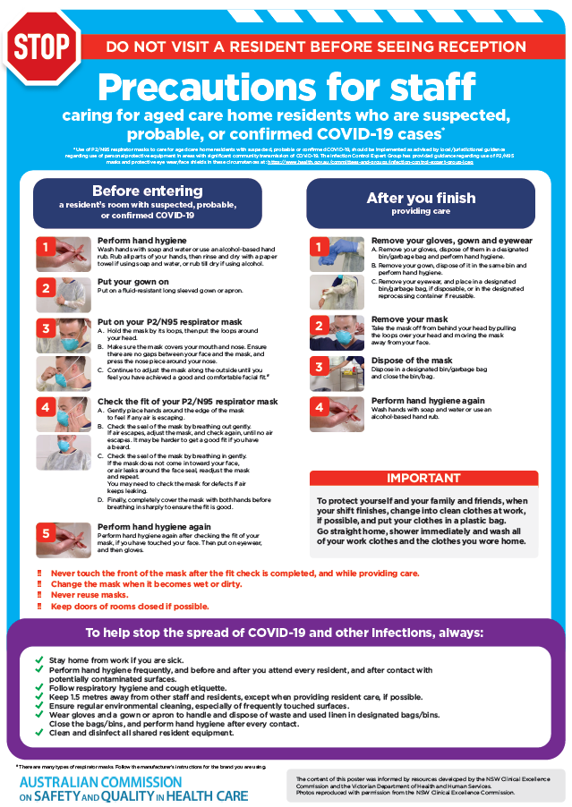](https://www.safetyandquality.gov.au/publications-and-resources/resource-library/covid-19-aged-care-staff-infection-prevention-and-control-precautions-poster)
* ***Environmental Cleaning and Infection Prevention and Control*** [www.safetyandquality.gov.au/environmental-cleaning](http://www.safetyandquality.gov.au/environmental-cleaning)
* ***Infection prevention and control Covid-19 PPE*** poster <https://www.safetyandquality.gov.au/publications-and-resources/resource-library/infection-prevention-and-control-covid-19-personal-protective-equipment>
* ***Special precautions for Covid-19 designated zones*** poster <https://www.safetyandquality.gov.au/publications-and-resources/resource-library/special-precautions-covid-19-designated-zones>
* ***COVID-19 infection prevention and control risk management – Guidance*** <https://www.safetyandquality.gov.au/publications-and-resources/resource-library/covid-19-infection-prevention-and-control-risk-management-guidance>
* ***Safe care for people with cognitive impairment during COVID-19***<https://www.safetyandquality.gov.au/our-work/cognitive-impairment/cognitive-impairment-and-covid-19>
* **Medicines Management COVID-19** <https://www.safetyandquality.gov.au/our-work/medication-safety/medicines-management-covid-19>, including position statements on medicine-related issues
  + ***Managing fever associated with COVID-19***
  + ***Managing a sore throat associated with COVID-19***
  + ***ACE inhibitors and ARBs in COVID-19***
  + ***Clozapine in COVID-19***
  + ***Management of patients on oral anticoagulants during COVID-19***
  + ***Ascorbic Acid: Intravenous high dose in COVID-19***
  + ***Treatment in acute care, including oxygen therapy and medicines to support intubation***
  + ***Nebulisation and COVID-19***
  + ***Managing intranasal administration of medicines during COVID-19***
  + ***Ongoing medicines management in high-risk patients***
  + ***Medicines shortages***
  + ***Conserving medicines***
  + ***Intravenous medicines administration in the event of an infusion pump shortage***
* ***Break the chain of infection: Stopping COVID-19*** poster<https://www.safetyandquality.gov.au/publications-and-resources/resource-library/break-chain-poster-a3>  
  **[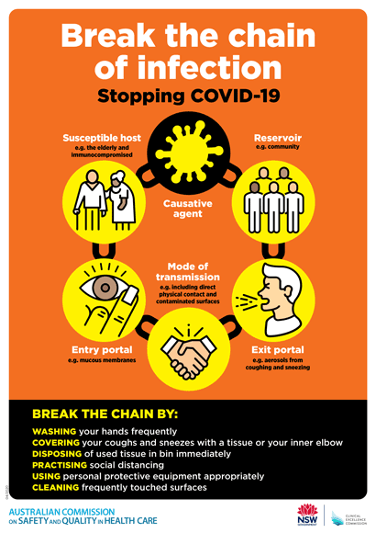](https://www.safetyandquality.gov.au/publications-and-resources/resource-library/break-chain-poster-a3https:/www.safetyandquality.gov.au/publications-and-resources/resource-library/break-chain-poster-a3)**
* ***COVID-19: Elective surgery and infection prevention and control precautions*** <https://www.safetyandquality.gov.au/publications-and-resources/resource-library/covid-19-elective-surgery-and-infection-prevention-and-control-precautions>
* ***FAQs for clinicians on elective surgery*** <https://www.safetyandquality.gov.au/node/5724>
* ***FAQs for consumers on elective surgery*** <https://www.safetyandquality.gov.au/node/5725>
* ***FAQs on community use of face masks***   
   <https://www.safetyandquality.gov.au/faqs-community-use-face-masks>
* ***COVID-19 and face masks – Information for consumers*** <https://www.safetyandquality.gov.au/publications-and-resources/resource-library/covid-19-and-face-masks-information-consumers>  
  The Commission’s fact sheet on use of face masks in the community to reduce the spread of COVID-19 is now available in Easy English and 10 other community languages from <https://www.safetyandquality.gov.au/wearing-face-masks-community>.  
  The factsheet was developed to help people understand when it is important to wear a mask to reduce the risk of the spread of COVID-19, and to explain how to safely put on and remove face masks. It also reinforces the importance of staying home if you have symptoms, physical distancing, hand hygiene and cough etiquette.

[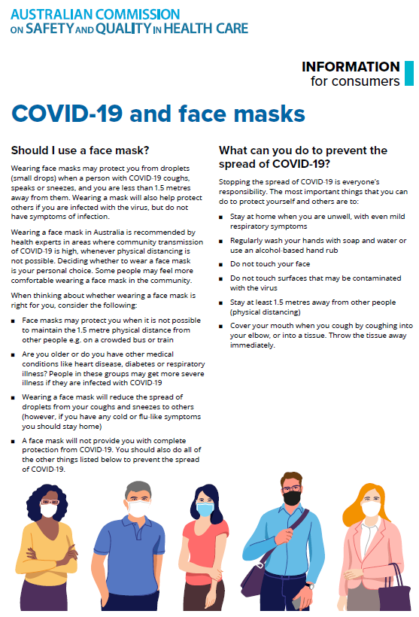](https://www.safetyandquality.gov.au/sites/default/files/2020-07/covid-19_and_face_masks_-_information_for_consumers.pdf)

*National COVID-19 Clinical Evidence Taskforce*

<https://covid19evidence.net.au/>

The National COVID-19 Clinical Evidence Taskforce is a collaboration of peak health professional bodies across Australia whose members are providing clinical care to people with COVID-19. The taskforce is undertaking continuous evidence surveillance to identify and rapidly synthesise emerging research in order to provide national, **evidence-based guidelines and clinical flowcharts for the clinical care of people with COVID-19**. The guidelines address questions that are specific to managing COVID-19 and cover the full disease course across mild, moderate, severe and critical illness. These are ‘living’ guidelines, updated with new research in near real-time in order to give reliable, up-to-the minute advice to clinicians providing frontline care in this unprecedented global health crisis.

*COVID-19 Critical Intelligence Unit*

<https://www.aci.health.nsw.gov.au/covid-19/critical-intelligence-unit>

The Agency for Clinical Innovation (ACI) in New South Wales has developed this page summarising rapid, evidence-based advice during the COVID-19 pandemic. Its operations focus on systems intelligence, clinical intelligence and evidence integration. The content includes a daily evidence digest and evidence checks on a discrete topic or question relating to the current COVID-19 pandemic. There is also a ‘Living evidence’ section summarising key studies and emerging evidence on **COVID-19 vaccines** and **SARS-CoV-2 variants**. Recent evidence check updates include:

* ***Post-acute sequelae SARSCoV2.***

**Disclaimer**

On the Radar is an information resource of the Australian Commission on Safety and Quality in Health Care. The Commission is not responsible for the content of, nor does it endorse, any articles or sites listed. The Commission accepts no liability for the information or advice provided by these external links. Links are provided on the basis that users make their own decisions about the accuracy, currency and reliability of the information contained therein. Any opinions expressed are not necessarily those of the Australian Commission on Safety and Quality in Health Care.