# Australian COmmission on Safety and Quality in Health Care logo with Radar imageOn the Radar

Issue 510

10 May 2021

*On the Radar* is a summary of some of the recent publications in the areas of safety and quality in health care. Inclusion in this document is not an endorsement or recommendation of any publication or provider. Access to particular documents may depend on whether they are Open Access or not, and/or your individual or institutional access to subscription sites/services. Material that may require subscription is included as it is considered relevant.

*On the Radar* is available online, via email or as a PDF or Word document from <https://www.safetyandquality.gov.au/publications-and-resources/newsletters/radar>

If you would like to receive *On the Radar* via email, you can subscribe on our website <https://www.safetyandquality.gov.au/publications-and-resources/newsletters>   
or by emailing us at H[Umail@safetyandquality.gov.auU](mailto:mail@safetyandquality.gov.au).   
You can also send feedback and comments to H[Umail@safetyandquality.gov.auU](mailto:mail@safetyandquality.gov.au).

For information about the Commission and its programs and publications, please visit <https://www.safetyandquality.gov.au>

You can also follow us on Twitter @ACSQHC.

**On the Radar**

Editor: Dr Niall Johnson [niall.johnson@safetyandquality.gov.au](mailto:niall.johnson@safetyandquality.gov.au)

Contributors: Niall Johnson, Kim Stewart, Amy Forsyth

[](https://kapara.rdbk.com.au/landers/17b225.html)

**Management of Peripheral Intravenous Catheters Clinical Care Standard**

Registrations are now open for the launch of Australia’s *Management of Peripheral Intravenous Catheters Clinical Care Standard*. Join experts in anaesthetic medicine, vascular access and infection control on better use of Peripheral Intravenous Catheters (PIVCs) discussing key topics such as reducing unnecessary cannulations, maximising first-time insertion success, preventing infection, preserving vessel health, and keeping patients informed and at the centre of care. Hear from:

* Associate Professor Amanda Walker – Clinical Director, the Australian Commission on Safety and Quality in Health Care (Host)
* Professor Michael Kidd AM – Deputy Chief Medical Officer and Principal Medical Advisor, Australian Government Department of Health
* Dr Jennifer Stevens – Anaesthetist and Pain Medicine Specialist, St Vincent's Hospitals
* Dr Evan Alexandrou – Senior Lecturer Western Sydney University, Clinical Nurse Consultant Liverpool Hospital NSW, Adjunct Associate Professor Griffith University
* Professor Peter Collignon AM – Infectious Diseases Physician and Microbiologist, Canberra Hospital, Australian National University

Date: Wednesday, **26 May 2021**

Time: **12.30 to 1.30pm** (AEST)

Click [here](https://kapara.rdbk.com.au/landers/17b225.html) to register now

Further information can be found on the Commission’s website at <https://www.safetyandquality.gov.au/standards/clinical-care-standards/peripheral-intravenous-catheters>

**Books**

*Implementing High-Quality Primary Care: Rebuilding the Foundation of Health Care*

National Academies of Sciences, Engineering, and Medicine

Linda M, Robert L. Phillips, Jr., Marc M, Sarah KR, editors

Washington, DC: The National Academies Press; 2021.

|  |  |
| --- | --- |
| DOI | <https://doi.org/10.17226/25983> |
| Notes | Primary care is regarded as the foundation of all health systems. As the authors of this report observe, ‘High-quality primary care provides comprehensive person-centered, relationship-based care that considers the needs and preferences of individuals, families, and communities.’ It’s also noted that, Primary care is the only health care component where an increased supply is associated with better population health and more equitable outcomes. For this reason, primary care is a common good, which makes the strength and quality of the country's primary care services a public concern.  However, primary care not always receive the attention (and funding) it warrants. This report from the National Academies of Sciences, Engineering, and Medicine in the USA offers recommendations on how primary care in the United States could be enhanced. The report also outlines a plan to implement high-quality primary care for everyone in the United States. The plan’s five objectives are:   1. Pay for primary care teams to care for people, not doctors to deliver services. 2. Ensure that high-quality primary care is available to every individual and family in every community. 3. Train primary care teams where people live and work. 4. Design information technology that serves the patient, family, and interprofessional care team. 5. Ensure that high-quality primary care is implemented in the United States. |

**Reports**

*CARAlert Annual Report 2020*

Australian Commission on Safety and Quality in Health Care

Sydney: ACSQHC; 2021. p. 44.

*CARAlert Data Update 21: 1 January 2021 – 28 February 2021*

Australian Commission on Safety and Quality in Health Care

Sydney: ACSQHC; 2021. p. 26.

|  |  |
| --- | --- |
| URL | *CARAlert Annual Report 2020* <https://www.safetyandquality.gov.au/publications-and-resources/resource-library/caralert-annual-report-2020>  *CARAlert Data Update 21* <https://www.safetyandquality.gov.au/publications-and-resources/resource-library/caralert-data-update-21-1-january-2021-28-february-2021> |
| Notes | The Australian Commission on Safety and Quality in Health Care has published two new reports on data submitted to the National Alert System for Critical Antimicrobial Resistances (CARAlert ).  The *CARAlert Annual Report* *2020* provides the results of analyses of data on confirmed critical antimicrobial resistances (CARs) submitted to the National Alert System for Critical Antimicrobial Resistances (CARAlert) for 2020, and trend data for 2017 to 2020. In 2020, compared with 2019:   * Excluding new CARs introduced in 2019, there was an overall decrease of 21% in CARs reported in 2020 compared to 2019. * Carbapenemase-producing *Enterobacterales* (including those with ribosomal methyltransferase or transmissible colistin resistance) was the most frequently reported CAR in 2020, followed by multidrug-resistant (MDR) *Shigella* species * The total number of CPE (either alone or in combination with other CARs) reported in 2020, compared to 2019, decreased by 26.4%. The decrease was seen in across all jurisdictions, except Western Australia, where reports increased by 22% * The overall number of reports of MDR *Shigella* species decreased by 9.7% in 2020, most notably in Victoria. There was however a 3-fold increase in reports from both New South Wales and Western Australia * There was a decrease in the number of ceftriaxone non-susceptible *Salmonella* species (n = 30, down 33.3%) * There were 16 reports of MDR Mycobacterium tuberculosis, compared with 24 reports in 2019 * The majority of CARs, where the setting was known, but excluding those from *Neisseria gonorrhoeae*, were reported from public hospitals.     The *CARAlert data update 21: 1 January 2021–28 February 2021* reports on data submitted to CARAlert for the reporting period 1 January 2021 to 28 February 2021, and complements previous analyses and updates of CARAlert data, and the CARAlert 2020 Annual Report. Nationally:   * The total number of critical antimicrobial resistances (CARs) reported was steady compared to the previous two-month reporting period * Almost one-half of the CARs reported were carbapenemase-producing *Enterobacterales* (CPE) (including those with ribosomal methyltransferase or transmissible resistance to colistin), followed by azithromycin non-susceptible (low-level resistance, MIC ≤ 256 mg/L) *Neisseria gonorrhoeae* * The total number of CPE (either alone or in combination with other CARs) reported this year, compared to the same period last year, decreased by 18.7% * The number of multidrug-resistant *Shigella* species decreased by 84% compared to the previous two-month reporting period * The number of daptomycin non-susceptible *Staphylococcus aureus* decreased by 32% compared to the previous two-month reporting period * The majority of CARs, excluding those from *N. gonorrhoeae*, were reported from public hospitals. |

*Multiple long-term conditions (multimorbidity): making sense of the evidence*

National Institute for Health Research

London: NHS NIHR; 2021.

|  |  |
| --- | --- |
| URL | <https://evidence.nihr.ac.uk/collection/making-sense-of-the-evidence-multiple-long-term-conditions-multimorbidity/> |
| Notes | Multimorbidity – having multiple long-term conditions – is possibly a defining feature of our age and a challenge for clinicians. Guidance, including guidelines, often lacks information to assist clinicians seeking to understand how best to tailor their treatment of their patients with multimorbidity so as to optimise the treatment while minimising risks. The National Institute for Health Research in the UK has compiled this document that ‘explores the impact of multiple conditions both on people’s lives and on the healthcare service. It looks at the dynamic interaction between different conditions – physical and mental – and between risk factors such as people’s behaviour, and socioeconomic status.’ |

*Telehealth coaching in oral healthcare*

Deeble Institute Perspectives Brief No. 17

Bourke C, McAuliffe A, Lobo K, Wainer Z

Canberra: Australian Healthcare and Hospitals Association; 2021. p. 13.

|  |  |
| --- | --- |
| URL | <https://ahha.asn.au/deeble-institute-perspective-briefs> |
| Notes | The COVID-19 pandemic led to many changes in health care, particularly delivery. This Perspectives Brief from the Australian Healthcare and Hospitals Association’s Deeble Institute looks at how the pandemic spurred the ‘emergence of tele-dentistry… including on-line screening, treatment planning and referral’ and how these changes could be extended. The authors look to how telehealth could become ‘a key component of comprehensive dentistry, through the establishment of an oral health telehealth coaching program’. |

**Journal articles**

*Surgical outcomes for people with serious mental illness are poorer than for other patients: a systematic review and meta-analysis*

McBride KE, Solomon MJ, Bannon PG, Glozier N, Steffens D

Medical Journal of Australia. 2021;214(8):379-385.

|  |  |
| --- | --- |
| DOI | <https://doi.org/10.5694/mja2.51009> |
| Notes | The fact that physical health outcomes are often poorer for those with mental health conditions has been long recognised. This study sought to examine whether this held true for surgery. The authors sought to ‘assess the association between having a serious mental illness and surgical outcomes for adults, including in‐hospital and 30‐day mortality, post‐operative complications, and hospital length of stay’. Based on 26 studies, the authors report that ‘Having a **serious mental illness is associated with higher rates of post‐operative complications and longer stays in hospital**, but not with higher in‐hospital or 30‐day mortality’. They suggest that ‘Targeted pre‐operative interventions may improve surgical outcomes for these vulnerable patients.’ |

<https://www.safetyandquality.gov.au/our-work/mental-health>

For information on the Commission’s work on

*Health Expectations*

Volume 24, Issue 2, April 2021

|  |  |
| --- | --- |
| URL | <https://onlinelibrary.wiley.com/toc/13697625/2021/24/2> |
| Notes | A new issue of *Health Expectations* has been published. Articles in this issue of *Health Expectations* include:   * Applying the principles of adaptive leadership to **person‐centred care for people with complex care needs**: Considerations for care providers, patients, caregivers and organizations (Kerry Kuluski R J Reid, G R Baker) * **Can patients contribute to enhancing the safety and effectiveness of test‐result follow‐up?** Qualitative outcomes from a health consumer workshop (Judith Thomas, Maria R Dahm, Julie Li, Andrew Georgiou) * Decision aids to **prepare patients for shared decision making**: Two randomized controlled experiments on the impact of awareness of preference‐sensitivity and personal motives (Simone Korger, Marie Eggeling, MSc Ulrike Cress, Joachim Kimmerle, Martina Bientzle) * The **impact of a physician’s recommendation and gender on informed decision making**: A randomized controlled study in a simulated decision situation (Anna Lea Meinhardt, Marie Eggeling, Ulrike Cress, Joachim Kimmerle, Martina Bientzle) * The experience of **financial burden for people with multimorbidity**: A systematic review of qualitative research (James Larkin, Louise Foley, Susan M. Smith, Patricia Harrington, Barbara Clyne) * **Providing culturally safe care to Indigenous people living with diabetes**: Identifying barriers and enablers from different perspectives (Marie‐Claude Tremblay, Maude Bradette‐Laplante, Holly O Witteman, Maman Joyce Dogba, Pascale Breault, Jean‐Sébastien Paquette, Emmanuelle Careau, S Echaquan) * Acceptability and potential impact on uptake of using different risk stratification approaches to determine **eligibility for screening**: A population‐based survey (Juliet A Usher‐Smith, Laragh L W Harvey‐Kelly, Sabrina H Rossi, Hannah Harrison, Simon J Griffin, Grant D Stewart) * Public perspectives on **acquired brain injury rehabilitation** and components of care: A Citizens’ Jury (Natasha A Lannin, Megan Coulter, Kate Laver, Nerida Hyett, Julie Ratcliffe, Anne E Holland, Libby Callaway, Coralie English, Peter Bragge, Sophie Hill, Carolyn A Unsworth) * **Stakeholder involvement in the development of trial material for a clinical trial** (Jacqueline Rix, Jonathan Branney, Alexander C Breen, Philip Sewell, Sharon Docherty) * Development of a novel **gout treatment patient decision aid** by patient and physician: A qualitative research study (Meykkumar Meyappan, Wei Siong Aaron Loh, Li Yen Tan, Sheng Feng Ian Tan, Pey Ying Ho, Yih Jia Poh, Ngiap Chuan Tan) * **Patient and public involvement cultures** and the perceived impact in the vulnerable context of **palliative care**: A qualitative study (Inge Melchior, Anouk van der Heijden, Esther Stoffers, Frits Suntjens, Albine Moser) * Improving the experience of **older people with colorectal and breast cancer in patient‐centred cancer care pathways** using experience‐based co‐design (Albine Moser, Inge Melchior, Marja Veenstra, Esther Stoffers, Elvira Derks, Kon‐Siong Jie) * Evaluation of **patient engagement in medicine development**: A multi‐stakeholder framework with metrics (Lidewij Eva Vat, Teresa Finlay, Paul Robinson, Giorgio Barbareschi, Mathieu Boudes, Ana Maria Diaz Ponce, Michaela Dinboeck, Lukas Eichmann, Elisa Ferrer, Sevgi E Fruytier, Claudia Hey, Jacqueline E W Broerse, Tjerk Jan Schuitmaker‐Warnaar) * Use of the ADAPTE method to develop a **clinical guideline for the improvement of psychoses and schizophrenia care**: Example of involvement and participation of patients and family caregivers (María M Hurtado, Casta Quemada, José M García‐Herrera, José M Morales‐Asencio) * **Aged care residents’ prioritization of care**: A mixed‐methods study (Kristiana Ludlow, Kate Churruca, Virginia Mumford, L A Ellis, J Braithwaite) * A scoping Review of tools used to assess **patient Complexity in rheumatic disease** (Kara Hawker, Cheryl Barnabe, Claire E H Barber) * Perceptions of aquatic physiotherapy and health‐related quality of life among people with **Parkinson’s disease** (Aan Fleur Terrens, Sze‐Ee Soh, P Morgan) * Evaluating the effectiveness of the **Family Connections program for caregivers of youth with mental health** challenges, part I: A quantitative analysis (Tali Z Boritz, N Y Sheikhan, L D Hawke, S F McMain, J Henderson) * Understanding multi‐stakeholder needs, preferences and expectations to define effective practices and processes of **patient engagement in medicine development**: A mixed‐methods study (Stuart D Faulkner, Suzanne Sayuri Ii, Chi Pakarinen, Fabian Somers, Maria Jose Vicente Edo, Lucia Prieto Remon, Ana Diaz Ponce, Dianne Gove, Elisa Ferrer, Begonya Nafria, Neil Bertelsen, Mathieu Boudes, Nicholas Brooke, Alexandra Moutet, Nick Fahy) * How **different health literacy dimensions influences health and well‐being** among men and women: The mediating role of health behaviours (Fan Zhang, Peggy P L Or, Joanne W Y Chung) * Knowledge sharing to support **long‐term condition self‐management**—Patient and health‐care professional perspectives (Sarah Brand, S Timmons) * “I would not go to him”: Focus groups exploring community responses to a public health campaign aimed at reducing **unnecessary diagnostic imaging of low back pain** (Sweekriti Sharma, Adrian C Traeger, Elise Tcharkhedian, Janet Harrison, Jolyn K Hersch, Kristen Pickles, Ian A Harris, Chris G Maher) * The Wellness Quest: A **health literacy and self‐advocacy tool developed by youth for youth mental health** (Asavari Syan, Janice Y Y Lam, Christal G L Huang, Maverick S M Smith, Karleigh Darnay, Lisa D Hawke, J Henderson) * The expectations and realities of **nutrigenomic testing in Australia**: A qualitative study (Erin Tutty, Chriselle Hickerton, Bronwyn Terrill, Belinda McClaren, Rigan Tytherleigh, Elaine Stackpoole, Jaqueline Savard, Ainsley Newson, A Middleton, A Nisselle, M Cusack, M Adamski, C Gaff, S Metcalfe) * Proposals for **person‐centred care in the COVID‐19 era**. Delphi study (José J Mira, Martín Blanco, Kamila Cheikh‐Moussa, Olga Solas, Aquilino Alonso, Rodrigo Gutierrez, Celia Gómez, Mercedes Guilabert) * Evaluating the effectiveness of the **Family Connections program for caregivers of youth with mental health challenges**, part II: A qualitative analysis (Natasha Y Sheikhan, Karen Wang, Tali Boritz, Lisa D Hawke, Shelley McMain, Joanna Henderson) * Identifying **coping strategies used by patients at a transgender health clinic** through analysis of free‐text autobiographical narratives (Angela Zottola, Lucy Jones, Alison Pilnick, Louise Mullany, W P Bouman, J Arcelus) |

*Health Affairs*

Volume 40, Number 5, May 2021

|  |  |
| --- | --- |
| URL | <https://www.healthaffairs.org/toc/hlthaff/40/5> |
| Notes | A new issue of *Health Affairs* has been published. Articles in this issue of *Health Affairs* include:   * The **American Rescue Plan** Expands The ACA (Katie Keith) * **Gaining Family Input** At A Children’s Medical Center (David Tuller) * Higher **Medicare Spending On Imaging And Lab Services** After Primary Care Physician Group Vertical Integration (Christopher M Whaley, Xiaoxi Zhao, Michael Richards, and Cheryl L Damberg) * **Private Equity Investments In Health Care**: An Overview Of Hospital And Health System Leveraged Buyouts, 2003–17 (Anaeze C Offodile II, Marcelo Cerullo, Mohini Bindal, Jose Alejandro Rauh-Hain, and Vivian Ho) * **Private Equity In Dermatology**: Effect On Price, Utilization, And Spending (Robert Tyler Braun, Amelia M. Bond, Yuting Qian, Manyao Zhang, and Lawrence P Casalino) * Outcomes After Shortened Skilled Nursing Facility Stays Suggest Potential For Improving **Postacute Care Efficiency** (Brian E McGarry, David C Grabowski, Lin Ding, and J. Michael McWilliams) * Spending On Targeted Therapies Reduced Mortality In Patients With **Advanced-Stage Breast Cancer** (Meng Li, Dana P Goldman, and A J Chen) * **Diabetes Drugs**: List Price Increases Were Not Always Reflected In Net Price; Impact Of Brand Competition Unclear (Ameet Sarpatwari, Frazer A Tessema, Marie Zakarian, Mehdi N Najafzadeh, and Aaron S Kesselheim) * Frequency Of **Generic Drug Price Spikes** And Impact On Medicaid Spending (Aayan N Patel, Aaron S Kesselheim, and Benjamin N Rome) * Medicare Beneficiaries With **Self-Reported Functional Hearing Difficulty Have Unmet Health Care Needs** (Nicholas S Reed, Lama Assi, Wakako Horiuchi, Julie E Hoover-Fong, Frank R Lin, Lauren E Ferrante, Sharon K Inouye, Edgar R Miller III, Emily F Boss, Esther S Oh, and Amber Willink) * **Nursing Home Staffing Levels Did Not Change Significantly During COVID-19** (Rachel M Werner and Norma B Coe) * **Fewer Pharmacies In Black And Hispanic/Latino Neighborhoods** Compared With White Or Diverse Neighborhoods, 2007–15 (Jenny S Guadamuz, Jocelyn R Wilder, Morgane C Mouslim, Shannon N Zenk, G Caleb Alexander, and Dima Mazen Qato) * Associations Between Individual Demographic Characteristics And **Involuntary Health Care Delays As A Result Of COVID-19** (Kevin Callison and Jason Ward) * The **Hidden Curriculum Of Hospice**: Die Fast, Not Slow (Krista Lyn Harrison) |

*BMJ Quality & Safety* online first articles

|  |  |
| --- | --- |
| URL | <https://qualitysafety.bmj.com/content/early/recent> |
| Notes | *BMJ Quality &Safety* has published a number of ‘online first’ articles, including:   * Bridging the feedback gap: a sociotechnical approach to **informing clinicians of patients’ subsequent clinical course and outcomes** (Christina L Cifra, Dean F Sittig, Hardeep Singh) * Nationwide study on trends in **unplanned hospital attendance and deaths** during the 7 weeks after the onset of the **COVID-19 pandemic in Denmark** (Søren Bie Bogh, Marianne Fløjstrup, Søren Kabell Nissen, Stine Hanson, Mickael Bech, Søren Paaske Johnsen, Mette Rahbek Kristensen, Line Emilie Laugesen, Jens Søndergaard, Lars Folkestad, Erika Frischknecht Christensen, Daniel Pilsgaard Henriksen, Renee Y Hsia, Colin A Graham, Tim Alex Lindskou, Keld-Erik Byg, Morten Breinholt Søvsø, Henrik Laugesen, Peter Hallas, Søren Mikkelsen, Kim Rose Olsen, Lau Caspar Thygesen, Hejdi Gamst-Jensen, Mikkel Brabrand) |

**Online resources**

*Future Leaders Communiqué*

Volume 6 Issue 2 April 2021

<https://www.thecommuniques.com/post/future-leaders-communiqu%C3%A9-volume-6-issue-2-april-2021>

This issue of *Future Leaders Communiqué* focuses on **diagnosis**. The *Communiqué* examines the challenges facing junior clinicians around the processes of diagnosis and explores the safeguards available to protect patients. The case study details the experience of a woman who died from a pulmonary embolism during the first trimester of pregnancy. Over the course of her illness, she had presented to the emergency department on three occasions but the diagnosis wasn’t correctly identified. There are also two expert commentaries exploring how to manage diagnostic uncertainty, and the importance of supervised practice.

*[UK] Healthcare Safety Investigation Branch investigation reports*

<https://www.hsib.org.uk/>

The UK’s Healthcare Safety Investigation Branch (HSIB) has recently released the final reports from a number of their investigations. While these investigations and their recommendations respond to specific ‘reference events’ in the context of the UK health system, they can offer useful material. Recent final reports include

* ***Outpatient appointments*** *intended but not booked after inpatient stays* <https://www.hsib.org.uk/investigations-cases/outpatient-appointments-intended-not-booked-after-inpatient-stays/>
* *Management of* ***chronic asthma in children*** *aged 16 years and under* <https://www.hsib.org.uk/investigations-cases/management-chronic-asthma-children-aged-16-years-and-under/final-report/>
* ***Wrong site surgery*** *- wrong tooth extraction*<https://www.hsib.org.uk/investigations-cases/wrong-site-surgery-wrong-tooth-extraction/final-report-wrong-site-surgery-wrong-tooth-extraction/>

**COVID-19 resources**

https://www.safetyandquality.gov.au/covid-19

The Australian Commission on Safety and Quality in Health Care has developed a number of resources to assist healthcare organisations, facilities and clinicians. These and other material on COVID-19 are available at <https://www.safetyandquality.gov.au/covid-19>

These resource include:

* ***COVID-19: Aged care staff infection prevention and control precautions*** *poster*<https://www.safetyandquality.gov.au/publications-and-resources/resource-library/covid-19-aged-care-staff-infection-prevention-and-control-precautions-poster>  
    
  [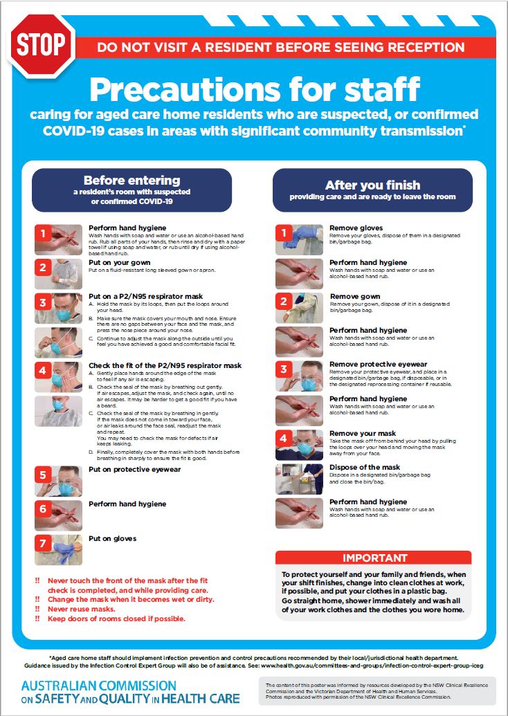](https://www.safetyandquality.gov.au/publications-and-resources/resource-library/covid-19-aged-care-staff-infection-prevention-and-control-precautions-poster)
* ***Environmental Cleaning and Infection Prevention and Control*** [www.safetyandquality.gov.au/environmental-cleaning](http://www.safetyandquality.gov.au/environmental-cleaning)
* ***Infection prevention and control Covid-19 PPE*** poster <https://www.safetyandquality.gov.au/publications-and-resources/resource-library/infection-prevention-and-control-covid-19-personal-protective-equipment>
* ***Special precautions for Covid-19 designated zones*** poster <https://www.safetyandquality.gov.au/publications-and-resources/resource-library/special-precautions-covid-19-designated-zones>
* ***COVID-19 infection prevention and control risk management – Guidance*** <https://www.safetyandquality.gov.au/publications-and-resources/resource-library/covid-19-infection-prevention-and-control-risk-management-guidance>
* ***Safe care for people with cognitive impairment during COVID-19***<https://www.safetyandquality.gov.au/our-work/cognitive-impairment/cognitive-impairment-and-covid-19>
* **Medicines Management COVID-19** <https://www.safetyandquality.gov.au/our-work/medication-safety/medicines-management-covid-19>, including position statements on medicine-related issues
  + ***Managing fever associated with COVID-19***
  + ***Managing a sore throat associated with COVID-19***
  + ***ACE inhibitors and ARBs in COVID-19***
  + ***Clozapine in COVID-19***
  + ***Management of patients on oral anticoagulants during COVID-19***
  + ***Ascorbic Acid: Intravenous high dose in COVID-19***
  + ***Treatment in acute care, including oxygen therapy and medicines to support intubation***
  + ***Nebulisation and COVID-19***
  + ***Managing intranasal administration of medicines during COVID-19***
  + ***Ongoing medicines management in high-risk patients***
  + ***Medicines shortages***
  + ***Conserving medicines***
  + ***Intravenous medicines administration in the event of an infusion pump shortage***
* ***Break the chain of infection: Stopping COVID-19*** poster<https://www.safetyandquality.gov.au/publications-and-resources/resource-library/break-chain-poster-a3>  
    
  **[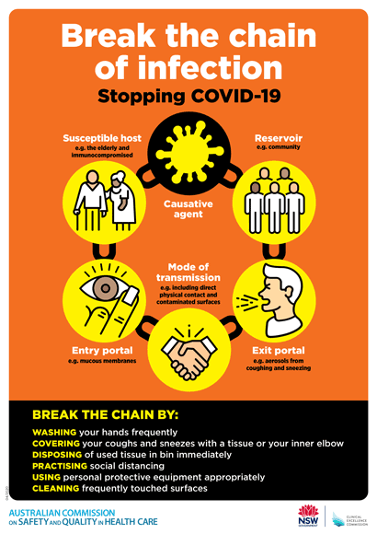](https://www.safetyandquality.gov.au/publications-and-resources/resource-library/break-chain-poster-a3https:/www.safetyandquality.gov.au/publications-and-resources/resource-library/break-chain-poster-a3)**
* ***COVID-19: Elective surgery and infection prevention and control precautions*** <https://www.safetyandquality.gov.au/publications-and-resources/resource-library/covid-19-elective-surgery-and-infection-prevention-and-control-precautions>
* ***FAQs for clinicians on elective surgery*** <https://www.safetyandquality.gov.au/node/5724>
* ***FAQs for consumers on elective surgery*** <https://www.safetyandquality.gov.au/node/5725>
* ***FAQs on community use of face masks***   
   <https://www.safetyandquality.gov.au/faqs-community-use-face-masks>
* ***COVID-19 and face masks – Information for consumers*** <https://www.safetyandquality.gov.au/publications-and-resources/resource-library/covid-19-and-face-masks-information-consumers>  
  The Commission’s fact sheet on use of face masks in the community to reduce the spread of COVID-19 is now available in Easy English and 10 other community languages from <https://www.safetyandquality.gov.au/wearing-face-masks-community>.  
  The factsheet was developed to help people understand when it is important to wear a mask to reduce the risk of the spread of COVID-19, and to explain how to safely put on and remove face masks. It also reinforces the importance of staying home if you have symptoms, physical distancing, hand hygiene and cough etiquette.

[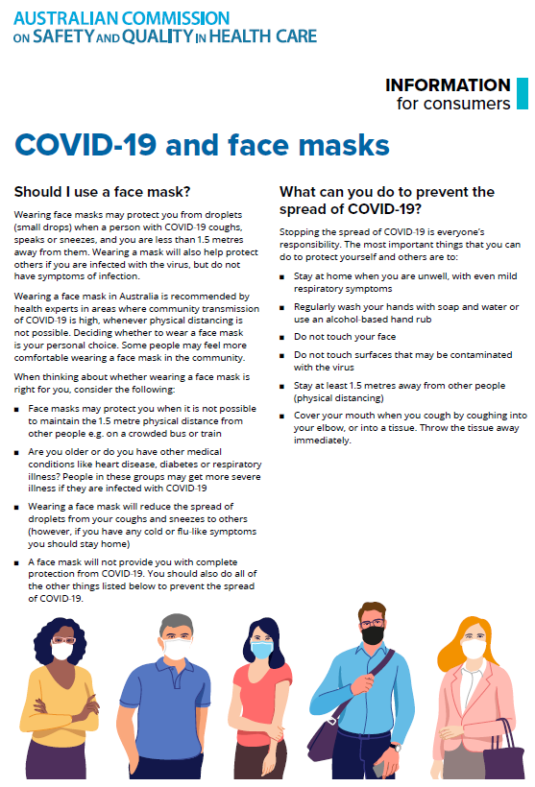](https://www.safetyandquality.gov.au/sites/default/files/2020-07/covid-19_and_face_masks_-_information_for_consumers.pdf)

*National COVID-19 Clinical Evidence Taskforce*

<https://covid19evidence.net.au/>

The National COVID-19 Clinical Evidence Taskforce is a collaboration of peak health professional bodies across Australia whose members are providing clinical care to people with COVID-19. The taskforce is undertaking continuous evidence surveillance to identify and rapidly synthesise emerging research in order to provide national, **evidence-based guidelines and clinical flowcharts for the clinical care of people with COVID-19**. The guidelines address questions that are specific to managing COVID-19 and cover the full disease course across mild, moderate, severe and critical illness. These are ‘living’ guidelines, updated with new research in near real-time in order to give reliable, up-to-the minute advice to clinicians providing frontline care in this unprecedented global health crisis.

*COVID-19 Critical Intelligence Unit*

<https://www.aci.health.nsw.gov.au/covid-19/critical-intelligence-unit>

The Agency for Clinical Innovation (ACI) in New South Wales has developed this page summarising rapid, evidence-based advice during the COVID-19 pandemic. Its operations focus on systems intelligence, clinical intelligence and evidence integration. The content includes a daily evidence digest and evidence checks on a discrete topic or question relating to the current COVID-19 pandemic. There is also a ‘Living evidence’ section summarising key studies and emerging evidence on **COVID-19 vaccines** and **SARS-CoV-2 variants**. Recent evidence check updates include:

* ***COVID-19 vaccines clotting disorders***
* ***Cerebral venous sinus thrombosis after AstraZeneca vaccination***

**Disclaimer**

On the Radar is an information resource of the Australian Commission on Safety and Quality in Health Care. The Commission is not responsible for the content of, nor does it endorse, any articles or sites listed. The Commission accepts no liability for the information or advice provided by these external links. Links are provided on the basis that users make their own decisions about the accuracy, currency and reliability of the information contained therein. Any opinions expressed are not necessarily those of the Australian Commission on Safety and Quality in Health Care.