# Australian COmmission on Safety and Quality in Health Care logo with Radar imageOn the Radar

Issue 513

31 May 2021

*On the Radar* is a summary of some of the recent publications in the areas of safety and quality in health care. Inclusion in this document is not an endorsement or recommendation of any publication or provider. Access to particular documents may depend on whether they are Open Access or not, and/or your individual or institutional access to subscription sites/services. Material that may require subscription is included as it is considered relevant.

*On the Radar* is available online, via email or as a PDF or Word document from <https://www.safetyandquality.gov.au/publications-and-resources/newsletters/radar>

If you would like to receive *On the Radar* via email, you can subscribe on our website <https://www.safetyandquality.gov.au/publications-and-resources/newsletters>   
or by emailing us at H[Umail@safetyandquality.gov.auU](mailto:mail@safetyandquality.gov.au).   
You can also send feedback and comments to H[Umail@safetyandquality.gov.auU](mailto:mail@safetyandquality.gov.au).

For information about the Commission and its programs and publications, please visit <https://www.safetyandquality.gov.au>

You can also follow us on Twitter @ACSQHC.

**On the Radar**

Editor: Dr Niall Johnson [niall.johnson@safetyandquality.gov.au](mailto:niall.johnson@safetyandquality.gov.au)

Contributors: Niall Johnson, Lucia Chiappini

[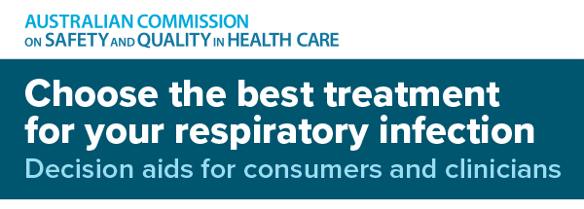](https://www.safetyandquality.gov.au/our-work/partnering-consumers/shared-decision-making/decision-support-tools-patients)

**Should I take antibiotics? Antibiotic use patient decision aids**

<https://www.safetyandquality.gov.au/our-work/partnering-consumers/shared-decision-making/decision-support-tools-patients>

The Australian Commission on Safety and Quality in Health Cate has updated three decision aids about antibiotic use for sore throat, acute bronchitis and middle ear infection in children. The decision aids *Should I take antibiotics?* are designed to be used by consumers and clinicians in the clinical encounter. They provide high-quality evidence about the possible benefits, harms and alternatives of using antibiotics, and support shared decision making. The decision aids are available on the Commission’s website at <https://www.safetyandquality.gov.au/our-work/partnering-consumers/shared-decision-making/decision-support-tools-patients>

**Reports**

*Managing the long term health consequences of COVID-19 in Australia*

Deeble Institute Issues Brief No. 40

Hensher M, Angeles MR, de Graaff B, Campbell J, Athan E, Haddock R

Canberra: Australian Healthcare and Hospitals Association; 2021. p. 74.

|  |  |
| --- | --- |
| URL | <https://ahha.asn.au/publication/health-policy-issue-briefs/deeble-issues-brief-no-40-managing-long-term-health> |
| Notes | This health policy issues brief from the Australian Healthcare and Hospitals Association’s Deeble Institute looks at how the health system could be improved, arguing that ‘Australian governments should now consider an effective and proportionate value-based response to COVID-19, Long COVID and its other longer-term consequences, that considers both patient health outcomes and costs.’ The recommendations include:   * Prioritising primary prevention of COVID-19 * Planning for rapid scaling-up of long-term care were COVID-19 control measures to fail. * Taking the opportunity to implement new approaches to integrated, well-coordinated, multidisciplinary, person-centred care to address long COVID and post-COVID sequelae * Considering the long-term care consequences of COVID and its associated additional cost burden in resource allocation and risk management decision processes in parallel with COVID-19 control strategy policies. * Supporting research that focuses on health policy, health economics, social determinants and more directly on the effect of COVID-19 on the structure and function of the health system. |

*Transforming the health system for sustainability: environmental leadership through a value-based health care strategy*

Deeble Institute Issues Brief No. 41

Hoban E, Haddock R, Woolcock K

Canberra: Australian Healthcare and Hospitals Association; 2021. p. 62.

|  |  |
| --- | --- |
| URL | <https://ahha.asn.au/publication/health-policy-issue-briefs/deeble-issues-brief-no-41-transforming-health-system> |
| Notes | A second health policy issues brief released by the Australian Healthcare and Hospitals Association’s Deeble Institute this week examines the sustainability of the Australian health system, particularly in response to climate change. The authors argue that transforming the health system for sustainability requires consideration of the systemic and complex nature of climate change as a determinant of health, for today’s and future generations. This will require attention to both patient level processes and different framework requirements at each level of the health system. The brief makes a number of recommendations, including:   * Environmental sustainability should be encompassed in the national vision and strategy for outcomes-focused, value-based health care in Australia. * Strong leadership must be demonstrated across the health system through a commitment to meet zero emissions. * Data-driven improvements in the health outcomes of individuals and populations should be enabled. However, improved health outcomes should not be achieved through care pathways that themselves create poorer health outcomes from their environmental impacts. * Health workforce strategies and plans must recognise the impact climate change will have on exacerbating health workforce shortages, particularly in rural and remote areas and already vulnerable communities. * Funding models should be introduced to incentivise environmental sustainability. * Climate and health research that provides a strong evidence base to support health sector sustainability must be supported. |

**Journal articles**

*Effects of a refined evidence-based toolkit and mentored implementation on medication reconciliation at 18 hospitals: results of the MARQUIS2 study*

Schnipper JL, Reyes Nieva H, Mallouk M, Mixon A, Rennke S, Chu E, et al

BMJ Quality & Safety. 2021:bmjqs-2020-012709.

|  |  |
| --- | --- |
| DOI | <http://dx.doi.org/10.1136/bmjqs-2020-012709> |
| Notes | Medication reconciliation (med rec) – reconciling the medications a patient has are those that have been prescribed and are appropriate – has been advocated as a mechanism for addressing a number of medication issues, including polypharmacy and medication discrepancies. This paper reports on a study that further refined a toolkit for med rec by including system-level and patient-level interventions as well as mentors providing remote coaching and in-person site visits. When implemented across 17 hospital sites in North America, the toolkit was associated with a significant decrease in unintentional mediation discrepancies. |

For information on the Commission’s work on medication safety, including medication reconciliation, see <https://www.safetyandquality.gov.au/our-work/medication-safety>

*Key Considerations in Ensuring a Safe Regional Telehealth Care Model: A Systematic Review*

Haveland S, Islam S

Telemedicine and e-Health. 2021 [epub]

*Direct-To-Consumer Telemedicine Visits For Acute Respiratory Infections Linked To More Downstream Visits*

Li KY, Zhu Z, Ng S, Ellimoottil C

Health Affairs. 2021;40(4):596-602.

*Remote care for mental health: qualitative study with service users, carers and staff during the COVID-19 pandemic*

Liberati E, Richards N, Parker J, Willars J, Scott D, Boydell N, et al

BMJ Open. 2021;11(4):e049210.

|  |  |
| --- | --- |
| DOI | Haveland and Islam <http://doi.org/10.1089/tmj.2020.0580>  Li et al <https://doi.org/10.1377/hlthaff.2020.01741>  Liberati et al <http://dx.doi.org/10.1136/bmjopen-2021-049210> |
| Notes | The COVID-19 pandemic has seen the rapid escalation in the use of telehealth. This has had many benefits for clinicians and patients. But, as these articles observe, the change in the delivery of care can lead to additional issues.  Haveland and Islam report on a systematic review that examined the literature from a patient safety perspective. Based on 21 studies, they identified three main themes: telehealth experience, telehealth outcomes, and telehealth risks. From their analysis, the authors argue ‘that patients generally have positive experiences and are accepting telehealth as a modality of care. Furthermore, patient outcomes appear to be comparable with in-person care, with additional benefits of lower costs to both the service and patients.’  Li et al. examined the downstream care utilization for the period 2016–19 and found that patients with initial visits for acute respiratory infection were more likely to obtain follow-up care within seven days after direct-to-consumer telemedicine visits (10.3 percent) than after in-person visits (5.9 percent). They also found that ‘In both settings approximately 90 percent of patients did not obtain additional care’ and that the ‘telemedicine cohort had fewer (0.5 percent versus 0.6 percent) emergency department visits—a small but statistically significant difference—but more subsequent office, urgent care, and telemedicine visits’. The authors suggest ‘potential savings from shifting initial care to a direct-to-consumer telemedicine setting should be balanced against the potential for higher spending on downstream care’.  Liberati et al examined the remote delivery of mental health during the COVID-19 pandemic in England. The results of this qualitative study included   * Some service users valued the convenience of remote methods in the context of maintaining contact with familiar clinicians. * Most participants commented that a lack of non-verbal cues and the loss of a therapeutic ‘safe space’ challenged therapeutic relationship building, assessments and identification of deteriorating mental well-being. * Some carers felt excluded from remote meetings and concerned that assessments were incomplete without their input.   The authors emphasise ‘the continued importance of a tailored, personal approach to decision making in this area’. |

*Patient-reported outcome measurement of symptom distress is feasible in most clinical scenarios in palliative care: an observational study involving routinely collected data*

Clapham S, Daveson BA, Allingham SF, Morris D, Blackburn P, Johnson CE, et al

International Journal for Quality in Health Care. 2021;33(2).

*Patient-reported outcomes and personalised cancer care*

Clinical Oncology Society of Australia Patient Reported Outcomes Working Group, Koczwara B, Bonnamy J, Briggs P, Brown B, Butow PN, et al

Medical Journal of Australia. 2021;214(9):406-408.e401.

|  |  |
| --- | --- |
| DOI | Clapham et al <https://doi.org/10.1093/intqhc/mzab075>  Clinical Oncology Society of Australia Patient Reported Outcomes Working Group <https://doi.org/10.5694/mja2.50893> |
| Notes | The use of PROMs (Patient Reported Outcome Measures) and PREMs (Patient Reported Experience Measures) has been increasing for a number of years. This two recent papers indicate how their use is spreading into many domains of care.  Clapham et al examined the potential for PROMs in palliative care. Using data from 1117 patients seen by 21 palliative care services, the authors report that ‘Three factors are associated with an increased likelihood of patient versus proxy reporting in palliative care: healthcare setting, diagnosis, and the acuity and urgency of the patient’s clinical needs’. They conclude that ‘PROMs are feasible in most clinical scenarios in palliative care, including when an urgent clinical response is required’.  The paper from the Clinical Oncology Society of Australia Patient Reported Outcomes Working Group furthers the argument that PROMs (or PROs as they prefer) are an important expression of making care personalised and patient-centred. They observe that there have been barriers to implementing, collecting and using PROMs, we do now ‘have technology for efficient, real-time collection, reporting of, and response to PROs through customisable portals and dashboards and integration with the electronic medical records.’ |

For information on the Commission’s work on patient-reported outcome measures, see <https://www.safetyandquality.gov.au/our-work/indicators-measurement-and-reporting/patient-reported-outcome-measures>

For information on the Commission’s work on patient experience, including the Australian Hospital Patient Experience Question Set (AHPEQS), see <https://www.safetyandquality.gov.au/our-work/indicators-measurement-and-reporting/australian-hospital-patient-experience-question-set>

For information on the Commission’s work on person centred care, see <https://www.safetyandquality.gov.au/our-work/partnering-consumers/person-centred-care>

For information on the Commission’s work on partnering with consumers, see <https://www.safetyandquality.gov.au/our-work/partnering-consumers>

*Journal of Patient Safety*

Volume 17, Number 4, June 2021

|  |  |
| --- | --- |
| URL | <https://journals.lww.com/journalpatientsafety/toc/2021/06000> |
| Notes | A new issue of the *Journal of Patient Safety* has been published. Articles in this issue of the *Journal of Patient Safety* include:   * **What Contributes to Diagnostic Error or Delay?** A Qualitative Exploration Across Diverse Acute Care Settings in the United States (Amelia Barwise, Aaron Leppin, Yue Dong, Chanyan Huang, Yuliya Pinevich, Svetlana Herasevich, Jalal Soleimani, Ognjen Gajic, Brian Pickering, Ashok Kumbamu) * Longitudinal **Association of a Medication Risk Score With Mortality Among Ambulatory Patients** Acquired Through Electronic Health Record Data (Amanda Rondinelli Ratigan, Veronique Michaud, Jacques Turgeon, Ravil Bikmetov, Gabriela G Villarreal, H D Anderson, G Pulver, W D Pace) * **Redeployment of Health Care Workers in the COVID-19 Pandemic**: A Qualitative Study of Health System Leaders’ Strategies (Nikhil Panda, Robert D Sinyard, Natalie Henrich, Christy E Cauley, Alexander A Hannenberg, Yves Sonnay, Asaf Bitton, Mary Brindle, George Molina) * **COVID-19–Related Circumstances for Hospital Readmissions**: A Case Series From 2 New York City Hospitals (Justin J Choi, Jigar H Contractor, Amy L Shaw, Youmna Abdelghany, Jesse Frye, Madelyn Renzetti, Emily Smith, Leland R Soiefer, Shuting Lu, Justin R Kingery, Jamuna K Krishnan, William J Levine, Monika M Safford, Martin F Shapiro) * Examining Causes and Prevention Strategies of **Adverse Events in Deceased Hospital** Patients: A Retrospective Patient Record Review Study in the Netherlands (Marleen Smits, Maaike Langelaan, Janke de Groot, C Wagner) * Impact of **Medication Reviews Delivered by Community Pharmacist to Elderly Patients on Polypharmacy**: A Meta-analysis of Randomized Controlled Trials (Sudprattana Tasai, Nattikarn Kumpat, Piyameth Dilokthornsakul, Nathorn Chaiyakunapruk, Bandana Saini, T Dhippayom) * The Relationship Between **Culture of Safety and Rate of Adverse Events** in Long-Term Care Facilities (Said Abusalem, Barbara Polivka, Mary-Beth Coty, Timothy N Crawford, Christian D Furman, Maryam Alaradi) * Ten-Year **Trend in Polypharmacy** in the Lausanne Population (Nazanin Abolhassani, Peter Vollenweider, Gérard Waeber, Pedro Marques-Vidal) * **Hospital Surveys by the Centers for Medicare and Medicaid Services**: An Analysis of More Than 34,000 Deficiencies (Joseph F Antognini) * Influence of Gender, Profession, and Managerial Function on **Clinicians’ Perceptions of Patient Safety Culture**: A Cross-National Cross-Sectional Study (Nikoloz Gambashidze, Antje Hammer, Anke Wagner, Monika A Rieger, Mareen Brösterhaus, Amanda Van Vegten, Tanja Manser, on behalf of the WorkSafeMed Consortium) * Perceptions of **Pediatric Hospital Safety Culture** in the United States: An Analysis of the 2016 Hospital Survey on Patient Safety Culture (Pamela J Gampetro, John P Segvich, Neil Jordan, Barbara Velsor-Friedrich, L Burkhart) * Comparison of **Patient Safety Incident Reporting Systems** in Taiwan, Malaysia, and Indonesia (Inge Dhamanti, Sandra Leggat, Simon Barraclough, Hsun-Hsiang Liao, Nor’Aishah Abu Bakar) * **Nursing Home Survey on Patient Safety Culture**: Cross-cultural Validation Data From Spanish Nursing Homes (Kalliopi Vrotsou, Pastora Pérez-Pérez, Gorka Alías, Mónica Machón, Maider Mateo-Abad, Itziar Vergara, C Silvestre) * **Teamwork Among Medicine House Staff During Work Rounds**: Development of a Direct Observation Tool (Saul N Weingart, Meagan Coakley, Omar Yaghi, Ariella Shayani, Megan Sweeney) * Investigating the **Impact of Intensive Care Unit Interruptions on Patient Safety Events and Electronic Health Records Use**: An Observational Study (Saif Khairat, Stevan Whitt, C K Craven, Y Pak, C-R Shyu, Y Gong) * Improvement in Patient Safety May Precede Policy Changes: **Trends in Patient Safety Indicators** in the United States, 2000–2013 (Dario Tedesco, Nuriel Moghavem, Yingjie Weng, Maria Pia Fantini, T Hernandez-Boussard) * A Qualitative Analysis of **Outpatient Medication Use in Community Settings**: Observed Safety Vulnerabilities and Recommendations for Improved Patient Safety (Helena C Lyson, Anjana E Sharma, Roy Cherian, Emily S Patterson, Kathryn M McDonald, Shin-Yu Lee, Urmimala Sarkar) * Sharing Lessons Learned to **Prevent Adverse Events in Anesthesiology** Nationwide (Christina Soncrant, Julia Neily, Sam John T Sum-Ping, Arthur W Wallace, Edward R Mariano, Kay B Leissner, P D Mills, L Mazzia, D E Paull) * Assessment of **Oral Anticoagulant Adverse Drug Events** Before and After Implementation of a Real-Time Clinical Surveillance Tool (Joel W Daniel, Joan Kramer, L Hayley Burgess) * Evaluation of the **Ability of Emergency Room Doctors** at a French University Hospital Center **to Identify Adverse Drug Events** (Pierre Nizet, Martine Tching-Sin, Clémentine Dubreuil, Virginie Pinaud, Myriam Van Tricht, Dominique Navas, Jean-François Huon) * The **Mental Health Trigger Tool**: Development and Testing of a Specialized Trigger Tool for Mental Health Settings (Sreedharan Geetha Sajith, Daniel Shuen Sheng Fung, Hong Choon Chua) * The Impact of the Built Environment on **Patient Falls in Hospital Rooms**: An Integrative Review (Debajyoti Pati, Shabboo Valipoor, Lesa Lorusso, Sahar Mihandoust, Saman Jamshidi, Apoorva Rane, Mahshad Kazem-Zadeh) * Effectiveness of **Discharge Education** With the Teach-Back Method on 30-Day Readmission: A Systematic Review (Eui Geum Oh, Hyun Joo Lee, You Lee Yang, Young Man Kim) * Enhancing **High Alert Medication Knowledge** Among Pharmacy, Nursing, and Medical Staff (Karyn M. Sullivan, Phuoc Lynsey Le, Michael J Ditoro, Jason T Andree, Diane J Charest, Kristin A Tuiskula) * Influence of Organizational Climate and Clinician Morale on **Seclusion and Physical Restraint Use in Inpatient Psychiatric Units** (Ekaterina Anderson, David C Mohr, Ilana Regenbogen, Lakshmana Swamy, Eric G Smith, Sarah Mourra, Seppo T Rinne) * Effectivity of a Program for the Control and Prevention of **COVID-19 Healthcare-Associated Infections** in a Spanish Academic Hospital (Paula Gras-Valentí, Juan G. Mora-Muriel, Pablo Chico-Sánchez, Natividad Algado-Sellés, Victor M. Soler-Molina, María Hernández-Maldonado, Ana S. Lameiras-Azevedo, Natali J. Jiménez Sepúlveda, Isel L. Gómez Sotero, César O. Villanueva-Ruiz, Julio Barrenengoa-Sañudo, Marina Fuster-Pérez, Sandra Cánovas-Jávega, Patricia Cerezo-Milan, Miranda Monerris-Palmer, Pere Llorens-Soriano, Esperanza Merino-Lucas, Juan C. Rodríguez-Diaz, Joan Gil-Carbonell, Rosario Sánchez-Martínez, Rogelio Pastor-Cesteros, Luis Mena-Esquivias, Maria Galiana-Ivars, Francisco A. Jaime-Sánchez, Cesar Margarit-Ferri, Javier Gonzalez-deDios, German Lloret, Miguel A. García-Alonso, Pablo Sánchez-Vela, José Sánchez-Payá) * **COVID-19 and Patient Safety**: Time to Tap Into Our Investment in High Reliability (Jason S Adelman, Tejal K Gandhi) * Reason for Exam **Imaging Reporting and Data System**: Consensus Reached on Quality Assessment of Radiology Requisitions (Salar Tofighi, Aidin Abedi, Sana Salehi, Lee Myers, Sravanthi Reddy, Ali Gholamrezanezhad) * The Perfect Storm: **Exam of a Medical Error** and Factors Contributing to Its Possible Escalation (Gerald K Walters) |

*Health Expectations*

Volume 24, Issue S1

|  |  |
| --- | --- |
| URL | <https://onlinelibrary.wiley.com/toc/13697625/2021/24/S1> |
| Notes | A new special issue of *Health Expectations* has been published. This is a special issue on mental health. Articles in this issue of *Health Expectations* include:   * Editorial: **Patient and public involvement in mental health research**: En route to maturity? (Alison Faulkner, Mary Chambers) * Whose story is it? **Mental health consumer and carer views on carer participation in research** (Alyssa R Morse), Owen Forbes, Bethany A Jones, Amelia Gulliver, Michelle Banfield) * ‘Dignity and respect’: An example of **service user leadership and co-production in mental health research** (Alison Faulkner, Sarah Carr, Dorothy Gould, Christine Khisa, Trish Hafford-Letchfield, Rachel Cohen, Claudia Megele, Jessica Holley) * ‘Sick and tired’: **Patients reported reasons for not participating** in clinical psychiatric research (Liv Bixo, Janet L Cunningham, Lisa Ekselius, Caisa Öster, Mia Ramklint) * ‘I felt like a human being’—An exploratory, multi-method study of **refugee involvement in the development of mental health intervention research** (Georgina Warner, Zaruhi Baghdasaryan, F Osman, E Lampa, A Sarkadi) * **Research priorities set by people with OCD and OCD researchers**: Do the commonalities outweigh the differences? (Franziska Kühne, Anna Levke Brütt, Mara Jasmin Otterbeck, Florian Weck) * Evaluating the impact of **patient and carer involvement in suicide and self-harm research**: A mixed-methods, longitudinal study protocol (Donna L Littlewood, Leah Quinlivan, Sarah Steeg, Carole Bennett, Harriet Bickley, Cathryn Rodway, Roger T Webb, Navneet Kapur) * Measuring the **impact of participatory research in psychiatry**: How the search for epistemic justifications obscures ethical considerations (Phoebe Friesen, Sapfo Lignou, Mark Sheehan, Ilina Singh) * Research and recovery: Can **patient participation in research promote recovery for people with complex post-traumatic stress disorder**, CPTSD? (Catherine Matheson, Elizabeth Weightman) * Analytic hierarchy process: An innovative technique for **culturally tailoring evidence-based interventions to reduce health disparities** (Jaime A Corvin, Isabella Chan, Claudia X Aguado Loi, Ian Dollman, Junius Gonzales) * Exploring factors influencing initiation, implementation and discontinuation of **medications in adults with ADHD** (Muhammad Umair Khan, Parisa Aslani) * Patient involvement in developing a **patient-targeted feedback intervention after depression screening in primary care** within the randomized controlled trial GET.FEEDBACK.GP (Tharanya Seeralan, Martin Härter, Cornelia Koschnitzke, Michael Scholl, Sebastian Kohlmann, Marco Lehmann, Marion Eisele, Lea-Elena Braunschneider, Gabriella Marx, Martin Scherer, Bernd Löwe, Julia Luise Magaard, Anna Levke Brütt) * An engaged approach to exploring issues around **poverty and mental health**: A reflective evaluation of the research process from researchers and community partners involved in the DeStress study (Felicity Thomas, Lorraine Hansford, Katrina Wyatt, Richard Byng, Karen Coombes, Jenna Finch, Kirsty Finnerty, Joe Ford, Keith Guppy, Rachel Guppy, Susanne Hughes, Rose McCabe, Hilary Richardson, Debbie Roche, Hazel Stuteley) * **No evidence synthesis about me without me**: Involving young people in the conduct and dissemination of a complex evidence synthesis (Erin Walker, Elizabeth Shaw, Michael Nunns, Darren Moore, Jo Thompson Coon) * Reflections, impact and recommendations of a **co-produced qualitative study with young people who have experience of mental health difficulties** (Lindsay H Dewa, Anna Lawrence-Jones, Caroline Crandell, Jack Jaques, Katy Pickles, Mary Lavelle, Sofia Pappa, Paul Aylin) * Finding harmony within dissonance: **Engaging patients, family/caregivers and service providers in research** to fundamentally restructure relationships through integrative dynamics (Gillian Mulvale, Jenn Green, Ashleigh Miatello, Ann E Cassidy, Terry Martens) * ‘It’s common sense that an individual must eat’: **Advocating for food justice with people with psychiatric disabilities** through photovoice (Lara Carson Weinstein, Mariana Chilton, Renee Turchi, Ann C Klassen, Marianna LaNoue, Alexis Silvero, Leopoldo J Cabassa) * ‘If we would change things outside we wouldn’t even need to go in…’ supporting recovery via community-based actions: A **focus group study on psychiatric rehospitalization** (Johanna Cresswell-Smith, Valeria Donisi, Laura Rabbi, Raluca Sfetcu, Lilijana Šprah, Christa Straßmayr Mag., Kristian Wahlbeck, Marian Ådnanes * What does **safety in mental healthcare transitions** mean for service users and other stakeholder groups: An open-ended questionnaire study (Natasha Tyler, Nicola Wright, Maria Panagioti, Andrew Grundy, Justin Waring) |

*Healthcare Policy*

Volume 16, Number 4, 2021

|  |  |
| --- | --- |
| URL | <https://www.longwoods.com/publications/healthcare-policy/26495/1/vol.-16-no.-4-2021> |
| Notes | A new issue of *Healthcare Policy* has been published.. Articles in this issue of *Healthcare Policy* include:   * Editorial: **COVID-19 and a Window into Healthcare Providers’ Resiliency** (Jason M Sutherland) * The **Shadow Pandemic of Alcohol Use during COVID-19**: A Canadian Health Leadership Imperative (Elizabeth Hartney) * Commentary: The **COVID-19 Pandemic Is Not a Good Time to Weaken Restrictions on Alcohol Availability** (Shannon Lange and Jürgen Rehm) * Describing the **Mental Health State of Nurses** in British Columbia: A Province-Wide Survey Study (Farinaz Havaei, Andy Ma, Michael Leiter and Adriane Gear) * Putting the Patient First: A **Scoping Review of Patient Desires** in Canada (Allie Peckham, James G. Wright, Husayn Marani, Reham Abdelhalim, Dara Laxer, Sara Allin, Nadia Alam and Greg Marchildon) * Despite Interventions, **Emergency Flow** Stagnates in Urban Western Canada (Sara A. Kreindler, Michael J. Schull, Brian H. Rowe, Malcolm B. Doupe and Colleen J. Metge) * **Non-Official Language Concordance in Urban Canadian Medical Practice**: Implications for Care during the COVID-19 Pandemic (Ruolz Ariste and Livio di Matteo) * **Time-Driven Activity-Based Costing for Cataract Surgery** in Canada: The Case of the Kensington Eye Institute (Hamid Sadri, Sara Sinigallia, Mahek Shah, Jason Vanderheyden and Bernard Souche) |

*BMJ Quality & Safety* online first articles

|  |  |
| --- | --- |
| URL | <https://qualitysafety.bmj.com/content/early/recent> |
| Notes | *BMJ Quality &Safety* has published a number of ‘online first’ articles, including:   * **Safety cases for digital health innovations**: can they work? (Mark Sujan, Ibrahim Habli) * Editorial: No one left behind: a case for more **inclusivity in authorship for quality improvement and implementation research** (Jennifer S Myers, Meghan Lane-Fall, Christine Soong) * **Implementation challenges to patient** safety in Guatemala: a mixed methods evaluation (Bria J Hall, Melany Puente, Angie Aguilar, Isabelle Sico, Monica Orozco Barrios, Sindy Mendez, Joy Noel Baumgartner, David Boyd, Erwin Calgua, Randall Lou-Meda, Carla C Ramirez, Ana Diez, Astrid Tello, J Bryan Sexton, Henry Rice) * **SEIPS 101 and seven simple SEIPS tools** (Richard J Holden, Pascale Carayon) |

**Online resources**

*[UK] NICE Guidelines and Quality Standards*

<https://www.nice.org.uk/guidance>

The UK’s National Institute for Health and Care Excellence (NICE) has published new (or updated) guidelines and quality standards. The latest reviews or updates are:

* NICE Guideline NG88 ***Heavy menstrual bleeding****: assessment and management* <https://www.nice.org.uk/guidance/ng88>
* NICE Guideline NG191 *COVID-19 rapid guideline:* ***managing COVID-19***<https://www.nice.org.uk/guidance/ng191>

*[USA] Effective Health Care Program reports*

<https://effectivehealthcare.ahrq.gov/>

The US Agency for Healthcare Research and Quality (AHRQ) has an Effective Health Care (EHC) Program. The EHC has released the following final reports and updates:

* ***Safety of Vaccines*** *Used for Routine Immunization in the United States: An Update* <https://effectivehealthcare.ahrq.gov/products/safety-vaccines/research>

**COVID-19 resources**

https://www.safetyandquality.gov.au/covid-19

The Australian Commission on Safety and Quality in Health Care has developed a number of resources to assist healthcare organisations, facilities and clinicians. These and other material on COVID-19 are available at <https://www.safetyandquality.gov.au/covid-19>

These resource include:

* ***COVID-19: Aged care staff infection prevention and control precautions*** *poster*<https://www.safetyandquality.gov.au/publications-and-resources/resource-library/covid-19-aged-care-staff-infection-prevention-and-control-precautions-poster>  
    
  [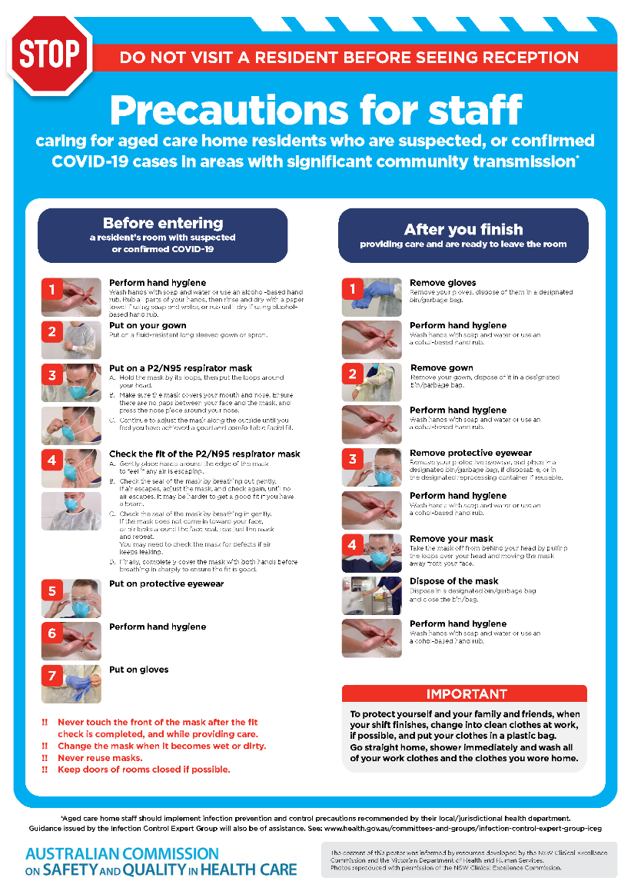](https://www.safetyandquality.gov.au/publications-and-resources/resource-library/covid-19-aged-care-staff-infection-prevention-and-control-precautions-poster)
* ***Environmental Cleaning and Infection Prevention and Control*** [www.safetyandquality.gov.au/environmental-cleaning](http://www.safetyandquality.gov.au/environmental-cleaning)
* ***Infection prevention and control Covid-19 PPE*** poster <https://www.safetyandquality.gov.au/publications-and-resources/resource-library/infection-prevention-and-control-covid-19-personal-protective-equipment>
* ***Special precautions for Covid-19 designated zones*** poster <https://www.safetyandquality.gov.au/publications-and-resources/resource-library/special-precautions-covid-19-designated-zones>
* ***COVID-19 infection prevention and control risk management – Guidance*** <https://www.safetyandquality.gov.au/publications-and-resources/resource-library/covid-19-infection-prevention-and-control-risk-management-guidance>
* ***Safe care for people with cognitive impairment during COVID-19***<https://www.safetyandquality.gov.au/our-work/cognitive-impairment/cognitive-impairment-and-covid-19>
* **Medicines Management COVID-19** <https://www.safetyandquality.gov.au/our-work/medication-safety/medicines-management-covid-19>, including position statements on medicine-related issues
  + ***Managing fever associated with COVID-19***
  + ***Managing a sore throat associated with COVID-19***
  + ***ACE inhibitors and ARBs in COVID-19***
  + ***Clozapine in COVID-19***
  + ***Management of patients on oral anticoagulants during COVID-19***
  + ***Ascorbic Acid: Intravenous high dose in COVID-19***
  + ***Treatment in acute care, including oxygen therapy and medicines to support intubation***
  + ***Nebulisation and COVID-19***
  + ***Managing intranasal administration of medicines during COVID-19***
  + ***Ongoing medicines management in high-risk patients***
  + ***Medicines shortages***
  + ***Conserving medicines***
  + ***Intravenous medicines administration in the event of an infusion pump shortage***
* ***Stop COVID-19: Break the chain of infection*** poster<https://www.safetyandquality.gov.au/publications-and-resources/resource-library/break-chain-poster-a3>  
    
  **[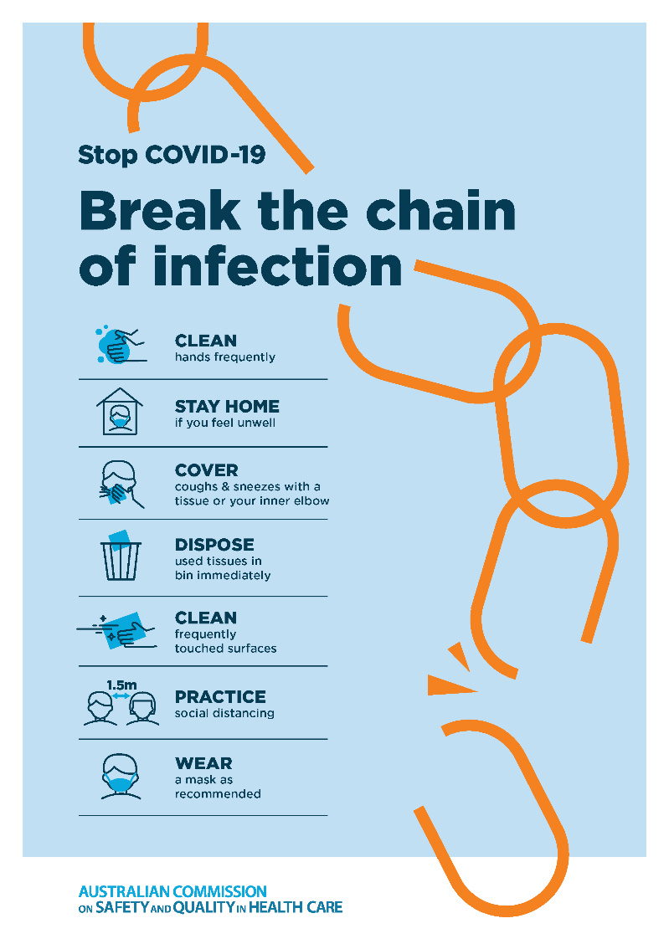](https://www.safetyandquality.gov.au/publications-and-resources/resource-library/break-chain-poster-a3https:/www.safetyandquality.gov.au/publications-and-resources/resource-library/break-chain-poster-a3)**
* ***COVID-19: Elective surgery and infection prevention and control precautions*** <https://www.safetyandquality.gov.au/publications-and-resources/resource-library/covid-19-elective-surgery-and-infection-prevention-and-control-precautions>
* ***FAQs for clinicians on elective surgery*** <https://www.safetyandquality.gov.au/node/5724>
* ***FAQs for consumers on elective surgery*** <https://www.safetyandquality.gov.au/node/5725>
* ***FAQs on community use of face masks***   
   <https://www.safetyandquality.gov.au/faqs-community-use-face-masks>
* ***COVID-19 and face masks – Information for consumers*** <https://www.safetyandquality.gov.au/publications-and-resources/resource-library/covid-19-and-face-masks-information-consumers>  
  The Commission’s fact sheet on use of face masks in the community to reduce the spread of COVID-19 is now available in Easy English and 10 other community languages from <https://www.safetyandquality.gov.au/wearing-face-masks-community>.  
  The factsheet was developed to help people understand when it is important to wear a mask to reduce the risk of the spread of COVID-19, and to explain how to safely put on and remove face masks. It also reinforces the importance of staying home if you have symptoms, physical distancing, hand hygiene and cough etiquette.

[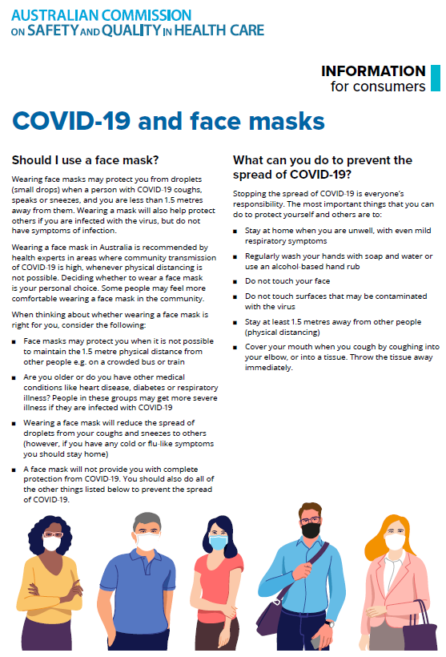](https://www.safetyandquality.gov.au/sites/default/files/2020-07/covid-19_and_face_masks_-_information_for_consumers.pdf)

*National COVID-19 Clinical Evidence Taskforce*

<https://covid19evidence.net.au/>

The National COVID-19 Clinical Evidence Taskforce is a collaboration of peak health professional bodies across Australia whose members are providing clinical care to people with COVID-19. The taskforce is undertaking continuous evidence surveillance to identify and rapidly synthesise emerging research in order to provide national, **evidence-based guidelines and clinical flowcharts for the clinical care of people with COVID-19**. The guidelines address questions that are specific to managing COVID-19 and cover the full disease course across mild, moderate, severe and critical illness. These are ‘living’ guidelines, updated with new research in near real-time in order to give reliable, up-to-the minute advice to clinicians providing frontline care in this unprecedented global health crisis.

*COVID-19 Critical Intelligence Unit*

<https://www.aci.health.nsw.gov.au/covid-19/critical-intelligence-unit>

The Agency for Clinical Innovation (ACI) in New South Wales has developed this page summarising rapid, evidence-based advice during the COVID-19 pandemic. Its operations focus on systems intelligence, clinical intelligence and evidence integration. The content includes a daily evidence digest and evidence checks on a discrete topic or question relating to the current COVID-19 pandemic. There is also a ‘Living evidence’ section summarising key studies and emerging evidence on **COVID-19 vaccines** and **SARS-CoV-2 variants**.

**Disclaimer**

On the Radar is an information resource of the Australian Commission on Safety and Quality in Health Care. The Commission is not responsible for the content of, nor does it endorse, any articles or sites listed. The Commission accepts no liability for the information or advice provided by these external links. Links are provided on the basis that users make their own decisions about the accuracy, currency and reliability of the information contained therein. Any opinions expressed are not necessarily those of the Australian Commission on Safety and Quality in Health Care.