# Australian Commission on Safety and Quality in Health Care logo with Radar imageOn the Radar

Issue 514

7 June 2021

*On the Radar* is a summary of some of the recent publications in the areas of safety and quality in health care. Inclusion in this document is not an endorsement or recommendation of any publication or provider. Access to particular documents may depend on whether they are Open Access or not, and/or your individual or institutional access to subscription sites/services. Material that may require subscription is included as it is considered relevant.

*On the Radar* is available online, via email or as a PDF or Word document from <https://www.safetyandquality.gov.au/publications-and-resources/newsletters/radar>

If you would like to receive *On the Radar* via email, you can subscribe on our website <https://www.safetyandquality.gov.au/publications-and-resources/newsletters>   
or by emailing us at H[Umail@safetyandquality.gov.auU](mailto:mail@safetyandquality.gov.au).   
You can also send feedback and comments to H[Umail@safetyandquality.gov.auU](mailto:mail@safetyandquality.gov.au).

For information about the Commission and its programs and publications, please visit <https://www.safetyandquality.gov.au>

You can also follow us on Twitter @ACSQHC.

**On the Radar**

Editor: Dr Niall Johnson [niall.johnson@safetyandquality.gov.au](mailto:niall.johnson@safetyandquality.gov.au)

Contributors: Niall Johnson, Dr Rashin Namivandi-Zangeneh

**Review of trigger tools to support the early identification of sepsis in healthcare settings**

Australian Commission on Safety and Quality in Health Care

Sydney: ACSQHC; 2021.

<https://www.safetyandquality.gov.au/publications-and-resources/resource-library/review-trigger-tools-support-early-identification-sepsis-healthcare-settings>

The Australian Commission on Safety and Quality in Health Care has published a review of trigger tools to support the early identification of sepsis in healthcare settings.

The [George Institute for Global Health](https://www.georgeinstitute.org/) undertook a review of the literature to investigate trigger tools that promote the early detection of sepsis symptoms, including the use of lactate testing in patients experiencing rapid clinical deterioration or suspected of having infection. The main findings from this systematic review include:

* Sufficient evidence to support use of the quick Sequential Organ Failure Assessment (qSOFA) scoring system with the addition of rapid lactate measurement (LqSOFA).
* The National Early Warning Score (NEWS) or Modified Early Warning (MEWS) scoring systems offer slightly improved sensitivity to identify deteriorating patients, but may not offer any advantage over LqSOFA (with which they have not been directly compared).
* Further research is required to identify the best tools for use in neonatal and maternal populations.
* An automated alert system embedded within electronic health records (EHR) is likely to be a viable alternative to identify patients deteriorating from sepsis in the acute care setting in the near future.

**Journal articles**

*Effects of nurse-to-patient ratio legislation on nurse staffing and patient mortality, readmissions, and length of stay: a prospective study in a panel of hospitals*

McHugh MD, Aiken LH, Sloane DM, Windsor C, Douglas C, Yates P

The Lancet. 2021;397(10288):1905-1913.

|  |  |
| --- | --- |
| DOI | <https://doi.org/10.1016/S0140-6736(21)00768-6> |
| Notes | The role of nursing in the quality and safety of care is known to be important. However, the issue of staffing levels has been much debated. This paper examines the experience in Queensland where 27 hospitals implemented new minimum nurse staffing ratios. When compared with 28 comparison hospitals that did not implement these minimum ratios, length of stay (LOS), mortality, and readmission rates were significantly lower in the intervention hospitals. The study ‘included 231 902 patients (142 986 in intervention hospitals and 88 916 in comparison hospitals) assessed at baseline (2016) and 257 253 patients (160 167 in intervention hospitals and 97 086 in comparison hospitals) assessed in the post-implementation period (2018).’ The study’s findings included:   * After implementation, **mortality rates** were not significantly higher than at baseline in comparison hospitals (adjusted odds ratio [OR] 1·07, 95% CI 0·97–1·17, p=0·18), but were **significantly lower** than at baseline **in intervention hospitals** (0·89, 0·84–0·95, p=0·0003). * From baseline to post-implementation, **readmissions increased in comparison [non-intervention] hospitals** (1·06, 1·01–1·12, p=0·015), but not in intervention hospitals (1·00, 0·95–1·04, p=0·92). * **LOS** decreased in both groups post-implementation, the **reduction was more pronounced in intervention hospitals** than in comparison hospitals (adjusted incident rate ratio [IRR] 0·95, 95% CI 0·92–0·99, p=0·010). * Staffing changed in hospitals from baseline to post-implementation: of the 36 hospitals with reliable staffing measures, 30 (83%) had more than 4·5 patients per nurse at baseline, with the number decreasing to 21 (58%) post-implementation. The majority of change was at intervention hospitals, and **staffing improvements by one patient per nurse produced reductions in mortality** (OR 0·93, 95% CI 0·86–0·99, p=0·045), **readmissions** (0·93, 0·89–0·97, p<0·0001), and **LOS** (IRR 0·97, 0·94–0·99, p=0·035). * The costs avoided due to fewer readmissions and shorter LOS were more than twice the cost of the additional nurse staffing. |

*Interprofessional and Intraprofessional Communication about Older People’s Medications across Transitions of Care*

Manias E, Bucknall T, Woodward-Kron R, Hughes C, Jorm C, Ozavci G, et al.

International Journal of Environmental Research and Public Health. 2021;18(8).

|  |  |
| --- | --- |
| DOI | <https://doi.org/10.3390/ijerph18083925> |
| Notes | This papers reports on an ethnographic approach to examining how interprofessional and intraprofessional communication occurs in managing older patients’ medications across transitions of care in acute and geriatric rehabilitation settings. This encounters a number of known issues about communication about polypharmacy and communication across transitions of care (or handovers). The study was undertaken at two sites in Melbourne, Australia: an acute tertiary referral hospital and a geriatric rehabilitation facility. The authors report that communication was influenced by the transferring setting, receiving setting, and ‘real-time’ communication. They also observed:   * Three themes reflected these clinical contexts: dissemination of medication information, safe continuation of medications and barriers to collaborative communication. * In transferring settings, nurses and pharmacists anticipated communication breakdowns and initiated additional communication activities to ensure safe information transfer. * In receiving settings, all health professionals contributed to facilitating safe continuation of medications. * Although health professionals of different disciplines sometimes communicated with each other, communication mostly occurred between health professionals of the same discipline. * Lack of communication with pharmacists occurred despite all health professionals acknowledging their important role. * Greater levels of proactive preparation by health professionals prior to transfers would reduce opportunities for errors relating to continuation of medications. |

*Medication-Related Hospital Readmissions Within 30 Days of Discharge: Prevalence, Preventability, Type of Medication Errors and Risk Factors*

Uitvlugt EB, Janssen MJA, Siegert CEH, Kneepkens EL, van den Bemt BJF, van den Bemt PML, et al

Frontiers in Pharmacology. 2021;12:381.

|  |  |
| --- | --- |
| DOI | <https://doi.org/10.3389/fphar.2021.567424> |
| Notes | This article reports of a study of hospital readmissions that sought to understand the prevalence and preventability of medication-related readmissions within 30 days after hospital discharge. The study also sought to describe the risk factors, type of medication errors and types of medication involved in these preventable readmissions.  The study examined 1,111 **readmissions** at a single hospital in the Netherlands and found that ‘181 (**16%)** were **medication-related**, of which 72 (**40%**) were **potentially preventable.**’ Further, ‘Of these preventable readmissions, 35% were due to prescribing errors, 35% by non-adherence and 30% by transition errors. Medications most frequently involved were diuretics and antidiabetics.’ |

For information on the Commission’s work on medication safety, see <https://www.safetyandquality.gov.au/our-work/medication-safety>

*Developing and user testing new pharmacy label formats—A study to inform labelling standards*

Tong V, Aslani P, Raynor DK, Shipp D, Parkinson B, Lalor D, et al

Health Expectations. 2021 [epub].

|  |  |
| --- | --- |
| DOI | <https://doi.org/10.1111/hex.13203> |
| Notes | Paper reporting on the investigation and development of medication labels that consumers should find more useful and understandable. The project involved multiple stages of developing, testing, revision and developing recommendations. The recommendations are to inform the development of updated standards for pharmacy medication labels to support safe and appropriate medicines use. |

*An electronic decision support-based complex intervention to improve management of cardiovascular risk in primary health care: a cluster randomised trial (INTEGRATE)*

Webster R, Usherwood T, Joshi R, Saini B, Armour C, Critchley S, et al

Medical Journal of Australia. 2021;214(9):420-427.

*Improving the management of cardiovascular disease risk in primary care*

Nelson MR

Medical Journal of Australia. 2021;214(9):415-416.

|  |  |
| --- | --- |
| DOI | Webster et al <https://doi.org/10.5694/mja2.51030>  Nelson <https://doi.org/10.5694/mja2.51028> |
| Notes | Paper reporting on a study that sought to determine whether a multifaceted primary health care intervention better controlled cardiovascular disease (CVD) risk factors in patients with high risk of CVD than usual care. The intervention combined an electronic point-of-care decision support for general practices, combination cardiovascular medications (polypills) and a pharmacy-based medication adherence program. The study was conducted as a parallel arm, cluster randomised trial in 71 Australian general practices in the period 5 December 2016 to 13 September 2019. It had been shown that each of the elements of the intervention is effective, but this combined intervention failed to have broad implementation and did not improve CVD risk management in the participating general practices. Bringing about change and the translation of knowledge/research to practice are challenging and take time. The authors recognised this in noting ‘Implementing complex quality improvement initiatives is difficult. Process evaluation will provide further information about factors that hindered more widespread adoption of the intervention.’ An accompanying editorial (<https://doi.org/10.5694/mja2.51028>) explores some of the barriers to implementation. |

*SEIPS 101 and seven simple SEIPS tools*

Holden RJ, Carayon P

BMJ Quality & Safety. 2021 [epub].

|  |  |
| --- | --- |
| DOI | <http://dx.doi.org/10.1136/bmjqs-2020-012538> |
| Notes | Narrative review providing an introduction to Systems Engineering Initiative for Patient Safety (SEIPS), a simplified, practice-oriented SEIPS model (SEIPS101) meant for easy use by practitioners, researchers and others, along with seven simple SEIPS tools. |

*Australian Health Review*

Volume 45, Number 3, June 2021

|  |  |
| --- | --- |
| URL | <https://www.publish.csiro.au/ah/issue/10149> |
| Notes | A new issue of *Australian Health Review* has been published. Articles in this issue of *Australian Health Review* include:   * Developing economic measures for **Aboriginal and Torres Strait Islander families on out-of-pocket healthcare expenditure** (Courtney Ryder, Tamara Mackean, Julieann Coombes, Kate Hunter, Shahid Ullad, Kris Rogers, Beverley Essue, Andrew J A Holland and Rebecca Ivers) * Inequalities in the utilisation of the **Child Dental Benefits Schedule** between Aboriginal and non-Aboriginal children (Neil Orr, Kylie Gwynne, Woosung Sohn and John Skinner) * What are the health and socioeconomic **impacts of allergic respiratory disease** in Tasmania? (Nicolas Borchers-Arriagada, Penelope J Jones, Andrew J Palmer, Bonnie Bereznicki, Nick Cooling, Janet M Davies and F H Johnston) * Issues for **reregulation of private hospital insurance** in Australia (Cale Dobrosak and Paul Dugdale) * **Psychological well-being of Australian hospital clinical staff during the COVID-19 pandemic** (Sara Holton, Karen Wynter, Melody Trueman, Suellen Bruce, Susan Sweeney, Shane Crowe, Adrian Dabscheck, Paul Eleftheriou, Sarah Booth, Danielle Hitch, Catherine M Said, K J Haines and B Rasmussen) * Value of **clinical engagement in the NSW Health response to COVID-19** (Nigel Lyons, Cathryn Cox and Vanessa Clements) * Is **Australia’s clinician scientist capacity** appropriate for addressing the next pandemic? (Diann S Eley, Shaun P O'Leary, A Young and P Buttrum) * **Virtual models of chronic disease management**: lessons from the experiences of virtual care during the COVID-19 response (Rachael Smithson, Elisha Roche and Christina Wicker) * Systematic review and content analysis of **Australian health care substitute decision making online resources** (Julien Tran, Marcus Sellars, Linda Nolte, Ben P White, Craig Sinclair, Deirdre Fetherstonhaugh and Karen Detering) * Using machine learning to predict **paediatric 30-day unplanned hospital readmissions**: a case-control retrospective analysis of medical records, including written discharge documentation (Huaqiong Zhou, Matthew A Albrecht, Pamela A Roberts, Paul Porter and Philip R Della) * Identification, management and care of **refugee patients at a metropolitan public health service**: a healthcare worker perspective (Anna Novak, Danielle Hitch, Lyn Bongiovanni and Angela Mucic) * Allied health primary contact services: results of a 2-year follow-up study of clinical effectiveness, safety, wait times and impact on **medical specialist out-patient waitlists** (Michelle Stute, Nicole Moretto, Rebecca Waters, Maree Raymer, Sonia Sam, Marita Bhagwat, M Banks, T Comans and P Buttrum) * Developing and piloting an adaptable oxycodone quality improvement strategy: steps towards **opioid stewardship** (Champika Pattullo, Benita Suckling, Sally Taylor, Jonathan Thomson, G Collins, L Hall and P Donovan) * Incidence of **lower limb amputation in Central Australia** (Laura Stuart, Lara Kimmel and Andrew Jolly) * Leading health reform: a critical review of **‘leadership’ within allied health competency standards** (Lisa Dalton, Kerryn Butler-Henderson, Toby Newstead and Wendy Quinn) * **Queensland Rural Generalist Pathway**: why do trainees separate without achieving a Rural Generalist end point? (S Kitchener, J Douyere and D Bond) * Substitution, delegation or addition? Implications of workforce skill mix on **efficiency and interruptions in computed tomography** (Andrew K Cartwright, Tilley Pain and David J Heslop) * **Research governance authorisation**: the next frontier (Samantha Hollingworth, Dan Mckavanagh, Ian McPherson, Euan Walpole and S-Y Yu) * Building trust and transparency: **health consumer organisation–pharmaceutical industry relationships** (Lisa Parker, A Brown and L Wells) |

*BMJ Quality & Safety* online first articles

|  |  |
| --- | --- |
| URL | <https://qualitysafety.bmj.com/content/early/recent> |
| Notes | *BMJ Quality &Safety* has published a number of ‘online first’ articles, including:   * Editorial: **Diagnostic errors and harms in primary care**: insights to action (Greg Rubin, Ashley Meyer) * Editorial: Support to scale **antibiotic stewardship in long-term care homes**: how much is enough? (Julia Szymczak, Barbara Trautner) |

*International Journal for Quality in Health Care* online first articles

|  |  |
| --- | --- |
| URL | <https://academic.oup.com/intqhc/advance-articles> |
| Notes | *International Journal for Quality in Health Care* has published a number of ‘online first’ articles, including:   * Impact of the Early Phase of the **COVID Pandemic on Cancer Treatment Delivery** and the Quality of Cancer Care: A Scoping Review and Conceptual Model (Melanie Powis, Carissa Milley-Daigle, Saidah Hack, Shabbir Alibhai, Simron Singh, Monika K Krzyzanowska) * Outcomes of a **Multicomponent Safe Surgery Intervention** in Tanzania’s Lake Zone: A Prospective, Longitudinal Study (Shehnaz Alidina, Gopal Menon, Steven J Staffa, Ian Nason, Taylor Wurdeman, et al.) |

**Online resources**

*[UK] NIHR Evidence alert*

<https://evidence.nihr.ac.uk/>alerts/

The UK’s National Institute for Health Research (NIHR) has posted new evidence alerts on its site. Evidence alerts are short, accessible summaries of health and care research which is funded or supported by NIHR. This is research which could influence practice and each Alert has a message for people commissioning, providing or receiving care. The latest alerts include:

* Better access to healthcare for Gypsy, Roma and Traveller communities is key to increasing **vaccination rates**
* **Preventing childhood obesity** requires a shift in focus away from individual behaviours towards the wider environment
* Nine in ten **shoulder replacements** last more than 10 years, with enduring improvements in pain, mobility and function
* Three effective treatments for **frozen shoulder** have different costs and benefits
* People who are active on the day of **hip surgery**, or the day after, are twice as likely to be home within a month.

**COVID-19 resources**

https://www.safetyandquality.gov.au/covid-19

The Australian Commission on Safety and Quality in Health Care has developed a number of resources to assist healthcare organisations, facilities and clinicians. These and other material on COVID-19 are available at <https://www.safetyandquality.gov.au/covid-19>

These resource include:

* ***COVID-19: Aged care staff infection prevention and control precautions*** *poster*<https://www.safetyandquality.gov.au/publications-and-resources/resource-library/covid-19-aged-care-staff-infection-prevention-and-control-precautions-poster>  
    
  [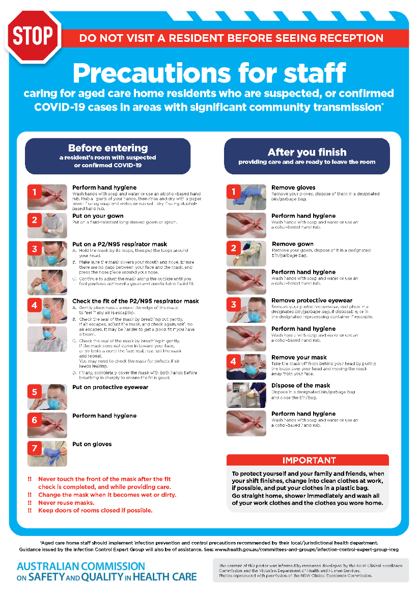](https://www.safetyandquality.gov.au/publications-and-resources/resource-library/covid-19-aged-care-staff-infection-prevention-and-control-precautions-poster)
* ***Environmental Cleaning and Infection Prevention and Control*** [www.safetyandquality.gov.au/environmental-cleaning](http://www.safetyandquality.gov.au/environmental-cleaning)
* ***Infection prevention and control Covid-19 PPE*** poster <https://www.safetyandquality.gov.au/publications-and-resources/resource-library/infection-prevention-and-control-covid-19-personal-protective-equipment>
* ***Special precautions for Covid-19 designated zones*** poster <https://www.safetyandquality.gov.au/publications-and-resources/resource-library/special-precautions-covid-19-designated-zones>
* ***COVID-19 infection prevention and control risk management – Guidance*** <https://www.safetyandquality.gov.au/publications-and-resources/resource-library/covid-19-infection-prevention-and-control-risk-management-guidance>
* ***Safe care for people with cognitive impairment during COVID-19***<https://www.safetyandquality.gov.au/our-work/cognitive-impairment/cognitive-impairment-and-covid-19>
* **Medicines Management COVID-19** <https://www.safetyandquality.gov.au/our-work/medication-safety/medicines-management-covid-19>, including position statements on medicine-related issues
  + ***Managing fever associated with COVID-19***
  + ***Managing a sore throat associated with COVID-19***
  + ***ACE inhibitors and ARBs in COVID-19***
  + ***Clozapine in COVID-19***
  + ***Management of patients on oral anticoagulants during COVID-19***
  + ***Ascorbic Acid: Intravenous high dose in COVID-19***
  + ***Treatment in acute care, including oxygen therapy and medicines to support intubation***
  + ***Nebulisation and COVID-19***
  + ***Managing intranasal administration of medicines during COVID-19***
  + ***Ongoing medicines management in high-risk patients***
  + ***Medicines shortages***
  + ***Conserving medicines***
  + ***Intravenous medicines administration in the event of an infusion pump shortage***
* ***Stop COVID-19: Break the chain of infection*** poster<https://www.safetyandquality.gov.au/publications-and-resources/resource-library/break-chain-poster-a3>  
    
  **[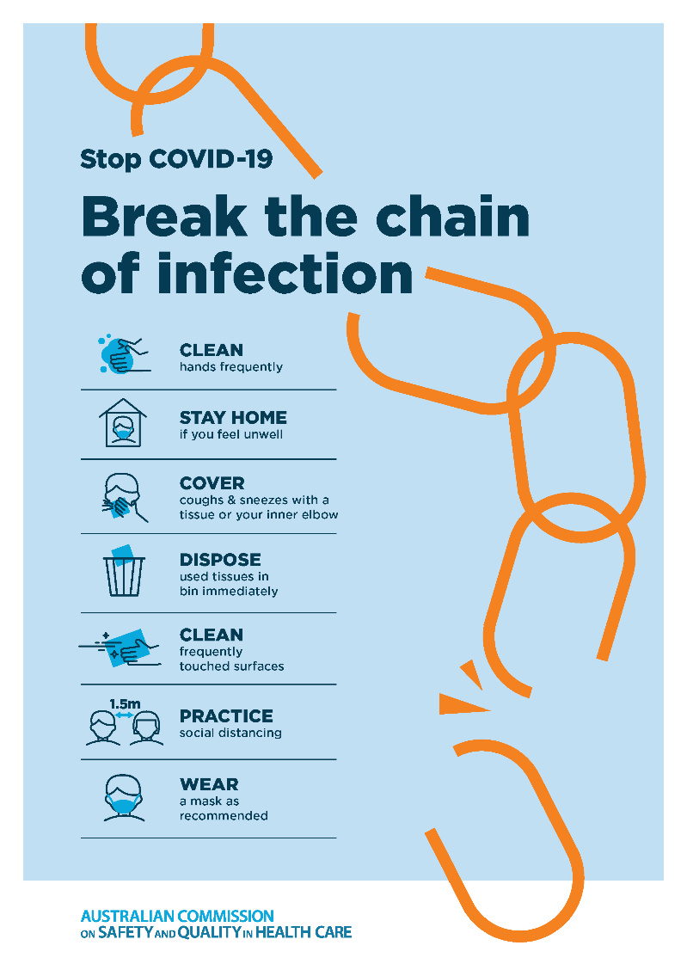](https://www.safetyandquality.gov.au/publications-and-resources/resource-library/break-chain-poster-a3https:/www.safetyandquality.gov.au/publications-and-resources/resource-library/break-chain-poster-a3)**
* ***COVID-19: Elective surgery and infection prevention and control precautions*** <https://www.safetyandquality.gov.au/publications-and-resources/resource-library/covid-19-elective-surgery-and-infection-prevention-and-control-precautions>
* ***FAQs for clinicians on elective surgery*** <https://www.safetyandquality.gov.au/node/5724>
* ***FAQs for consumers on elective surgery*** <https://www.safetyandquality.gov.au/node/5725>
* ***FAQs on community use of face masks***   
   <https://www.safetyandquality.gov.au/faqs-community-use-face-masks>
* ***COVID-19 and face masks – Information for consumers*** <https://www.safetyandquality.gov.au/publications-and-resources/resource-library/covid-19-and-face-masks-information-consumers>  
  The Commission’s fact sheet on use of face masks in the community to reduce the spread of COVID-19 is now available in Easy English and 10 other community languages from <https://www.safetyandquality.gov.au/wearing-face-masks-community>.  
  The factsheet was developed to help people understand when it is important to wear a mask to reduce the risk of the spread of COVID-19, and to explain how to safely put on and remove face masks. It also reinforces the importance of staying home if you have symptoms, physical distancing, hand hygiene and cough etiquette.

[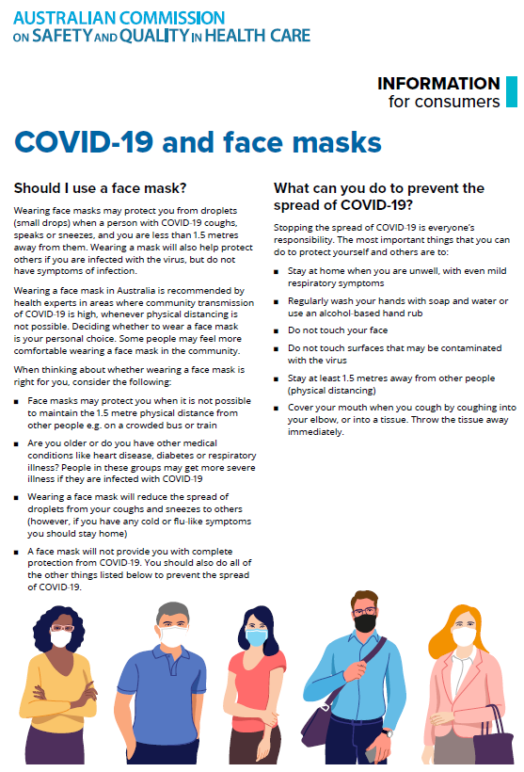](https://www.safetyandquality.gov.au/sites/default/files/2020-07/covid-19_and_face_masks_-_information_for_consumers.pdf)

*National COVID-19 Clinical Evidence Taskforce*

<https://covid19evidence.net.au/>

The National COVID-19 Clinical Evidence Taskforce is a collaboration of peak health professional bodies across Australia whose members are providing clinical care to people with COVID-19. The taskforce is undertaking continuous evidence surveillance to identify and rapidly synthesise emerging research in order to provide national, **evidence-based guidelines and clinical flowcharts for the clinical care of people with COVID-19**. The guidelines address questions that are specific to managing COVID-19 and cover the full disease course across mild, moderate, severe and critical illness. These are ‘living’ guidelines, updated with new research in near real-time in order to give reliable, up-to-the minute advice to clinicians providing frontline care in this unprecedented global health crisis.

*COVID-19 Critical Intelligence Unit*

<https://www.aci.health.nsw.gov.au/covid-19/critical-intelligence-unit>

The Agency for Clinical Innovation (ACI) in New South Wales has developed this page summarising rapid, evidence-based advice during the COVID-19 pandemic. Its operations focus on systems intelligence, clinical intelligence and evidence integration. The content includes a daily evidence digest and evidence checks on a discrete topic or question relating to the current COVID-19 pandemic. There is also a ‘Living evidence’ section summarising key studies and emerging evidence on **COVID-19 vaccines** and **SARS-CoV-2 variants**.

**Disclaimer**

On the Radar is an information resource of the Australian Commission on Safety and Quality in Health Care. The Commission is not responsible for the content of, nor does it endorse, any articles or sites listed. The Commission accepts no liability for the information or advice provided by these external links. Links are provided on the basis that users make their own decisions about the accuracy, currency and reliability of the information contained therein. Any opinions expressed are not necessarily those of the Australian Commission on Safety and Quality in Health Care.