# Australian Commission on Safety and Quality in Health Care logo with Radar imageOn the Radar

Issue 517

28 June 2021

*On the Radar* is a summary of some of the recent publications in the areas of safety and quality in health care. Inclusion in this document is not an endorsement or recommendation of any publication or provider. Access to particular documents may depend on whether they are Open Access or not, and/or your individual or institutional access to subscription sites/services. Material that may require subscription is included as it is considered relevant.

*On the Radar* is available online, via email or as a PDF or Word document from <https://www.safetyandquality.gov.au/publications-and-resources/newsletters/radar>

If you would like to receive *On the Radar* via email, you can subscribe on our website <https://www.safetyandquality.gov.au/publications-and-resources/newsletters>  
or by emailing us at H[Umail@safetyandquality.gov.auU](mailto:mail@safetyandquality.gov.au).   
You can also send feedback and comments to H[Umail@safetyandquality.gov.auU](mailto:mail@safetyandquality.gov.au).

For information about the Commission and its programs and publications, please visit <https://www.safetyandquality.gov.au>

You can also follow us on Twitter @ACSQHC.

**On the Radar**

Editor: Dr Niall Johnson [niall.johnson@safetyandquality.gov.au](mailto:niall.johnson@safetyandquality.gov.au)

Contributors: Niall Johnson, Jennifer Caldwell

**Environmental cleaning**

[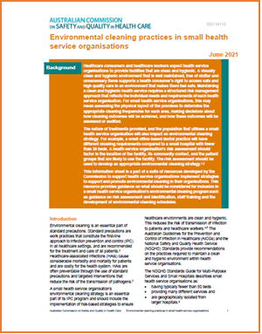https://www.safetyandquality.gov.au/our-work/infection-prevention-and-control/environmental-cleaning-and-infection-prevention-and-control](https://www.safetyandquality.gov.au/our-work/infection-prevention-and-control/environmental-cleaning-and-infection-prevention-and-control)

The Australian Commission on Safety and Quality in Health Care has produced a suite of environmental cleaning resources to support health service organisations in their infection prevention and control activities, particularly during COVID-19. Two new resources have been added to the existing suite of environmental cleaning resources.

* ***Environmental cleaning principles for small health organisations*** has been developed to support the unique needs of small health service organisations to develop environmental cleaning programs. The target audience for this resource includes small health service organisation, such as, but not limited to rural and remote settings, aged care facilities, general medical and dental practices, outpatient or day only procedural services and rehabilitation services.
* [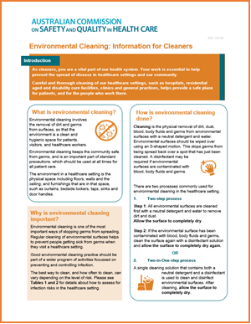](https://www.safetyandquality.gov.au/our-work/infection-prevention-and-control/environmental-cleaning-and-infection-prevention-and-control)***Environmental cleaning: Information for cleaners*** was developed to highlight the importance of cleaners in health service organisations and provide cleaning staff with basic information on the principles of environmental cleaning in health service facilities. The target audience is cleaning staff in all health service organisations, aged care and disability services, clinics and general medical and dental practice.

These resources support the recommendations for environmental cleaning from the National Safety and Quality Health Services standards and the implementation of the environmental cleaning requirements of the *Australian Guidelines for the Prevention and Control of Infection in Healthcare*.

**Reports**

*Towards a sustainable funding model for telehealth in Australia*

Deeble Institute Issues Brief No. 43

Tran M, Haddock R

Canberra: Australian Healthcare and Hospitals Association; 2021. p. 45.

|  |  |
| --- | --- |
| URL | <https://ahha.asn.au/publication/health-policy-issue-briefs/deeble-issues-brief-no-43-towards-sustainable-funding-model> |
| Notes | The COVID-19 pandemic saw the rapid expansion of the use of telehealth. This issues brief from the Australian Healthcare and Hospitals Association’s Deeble Institute examines the implications of telehealth, particularly the costs for Australia’s health system. The brief has a number of recommendations aimed at ensuring the quality and value of care delivered by telehealth. The recommendations include:   1. Blend payment methods for telehealth such as bundled payments and add-on payments to improve efficiency and reduce unnecessary costs 2. Reviewing MBS telehealth items and re-directing funding towards high value services to reduce unwarranted variation 3. Monitoring and evaluating the impacts of telehealth services on secondary care 4. Establish a primary care dataset, linkable to hospital and aged care data to support evidence-based funding reforms 5. Develop national telehealth standards to promote safe and high quality care. |

*Whole System Quality: A Unified Approach to Building Responsive, Resilient Health Care Systems*

IHI White Paper

Sampath B, Rakover J, Baldoza K, Mate KS, Lenoci-Edwards J, Barker P

Boston: Institute for Healthcare Improvement; 2021. p. 54.

|  |  |
| --- | --- |
| URL | <http://www.ihi.org/resources/Pages/IHIWhitePapers/whole-system-quality.aspx> |
| Notes | The Institute for Healthcare Improvement in the USA has released this white paper proposing ‘a more holistic approach to quality management — whole system quality’ — to enable health organisations to ‘close the gap between the quality that customers are currently receiving and the quality that they could be receiving by integrating quality planning, quality control, and quality improvement activities across multiple levels of the system.’  According to the IHI, ‘Whole system quality requires leadership principles and practices that foster a culture of learning to reliably and sustainably meet the evolving needs of patients, populations, and communities. The paper details how these leadership principles and management practices can enable health systems to pursue quality — with ambition, alignment, and agility — through a commitment to learning.’  The white paper includes the following:   * Definitions for whole system quality and the leadership principles required to support this approach * A description of how whole system quality links to customer needs, organizational vision, and quality strategy * Detailed descriptions of three interrelated components — quality planning, quality improvement, and quality control — that inform a more holistic whole system quality approach * A proposed set of simultaneous activities that health care organizations can undertake to build a foundation for the transition to whole system quality’   [Figure 4.  Journey to Whole System Quality. From IHI report "Whole System Quality"](http://www.ihi.org/resources/Pages/IHIWhitePapers/whole-system-quality.aspx) |

**Journal articles**

*How to sustainably build capacity in quality improvement within a healthcare organisation: a deep-dive, focused qualitative analysis*

Hibbert PD, Basedow M, Braithwaite J, Wiles LK, Clay-Williams R, Padbury R

BMC Health Services Research. 2021;21(1):588.

|  |  |
| --- | --- |
| DOI | <https://doi.org/10.1186/s12913-021-06598-8> |
| Notes | Identifying and implementing change and quality improvement can be challenging. Even more challenging is making such efforts sustainable. This Australian study examined the efforts and experience in one local health network, the Southern Adelaide Local Health Network (SALHN), in order ‘to explore the factors that lead to successful implementation of a program of quality improvement projects and a capacity and capability building program that facilitates or support these.’ The researchers ‘found four interacting components that lead to successful implementation of quality improvement projects and the overall program that facilitates or support these’. The four components being:   1. an agreed and robust **quality improvement methodology** 2. a **skilled faculty** to assist improvement teams 3. active **involvement of leadership and management**, and 4. a deep understanding that **teams matter**.   The authors also observed that a pre-existing ‘strong safety culture is not necessarily a pre-requisite for quality improvement gains to be made; indeed, undertaking quality improvement activities can contribute to an **improved safety culture**.’ |

*Older patients’ engagement in hospital medication safety behaviours*

Tobiano G, Chaboyer W, Dornan G, Teasdale T, Manias E

Aging Clinical and Experimental Research. 2021.

|  |  |
| --- | --- |
| DOI | <https://doi.org/10.1007/s40520-021-01866-3> |
| Notes | Medication errors (broadly defined) are among the most common errors and a leading cause of hospitalisation. Older people tend to be taking more medications and this “polypharmacy” can contribute to errors. This study sought to   * examine older patients’ preferences for and reported medication safety behaviours * identify the relationship between preferred and reported medication safety behaviours * identify whether perceptions of medication safety behaviours differ between groups of young–old, middle–old and old–old patients (65–74 years, 75–84 years, and ≥ 85 years).   The study surveyed 200 patients at an Australian hospital. The authors concluded that ‘Older patients may prefer verbal medication safety behaviours like asking questions and notifying healthcare professionals of medication errors, over viewing medication charts and self-administering medications. The young-old group wanted to identify perceived medication errors more than other age groups. Older patients are willing to engage in medication safety behaviours, and healthcare professionals and organisations need to embrace this engagement in an effort to reduce medication harm.’ It may be argued that a more patient-centred approach may to engage individual patients about their preferences rather than make assumptions based on chronological age. |

For information on the Commission’s work on medication safety, see <https://www.safetyandquality.gov.au/our-work/medication-safety>

*Facilitators and barriers of care transitions - Comparing the perspectives of hospital and community healthcare staff*

Carman E-M, Fray M, Waterson P

Applied Ergonomics. 2021;93:103339.

|  |  |
| --- | --- |
| DOI | <https://doi.org/10.1016/j.apergo.2020.103339> |
| Notes | Transitions of care have long been recognised as being potentially risky, with an increased risk of communication errors. This paper reports on a British study that sought to ‘analyse the discharge process to identify and compare the barriers and facilitators within the context of the system in which they occur’. Based on the analysis of analysis of 348 incident reports, discharge planning meetings, focus groups with hospital staff and community healthcare staff, the authors found that:   * **Barriers** included **discharge tasks not being complete**, **missing or inaccurate information**, and **limited staff capacity** * **Facilitators** included **improved staff capacity** and **good communication between hospital staff, community healthcare staff, and family members**. |

For information on the Commission’s work on communicating for safety, including clinical handover, see <https://www.safetyandquality.gov.au/our-work/communicating-safety>

*External Validation of a Widely Implemented Proprietary Sepsis Prediction Model in Hospitalized Patients*

Wong A, Otles E, Donnelly JP, Krumm A, McCullough J, DeTroyer-Cooley O, et al

JAMA Internal Medicine. 2021 [epub].

*The Epic Sepsis Model Falls Short—The Importance of External Validation*

Habib AR, Lin AL, Grant RW

JAMA Internal Medicine. 2021.

*Algorithmic Bias Playbook*

Obermeyer Z, Nissan R, Stern M, Eaneff S, Bembeneck EJ, Mullainathan S

Chicago: Center for Applied AI at the University of Chicago Booth School of Business; 2021. p. 21.

|  |  |
| --- | --- |
| DOI | Wong et al <https://doi.org/10.1001/jamainternmed.2021.2626>  Habib et al <https://doi.org/10.1001/jamainternmed.2021.3333>  Obermeyer et al <https://www.chicagobooth.edu/-/media/project/chicago-booth/centers/caai/docs/algorithmic-bias-playbook-june-2021.pdf> |
| Notes | Wong et al evaluated the proprietary sepsis prediction model in use in many hospitals in the USA to determine its accuracy and to determine its potential clinical value compared to usual care. This was a retrospective cohort study conducted among 27,697 adult patients admitted to Michigan Medicine, the academic health system of the University of Michigan, Ann Arbor, with 38,455 hospitalisations between 6 December 2018, and 20 October 2019 of whom sepsis occurred in 2552 (7%). The study found that Epic Sepsis Model (ESM) ‘identified 183 of 2552 patients with sepsis (7%) who did not receive timely administration of antibiotics, highlighting the low sensitivity of the ESM in comparison with contemporary clinical practice. The ESM also did not identify 1709 patients with sepsis (67%) despite generating alerts for an ESM score of 6 or higher for 6971 of all 38 455 hospitalized patients (18%), thus creating a large burden of alert fatigue.’ The authors concluded that ‘the ESM has poor discrimination and calibration in predicting the onset of sepsis. The widespread adoption of the ESM despite its poor performance raises fundamental concerns about sepsis management on a national level.’  In a related editorial, Habib et al noted that the study ‘found that the ESM had a sensitivity of 33%, specificity of 83%, positive predictive value of 12%, and negative predictive value of 95%, with an area under the curve of 0.63 (95% CI, 0.62-0.64).’ They also observed that such models need to be better calibrated for the population served and suggest that ‘Keys to the effective use of prediction models are:   1. moving toward open-access models or enjoining proprietary model creators to provide end users with validation studies that detail original data that are used and variable selection, 2. having the appropriate staff to evaluate performance in each hospital’s own clinical setting, 3. developing well-considered workflows by collaborating closely with primary stakeholders and end users to focus on the optimal use strategy (eg, when is information presented, to whom, and how often?), 4. maintaining a culture of independent clinical thinking so that model results inform but do not supplant the clinician’s interpretation of the patient’s clinical presentation, and 5. designing a future-oriented governance strategy to iteratively recalibrate or retire models as they age beyond their initial validation.’   Somewhat related to this is the whole issue of bias in algorithms. Bias can come from the data that the algorithms ‘learn’ from or from the assumptions underlying the algorithm. In response to these, a group at the University of Chicago has developed a playbook for providers, funders and others to identify and eliminate bias in their tools. This ‘playbook’ explicitly includes bias in healthcare algorithms. |

*Variation in timely surgery for hip fracture by day and time of presentation: a nationwide prospective cohort study from the National Hip Fracture Database for England, Wales and Northern Ireland*

Shah A, Matharu GS, Inman D, Fagan E, Johansen A, Judge A

BMJ Quality & Safety. 2021;30(7):559-566.

|  |  |
| --- | --- |
| DOI | <http://dx.doi.org/10.1136/bmjqs-2020-011196> |
| Notes | For some years it has been considered that the door-to-surgery time is a marker of quality in the care of hip fracture patients. This population-based cohort study used 2017 data from the UK’s National Hip Fracture Database, which recorded all patients aged 60 years and over who presented with a hip fracture at a hospital in England, Wales and Northern Ireland. Using data covering 68,977 patients frim 177 hospitals, the study found both an “evening” and a “night” effect as:   * The average patient presenting during the day on Friday or Saturday was significantly less likely to undergo prompt surgery * Patients presenting during the evening (16:00–23:59) were consistently significantly less likely to undergo prompt surgery, and the effect was more marked on Fridays and Saturdays * Patients presenting overnight (00:00–07:59), except on Saturdays, were significantly more likely to undergo surgery within 36 hours. |

*BMJ Quality & Safety*

July 2021 - Volume 30 - 7

|  |  |
| --- | --- |
| URL | <https://qualitysafety.bmj.com/content/30/7> |
| Notes | A new issue of *BMJ Quality & Safety* has been published. Many of the papers in this issue have been referred to in previous editions of *On the Radar* (when they were released online). Articles in this issue of *BMJ Quality & Safety* include:   * Editorial: **Moving beyond the weekend effect**: how can we best target interventions to improve patient care? (Perla J Marang-van de Mheen, Charles Vincent) * Editorial: **National adverse event analysis** over time: current state and future directions (Emily L Aaronson, David W Bates) * Editorial: Assuring safety and efficacy of **nurse triage for electronic consultation** to improve access to specialty care (Elizabeth J Murphy, Delphine S Tuot) * Changes in **weekend and weekday care quality of emergency medical admissions** to 20 hospitals in England during implementation of the 7-day services national health policy (Julian Bion, Cassie Aldridge, Alan J Girling, Gavin Rudge, Jianxia Sun, Carolyn Tarrant, Elizabeth Sutton, Janet Willars, Chris Beet, Amunpreet Boyal, Peter Rees, Chris Roseveare, Mark Temple, Samuel Ian Watson, Yen-Fu Chen, Mike Clancy, Louise Rowan, Joanne Lord, Russell Mannion, Timothy Hofer, Richard Lilford) * The **Irish National Adverse Event Study-2 (INAES-2)**: longitudinal trends in adverse event rates in the Irish healthcare system (Warren Connolly, Natasha Rafter, Ronan M Conroy, Cornelia Stuart, Anne Hickey, David J Williams) * **Variation in timely surgery for hip fracture by day and time of presentation**: a nationwide prospective cohort study from the National Hip Fracture Database for England, Wales and Northern Ireland (Anjali Shah, Gulraj S Matharu, Dominic Inman, Elizabeth Fagan, Antony Johansen, Andrew Judge) * Retrospective analysis of reported **suicide deaths and attempts on veterans health administration** campuses and inpatient units (Peter D Mills, Christina Soncrant, William Gunnar) * Priorities to improve the **care for chronic conditions and multimorbidity**: a survey of patients and stakeholders nested within the ComPaRe e-cohort (Viet-Thi Tran, Elise Diard, Philippe Ravaud) * **Rethinking standardised infection rates and risk adjustment** in the COVID-19 era (Hojjat Salmasian, Jennifer Beloff, Andrew Resnick, Chanu Rhee, Meghan A Baker, Michael Klompas, Marc P Pimentel) * Bridging the feedback gap: a sociotechnical approach to **informing clinicians of patients’ subsequent clinical course and outcomes** (Christina L Cifra, Dean F Sittig, Hardeep Singh) * Nurse-led triage of new **sleep referrals** is associated with lower risk of potentially contraindicated sleep testing: a retrospective cohort study (Lucas M Donovan, Brian N Palen, Adnan Syed, Richard Blankenhorn, Kelly Blanchard, William J Feser, Kate Magid, Justina Gamache, Laura J Spece, Laura C Feemster, Laurie Fernandes, Susan Kirsh, David H Au) |

*BMJ Quality & Safety* online first articles

|  |  |
| --- | --- |
| URL | <https://qualitysafety.bmj.com/content/early/recent> |
| Notes | *BMJ Quality &Safety* has published a number of ‘online first’ articles, including:   * Editorial: Addressing disparities in **patients’ opportunities for and competencies in shared decision making** (Naomi Q P Tan, Robert J Volk) * **Quality of acute myocardial infarction care** in England and Wales during the COVID-19 pandemic: linked nationwide cohort study (Suleman Aktaa, Mohammad E Yadegarfar, Jianhua Wu, Muhammad Rashid, Mark de Belder, John Deanfield, Francois Schiele, Mark Minchin, Mamas Mamas, Chris P Gale) |

*International Journal for Quality in Health Care* online first articles

|  |  |
| --- | --- |
| URL | <https://academic.oup.com/intqhc/advance-articles> |
| Notes | *International Journal for Quality in Health Care* has published a number of ‘online first’ articles, including:   * **Understanding Complaints Made About Surgical Departments** in a UK District General Hospital (Oliver Claydon, Barrie Keeler, Achal Khanna) * The Cross-national Applicability of **Lean Implementation Measures and Hospital Performance Measures**: A Case Study of Finland and the United States (Elina Reponen, Thomas G Rundall, Stephen M Shortell, Janet C Blodgett, Ritva Jokela, Markku Mäkijärvi, Paulus Torkki) |

**Online resources**

*[UK] NICE Guidelines and Quality Standards*

<https://www.nice.org.uk/guidance>

The UK’s National Institute for Health and Care Excellence (NICE) has published new (or updated) guidelines and quality standards. The latest reviews or updates are:

* NICE Guideline NG198 ***Acne*** *vulgaris: management* <https://www.nice.org.uk/guidance/ng198>

*[USA] Effective Health Care Program reports*

<https://effectivehealthcare.ahrq.gov/>

The US Agency for Healthcare Research and Quality (AHRQ) has an Effective Health Care (EHC) Program. The EHC has released the following final reports and updates:

* *Living Systematic Review on Cannabis and Other Plant-Based Treatments for* ***Chronic Pain*** <https://effectivehealthcare.ahrq.gov/products/plant-based-chronic-pain-treatment/living-review>

**COVID-19 resources**

https://www.safetyandquality.gov.au/covid-19

The Australian Commission on Safety and Quality in Health Care has developed a number of resources to assist healthcare organisations, facilities and clinicians. These and other material on COVID-19 are available at <https://www.safetyandquality.gov.au/covid-19>

These resource include:

* ***COVID-19: Aged care staff infection prevention and control precautions*** *poster*<https://www.safetyandquality.gov.au/publications-and-resources/resource-library/covid-19-aged-care-staff-infection-prevention-and-control-precautions-poster>  
    
  [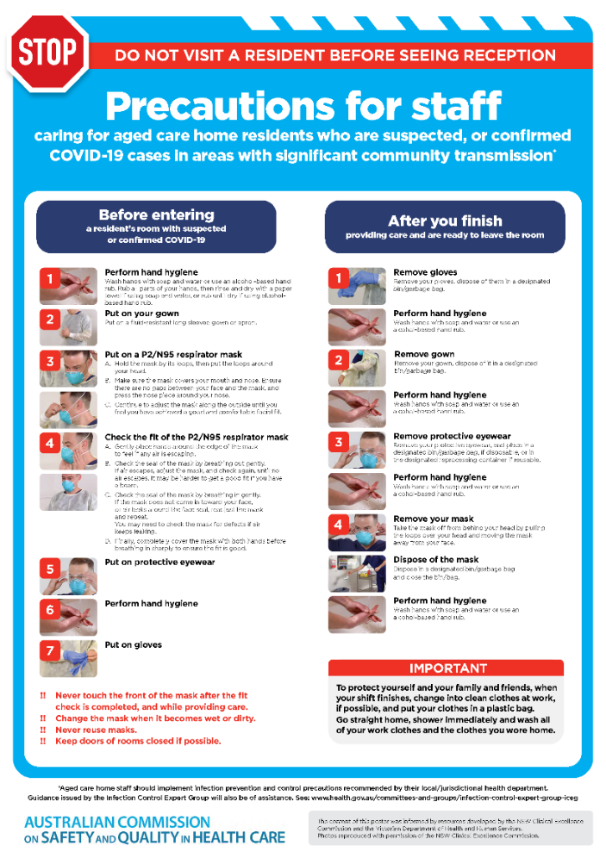](https://www.safetyandquality.gov.au/publications-and-resources/resource-library/covid-19-aged-care-staff-infection-prevention-and-control-precautions-poster)
* ***Environmental Cleaning and Infection Prevention and Control*** [www.safetyandquality.gov.au/environmental-cleaning](http://www.safetyandquality.gov.au/environmental-cleaning)
* ***Infection prevention and control Covid-19 PPE*** poster <https://www.safetyandquality.gov.au/publications-and-resources/resource-library/infection-prevention-and-control-covid-19-personal-protective-equipment>
* ***Special precautions for Covid-19 designated zones*** poster <https://www.safetyandquality.gov.au/publications-and-resources/resource-library/special-precautions-covid-19-designated-zones>
* ***COVID-19 infection prevention and control risk management – Guidance*** <https://www.safetyandquality.gov.au/publications-and-resources/resource-library/covid-19-infection-prevention-and-control-risk-management-guidance>
* ***Safe care for people with cognitive impairment during COVID-19***<https://www.safetyandquality.gov.au/our-work/cognitive-impairment/cognitive-impairment-and-covid-19>
* **Medicines Management COVID-19** <https://www.safetyandquality.gov.au/our-work/medication-safety/medicines-management-covid-19>, including position statements on medicine-related issues
  + ***Managing fever associated with COVID-19***
  + ***Managing a sore throat associated with COVID-19***
  + ***ACE inhibitors and ARBs in COVID-19***
  + ***Clozapine in COVID-19***
  + ***Management of patients on oral anticoagulants during COVID-19***
  + ***Ascorbic Acid: Intravenous high dose in COVID-19***
  + ***Treatment in acute care, including oxygen therapy and medicines to support intubation***
  + ***Nebulisation and COVID-19***
  + ***Managing intranasal administration of medicines during COVID-19***
  + ***Ongoing medicines management in high-risk patients***
  + ***Medicines shortages***
  + ***Conserving medicines***
  + ***Intravenous medicines administration in the event of an infusion pump shortage***
* ***Stop COVID-19: Break the chain of infection*** poster<https://www.safetyandquality.gov.au/publications-and-resources/resource-library/break-chain-poster-a3>  
  **[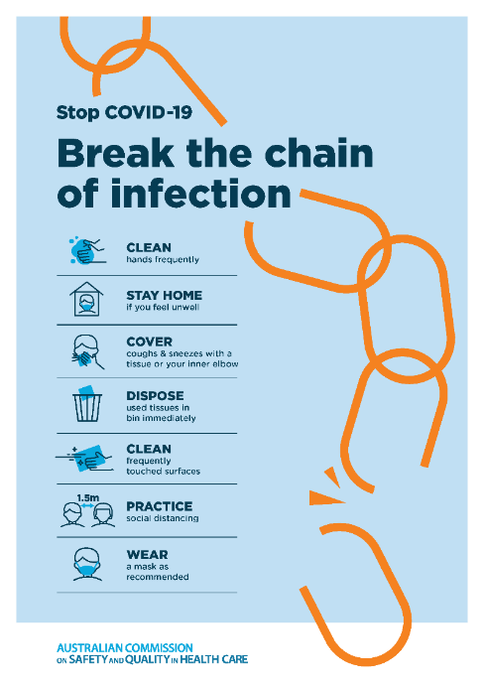](https://www.safetyandquality.gov.au/publications-and-resources/resource-library/break-chain-poster-a3https:/www.safetyandquality.gov.au/publications-and-resources/resource-library/break-chain-poster-a3)**
* ***COVID-19: Elective surgery and infection prevention and control precautions*** <https://www.safetyandquality.gov.au/publications-and-resources/resource-library/covid-19-elective-surgery-and-infection-prevention-and-control-precautions>
* ***FAQs for clinicians on elective surgery*** <https://www.safetyandquality.gov.au/node/5724>
* ***FAQs for consumers on elective surgery*** <https://www.safetyandquality.gov.au/node/5725>
* ***FAQs on community use of face masks***   
   <https://www.safetyandquality.gov.au/faqs-community-use-face-masks>
* ***COVID-19 and face masks – Information for consumers*** <https://www.safetyandquality.gov.au/publications-and-resources/resource-library/covid-19-and-face-masks-information-consumers>  
  The Commission’s fact sheet on use of face masks in the community to reduce the spread of COVID-19 is now available in Easy English and 10 other community languages from <https://www.safetyandquality.gov.au/wearing-face-masks-community>.  
  The factsheet was developed to help people understand when it is important to wear a mask to reduce the risk of the spread of COVID-19, and to explain how to safely put on and remove face masks. It also reinforces the importance of staying home if you have symptoms, physical distancing, hand hygiene and cough etiquette.

[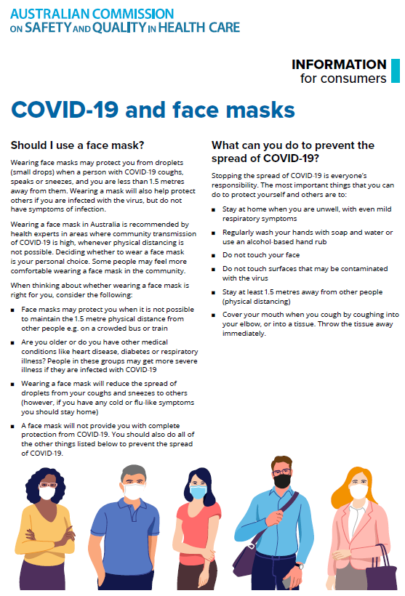](https://www.safetyandquality.gov.au/sites/default/files/2020-07/covid-19_and_face_masks_-_information_for_consumers.pdf)

*National COVID-19 Clinical Evidence Taskforce*

<https://covid19evidence.net.au/>

The National COVID-19 Clinical Evidence Taskforce is a collaboration of peak health professional bodies across Australia whose members are providing clinical care to people with COVID-19. The taskforce is undertaking continuous evidence surveillance to identify and rapidly synthesise emerging research in order to provide national, **evidence-based guidelines and clinical flowcharts for the clinical care of people with COVID-19**. The guidelines address questions that are specific to managing COVID-19 and cover the full disease course across mild, moderate, severe and critical illness. These are ‘living’ guidelines, updated with new research in near real-time in order to give reliable, up-to-the minute advice to clinicians providing frontline care in this unprecedented global health crisis.

*COVID-19 Critical Intelligence Unit*

<https://www.aci.health.nsw.gov.au/covid-19/critical-intelligence-unit>

The Agency for Clinical Innovation (ACI) in New South Wales has developed this page summarising rapid, evidence-based advice during the COVID-19 pandemic. Its operations focus on systems intelligence, clinical intelligence and evidence integration. The content includes a daily evidence digest and evidence checks on a discrete topic or question relating to the current COVID-19 pandemic. There is also a ‘Living evidence’ section summarising key studies and emerging evidence on **COVID-19 vaccines** and **SARS-CoV-2 variants**.

**Disclaimer**

On the Radar is an information resource of the Australian Commission on Safety and Quality in Health Care. The Commission is not responsible for the content of, nor does it endorse, any articles or sites listed. The Commission accepts no liability for the information or advice provided by these external links. Links are provided on the basis that users make their own decisions about the accuracy, currency and reliability of the information contained therein. Any opinions expressed are not necessarily those of the Australian Commission on Safety and Quality in Health Care.