**WHAT’S NEW IN AURA**

December 2018 Newsletter

**Welcome**

Dr Kathryn Daveson, an infectious diseases physician, has joined the AURA National Coordination Unit (NCU) as Clinical Director. Kathryn has jurisdictional level experience in both Queensland and ACT Health, where she worked in antimicrobial stewardship and clinical infectious diseases in rural and tertiary healthcare settings. Kathryn’s also has interests in health economics, antibiotic pharmacokinetics and pharmacodynamics, infection control and the immunocompromised host.

The Commission is pleased to advise that Professor John Turnidge AO, former AURA Clinical Director, will stay on board for a few months more in an advisory role to assist with the development of AURA 2019.

**Third AURA Report (AURA 2019)**

Development of the Third National AURA Report, which is planned for release by April 2019 is underway. AURA 2019 builds on the analyses presented in the First (AURA 2016) and Second (AURA 2017) AURA reports and will feature analyses of antimicrobial resistance (AMR) and antimicrobial use data collected in 2016, 2017 and 2018 (where appropriate). The report will also highlight enhanced national coverage and representativeness of AURA data, and analyses of five years of Pharmaceutical Benefits Schedule data.

Four core longstanding surveillance programs provide the foundation for the AURA Surveillance System:

* Australian Group on Antimicrobial Resistance
* National Antimicrobial Prescribing Survey
* National Antimicrobial Utilisation Surveillance Program
* Queensland Health OrgTRx System, which is the base for the Australian Passive AMR Surveillance System (APAS).

In addition, data and reports are gathered from:

* The National Neisseria Network, on *Neisseria gonorrhoeae* and *N. meningitidis*
* The National Notifiable Diseases Surveillance System, on *Mycobacterium tuberculosis*
* The Pharmaceutical Benefits Scheme and the Repatriation Pharmaceutical Benefits Scheme
* The NPS MedicineWise MedicineInsight program
* Sullivan Nicolaides Pathology, on rates of AMR from the community and private hospital settings.
* CARAlert on priority organisms with resistance to last-line antibiotics.

# National Antimicrobial Resistance Outbreak Response Network

The Department of Health has contracted the Commission to work with the states and territories to establish an AMR outbreak response network model and provide epidemiology advice to the process. This work is expected to continue until September 2019.

The objective is to build effective links across Australia in regard to outbreak responses across states and territories, and establish a national network that facilitates response to AMR outbreaks. The aim of the network is to improve opportunities for response, using surveillance data from AURA and other sources, and to promote engagement and collaboration across the jurisdictions in this process.

Each of the jurisdictions has nominated a representative to participate in the working group that is co-chaired by the Australian Government Chief Medical Officer and the NSW Health Chief Health Officer. Representatives of Communicable Diseases Network of Australia and the Public Health Laboratory Network are also included in the group.

A number of representatives from each jurisdiction participated in a national workshop on 30 August 2018. This has been complemented by responses to a survey which provides detail on current arrangements for governance, priority organisms, surveillance, and outbreak processes for AMR.

If you would like more information on the Antimicrobial Resistance Outbreak Response Network please email [aura@safetyandquality.gov.au](mailto:aura@safetyandquality.gov.au)

# CARAlert-logo---rectangle(2) - 18 Sep 2017CARAlert

In December 2018, the Commission released the latest in a series of reports to provide regular data updates and six-monthly detailed analyses of CARAlert data. This report includes information about isolates collected between 1 April 2018 and 30 September 2018, and the results reported into CARAlert by 31 October 2018.

During this reporting period, carbapenemase-producing Enterobacterales (CPE) were the most frequently reported critical antimicrobial resistance (CAR) of all CAR types (42.5%), with 2.7% of these also occurring in combination with ribosomal methyltransferases (RMT) (2.7%). CPE reports continue to be dominated by those of the IMP type, found most often in the *Enterobacter cloacae* complex. Azithromycin non-susceptible *Neisseria gonorrhoeae* accounted for 40.5% of CARs during the reporting period.

A total of 691 CARs was reported during this six month period. Compared with the corresponding period in 2017, there was a 9% decrease in the number of CARs reported, a 50% increase in ceftriaxone non-susceptible *Salmonella* species, mostly reported from Victoria (56.7%), and an 86% increase in multidrug-resistant *Shigella* species, mostly reported from NSW (38.5%) and Victoria (30.8%). There is now an equal proportion of CARs reported from the community and hospital setting (49%). However there are differences in the distribution of CAR types across these settings.

One *N. gonorrhoeae* strain with high-level azithromycin non-susceptibility (MIC > 256 mg/L) was confirmed from New South Wales (May 2018). Since 2014, there have been sporadic reports of *N. gonorrhoeae* strains with high-level resistance to azithromycin reported in Australia.

In addition, there were three *N. gonorrhoeae* strains reported that were non-susceptible to ceftriaxone, one of which was also azithromycin non-susceptible (low-level resistance, MIC < 256 mg/L), confirmed from Victoria. The detection of these strains is of concern because of the potential public health implications of an outbreak of ceftriaxone non-susceptible *N. gonorrhoeae*.

The frequency of reporting of CPE highlights the importance of the implementation of the Commission’s [*Recommendations for the control of carbapenemase-producing Enterobacterales: a guide for acute health facilities*.](https://www.safetyandquality.gov.au/our-work/healthcare-associated-infection/cpe-guide/)

The Commission continues to regularly monitor CARAlert records, prepare summary reports and ensure regular discussion with state and territory health departments about trends and potential CAR outbreaks to inform quality improvement initiatives and policies to reduce antimicrobial resistance.

Each state and territory health department has designated officers who have access to the CARAlert database to enable detailed review of CARs reported for their jurisdiction, including the name of the public hospital where a patient with a confirmed CAR was cared for. This information assists states and territories to determine whether infection prevention and control and/or follow-up response action is required. To support implementation of CARAlert, the Commission is developing an information pack to provide an overview of the system and an “easy guide”. For access to the information pack, contact [CARAlert@safetyandquality.gov.au](mailto:CARAlert@safetyandquality.gov.au).

In 2018, in conjunction with relevant experts and the states and territories, the Commission completed a review of the resistances and species reported to CARAlert. From 2019, four new CARs will be reported to CARAlert. These are: transferrable resistance to colistin in Enterobacterales, carbapenemase-producing *Acinetobacter baumannii* complex, carbapenemase-producing *Pseudomonas aeruginosa* and *Candida auris.*

More information on CARAlert is available from: [www.safetyandquality.gov.au/antimicrobial-use-and-resistance-in-australia/what-is-aura/national-alert-system-for-critical-antimicrobial-resistances-caralert/](http://www.safetyandquality.gov.au/antimicrobial-use-and-resistance-in-australia/what-is-aura/national-alert-system-for-critical-antimicrobial-resistances-caralert/)

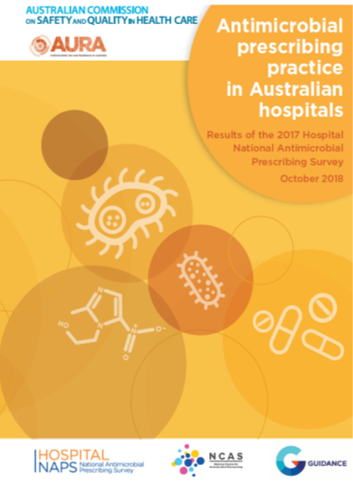**Hospital National Antimicrobial Prescribing Survey (NAPS)**

The Hospital National Antimicrobial Prescribing Survey (NAPS) is a key component of the AURA Surveillance System. The Hospital NAPS is a collaborative project between the National Centre for Antimicrobial Stewardship and the Guidance Group (Royal Melbourne Hospital).

The 2017 Hospital NAPS was published by the Commission on 12 November 2018 coinciding with Antibiotic Awareness Week, and provides an overview of antimicrobial prescribing in Australian public and private hospitals. This is the fifth year in which the survey has been conducted, and consistent themes are emerging in relation to the appropriateness of antimicrobial prescribing across the country.

This report presents analyses of 26,277 prescriptions submitted to the Hospital NAPS database by 314 hospitals (228 public and 86 private) during 2017, and analyses of trends from 2013 to 2017.

The changes in key indicators of appropriateness of antimicrobial prescribing monitored using the Hospital NAPS from 2013 to 2017 are:

* Improvement in documentation of indication from 70.9% to 77.7%
* Improvement in documentation of review or stop date from 35.5% to 40.5%
* Improvement in the proportion of surgical prophylaxis given for greater than 24 hours from 41.8% to 30.5%
* A decline in compliance with *Therapeutic Guidelines: Antibiotic*or local guidelines from 72.2% to 67.3%
* A static rate of overall appropriateness of prescribing, of approximately 76% each year
* The highest proportions of prescriptions assessed as inappropriate in Australian hospitals participating in NAPS in 2017 were for: surgical prophylaxis, infective exacerbation of chronic obstructive pulmonary disease, traumatic injuries and various types of pneumonia
* Key markers for prescribing appropriateness improved in hospitals that were repeat participants in Hospital NAPS Hospitals from 2013 to 2017.

The report is available at: [www.safetyandquality.gov.au/wp-content/uploads/2018/11/2017-Hospital-NAPS.pdf](http://www.safetyandquality.gov.au/wp-content/uploads/2018/11/2017-Hospital-NAPS.pdf)

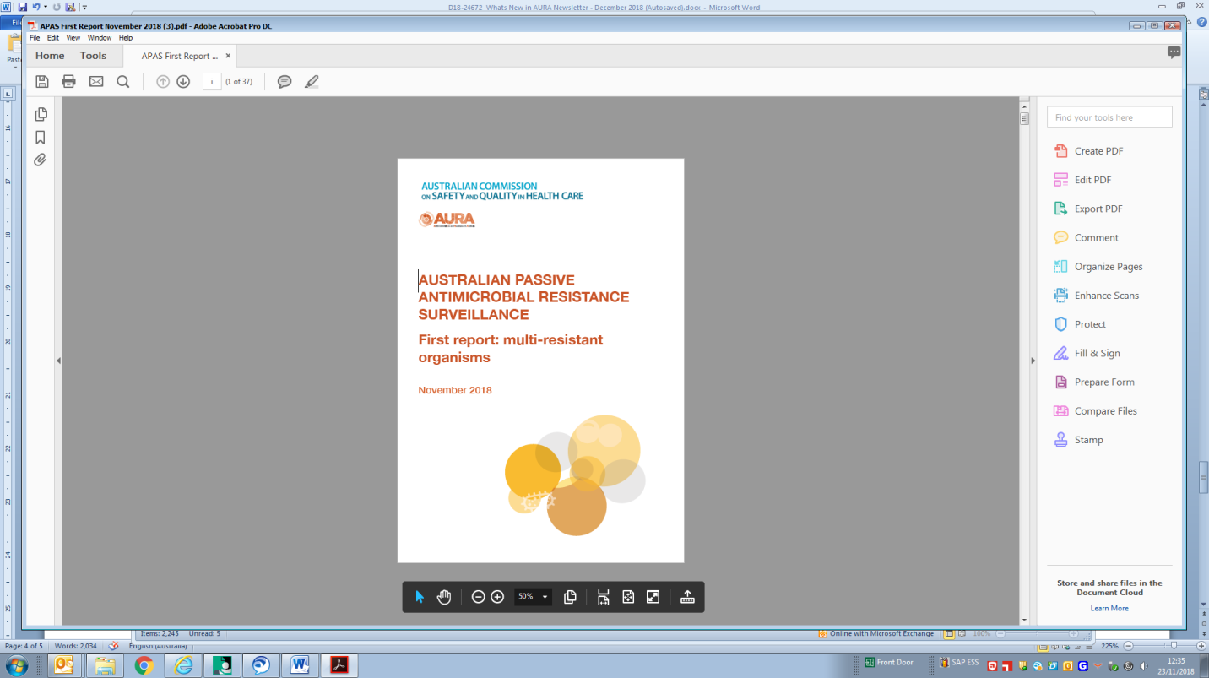**Australian Passive AMR Surveillance (APAS) First report on multi resistant organisms**

Australian Passive AMR Surveillance (APAS) is a key component of the AURA Surveillance System. APAS is providing an increasingly comprehensive picture of AMR in Australia. APAS was established by the Commission in 2015 with the support of Queensland Health, which enabled access to the OrgTRx system, as the information technology infrastructure.

APAS collects, analyses and reports on de-identified patient level AMR data contributed by public and private pathology services across Australia. These laboratories report AMR detected in isolates referred from public and private hospitals, aged care homes and community settings. At present, there is variable geographic representation in APAS, as not all states and territories have laboratories that contribute data. The Commission continues to work with public and private laboratories to increase participation in APAS.

Initially, data were captured from January 2015 from all contributing laboratories, with historical data now incorporated from four of these laboratories. The APAS system includes over 50 million AMR records from 2006 to 2018 enabling trend analysis and examination of patterns of AMR across Australia.

The *APAS first report multi resistant organisms*, released in December 2018, include analyses of APAS data for three types of significant resistances in Australia. These are:

* Methicillin resistance in *Staphylococcus aureus* (MRSA)
* Fluoroquinolone non-susceptibility in *Escherichia coli*
* Vancomycin non-susceptibility in *Enterococcus faecium*.

### Key findings of APAS data from 2006 to 2017:

* Methicillin-resistance in *S. aureus* was stable at around 20% in New South Wales, Queensland and South Australia for a decade (2006 to 2015); there is evidence that rates are slowly increasing nationally over the last three years (from 21.6% in 2015 to 22.5% in 2017)
* Methicillin-resistance in *S. aureus* is higher and worsening in remote and very remote areas of Australia (40.6% and 40.2%, respectively, in 2017), reflecting the growing problem of MRSA in some communities
* Methicillin-resistance in *S. aureus* is also higher and worsening in aged care homes (increasing from 25.1% in 2006 to 36.2% in 2014 from long term APAS contributor data; and was 32.1% in 2017 for all contributing laboratories)
* The proportion of MRSA has been stable at around 22% in hospitals for both cohorts of contributors
* Methicillin-resistance in *S. aureus* in the community has risen from 8.5% in 2006 to 14.6% in 2014, and 19.1% in 2017
* Despite significant restriction of fluoroquinolones in hospitals and the community, the proportion of non-susceptibility to fluoroquinolones in *E. coli* has risen from 2% in 2006 to 11.8% in 2017; the trend is most apparent in major cities and the proportion has risen in all regions of Australia
* In 2017 the proportion of fluoroquinolone non-susceptibility in *E. coli* were highest in aged care homes (18.1%), followed by hospitals (12.1%), and the community (10.2%)
* Vancomycin non-susceptible *E. faecium* strains are now very common across Australia, exceeding 40% of all *E. faecium* for all specimen types since 2010
* Vancomycin non-susceptible *E. faecium* are principally seen in hospitals in urban settings; there is evidence that rates are decreasing nationally over the last three years, from 51% in 2015 to 42% in 2017.



|  |
| --- |
| **Further information and AURA resources can be found at:**  www.safetyandquality.gov.au/antimicrobial-use-and-resistance-in-australia/resources-page/ |

The AURA Surveillance System is funded by the Australian Government’s Department of Health

and the Australian Commission on Safety and Quality in Health Care.

**What’s new in AntiMicrobial Stewardship**

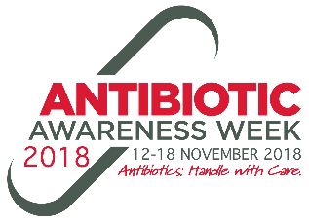**Antibiotic Awareness Week**

The Commission developed a number of resources to assist hospitals and health service organisations in running activities and events in the lead up to and during Antibiotic Awareness Week. These resources are available throughout the year at

[www.safetyandquality.gov.au/our-work/healthcare-associated-infection/antimicrobial-stewardship/antibiotic-awareness-week/](http://www.safetyandquality.gov.au/our-work/healthcare-associated-infection/antimicrobial-stewardship/antibiotic-awareness-week/)

**Antimicrobial Stewardship Program Indicators**

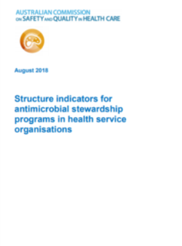The Indicators were developed to support health service organisations in their implementation of effective AMS programs to meet the National Safety and Quality Health Service (NSQHS) Preventing and Controlling Healthcare-Associated Infections Standard, using a standardised methodology for assessment of these programs. Whilst the suite comprises 26 indicators which describe a range of characteristics considered necessary for an effective AMS program, they are not mandatory and aim to complement health service organisations in their local review of AMS.

The indicators are intended to support health service organisations with implementation of initiatives. This resource is available at [www.safetyandquality.gov.au/our-work/healthcare-associated-infection/ams-and-hai-resources-and-links/](http://www.safetyandquality.gov.au/our-work/healthcare-associated-infection/ams-and-hai-resources-and-links/)

**Surgical Antimicrobial Prophylaxis**

The AURA team are working with a number of Colleges and other stakeholders to develop resources tailored for improving surgical antimicrobial prophylaxis. In 2017, the Hospital NAPS showed that, on average, 30.5% of surgical antimicrobial prophylaxis prescriptions extended 24 hours beyond the time of surgery (*n*= 26,227 prescriptions). Whilst this is an improvement compared with the first Hospital NAPS in 2013 (*n*= 12,800 prescriptions), when the overall proportion of surgical prophylaxis given for greater than 24 hours was 41.8%, there is still significant room for improvement. Patients with unnecessary exposure to long courses of antibiotic prophylaxis are also at higher risk of morbidity and mortality if they develop an infection, as it is more likely the organism will be resistant to antibiotics commonly prescribed.

The surgical antimicrobial prophylaxis resources are available at [www.safetyandquality.gov.au/our-work/healthcare-associated-infection/antimicrobial-stewardship/surgical-antimicrobial-prophylaxis/](http://www.safetyandquality.gov.au/our-work/healthcare-associated-infection/antimicrobial-stewardship/surgical-antimicrobial-prophylaxis/)

**Options to support implementation of antimicrobial stewardship**

The AURA team have updated guidance for health service organisations to support the implementation of AMS programs in different contexts.

[www.safetyandquality.gov.au/our-work/healthcare-associated-infection/ams-and-hai-resources-and-links/](http://www.safetyandquality.gov.au/our-work/healthcare-associated-infection/ams-and-hai-resources-and-links/)

|  |
| --- |
| **For further information on AMS or HAI please visit**  [**www.safetyandquality.gov.au/our-work/healthcare-associated-infection/antimicrobial-stewardship/**](http://www.safetyandquality.gov.au/our-work/healthcare-associated-infection/antimicrobial-stewardship/) |

