# Australian Commission on Safety and Quality in Health Care logo with Radar imageOn the Radar

Issue 520

19 July 2021

*On the Radar* is a summary of some of the recent publications in the areas of safety and quality in health care. Inclusion in this document is not an endorsement or recommendation of any publication or provider. Access to particular documents may depend on whether they are Open Access or not, and/or your individual or institutional access to subscription sites/services. Material that may require subscription is included as it is considered relevant.

*On the Radar* is available online, via email or as a PDF or Word document from <https://www.safetyandquality.gov.au/publications-and-resources/newsletters/radar>

If you would like to receive *On the Radar* via email, you can subscribe on our website <https://www.safetyandquality.gov.au/publications-and-resources/newsletters>  
or by emailing us at H[Umail@safetyandquality.gov.auU](mailto:mail@safetyandquality.gov.au).   
You can also send feedback and comments to H[Umail@safetyandquality.gov.auU](mailto:mail@safetyandquality.gov.au).

For information about the Commission and its programs and publications, please visit <https://www.safetyandquality.gov.au>

You can also follow us on Twitter @ACSQHC.

**On the Radar**

Editor: Dr Niall Johnson [niall.johnson@safetyandquality.gov.au](mailto:niall.johnson@safetyandquality.gov.au)

Contributors: Niall Johnson, Meredith Page, Dr Jan Gralton

**Basics of Infection Prevention and Control for Aged Care**

<https://nhhi.southrock.com/>

The Australian Commission on Safety and Quality in Health Care is expanding its suite of online learning resources to also support infection prevention and control (IPC) in the aged care sector. This work has been undertaken in conjunction with the New South Wales Clinical Excellence Commission (CEC) and the Aged Care Quality and Safety Commission (ACQSC).

The *Basics of Infection Prevention and Control for Aged Care* is the first module in this suite of specific aged care resources; based on the existing eLearning module - *Basics of Infection Prevention and Control Orientation* and material developed by the CEC. The existing Basics module has been regularly used by workers in aged care and has now been updated to consider this specific environment. The module may be used when inducting new staff, or as an annual update.

The module is available by registering with the National Hand Hygiene Initiative Learning Management System at <https://nhhi.southrock.com/>

**Journal articles**

*Association Between Iatrogenic Delivery for Suspected Fetal Growth Restriction and Childhood School Outcomes*

Selvaratnam RJ, Wallace EM, Wolfe R, Anderson PJ, Davey M-A

JAMA. 2021;326(2):145-153.

*Delivery Before 39 Weeks’ Gestation for Suspected Fetal Growth Restriction: More Harm Than Good?*

Silver RM, Blue NR

JAMA. 2021;326(2):135-136.

*Comparison of costs related to infant hospitalisations for spontaneous, induced and Caesarean births: population-based cohort study*

Owen KB, Ibiebele I, Simpson JM, Morton RL, Morris JM, Torvaldsen S

Australian Health Review. 2021 [epub].

*A decline in planned, but not spontaneous, preterm birth rates in a large Australian tertiary maternity centre during COVID-19 mitigation measures*

Gallo LA, Gallo TF, Borg DJ, Moritz KM, Clifton VL, Kumar S

Australian and New Zealand Journal of Obstetrics and Gynaecology. 2021 [epub].

|  |  |
| --- | --- |
| DOI | Selvaratnam et al <https://doi.org/10.1001/jama.2021.8608>  Silver and Blue <https://doi.org/10.1001/jama.2021.8381>  Owen et al <https://doi.org/10.1071/AH20237>  Gallo et al <https://doi.org/10.1111/ajo.13406> |
| Notes | The importance of full term gestation on best outcomes for babies is established, yet there has been a shift towards earlier births in recent years. These recent papers build on our knowledge of the short and long-term outcomes associated with pre-term and early-term births, and the implications for planned births.  Fetal growth restriction (FGR) is the largest contributor to late pregnancy stillbirth but detection and timely management of it can reduce the rate of stillbirth. However, timing a birth to prevent stillbirth where FGR is suspected must be weighed against the risks of premature birth. Given the low incidence of stillbirth, improving FGR detection may prevent a small number of stillbirths but may also cause inadvertent harm for an increasing number of healthy infants.  Selvaratnam et al report on an exploratory study that examined developmental and educational outcomes for liveborn singleton babies born at 32 weeks’ or more gestation in Victoria from 2003 to 2013 (705, 937 infants). Data were sourced from the Victoria Perinatal Data Collection, the Australian Early Development Census records and the National Assessment Program–Literacy and Numeracy (NAPLAN) assessment bands. The study found:   * **infants who were severely small for gestational age** (birth weight <3rd percentile) **and who were delivered for suspected FGR**, had a **significantly increased risk of poor developmental outcome at school entry** (16.2% vs 12.7%; adjusted odds ratio, 1.36 [95% CI, 1.07-1.74]) and **poorer educational outcomes in grades 3, 5, and 7**, compared with infants who were severely small for gestational age and who were not suspected of having FGR. * no significant difference between infants with normal birth weight (birth weight ≥10th percentile) delivered for suspected FGR and those not suspected of having FGR in risk of poor developmental outcome at school entry (8.6% vs 8.1%; adjusted odds ratio, 1.17 [95% CI, 0.95-1.45]) or educational outcomes in grade 3, 5, or 7.   Silver and Blue’s editorial in the same issue of *JAMA*, ‘Delivery Before 39 Weeks’ Gestation for Suspected Fetal Growth Restriction: More Harm Than Good?’, states that the study highlights ‘the need to truly evaluate the long-term outcomes associated with obstetric interventions for severely small for gestational age and FGR’.  Owen et al examined the costs and cumulative length of hospitalisations for babies in their first year of life according to mode of birth and gestational age. The study included women who gave birth to liveborn singleton babies (1,187 451 babies) in New South Wales from 2005 to 2014. This study found:   * The **total length of hospitalisations and hospital costs were significantly** (p< 0.001) **lower for babies born after spontaneous labour** (5.6 days and A$8405 respectively) **than for babies born following labour induction (**6.1 days and A$9452 respectively) **or prelabour Caesarean section** (8.2 days and A$12 320 respectively). * The mean total length of hospitalisations and costs of hospitalisations for babies in the first year of life declined steeply between 33 and 37 weeks gestation, then gradually declined between 38 and 39 weeks before plateauing at 39 weeks. * Once babies had been discharged, **those born before 37 weeks** were **more likely to be readmitted** and the most common diagnosis was bronchiolitis. * At each week of gestational age, the total hospital cost was significantly higher for babies born following a prelabour caesarean and labour induction than for babies born following a spontaneous labour.   The authors concluded that ‘It is important for judicious decision making to balance the risks and benefits of planned early births for the baby and mother, because avoiding unnecessary early births is associated with a reduction in the time spent in hospital and decreased costs.’  During the COVID-19 pandemic it was suggested that rates of preterm birth decreased during COVID-19 lockdown measures. Gallo et al have compared the prevalence of preterm birth and stillbirth rates during COVID-19 restriction measures with infants born at the same maternity centre during the same weeks in 2013–2019. They report finding ‘Planned moderate/late preterm births declined by more than half during early COVID-19 restrictions compared with the previous seven years’. This finding suggests a discretionary nature of timing for planned births.  The Australian Commission on Safety and Quality in Health Care released *The Fourth Australian Atlas of Healthcare Variation* in April 2021. The Atlas examined rates of planned (pre-labour) caesarean section without medical or obstetric indication, and rates of induced labour without medical or obstetric indication, according to gestation (< 37 weeks, <38 weeks and < 39 weeks). The Atlas found that almost half (43–56%) of pre-labour caesarean sections < 39 weeks in 2017 did not have a medical or obstetric indication, based on the range of rates for the seven states and territories for which data could be reported.  Read more about the fourth Atlas at [www.safetyandquality.gov.au/fourth-atlas-2021](http://www.safetyandquality.gov.au/fourth-atlas-2021) |

*An Ageing Population Creates New Challenges Around Consent to Medical Treatment*

Holmes AL, Ibrahim JE

Journal of Bioethical Inquiry. 2021 [epub].

|  |  |
| --- | --- |
| DOI | <https://doi.org/10.1007/s11673-021-10113-3> |
| Notes | Informed consent is an important element in ensuring care is patient-centred and accords with a patient’s wishes. Ensuring informed consent is properly obtained is a legal, ethical and professional requirement on the part of all treating health professionals and supports person-centred care. Informed consent is a safety and quality issue. However, gaining consent from some patient’s is not always easy. This piece reflects on some of the issues that older patients – and an ageing population – may pose when it comes to ensuring that properly informed consent is gained. The authors contend that ‘Despite being required by ethics and the law, consent for medical treatment is not always validly sought in this population.’ They highlight issues around capacity and comprehension that may be greater in this population. As they observe, ‘The dynamic nature of capacity, particularly in individuals who have dementia or other cognitive impairments, adds complexity to obtaining consent.’ They foresee that an increasingly ageing population means ‘these issues are likely to become more profound’ and urge action on ‘Raising awareness, more education, engaging with people with dementia, and conducting further research’. |

For information on the Commission’s work and resources on informed consent, see <https://www.safetyandquality.gov.au/our-work/partnering-consumers/informed-consent>

*Barriers to evidence-based practice implementation in physiotherapy: a systematic review and meta-analysis*

Paci M, Faedda G, Ugolini A, Pellicciari L

International Journal for Quality in Health Care. 2021;33(2).

|  |  |
| --- | --- |
| DOI | <https://doi.org/10.1093/intqhc/mzab093> |
| Notes | It is said that the lag between research and implementation is of the order of 17 years. This piece reports on a systematic review and meta-analysis that focused on 29 studies in order to examine the reported barriers to evidence-based practice (EBP) in physiotherapy. The authors report that the findings of meta-analysis revealed that **lack of time** was the most frequently reported barrier, followed by **language**, lack of **access** and lack of **statistical skills**. |

*Getting the whole story: Integrating patient complaints and staff reports of unsafe care*

Van Dael J, Gillespie A, Reader T, Smalley K, Papadimitriou D, Glampson B, et al

Journal of Health Services Research & Policy. 2021:13558196211029323.

|  |  |
| --- | --- |
| DOI | <https://doi.org/10.1177%2F13558196211029323> |
| Notes | Paper looking at the potential of combining insights from patient complaints and staff incident reports for a more comprehensive understanding of the causes and severity of harm. The particular study used five years of patient complaints and staff incident reporting data at a large multi-site hospital in London to do a retrospective patient-level data linkage to identify overlapping reports. The authors concluded that there is value in ‘using patient complaints to supplement, test, and challenge staff reports, including to provide greater insight on the many potential factors that may give rise to unsafe care’. They go on to ‘we propose that a more holistic analysis of critical safety incidents can be achieved through combining heterogeneous data from different viewpoints, such as through the integration of patient complaints and staff incident reporting data.’ Extending this to use information from many complementary sources, including staff (clinical and non-clinical) reports, patient complaints, patient compliments, would seem to make sense as they each only reveal part of the picture and by using the multiple sources a more complete picture can be pieced together. |

For information on the Commission’s work on partnering with consumers, see <https://www.safetyandquality.gov.au/our-work/partnering-consumers>

*Evaluating factors associated with the cancellation and delay of elective surgical procedures: a systematic review*

Koushan M, Wood LC, Greatbanks R

International Journal for Quality in Health Care. 2021;33(2).

|  |  |
| --- | --- |
| DOI | <https://doi.org/10.1093/intqhc/mzab092> |
| Notes | The cancelation of elective surgery, particularly at short notice, can cause disruption and dissatisfaction, as the authors note, ‘it causes considerable disruption to patient flow, further eroding often already stretched operating capacity, and consequentially reduces both hospital performance and patient satisfaction.’ The systematic review, based on 78 items, found cancellation reasons varied by hospital, but that ‘that **hospital-related causes** (e.g. unavailable operation room time, inappropriate scheduling policy and lack of beds) are the **primary reason for surgery cancellation**, **followed by work-up related causes** (e.g. medically unfit and changes in the treatment plan) and **patient-related causes** (e.g. absence of a patient and patient refusal).’ The authors suggest that ‘that **the main causes** for surgery cancellation **can be controlled by hospital managers**, who can aim to **improve areas such as patient flow and capacity management**.’ |

*Longitudinal rates of hospital adverse events that contributed to death in Norway and Sweden from 2013 to 2018*

Deilkås ET, Haugen M, Risberg MB, Narbuvold H, Flesland Ø, Nylén U, et al

Journal of Patient Safety and Risk Management. 2021:25160435211026125.

|  |  |
| --- | --- |
| DOI | <https://doi.org/10.1177%2F25160435211026125> |
| Notes | The rate of errors experience by patients is often given of the order 9–10%. This study looked at adverse events (AEs) in hospitals in Sweden and Norway in the period 2013–2018. Having examined 53,367 medical records in Norway and 88,637 medical records in Sweden the authors report finding:   * **13.2% of hospital admissions in Norway** and **13.1% in Sweden** were **associated with an AE** of all severities * **0.23% of hospital admissions in Norway** and **0.26% in Sweden** were associated with **an AE that contributed to death**. |

*Safety Checklists for Emergency Response Driving and Patient Transport: Experiences from Emergency Medical Services*

Jakonen A, Mänty M, Nordquist H

The Joint Commission Journal on Quality and Patient Safety. 2021 [epub].

|  |  |
| --- | --- |
| DOI | <https://doi.org/10.1016/j.jcjq.2021.05.008> |
| Notes | The examination of safety and quality issues in health care have often been focused on what happens in hospitals. But health care happens in many settings and one of this is the transporting of patients. This piece examined how the safety checklists developed for emergency response driving (ERD) and patient transport in Finland are experienced in practical work in emergency medical services by paramedics. |

*BMJ Quality & Safety* online first articles

|  |  |
| --- | --- |
| URL | <https://qualitysafety.bmj.com/content/early/recent> |
| Notes | *BMJ Quality &Safety* has published a number of ‘online first’ articles, including:   * **The problem with ‘My Five Moments for Hand Hygiene’** (Dinah Gould, Edward Purssell, Annette Jeanes, Nicolas Drey, Jane Chudleigh, Jacob McKnight) * Editorial: Learning from successes: designing **medication adherence intervention research** so that we can learn what works and why (Sara Garfield, Gaby Judah) * Co-produced capability framework for successful **patient and staff partnerships in healthcare quality improvement**: results of a scoping review (Ruth Cox, Matthew Molineux, Melissa Kendall, Bernadette Tanner, Elizabeth Miller) |

*International Journal for Quality in Health Care* online first articles

|  |  |
| --- | --- |
| URL | <https://academic.oup.com/intqhc/advance-articles> |
| Notes | *International Journal for Quality in Health Care* has published a number of ‘online first’ articles, including:   * **Appropriateness of Imaging Decisions for Low Back Pain Presenting to the Emergency Department**: A Retrospective Chart Review Study (Adrian Traeger, Gustavo C Machado, Sally Bath, Martin Tran, Lucinda Roper, Crystian Oliveira, Aimie Peek, Danielle Coombs, Amanda Hall, Elise Tcharkhedian, Chris Maher) |

**Online resources**

*Safer Care Victoria maternity care guidelines*

<https://www.bettersafercare.vic.gov.au/>

Safer Care Victoria has released 3 new guidelines for maternity and newborn services to help improve outcomes and experiences for their patients and families. The new guidelines include:

* ***Safe infant sleeping guidance*** promotes the key steps to sleeping infants safely in hospital and at home, to help reduce the risk of sudden unexpected death in infancy (SUDI). It includes advice on shared sleeping.   
  <https://www.bettersafercare.vic.gov.au/clinical-guidance/neonatal/infant-safe-sleeping>
* ***Homebirth guidance*** helps services develop or expand a safe homebirth program, which may result in less intervention (e.g. caesarean sections) and complications (e.g. post-partum haemorrhage or severe perineal trauma).  
  <https://www.bettersafercare.vic.gov.au/clinical-guidance/maternity/homebirth>
* ***Water for labour and birth guidance*** supports women to use a shower or bath for pain relief during labour and if appropriate, water birth.  
  <https://www.bettersafercare.vic.gov.au/clinical-guidance/maternity/water-for-labour-and-birth>

*Quality Improvement toolkits*

<https://www.cec.health.nsw.gov.au/improve-quality/quality-improvement-toolkits>

The Clinical Excellence Commission in New South Wales has a range of quality improvement toolkits designed to support local healthcare teams to start and sustain a quality improvement (QI) project focusing on clinical areas where the risk of harm is well recognised. The toolkits include step by step guides to solve small or large problems using QI methodology. Toolkits available include:

* ***AMBER Care Bundle***
* ***Comprehensive Care - Minimising Harm***
* ***Last Days of Life***
* ***Medication Reconciliation***
* ***Sepsis***
* ***Venous Thromboembolism (VTE) Prevention.***

*[USA] Effective Health Care Program reports*

<https://effectivehealthcare.ahrq.gov/>

The US Agency for Healthcare Research and Quality (AHRQ) has an Effective Health Care (EHC) Program. The EHC has released the following final reports and updates:

* *Breast Reconstruction After* ***Mastectomy***<https://effectivehealthcare.ahrq.gov/products/breast-reconstruction-mastectomy/research>

*[Canada] Integrated Care Standard*

<https://healthstandards.org/integratedcare/>

The Health Standards Organisation in Canada is claiming that their CAN/HSO 76000:2021 Integrated People-Centred Health Systems (IPCHS) is ‘the world’s first co-designed, evidence-based standard on integrated people-centred care and service’. The HSO has adopted a definition of integrated care as being ‘An Integrated People-Centered health system is one with health and social services that are organized and managed across sectors and organizational boundaries so that people can receive coordinated and comprehensive services – at the right time, by the right provider in the right place.’

The standard is structured around 10 design principles. To make the standard relevant and actionable, each design principle sets out explicit, objective requirements (criteria) to be met by health systems. The standard has 66 criteria in total that people can use as aspirational targets in their journey toward a fully integrated health system. Guidance is available for each criteria to help policy makers and health system partners know what actions to take together as they set and advance their local priorities.

[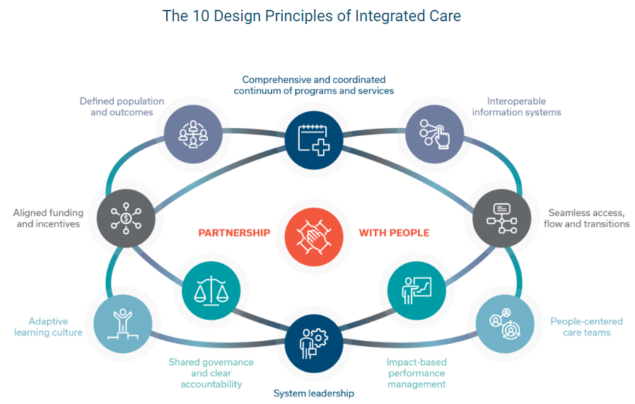](https://healthstandards.org/integratedcare/)

**COVID-19 resources**

https://www.safetyandquality.gov.au/covid-19

The Australian Commission on Safety and Quality in Health Care has developed a number of resources to assist healthcare organisations, facilities and clinicians. These and other material on COVID-19 are available at <https://www.safetyandquality.gov.au/covid-19>

These resource include:

* ***COVID-19: Aged care staff infection prevention and control precautions*** *poster*<https://www.safetyandquality.gov.au/publications-and-resources/resource-library/covid-19-aged-care-staff-infection-prevention-and-control-precautions-poster>  
    
  [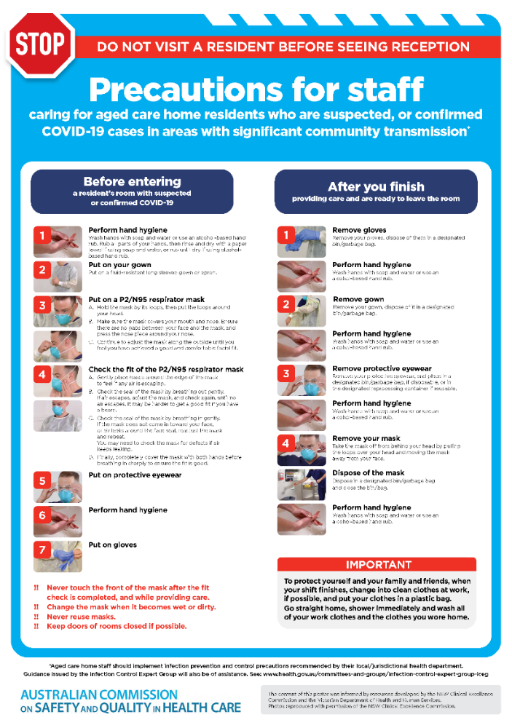](https://www.safetyandquality.gov.au/publications-and-resources/resource-library/covid-19-aged-care-staff-infection-prevention-and-control-precautions-poster)
* ***Environmental Cleaning and Infection Prevention and Control*** [www.safetyandquality.gov.au/environmental-cleaning](http://www.safetyandquality.gov.au/environmental-cleaning)
* ***Infection prevention and control Covid-19 PPE*** poster <https://www.safetyandquality.gov.au/publications-and-resources/resource-library/infection-prevention-and-control-covid-19-personal-protective-equipment>
* ***COVID-19 infection prevention and control risk management – Guidance*** <https://www.safetyandquality.gov.au/publications-and-resources/resource-library/covid-19-infection-prevention-and-control-risk-management-guidance>
* ***Safe care for people with cognitive impairment during COVID-19***<https://www.safetyandquality.gov.au/our-work/cognitive-impairment/cognitive-impairment-and-covid-19>
* ***Stop COVID-19: Break the chain of infection*** poster<https://www.safetyandquality.gov.au/publications-and-resources/resource-library/break-chain-poster-a3>  
  **[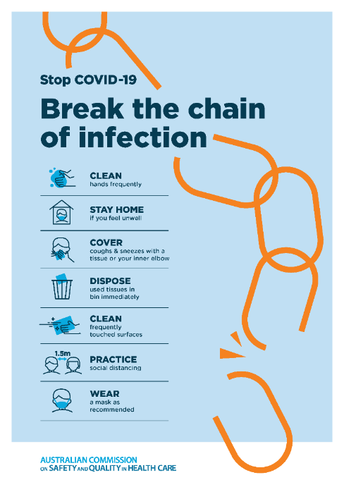](https://www.safetyandquality.gov.au/publications-and-resources/resource-library/break-chain-poster-a3https:/www.safetyandquality.gov.au/publications-and-resources/resource-library/break-chain-poster-a3)**
* ***COVID-19: Elective surgery and infection prevention and control precautions*** <https://www.safetyandquality.gov.au/publications-and-resources/resource-library/covid-19-elective-surgery-and-infection-prevention-and-control-precautions>
* ***FAQs for clinicians on elective surgery*** <https://www.safetyandquality.gov.au/node/5724>
* ***FAQs for consumers on elective surgery*** <https://www.safetyandquality.gov.au/node/5725>
* ***FAQs on community use of face masks***   
   <https://www.safetyandquality.gov.au/faqs-community-use-face-masks>
* ***COVID-19 and face masks – Information for consumers*** <https://www.safetyandquality.gov.au/publications-and-resources/resource-library/covid-19-and-face-masks-information-consumers>  
  The Commission’s fact sheet on use of face masks in the community to reduce the spread of COVID-19 is now available in Easy English and 10 other community languages from <https://www.safetyandquality.gov.au/wearing-face-masks-community>.  
  The factsheet was developed to help people understand when it is important to wear a mask to reduce the risk of the spread of COVID-19, and to explain how to safely put on and remove face masks. It also reinforces the importance of staying home if you have symptoms, physical distancing, hand hygiene and cough etiquette.

[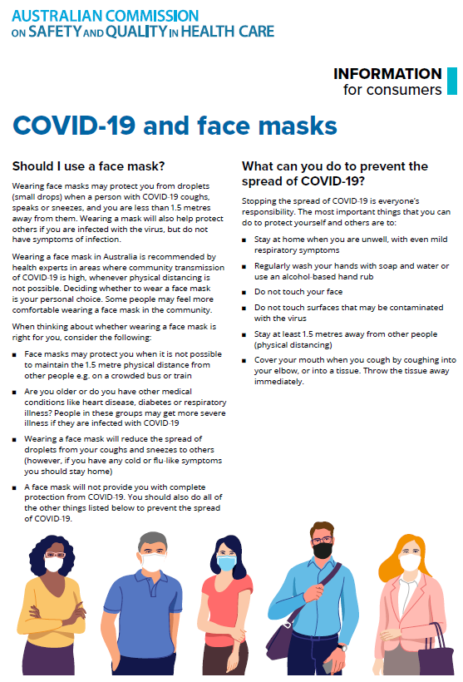](https://www.safetyandquality.gov.au/sites/default/files/2020-07/covid-19_and_face_masks_-_information_for_consumers.pdf)

*National COVID-19 Clinical Evidence Taskforce*

<https://covid19evidence.net.au/>

The National COVID-19 Clinical Evidence Taskforce is a collaboration of peak health professional bodies across Australia whose members are providing clinical care to people with COVID-19. The taskforce is undertaking continuous evidence surveillance to identify and rapidly synthesise emerging research in order to provide national, **evidence-based guidelines and clinical flowcharts for the clinical care of people with COVID-19**. The guidelines address questions that are specific to managing COVID-19 and cover the full disease course across mild, moderate, severe and critical illness. These are ‘living’ guidelines, updated with new research in near real-time in order to give reliable, up-to-the minute advice to clinicians providing frontline care in this unprecedented global health crisis.

*COVID-19 Critical Intelligence Unit*

<https://www.aci.health.nsw.gov.au/covid-19/critical-intelligence-unit>

The Agency for Clinical Innovation (ACI) in New South Wales has developed this page summarising rapid, evidence-based advice during the COVID-19 pandemic. Its operations focus on systems intelligence, clinical intelligence and evidence integration. The content includes a daily evidence digest and evidence checks on a discrete topic or question relating to the current COVID-19 pandemic. There is also a ‘Living evidence’ section summarising key studies and emerging evidence on **COVID-19 vaccines** and **SARS-CoV-2 variants**.

**Disclaimer**

On the Radar is an information resource of the Australian Commission on Safety and Quality in Health Care. The Commission is not responsible for the content of, nor does it endorse, any articles or sites listed. The Commission accepts no liability for the information or advice provided by these external links. Links are provided on the basis that users make their own decisions about the accuracy, currency and reliability of the information contained therein. Any opinions expressed are not necessarily those of the Australian Commission on Safety and Quality in Health Care.