Australian Commission on Safety and Quality in Health Care logo 


TRIM: D21-354

May 2021

National Standard Medication Chart (NSMC)

2020 national audit report

Published by the Australian Commission on Safety and Quality in Health Care  
Level 5, 255 Elizabeth Street, Sydney NSW 2000

Phone: (02) 9126 3600

Email: mail@safetyandquality.gov.au   
Website: www.safetyandquality.gov.au

ISBN: 978-1-922563-32-3

© Australian Commission on Safety and Quality in Health Care 2021

All material and work produced by the Australian Commission on Safety and Quality in Health Care is protected by copyright. The Commission reserves the right to set out the terms and conditions for the use of such material.

As far as practicable, material for which the copyright is owned by a third party will be clearly labelled. The Australian Commission on Safety and Quality in Health Care has made all reasonable efforts to ensure that this material has been reproduced in this publication with the full consent of the copyright owners.

With the exception of any material protected by a trademark, any content provided by third parties, and where otherwise noted, all material presented in this publication is licensed under a [Creative Commons Attribution-NonCommercial-NoDerivatives 4.0 International Licence](http://creativecommons.org/licenses/by-nc-nd/4.0/).

Creative Commons Licence

Enquiries regarding the licence and any use of this publication are welcome and can be sent to [communications@safetyandquality.gov.au](mailto:communications@safetyandquality.gov.au).

The Commission’s preference is that you attribute this publication (and any material sourced from it) using the following citation:

Australian Commission on Safety and Quality in Health Care. National Standard Medication Chart – National audit technical report 2020. Sydney: ACSQHC; 2021

**Disclaimer**

The content of this document is published in good faith by the Australian Commission on Safety and Quality in Health Care for information purposes. The document is not intended to provide guidance on particular healthcare choices. You should contact your health care provider on particular healthcare choices.

The Commission does not accept any legal liability for any injury, loss or damage incurred by the use of, or reliance on, this document.

Contents

Introduction 3

Context 3

Background 3

Objective 3

Scope 4

Method 4

NSMC safety features and best practice indicators 5

Participation in the 2020 NSMC national audit 5

Breakdown of hospital participation 5

Breakdown of patient level responses 6

Findings of the 2020 NSMC national audit 8

Patient identification 8

Prescriber details 9

Weight documentation 10

Adverse drug reactions 11

Medication history 12

VTE risk assessment and VTE prophylaxis 13

Pharmaceutical review 14

Chart numbering 14

Anticoagulant education record 15

Medicine orders 16

Regular medicine orders 17

PRN medicine orders 18

Variable dose medicine orders 19

Warfarin orders 20

Discussion 21

Breakdown of hospital participation in the audit and responses at the patient level 21

Compliance with NSMC safety features 21

Limitations 22

Aggregated data, hospital and patient demographics 22

Comparison to the NIMC national audit 22

Use of a sampling method 22

Recommendations 22

Recommendation 1 22

Recommendation 2 23

Recommendation 3 23

Conclusions 23

Appendices 24

Appendix 1 – Best practice indicators linked to NSQHS Standard 4: Medication Safety2 and National QUM Indicators for Australian Hospitals3 24

References 28

Acknowledgements 28

# Introduction

The focus of the National Standard Medication Chart (NSMC) national audit is to drive local safety and quality improvements in medicines management through use of the NSMC across Australia. The NSMC national audit was conducted between 21 September 2020 to 31 October 2020 for participating hospitals across all Australian states and territories, including private hospitals.

This report outlines the findings and recommendations from the 2020 National Standard Medication Chart (NSMC) national audit. This report also draws comparisons with the most recent NSMC national audit1 (conducted in 2018) to provide further context and insight. Audit indicators are linked to the Medication Safety standard of the National Safety and Quality Health Service (NSQHS) Standards2 and National Quality Use of Medicines (QUM) Indicators for Australian Hospitals3 (Appendix 1).

## Context

The Australian Commission on Safety and Quality in Health Care (the Commission) provides stewardship of the NSMC, in collaboration with the medication safety community from the public and private sectors. The NSMC includes the Pharmaceutical Benefits Scheme hospital medication chart (PBS HMC) and the National Inpatient Medication Chart (NIMC). The Commission is advised on this stewardship role by an expert representative group: the Health Services Medication Expert Advisory Group (HSMEAG).

## Background

The NSMC Audit System was first utilised in the 2018 NSMC national audit1. It is a web-based platform used by participating hospitals. It can be used to generate reports for self-evaluation and to perform ‘spot-check’ audits outside of the national audit period. It has a user-friendly design and is compatible with mobile and tablet devices. The NSMC Audit System is accessed securely from the Commission’s website[1]§.

Enhancements were made to the NSMC since the 2018 national audit. Updates were also made to the NSMC Audit System and audit materials following feedback received from the 2018 NSMC national audit. Changes to the NSMC that impact the interpretation of the NSMC national audit 2020 are:

* The ‘Anticoagulation education record’ replaces the ‘Warfarin education record’.
* The addition of a dose calculation box to document the reference for a dose calculation (e.g. mg/kg), in line with prescribers’ requirement to record this information.

## Objective

The 2020 NSMC national audit report aims to:

* Determine hospitals’ compliance with the NSMC safety features
* Draw comparisons between the 2020 and 2018 NSMC national audit reports
* Identify if the NSMC or the NSMC Audit System requires modification
* Identify other medication safety considerations for the Commission’s HSMEAG.

## Scope

Participation in the 2020 NSMC national audit is voluntary. Australian hospitals and day procedure services using standardised NSMC charts, with no local modifications, were invited to participate in the audit. Both acute and long-stay versions of in-scope NSMC charts were audited. Acute charts have space for 10 days of medication documentation, whereas long stay charts have 28 days. The charts included in the audit were:

* PBS HMC (acute)
* PBS HMC (long-stay)
* NIMC (acute)
* NIMC (long-stay)
* NIMC (paediatric)
* NIMC (paediatric long-stay).

The NSMC audit is not designed to audit specialised medication charts. The charts not included in the audit were:

* National Subcutaneous Insulin Chart
* NIMC (clozapine)
* National Residential Medication Chart
* Other medication charts that do not conform to the NSMC
* Electronic medication management (EMM) systems.

The NSMC is a documentation audit, therefore, clinical appropriateness of medicine, route, dose and frequency, and patient outcomes were not examined.

## Method

It was recommended that a multidisciplinary team conduct the NSMC national audit to emulate how clinicians use the NSMC in practice. Auditors were asked to work in pairs to eliminate bias from the assessment of audit questions. These pairings were typically a nurse working with either a doctor or a pharmacist.

Participating hospitals were encouraged to audit all NSMCs during the national audit period. A sampling method was recommended when all NSMCs could not be audited (Table 1).

**Table 1 Suggested hospital audit sample size**

|  |  |
| --- | --- |
| Number of adult beds in hospital | Sample size |
| Less than 30 | All current individual patient charts |
| 30 – 149 | 30% of current individual patient charts |
| 150 or more | 20% of current individual patient charts |

Where sampling was used, the selection of clinical units within each hospital may introduce factors that influence audit results, including variation in the complexity and volume of prescribing. These factors are not taken into account in this report.

All medicine orders on active NSMCs should be reviewed, including those cancelled or previously changed.

## NSMC safety features and best practice indicators

The 2020 NSMC national audit comprises fourteen sections. Each section audits a particular safety feature of the NSMC. Medicine errors are due to sub-optimal use of the NSMC’s safety features (Table 2).

**Table 2 Medicine errors due to sub-optimal use of the NSMC’s safety features**

|  |  |
| --- | --- |
| Safety feature | Medicine error |
| Patient identification | Patient wrongly identified and receives unintended medicine |
| Prescriber details | Delay in therapy due to inability to clarify medicine order with prescriber |
| Weight documentation | Wrong dose administered to the patient resulting in the an overdose or under-dose of a medicine |
| Adverse drug reactions | Re-exposure of patients to a medicine or similar class of medicines previously causing an adverse drug reaction |
| Medication history | Discontinuity of appropriate therapy, or inappropriate recommencement of previously ceased medicine |
| VTE risk assessment and VTE prophylaxis | Patient does not receive appropriate VTE prophylaxis and develops a deep vein thrombosis |
| Pharmaceutical review | Medicine error e.g. drug interaction not detected resulting in adverse outcomes for the patient |
| Chart numbering | Patient misses essential therapy as documentation unknowingly incomplete |
| Anticoagulant education record | Patient incorrectly uses anticoagulant resulting in harm as clinician unaware counselling had not been provided |
| Regular medicine orders | Patient receives incorrect medication, or intended medication via incorrect route, frequency or duration |
| PRN medicine orders | Patient receives incorrect medication, or intended medication via incorrect route, frequency or duration |
| Once only, nurse initiated and phone orders | Patient receives incorrect medication, or intended medication via incorrect route, frequency or duration |
| Variable dose medicine orders | Patient receives incorrect medication, or intended medication via incorrect route, frequency or duration |
| Orders in warfarin section | Patient receives and incorrect dose of warfarin resulting in harm |
| Patient Identification | Patient wrongly identified and receives unintended medicine |

# Participation in the 2020 NSMC national audit

## Breakdown of hospital participation

There were 377 hospitals that participated in the 2020 NSMC national audit. This was a 4% increase compared to the 2018 NSMC national audit and is due to the increased participation of private hospitals. There was a decrease of 213 individual charts audited, this was the result of the different demographics of participating hospitals.

The breakdown of hospital participation by hospital type and location is outlined in Table 3.

**Table 3 Participation by hospital type and location**

|  |  |  |  |
| --- | --- | --- | --- |
| Hospital type | Location | Number of participating hospitals | |
| **2020** | **2018** |
| Public | NSW | 14 | 37 |
| VIC | 51 | 50 |
| QLD | 82 | 86 |
| SA | 62 | 60 |
| WA | 48 | 43 |
| TAS | 17 | 17 |
| NT | 0 | 0 |
| ACT | 2 | 2 |
| **Total** | **276** | **295** |
| Private | NSW | 29 | 16 |
| VIC | 17 | 13 |
| QLD | 27 | 19 |
| SA | 9 | 8 |
| WA | 10 | 6 |
| TAS | 4 | 2 |
| NT | 1 | 1 |
| ACT | 4 | 1 |
| **Total** | **101** | **66** |

## Breakdown of patient level responses

The 2020 NSMC national audit encompassed 10,359 individual patient charts. This comprised 6,609 responses from public hospitals and 3,750 responses from private hospitals (Table 4). Patient charts from public hospitals decreased by 20% and private hospital responses increased by 35%, when compared to the 2018 NSMC national audit.

**Table 4 Individual patient charts by location and hospital type**

|  |  |  |  |
| --- | --- | --- | --- |
| Location | Public hospital | Private hospital | Total |
| NSW | 284 | 1,041 | 1,325 |
| VIC | 1,210 | 636 | 1,846 |
| QLD | 2,121 | 974 | 3,095 |
| SA | 1,265 | 349 | 1,614 |
| WA | 1,353 | 419 | 1,772 |
| TAS | 268 | 95 | 363 |
| NT | 0 | 32 | 32 |
| ACT | 108 | 204 | 312 |
| **Total** | **6,609** | **3,750** | **10,359** |

The 2020 NSMC national audit included six different chart types. A paediatric patient is classified as an individual 12 years of age and under and should be allocated a NIMC paediatric chart. Responses can be classified according to chart type used (Table 5).

**Table 5 Responses by chart type**

|  |  |  |  |
| --- | --- | --- | --- |
| Chart type | Responses | Patient charts | Age demographic |
| PBS HMC (acute) | 2,200 | 9,693 | 9,730 individuals aged over 12 |
| PBS HMC (long-stay) | 637 |
| NIMC (acute) | 5,311 |
| NIMC (long-stay) | 1,545 |
| NIMC (paediatric long-stay) | 93 | 666 | 629 individuals  aged 12 and under |
| NIMC (paediatric) | 573 |

The chart type used is recorded independently and is verified against the patient’s age. This can result in a chart type being used not corresponding to the number of adult and paediatric patients recorded. This was observed in 15% of the paediatric patients, who appear to not have been allocated the appropriate chart based on their age (Figure 1).

**Figure 1 NIMC paediatric chart allocated for individuals aged 12 and under**

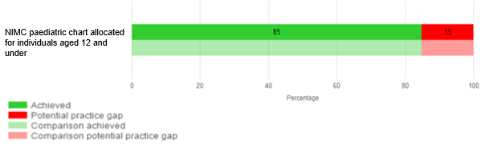

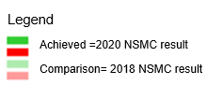

# Findings of the 2020 NSMC national audit

The findings of the 2020 NSMC national audit are presented according to best practice indicators that reflect NSMC safety features.

## Patient identification

Incomplete or illegible patient identification on any page of a medication chart presents a risk that a medicine may be administered to the incorrect patient. The NSMC provides space for patient identification on each page. When a patient identification sticker is used, there is room for the prescriber to confirm the patient’s details by handwriting the patient’s last name.

From the 2020 NSMC national audit, patient identification, on all pages, had a 91% completion rate and 82% of the handwritten patient details were legible and complete (Figure 2). Correct patient identification requires the patient’s full name, address, D.O.B and gender. 33% of individual patient charts had all of these details completed correctly on all pages (Figure 3).

**Figure 2 Components of patient identification completion**

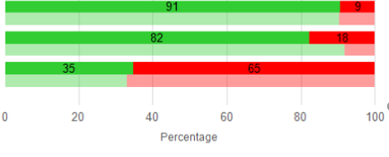

Patient identification section completed on all pages

Handwritten patient details legible and complete

Patient’s name handwritten under patient identification label(s) by first prescriber

**Figure 3 Patient identification completed correctly in full on all pages**

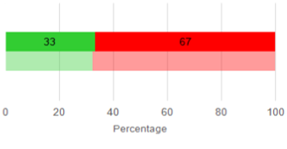

Patient identification completed correctly on all pages

## Prescriber details

On the PBS HMC, full prescriber details are required to confirm the prescriber’s authority to prescribe and to provide contact details if follow up is required.

The 2020 NSMC national audit showed the prescriber details section was legible and complete for 51% of individual PBS HMCs (Figure 4). This is a 12% increase in compliance from the 2018 NSMC national audit and is likely due to increased familiarity with the chart since its implementation in 2016.

**Figure 4 Prescriber details section legible and complete on PBS HMC**

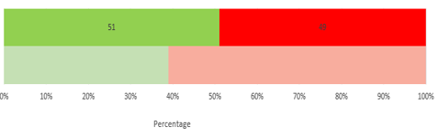

Prescriber details section legible and complete on PBS HMC

## Weight documentation

Dosage errors are one of the most common medication errors in paediatric patients. A current and accurate weight should be available at the point of prescribing so that weight based doses can be calculated. The weight of a child documented on the chart, irrespective of the date, was 85% of NIMC paediatric charts (Figure 5).

The date the weight was recorded is important as a paediatric patient’s weight can change during admission. Out of the 85%, there were 57% of charts that had the date documented with weight.

The 2020 NSMC national audit results showed an 8% improvement in the date of the weight being documented when compared to the 2018 NSMC national audit.

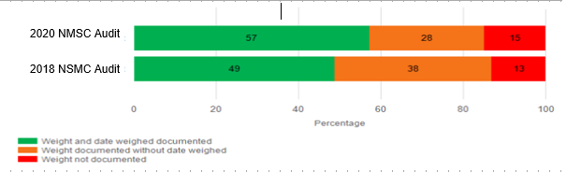**Figure 5 Weight documented on NIMC paediatric charts**

Adverse drug reactions

Complete documentation of adverse drug reaction (ADR) information prevents patient harm. Clinicians can be alerted to avoid prescribing, dispensing or administering a medicine, or similar medicine, that has previously caused an ADR.

Complete and correct ADR details were documented on all charts for 74% of individual patient charts (Figure 6). For patients with a documented ADR, 67% of charts had the medicine and reaction type documented (Figure 7). When ADRs were documented, 58% of charts had the medicine and reaction type recorded with a clinician’s signature.

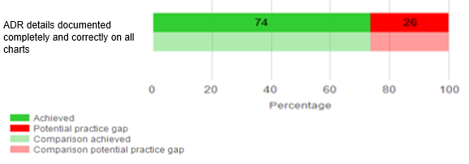**Figure 6 ADR details documented completed and correctly on all charts**

**Figure 7 ADR section and medicine, reaction type, and clinician signature** 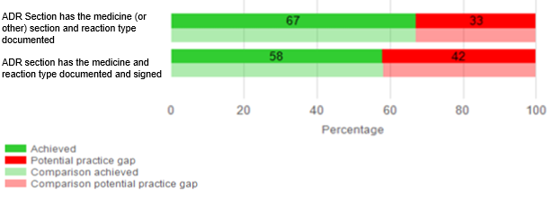

## Medication history

Accurate information on medicines taken prior to admission should be available to clinicians at the point of prescribing. This informs treatment decisions and improves safety and quality of care. Documented medication history details can prevent unintentional medication errors that are common during transitions of care and can cause patient harm. In the acute setting an individual’s medication history can be documented elsewhere, such as in the medication management plan, therefore it is important that this information is cross-referenced on the chart to inform clinicians.

A medication history was documented in 70% of the patient charts audited (Figure 8). Of these, 41% had the medication history documented elsewhere and cross-referenced on the charts. 10% of charts had the medication history documented for the current episode of care (Figure 9), which was a 5% improvement compared to the 2018 NSMC national audit.

**Figure 8 Medication history documentation**

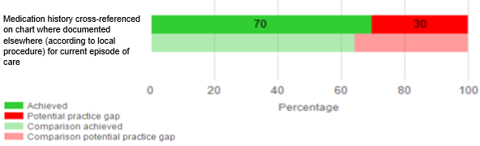

**Figure 9 Medication history cross-referenced when documented elsewhere**

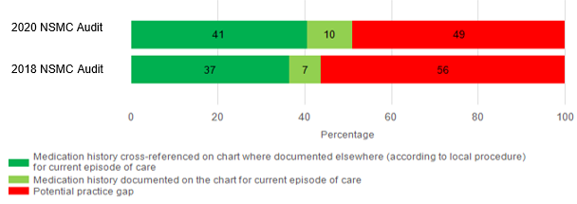

## VTE risk assessment and VTE prophylaxis

Reducing the rate of hospital-associated VTE is a national safety and quality priority. Preventative measures are effective and there is high potential to improve safety and quality.

For the NIMC acute and PBS HMC acute, 11% of charts had a complete VTE risk assessment documented and, where indicated, prophylaxis prescribed (Figure 10). This indicates a potential practice gap with the use of the VTE risk assessment section of the NSMC.

Where VTE prophylaxis was prescribed, 87% of charts showed it was prescribed in the correct VTE prophylaxis order section only (Figure 11).

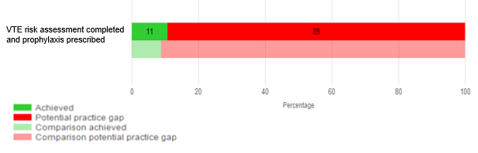**Figure 10 VTE risk assessment completed and prophylaxis prescribed**

**Figure 11 VTE prophylaxis documented in the prophylaxis order section only**

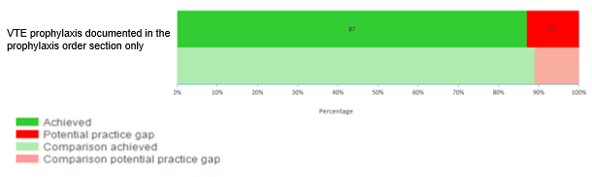

## Pharmaceutical review

Review of a medication chart by pharmacists reduces the risk of patient harm from medication errors. For 45% of charts, pharmaceutical review had been documented at least once on all charts (Figure 12). These results are similar to the 2018 NSMC national audit and suggest a persistent practice gap of undocumented pharmaceutical reviews.

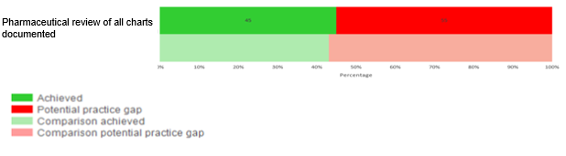 **Figure 12 Pharmaceutical review of all charts documented**

## Chart numbering

Correct chart numbering reduces medication errors and promotes patient safety by ensuring clarity about available clinical information, particularly when multiple charts are in use.

Of all individual patient charts, 62% were correctly numbered (Figure 13) revealing a practice gap for improvement, which has remained unchanged since the 2018 NSMC national audit.

**Figure 13 All charts for patients correctly numbered**

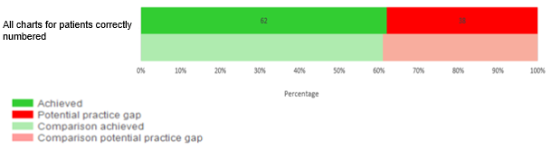

## Anticoagulant education record

There are documented risks with anticoagulant use and all patients receiving therapeutic anticoagulation should be provided with structured verbal and written education. Documentation of this education ensures clinicians are aware that this has been completed.

When a patient was initiated on an anticoagulant for ongoing treatment, 19% of charts had a completed education record (Figure 14), which has remained unchanged since the 2018 NSMC national audit. This is a practice gap related to this NSMC safety feature.

**Figure 14 Anticoagulant education record completed**

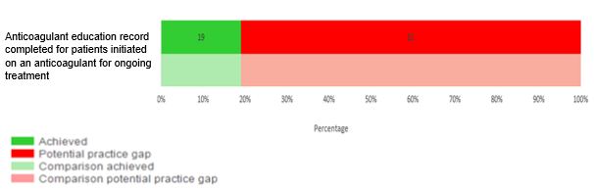

## Medicine orders

An accurate medicine order should be completed to reduce the risk of misinterpretation by clinicians responsible for dispensing, administering and transcribing orders. Intended medicine, formulation, dose, frequency and indication should be included.

Overall, 56% of individual patient charts, had all medicine orders complete and correct. There was varying compliance in each section of the chart:

* 65% of charts had regular medicine orders complete and correct
* 33% of charts had PRN medicine orders complete and correct
* 58% of charts had once only, nurse initiated and phone orders complete and correct
* 56% of charts had variable dose medicine orders complete and correct
* 59% of charts had warfarin orders complete and correct

These results reveal a potential practice gap. This remains similar to the 2018 NSMC national audit, as indicated by the purple triangles (Figure 15).

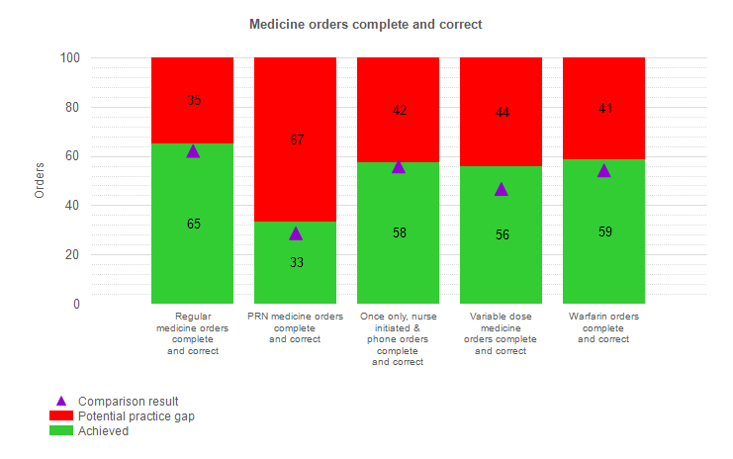**Figure 15 All medicine orders complete and correct by chart section**

## Regular medicine orders

65% of individual regular medicine orders were complete and correct (Figure 16).

Documentation of the therapy indication is important to assist clinicians when making an assessment on the appropriateness of therapy at the point of dispensing, administering and transcribing orders. 30% of regular medicines had an indication documented.

It is important that ensuring the slow-release (SR) box is ticked for medicines that SR. This minimises the risk of an incorrect formulation being dispensed, administered or transcribed. 64% of regular medicine orders had the SR box ticked.

Dosage errors are one of the most common medication errors in paediatric patients. Documenting the dose calculation enables double checking by clinicians involved in the medicines management process. Of the NIMC paediatric individual charts, 76% of regular medicine orders had dose calculations documented.

Appropriate documentation of dose administration or reason for not administering is important to minimise misinterpretation which could lead either to double dosing or omission of a dose. 98% of charts had a recorded dose administration.

Most of these indicators are comparable to the 2018 NSMC national audit, with the exception of a 10% increase in compliance of dose calculations documented on orders in the regular section of the NIMC paediatric chart.

**Figure 16 Regular medicine indicators**

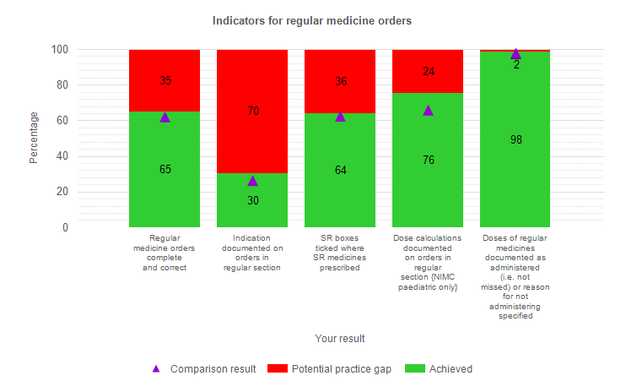

## PRN medicine orders

33% of the PRN medicine orders were complete and correct (Figure 17). 54% of PRN medicines had an indication documented and 51% of medicine orders had dose calculations documented. This is a 15% decrease from the 2018 NSMC national audit.

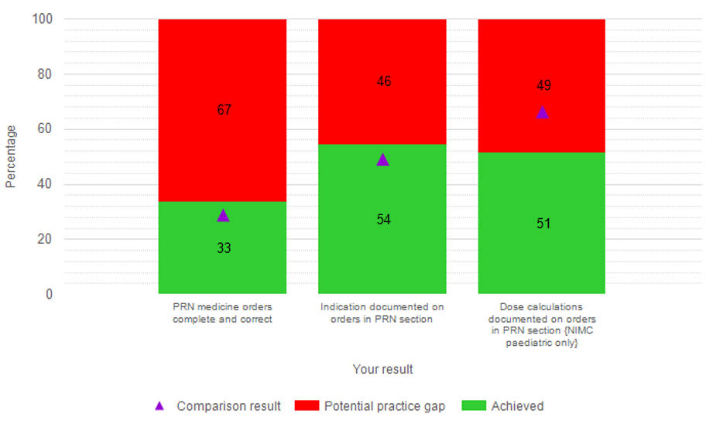**Figure 17 PRN medicine indicators**



## Variable dose medicine orders

Variable dose orders are medications administered at different doses. 56% of these orders were complete and correct (Figure 18). Of the individual charts, 40% of variable dose medicines had an indication documented and 96% had correct documentation.

**Figure 18 Variable dose medicine orders**

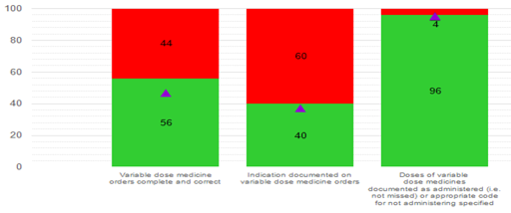



## Warfarin orders

Warfarin is an anticoagulant and has the ability to cause harm. It is important that the warfarin section of the medication chart is properly documented.

59% of warfarin orders were complete and correct (Figure 19). 85% had warfarin ordered in the warfarin section, 76% had a warfarin indication documented and 98% doses were documented as administered or the appropriate code for not administering was specified.

The international normalised ratio (INR) is important to measure as it assesses the effectiveness of the therapy and monitors if dosing is correct for the individual.

86% of INR target ranges were documented and 82% had INR results documented on orders in the warfarin section at least once.

**Figure 19 Indicators of warfarin**

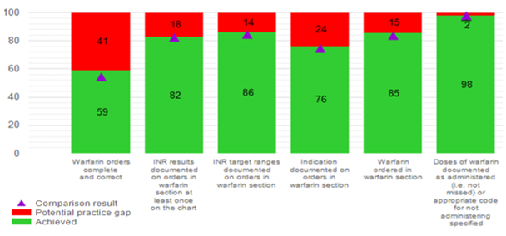

# Discussion

## Breakdown of hospital participation in the audit and responses at the patient level

As mentioned above, the decrease in public hospital participation is likely due to the implementation of EMM systems. There was no clear indication as to why there was an increase in private hospital participation.

The classification of what constitutes a paediatric patient appears to differ across different settings and in some cases does not align with the Commission’s policy, which specifies a paediatric chart is for children 12 and under. Paediatric charts contain specific safety and quality features, such as dosage based on weight. The discrepancies of paediatric charts used compared to the documented age of the patient represents a potential safety risk for paediatric patients who have been allocated an adult chart. (Figure 1).

## Compliance with NSMC safety features

NSMC safety features are known to prevent medicine errors, as previously indicated in Table 2. The 2020 NSMC national audit identified a number of safety features where compliance rate was below 60%:

* All medicine orders are complete and correct
* Patient identification completed correctly on all pages, specifically the first prescriber handwriting the patient’s name under an identification sticker
* Indication documented on regular, variable medicines and PRN
* Dose calculations documented on orders in the PRN section of the NIMC paediatric
* VTE risk assessment completed and, where indicated, prophylaxis prescribed
* Anticoagulant education record completed for patients on an anticoagulant
* Prescriber details section legible and completed on the PBS HMC
* Pharmaceutical review of all charts documented
* Medication history documented on the chart or documented elsewhere and cross-referenced on the chart
* Weight and date child weighed documented on all NIMC paediatric for patients aged 12 years and under

Overall, the results were comparable to 2018 compliance with these NSMC safety features since the 2018 NSMC national audit.

Safety features of the NSMC which had a compliance rate between 60-85%:

* ADR details documented completely and correctly on all charts
* All charts for patients correctly numbered
* SR boxes ticked where SR medicines prescribed
* Dose calculations documented on orders in the regular section of the NIMC paediatric
* Warfarin orders ordered in the warfarin section
* INR results documented on orders in warfarin section at least once on the chart.
* Weight documented, without date, on all NIMC paediatric charts for patients aged 12 years and under

Overall the compliance of these NSMC safety features were similar to the 2018 NSMC national audit. Encouragingly, there was a 10% increase in compliance to the documentation of dose calculations on orders in the regular section of the NIMC paediatric.

NSMC safety features that had compliance rate of >85% were:

* Where VTE prophylaxis has been prescribed, it is prescribed in the VTE prophylaxis order section only
* Doses of medicines documented as administered (that is not missed) or reason for not administering specified

# Limitations

Audit limitations should be considered when interpreting the findings.

## Aggregated data, hospital and patient demographics

Using national aggregated data to compare individual hospital findings is limited due to variable demographics across jurisdictions. With the increased uptake of EMM, participation rates of public hospitals are expected to decline further, limiting the pool of data for analysis.

## Comparison to the NIMC national audit

Comparison to previous NIMC national audits may not be reliable as the patient and hospital demographics vary, hospitals are unmatched across audits. Based on the most recent Australian Institute Health and Welfare data, 2017-185 51% of hospitals in Australia were public. In our sample 73% of hospital participation was public. The overrepresentation of public hospitals in the audit results introduces a bias as it is not a true representative sample.

## Use of a sampling method

Given the size of some facilities the sampling method (as described in Table 1) may have been used. As the complexity and volume of prescribing can vary within a hospital, the use of sampling could influence the findings. Also, as some sections of the NSMC are used less frequently in certain areas or specialities of a hospital, there may be some safety features that are being assessed against limited data.

# Recommendations

## Recommendation 1

**Participating hospitals should share national audit findings with clinicians to drive local review and development of action plans to address areas of sub-optimal performance**

The 2020 NSMC national audit report identifies a number of NSMC safety features where improvement is required. Participating hospitals should determine areas of sub-optimal performance and engage clinicians to drive local improvement.

## Recommendation 2

**Individual hospital sites can utilise the NSMC audit as a quality improvement tool and track their individual performance overtime.**

It is recommended that individual hospital sites utilise the NSMC national audit on a regular basis to identify priority focus areas, implement quality improvement processes and trend improvements. This data can be utilised as evidence for the NSQHS standards, specifically the Medication Safety standard 4 (Appendix 1).

## Recommendation 3

**The Commission should develop an advisory for accreditation agencies to review compliance evidence with the NSMC safety features at hospital sites with paper-based medication charts.**

It is recommended that the Commission appropriately engage with accrediting bodies to inform them of the current compliance levels with the NSMC national audit whereby fifty-three percent of the audit measures fell below 60% compliance. This advisory will require accreditors to review the audit results at individual hospital sites with paper based medication charts.

# Conclusions

The 2018 and 2020 NSMC national audit results had similar trends; however, caution should be exercised when interpreting such trends. The demographic, size and number of participating hospitals is different compared to previous audits. To address this, the Commission will appropriately engage with accrediting bodies. It will specifically require that accreditors assessing hospitals with NSMC charts review the audit outcomes.

The findings of the NSMC national audit indicate an 11% compliance of the to the VTE risk assessment section on the NSMC. There are patient safety benefits for the outcome of a VTE risk assessment to be documented at the point of prescribing. Hospital-acquired VTE is a major cause of morbidity and mortality6. Prevention strategies have been shown to significantly reduce the incidence of VTE by about 70%6. Local organisations should identify their compliance with the VTE risk assessment safety feature and create a quality improvement process to increase compliance.

Use of the NSMC safety feature for anticoagulant education documentation for patients initiated on an anticoagulant was 19%. Local organisations should review their individual findings and consider their use of the anticoagulant education record section.

Standard 4.5 from the NSQHS Standards requires best possible medication history to be documented for patients as early as possible in the episode of care2. The findings from the 2020 NSMC national audit showed that 51% of patients had the medication history documented on the medication chart or elsewhere. This is a 6% increase in compliance when compared to the 2018 NSMC national The NSMC national audit aligns with the NSQHS Medication Safety Standard.

The audit is designed to capture the compliance of safety features that reduce the risk of medication harm to patients. It is encouraged that hospitals utilising paper based medication charts participate in the audit to identify their compliance of safety features and use it to prioritise and drive quality improvement processes.

# Appendices

## Appendix 1 – Best practice indicators linked to NSQHS Standard 4: Medication Safety2 and National QUM Indicators for Australian Hospitals3

| Best practice indicators | | NSQHS  Standard 4 | National QUM Indicators |
| --- | --- | --- | --- |
| **1** | **Patient identification completed correctly on all pages** | 4.1 |  |
| 1.1 | Patient ID section completed on all pages |
| 1.2 | Handwritten patient details legible and complete |
| 1.3 | Patient’s name handwritten under patient identification label(s) by first prescriber |
| **2** | **Prescriber details section legible and complete on PBS HMC** | 4.4 |  |
| 2.1 | All prescribers listed in prescriber details section of PBS HMC |
| **3** | **Weight and date child was weighed documented on all NIMC paediatric for patients aged 12 years and under** | 4.11, 4.13 | 3.4 |
| 3.1 | Weight documented on all NIMC paediatric charts for patients aged 12 years and under (regardless of documentation of date that child was weighed) |
| **4** | **ADR details documented completely and correctly on all charts** | 4.7, 4.8 | 3.2 |
| 4.1 | ADR section has the medicine (or other) section and reaction type documented. |
| 4.2 | ADR section has the medicine and reaction type documented and is signed by person documenting the ADR |
| **5** | **Medication history documented on chart or documented elsewhere and cross-referenced on chart** | 4.5, 4.6, 4.13 | 3.1 |
| 5.1 | Medication history documented on the chart for current episode of care |
| 5.2 | Medication history cross-referenced on chart where documented elsewhere (according to local procedure) for current episode of care |
| **6a** | **VTE risk assessment completed and where indicated prophylaxis prescribed** | 4.15 | 1.1 |
| 6a.1 | VTE prophylaxis prescribed (in the VTE prophylaxis order section, regular medicines section or both) where indicated |
| 6a.2 | VTE prophylaxis prescribed in VTE prophylaxis order section only |
| **7** | **Pharmaceutical review of all charts documented** | 4.10 | 6.2 |
| **8** | **All charts for patients correctly numbered** | 4.1, 4.13 |  |
| **9** | **Anticoagulant education record completed for patients initiated on an anticoagulant for ongoing treatment** | 4.3, 4.11, 4.15 | 5.4 |
| **10a** | **Regular medicine orders complete and correct** | 4.1, 4.15 | 3.3 |
| 10a.1 | Orders are legible |
| 10a.2 | Orders do not contain error-prone abbreviations |
| 10a.3 | Medicine name complete and correct on orders |
| 10a.4 | Route complete and correct on orders |
| 10a.5 | Dose complete and correct on orders |
| 10a.6 | Frequency complete and correct on orders |
| 10a.7 | Prescriber name legible on the chart |
| 10a.8 | Orders signed by prescriber |
| **10b** | **Indication documented on orders in regular section** | 4.1, 4.15 | 3.3 |
| **10c** | **SR boxes ticked where SR medicines prescribed** | 4.1, 4.13 |  |
| **10d** | **Dose calculations documented on orders in regular section** | 4.1, 4.11, 4.13 | 3.4 |
| **10e** | **Doses of regular medicines documented as administered (i.e. not missed) or reason for not administering specified** | 4.1, 4.13 |  |
| **11a** | **PRN medicine orders complete and correct** | 4.1, 4.15 | 3.3 |
| 11a.1 | Orders are legible |
| 11a.2 | Orders do not contain error-prone abbreviations |
| 11a.3 | Medicine name complete and correct on orders |
| 11a.4 | Route complete and correct on orders |
| 11a.5 | Dose complete and correct on orders |
| 11a.6 | Hourly frequency complete and correct on orders |
| 11a.7 | Prescriber name legible on the chart |
| 11a.8 | Orders signed by prescriber |
| 11a.9 | Maximum PRN dose in 24 hours documented on orders |
| **11b** | **Indication documented on orders in PRN section** | 4.1, 4.15 | 3.3 |
| **11c** | **Dose calculations documented on orders in PRN section.** | 4.1, 4.11, 4.13 | 3.4 |
| **12a** | **Once only, nurse initiated & phone orders complete and correct** | 4.1, 4.15 | 3.3 |
| 12a.1 | Orders are legible |
| 12a.2 | Orders do not contain error-prone abbreviations |
| 12a.3 | Medicine name complete and correct on orders |
| 12a.4 | Route complete and correct on orders |
| 12a.5 | Dose complete and correct on orders |
| 12a.6 | Frequency complete and correct on orders (phone orders only) |
| 12a.7 | Double signatures complete on orders (phone orders only) |
| 12a.8 | Prescriber name legible on the chart |
| 12a.9 | Orders signed by prescriber |
| **12b** | **Doses of once only, nurse initiated & phone orders documented as administered (i.e. not missed) or appropriate code for not administering specified** | 4.1, 4.13 |  |
| **13a** | **Variable dose medicine orders complete and correct** | 4.1, 4.15 | 3.3 |
| 13a.1 | Orders are legible |
| 13a.2 | Orders do not contain error-prone abbreviations |
| 13a.3 | Medicine name complete and correct on orders |
| 13a.4 | Route complete and correct on orders |
| 13a.5 | Dose complete and correct for each day of administration on orders |
| 13a.6 | Frequency complete and correct on orders |
| 13a.7 | Time to be given documented on orders |
| 13a.8 | Prescriber name legible on the chart |
| 13a.9 | Orders signed by prescriber |
| **13b** | **Indication documented on variable dose medicine orders** | 4.1, 4.15 | 3.3 |
| **13c** | **Doses of variable dose medicines documented as administered (i.e. not missed) or appropriate code for not administering specified** | 4.1, 4.11, 4.13 | 3.4 |
| **14a** | **Warfarin orders complete and correct** | 4.1, 4.15 | 3.3 |
| 14a.1 | Orders are legible |
| 14a.2 | Orders do not contain error-prone abbreviations |
| 14a.3 | Brand name selected on orders |
| 14a.4 | Route complete and correct on orders |
| 14a.5 | Prescriber name legible on the chart |
| 14a.6 | Orders signed by prescriber |
| 14a.7 | Daily doses of warfarin documented and signed on orders |
| **14b** | **INR results documented on orders in warfarin section at least once on the chart** | 4.1, 4.13, 4.15 | 5.4 |
| **14c** | **INR target ranges documented on orders in warfarin section** | 4.1, 4.13, 4.15 | 5.4 |
| **14d** | **Indication documented on orders in warfarin section** | 4.1, 4.15 | 3.3 |
| **14e** | **Doses of warfarin documented as administered (i.e. not missed) or appropriate code for not administering specified** | 4.1, 4.13 |  |
| **14f** | **Warfarin ordered in warfarin section** | 4.1, 4.13, 4.15 | 5.4 |

# References

1. Australian Commission on Safety and Quality in Health Care. National Standard Medication Chart - National audit summary report 2018. Sydney; 2019.

2. Australian Commission on Safety and Quality in Health Care. National Safety and Quality Health Service Standards. 2nd ed. Sydney; 2017.

3. Australian Commission on Safety and Quality in Health Care and NSW Therapeutic Advisory Group Inc. National Quality Use of Medicines Indicators for Australian Hospitals. Sydney; 2014.

4. Australian Commission on Safety and Quality in Health Care. ACSQHC Strategic Intent 2020-2025. Sydney; 2020.

5. Australian Institute of Health and Welfare. Hospital resources 2017–18: Australian hospital statistics [Internet]. Canberra: Australian Institute of Health and Welfare, 2019 [cited 2021 May. 11]. Available from: https://www.aihw.gov.au/reports/hospitals/hospital-resources-2017-18-ahs

6. Australian Commission on Safety and Quality in Health Care. Venous Thromboembolism Prevention Clinical Care Standard. Sydney; 2018.

# Acknowledgements

This report was developed following the contribution of many individuals and organisations who freely gave their time and expertise to contribute to the development of the NSMC national audit. In particular, the Commission thanks the participating hospitals and auditors for gathering and submitting data for the audit.

1. § https://nsmc.safetyandquality.gov.au/Login/?ReturnUrl=%2fUI%2f