# Australian Commission on Safety and Quality in Health Care logo with Radar imageOn the Radar

Issue 521

26 July 2021

*On the Radar* is a summary of some of the recent publications in the areas of safety and quality in health care. Inclusion in this document is not an endorsement or recommendation of any publication or provider. Access to particular documents may depend on whether they are Open Access or not, and/or your individual or institutional access to subscription sites/services. Material that may require subscription is included as it is considered relevant.

*On the Radar* is available online, via email or as a PDF or Word document from <https://www.safetyandquality.gov.au/publications-and-resources/newsletters/radar>

If you would like to receive *On the Radar* via email, you can subscribe on our website <https://www.safetyandquality.gov.au/publications-and-resources/newsletters>  
or by emailing us at H[Umail@safetyandquality.gov.auU](mailto:mail@safetyandquality.gov.au).   
You can also send feedback and comments to H[Umail@safetyandquality.gov.auU](mailto:mail@safetyandquality.gov.au).

For information about the Commission and its programs and publications, please visit <https://www.safetyandquality.gov.au>

You can also follow us on Twitter @ACSQHC.

**On the Radar**

Editor: Dr Niall Johnson [niall.johnson@safetyandquality.gov.au](mailto:niall.johnson@safetyandquality.gov.au)

Contributors: Niall Johnson, Meredith Page

**Reports**

*Aboriginal people’s experiences of hospital care*

The Insight series

Bureau of Health Information.

Sydney: BHI; 2021. p. 60.

|  |  |
| --- | --- |
| URL | <https://www.bhi.nsw.gov.au/BHI_reports/Insights_Series/Aboriginal-peoples-experiences-of-hospital-care> |
| Notes | It has been observed that while safety and quality issues can affect anyone, certain populations have been more vulnerable than others. This report from the NSW Bureau of Health Information (BHI) draws on the feedback of more than 3,000 Aboriginal patients admitted to hospital and almost 300 women who received maternity care in 2019 alone, along with feedback gathered in previous years, in order to gain insights including comparisons of Aboriginal and non-Aboriginal people’s experiences of care, and for Aboriginal patients, differences between rural and urban experiences, trends over time and the importance of Aboriginal Health Workers in delivering their care. While there have been improvements there are still issues identified in the feedback on the experiences of care. |

*Understanding integration: how to listen to and learn from people and communities*

Thorstensen-Woll C, Wellings D, Crump H, Graham C

London: The King's Fund and Picker Institute Europe; 2021. p. 34.

|  |  |
| --- | --- |
| URL | <https://www.kingsfund.org.uk/publications/understanding-integration-listen-people-communities> |
| Notes | This latest report from The King’s Fund in the UK adds to their material on integrated care. As is noted, ‘The aim of integrated care is to improve people’s outcomes and experiences of care by bringing services together around people and communities. This means addressing the fragmentation of services and lack of co-ordination that people often experience by providing person-centred, joined-up care.’ This guide seeks to provide practical guidance on how integrated care systems can listen to and learn from people and communities so as to develop and deliver integrate care that works for their patient populations. |

**Journal articles**

*The health and educational costs of preterm birth to 18 years of age in Australia*

Newnham JP, Schilling C, Petrou S, Morris JM, Wallace EM, Brown K, et al

Australian and New Zealand Journal of Obstetrics and Gynaecology. 2021 [epub].

|  |  |
| --- | --- |
| DOI | <https://doi.org/10.1111/ajo.13405> |
| Notes | Last week’s issue of *On the Radar* featured three studies that examined short and long-term outcomes associated with pre-term and early-term births. Adding to our understanding of societal impacts of preterm births, Newnham et al report the estimated costs for the first 18 years of life of births at less than 37 weeks’ gestation. The study used a decision-analytical model to estimate the costs of pre-term birth for a hypothetical cohort of 314 814 children, the number of live births in 2016. The study found that the overall cost to the Australian Government each year of preterm birth up to the age of 18 years was $1.4 billion. Reducing Australia’s rate of pre-term birth by 10% would potentially save $140 million a year, with education costs accounting for one quarter of these savings. The authors concluded that ‘Prevention of a reasonable proportion of untimely preterm births is now possible, and these data need to be applied when decisions are made to allocate resources to prevention and treatment interventions.’ To read about Australia’s rates of potentially avoidable early planned births in *The Fourth Australian Atlas of Healthcare Variation* visit <http://www.safetyandquality.gov.au/fourth-atlas-2021> |

*Effects of night surgery on postoperative mortality and morbidity: a multicentre cohort study*

Althoff FC, Wachtendorf LJ, Rostin P, Santer P, Schaefer MS, Xu X, et al

BMJ Quality & Safety. 2021;30(8):678-688.

|  |  |
| --- | --- |
| DOI | <https://doi.org/10.1136/bmjqs-2020-011684> |
| Notes | The timing of surgery (time of day, day of the week, etc.) has been suggested to influence the outcomes of surgery. However, there is a large contested literature on this. This paper is the latest addition and looks at the influence of night-time surgery (between 5pm and 7am) on outcomes. This was a multicentre retrospective cohort study of adult patients undergoing non-cardiac surgery with general anaesthesia at two major, competing tertiary care hospital networks in the USA that covered 350,235 patients. The authors report that the **mortality rate** was **0.9%** (n=2804/322 327) **after day surgery** and **3.4%** (n=940/27 908) **after night surgery**. **Night surgery** was associated with an **increased risk of mortality** (ORadj 1.26), **increased morbidity** (ORadj 1.41), and the proportion of patients receiving intraoperative blood transfusion and anaesthesia handovers were higher during night-time. |

*Low value care is a health hazard that calls for patient empowerment*

Scott IA, Elshaug AG, Fox M

Medical Journal of Australia. 2021 [epub].

|  |  |
| --- | --- |
| DOI | <https://doi.org/10.5694/mja2.51168> |
| Notes | Low value care has been something of a recurring topic for On the Radar over the years. This piece in the *Medical Journal of Australia* rehearses many of the arguments around ow value care but also focuses on the role of the patient in addressing it. The authors emphasise that low value care is a risk to the patient as they not only bear the cost (at least partially) but they bear the burden of negative consequences. The informed patient who engages in shared decision making with their clinicians can help ensure that appropriate choices are made.  This piece, written by a clinician, an academic and a consumer advocate, advocates for patients to be encouraged to ask these questions:   * Is there a decision we need to make? In urgent situations, clinicians may need to reach out and not wait for patients to ask. * What are my options? All clinically viable options should be presented, including doing nothing. * What are potential benefits and harms of each option? Where possible, these should be expressed using natural numbers (e.g., four out of 100 people like you will experience a stroke every year; this treatment will reduce that to two out of 100, although one person of 100 will have a significant bleeding event). * How will each option affect me in terms of what I consider important? Patients may want to know costs involved, duration of inability to work or perform social activities, skill and place of those performing a procedure. |

For information on the Commission’s shared decision making, see <https://www.safetyandquality.gov.au/our-work/partnering-consumers/shared-decision-making>

*How do health services engage culturally and linguistically diverse consumers? An analysis of consumer engagement frameworks in Australia*

Chauhan A, Walpola RL, Manias E, Seale H, Walton M, Wilson C, et al

Health Expectations. 2021 [epub].

|  |  |
| --- | --- |
| DOI | <https://doi.org/10.1111/hex.13315> |
| Notes | One of the challenges of the COVID-19 pandemic in Australia has been the rapid and accurate dissemination of information to the wider population. This has been seen to be difficult in a number of lockdowns, particularly in getting information to some populations where information has not been provided in the community languages. This paper looked at how various ‘engagement frameworks’ used in Australian health systems have been ‘conceptualised and operationalized’ with a viewing to determining ‘the implications of current consumer engagement frameworks for engagement with CALD [culturally and linguistically diverse] consumers.’  The authors identified 11 such engagement frameworks that had been published between 2007 and 2019. On analysis it was found that only four of the frameworks explicitly addressed engagement with CALD consumers. Where CALD consumers were a focus, it tended to centre on community languages rather than the issue of culturally sensitive health services. The authors suggest that ‘Health services and policy makers can enhance opportunities for engagement with CALD consumers by being flexible in their approach, implementing policies for reimbursement for participation and evaluating and adapting the activities of engagement in collaboration with CALD consumers.’ |

For information on the Commission’s work on partnering with consumers, see <https://www.safetyandquality.gov.au/our-work/partnering-consumers>

*Co-produced capability framework for successful patient and staff partnerships in healthcare quality improvement: results of a scoping review*

Cox R, Molineux M, Kendall M, Tanner B, Miller E

BMJ Quality & Safety. 2021 [epub].

|  |  |
| --- | --- |
| DOI | <https://doi.org/10.1136/bmjqs-2020-012729> |
| Notes | Another Australian paper looking at frameworks for engaging patients, in this instance frameworks for engaging patients and healthcare workers in quality improvement. It’s been observed that even in the wake of sever or tragic events, patients and their families are keen to support improvement and prevent future adverse events.  This scoping review examined 49 papers but found that ‘Very little peer-reviewed literature focused explicitly on capabilities for QI partnerships’. The authors have developed a ‘Capability framework for successful partnerships in healthcare quality improvement’. This framework includes ‘knowledge, skills and attitudes across three capability domains: Personal Attributes; Relationships and Communication; and Philosophies, Models and Practices, and incorporates 10 capabilities. Sharing power and leadership was discussed in many papers as fundamental and was positioned across all of the domains.’ The authors hope that their framework ‘could guide individualised development or learning plans for patient partners and staff, or could assist organisations to review learning topics and approaches such as training content, mentoring guidelines or community of practice agendas.’ |

*A team mental model approach to understanding team effectiveness in an emergency department: A qualitative study*

Wise S, Duffield C, Fry M, Roche M

Journal of Health Services Research & Policy. 2021:13558196211031285.

|  |  |
| --- | --- |
| DOI | <https://doi.org/10.1177%2F13558196211031285> |
| Notes | Health care is s team sport is a truism that has been recognised for many years now. The myth of the heroic lone medic has lapsed. However, getting people to actually adopt a team approach is not always easy and some settings are perhaps particularly difficult. In some instances it’s not so much a team as a chain along which a patient is passed from one to another. This article describes ‘how the team mental model concept can broaden our understanding of team effectiveness in health care …and the workplace conditions that sustain it in a metropolitan emergency department (ED) in Sydney’. Drawing on the experiences of 19 ED clinicians (registered nurses, doctors and nurse practitioners), the authors assert that   * Team effectiveness not only relied on how well team members coordinate, but also their ability to perform their own role effectively and efficiently. * Three workplace conditions were identified as enablers to individuals acquiring the knowledge needed to work effectively in the team: **stability** in team membership; **workplace experience**; and the **spatial-temporal conditions** of emergency work where permanent emergency doctors and nurses executed their tasks concurrently, regularly interacted and shared a common goal.   The authors observe that ‘Getting health care teams ‘on the same page’ is a long-standing challenge. This study suggests that solutions may lay in the organisation of health care work, creating team stability and opportunities for team members to interact that allows a team mental model to emerge.’ |

*Medication Safety in Mental Health Hospitals: A Mixed-Methods Analysis of Incidents Reported to the National Reporting and Learning System*

Alshehri GH, Keers RN, Carson-Stevens A, Ashcroft DM

Journal of Patient Safety. 2021;17(5):341-351.

|  |  |
| --- | --- |
| DOI | <https://doi.org/10.1097/PTS.0000000000000815> |
| Notes | Analysis of National Reporting and Learning System data in England and Wales in 2010 to 2017 covering 94,134 **medication incident reports in mental health hospitals**. The authors report that of the 94,134 reported incidents, ‘**10.4%** (n = 9811) were reported to have **resulted in harm’**. They go on to report that:   * The 3 most frequent types of reported medication incidents involved **omission of medication** (17,302; 18.3%), **wrong frequency** (11,882; 12.6%), and **wrong/unclear dose** of medication (10,272; 10.9%). * Medicines from the central nervous system (42,609; 71.0%), cardiovascular (4537; 7.6%), and endocrine (3669; 6.1%) medication classes were the most frequently involved with incidents. * Failure to follow protocols (n = 93), lack of continuity of care (n = 92), patient behaviours (n = 62), and lack of stock (n = 51) were frequently reported as contributory factors.’   This study appears to follow up 2017 (<https://doi.org/10.1007/s40264-017-0557-7>) and 2020 papers (<http://doi.org/10.1371/journal.pone.0228868>) authored by some of the same people.  The 2017 paper was a systematic review examining the literature on medication errors (MEs) and adverse drug events (ADEs) that occur in mental health hospitals. In the 20 studies identified the authors report the rate of medication errors ranged from 10.6 to 17.5 per 1000 patient-days) and of adverse drug events from 10.0 to 42.0 per 1000 patient-days with 13.0–17.3% of ADEs found to be preventable.  The 2020 paper reported on a study of medication omission errors in two English National Health Service mental health trusts with 9 psychiatric hospitals. In examining 18,664 scheduled medication doses for 444 inpatients they found:   * 2,717 omissions, resulting in a rate of 14.6% (95% CI 14.1–15.1). * The rate of ‘time critical’ omitted doses was 19.3% (95% CI 16.3–22.6%). ‘Preventable’ omitted doses comprised one third of all omissions (34.5%, 930/2694). |

*The Impact of Electronic Health Records and Meaningful Use on Inpatient Quality*

Trout KE, Chen L-W, Wilson FA, Tak HJ, Palm D

The Journal for Healthcare Quality (JHQ). 2021 [epub].

|  |  |
| --- | --- |
| DOI | <https://doi.org/10.1097/JHQ.0000000000000314> |
| Notes | Demonstrating the impact and extent of an intervention on the safety and quality of care can be rather difficult. This can be due to the myriad of factors that influence care delivery and the difficultly of actually measuring those impacts.  Notwithstanding this, this paper reports on an attempt to determine the impact of electronic health records (EHRs) and the “meaningful Use” (MU) approach to them in the USA on inpatient quality. The study used inpatient hospitalisation data, the American Hospital Association annual survey data, and the US Centers for Medicare and Medicaid Services attestation records to study the impact of EHRs on inpatient quality composite scores. The authors report finding that ‘EHRs that attested to MU had a positive impact on the quality scores, with an 8% decrease in composites for mortality for selected procedures and 18% decrease in composites for mortality for selected conditions. |

*Efficacy, acceptability, and safety of muscle relaxants for adults with non-specific low back pain: systematic review and meta-analysis*

Cashin AG, Folly T, Bagg MK, Wewege MA, Jones MD, Ferraro MC, et al.

BMJ. 2021;374:n1446.

*Effectiveness of a multifaceted intervention to improve emergency department care of low back pain: a stepped-wedge, cluster-randomised trial*

Coombs DM, Machado GC, Richards B, Needs C, Buchbinder R, Harris IA, et al

BMJ Quality & Safety. 2021 [epub].

*Development of a Patient-Oriented Intervention to Support Patient-Provider Conversations about Unnecessary Lower Back Pain Imaging*

Madani Larijani M, Dumba C, Thiessen H, Palen A, Carr T, Vanstone JR, et al

International Journal of Environmental Research and Public Health. 2021;18(5).

*Appropriateness of Imaging Decisions for Low Back Pain Presenting to the Emergency Department: A Retrospective Chart Review Study*

Traeger A, Machado GC, Bath S, Tran M, Roper L, Oliveira C, et al

International Journal for Quality in Health Care. 2021 [epub].

*Low Back Pain*

Traeger AC, Qaseem A, McAuley JH

JAMA. 2021;326(3):286-286.

|  |  |
| --- | --- |
| DOI | Cashin et al <https://doi.org/10.1136/bmj.n1446>  Coombs et al <https://doi.org/10.1136/bmjqs-2020-012337>  Madani Larijani et al <https://doi.org/10.3390/ijerph18052786>  Traeger, Machado et al <https://doi.org/10.1093/intqhc/mzab103>  Traeger, Qaseem and McAuley <https://doi.org/10.1001/jama.2020.19715> |
| Notes | Low back pain is an extremely common condition and one which generates a lot of discussion and literature – a small sample of the recent literature identified here. Much of the discussion in recent years has about the value – or lack thereof – of various treatments.  Tregear, Qaseem and McAuley offer a distillation of current thinking in the “Patient Page” in *JAMA*.  [Treatment options for low back pain](https://doi.org/10.1001/jama.2020.19715) |

*BMJ Quality & Safety*

August 2021 - Volume 30 - 8

|  |  |
| --- | --- |
| URL | <https://qualitysafety.bmj.com/content/30/8> |
| Notes | A new issue of *BMJ Quality & Safety* has been published. Many of the papers in this issue have been referred to in previous editions of *On the Radar* (when they were released online). Articles in this issue of *BMJ Quality & Safety* include:   * Editorial: Time out! **Rethinking surgical safety**: more than just a checklist (Matthew B Weinger) * Editorial**: Paving the PICC journey**: building structures, process and engagement to improve outcomes (Mohamad Fakih, Lisa Sturm) * **Timeout procedure in paediatric surgery**: effective tool or lip service? A randomised prospective observational study (Oliver J Muensterer, Hendrik Kreutz, Alicia Poplawski, Jan Goedeke) * Comparing **peripherally inserted central catheter**-related practices across hospitals with different insertion models: a multisite qualitative study (Sarah L Krein, Molly Harrod, Lauren E Weston, Brittani R Garlick, Martha Quinn, Kathlyn E Fletcher, Vineet Chopra) * **Chronic hospital nurse understaffing meets COVID-19**: an observational study (1Karen B Lasater, Linda H Aiken, Douglas M Sloane, Rachel French, Brendan Martin, Kyrani Reneau, Maryann Alexander, Matthew D McHugh) * Differences in t**ransitional care processes** among high-performing and low-performing hospital-SNF pairs: a rapid ethnographic approach (Kirstin A Manges, Roman Ayele, Chelsea Leonard, M Lee, E Galenbeck, R E Burke) * The cost of improving care: a multisite economic analysis of hospital resource use for implementing recommended **postpartum contraception programmes** (Vivian B Ling, Erika E Levi, Amy R Harrington, Nikki B Zite, Saul D Rivas, Vanessa K Dalton, Roger Smith, Michelle H Moniz) * Variation in the design of **Do Not Resuscitate orders and other code status options**: a multi-institutional qualitative study (Jason N Batten, Jacob A Blythe, Sarah Wieten, Miriam Piven Cotler, Joshua B Kayser, Karin Porter-Williamson, Stephanie Harman, Elizabeth Dzeng, David Magnus) * Effects of **night surgery on postoperative mortality and morbidity**: a multicentre cohort study (Friederike C Althoff, Luca J Wachtendorf, Paul Rostin, Peter Santer, Maximilian S Schaefer, Xinling Xu, Stephanie D Grabitz, Hovig Chitilian, Timothy T Houle, Gabriel A Brat, O Akeju, M Eikermann) |

*Journal of Patient Safety*

Vol. 17, No. 5, August 2021

|  |  |
| --- | --- |
| URL | <https://journals.lww.com/journalpatientsafety/toc/2021/08000> |
| Notes | A new issue of the *Journal of Patient Safety* has been published. Articles in this issue of the *Journal of Patient Safety* include:   * **Support for Healthcare Professionals After Surgical Patient Safety Incidents**: A Qualitative Descriptive Study in 5 Teaching Hospitals (Naresh Serou, Andy K Husband, Simon P Forrest, Robert D Slight, Sarah P Slight) * **Medication Safety in Mental Health Hospitals**: A Mixed-Methods Analysis of Incidents Reported to the National Reporting and Learning System (Ghadah H Alshehri, Richard N Keers, A Carson-Stevens, D M Ashcroft) * **Quantitative Neuromuscular Monitoring** With Train-of-Four Ratio During Elective Surgery: A Prospective, Observational Study (Mustafa Azizoglu, Levent Özdemir) * **Medical Students Raising Concerns** (Maralyn R Druce, Andrea Hickey, Anthony N Warrens, Olwyn M R Westwood) * **Making Residents Part of the Safety Culture**: Improving Error Reporting and Reducing Harms (Michael D Fox, Gregory M Bump, Gabriella A Butler, Ling-Wan Chen, Andrew R Buchert) * **30-Day Potentially Avoidable Readmissions Due to Adverse Drug Events** (Olivia Dalleur, Patrick E. Beeler, Jeffrey L. Schnipper, J Donzé) * The Patients’ Perspective: **Hematological Cancer Patients’ Experiences of Adverse Events** as Part of Care (Jamie Bryant, Mariko Carey, Rob Sanson-Fisher, Heidi Turon, Andrew Wei, Bryone Kuss) * **Communication Training, Adverse Events, and Quality Measures**: 2 Retrospective Database Analyses in Washington State Hospitals (Ian R Slade, Sara J Beck, C Bradley Kramer, Rebecca G Symons, Michael Cusumano, David R Flum, Thomas H Gallagher, Emily Beth Devine) * **Changes to Hospital Inpatient Volume After Newspaper Reporting of Medical Errors** (Haruhisa Fukuda) * A Systematic Review of Measurement Tools for the **Proactive Assessment of Patient Safety in General Practice** (Sinéad Lydon, Margaret E Cupples, Andrew W Murphy, Nigel Hart, Paul O'Connor) * Validating **Fall Prevention Icons** to Support Patient-Centered Education (Wai Yin Leung, Jason Adelman, David W Bates, Alexandra Businger, John S Dykes, Awatef Ergai, Ann Hurley, Zachary Katsulis, Sarah Khorasani, Maureen Scanlan, Laura Schenkel, Amisha Rai, Patricia C Dykes) * **Suicide and Suicide Attempts on Hospital Grounds and Clinic Areas** (Peter D Mills, Bradley V Watts, Robin R Hemphill) * **Medication Safety in Two Intensive Care Units** of a Community Teaching Hospital After Electronic Health Record Implementation: Sociotechnical and Human Factors Engineering Considerations (Pascale Carayon, Tosha B Wetterneck, Randi Cartmill, Mary Ann Blosky, Roger Brown, Peter Hoonakker, Robert Kim, Sandeep Kukreja, Mark Johnson, Bonnie L Paris, Kenneth E Wood, James M Walker) * Defining **Potentially Preventable Adverse Outcomes in Medicare Elective Lung Resections** (Donald E Fry, Michael Pine, Susan M Nedza, David G Locke, Agnes M Reband, Gregory Pine) * Effects of a Brief Team Training Program on **Surgical Teams’ Nontechnical Skills**: An Interrupted Time-Series Study (Brigid M Gillespie, E Harbeck, E Kang, C Steel, N Fairweather, K Panuwatwanich, W Chaboyer) * **Motivating Physicians to Report Adverse Medical Events** in China: Stick or Carrot? (Yajiong Xue, Jing Yang, Jing Zhang, M Luo, Z Zhang, H Liang) * Evaluating the Impact of **Radio Frequency Identification Retained Surgical Instruments Tracking on Patient Safety**: Literature Review (Kumiko O Schnock, B Biggs, A Fladger, D W Bates, Ronen Rozenblum) * **Reducing Surgery Scheduling Errors** in Multihospital System (Donna S Watson, Cynthia F Corbett, Gail Oneal, Kenn B Daratha) * **Putting the Patient in Patient Safety Investigations**: Barriers and Strategies for Involvement (Isolde Martina Busch, Ankita Saxena, Albert W Wu) * Development of the Barriers to **Error Disclosure Assessment Tool** (Darlene Welsh, Dominique Zephyr, Andrea L Pfeifle, D E Carr, J L Fink, III, M Jones) * Effectiveness of **Pharmacist Intervention to Reduce Medication Errors and Health-Care Resources Utilization After Transitions of Care**: A Meta-analysis of Randomized Controlled Trials (Gildasio S De Oliveira, Jr, Lucas J Castro-Alves, Mark C Kendall, Robert McCarthy) * **Patient Safety Incidents and Adverse Events in Ambulatory Dental Care**: A Systematic Scoping Review (Eduardo Ensaldo-Carrasco, Milton Fabian Suarez-Ortegon, Andrew Carson-Stevens, K Cresswell, R Bedi, A Sheikh) * Patients’ and Care Partners’ Perspectives on **Dignity and Respect During Acute Care Hospitalization** (Priscilla K Gazarian, Constance R C Morrison, Lisa Soleymani Lehmann, Orly Tamir, David W Bates, Ronen Rozenblum) * **Burnout and Work Engagement Among US Dentists** (Jean Marie Calvo, Japneet Kwatra, Alfa Yansane, O Tokede, R C Gorter, E Kalenderian) |

*Healthcare Quarterly*

Volume 24, Number 2, 2021

|  |  |
| --- | --- |
| URL | <https://www.longwoods.com/publications/healthcare-quarterly/26506/1/vol.-24-no.-2-2021> |
| Notes | A new issue of *Healthcare Quarterly* has been published. Articles in this issue of *Healthcare Quarterly* include:   * The **Role of a Resilient Information Infrastructure in COVID-19 Vaccine Uptake** in Ontario (Raquel Duchen, Carina Iskander, Hannah Chung, J Michael Paterson, Jeffrey C Kwong, Susan E Bronskill, Laura Rosella and Astrid Guttmann) * **Impact of the COVID-19 Pandemic on Health System Use** in Canada (Alexey Dudevich and Jennifer Frood) * **COVID-19, Workforce Autonomy and the Health Supply Chain** (Anne W Snowdon and Michael Saunders) * **Health Professional Redeployment and Cross-Training** in Response to the COVID-19 Pandemic )Lisa A S Walker, Amanda J Pontefract and Debra A Bournes) * Do Not Waste a Crisis: **Physician Engagement during the COVID-19 Pandemic** (Meiqi Guo, Richard Dunbar-Yaffe, Erin Bearss, Sabrina Lim-Reinders and Christine Soong) * **Mental Health Clinician Leaders in “Lockstep” as a Necessary Means to Address Care Challenges** during the Pandemic (Gillian Strudwick and Vicky Stergiopoulos) * Helping Families Thrive: Co-Designing a Program to **Support Parents of Children with Medical Complexity** (Chantal Krantz, Michel Hynes, Amélie DesLauriers, Lillian L. Kitcher, Teresa MacMillan, Diane Parad... * Utilizing the Failure Mode and Effects Analysis Tool to Assess and Address **Risks Associated with Transitions in Care** (Sarah Corkey and Terry Holland) * The Relationship between **Value-Based Care, Workforce Engagement and Clinical Leadership**: Learning from an Outpatient Physiotherapy Team (Michelle Smart and Penelope O’Gorman) |

*BMJ Quality & Safety* online first articles

|  |  |
| --- | --- |
| URL | <https://qualitysafety.bmj.com/content/early/recent> |
| Notes | *BMJ Quality &Safety* has published a number of ‘online first’ articles, including:   * Editorial: Have we forgotten the **moral justification for patient-centred care**? (Grant Russell) * Editorial: **Antibiotic overuse**: managing uncertainty and mitigating against overtreatment (Carolyn Tarrant, Eva M Krockow) * Editorial: **Measuring overuse**: a deceptively complicated endeavour (Christine Soong, Scott M Wright) * **Barcode medication administration technology** use in hospital practice: a mixed-methods observational study of policy deviations (Alma Mulac, Liv Mathiesen, Katja Taxis, Anne Gerd Granås) |

*International Journal for Quality in Health Care* online first articles

|  |  |
| --- | --- |
| URL | <https://academic.oup.com/intqhc/advance-articles> |
| Notes | *International Journal for Quality in Health Care* has published a number of ‘online first’ articles, including:   * Home Before Hospital: A Whole of System Re-Design Project to Improve Rates of **Home–Based Dialysis Therapy**: Experience and Outcomes Over 8 Years (Omar Tombocon, Peter Tregaskis, Catherine Reid, Daniella Chiappetta, Kethly Fallon, Susannah Jackson, Fiona Frawley, Dianne Peart, Ann Weston, Kim Wong, Leanne Palaster, Robert Flanc, Sandra MacDonald, Scott Wilson, Rowan Walker) * What Makes a Good **Quality Indicator Set**? A Systematic Review of Criteria (Laura Schang, Iris Blotenberg, Dennis Boywitt) * How is the Theoretical Domains Framework Applied in Designing Interventions to Support **Healthcare Practitioner Behaviour Change**? A Systematic Review (Judith Dyson, Fiona Cowdell) * Improving **Primary Care Access to Respirologists Using eConsult** (Jean-Grégoire Leduc, Erin Keely, Clare Liddy, Amir Afkham, Misha Marovac, Sheena Guglani) * Quality Gap in **Venous Thromboembolism Prophylaxis** Practices in Inpatients: Assessment of Prophylaxis Practices in a University Hospital (Alper Tuna Güven, Sabri Engin Altıntop, Murat Özdede, Oğuz Abdullah Uyaroğlu, Mine Durusu Tanrıöver) |

**Online resources**

*[UK] NICE Guidelines and Quality Standards*

<https://www.nice.org.uk/guidance>

The UK’s National Institute for Health and Care Excellence (NICE) has published new (or updated) guidelines and quality standards. The latest reviews or updates are:

* NICE Guideline NG17 ***Type 1 diabetes*** *in adults: diagnosis and management* <https://www.nice.org.uk/guidance/ng17>
* NICE Guideline NG164 *COVID-19 rapid guideline:* ***haematopoietic stem cell transplantation***<https://www.nice.org.uk/guidance/ng164>

**COVID-19 resources**

https://www.safetyandquality.gov.au/covid-19

The Australian Commission on Safety and Quality in Health Care has developed a number of resources to assist healthcare organisations, facilities and clinicians. These and other material on COVID-19 are available at <https://www.safetyandquality.gov.au/covid-19>

These resource include:

* ***COVID-19: Aged care staff infection prevention and control precautions*** *poster*<https://www.safetyandquality.gov.au/publications-and-resources/resource-library/covid-19-aged-care-staff-infection-prevention-and-control-precautions-poster>  
    
  [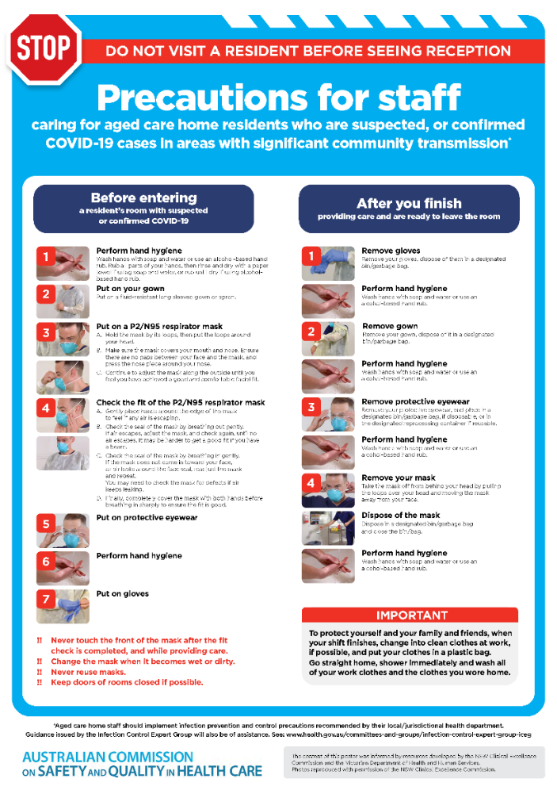](https://www.safetyandquality.gov.au/publications-and-resources/resource-library/covid-19-aged-care-staff-infection-prevention-and-control-precautions-poster)
* ***Environmental Cleaning and Infection Prevention and Control*** [www.safetyandquality.gov.au/environmental-cleaning](http://www.safetyandquality.gov.au/environmental-cleaning)
* ***Infection prevention and control Covid-19 PPE*** poster <https://www.safetyandquality.gov.au/publications-and-resources/resource-library/infection-prevention-and-control-covid-19-personal-protective-equipment>
* ***COVID-19 infection prevention and control risk management – Guidance*** <https://www.safetyandquality.gov.au/publications-and-resources/resource-library/covid-19-infection-prevention-and-control-risk-management-guidance>
* ***Safe care for people with cognitive impairment during COVID-19***<https://www.safetyandquality.gov.au/our-work/cognitive-impairment/cognitive-impairment-and-covid-19>
* ***Stop COVID-19: Break the chain of infection*** poster<https://www.safetyandquality.gov.au/publications-and-resources/resource-library/break-chain-poster-a3>  
  **[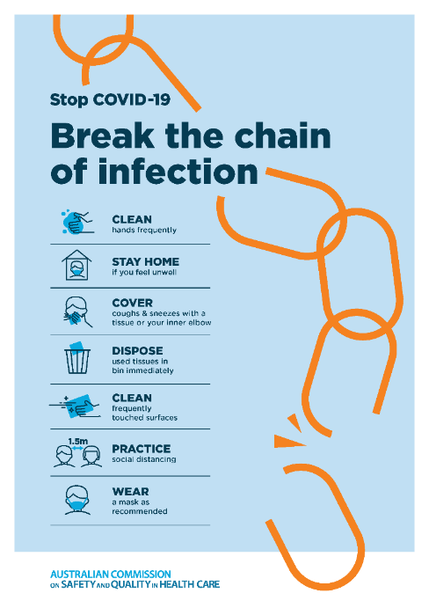](https://www.safetyandquality.gov.au/publications-and-resources/resource-library/break-chain-poster-a3https:/www.safetyandquality.gov.au/publications-and-resources/resource-library/break-chain-poster-a3)**
* ***COVID-19: Elective surgery and infection prevention and control precautions*** <https://www.safetyandquality.gov.au/publications-and-resources/resource-library/covid-19-elective-surgery-and-infection-prevention-and-control-precautions>
* ***FAQs for clinicians on elective surgery*** <https://www.safetyandquality.gov.au/node/5724>
* ***FAQs for consumers on elective surgery*** <https://www.safetyandquality.gov.au/node/5725>
* ***FAQs on community use of face masks***   
   <https://www.safetyandquality.gov.au/faqs-community-use-face-masks>
* ***COVID-19 and face masks – Information for consumers*** <https://www.safetyandquality.gov.au/publications-and-resources/resource-library/covid-19-and-face-masks-information-consumers>  
  The Commission’s fact sheet on use of face masks in the community to reduce the spread of COVID-19 is now available in Easy English and 10 other community languages from <https://www.safetyandquality.gov.au/wearing-face-masks-community>.  
  The factsheet was developed to help people understand when it is important to wear a mask to reduce the risk of the spread of COVID-19, and to explain how to safely put on and remove face masks. It also reinforces the importance of staying home if you have symptoms, physical distancing, hand hygiene and cough etiquette.

[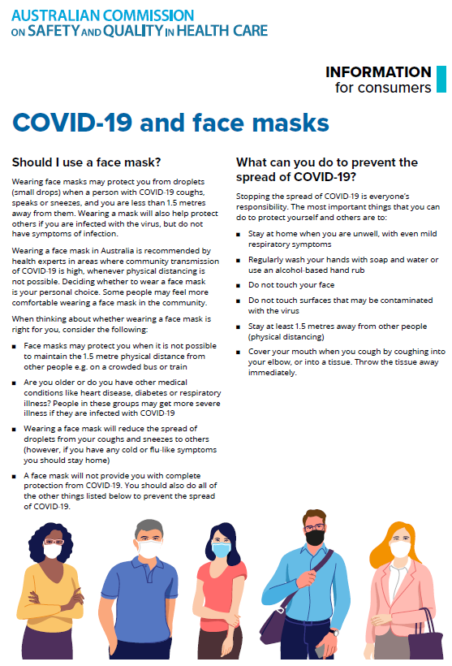](https://www.safetyandquality.gov.au/sites/default/files/2020-07/covid-19_and_face_masks_-_information_for_consumers.pdf)

*National COVID-19 Clinical Evidence Taskforce*

<https://covid19evidence.net.au/>

The National COVID-19 Clinical Evidence Taskforce is a collaboration of peak health professional bodies across Australia whose members are providing clinical care to people with COVID-19. The taskforce is undertaking continuous evidence surveillance to identify and rapidly synthesise emerging research in order to provide national, **evidence-based guidelines and clinical flowcharts for the clinical care of people with COVID-19**. The guidelines address questions that are specific to managing COVID-19 and cover the full disease course across mild, moderate, severe and critical illness. These are ‘living’ guidelines, updated with new research in near real-time in order to give reliable, up-to-the minute advice to clinicians providing frontline care in this unprecedented global health crisis.

*COVID-19 Critical Intelligence Unit*

<https://www.aci.health.nsw.gov.au/covid-19/critical-intelligence-unit>

The Agency for Clinical Innovation (ACI) in New South Wales has developed this page summarising rapid, evidence-based advice during the COVID-19 pandemic. Its operations focus on systems intelligence, clinical intelligence and evidence integration. The content includes a daily evidence digest and evidence checks on a discrete topic or question relating to the current COVID-19 pandemic. There is also a ‘Living evidence’ section summarising key studies and emerging evidence on **COVID-19 vaccines** and **SARS-CoV-2 variants**.

**Disclaimer**

On the Radar is an information resource of the Australian Commission on Safety and Quality in Health Care. The Commission is not responsible for the content of, nor does it endorse, any articles or sites listed. The Commission accepts no liability for the information or advice provided by these external links. Links are provided on the basis that users make their own decisions about the accuracy, currency and reliability of the information contained therein. Any opinions expressed are not necessarily those of the Australian Commission on Safety and Quality in Health Care.