# Australian Commission on Safety and Quality in Health Care logo with Radar imageOn the Radar

Issue 522

2 August 2021

*On the Radar* is a summary of some of the recent publications in the areas of safety and quality in health care. Inclusion in this document is not an endorsement or recommendation of any publication or provider. Access to particular documents may depend on whether they are Open Access or not, and/or your individual or institutional access to subscription sites/services. Material that may require subscription is included as it is considered relevant.

*On the Radar* is available online, via email or as a PDF or Word document from <https://www.safetyandquality.gov.au/publications-and-resources/newsletters/radar>

If you would like to receive *On the Radar* via email, you can subscribe on our website <https://www.safetyandquality.gov.au/publications-and-resources/newsletters>  
or by emailing us at H[Umail@safetyandquality.gov.auU](mailto:mail@safetyandquality.gov.au).   
You can also send feedback and comments to H[Umail@safetyandquality.gov.auU](mailto:mail@safetyandquality.gov.au).

For information about the Commission and its programs and publications, please visit <https://www.safetyandquality.gov.au>

You can also follow us on Twitter @ACSQHC.

**On the Radar**

Editor: Dr Niall Johnson [niall.johnson@safetyandquality.gov.au](mailto:niall.johnson@safetyandquality.gov.au)

Contributors: Niall Johnson, Diana Shipp, Angie Dalli

**National Standard for Labelling Dispensed Medicines**

Australian Commission on Safety and Quality in Health Care

[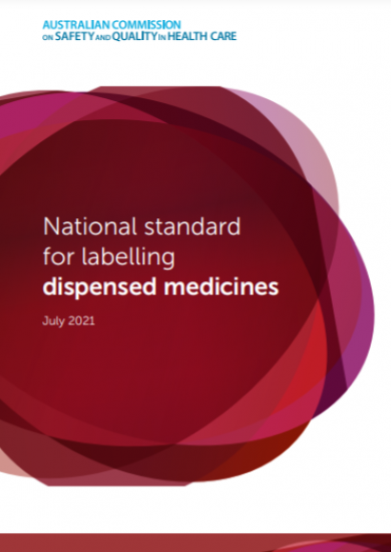](https://www.safetyandquality.gov.au/publications-and-resources/resource-library/national-standard-labelling-dispensed-medicines)Sydney: ACSQHC; 2021. p. 75.

<https://www.safetyandquality.gov.au/publications-and-resources/resource-library/national-standard-labelling-dispensed-medicines>

A new *National Standard for Labelling Dispensed Medicines* provides guidance on the format and content of information on dispensed medicine labels.

Consistent presentation of information on all dispensed medicine labels will make it easier for consumers to know how to take their medicines safely and effectively. This will help consumers achieve the best possible health outcomes.

The standard is for all health professionals who dispense medicines, including pharmacists, pharmacy technicians, nurse practitioners, general practitioners, optometrists and dentists.

The standard is evidence-based and informed by a literature review, legislation and guidelines, user testing, hospital evaluation of prototype labels, and extensive consultation. The qualitative user testing was reported earlier this year in *On the Radar*. That paper is available at <https://doi.org/10.1111/hex.13203>

The following 12 standards are presented with a rationale and label examples. They are supported by a set of supporting strategies.

1. Prominently display the information that consumers need to take their medicine safely and effectively
2. Use a standardised format and order so that each element appears in the same place every time
3. Signpost and display the active ingredient name first, followed by the brand name
4. Include strength, as a quantity of active ingredient(s) with the relevant unit(s) of measure, after each active ingredient name. Use a clear statement of strength for liquid medicines
5. Include the formulation in full
6. Use numerals (digits) for dosage quantities, except for fractions
7. Use explicit and clear dosing instructions
8. Include the indication for use of the medicine, whenever possible, and consider consumer confidentiality
9. Include the maximum dose, if relevant
10. Express the pack size or quantity with units and place in a separate location from the strength
11. Express discard-by information with a date, if possible
12. Include a machine-readable verification code on the dispensed label to allow verification of the medicine during the dispensing process.

**Delivering and supporting comprehensive end-of-life care: a user guide**

Australian Commission on Safety and Quality in Health Care

Sydney: ACSQHC; 2021.

<https://www.safetyandquality.gov.au/publications-and-resources/resource-library/delivering-and-supporting-comprehensive-end-life-care-user-guide>

Many Australians spend their last year of life going in and out of hospital, and more than half of those who die each year do so in acute care settings. The right care can significantly reduce the distress of the dying and the grief of loved ones.

Our new *Delivering and Supporting Comprehensive End-of-Life Care* user guide covers 10 essential elements for delivering excellent end-of-life care.

Excellent end-of-life care is about delivering comprehensive care that aligns with the patient’s needs and preferences, and considers the impact of their condition on their life and wellbeing.

This guide has practical strategies to support health services and clinicians in improving care and implementing the six end-of life care actions in the [Comprehensive Care Standard](https://www.safetyandquality.gov.au/standards/nsqhs-standards/comprehensive-care-standard) along with the *National Consensus Statement: Essential elements for safe and high-quality end-of-life care* ([Adults](https://www.safetyandquality.gov.au/publications-and-resources/resource-library/national-consensus-statement-essential-elements-safe-and-high-quality-end-life-care) and [Paediatric](https://www.safetyandquality.gov.au/publications-and-resources/resource-library/national-consensus-statement-essential-elements-safe-and-high-quality-paediatric-end-life-care)).

[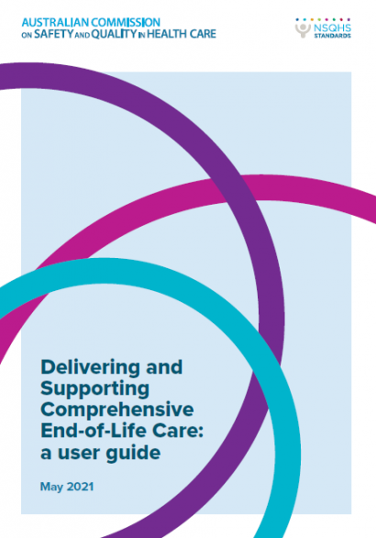](https://www.safetyandquality.gov.au/publications-and-resources/resource-library/delivering-and-supporting-comprehensive-end-life-care-user-guide)

**Journal articles**

*Epidemiology of healthcare harm in New Zealand general practice: a retrospective records review study*

Leitch S, Dovey S, Cunningham W, Wallis K, Eggleton K, Lillis S, et al

BMJ Open. 2021;11(7):e048316.

|  |  |
| --- | --- |
| DOI | <http://dx.doi.org/10.1136/bmjopen-2020-048316> |
| Notes | Much of the focus of the safety and quality movement has been on what happens in hospitals, in acute care. Primary care, where much of health care delivery actually takes place, remains somewhat uncharted territory. This paper reports on a records review study undertaken in 44 general practices in New Zealand. The study examined 9076v patient records to identify harms, harm severity and preventability. The reviewers found:   * 2972 harms affecting 1505 patients aged 0–102 years. * **Most patients** (82.0%, weighted) **experienced no harm**. * The estimated **incidence of harm was 123 per 1000 patient-years**. * **Most harms** (2160; **72.7%,** 72.4% weighted) **were minor**, 661 (22.2%, 22.8% weighted) were moderate, and 135 (**4.5%**, 4.4% weighted) **severe**. * Eleven patients died, five following a preventable harm. * Of the non-fatal harms, 2411 (**81.6%**, 79.4% weighted) were **considered not preventable**. * **Increasing age and number of consultations were associated with increased odds of harm**. Compared with patients aged ≤49 years, patients aged 50–69 had an OR of 1.77 (95% CI 1.61 to 1.94), ≥70 years OR 3.23 (95% CI 2.37 to 4.41). Compared with patients with ≤3 consultations, patients with 4–12 consultations had an OR of 7.14 (95% CI 5.21 to 9.79); ≥13 consultations OR 30.06 (95% CI 21.70 to 41.63). |

*Nine Lessons Learned From the COVID-19 Pandemic for Improving Hospital Care and Health Care Delivery*

Wei EK, Long T, Katz MH

JAMA Internal Medicine. 2021 [epub].

|  |  |
| --- | --- |
| DOI | <https://doi.org/10.1001/jamainternmed.2021.4237> |
| Notes | As the COVID-19 pandemic passes (in many locations) from a crisis phase into one of increasing vaccination rates and a focus on variants a number of “lessons learned” or “building back better” pieces have been appearing. This piece written from a New York City perspective offers 9 lessons for improving hospital care and health care delivery. The authors acknowledge the advent of telehealth and offer these nine in addition:   1. Prepare for Unexpected Increases in Demand for Services 2. Maintain Line of Sight 3. Mind the Air 4. Emotionally Support Health Care Workers 5. Masks Forever (at Least for Some) 6. Use Technology to Connect Families Near and Far 7. Maintain Caches of Supplies and Diversify Supply Chains 8. Reduce the Burden of Unnecessary Documentation 9. Address Persistent Racial and Ethnic Disparities in Health. |

*Guidance for Health Care Leaders During the Recovery Stage of the COVID-19 Pandemic: A Consensus Statement*

Geerts JM, Kinnair D, Taheri P, Abraham A, Ahn J, Atun R, et al

JAMA Network Open. 2021;4(7):e2120295-e2120295.

|  |  |
| --- | --- |
| DOI | <https://doi.org/10.1001/jamanetworkopen.2021.20295> |
| Notes | In a similar vein, this piece represents the consensus thinking of an international panel of 32 individuals from 17 countries with expertise in health leadership, health care, and public health. The panel identified 10 imperatives to guide health and public leaders during the post-emergency stage of the pandemic.  The 10 imperatives in the framework are:   1. acknowledge staff and celebrate successes; 2. provide support for staff well-being; 3. develop a clear understanding of the current local and global context, along with informed projections; 4. prepare for future emergencies (personnel, resources, protocols, contingency plans, coalitions, and training); 5. reassess priorities explicitly and regularly and provide purpose, meaning, and direction; 6. maximize team, organizational, and system performance and discuss enhancements; 7. manage the backlog of paused services and consider improvements while avoiding burnout and moral distress; 8. sustain learning, innovations, and collaborations, and imagine future possibilities; 9. provide regular communication and engender trust; and 10. in consultation with public health and fellow leaders, provide safety information and recommendations to government, other organizations, staff, and the community to improve equitable and integrated care and emergency preparedness system-wide. |

*Identifying Health Information Technology Usability Issues Contributing to Medication Errors Across Medication Process Stages*

Adams KT, Pruitt Z, Kazi S, Hettinger AZ, Howe JL, Fong A, et al

Journal of Patient Safety. 2021 [epub].

|  |  |
| --- | --- |
| DOI | <https://doi.org/10.1097/PTS.0000000000000868> |
| Notes | The introduction of new technologies can help address errors, but can also lead to changed or new issues. This is known to be true of the use of health information technology (HIT) in the medication process. This US study examined more than 2700 patient safety event reports from nearly 600 facilities from the period January 2013 to September 2018. The study sought to identify the types of medication errors associated with health IT use, whether they reached the patient, where in the medication process those errors occurred, and the specific usability issues contributing to those errors. Form their review, the authors report:   * Of the 2700 reviewed reports, 1508 (55.9%) described a medication error that was associated with health IT use and 750 (49.7%) reached the patient. * **Improper dose errors were frequent** (1214 of 1508, 80.5%) with **most errors during ordering** (673 of 1508, 44.6%) **and reviewing medications** (639 of 1508, 42.4%). * Most health IT–associated medication error reports described **usability issues** (n = 1468 of 1508, 97.3%) including **data entry**, **workflow support**, and **alerting**. Data entry usability issues impacted few medication process stages, whereas workflow support and alerting impacted several stages. |

For information on the Commission’s work on medication safety, including electronic medication management, see <https://www.safetyandquality.gov.au/our-work/medication-safety>

*Antibiotic overuse: managing uncertainty and mitigating against overtreatment*

Tarrant C, Krockow EM

BMJ Quality & Safety. 2021 [epub].

|  |  |
| --- | --- |
| DOI | <http://dx.doi.org/10.1136/bmjqs-2021-013615> |
| Notes | Editorial in *BMJ Quality & Safety* reflecting on a piece that examined clinician decision-making about antibiotic/antimicrobial prescribing. The piece expands from those reflections to the greater issue of how to reduce overuse of these agents. The piece identifies the importance of uncertainty in driving our actions. As the authors observe, ‘there are fundamental human tendencies towards action in the face of uncertainty, a preference for certainty even at a cost and a desire to protect one’s own patients from the risk of serious harm (figure below). These tendencies underpin a reliance on active treatment, such as antibiotic prescribing, as a way of managing uncertainty. Psychosocial strategies that could have value in mitigating against antibiotic overuse as a response to uncertainty are outlined in figure 1 and described below. These include strategic framing of options, substitution, documentation of decision-making processes and social support.’ Further, they conclude their editorial with ‘Recognising that uncertainty is an inherent aspect of medicine and considering how best to support clinicians to avoid reliance on antibiotics as a remedy for uncertainty should be the foundation for future efforts to mitigate against antibiotic overuse in clinical practice.’  [Diagnostic uncertainty and antibiotic overprescribing](http://dx.doi.org/10.1136/bmjqs-2021-013615) |

For information on the Commission's work on antimicrobial stewardship, see <https://www.safetyandquality.gov.au/our-work/antimicrobial-stewardship>

*Effectiveness of a tailored intervention to reduce antibiotics for urinary tract infections in nursing home residents: a cluster, randomised controlled trial*

Arnold SH, Nygaard Jensen J, Bjerrum L, Siersma V, Winther Bang C, Brostrøm Kousgaard M, et al.

The Lancet Infectious Diseases 2021 [epub].

|  |  |
| --- | --- |
| DOI | <https://doi.org/10.1016/S1473-3099(21)00001-3> |
| Notes | Paper reporting on an open-label, parallel-group, cluster randomised controlled trial undertaken at 22 nursing homes in Denmark to examine whether a tailored intervention that improved knowledge about urinary tract infections (UTI) and communication skills in nursing home staff influenced antibiotic prescriptions for UTI. The study found that the intervention led to the reduction in the number of antibiotic prescriptions for UTIs by 58% without substantially increasing the risk of all-cause hospitalisation or death. |

*Clinician Conceptualization of the Benefits of Treatments for Individual Patients*

Morgan DJ, Pineles L, Owczarzak J, Magder L, Scherer L, Brown JP, et al

JAMA Network Open. 2021;4(7):e2119747-e2119747.

|  |  |
| --- | --- |
| DOI | <https://doi.org/10.1001/jamanetworkopen.2021.19747> |
| Notes | The benefits of a treatment, including placebos, are sometimes attributed to the expectations of the patient. This paper illustrates how clinicians can also have conceived what might be considered overly positive views of a treatment. Based on a survey of 542 American clinicians that asked the clinicians to estimate the probability of adverse disease outcomes and expected effects of therapies for diseases common in primary care. The survey found that ‘, most respondents significantly overestimated the benefits of common therapies. Clinicians who conceptualized a greater chance of benefits of therapy were more likely to treat similar patients in their practice.’ The authors consider that ‘most clinicians were not well prepared to estimate individual patient chance of benefit, suggesting that an improved understanding of the effects of treatments could lead to more precise use of therapies and better patient outcomes.’ |

*International Journal for Quality in Health Care* online first articles

|  |  |
| --- | --- |
| URL | <https://academic.oup.com/intqhc/advance-articles> |
| Notes | *International Journal for Quality in Health Care* has published a number of ‘online first’ articles, including:   * **Predictors of Patient-Reported Quality of Care** in Low- and Middle-Income Countries: A Four-Country Survey of Person-Centered Care (June-Ho Kim, Griffith A Bell, Hannah L Ratcliffe, Leah Moncada, Stuart Lipsitz, Lisa R Hirschhorn, Asaf Bitton, Dan Schwarz) * Multi-Prong Quality Improvement Initiatives Improve **Sepsis Prevention and Reducing Surgical Site Infection After Childbirth** (Emma Sacks, Katherine E A Semrau) * Improving Accuracy of American Society of Anesthesiologists Physical Status Using **Audit-Feedback and Artificial Intelligence**: A Time Series Analysis (Dan M Drzymalski, Sonika Seth, Jeffrey R Johnson, Agnieszka Trzcinka) |

**Online resources**

*Future Leaders Communiqué*

Volume 6 Issue 3 July 2021

<https://www.thecommuniques.com/post/future-leaders-communiqu%C3%A9-volume-6-issue-3-july-2021>

This issue of Future Leaders Communiqué focuses on two issues, **medication safety** and **recognising and responding to clinical deterioration**. The case examined highlights aspects of both issues. The expert commentaries examine the prescribing of analgesics and pain management and ensuring pharmacist involvement within the multidisciplinary team.

For information on the Commission’s work on medication safety, see <https://www.safetyandquality.gov.au/our-work/medication-safety>

For information on the Commission’s work on recognising and responding to deterioration, see <https://www.safetyandquality.gov.au/our-work/recognising-and-responding-deterioration>

*[UK] NICE Guidelines and Quality Standards*

<https://www.nice.org.uk/guidance>

The UK’s National Institute for Health and Care Excellence (NICE) has published new (or updated) guidelines and quality standards. The latest reviews or updates are:

* NICE Guideline NG199 ***Clostridioides difficile infection****: antimicrobial prescribing* <https://www.nice.org.uk/guidance/ng199>
* NICE Guideline NG200 ***COVID-19*** *rapid guideline:* ***vaccine-induced immune thrombocytopenia and thrombosis (VITT)*** <https://www.nice.org.uk/guidance/ng200>

*[UK] NIHR Evidence alert*

<https://evidence.nihr.ac.uk/>alerts/

The UK’s National Institute for Health Research (NIHR) has posted new evidence alerts on its site. Evidence alerts are short, accessible summaries of health and care research which is funded or supported by NIHR. This is research which could influence practice and each Alert has a message for people commissioning, providing or receiving care. The latest alerts include:

* Most **children with life-limiting conditions** still die in hospital, not home or hospice
* **Women with kidney disease** can be given a personal risk assessment for pregnancy
* **Loneliness** is strongly linked to depression among older adults, a long-term study suggests
* What support do young people with **sickle cell disease** need when moving into adult services?
* People with **painful rheumatic conditions** are at increased risk of self-harm
* **Slip-resistant shoes** could prevent injury among NHS workers.

**COVID-19 resources**

https://www.safetyandquality.gov.au/covid-19

The Australian Commission on Safety and Quality in Health Care has developed a number of resources to assist healthcare organisations, facilities and clinicians. These and other material on COVID-19 are available at <https://www.safetyandquality.gov.au/covid-19>

These resource include:

* ***COVID-19: Aged care staff infection prevention and control precautions*** *poster*<https://www.safetyandquality.gov.au/publications-and-resources/resource-library/covid-19-aged-care-staff-infection-prevention-and-control-precautions-poster>  
    
  [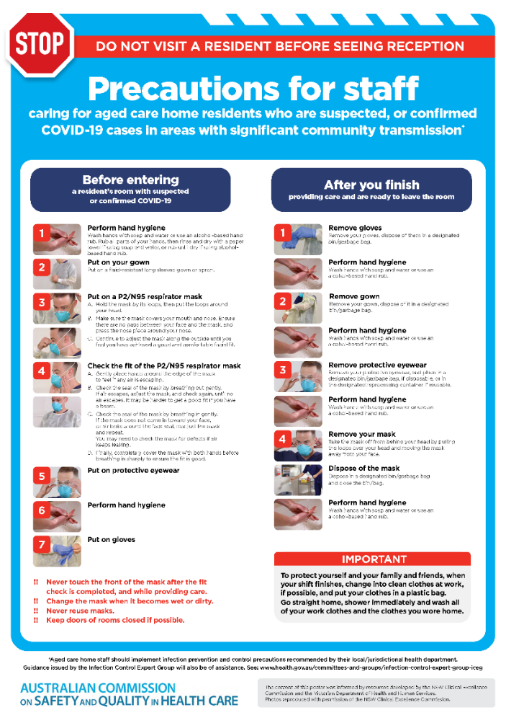](https://www.safetyandquality.gov.au/publications-and-resources/resource-library/covid-19-aged-care-staff-infection-prevention-and-control-precautions-poster)
* ***Environmental Cleaning and Infection Prevention and Control*** [www.safetyandquality.gov.au/environmental-cleaning](http://www.safetyandquality.gov.au/environmental-cleaning)
* ***Infection prevention and control Covid-19 PPE*** poster <https://www.safetyandquality.gov.au/publications-and-resources/resource-library/infection-prevention-and-control-covid-19-personal-protective-equipment>
* ***COVID-19 infection prevention and control risk management – Guidance*** <https://www.safetyandquality.gov.au/publications-and-resources/resource-library/covid-19-infection-prevention-and-control-risk-management-guidance>
* ***Safe care for people with cognitive impairment during COVID-19***<https://www.safetyandquality.gov.au/our-work/cognitive-impairment/cognitive-impairment-and-covid-19>
* ***Stop COVID-19: Break the chain of infection*** poster<https://www.safetyandquality.gov.au/publications-and-resources/resource-library/break-chain-poster-a3>  
  **[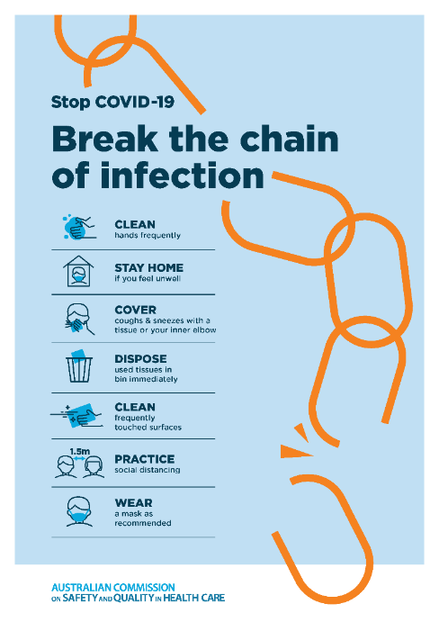](https://www.safetyandquality.gov.au/publications-and-resources/resource-library/break-chain-poster-a3https:/www.safetyandquality.gov.au/publications-and-resources/resource-library/break-chain-poster-a3)**
* ***COVID-19: Elective surgery and infection prevention and control precautions*** <https://www.safetyandquality.gov.au/publications-and-resources/resource-library/covid-19-elective-surgery-and-infection-prevention-and-control-precautions>
* ***FAQs for clinicians on elective surgery*** <https://www.safetyandquality.gov.au/node/5724>
* ***FAQs for consumers on elective surgery*** <https://www.safetyandquality.gov.au/node/5725>
* ***FAQs on community use of face masks***   
   <https://www.safetyandquality.gov.au/faqs-community-use-face-masks>
* ***COVID-19 and face masks – Information for consumers*** <https://www.safetyandquality.gov.au/publications-and-resources/resource-library/covid-19-and-face-masks-information-consumers>  
  The Commission’s fact sheet on use of face masks in the community to reduce the spread of COVID-19 is now available in Easy English and 10 other community languages from <https://www.safetyandquality.gov.au/wearing-face-masks-community>.  
  The factsheet was developed to help people understand when it is important to wear a mask to reduce the risk of the spread of COVID-19, and to explain how to safely put on and remove face masks. It also reinforces the importance of staying home if you have symptoms, physical distancing, hand hygiene and cough etiquette.

[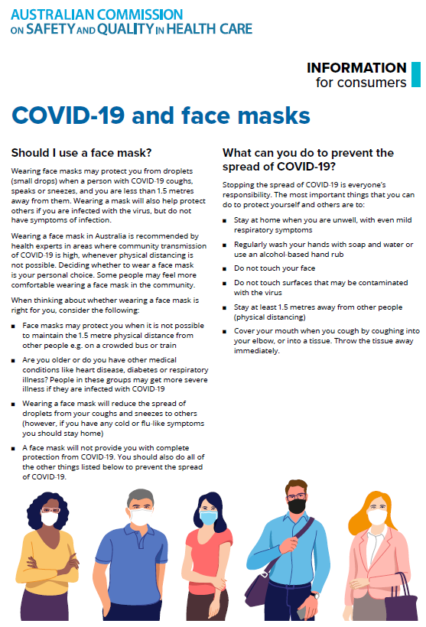](https://www.safetyandquality.gov.au/sites/default/files/2020-07/covid-19_and_face_masks_-_information_for_consumers.pdf)

*National COVID-19 Clinical Evidence Taskforce*

<https://covid19evidence.net.au/>

The National COVID-19 Clinical Evidence Taskforce is a collaboration of peak health professional bodies across Australia whose members are providing clinical care to people with COVID-19. The taskforce is undertaking continuous evidence surveillance to identify and rapidly synthesise emerging research in order to provide national, **evidence-based guidelines and clinical flowcharts for the clinical care of people with COVID-19**. The guidelines address questions that are specific to managing COVID-19 and cover the full disease course across mild, moderate, severe and critical illness. These are ‘living’ guidelines, updated with new research in near real-time in order to give reliable, up-to-the minute advice to clinicians providing frontline care in this unprecedented global health crisis.

*COVID-19 Critical Intelligence Unit*

<https://www.aci.health.nsw.gov.au/covid-19/critical-intelligence-unit>

The Agency for Clinical Innovation (ACI) in New South Wales has developed this page summarising rapid, evidence-based advice during the COVID-19 pandemic. Its operations focus on systems intelligence, clinical intelligence and evidence integration. The content includes a daily evidence digest and evidence checks on a discrete topic or question relating to the current COVID-19 pandemic. There is also a ‘Living evidence’ section summarising key studies and emerging evidence on **COVID-19 vaccines** and **SARS-CoV-2 variants**.

**Disclaimer**

On the Radar is an information resource of the Australian Commission on Safety and Quality in Health Care. The Commission is not responsible for the content of, nor does it endorse, any articles or sites listed. The Commission accepts no liability for the information or advice provided by these external links. Links are provided on the basis that users make their own decisions about the accuracy, currency and reliability of the information contained therein. Any opinions expressed are not necessarily those of the Australian Commission on Safety and Quality in Health Care.