# Australian Commission on Safety and Quality in Health Care logo with Radar imageOn the Radar

Issue 525

23 August 2021

*On the Radar* is a summary of some of the recent publications in the areas of safety and quality in health care. Inclusion in this document is not an endorsement or recommendation of any publication or provider. Access to particular documents may depend on whether they are Open Access or not, and/or your individual or institutional access to subscription sites/services. Material that may require subscription is included as it is considered relevant.

*On the Radar* is available online, via email or as a PDF or Word document from <https://www.safetyandquality.gov.au/publications-and-resources/newsletters/radar>

If you would like to receive *On the Radar* via email, you can subscribe on our website <https://www.safetyandquality.gov.au/publications-and-resources/newsletters>  
or by emailing us at H[Umail@safetyandquality.gov.auU](mailto:mail@safetyandquality.gov.au).   
You can also send feedback and comments to H[Umail@safetyandquality.gov.auU](mailto:mail@safetyandquality.gov.au).

For information about the Commission and its programs and publications, please visit <https://www.safetyandquality.gov.au>

You can also follow us on Twitter @ACSQHC.

**On the Radar**

Editor: Dr Niall Johnson [niall.johnson@safetyandquality.gov.au](mailto:niall.johnson@safetyandquality.gov.au)

Contributors: Niall Johnson, Amy Forsyth, Kim Stewart, Larissa Collins

[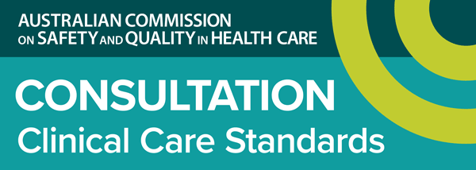](https://www.safetyandquality.gov.au/standards/clinical-care-standards/consultations-clinical-care-standards)

**Draft Sepsis Clinical Care Standard consultation**

<https://www.safetyandquality.gov.au/standards/clinical-care-standards/consultations-clinical-care-standards>

The Australian Commission on Safety and Quality in Health Care has released the draft *Sepsis Clinical Care Standard* for public consultation.

This new clinical care standard will support a national approach to the treatment of sepsis to ensure that a patient presenting with signs and symptoms of sepsis is recognised early, receives timely treatment and coordinated multidisciplinary care, from first presentation through to discharge and survivorship.

Supporting documents have been created to support this standard, including:

* •Sepsis Clinical Care Standard consumer fact sheet
* •Sepsis Clinical Care Standard clinician fact sheet

The Commission is seeking comments on the draft clinical care standard and supporting resources until midnight 26th September 2021.

Submissions are requested via online survey, or in writing. The survey link and further details are available at <https://www.surveymonkey.com/r/CCS-sepsis>

Australian Clinicians, Health Service Organisations and consumers are encouraged to provide feedback as part of the Consultation process. Please consider distributing the consultation details to anyone in your network who you think might be interested.

[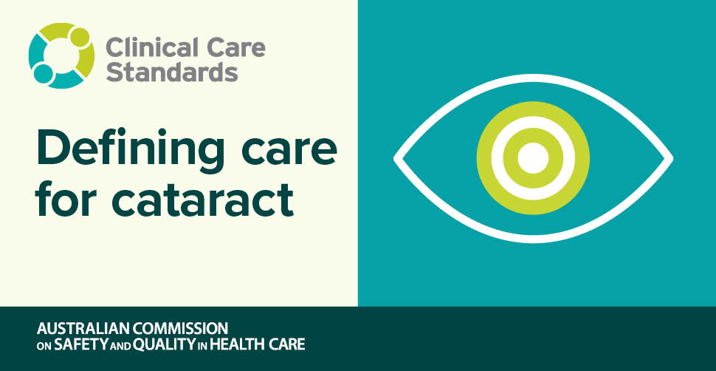](https://www.safetyandquality.gov.au/our-work/clinical-care-standards/cataract-clinical-care-standard)

**Cataract Clinical Care Standard**

Australian Commission on Safety and Quality in Health Care

Sydney: ACSQHC; 2021. p. 48.

<https://www.safetyandquality.gov.au/our-work/clinical-care-standards/cataract-clinical-care-standard>

The new *Cataract Clinical Care Standard* was launched by the Australian Commission on Safety and Quality in Health Care on Tuesday 17th August via a live-streamed event. The panel discussion was hosted by GP Dr Liz Marles and included the Commission’s Chief Medical Officer, Conjoint Professor Anne Duggan, Tracy Siggins and Catherine Mancuso from The Royal Victorian Eye and Ear Hospital.

The national standard will help to define clear pathways of care so that decisions about cataract surgery are more consistent nationally and based on clinical need.

Each year more than 250,000 people undergo cataract surgery to replace the eye lens with an artificial one.

Learn more about Australia’s first standard for Cataract’s, access the new standard, case studies and other resources at <https://www.safetyandquality.gov.au/cataract-ccs>

**AURA 2021. Fourth Australian report on antimicrobial use and resistance in human health**

<https://kapara.rdbk.com.au/landers/33e36b.html>

AURA 2021, which will be launched during a webcast on 27 August 2021, provides the most comprehensive picture of antimicrobial resistance (AMR) and antimicrobial use (AU) ever produced in Australia.

AMR threatens the provision of safe healthcare now and in the future. Monitoring and reporting on Australia’s antimicrobial usage and resistance patterns over time is important to inform clinical policy and practice.

The Commission’s experts and partners in AMR and antimicrobial use (AU) surveillance will present on key findings of AURA 2021. A panel of experts will discuss trends in AMR and AU in Australia, and priorities for prevention and control of AMR and improvement of antimicrobial use for patient safety.

Speakers and panellists include:

* Professor Villis Marshall AC, Chair, Board of the Australian Commission on Safety and Quality in Health Care
* Professor John Turnidge AO, Senior Medical Advisor, AURA
* Professor Michael Kidd , Deputy Chief Medical Officer, Australian Government Department of Health
* Professor Karin Thursky, Director, National Centre for Antimicrobial Stewardship
* Dr Morgyn Warner, Consultant Physician, Microbiology & Infectious Diseases, SA Pathology
* Dr Teresa Wozniak, Senior Research Fellow, Menzies School of Health Research Director
* Professor Geoff Coombs, President, Australian Society for Antimicrobials
* Conjoint Professor Anne Duggan, Chief Medical Officer, Australian Commission on Safety and Quality in Health Care
* Ms Nadine Hillock, Program Manager, National Antimicrobial Utilisation Surveillance Program, SA Health.

[Register](https://kapara.rdbk.com.au/landers/33e36b.html) now to join the launch of AURA 2021 at <https://kapara.rdbk.com.au/landers/33e36b.html>

**Reports**

*Becoming the Best Place To Be: Elevating the Human Experience in Senior Living*

Ipsen T

Nashville: The Beryl Institute; 2021.

|  |  |
| --- | --- |
| URL | <https://www.theberylinstitute.org/store/viewproduct.aspx?id=18854187> |
| Notes | The Beryl Institute in the USA focuses on the patient experience. This White Paper looks at experience in ‘senior living communities’ or aged care through the eyes of those who live and work there. |

**Journal articles**

*Changes in antibiotic prescribing following COVID-19 restrictions: Lessons for post-pandemic antibiotic stewardship*

Gillies MB, Burgner DP, Ivancic L, Nassar N, Miller JE, Sullivan SG, et al

British Journal of Clinical Pharmacology. 2021 [epub].

|  |  |
| --- | --- |
| DOI | <https://doi.org/10.1111/bcp.15000> |
| Notes | Australian study that found that restrictions due to COVID-19 restrictions were associated with a reduction in use of antibiotics for respiratory infections. Using Medicare data for from November 2015 to October 2020, the authors observed ‘a sustained 36% (95% CI: 33–40%) reduction in antibiotic dispensings from April 2020. Antibiotics recommended for managing respiratory tract infections showed large reductions (range 51–69%), whereas those recommended for non-respiratory infections were unchanged.’ The data revealed that the mean monthly rate of antibiotic dispensing for April through October 2020 fell to 56.8 per 1,000 population, from 91.1 per 1,000 population for the corresponding period in 2019. It is noted that ‘Total GP consultation rates remained stable, but from April 2020, 31% of consultations were telehealth.’ |

For information on the Commission’s work on antimicrobial stewardship, see <https://www.safetyandquality.gov.au/our-work/antimicrobial-stewardship>

For information on the Commission’s work on antimicrobial resistance, see <https://www.safetyandquality.gov.au/our-work/antimicrobial-resistance>

*Rigorous antibiotic stewardship in the hospitalized elderly population: saving lives and decreasing cost of inpatient car*

Mauro J, Kannangara S, Peterson J, Livert D, Tuma RA

JAC-Antimicrobial Resistance. 2021;3(3).

|  |  |
| --- | --- |
| DOI | <https://doi.org/10.1093/jacamr/dlab118> |
| Notes | Paper reporting on a US cohort study that examined the impact of antibiotic stewardship programmes (ASPs) in hospitalized geriatric patients. The study examined the rates of 30 day hospital readmissions because of reinfection or development of *Clostridioides difficile* infection (CDI) in patients 65 years and older who received ASP interventions between January and June 2017. The study also examined mortality rates and length of stay. The ASP team reviewed patients on antibiotics daily. ASP interventions included de-escalation of empirical or definitive therapy, change in duration of therapy or discontinuation of therapy. Results included:   * 30 day hospital readmission rate for all infection types decreased during the ASP intervention period from 24.9% to 9.3%, P < 0.001. * Rate of 30 day readmissions because of CDI decreased during the intervention period from 2.4% to 0.30%, P = 0.02. * Mortality in the cohort that underwent ASP interventions decreased from 9.6% to 5.4%, P = 0.03. * Antibiotic expenditure decreased after implementation of the ASP from $23.3 to $4.3 per adjusted patient day, in just 6 months. |

*Optimizing Therapy to Prevent Avoidable Hospital Admissions in Multimorbid Older Adults (OPERAM): cluster randomised controlled trial*

Blum MR, Sallevelt BTGM, Spinewine A, O’Mahony D, Moutzouri E, Feller M, et al

BMJ. 2021;374:n1585.

|  |  |
| --- | --- |
| DOI | <http://doi.org/10.1136/bmj.n1585> |
| Notes | Having multiple conditions (multimorbidity) and being on multiple medications (polypharmacy) are associated with increased risk of adverse drug events (ADE). This paper in the *BMJ* reports on a cluster randomised controlled trial that compared drug-related hospitalisation rates of older adults who received a deprescribing intervention and those who received usual care. The study involved 2008 older adults (≥70 years) with multimorbidity (≥3 chronic conditions) and polypharmacy (≥5 drugs used long term) and inpatient wards within university based hospitals in four European countries (Switzerland, Netherlands, Belgium, and Republic of Ireland). The study found that in the intervention arm, **86.1%** of participants (n=789) had **inappropriate prescribing**. The intervention reduced the inappropriate prescribing there was no effect on drug-related hospital admissions. |

For information on the Commission’s work on medication safety, see <https://www.safetyandquality.gov.au/our-work/medication-safety>

*The effect of providing staff training and enhanced support to care homes on care processes, safety climate and avoidable harms: evaluation of a care home quality improvement programme in England*

Damery S, Flanagan S, Jones J, Jolly K

International Journal of Environmental Research and Public Health. 2021;18(14).

|  |  |
| --- | --- |
| DOI | <http://doi.org/10.3390/ijerph18147581> |
| Notes | Aged care has been seen to be a site of lapses in the safety and quality of care. This provides a mixed methods evaluation of a large quality improvement programme providing skills training and facilitated support to staff in 29 care homes across two localities in England. After 24 months it was found that safety climate scores were improved and that there were ‘significant reductions in falls (p = 0.0006), severe pressure ulcers (p = 0.014), UTIs (p = 0.001) and ‘any’ events (p = 0.0003).’ the authors reported that interview responded reported ‘improvements to teamwork, working practices, information sharing, knowledge and skills’. The authors suggest that ‘**Upskilling care home staff can improve working practices and attitudes towards resident safety and care quality, which may be associated with significant reductions in avoidable harms rates**.’ |

*BMJ Quality & Safety*

September 2021 - Volume 30 - 9

|  |  |
| --- | --- |
| URL | <https://qualitysafety.bmj.com/content/30/9> |
| Notes | A new issue of *BMJ Quality & Safety* has been published. Many of the papers in this issue have been referred to in previous editions of *On the Radar* (when they were released online). Articles in this issue of *BMJ Quality & Safety* include:   * Editorial: **Crisis checklists in emergency medicine**: another step forward for cognitive aids (Yun-Yun K Chen, Alexander Arriaga) * Editorial: Timely testing: who needs to do what differently to improve adherence to **guideline-recommended glycaemic monitoring**? (Sheena McHugh, Kate O'Neill, Patricia M. Kearney) * **Medical crisis checklists in the emergency department**: a simulation-based multi-institutional randomised controlled trial (Eric Dryver, Jakob L Forberg, C Hård af Segerstad, W D Dupont, A Bergenfelz, U Ekelund) * Adherence to **guideline-recommended HbA1c testing** frequency and better outcomes in patients with type 2 diabetes: a 5-year retrospective cohort study in Australian general practice (Chisato Imai, Ling Li, R-A Hardie, A Georgiou) * Use of **telecritical care for family visitation to ICU** during the COVID-19 pandemic: an interview study and sentiment analysis (Farzan Sasangohar, Atiya Dhala, Feibi Zheng, Nima Ahmadi, Bita Kash, Faisal Masud) * International recommendations for a **vascular access minimum dataset**: a Delphi consensus-building study (Jessica Schults, Tricia Kleidon, Vineet Chopra, Marie Cooke, Rebecca Paterson, Amanda J Ullman, Nicole Marsh, Gillian Ray-Barruel, Jocelyn Hill, İlker Devrim, Fredrik Hammarskjold, Mavilde L Pedreira, Sergio Bertoglio, Gail Egan, Olivier Mimoz, Ton van Boxtel, Michelle DeVries, Maria Magalhaes, C Hallam, S Oakley, C M Rickard) * “It’s not just hacking for the sake of it”: a qualitative study of health innovators’ views on **patient-driven open innovations, quality and safety** (Lysanne Rivard, Pascale Lehoux, Hassane Alami) * **Trauma Resuscitation** Using in situ Simulation Team Training (TRUST) study: latent safety threat evaluation using framework analysis and video review (Andrew Petrosoniak, Mark Fan, Christopher M Hicks, Kari White, Melissa McGowan, Doug Campbell, Patricia Trbovich) * Factors influencing **physician responsiveness to nurse-initiated communication**: a qualitative study (Milisa Manojlovich, Molly Harrod, Timothy Hofer, Megan Lafferty, Michaella McBratnie, Sarah L Krein) * Association between **paediatric intraoperative anaesthesia handover and adverse postoperative outcomes** (Thomas Kannampallil, Daphne Lew, Ethan E Pfeifer, Anshuman Sharma, Joanna Abraham) |

*Journal of Patient Safety*

Volume 26 Number 4 August 2021

|  |  |
| --- | --- |
| URL | <https://journals.sagepub.com/toc/cric/26/4> |
| Notes | A new issue of the *Journal of Patient Safety* been published. Articles in this issue of the *Journal of Patient Safety* include:   * Editorial: The masks are off–**maintaining gains in patient safety post COVID-19** (Albert W Wu) * **I have found my tribe** (Helen Elliott-Mainwaring) * Longitudinal **rates of hospital adverse events that contributed to death** in Norway and Sweden from 2013 to 2018 (Ellen Tveter Deilkås, Marion Haugen, M B Risberg, H Narbuvold, Ø Flesland, U Nylén, and H Rutberg) * Implementation of an **antibiotic stewardship intervention to reduce prescription of fluoroquinolones**: A human factors analysis in two intensive care units (Pascale Carayon, Teresa Thuemling, Vishala Parmasad, Songtao Bao, John O’Horo, Nicholas T Bennett, and Nasia Safdar) * **Improving VTE prophylaxis adherence** among hospitalized adolescents using Human-Centered Design (Soobin Kim, Jessie Klugman, Sarah Norell, Alexandra Kenefake, Laurel Komos, Divya Jain, Moire Corcoran, Carlos Montero, Andrew Kreppel, J Sales, I Porto, J Wang, L L Hsu, and K Erwin) * Implementation and effectiveness of drive-through **medication pick-up and home delivery services**. A patient safety initiative during COVID-19 pandemic (Haneen K AlAbbasi, Shabeer A Thorakkattil, Syed I Mohiuddin, Habib S Nemr, Rita Jabbour, and Fuad Al-Ghamdi) * Case Report: Dispute over liability for **subarachnoid haemorrhage** – HXC v. Ms. Tracy Hind and Dr. Andrew Craze (High Court, 5 October 2020 – Judge Cotter QC) (John Mead) |

*Health Expectations*

Volume 24, Issue 4, August 2021

|  |  |
| --- | --- |
| URL | <https://onlinelibrary.wiley.com/toc/13697625/2021/24/4> |
| Notes | A new issue of *Health Expectations* been published. Articles in this issue of *Health Expectations* include:   * **Patient-reported outcome measures (PROMs)**: A review of generic and condition-specific measures and a discussion of trends and issues (Kate Churruca, Chiara Pomare, Louise A Ellis, Janet C Long, Suzanna B Henderson, Lisa E D Murphy, Christopher J Leahy, Jeffrey Braithwaite) * A scoping review of practice recommendations for **clinicians’ communication of uncertainty** (Niki M Medendorp, Anne M Stiggelbout, Cora M Aalfs, Paul K J Han, Ellen M A Smets Marij A Hillen) * **Adolescent and young adult patients as co-researchers**: A scoping review (Kjersti J Ø Fløtten, Ana Isabel Fernandes Guerreiro, Ilaria Simonelli, Anne Lee Solevåg, Isabelle Aujoulat) * **Patient partners’ perspectives of meaningful engagement** in synthesis reviews: A patient-oriented rapid review (Catherine Boden, Anne Marie Edmonds, Tom Porter, B Bath, K Dunn, A Gerrard, D Goodridge, C Stobart) * Ensuring patient and public involvement in the transition to **AI-assisted mental health care**: A systematic scoping review and agenda for design justice (Teodor Zidaru, Elizabeth M Morrow, Rich Stockley) * Developing and user testing new **pharmacy label formats**—A study to inform labelling standards (Vivien Tong, Parisa Aslani, David K Raynor, Diana Shipp, Brian Parkinson, Daniel Lalor, Andrew Sobey, Alice Gilbert, Jackie Crofton, Joanne Young, Sophie Carter, Wing Poon, Shrada Chitlangia) * Talk to us! Communication is a key factor in improving the comfort of **MRI research participants** (Rebecca S Dewey, Claire Ward, A Junor, A Horobin) * A nationwide participatory programme to **measure person-centred hospital care** in Italy: Results and implications for continuous improvement (Flavia Cardinali, Sara Carzaniga, Giorgia Duranti, Barbara Labella, Alessandro Lamanna, Micaela Cerilli, Giovanni Caracci, Fabrizio Carinci) * **Understanding COVID-19 misinformation and vaccine hesitancy** in context: Findings from a qualitative study involving citizens in Bradford, UK (Bridget Lockyer, Shahid Islam, Aamnah Rahman, Josie Dickerson, Kate Pickett, Trevor Sheldon, John Wright, Rosemary McEachan, Laura Sheard, the Bradford Institute for Health Research Covid-19 Scientific Advisory Group) * Patient perspectives on quality of care for **depression and anxiety in primary health care teams**: A qualitative study (Rachelle Ashcroft, Matthew Menear, Andrea Greenblatt, Jose Silveira, Simone Dahrouge, Nadiya Sunderji, M Emode, J Booton, M Muchenje, R Cooper, A Haughton, K McKenzie) * Processes for evidence summarization for **patient decision aids**: A Delphi consensus study (Peter Scalia, Catherine H Saunders, Michelle Dannenberg, Anik MC Giguere, Brian S Alper, Tammy Hoffmann, Lilisbeth Perestelo-Perez, Marie-Anne Durand, Glyn Elwyn) * Dissonance in the discourse of the **duration of diabetes**: A mixed methods study of patient perceptions and clinical practice (Christy J W Ledford, Stephanie T Fulleborn, Jeremy T Jackson, Tyler Rogers, Haroon Samar) * **Patient representatives**: Crucial members of health-care working groups facing an uncertain role and conflicting expectations. A qualitative study (Anna Hult, Ewa Lundgren Eva Jangland) * **Digital reminiscence app** co-created by people living with dementia and carers: Usability and eye gaze analysis (Kyle Boyd, Raymond Bond, Assumpta Ryan, Deborah Goode, Maurice Mulvenna) * Participatory design and qualitative evaluation of a **decision guide for workplace human immunodeficiency virus self-disclosure**: The importance of a socio-ecological perspective (Gayle Restall, Francis Diaz, Patrick Faucher, Kerstin Roger) * Assessing and promoting **partnership between patients and health-care professionals**: Co-construction of the CADICEE tool for patients and their relatives (Marie-Pascale Pomey, Nathalie Clavel, Louise Normandin, Claudio Del Grande, Djahanchah Philip Ghadiri, Isabel Fernandez-McAuley, Antoine Boivin, Luigi Flora, Annie Janvier, Philippe Karazivan, Jean-François Pelletier, Nicolas Fernandez, Jesseca Paquette, Vincent Dumez) * **Barriers to preventive care utilization** among Hong Kong community-dwelling older people and their views on using financial incentives to improve preventive care utilization (Qiuyan Liao, Wingyan Lau, Sarah McGhee, Maurice Yap, Rita Sum, Jun Liang, Jinxiao Lian) * **Patients as qualitative data analysts**: Developing a method for a process evaluation of the ‘Improving the Safety and Continuity of Medicines management at care Transitions’ (ISCOMAT) cluster randomised control trial (Catherine Powell, Hanif Ismail, R Cleverley, A Taylor, L Breen, B Fylan, S L Alderson, D P Alldred, on behalf of the ISCOMAT Programme Team) * **Long-term consumer involvement in cancer research**: Working towards partnership (Kristi Milley, S Chima, J G McIntosh, E Ackland, J D Emery) * ‘Birthing a Better Future’: A mixed-methods evaluation of an **exhibition on the early years of life** (Maya Lakhanpaul, Emma C Alexander, Meghan A Cupp, Jessica Taripre Owugha, Alex Florschutz, Andy Beckingham, Virad Kisan, Monica Lakhanpaul, Logan Manikam) * Public perspectives on **health improvement within a remote-rural island community** (Bobby Macaulay, Neil McHugh, Artur Steiner) * Priorities and preferences for **care of people with multiple chronic conditions** (Mieke Rijken, René Stüssgen, Chantal Leemrijse, Mieke J L Bogerd, Joke C Korevaar) * **Advance care directive prevalence** among older Australians and associations with person-level predictors and quality indicators (Kimberly Buck, Linda Nolte, M Sellars, C Sinclair, B P White, H Kelly, A Macleod, K M Detering) * Acceptability of **risk-stratified population screening across cancer types**: Qualitative interviews with the Australian public (Kate Dunlop, Nicole M Rankin, Amelia K Smit, Zofia Salgado, Ainsley J Newson, L Keogh, A E Cust) * **Sharing administrative health data with private industry**: A report on two citizens' juries (Jackie Street, Belinda Fabrianesi, Carolyn Adams, Felicity Flack, Merran Smith, Stacy M Carter, Sean Lybrand, Anthony Brown, Serena Joyner, Judy Mullan, Luise Lago, L Carolan, K Irvine, C Wales, A J Braunack-Mayer) * **Patient and public involvement in care home research**: Reflections on the how and why of involving patient and public involvement partners in qualitative data analysis and interpretation (Rachel Stocker, Katie Brittain, Karen Spilsbury, Barbara Hanratty) * A qualitative study of **nurse-patient communication and information provision during surgical pre-admission clinics** (Dominic Roche, A Jones) * Health-care professionals’ assessment of a **person-centred intervention to empower self-management and health across chronic illness**: Qualitative findings from a process evaluation study (Kristin Heggdal, Joshua B Mendelsohn, Natalie Stepanian, Bjørg Frøysland Oftedal, Marie H Larsen) * **Patients as partners in health research**: A scoping review (Tamara L McCarron, Fiona Clement, Jananee Rasiah, Chelsea Moran, Karen Moffat, Andrea Gonzalez, Tracy Wasylak, Maria Santana) * Patient perspectives on the **need for implanted device information**: Implications for a post-procedural communication framework (Natalia A Wilson, Amanda J Reich, J Graham, D L Bhatt, L L Nguyen, J S Weissman) * Delivering the unexpected—**Information needs for PSA screening** from Men's perspective: A qualitative study (Katrin Kuss, Charles Christian Adarkwah, Miriam Becker, Norbert Donner-Banzhoff, Kathrin Schloessler) * More than cost-effectiveness? Applying a second-stage filter to **improve policy decision making** (Kaying Kan, Frederike Jörg, Joran Lokkerbol, Cathrine Mihalopoulos, Erik Buskens, Robert A Schoevers, Talitha L. Feenstra) * User involvement in the making: Positions and types of knowledge enacted in the interaction between **service users and researchers in user panel meetings** (Per Koren Solvang, Unni Sveen, Helene Lundgaard Søberg) * Implementation of training to improve **communication with disabled children on the ward**: A feasibility study (Kath Wilkinson, Rebecca Gumm, Helen Hambly, Stuart Logan, Christopher Morris) * Conceptualizing **patient participation in psychiatry**: A survey describing the voice of patients in outpatient care (Rikard Wärdig, F Olofsson, A C Eldh) * A Community Jury on initiating **weight management conversations in primary care** (Rebecca J Beeken, Anna M Scott, Rebecca Sims, Gina Cleo, Helen Clifford, Paul Glasziou, Rae Thomas) * Experiences of **cervical screening** participation and non-participation in women from minority ethnic populations in Scotland (Mia Nelson, Andrea Patton, K Robb, D Weller, A Sheikh, K Ragupathy, D Morrison, C Campbell) * Awareness of diagnosis, treatment and risk of late effects in Chinese survivors of **childhood cancer in Hong Kong** (Lok Sum Yang, Chung Tin Ma, Chun Him Chan, Mei Shum Luk, Hoi Kei Woo, Vivian Wai-yan Lee, Alex Wing Kwan Leung, Samantha Lai-ka Lee, Nelson Chun-yiu Yeung, Chi-kong Li, Yin Ting Cheung) * Prioritizing **Chinese medicine clinical research questions** in cancer palliative care from patient and caregiver perspectives (Charlene H L Wong, Wendy Wong, Wai Ling Lin, David K Y Au, Justin C Y Wu, Ting Hung Leung, Irene X Y Wu, Vincent C H Chung) * An intervention of **sustainable weight change**: Influence of self-help group and expectations (Kristina Carlén, Elisabeth Kylberg) * ‘I hated being ghosted’ – The relevance of social participation for living well with **post-stroke aphasia**: Qualitative interviews with working aged adults (Molly Manning, Anne MacFarlane, Anne Hickey, Rose Galvin, Sue Franklin) * Improving the depth of data quality or increasing confusion? Reflections on a data analysis involving members of a **self-help group for relatives of people living with dementia** (Antonia Kowe, Stefanie Köhler, Stefan Teipel) * **Assessing people with dementia participating in cognitive stimulation activities**—A qualitative pilot video analysis exploring the importance of facilitating the participation (Diana Schack Thoft, Anna Camilla Ottesen, Anne Melchior Jensen, Alison Ward) * Understanding young adults’ **reasons for seeking ‘clinically unnecessary’ urgent and emergency care**: A qualitative interview study (Jaqui Long, Emma Knowles, Lindsey Bishop-Edwards, Alicia O’Cathain) |

*BMJ Quality & Safety* online first articles

|  |  |
| --- | --- |
| URL | <https://qualitysafety.bmj.com/content/early/recent> |
| Notes | *BMJ Quality &Safety* has published a number of ‘online first’ articles, including:   * Interventions targeted at **reducing diagnostic error**: systematic review (Neha Dave, Sandy Bui, Corey Morgan, Simon Hickey, Christine L Paul) * Association between acute psychiatric bed availability in the Veterans Health Administration and **veteran suicide risk**: a retrospective cohort study (Peter J Kaboli, Matthew R Augustine, Bjarni Haraldsson, Nicholas M Mohr, M Bryant Howren, Michael P Jones, Ranak Trivedi) * Editorial: Why do homeless women in New York state experience fewer **hospital revisits after childbirth** than housed women? (Atsushi Miyawaki, Yusuke Tsugawa) |

*International Journal for Quality in Health Care* online first articles

|  |  |
| --- | --- |
| URL | <https://academic.oup.com/intqhc/advance-articles> |
| Notes | *International Journal for Quality in Health Care* has published a number of ‘online first’ articles, including:   * A Meta-Review of Methods of Measuring and Monitoring **Safety in Primary Care** (Paul O’Connor, Caoimhe Madden, Emily O’Dowd, Dara Byrne, Sinéad Lydon) * Effect of **Nationwide Concurrent Drug Utilization Review Program** on Drug-Drug Interactions and Related Health Outcome (Dong-Sook Kim, Nam Kyung Je, Juhee Park, Sukhyang Lee) * Express Check-In: Developing a **Personal Health Record for Patients Admitted to Hospital with Medical Emergencies** – A Mixed Method Feasibility Study (Christian P Subbe, Hawys Tomos, Gwenlli Mai Jones, Paul Barach) |

**Online resources**

*[UK] NICE Guidelines and Quality Standards*

<https://www.nice.org.uk/guidance>

The UK’s National Institute for Health and Care Excellence (NICE) has published new (or updated) guidelines and quality standards. The latest reviews or updates are:

* NICE Guideline NG201 ***Antenatal care*** <https://www.nice.org.uk/guidance/ng201>
* Quality Standard QS22 ***Antenatal care*** <https://www.nice.org.uk/guidance/qs22>
* Quality Standard QS60 ***Inducing labour*** <https://www.nice.org.uk/guidance/qs60>
* Quality Standard QS201 ***Venous thromboembolism*** *in adults* <https://www.nice.org.uk/guidance/qs201>

**COVID-19 resources**

https://www.safetyandquality.gov.au/covid-19

The Australian Commission on Safety and Quality in Health Care has developed a number of resources to assist healthcare organisations, facilities and clinicians. These and other material on COVID-19 are available at <https://www.safetyandquality.gov.au/covid-19>

These resource include:

* ***COVID-19: Aged care staff infection prevention and control precautions*** *poster*<https://www.safetyandquality.gov.au/publications-and-resources/resource-library/covid-19-aged-care-staff-infection-prevention-and-control-precautions-poster>  
    
  [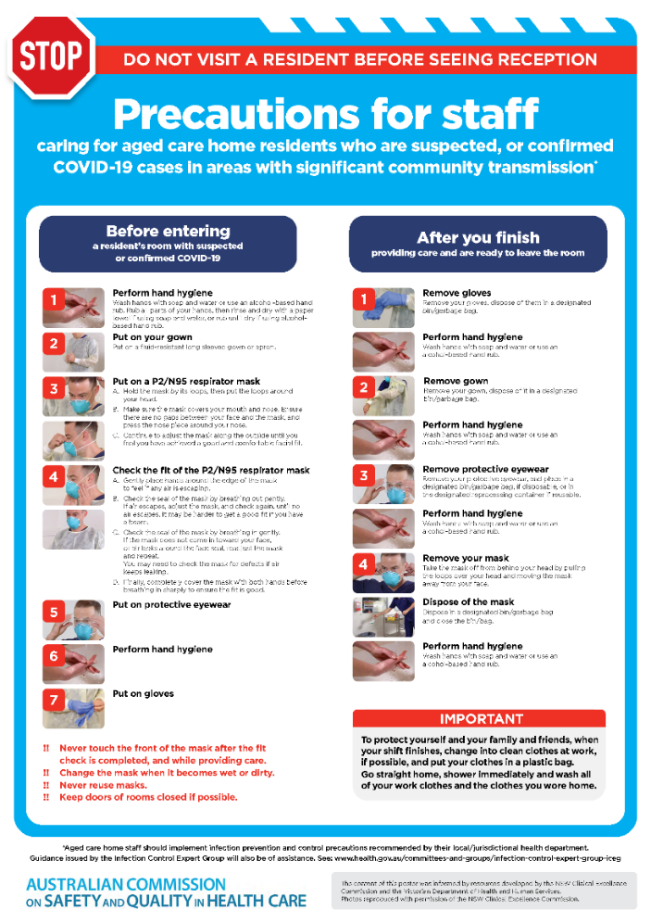](https://www.safetyandquality.gov.au/publications-and-resources/resource-library/covid-19-aged-care-staff-infection-prevention-and-control-precautions-poster)
* ***Environmental Cleaning and Infection Prevention and Control*** [www.safetyandquality.gov.au/environmental-cleaning](http://www.safetyandquality.gov.au/environmental-cleaning)
* ***Infection prevention and control Covid-19 PPE*** poster <https://www.safetyandquality.gov.au/publications-and-resources/resource-library/infection-prevention-and-control-covid-19-personal-protective-equipment>
* ***COVID-19 infection prevention and control risk management – Guidance*** <https://www.safetyandquality.gov.au/publications-and-resources/resource-library/covid-19-infection-prevention-and-control-risk-management-guidance>
* ***Safe care for people with cognitive impairment during COVID-19***<https://www.safetyandquality.gov.au/our-work/cognitive-impairment/cognitive-impairment-and-covid-19>
* ***Stop COVID-19: Break the chain of infection*** poster<https://www.safetyandquality.gov.au/publications-and-resources/resource-library/break-chain-poster-a3>  
  **[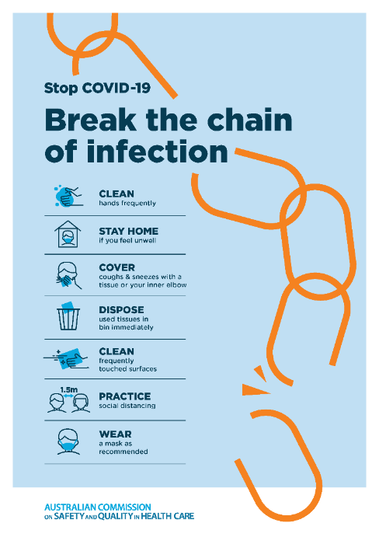](https://www.safetyandquality.gov.au/publications-and-resources/resource-library/break-chain-poster-a3https:/www.safetyandquality.gov.au/publications-and-resources/resource-library/break-chain-poster-a3)**
* ***COVID-19: Elective surgery and infection prevention and control precautions*** <https://www.safetyandquality.gov.au/publications-and-resources/resource-library/covid-19-elective-surgery-and-infection-prevention-and-control-precautions>
* ***FAQs for clinicians on elective surgery*** <https://www.safetyandquality.gov.au/node/5724>
* ***FAQs for consumers on elective surgery*** <https://www.safetyandquality.gov.au/node/5725>
* ***FAQs on community use of face masks***   
   <https://www.safetyandquality.gov.au/faqs-community-use-face-masks>
* ***COVID-19 and face masks – Information for consumers*** <https://www.safetyandquality.gov.au/publications-and-resources/resource-library/covid-19-and-face-masks-information-consumers>  
  The Commission’s fact sheet on use of face masks in the community to reduce the spread of COVID-19 is now available in Easy English and 10 other community languages from <https://www.safetyandquality.gov.au/wearing-face-masks-community>.  
  The factsheet was developed to help people understand when it is important to wear a mask to reduce the risk of the spread of COVID-19, and to explain how to safely put on and remove face masks. It also reinforces the importance of staying home if you have symptoms, physical distancing, hand hygiene and cough etiquette.

[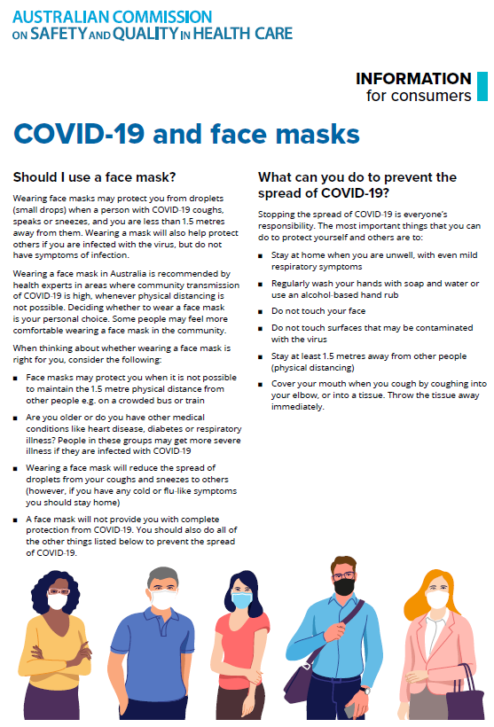](https://www.safetyandquality.gov.au/sites/default/files/2020-07/covid-19_and_face_masks_-_information_for_consumers.pdf)

*National COVID-19 Clinical Evidence Taskforce*

<https://covid19evidence.net.au/>

The National COVID-19 Clinical Evidence Taskforce is a collaboration of peak health professional bodies across Australia whose members are providing clinical care to people with COVID-19. The taskforce is undertaking continuous evidence surveillance to identify and rapidly synthesise emerging research in order to provide national, **evidence-based guidelines and clinical flowcharts for the clinical care of people with COVID-19**. The guidelines address questions that are specific to managing COVID-19 and cover the full disease course across mild, moderate, severe and critical illness. These are ‘living’ guidelines, updated with new research in near real-time in order to give reliable, up-to-the minute advice to clinicians providing frontline care in this unprecedented global health crisis.

*COVID-19 Critical Intelligence Unit*

<https://www.aci.health.nsw.gov.au/covid-19/critical-intelligence-unit>

The Agency for Clinical Innovation (ACI) in New South Wales has developed this page summarising rapid, evidence-based advice during the COVID-19 pandemic. Its operations focus on systems intelligence, clinical intelligence and evidence integration. The content includes a daily evidence digest and evidence checks on a discrete topic or question relating to the current COVID-19 pandemic. There is also a ‘Living evidence’ section summarising key studies and emerging evidence on **COVID-19 vaccines** and **SARS-CoV-2 variants**. Recent updates or additions to the Evidence Check section include:

* ***Rapid antigen testing***
* ***Delta variant***
* ***COVID-19 vaccines in Australia - AstraZeneca and Pfizer.***

**Disclaimer**

On the Radar is an information resource of the Australian Commission on Safety and Quality in Health Care. The Commission is not responsible for the content of, nor does it endorse, any articles or sites listed. The Commission accepts no liability for the information or advice provided by these external links. Links are provided on the basis that users make their own decisions about the accuracy, currency and reliability of the information contained therein. Any opinions expressed are not necessarily those of the Australian Commission on Safety and Quality in Health Care.