


Every year, over 55,000 Australians are diagnosed with sepsis and sadly, more than 8,700 will lose their lives to the condition.
Sepsis is a medical emergency, requiring time-critical treatment to reduce serious health complications and death.

OVER 80% OF SEPSIS CASES START IN THE COMMUNITY

KNOW THE SIGNS OF SEPSIS:
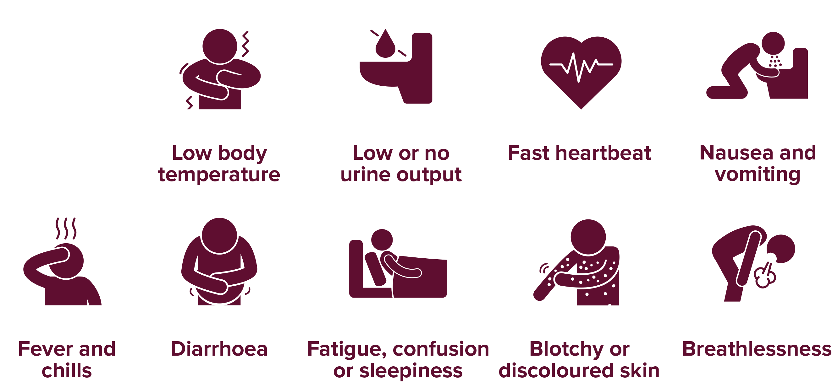

For more information:
safetyandquality.gov.au/our-work/partnering-consumers/national-sepsis-program
australiansepsisnetwork.net.au



