KEY ACTIONS

for consumers

Introduction to the   
National Safety and Quality   
Health Service Standards

## About the NSQHS Standards

The National Safety and Quality Health Service (NSQHS) Standards were developed by the Australian Commission on Safety and Quality in Health Care (the Commission) in collaboration with the Australian Government, state and territories, the private sector, clinical experts, consumers and carers.

The primary aims of the NSQHS Standards are to protect the public from harm and to improve the safety and quality of health care provision. They require health service organisations to develop ways of working that reduce harm and improve care.

In Australia, all public and private hospitals, day procedure services and most public dental practices must be assessed against the NSQHS Standards, under the Australian Health Service Safety and Quality Accreditation (AHSSQA) Scheme.

The NSQHS Standards describe the processes and structures that are needed in healthcare services to help keep people safe and improve the quality of health care they receive.

There are eight NSQHS Standards that include 151 actions. They describe the standard of care that consumers should expect to receive from a health service organisation (see Box 1 on next page for details):

1. Clinical **Governance**
2. **Partnering with Consumers**
3. **Preventing and Controlling Infections**
4. **Medication Safety**
5. **Comprehensive Care**
6. **Communicating for Safety**
7. **Blood Management**
8. **Recognising and Responding to Acute Dete**rioration**.**

The second edition of the NSQHS Standards includes requirements for providing person-centred, comprehensive care for all patients (see below).

Person-centred care is respectful of, and responsive to, the preferences, needs and values of patients and consumers.

Person-centred care is the foundation for achieving safe, high-quality care. Focusing on effective delivery of person-centred care will enable healthcare organisations to be successful in achieving better outcomes for their patients, better experience for their patients and workforce, and better value care.

|  |  |
| --- | --- |
| Box 1: The eight NSQHS Standards | |
| Clinical Governance Standard icon | **Clinical Governance**, ensures there are processes to maintain and improve the reliability, safety and quality of health care. |
| Partnering with Consumers Standard icon | **Partnering with Consumers**, ensures consumers are partners in the design, delivery and evaluation of healthcare systems and services, and they are supported to be partners in their own care. |
| Preventing and Controlling Infections Standard icon | **Preventing and Controlling Infections**, ensures processes are in place to prevent and control infection, and support antimicrobial stewardship, as well as the sustainable use of infection prevention and control resources. |
| Medication Safety Standard icon | **Medication Safety**, ensures clinicians safely prescribe, dispense and administer appropriate medicines, and monitor medicine use. It also ensures consumers are informed about medicines, and understand their own medicine needs and risks. |
| Comprehensive Care Standard icon | **Comprehensive Care**, ensures that consumers receive comprehensive health care that meets their individual needs. It considers the impact of their health issues on their life and wellbeing and it ensures risks to patients during health care are prevented and managed. |
| Communicating for Safety Standard icon | **Communicating for Safety**, ensures there is effective communication between patients, carers and families, multidisciplinary teams and clinicians, and across the health service organisation, to support continuous, coordinated and safe care for patients. |
| Blood Management Standard icon | **Blood Management**, ensures patients’ own blood is safely and appropriately managed, and that any blood and blood products that patients receive are safe and appropriate. |
| Recognising and Responding to Acute Deterioration Standard icon | **Recognising and Responding to Acute Deterioration**, ensures acute deterioration in a patient’s physical mental or cognitive condition is recognised promptly and appropriate action is taken. |

### How can the NSQHS Standards improve safety and quality of health care?

What is safety and quality?

Patient safety and quality is often summarised as the right care, in the right place, at the right time and cost.

When a healthcare service organisation implements the NSQHS Standards, you can be assured that:

* A healthcare service organisation has safety and quality systems and process in place to provide safe and high-quality health care
* The healthcare service organisation has processes to continuously improve the care they provide
* Everyone in the healthcare service organisation is accountable for the delivery of safe, effective and high-quality health care.

### Partnering with Consumers

The Partnering with Consumers Standard places an increasing emphasis on the need for health service organisations to engage with consumers as partners in their own care, as well as involving consumers as partners in governance systems and processes.

The NSQHS Standards require all organisations to implement a charter of rights for patients that is consistent with the *Australian Charter of Healthcare Rights* (the Charter). The Charter sets out seven rights and principles that people can expect when accessing health care in Australia.

The Australian Charter of Healthcare Rights poster

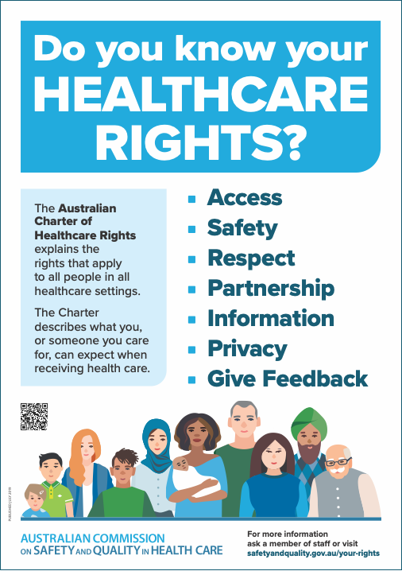

The Commission has developed a range of resources to support people to understand and use the Australian Charter of Healthcare Rights (the Charter). These are available at: safetyandquality.gov.au/consumers/working-your-healthcare-provider/australian-charter-healthcare-rights

The NSQHS Standards strengthen the roles of consumers, carers and families as partners in their own care, recognising that patient involvement leads to a more positive experience for consumers.

This means health service organisations will support you or the person you care for to understand information about your health and treatment options, to ask questions and involve you in decisions about your care to the degree you want, so that the care you receive is right for you.

Definitions

The glossary section of the NSQHS Standards contains a list of definitions for words and terms that are used frequently in the Standards and supporting resources.

## Further information

For more information about the NSQHS Standards and accreditation, please visit: safetyandquality.gov.au/standards/nsqhs-standards

You can also email the NSQHS Standards Advice Centre at AdviceCentre@safetyandquality.gov.au or 1800 304 056.

[**safetyandquality.gov.au**](http://www.safetyandquality.gov.au)

Creative Commons Licence© Australian Commission on   
Safety and­­ ­Quality in Health Care 2021