# Australian Commission on Safety and Quality in Health Care logo with Radar imageOn the Radar

Issue 543

17 January 2022

*On the Radar* is a summary of some of the recent publications in the areas of safety and quality in health care. Inclusion in this document is not an endorsement or recommendation of any publication or provider. Access to particular documents may depend on whether they are Open Access or not, and/or your individual or institutional access to subscription sites/services. Material that may require subscription is included as it is considered relevant.

*On the Radar* is available online, via email or as a PDF or Word document from <https://www.safetyandquality.gov.au/publications-and-resources/newsletters/radar>

If you would like to receive *On the Radar* via email, you can subscribe on our website <https://www.safetyandquality.gov.au/publications-and-resources/newsletters>  
or by emailing us at H[Umail@safetyandquality.gov.auU](mailto:mail@safetyandquality.gov.au).   
You can also send feedback and comments to H[Umail@safetyandquality.gov.auU](mailto:mail@safetyandquality.gov.au).

For information about the Commission and its programs and publications, please visit <https://www.safetyandquality.gov.au>

You can also follow us on Twitter @ACSQHC.

**On the Radar**

Editor: Dr Niall Johnson [niall.johnson@safetyandquality.gov.au](mailto:niall.johnson@safetyandquality.gov.au)

Contributors: Niall Johnson, Girish Swaminathan, Suzanna Henderson

**Incident Management Guide**

Australian Commission on Safety and Quality in Health Care

Sydney: ACSQHC; 2021. p. 24.

<https://www.safetyandquality.gov.au/publications-and-resources/resource-library/incident-management-guide>

An incident is an event or circumstance that could have resulted, or did result, in unnecessary harm to a patient. A well-designed incident management system can assist health services to identify, report, manage and learn from incidents.

The Australian Commission on Safety and Quality in Health Care has released the *Incident Management Guide*. This short guide provides a concise overview of the incident management process and consolidates best practice approaches. The guide is based on Australian state and territory incident management policies and literature on best practice. It aims to complement state and territory policies, which provide more detailed information on local processes. Links to these policies are included in the guide.

**Patient Safety Culture Measurement Toolkit**

<https://www.safetyandquality.gov.au/our-work/indicators-measurement-and-reporting/patient-safety-culture>

The Australian Commission on Safety and Quality in Health Care has released a *Patient Safety Culture Measurement Toolkit*. The web-based toolkit provides advice on collecting and using information on patient safety culture for quality improvement. There is also a suite of templates and a new survey that has been validated in Australian hospitals. Use of the survey is voluntary.

Recognising COVID-19 is the current priority, the toolkit is available to support quality improvement initiatives when the time is right. In 2022, the Commission will host events and release new resources to support improvements in this area.

**Journal articles**

*What counts as a voiceable concern in decisions about speaking out in hospitals: A qualitative study*

Dixon-Woods M, Aveling EL, Campbell A, Ansari A, Tarrant C, Willars J, et al

Journal of Health Services Research & Policy. 2022:13558196211043800 [epub].

|  |  |
| --- | --- |
| DOI | <https://doi.org/10.1177%2F13558196211043800> |
| Notes | This piece starts with the observation ‘Those who work in health care organisations are a potentially valuable source of information about safety concerns, poor care, faulty systems or inappropriate conduct. However, health care workers do not always give voice to concerns. Their reasons for remaining silent on workplace issues include their perceptions of hierarchical unsupportive organisational climates, of the likely benefits and risks of an act of voice, including damage to relationships and being viewed negatively, and of having insufficient authority or security of employment.’ The piece proposes the concept of ‘voiceable concern’. Based on 165 semi-structured interviews with a range of staff (clinical, non-clinical and at different hierarchical levels) in three hospitals in two countries, they argue that ‘identifying what counts as a concern, and what counts as a occasion for voice by a given individual, is not a straightforward matter of applying objective criteria.’ Four influences that ‘shape whether incidents, events and patterns were classified as voiceable concerns’ were identified: ‘certainty that something is wrong and is an occasion for voice; system versus conduct concerns, forgivability and normalisation’. |

*Case for mandatory COVID-19 vaccinations for workers in health and aged care settings: a guide for leaders*

Loh E, Michael S, Beetson R, Schmidt A

BMJ Leader. 2021:leader-2021-000572 [epub].

|  |  |
| --- | --- |
| DOI | <http://dx.doi.org/10.1136/leader-2021-000572> |
| Notes | Mandatory vaccination of healthcare workers has been a somewhat contentious topic for many years, usually around influenza vaccination. This piece looks to the current pandemic and whether those working in health and aged care should be vaccinated. The authors seek to provide ‘s an overview of the analysis in support of mandating COVID-19 vaccinations for all workers in health and aged care settings in Australia.’ They argue that ‘Leaders of health and aged care organisations have a duty of care under work health and safety legislation to eliminate and/or control the risk of transmission of vaccine-preventable disease in their facilities, including COVID-19.’ |

*Paying for value: options for value-based payment reform in Australia*

Wise S, Hall J, Haywood P, Khana N, Hossain L, van Gool K

Australian Health Review. 2021 [epub].

|  |  |
| --- | --- |
| DOI | <https://doi.org/10.1071/AH21115> |
| Notes | There has been a degree of interest in value, particularly around what may constitute “low value” care. It has been observed that how care is paid for or funded may not relate to the actual value of care. This paper examines how payment reforms may place a greater emphasis on the value of care. In the paper, the authors describe the ‘three main options for value-based payment reform: episode-based bundled payments chronic condition bundled payments and comprehensive capitation payments.’ They also identify ‘two challenges critical for success: attributing financial risk fairly and organisational structures.’ As they also note, ‘Payment reform is always fraught and complex, not least because it affects providers’ incomes and well-established business models. Reform should not be undertaken unless it is clear it will address health system problems without significant unintended consequences.’ |

*Australian Journal of Primary Health*

Volume 27, Number 6, December 2021

|  |  |
| --- | --- |
| URL | <https://www.publish.csiro.au/py/issue/10191> |
|  | A new issue of the *Australian Journal of Primary Health* has been published. Articles in this issue of the *Australian Journal of Primary Health* include:   * Reflecting on 2021 for the **Australian Journal of Primary Health** (Ben Harris-Roxas, Virginia Lewis and Jenny Macmillan) * The **Refugee Co-Location Model** may be useful in addressing refugee barriers to care. What do refugees think? (Michael Au, Robyn Preston, Robin A. Ray and Meg Davis) * **Practice nurse provision of early medical abortion in general practice**: opportunities and limitations (Jessica E Moulton, Asvini K Subasinghe and Danielle Mazza) * **Stepped care for musculoskeletal pain is ineffective**: a model for utilisation of specialist physiotherapists in primary healthcare management (Darren Beales, Tim Mitchell and David Holthouse) * **Allied health are key to improving health for people with chronic disease**: but where are the outcomes and where is the strategy? (Sarah Dennis, Lauren Ball, Mark Harris and Kathryn Refshauge) * Symptoms of **anxiety, depression and fear in healthcare workers and non-healthcare workers undergoing outpatient COVID-19 testing** in an urban Australian setting (M E Brennan, M L Marinovich, B Verdonk, M Vukasovic and A Coggins) * Are we on the same page? **Mental health literacy and access to care: a qualitative study in young Hazara refugees** in Melbourne (Sahema Saberi, Caroline Wachtler and Phyllis Lau) * General practitioner knowledge of and engagement with **telehealth-at-home medical abortion provision** (Danielle Mazza, Jane W Seymour, Monisha Vaid Sandhu, Catriona Melville, Jacquie O’Brien and Terri-Ann Thompson) * Evaluation of an online learning module to improve **nurses’ and midwives’ capacity to promote preconception health** in primary healthcare settings (Karin Hammarberg and Ruby Stocker) * Requesting **early removal of long-acting reversible contraception**: a qualitative study exploring the experiences of doctors working in primary care (Jacqueline Ding, Henrietta Williams, Jane S Hocking and Jacqueline Coombe) * Evaluation of an **online toolkit for carers of people with a life-limiting illness at the end-of-life**: health professionals’ perspectives (D Parker, P Hudson, J Tieman, K Thomas, D Saward and S Ivynian) * Implementing **dementia risk reduction in primary care**: views of enrollees in the Preventing Dementia Massive Open Online Course (Kali Godbee, Maree Farrow, Aidan Bindoff, Jane Gunn, N Lautenschlager and V Palmer) * Determining the credibility, accuracy and comprehensiveness of **websites educating consumers on complex regional pain syndrome** accessible in Australia: a systematic review (Emily Moore, Tasha R Stanton, Adrian Traeger, G Lorimer Moseley and Carolyn Berryman) * Evaluating the effects of a **Therapeutic Day Rehabilitation program and inclusion of gardening** in an Australian Rural Community Health Service (Karen Missen, Mark Anthony Alindogan, Scott Forrest and Susan Waller) * Factors patients consider when **accessing oral health care** (Van Anh Trinh, Peter Lee, Jonathan Robson, Emma Yu, Victoria Jung, Yoonju Heo, Santosh Kumar Tadakamadla and Jane L Evans) * Knowledge and attitudes towards **periodontal health among Australians diagnosed with diabetes** (Eren Tuncer and Ivan Darby) |

*Journal of Patient Safety*

Volume 18, Number 1, January 2022

|  |  |
| --- | --- |
| URL | <https://journals.lww.com/journalpatientsafety/toc/2022/01000> |
|  | A new issue of the *Journal of Patient Safety* has been published. Articles in this issue of the *Journal of Patient Safety* include:   * Characterization of **Medication Errors in a Medical Intensive Care Unit** of a University Teaching Hospital in South Korea (Jimin Yoon, Ji Seob Yug, Dae Yun Ki, Ji-Eun Yoon, Sung Wook Kang, Eun Kyoung Chung) * A Retrospective, Matched Case-Control Study on the **Risk Factors of Falls and Varying Severities of Fall-Related Injuries** in Inpatients (Wen-Pei Chang, Hsiu-Ju Jen) * **Medication Errors in Anesthesiology**: Is It Time to Train by Example? Vignettes Can Assess Error Awareness, Assessment of Harm, Disclosure, and Reporting Practices (Caoimhe C Duffy, Gary A Bass, James Duncan, Barry Lyons, Angela O’Dea) * Psychometric Evaluation of the **Korean Version of Hospital Survey on Patient Safety Culture** (Seung Eun Lee, Farinaz Havaei, Oscar Lorenzo Olvera Astivia, Jeong Ae Shin) * **Suicide and Suicide Attempts on Veterans Affairs Medical Center** Outpatient Clinic Areas, Common Areas, and Hospital Grounds (Sreevaishali Rajendran, Peter D Mills, Bradley V Watts, William Gunnar) * **Missed Acute Coronary Syndrome During Telephone Triage** at Out-of-Hours Primary Care: Lessons From A Case-Control Study (Daphne C Erkelens, Frans H Rutten, Loes T Wouters, Harmke G Kirkels, Judith M Poldervaart, Esther de Groot, Roger A Damoiseaux, A W Hoes, D L Zwart) * **Social Determinants of Health and Patient Safety**: An Analysis of Patient Safety Event Reports Related to Limited English-Proficient Patients (Natalie C Benda, Deliya B Wesley, Matthew Nare, A Fong, R M Ratwani, K M Kellogg) * Self-Reported **Neurotoxic Symptoms in Hip Arthroplasty Patients With Highly Elevated Blood Cobalt**: A Case-Control Study (Ilona Swiatkowska, Johann Henckel, Shiraz A Sabah, Alister J Hart) * Evaluation of the Green Cross Method Regarding **Patient Safety Culture and Incidence Reporting** (Ulrika Källman, Marie Rusner, Anneli Schwarz, Sophia Nordström, Stina Isaksson) * **Improving Capnography Use for Critically Ill Emergency Patients**: An Implementation Study (Rahul Shah, Douglas A Streat, Marc Auerbach, Veronika Shabanova, Melissa L Langhan) * Unique Patient-Reported Hospital Safety Concerns With **Online Tool: MySafeCare** (Kumiko O. Schnock, Julia E. Snyder, Esteban Gershanik, Stuart Lipsitz, Patricia C. Dykes, David W. Bates, Sarah Collins Rossetti) * The Effects of **Interdisciplinary Bedside Rounds on Patient Centeredness, Quality of Care, and Team Collaboration**: A Systematic Review (Tine Heip, Ann Van Hecke, S Malfait, W Van Biesen, K Eeckloo) * Do **Patients and Relatives Have Different Dispositions When Challenging Healthcare Professionals** About Patient Safety? Results Before and After an Educational Program (Isabel Rodrigo‐Rincon, Isabel Irigoyen-Aristorena, Belen Tirapu-Leon, Nicolás Zaballos-Barcala, Maite Sarobe-Carricas, May Antelo-Caamaño, Joaquín Lobo-Palanco, M Martin-Vizcaino) * Organizational Interventions to Support **Second Victims in Acute Care Settings**: A Scoping Study (Laura Wade, Eleanor Fitzpatrick, Natalie Williams, Robin Parker, Katrina F Hurley) * Characteristics of **Critical Incident Reporting Systems in Primary Care**: An International Survey (Andreas Höcherl, Dagmar Lüttel, Dania Schütze, Tatjana Blazejewski, Ana Isabel González-González, F M Gerlach, B S Müller) * Wide Variation in **Unplanned Extubation** Rates Related to Differences in Operational Definitions (Sussan Mbi Ndakor, Chad J Pezzano, Lynn Spilman, Gina Geis, Upender Munshi, Cheryl Dunton, Joaquim M B Pinheiro) * Improving **Allergy Documentation**: A Retrospective Electronic Health Record System–Wide Patient Safety Initiative (Lily Li, Dinah Foer, Robert K Hallisey, Carol Hanson, Ashley E McKee, Gianna Zuccotti, Elizabeth A Mort, Thomas D Sequist, Nathan E Kaufman, Claire M Seguin, Allen Kachalia, Kimberly G Blumenthal, Paige G Wickner) * Analysis of Risk Factors for **Patient Safety Events Occurring in the Emergency Department** (Mohamed Alsabri, Zoubir Boudi, Taoufik Zoubeidi, Ibrahim Abdalla Alfaki, Phillip Levy, Churchill Oneyji, Liu Shan, Carlos A. Camargo, Jr, Philippe Michel, Karim Tazarourte, Said Hachimi-Idrissi, Shamai Grossman, Abdelouahab Bellou) * Let the EHR Talk Loudly: An **EHR-Connected Verbal Surgical Safety Checklist** for Medical Procedures in the Intensive Care Unit (Raul N Uppot, Alvin Yiu Chun Yu, Katayoun Samadi, Richard M Pino, Jarone Lee) * **Medication Order Errors at Hospital Admission Among Children** With Medical Complexity (Kevin Blaine, John Wright, Amy Pinkham, Margaret O’Neill, Sarah Wilkerson, Jayne Rogers, Sarah McBride, Charis Crofton, Sarah Grodsky, David Hall, S Mauskar, V Akula, A Khan, A Mercer, J G Berry) * A Root Cause Analysis of **Barriers to Timely Colonoscopy** in California Safety-Net Health Systems (Anjana E. Sharma, Helena C. Lyson, Roy Cherian, Ma Somsouk, Dean Schillinger, Urmimala Sarkar * User Testing to Improve Retrieval and Comprehension of **Information in Guidelines to Improve Medicines Safety** (Matthew D Jones, Bryony Dean Franklin, Margaret C Watson, D K Raynor) * Association Between **Physician Burnout and Self-reported Errors**: Meta-analysis (Jakub Owoc, Małgorzata Mańczak, Magdalena Jabłońska, Marek Tombarkiewicz, Robert Olszewski) * Sustaining the Gains: A 7-Year Follow-Through of a Hospital-Wide Patient Safety Improvement Project on **Hospital-Wide Adverse Event Outcomes and Patient Safety Culture** (Ming Ann Sim, Lian Kah Ti, Sandhya Mujumdar, Sophia Tsong Huey Chew, Donna Joy B Penanueva, Bhuvaneshwari Mohan Kumar, Sophia Bee Leng Ang) * **In-Hospital Patient Harm Across Linguistic Groups**: A Retrospective Cohort Study of Home Care Recipients (Michael Reaume, Ricardo Batista, R Talarico, E Guerin, E Rhodes, S Carson, D Prud’homme, P Tanuseputro) * Evaluation of Protective Properties of Commercially Available **Medical Helmets**: Are Medical Helmets Protective? (Blake Barrett, Matthew J Peterson, Sam L Phillips, John Lloyd, Linda Cowan, Yvonne Friedman, Padmaja Ramaiah, Julia Neily, Tatjana Bulat) * Do Health Care Providers Pay Attention to **Sharing Hospital Patient Safety Incidents Through Social Media** in Saudi Arabia? (T Alanzi, A Alfuraikh) * **High Concurrent Use of Sulfonylureas and Antimicrobials With Drug Interactions Causing Hypoglycemia** (Scott J Pilla, S I Pitts, N M Maruthur) * **Vulnerabilities for Drug Diversion** in the Handling, Data Entry, and Verification Tasks of 2 Inpatient Hospital Pharmacies: Clinical Observations and Healthcare Failure Mode and Effect Analysis (Maaike de Vries, Mark Fan, Dorothy Tscheng, Michael Hamilton, Patricia Trbovich) * **Fall Prevention Practices and Implementation Strategies**: Examining Consistency Across Hospital Units (Kea Turner, Vincent S Staggs, Catima Potter, Emily Cramer, Ronald I Shorr, Lorraine C Mion) * Influence of a **Preadmission Procedure-Specific Consent Document** on Patient Recall of Informed Consent at 4 Weeks After Total Hip Replacement: A Randomized Controlled Trial (Fiachra R Power, A McClean, J Cashman) * Association of Implementation and Social Network Factors With **Patient Safety Culture in Medical Homes**: A Coincidence Analysis (Sydney M Dy, Ryan M Acton, Christina T Yuan, Yea-Jen Hsu, Alden Yuanhong Lai, Jill Marsteller, Faye C Ye, Nancy McGee, Hadi Kharrazi, Darshan Mahabare, Julia Kim, Ayse P Gurses, Mark Bittle, Sarah Hudson Scholle) * To What Extent Is the **World Health Organization’s Medication Safety Challenge** Being Addressed in English Hospital Organizations? A Descriptive Study (Sara Garfield, Vivien Teo, Li Chan, Biljana Vujanovic, Ansa Aftab, Bridget Coleman, Seetal Puaar, Namrita Sen Green, Bryony Dean Franklin) * Technology-Based Closed-Loop Tracking for Improving **Communication and Follow-up of Pathology Results** (Suja S Rajan, Jessica L Baldwin, Traber D Giardina, Hardeep Singh) * **Stimulant Prescribing Error Assessment** Rubric Development (Natalia Y Loskutova, Cory Lutgen, Craig Smail, Elizabeth W Staton, Stephanie D Nichols, Richard G Pinckney) * **Patient Misidentification Events** in the Veterans Health Administration: A Comprehensive Review in the Context of High-Reliability Health Care (Stephen Kulju, Wendy Morrish, Lori King, John Bender, William Gunnar) * Perception of **Patient Safety and the Reporting System** Between Medical Staffs and Patients in China: A Cross-Sectional Online Study (Zhun Xiang, Qianying Jin, Xuecheng Gao, Xingming Li, Han Liu, Kun Qiao, B Jiang) * Healing Our Own: A Randomized Trial to Assess **Benefits of Peer Support** (Enid Y Rivera-Chiauzzi, Heather A Smith, Tanya Moore-Murray, Colleen Lee, Dena Goffman, Peter S Bernstein, Cynthia Chazotte) * **Potentially Severe Incidents During Interhospital Transport of Critically Ill Patients**, Frequently Occurring But Rarely Reported: A Prospective Study (Helge Eiding, Olav Røise, Ulf E Kongsgaard) * Room of Hazards: An Interprofessional **Evaluation of Safety Risks in a Simulated Patient Room** (Melinda Wang, Victor P Bilan, Megan McCullough, Barbara Banda, Naseema B Merchant, Benjamin A Rodwin) * Routine Bedside Use of **Obstetric Early Warning System** in the Postnatal Ward to Identify Maternal Morbidity Among High-Risk Women (Sanna Hoppu, Katja Hannola, Susanna Mennander, Heini Huhtala, Maria Rissanen, Eveliina Tulensalo, Hannele Laivuori, Kati Tihtonen) * Development of a Trigger Tool to Identify **Adverse Events and Harm in a Neuropsychiatry Setting** (Sangeeta Sharma, Kaveri Kapoor, Namita Nasare, Ankit Bhardhwaj, Suman Kushwaha) * A Keyword Approach to **Identify Adverse Events Within Narrative Documents** From 4 Italian Institutions (Antonio Piscitelli, Luciana Bevilacqua, Barbara Labella, Elena Parravicini, Francesco Auxilia) * The **Impact of Malpractice Claims on Physicians**’ Well-Being and Practice (Marta Vizcaíno-Rakosnik, Carles Martin-Fumadó, Josep Arimany-Manso, Esperanza L. Gómez-Durán) * What Can We Learn From the Past? **Pandemic Health Care Workers’ Fears, Concerns, and Needs**: A Review (Caoimhe C Duffy, Gary A Bass, Gerry Fitzpatrick, Eva M Doherty) * **Optimizing Discharge Summaries**: A Multispecialty, Multicenter Survey of Primary Care Clinicians (Aaron M Silver, Leigh Anne Goodman, Romil Chadha, Jason Higdon, Michael Burton, Venkataraman Palabindala, Nageshwar Jonnalagadda, Abey Thomas, Christopher O’Donnell) * A **High-Reliability Organization Framework for Health Care**: A Multiyear Implementation Strategy and Associated Outcomes (Gary L Sculli, Robin Pendley-Louis, Julia Neily, Timothy M Anderson, David B Isaacks, Regina Knowles, Yinong Young-Xu, William Gunnar) * A Systematic Review of **Patient-Report Safety Climate Measures** in Health Care (Caoimhe Madden, Sinéad Lydon, Emily O’Dowd, Andrew W Murphy, Paul O’Connor) * **Physician-to-Nurse Handover**: A Systematic Review on the Effectiveness of Different Models (Anna Odone, Eleonora Bossi, Alessandro Scardoni, Federica Balzarini, Carlo Orlandi, Cristina Arrigoni, C Signorelli, P Garancini) * A Mixed-Methods Systematic Review of the Effectiveness and Experiences of **Quality Improvement Interventions in Radiology** (Shafiqur Rahman Jabin, Tim Schultz, Catherine Mandel, Taryn Bessen, Peter Hibbert, Louise Wiles, William Runciman) * The Use of **Anatomical Side Markers in General Radiology**: A Systematic Review of the Current Literature (Lilian Chung, Saravana Kumar, Joanne Oldfield, Maureen Phillips, Megan Stratfold) * **Failure to Rescue Deteriorating Patients**: A Systematic Review of Root Causes and Improvement Strategies (J R Burke, C Downey, A M Almoudaris) * **Catastrophic Human Error in Assisted Reproductive Technologies**: A Systematic Review (Carleigh Nesbit, Misty Blanchette Porter, N Esfandiari) * **Implementing High-Reliability Organization Principles Into Practice**: A Rapid Evidence Review (Stephanie Veazie, Kim Peterson, Donald Bourne, Johanna Anderson, Laura Damschroder, William Gunnar) * Impact of Teamwork and Communication Training Interventions on **Safety Culture and Patient Safety in Emergency Departments**: A Systematic Review (Mohamed Alsabri, Zoubir Boudi, Dominique Lauque, Roger Daglius Dias, Julia S Whelan, Linda Östlundh, Guillaume Alinier, Churchill Onyeji, Philippe Michel, Shan W Liu, Carlos A Camargo, Tobias Lindner, Anna Slagman, David W Bates, Karim Tazarourte, Sara J Singer, Anita Toussi, Shamai Grossman, Abdelouahab Bellou) * Editorial: **Avoiding Overuse of Venipuncture and Laboratory Testing in Hospitalized Patients on Hemodialysis** (Sri Lekha Tummalapalli, Chi D Chu, Delphine S Tuot) * The **Morbidity and Mortality Conference**: Opportunities for Enhancing Patient Safety (Elizabeth H Lazzara, Mary Salisbury, Ashley M Hughes, Jordan E Rogers, Heidi B King, Eduardo Salas) * Behind the Scenes of a **Patient Safety Leadership Intervention in Nursing Homes and Homecare**: Researchers’ Tips for Success (Ingunn Aase, Eline Ree, Torunn Strømme, Siri Wiig) |

*Journal for Healthcare Quality*

Volume 44, Number 1, January/February 2022

|  |  |
| --- | --- |
| URL | <https://journals.lww.com/jhqonline/toc/2022/02000> |
|  | A new issue of *The Journal for Healthcare Quality (JHQ)* has been published. Articles in this issue of *The Journal for Healthcare Quality* include:   * Adverse Discharge Outcomes Associated With the **Medicare Hospital Readmissions Reduction Program** Among Commercially Insured Adults (David Alfandre, Aakash Bipin Gandhi, Eberechukwu Onukwugha) * Using Routinely Collected **Electronic Health Record Data to Predict Readmission and Target Care Coordination** (Courtney Omary, Phyllis Wright, Mathu A Kumarasamy, Nicole Franks, Gregory Esper, Helen B Mouzon, Shimika Barrolle, Kandra Horne, John Cranmer) * **Implementing a Robust Process Improvement Program in the Neonatal Intensive Care Unit** to Reduce Harm (Klaus G Nether, Eric J Thomas, Amir Khan, Madelene J Ottosen, Lauren Yager) * Initiative to Improve **Postintubation Sedation in a Pediatric Emergency Department** (Whitney W Irwin, Kathleen T Berg, Timothy K Ruttan, Matthew H Wilkinson, Sujit S Iyer) * Practicing What We Teach: Increasing **Inhaler Use for Mild Asthma in the Pediatric Emergency Department** (Chisom Agbim, Shilpa J Patel, Kathleen Brown, Jaclyn Kline) * **Clinical Pathway for Vaso-Occlusive Pain** Reduces Hospital Admissions (Wallace Jones, Albert Jang, Leann Myers, Aditi Dasgupta, Jessica DeBord) * Improving Communication by **Standardizing Pediatric Rapid Response Team Documentation** (Riwaaj Lamsal, Jenna K Johnson, Mehdijaffer Mulla, Jordan Marmet, Arif Somani) * Preventing **Postoperative Opioid-Induced Respiratory Depression** Through Implementation of an Enhanced Monitoring Program (Elizabeth Kozub, Anne Uttermark, Richard Skoog, William Dickey) |

*Pediatric Quality & Safety*

Volume 6, Number 6, November/December 2021

|  |  |
| --- | --- |
| URL | <https://journals.lww.com/pqs/toc/2021/11000> |
|  | A new issue of *Pediatric Quality & Safety* has been published. Articles in this issue of *Pediatric Quality & Safety* include:   * **Labeling Sepsis**: Many Square Pegs into Countless Round Roles (Scott L Weiss, Jing Huang, Fran Balamuth) * **Perioperative Safety**: Engage, Integrate, Empower, Sustain to Eliminate Patient Safety Events (Richard A Falcone, Jeffrey Simmons, Amanda M Carver, Brooke Mullett, Meera Kotagal, Erica Lin, S Muething, D von Allmen) * Urgent **COVID-19 Vaccination of Healthcare Workers** via a Quality Improvement Initiative (Shannon H Baumer-Mouradian, Stacey Collins, Thomas Lausten, Cecile Pohl, Mary Sisney, Smriti Khare, Megan Ose, Jennifer Roe, Chelsi Reilly, Michael Gutzeit) * Utilization of Kotter’s Stages and Statistical Process Control to Implement and Sustain **Delirium Screening in PICU** (Megan Kupferschmid, S Tripathi) * “First Five” **Quality Improvement Program Increases Adherence and Continuity with Well-child Care** (Maya Bunik, Kelly Galloway, Mike Maughlin, Daniel Hyman) * A Quality Improvement Approach to **Early Patient Discharge** (Nicholas Stansbury, Richard Marlow Taylor, Beth Wueste) * An Evaluation of **Antimicrobial Prescribing and Risk-adjusted Mortality** (Jonathan H Pelletier, Alicia K Au, Dana Fuhrman, James Zullo, Ann E Thompson, Robert S B Clark, Christopher Horvat) * Lessons Learned from a Quality Improvement Initiative: **Adverse Childhood Experiences Screening** in a Pediatric Clinic (Molly M Crenshaw, Caitlyn R Owens, Carrie Dow-Smith, Casey Olm-Shipman, Rasheeda T Monroe) * Improving **Equity of Care for Patients with Limited English Proficiency** Using Quality Improvement Methodology (Elizabeth M Martinez, Daniel Timothy Carr, Paul C Mullan, Lakisha E Rogers, Wendy L Howlett-Holley, Coleman A McGehee, Christopher D Mangum, Sandip A Godambe) * Standardized Process Measures in **Radiographic Hip Surveillance for Children with Cerebral Palsy** (Kathryn S Milks, Erin L Mesi, Amanda T Whitaker, Lynne Ruess) * Standardization of Care Reduces **Length of Stay for Postoperative Congenital Heart Disease Patients** (Tara C Cosgrove, Lauren N Carlozzi, Kevin F Dolan, Sean P Gleeson, Lanette L Johnson, S C Cassidy, R J Gajarski) * Utilizing High-fidelity Simulators in Improving Trainee **Confidence and Competency in Code Management** (Lauren M Tufts, Christina A Hensley, Marie D Frazier, Deena Hossino, Renee S Domanico, J K Harris, S L Flesher) * Quality Improvement Initiative to Improve **Hand Hygiene Compliance in Indian Special Newborn Care Unit** (Reena Rai, Amanpreet Sethi, Amarpreet Kaur, Gurmeet Kaur, Harsh Vardhan Gupta, Sumandeep Kaur, Man Singh Parihar, Satwinder Paul Singh) * Increasing Adherence to **Acute Otitis Media Treatment Duration Guidelines** using a Quality Improvement Approach (Bethany D Uhl, Angelique Boutzoukas, N Gallup, M Patrick, J Stultz, C Porter, J R Watson) * Implementation of a Nurse-Driven **Asthma Pathway in the Pediatric Intensive Care Unit** (Michael R. Flaherty, Kimberly Whalen, Ji Lee, Carlos Duran, Ohood Alshareef, Phoebe Yager, Brian Cummings) |

*BMJ Leader*

Volume 25, Number 4, December 2021

|  |  |
| --- | --- |
| URL | <https://bmjleader.bmj.com/content/5/4> |
|  | A new issue of *BMJ Leader* has been published. Articles in this issue of *BMJ Leader* include:   * 6Ps…reflections on **leadership in the NHS** (David James Fillingham) * Leveraging **physician leadership in healthtech startups** in India (Ankit Raj) * **Medical leadership in the military and NHS**: what transferable lessons can be identified? (Rhys L Davies, Mayur Murali) * **Medical leadership in transformation**: new ideas and practices at a crossroads in social sciences (Wouter Keijser, Graeme Martin) * **Assessing leadership in junior resident physicians**: using a new multisource feedback tool to measure Learning by Evaluation from All-inclusive 360 Degree Engagement of Residents (LEADER) (Aleem Bharwani, Dana Swystun, Elizabeth Oddone Paolucci, C G Ball, L A Mack, A Kassam) * Developing **medical leadership in India**: A mission impossible? (Kamal Gulati, Ian Kirkpatrick) * National Health Service (NHS) trust boards adopt **statistical process control reporting**: the impact of the Making Data Count Training Programme (Samantha Riley, Anna Burhouse, Thomas Nicholas) * **Role model nursing leaders in COVID-19 crisis** (Mohsen Mollahadi, Jamileh Mokhtari Nouri, Seyed Tayeb Moradian) * Bridging **leadership science and medical leadership using servant leadership theory** (Melanie P Standish, Jose L Alba, Roya Ayman) * **Leadership during the COVID-19 pandemic**: building and sustaining trust in times of uncertainty (Susannah Ahern, Erwin Loh) * Speaking truth to power: **why leaders cannot hear what they need to hear** (Megan Reitz, John Higgins) * **Psychiatrists on boards**: the diversity of psychiatrists working as board directors in Mental Health Trusts in England (Peter L Cornwall, A Osborne) * South West England **leadership training survey** (2019) (Samuel Hayward, Sophie McGlade, Samantha Cockburn, Ben Ballisat, Freya Smith-Jack, Carla Fleming, Mark Everleigh, Jane Thurlow) * **Women in surgery**: a systematic review of 25 years (Charleen Singh, Caitlin Loseth, Noordeen Shoqirat) * Translating 6 key **insights from research on leadership and management in times of crisis** (Denise Lucia Reyes, Tiffany Bisbey, David Day, E Salas) |

*Nursing Leadership*

Volume 34, Number 4

|  |  |
| --- | --- |
| URL | <https://www.longwoods.com/publications/nursing-leadership/26673/1/vol.-34-no.-4-2021> |
|  | A new issue of *Nursing Leadership* has been published with the theme “The Future of Nursing”. Articles in this issue of *Nursing Leadership* include:   * Editorial: The Dawning of a **New Era of Leadership** (Lynn M Nagle) * Publisher's Note: Thank you, Dr. Nagle (Matthew Hart) * Evolving Our Workforce: What Needs To Change? **Vulnerabilities in the Nursing Workforce** in Canada: The Anatomy and Physiology of Nursing Workforce Challenges and Potential Solutions for Better Planning, Policy and Management (Ivy Lynn Bourgeault) * Evolving Our Workforce: What Needs To Change? Evidence to Care: Learning from a Case Study of **Health Workforce Planning and COVID-19 Response** in Nova Scotia (Gail Tomblin Murphy, Adrian MacKenzie, Cindy MacQuarrie, Tara Sampalli and Janet Rigby) * Evolving Our Workforce: What Needs To Change? Commentary – **The Nursing Workforce: Who Will Be Left to Answer the Call?** (R Lynn Stevenson, Joanne Maclaren and Kimberley Vaulkhard) * Evolving Our Workforce: What Needs To Change? Commentary – **Nursing Workforce Mobility** in a Changing Global Landscape (Linda McGillis Hall) * Evolving Our Workforce: What Needs To Change? Commentary – **Transition to Practice**: Future Considerations for New Graduate Nurses (Judy E Boychuk Duchscher, Kathryn Corneau and Michelle Lamont) * Evolving Our Workforce: What Needs To Change? Commentary – **Transition of Internationally Educated Nurses into Practice**: What We Need to Do to Evolve as an Inclusive Profession over the Next Decade (Ruth Lee and Ruth Wojtiuk) * Anticipating Practice Transformations: What's Next? In Pursuit of **a More Unified Nursing Voice** (Joan Almost) * Anticipating Practice Transformations: What's Next? Commentary – **Intraprofessional Collaborative Practice**: Strengthening Nursing to Support Health System Transformation (Sara Lankshear and Jacqueline Limoges) * Anticipating Practice Transformations: What’s Next? Commentary – The **Future of Advanced Practice Nursing**: What’s Next for Canada and the World? (Michelle Acorn) * Anticipating Practice Transformations: What's Next? Preparing Nursing for the **Virtual Care Realities of a Post-Pandemic Future** (Richard G Booth and Gillian Strudwick) * Anticipating Practice Transformations: What's Next? Commentary – **Access to Virtual Care Matters**: The Problem with Giving to Some and Not All (Leinic Chung-Lee, Cristina Catallo and Suzanne Fredericks) * Anticipating Practice Transformations: What's Next? Baccalaureate Education as an **Entry-to-Practice Requirement**: Why It Matters Now More Than Ever (Netha Dyck, Donna Martin and Susan McClement) * Anticipating Practice Transformations: What's Next? Commentary – The **Need for Baccalaureate Education** Now More than Ever: Implications for the Role of Nurse Leaders (Lorna Butler) * A Sea Change Ahead: What If? **Shifting Sands**: A View from the Centre in 2021 (Michael Villeneuve and Tim Guest) * A Sea Change Ahead: What If? Commentary – Dear **Federal Chief Nursing Officer**: Why Canada Needs You (Angela Wignall) * A Sea Change Ahead: What If? Commentary – **Equity, Diversity and Inclusion**: A Key Solution to the Crisis of Doctoral Nursing Education in Canada (Sioban Nelson and Bukola Oladunni Salami) * A Sea Change Ahead: What If? Commentary – Advancing Nursing in Canada: Toward the **Elimination of Anti-Black Racism** (Keisha Jefferies) * A Sea Change Ahead: What If? Commentary - Piinaat’stikaanookiinan: A Call to Action for Nursing Leaders to **Decolonize Nursing** (Chloe Crosschild and Colleen Varcoe) * A Sea Change Ahead: What If? Commentary – Regaining **Our Professional Vision** (Sally Thorne) * The Nursing Workforce of The Future What If? Reimagining Structural Change for the **Nursing Workforce of the Future** (Alexandra Harris and Gail Donner) * Postscript: **Nurses Have Names** (Dorothy M Pringle) |

*The Milbank Quarterly*

Volume 99, December 2021

|  |  |
| --- | --- |
| URL | <https://www.milbank.org/quarterly/issues/december-2021/> |
|  | A new issue of *The Milbank Quarterly* has been published. Articles in this issue of *The Milbank Quarterly* include:   * Beyond Causality: Additional Benefits of **Randomized Controlled Trials for Improving Health Care Delivery** (Marcella Alsan, Amy N Finkelstein) * **Oral Health Stakeholders**: A Time for Alignment and Action (Shenam Ticku, Jane Barrow, Ralph Fuccillo, John E McDonough) * Advancing Action on **Health Equity** Through a Socio-Legal Model of Health (Ashley Schram, Tessa Boyd-Caine, Suzie Forell, Fran Baum, Sharon Friel) * Population Health Innovations and Payment to Address **Social Needs Among Patients and Communities With Diabetes** (Kathryn E Gunter, Monica E Peek, Jacob P Tanumihardjo, Evalyn Carbrey, Richard D Crespo, Trista W Johnson, Brenda Rueda-Yamashita, Eric I Schwartz, Catalina Sol, Cody M Wilkinson, Jo Wilson, Emily Loehmer, Marshall H Chin) * The **Impact of Choosing Wisely Interventions on Low-Value Medical Services**: A Systematic Review (Betsy Q Cliff, Anton L V Avanceña, Richard A Hirth, Shoo-Yih Daniel Lee) * When All That Glitters is Gold: **Dominated Plan Choice on Covered California** for the 2018 Plan Year (Petra W Rasmussen, David Anderson) * Evidence-Based Message Strategies to Increase Public Support for State Investment in **Early Childhood Education**: Results from a Longitudinal Panel Experiment (Jeff Niederdeppe, Liana B Winett, Yiwei Xu, Erika Franklin Fowler, Sarah E Gollust) * County-level **Recreational Marijuana** Policies and Local Policy Changes In Colorado and Washington States (2012-2019) (Denise D Payán, Paul Brown, Anna V Song) * Pursuing **Value-Based Prices for Drugs**: A Comprehensive Comparison of State Prescription Drug–Pricing Boards (Liam Bendicksen, Benjamin N Rome, Jerry Avorn, Aaron S Kesselheim) |

*Health Affairs*

Volume 41, Number 1 (January 2022)

|  |  |
| --- | --- |
| URL | <https://www.healthaffairs.org/toc/hlthaff/41/1> |
| Notes | A new issue of *Health Affairs* has been published with the themes “Coverage, Medicaid, Nurses & More”. Articles in this issue of *Health Affairs* include:   * House Advances **Build Back Better Act** (Katie Keith) * Expanding Services And Tailoring Outreach To **Prevent Suicide** (C Huff) * **National Health Care Spending In 2020**: Growth Driven By Federal Spending In Response To The COVID-19 Pandemic (Micah Hartman, Anne B Martin, Benjamin Washington, Aaron Catlin, and The National Health Expenditure Accounts Team) * How **Price Regulation Is Needed To Advance Market Competition** (Robert A Berenson, and Robert B Murray) * The Impact Of **Household Health Insurance Coverage Gains On Children’s Achievement In Iowa**: Evidence From The ACA (G L Wehby) * **Racial And Ethnic Disparities In Dental Services Use** Declined After Medicaid Adult Dental Coverage Expansions (George L Wehby, Wei Lyu, and Dan Shane) * Louisiana **Medicaid Expansion Associated With Reduced Travel For Care** Among Minority Groups And Rural Residents (Dimitris Karletsos, and Charles Stoecker) * The **ACA Medicaid Expansion And Perinatal Insurance, Health Care Use, And Health Outcomes**: A Systematic Review (Meghan Bellerose, Lauren Collin, and Jamie R Daw) * **Extended Postpartum Medicaid Eligibility** Is Associated With Improved Continuity Of Coverage In The Postpartum Year (Sarah H Gordon, Alex Hoagland, Lindsay K Admon, and Jamie R Daw) * **Nurse Employment** During The First Fifteen Months Of The COVID-19 Pandemic (Peter I Buerhaus, Douglas O Staiger, David I Auerbach, Max C Yates, and Karen Donelan * Policy Evaluation Of The **Affordable Care Act Graduate Nurse Education Demonstration** (Joshua Porat-Dahlerbruch, Linda H Aiken, Barbara Todd, Regina Cunningham, Heather Brom, Morgan E Peele, and M D McHugh) * US Physicians’ Knowledge About The Americans With Disabilities Act And **Accommodation Of Patients With Disability** (Lisa I Iezzoni, Sowmya R Rao, Julie Ressalam, Dragana Bolcic-Jankovic, Nicole D Agaronnik, Tara Lagu, Elizabeth Pendo, and Eric G Campbell) * **Informal Caregivers** Provide Considerable Front-Line Support In Residential Care Facilities And Nursing Homes (Norma B Coe, and Rachel M Werner) * Understanding The Use Of **Medicare Procedure Codes For Advance Care Planning**: A National Qualitative Study (Keren Ladin, Olivia C Bronzi, Priscilla K Gazarian, Julia M Perugini, Thalia Porteny, Amanda J Reich, Phillip E Rodgers, Stephen Perez, and Joel S Weissman) * **Coverage Denials**: Government And Private Insurer Policies For Medical Necessity In Medicare (Aaron L Schwartz, Yujun Chen, Chris L Jagmin, Dorothea J Verbrugge, T A Brennan, P W Groeneveld, and J P Newhouse) * Personalized Telephone Outreach Increased **Health Insurance Take-Up For Hard-To-Reach Populations**, But Challenges Remain (Rebecca Myerson, Nicholas Tilipman, Andrew Feher, H Li, W Yin, and I Menashe) * **ACO Investment Model** Produced Savings, But The Majority Of Participants Exited When Faced With Downside Risk (Matthew J Trombley, J Michael McWilliams, Betty Fout, and Brant Morefield) * After A Death, Bringing **Stillbirth Prevention** To The US (Marny Smith) |

*BMJ Quality & Safety* online first articles

|  |  |
| --- | --- |
| URL | <https://qualitysafety.bmj.com/content/early/recent> |
| Notes | *BMJ Quality &Safety* has published a number of ‘online first’ articles, including:   * Editorial: Research to **improve diagnosis**: time to study the real world (Sumant R. Ranji, Eric J Thomas) * **Overdiagnosis of urinary tract infection linked to overdiagnosis of pneumonia**: a multihospital cohort study (Ashwin Gupta, Lindsay Petty, Tejal Gandhi, Scott Flanders, Lama Hsaiky, Tanima Basu, Qisu Zhang, Jennifer Horowitz, Zainab Masood, Vineet Chopra, Valerie M Vaughn) |

*International Journal for Quality in Health Care* online first articles

|  |  |
| --- | --- |
| URL | <https://academic.oup.com/intqhc/advance-articles> |
| Notes | *International Journal for Quality in Health Care* has published a number of ‘online first’ articles, including:   * Evaluation of the Association of **Length of Stay in Hospital and Outcomes** (Thang S Han, Paul Murray, Jonathan Robin, Peter Wilkinson, David Fluck, Christopher H Fry) * **Improving Results Management Processes** in an Acute Hospital Using a Multi-Faceted Approach (Darrel Koh, Tracy Wee, Michelle Fong, Xiaohui Tan, Rudyanna Tan, Shalini Menon, Joey Goh, Stephanie Teo, Joanna Chia, William Kristanto, Ghee Hian Lim) * **Incident Reporting Reduction during the Covid-19 Pandemic** in a Tertiary Italian Hospital. A Retrospective Analysis (G Pauletti, C Girotto, G De Luca, A M Saieva) * **Organisational Capacity for Family Engagement During COVID**: Ensuring Family Communication Needs are met for Better Engagement with Care (Jenny Barr, Elizabeth Cashill) * Regulatory **Relationships of Demographic, Clinical Characteristics and Quality of Care for Heart Failure Patients** in Southern China (Rong Fu, Shaodan Feng, Qidong Chen, Yulan Lin, Zheng Lin, Zhijian Hu) * Interpreting the Lived **Experiences of Home Caregivers in the Families of Patients with Covid-19** in Iran: A Phenomenological Study (Masumeh Akbarbegloo, Mahnaz Sanaeefar) |

**Online resources**

*[USA] Patient Safety Primers*

<https://psnet.ahrq.gov/primers/>

The Patient Safety Primers from the (US) Agency for Healthcare Research and Quality (AHRQ) discuss key concepts in patient safety. Each primer defines a topic, offers background information on its epidemiology and context, and provides links to relevant materials.

* ***Coronavirus Disease 2019 (COVID-19) and Diagnostic Error*** – Diagnostic error has been increasingly recognized as an important and evolving patient safety issue. Amid a global pandemic, delayed diagnosis of infection with SARS-CoV-2, the virus that causes COVID-19, may lead to preventable transmission and delayed initiation of effective treatment. Perhaps even more importantly, other treatable diagnoses may be missed as clinicians focus on suspected or confirmed COVID-19. As state and federal governments relax COVID-19-related restrictions, the healthcare system faces increased pressure to diagnose cases rapidly and accurately. This primer has been updated to incorporate new information and evidence.  
  <https://psnet.ahrq.gov/primer/coronavirus-disease-2019-covid-19-and-diagnostic-error>

*[USA] AHRQ Perspectives on Safety*

<https://psnet.ahrq.gov/psnet-collection/perspectives>

The US Agency for Healthcare Research and Quality (AHRQ) publishes Perspectives on Safety essays. Recent essays include:

* ***Patient Safety Events and the Role of Patient Safety Organizations During the COVID-19 Pandemic***<https://psnet.ahrq.gov/perspective/patient-safety-events-and-role-patient-safety-organizations-during-covid-19-pandemic>

*[UK] NICE Guidelines and Quality Standards*

<https://www.nice.org.uk/guidance>

The UK’s National Institute for Health and Care Excellence (NICE) has published new (or updated) guidelines and quality standards. The latest reviews or updates are:

* Quality Standard QS91 ***Prostate cancer*** <https://www.nice.org.uk/guidance/qs91>
* Clinical Guideline CG150 ***Headaches in over 12s****: diagnosis and management* <https://www.nice.org.uk/guidance/cg150>

*[UK] NIHR Evidence alerts*

<https://evidence.nihr.ac.uk/>alerts/

The UK’s National Institute for Health Research (NIHR) has posted new evidence alerts on its site. Evidence alerts are short, accessible summaries of health and care research which is funded or supported by NIHR. This is research which could influence practice and each Alert has a message for people commissioning, providing or receiving care. The latest alerts include:

* Research shows some types of **HRT** are linked to lower risks of breast cancer
* A highly personalised approach to **end of life care** is needed to help Gypsy, Traveller and Roma communities
* Special **arthritis gloves** are no better at reducing pain and stiffness than looser-fitting gloves
* A booklet about **low blood sugar** reduced repeat emergency callouts
* Rapid tests for **flu in hospital** led to earlier isolation, and less serious illness
* Vaccinating teenagers reduces the spread of **flu**, model shows
* Vision screening for all **stroke** survivors would identify many who need support
* **Advance care planning** is welcomed by older people after an emergency admission
* New tool can predict the **risks of surgery for people with COVID-19**
* **Better pathways promote physical activity** and can decrease health inequalities
* Continuous monitoring of **sugar levels in premature infants** is better than standard care
* **Earlier decisions on breast and ovarian surgery** reduce cancer in women at high risk
* Self-testing for **sexually transmitted infections** increases diagnoses while reducing costs
* Increased rates of organ damage are seen in **people discharged from hospital after COVID-19.**

**COVID-19 resources**

https://www.safetyandquality.gov.au/covid-19

The Australian Commission on Safety and Quality in Health Care has developed a number of resources to assist healthcare organisations, facilities and clinicians. These and other material on COVID-19 are available at <https://www.safetyandquality.gov.au/covid-19>

These resource include:

* ***COVID-19 infection prevention and control risk management*** <https://www.safetyandquality.gov.au/publications-and-resources/resource-library/covid-19-infection-prevention-and-control-risk-management-guidance>
* ***Poster - PPE use for aged care staff caring for residents with COVID-19*** <https://www.safetyandquality.gov.au/publications-and-resources/resource-library/poster-ppe-use-aged-care-staff-caring-residents-covid-19>

[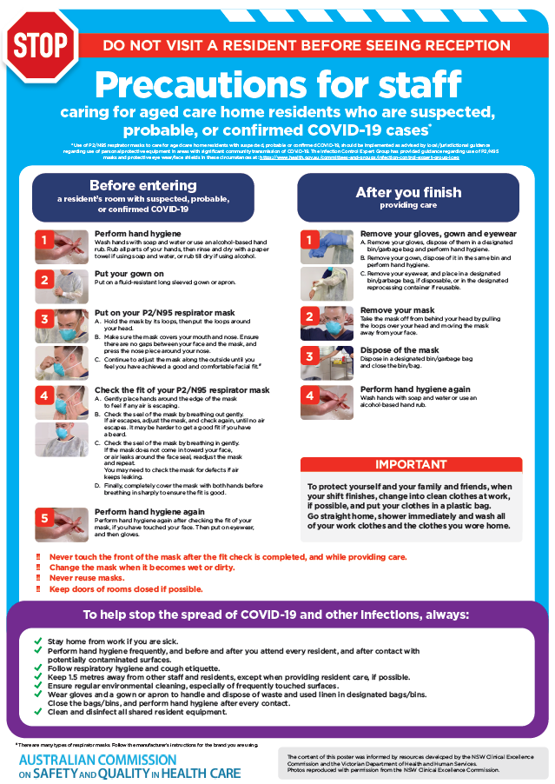](https://www.safetyandquality.gov.au/publications-and-resources/resource-library/poster-ppe-use-aged-care-staff-caring-residents-covid-19)

* ***Poster – Combined contact and droplet precautions*** <https://www.safetyandquality.gov.au/publications-and-resources/resource-library/poster-combined-contact-and-droplet-precautions>  
  [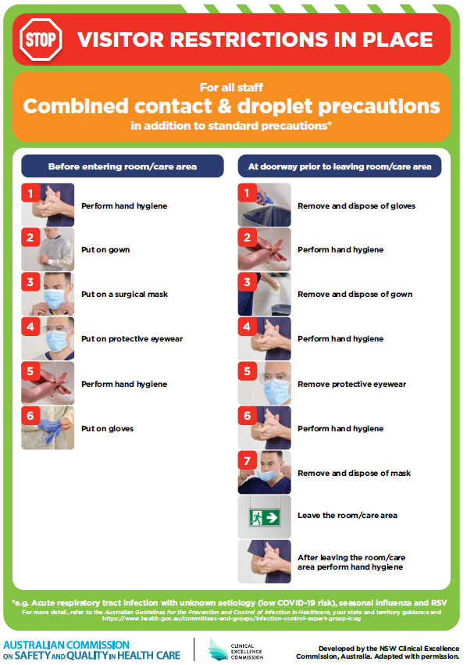](https://www.safetyandquality.gov.au/publications-and-resources/resource-library/poster-combined-contact-and-droplet-precautions)
* ***Poster – Combined airborne and contact precautions*** <https://www.safetyandquality.gov.au/publications-and-resources/resource-library/poster-combined-airborne-and-contact-precautions>   
  [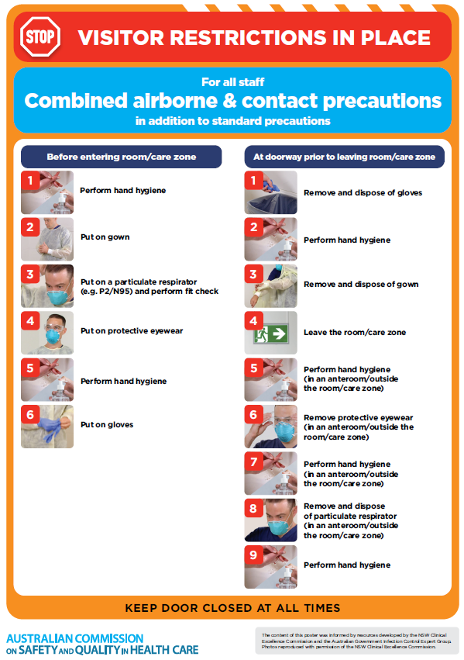](https://www.safetyandquality.gov.au/publications-and-resources/resource-library/poster-combined-airborne-and-contact-precautions)
* ***Environmental Cleaning and Infection Prevention and Control*** [www.safetyandquality.gov.au/environmental-cleaning](http://www.safetyandquality.gov.au/environmental-cleaning)
* ***COVID-19 infection prevention and control risk management – Guidance*** <https://www.safetyandquality.gov.au/publications-and-resources/resource-library/covid-19-infection-prevention-and-control-risk-management-guidance>
* ***Safe care for people with cognitive impairment during COVID-19***<https://www.safetyandquality.gov.au/our-work/cognitive-impairment/cognitive-impairment-and-covid-19>
* ***Stop COVID-19: Break the chain of infection*** posterhttps://www.safetyandquality.gov.au/publications-and-resources/resource-library/break-chain-infection-poster-a3  
  **[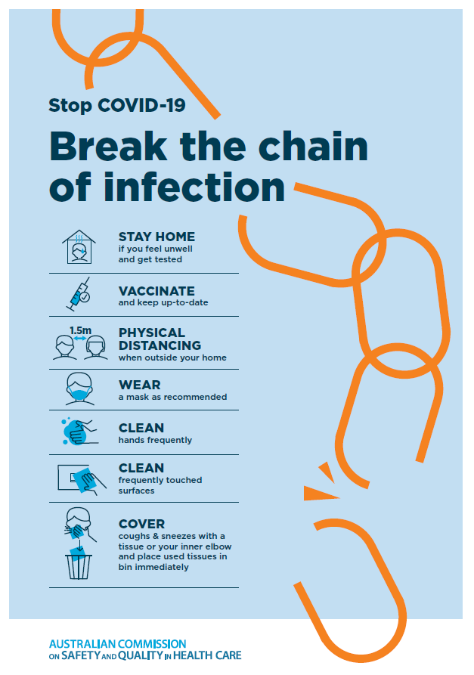](https://www.safetyandquality.gov.au/publications-and-resources/resource-library/break-chain-poster-a3https:/www.safetyandquality.gov.au/publications-and-resources/resource-library/break-chain-poster-a3)**
* ***FAQs for clinicians on elective surgery*** <https://www.safetyandquality.gov.au/node/5724>
* ***FAQs for consumers on elective surgery*** <https://www.safetyandquality.gov.au/node/5725>
* ***COVID-19 and face masks – Information for consumers*** <https://www.safetyandquality.gov.au/publications-and-resources/resource-library/covid-19-and-face-masks-information-consumers>

[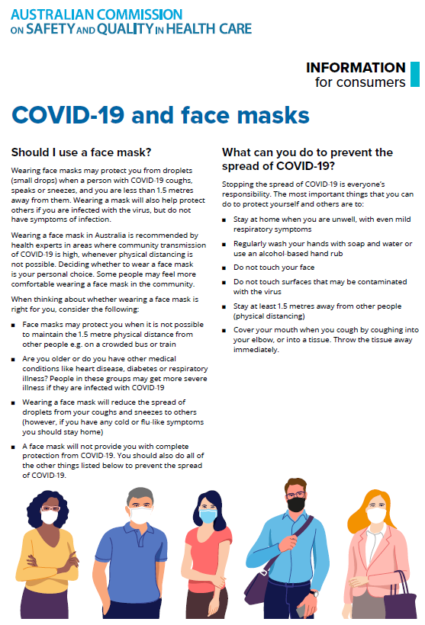](https://www.safetyandquality.gov.au/sites/default/files/2020-07/covid-19_and_face_masks_-_information_for_consumers.pdf)

*National COVID-19 Clinical Evidence Taskforce*

<https://covid19evidence.net.au/>

The National COVID-19 Clinical Evidence Taskforce is a collaboration of peak health professional bodies across Australia whose members are providing clinical care to people with COVID-19. The taskforce is undertaking continuous evidence surveillance to identify and rapidly synthesise emerging research in order to provide national, **evidence-based guidelines and clinical flowcharts for the clinical care of people with COVID-19**. The guidelines address questions that are specific to managing COVID-19 and cover the full disease course across mild, moderate, severe and critical illness. These are ‘living’ guidelines, updated with new research in near real-time in order to give reliable, up-to-the minute advice to clinicians providing frontline care in this unprecedented global health crisis.

*COVID-19 Critical Intelligence Unit*

<https://www.aci.health.nsw.gov.au/covid-19/critical-intelligence-unit>

The Agency for Clinical Innovation (ACI) in New South Wales has developed this page summarising rapid, evidence-based advice during the COVID-19 pandemic. Its operations focus on systems intelligence, clinical intelligence and evidence integration. The content includes a daily evidence digest, a COVID status monitor, a risk monitoring dashboard and evidence checks on a discrete topic or question relating to the current COVID-19 pandemic. There is also a ‘Living evidence’ section summarising key studies and emerging evidence on **COVID-19 vaccines** and **SARS-CoV-2 variants**. The most recent updates include:

* ***Face masks and COVID-19 transmission in the community*** – What is the evidence for the effectiveness of face masks in community settings for reducing influenza-like illnesses, including COVID-19?
* ***COVID-19 vaccines in Australia*** – What is the evidence on COVID-19 vaccines in Australia?
* ***Omicron (B.1.1.529) variant*** – What is the evidence for the variant of concern Omicron (B.1.1.529) in terms of transmissibility, disease severity, COVID-19 treatments and vaccines?

**Disclaimer**

On the Radar is an information resource of the Australian Commission on Safety and Quality in Health Care. The Commission is not responsible for the content of, nor does it endorse, any articles or sites listed. The Commission accepts no liability for the information or advice provided by these external links. Links are provided on the basis that users make their own decisions about the accuracy, currency and reliability of the information contained therein. Any opinions expressed are not necessarily those of the Australian Commission on Safety and Quality in Health Care.