# Australian Commission on Safety and Quality in Health Care logo with Radar imageOn the Radar

Issue 545

7 February 2022

*On the Radar* is a summary of some of the recent publications in the areas of safety and quality in health care. Inclusion in this document is not an endorsement or recommendation of any publication or provider. Access to particular documents may depend on whether they are Open Access or not, and/or your individual or institutional access to subscription sites/services. Material that may require subscription is included as it is considered relevant.

*On the Radar* is available online, via email or as a PDF or Word document from <https://www.safetyandquality.gov.au/publications-and-resources/newsletters/radar>

If you would like to receive *On the Radar* via email, you can subscribe on our website <https://www.safetyandquality.gov.au/publications-and-resources/newsletters>  
or by emailing us at H[Umail@safetyandquality.gov.auU](mailto:mail@safetyandquality.gov.au).   
You can also send feedback and comments to H[Umail@safetyandquality.gov.auU](mailto:mail@safetyandquality.gov.au).

For information about the Commission and its programs and publications, please visit <https://www.safetyandquality.gov.au>

You can also follow us on Twitter @ACSQHC.

**On the Radar**

Editor: Dr Niall Johnson [niall.johnson@safetyandquality.gov.au](mailto:niall.johnson@safetyandquality.gov.au)

Contributors: Niall Johnson, Lilly Crino

**Australian Charter of Healthcare Rights**

<https://www.safetyandquality.gov.au/consumers/working-your-healthcare-provider/australian-charter-healthcare-rights>

The Australian Charter of Healthcare Rights (the Charter) provides consumers, their families, carers and health service organisations with a shared understanding of healthcare rights.

The Australian Commission on Safety and Quality in Health Care has released new resources for consumers and health service organisations to provide quick-reference summaries of the seven healthcare rights.

For consumers, the new easy-to-read [flyer](https://www.safetyandquality.gov.au/publications-and-resources/resource-library/my-healthcare-rights-flyer-consumers) might be included in welcome packs when they are admitted into hospital or for a day procedure. It describes what to expect when receiving healthcare, and is useful to help patients have conversations with their clinicians about healthcare rights.

For health service organisations, this [flyer](https://www.safetyandquality.gov.au/publications-and-resources/resource-library/australian-charter-healthcare-rights-flyer-health-service-organisations) shares clear information summarising the key responsibilities of health services in upholding consumer rights.

The Commission has previously released a suite of supportive resources on the Charter including a comprehensive guide for consumers, an animation, audio resources, translations into 19 community languages, and Braille, Auslan and Easy English versions. These are available at <https://www.safetyandquality.gov.au/consumers/working-your-healthcare-provider/australian-charter-healthcare-rights/supportive-resources-second-edition-australian-charter-healthcare-rights>

The Charter applies to care provided in all health settings, including public and private hospitals, general practice, dental services and other community settings. Please share these resources with anyone you know who may find them helpful.

For more information, email [partneringwithconsumers@safetyandquality.gov.au](mailto:partneringwithconsumers@safetyandquality.gov.au) or visit our Charter web page <https://www.safetyandquality.gov.au/consumers/working-your-healthcare-provider/australian-charter-healthcare-rights>

**Reports**

*What enabled health service innovation during the pandemic? Crisis, staff, system or management?*Kuipers P, Finch J, Gavaghan B, Young G, Haddock R

Deeble Institute Perspectives Brief No. 19.

Canberra: Australian Healthcare and Hospitals Association; 2022.

|  |  |
| --- | --- |
| URL | <https://ahha.asn.au/sites/default/files/docs/policy-issue/perspectives_brief_no_19_health_service_innovation_during_the_pandemic.pdf> |
| Notes | This Perspectives brief from the Australian Healthcare and Hospitals Association‘s Deeble Institute examines some of the changes that happened in Queensland during the VOVID-19 pandemic. The authors argue that the pandemic saw rapid shifts in the way health care is being delivered, but their focus on the factors that enabled innovation to occur. They examine the key enablers of innovative allied health models of care and practice changes within Queensland’s publicly funded health services during the pandemic preparedness phase. Based on interviews with 28 health professionals conducted by the Allied Health Professions’ Office of Queensland (AHPOQ) the brief identifies three key innovation enablers: adaptive management style, devolved authority structures and trust in staff capability. |

Journal articles

*The Extent of Medication-Related Hospital Admissions in Australia: A Review from 1988 to 2021*

Lim R, Ellett LMK, Semple S, Roughead EE

Drug Safety. 2022 [epub]

|  |  |
| --- | --- |
| DOI | <https://doi.org/10.1007/s40264-021-01144-1> |
| Notes | Paper seeking to ‘determine the overall incidence, severity and preventability of medication-related hospital admissions, as well as providing a national estimate on their extent and cost’ in Australia. The authors conclude that ‘**at least 250,000 hospital admissions annually in Australia are medication** related, with an estimated cost of **1.4 billion Australian dollars’**.They also observe that ‘**two-thirds of medication-related hospital admissions are potentially preventable**.’ |

For information on the Commission’s work on medication safety, see <https://www.safetyandquality.gov.au/our-work/medication-safety>

*Hospital-acquired complications: the relative importance of hospital- and patient-related factors*

Duke GJ, Moran JL, Bersten AD, Bihari S, Roodenburg O, Karnon J, et al

Medical Journal of Australia. 2021 [epub].

|  |  |
| --- | --- |
| DOI | <https://doi.org/10.5694/mja2.51375> |
| Notes | This study sought to quantify the prevalence of hospital‐acquired complications and to determine the relative influence of patient‐ and hospital‐related factors on complication rates. Using data on 38 public hospitals in South Australia and Victoria during 2015–2018, this study found HACs are quite common. ‘**Hospital‐acquired complications were recorded for 9.7% of hospital episodes**, but patient‐related factors played a greater role in determining their prevalence than the treating hospital.’  There may be a risk of this being seem somewhat victim-blaming by this evoking of 'patient characteristics'.  Sometime ago there was a degree of pushback on the use of the term "second victim" for the clinicians involved in instances of harm. That struck one then as perhaps lacking in compassion. Clinicians are motivated to provide care and relief and are often very invested in their expertise and competence in doing so. Patient harm challenges that. But this should also not obscure the patient, the first victim. And where does this taxonomy place the patient's family, "third victim?"  As the very recent "first victim" of a potentially catastrophic complication (a brain haemorrhage) this has brought some of these concepts into sharp relief.  There needs to be room for compassion for all those affected by an incident, error or HAC. |

For further information about the Commission’s work on hospital-acquired complications (HACs), see <https://www.safetyandquality.gov.au/our-work/indicators/hospital-acquired-complications>

*Australian Health Review*

Volume 46 Number 1 2022

|  |  |
| --- | --- |
| URL | <https://www.publish.csiro.au/ah/issue/10696> |
|  | A new issue of *Australian Health Review* has been published. Articles in this issue of *Australian Health Review* include:   * **Racism complaints in the Australian health system**: an overview of existing approaches and some recommendations (Mandy Truong, Dominique Allen, Jocelyn Chan and Yin Paradies) * Examining the **health and well-being profile of people experiencing primary homelessness**: the social work perspective at a major metropolitan teaching hospital (Penny Lording, Katrina Rushworth, Helen McNicol and Lisa Braddy) * Understanding consumer preference for **vascular access safety and quality measurement**: an international survey (Jessica Schults, Rebecca Paterson, Tricia Kleidon, Marie Cooke, Amanda Ullman, Keith McNeil, Vineet Chopra, Karina Charles, Gillian Ray-Barruel, Nicole Marsh, Clair Sullivan, David J Sturgess and Claire Rickard) * Inappropriate **antibiotic prescribing**: understanding clinicians’ perceptions to enable changes in prescribing practices (Mah Laka, Adriana Milazzo and Tracy Merlin) * Characteristics and outcomes of patients receiving **review requests for pre-medical emergency team deterioration**: a cohort study (Judy Currey, Matthew Macaulay, Daryl Jones and Julie Considine) * Emergency department care-related causal factors of **in-patient deterioration** (Kirollos Nassief, Mark Azer, Michael Watts, Erin Tuala, Peter McLennan and Kate Curtis) * Healthcare resource utilisation and predictors for **critical care unit admissions after primary bariatric surgery** in an Australian public hospital setting: an exploratory study using a mixed-methods approach (Qing Xia, Julie A Campbell, Lei Si, Hasnat Ahmad, Barbara de Graaff, Kevin Ratcliffe, Julie Turtle, John Marrone, Alexandr Kuzminov and Andrew J Palmer) * Analysis of current **maternity leave policies for doctors in training** (Rebekah Hoffman, Judy Mullan and Andrew Bonney) * **What does co-design mean for Australia’s diverse clinical workforce?** (Reema Harrison, Melvin Chin and Eidin Ni She) * **Communication as a clinical** skill: a challenge in the delivery of safe and effective patient care (Sarah J White and Veronica Preda) * Socio-environmental models of **allied health disability support**: an exploration of narrative experiences in the Australian National Disability and Insurance Scheme (Mitchell N Sarkies, Sarah Milne and Annette Davis) * **Chronic pain and cardiovascular disease prevention in primary care**: a review of Australian primary health network needs assessments (Pippy Walker, Samuel Cornell, Simone De Morgan, Carissa Bonner and Fiona M Blyth) * Implementation and evaluation of a **university–hospital partnership program for Type 2 diabetes** (Jane Musial, Andrea Cawte, Robert Mullins, Mary Hannan-Jones and Susan de Jersey) * Back2Work: a new model of early **vocational rehabilitation for people with spinal cord injury** (Vanette McLennan, Pat Dorsett, Julia Bloom, Tania Goossen and Frances Porter) * Who needs, receives and misses out on **palliative and end-of-life care**? A population-based study to identify needs and gaps in a regional health service (Victoria Westley-Wise, Stephen Moules, Malcolm Masso, Greg Barclay, Zivai Nangati, Sam Allingham, Joanne Davis and Kathy Eagar) * Reduced individual treatment delivery has no effect on outcomes in a **multidisciplinary pain management program** (Rebecca M Mowat, Gwyn N Lewis and Robert Borotkanics) * Predictors of **mortality in older patients with isolated severe head injury**: a data linkage study from New South Wales, Australia (Sally Bath, Michael M Dinh, Stacey Casley and Pooria Sarrami) * Patient satisfaction with a **consumer codesigned lower limb cellulitis leaflet** (Jaclyn L Bishop, Mark Jones, James Farquharson, Kathrine Summerhayes, Roxanne Tucker, Mary Smith, Raquel Cowan, N.Deborah Friedman, Thomas R Schulz, David C M Kong and Kirsty L Buising) * **Bringing organisations together during a pandemic**: the case of an intersectoral community support group (Shirley-Anne Gardiner and Priya Martin) |

Journal of the Australian Indigenous HealthInfoNet

Volume 3, Issue 1, 2022

|  |  |
| --- | --- |
| URL | <https://ro.ecu.edu.au/aihjournal/> |
|  | A new issue of the Journal of the Australian Indigenous HealthInfoNet has been published. Articles in this issue of the Journal of Australian Indigenous HealthInfoNet include:   * **Culturally Safe and Integrated Primary Health Care**: A Case Study of Yerin Eleanor Duncan Aboriginal Health Services’ Holistic Model (Julieann Coombes, Patricia Cullen, Keziah Bennett-Brook, Marlene Longbottom, Tamara Mackean, Belinda Field, and Vickie Parry) * Evaluating **Patient Experience at a Novel Health Service for Aboriginal and Torres Strait Islander Prisoners**: A Pilot Study (Lachlan Arthur, Ana Herceg, Heidi Shukralla, Jason Payne, and Julie Tongs OAM) * Examining the **Associations Between Experiences of Perceived Racism and Drug and Alcohol Use in Aboriginal Australians** (Victoria Gentile, Adrian Carter, and Laura Jobson) * Protocols for an Aboriginal-led, Multi-methods Study of the Role of **Aboriginal and Torres Strait Islander Health Workers, Practitioners and Liaison Officers in Quality Acute Health Care** (Annabelle Wilson, Tamara Mackean, Liz Withall, Eileen M. Willis, Odette Pearson, Colleen Hayes, Kim O'Donnell, Janet Kelly, Kerry Taylor, Judith Dwyer, Elizabeth Bourke, Kate Hunter, Lorna Murakami-Gold, Rebecca Ivers, and Fran Baum) |

**Online resources**

*Future Leaders Communiqué*

Volume 7 Issue 1 January 2022

<https://www.thecommuniques.com/post/future-leaders-communiqu%C3%A9-volume-7-issue-1-january-2022>

This issue of *Future Leaders Communiqué* focuses on the crucial importance of **teams and teamwork**. It is often said that healthcare is a team sport. This issue examines two cases where the patient care was impacted by the composition of the clinical team and the nature of their teamwork. The expert commentary explains the five forms of dysfunctions affecting teams and teamwork. Viewpoints on teams from clinicians of varying experience are also offered. The issue concludes with an article describing the important role of junior doctors in promoting patient safety.

*[UK] NICE Guidelines and Quality Standards*

<https://www.nice.org.uk/guidance>

The UK’s National Institute for Health and Care Excellence (NICE) has published new (or updated) guidelines and quality standards. The latest reviews or updates are:

* Quality Standard QS20 ***Colorectal cancer*** <https://www.nice.org.uk/guidance/qs20>

*[UK] NIHR Evidence alerts*

<https://evidence.nihr.ac.uk/>alerts/

The UK’s National Institute for Health Research (NIHR) has posted new evidence alerts on its site. Evidence alerts are short, accessible summaries of health and care research which is funded or supported by NIHR. This is research which could influence practice and each Alert has a message for people commissioning, providing or receiving care. The latest alerts include:

* Giving the progestogen only pill along with emergency contraception encouraged women to use **long-term contraception**
* A 'sandpit' event encouraged diverse groups to **work jointly with researchers**
* **Are you sure you're allergic to penicillin?** Professionals and patients are urged to double-check
* **Persistent throat symptoms** should not be treated with pills that reduce stomach acid.

**COVID-19 resources**

https://www.safetyandquality.gov.au/covid-19

The Australian Commission on Safety and Quality in Health Care has developed a number of resources to assist healthcare organisations, facilities and clinicians. These and other material on COVID-19 are available at <https://www.safetyandquality.gov.au/covid-19>

These resource include:

* ***COVID-19 infection prevention and control risk management*** <https://www.safetyandquality.gov.au/publications-and-resources/resource-library/covid-19-infection-prevention-and-control-risk-management-guidance>
* ***Poster - PPE use for aged care staff caring for residents with COVID-19*** <https://www.safetyandquality.gov.au/publications-and-resources/resource-library/poster-ppe-use-aged-care-staff-caring-residents-covid-19>

[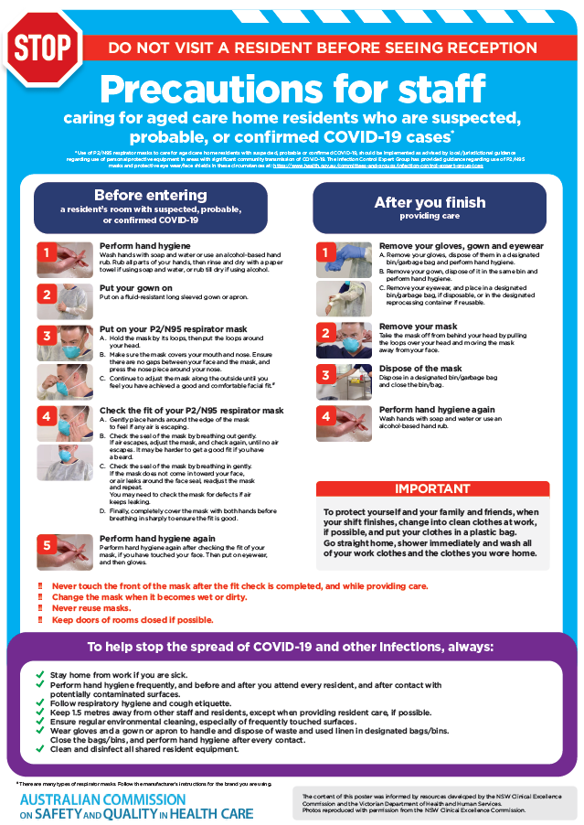](https://www.safetyandquality.gov.au/publications-and-resources/resource-library/poster-ppe-use-aged-care-staff-caring-residents-covid-19)

* ***Poster – Combined contact and droplet precautions*** <https://www.safetyandquality.gov.au/publications-and-resources/resource-library/poster-combined-contact-and-droplet-precautions>  
  [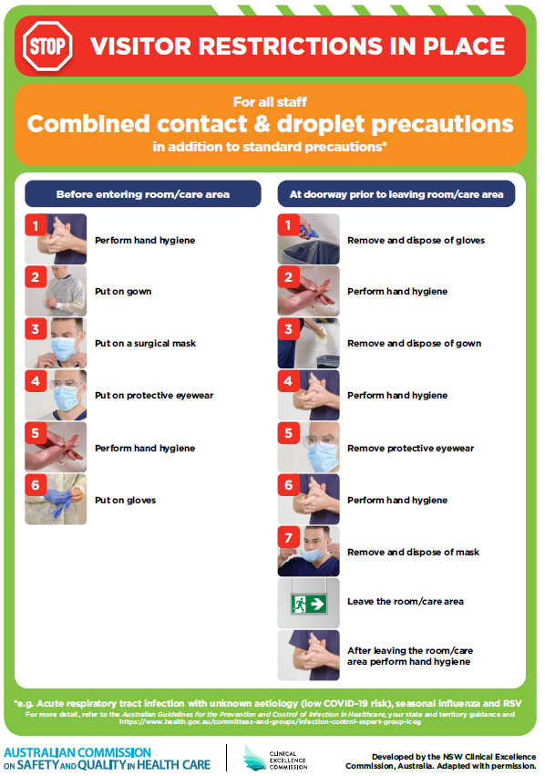](https://www.safetyandquality.gov.au/publications-and-resources/resource-library/poster-combined-contact-and-droplet-precautions)
* ***Poster – Combined airborne and contact precautions*** <https://www.safetyandquality.gov.au/publications-and-resources/resource-library/poster-combined-airborne-and-contact-precautions>   
  [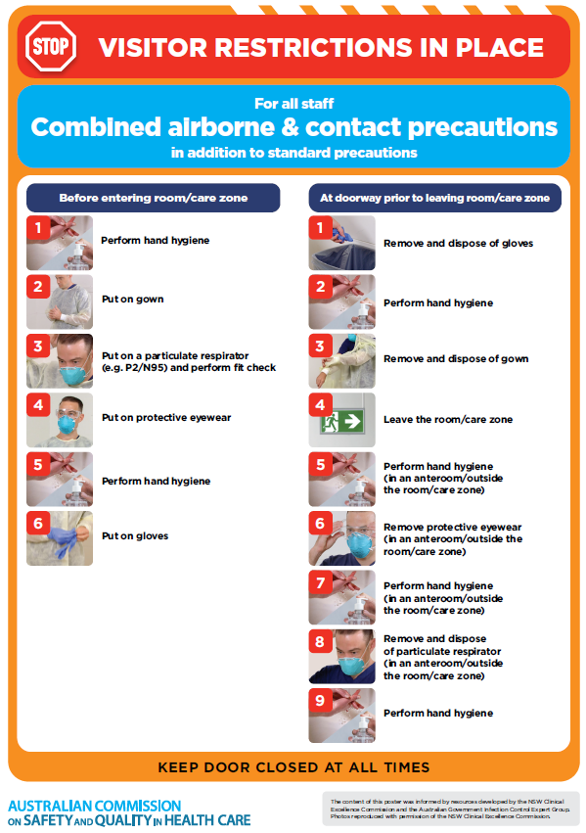](https://www.safetyandquality.gov.au/publications-and-resources/resource-library/poster-combined-airborne-and-contact-precautions)
* ***Environmental Cleaning and Infection Prevention and Control*** [www.safetyandquality.gov.au/environmental-cleaning](http://www.safetyandquality.gov.au/environmental-cleaning)
* ***COVID-19 infection prevention and control risk management – Guidance*** <https://www.safetyandquality.gov.au/publications-and-resources/resource-library/covid-19-infection-prevention-and-control-risk-management-guidance>
* ***Safe care for people with cognitive impairment during COVID-19***<https://www.safetyandquality.gov.au/our-work/cognitive-impairment/cognitive-impairment-and-covid-19>
* ***Stop COVID-19: Break the chain of infection*** posterhttps://www.safetyandquality.gov.au/publications-and-resources/resource-library/break-chain-infection-poster-a3  
  **[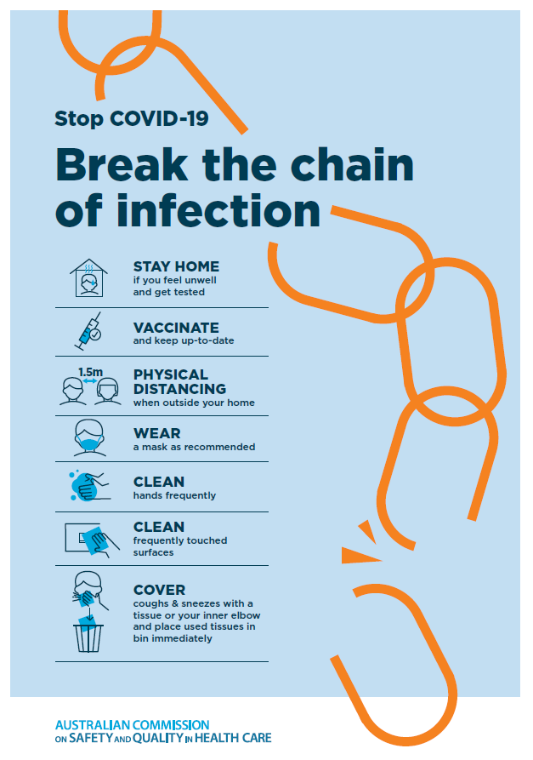](https://www.safetyandquality.gov.au/publications-and-resources/resource-library/break-chain-poster-a3https:/www.safetyandquality.gov.au/publications-and-resources/resource-library/break-chain-poster-a3)**
* ***FAQs for clinicians on elective surgery*** <https://www.safetyandquality.gov.au/node/5724>
* ***FAQs for consumers on elective surgery*** <https://www.safetyandquality.gov.au/node/5725>
* ***COVID-19 and face masks – Information for consumers*** <https://www.safetyandquality.gov.au/publications-and-resources/resource-library/covid-19-and-face-masks-information-consumers>

[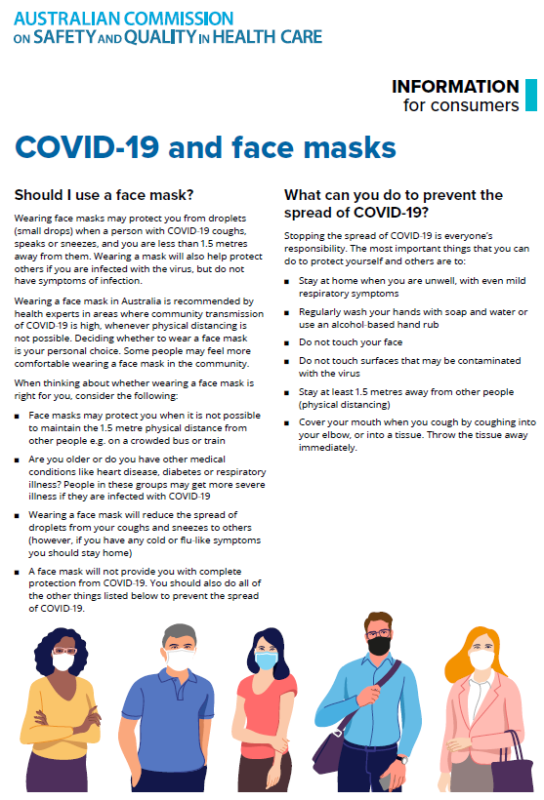](https://www.safetyandquality.gov.au/sites/default/files/2020-07/covid-19_and_face_masks_-_information_for_consumers.pdf)

*National COVID-19 Clinical Evidence Taskforce*

<https://covid19evidence.net.au/>

The National COVID-19 Clinical Evidence Taskforce is a collaboration of peak health professional bodies across Australia whose members are providing clinical care to people with COVID-19. The taskforce is undertaking continuous evidence surveillance to identify and rapidly synthesise emerging research in order to provide national, **evidence-based guidelines and clinical flowcharts for the clinical care of people with COVID-19**. The guidelines address questions that are specific to managing COVID-19 and cover the full disease course across mild, moderate, severe and critical illness. These are ‘living’ guidelines, updated with new research in near real-time in order to give reliable, up-to-the minute advice to clinicians providing frontline care in this unprecedented global health crisis.

*COVID-19 Critical Intelligence Unit*

<https://www.aci.health.nsw.gov.au/covid-19/critical-intelligence-unit>

The Agency for Clinical Innovation (ACI) in New South Wales has developed this page summarising rapid, evidence-based advice during the COVID-19 pandemic. Its operations focus on systems intelligence, clinical intelligence and evidence integration. The content includes a daily evidence digest, a COVID status monitor, a risk monitoring dashboard and evidence checks on a discrete topic or question relating to the current COVID-19 pandemic. There is also a ‘Living evidence’ section summarising key studies and emerging evidence on **COVID-19 vaccines** and **SARS-CoV-2 variants**. The most recent updates include:

* ***Hospital visitor policies*** – What is the evidence for hospital visitor policies during and outside of the COVID-19 pandemic?
* ***Surgical masks, eye protection and PPE guidance*** –What is the evidence for surgical masks in the endemic phase in hospitals and for eyewear to protect against COVID-19?
* ***Paediatrics and COVID-19 reporting rates and differences*** – How are paediatric patients with COVID-19 reported, and what are the differences in rates and severity with Omicron?
* ***Incidental COVID-19*** – How are incidental COVID-19 cases being reported internationally, and what is the proportional of incidental COVID-19 cases?
* ***Sotrovimab*** –What is the evidence for sotrovimab as a treatment for COVID-19?
* ***Omicron - symptoms and hospitalised patients*** – What are the symptoms associated with Omicron and what is the risk of hospitalisation for Omicron
* ***COVID-19 vaccines in Australia*** – What is the evidence on COVID-19 vaccines in Australia?

**Disclaimer**

On the Radar is an information resource of the Australian Commission on Safety and Quality in Health Care. The Commission is not responsible for the content of, nor does it endorse, any articles or sites listed. The Commission accepts no liability for the information or advice provided by these external links. Links are provided on the basis that users make their own decisions about the accuracy, currency and reliability of the information contained therein. Any opinions expressed are not necessarily those of the Australian Commission on Safety and Quality in Health Care.