# On the Radar

Issue 546

14 February 2022

*On the Radar* is a summary of some of the recent publications in the areas of safety and quality in health care. Inclusion in this document is not an endorsement or recommendation of any publication or provider. Access to particular documents may depend on whether they are Open Access or not, and/or your individual or institutional access to subscription sites/services. Material that may require subscription is included as it is considered relevant.

*On the Radar* is available online, via email or as a PDF or Word document from <https://www.safetyandquality.gov.au/publications-and-resources/newsletters/radar>

If you would like to receive *On the Radar* via email, you can subscribe on our website <https://www.safetyandquality.gov.au/publications-and-resources/newsletters>  
or by emailing us at H[Umail@safetyandquality.gov.auU](mailto:mail@safetyandquality.gov.au).   
You can also send feedback and comments to H[Umail@safetyandquality.gov.auU](mailto:mail@safetyandquality.gov.au).

For information about the Commission and its programs and publications, please visit <https://www.safetyandquality.gov.au>

You can also follow us on Twitter @ACSQHC.

**On the Radar**

Editor: Dr Niall Johnson [niall.johnson@safetyandquality.gov.au](mailto:niall.johnson@safetyandquality.gov.au)

Contributors: Niall Johnson, Amy Forsyth, Dr Jan Gralton, Leanne Vidler, Jennifer Caldwell

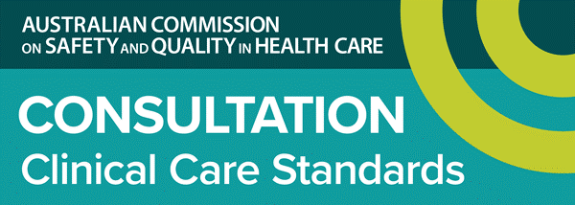

**Have your say on the national Stillbirth Clinical Care Standard**

<https://www.safetyandquality.gov.au/standards/clinical-care-standards/stillbirth-clinical-care-standard>

The Australian Commission on Safety and Quality in Health Care (the Commission) has released the draft *Stillbirth Clinical Care Standard* for public consultation.

The standard aims to reduce unwarranted variation and improve the appropriateness of care for stillbirth prevention, and the quality of bereavement care following perinatal loss. The clinical care standard reflects current best practice and Australian guidelines on stillbirth prevention and management, including the *Clinical Practice Guideline for Care around Stillbirth and NeonatalDeath* (<https://sanda.psanz.com.au/clinical-practice/clinical-guidelines/>), the *Clinical Practice Guidelines: Pregnancy Care* (<https://www.health.gov.au/resources/collections/pregnancy-care-guidelines-and-related-documents>) and the Safer Baby Bundle (<https://stillbirthcre.org.au/about-us/our-work/the-safer-baby-bundle/>)

***Public consultation***

The Commission is seeking feedback on the draft clinical care standard from consumers, clinicians, health services and anyone with an interest in maternity care, stillbirth, or bereavement care.

The standard particularly relates to the care provided by clinicians working in general practice, midwifery, nursing, obstetrics, sonography, radiology, perinatal pathology, and bereavement care.

***Provide your feedback***

You are invited to view and comment on the draft Stillbirth Clinical Care Standard and supporting resources using the online survey available at <https://www.safetyandquality.gov.au/standards/clinical-care-standards/consultations-clinical-care-standards>

This public consultation will be open until midnight Monday, **14 March 2022.**

Developed in consultation with an expert working group, the standard is based on current Australian clinical guidance for pregnancy and stillbirth care and supported by the Australian Government Department of Health as part of the National Stillbirth Action and Implementation Plan.

For more information, please contact our Clinical Care Standards team at [CCS@safetyandquality.gov.au](mailto:CCS@safetyandquality.gov.au).

**Reports**

Clostridioides difficile *infection 2019 Data Snapshot Report*

Australian COmmission on Safety and Quality in Health Care

. Sydney: ACSQHC; 2021. p. 18

|  |  |
| --- | --- |
| URL | <https://www.safetyandquality.gov.au/publications-and-resources/resource-library/clostridioides-difficile-infection-2019-data-snapshot> |
| Notes | The Australian Commission on Safety and Quality in Health Care (the Commission) has published the *Clostridium difficile infections – 2019 Data Snapshot report*. This report is the fourth in a series of reports on the prevalence of *Clostridioides difficile* infection (CDI) in Australia. This was produced to investigate if the increase in community-onset CDI, reported in the CDI 2018 Data Snapshot report and the technical report: *Monitoring the national burden of CDI in Australian public hospitals: 2016 to 2018 (*<https://www.safetyandquality.gov.au/publications-and-resources/resource-library/monitoring-national-burden-clostridioides-difficile-infection-australian-public-hospitals-2016-2018> *)*, has been sustained.  The key findings from the CDI 2019 Data Snapshot report indicate:   * The average rate of all CDI diagnoses in 2019 was 4.0 diagnoses per 10,000 patient bed days. * The rate of CDI diagnoses acquired during an episode of inpatient care, declined by 7.24% between 2018 and 2019. * Patients admitted to hospital with pre-existing CDI symptoms, which include patients that have acquired CDI in the community or during a previous hospital admission, account for 80% of all CDI separations in 2019 * Patients with pre-existing CDI symptoms have increased by 3.35% from 2018 to 2019, indicating that community-onset CDI is increasing in Australia.   The report is available from the Commission’s website at <https://www.safetyandquality.gov.au/publications-and-resources/resource-library/clostridioides-difficile-infection-2019-data-snapshot>  Recent information on CDI and AMS in Australia which is consistent with the Commission’s work include the following articles:   * Hong, S., Putsathit, P., George, N., Hemphill, C., Huntington, P. G., Korman, T. M., Kotsanas, D., Lahra, M., McDougall, R., Moore, C. V., Nimmo, G. R., Prendergast, L., Robson, J., Waring, L., Wehrhahn, M. C., Weldhagen, G. F., Wilson, R. M., Riley, T. V., & Knight, D. R. (2020). Laboratory-Based Surveillance of Clostridium difficile Infection in Australian Health Care and Community Settings, 2013 to 2018. *Journal of clinical microbiology*, 58(11), e01552-20. <https://doi.org/10.1128/JCM.01552-20> * Lim, S. C., Knight, D. R., & Riley, T. V. (2020). Clostridium difficile and One Health. *Clinical microbiology and infection : the official publication of the European Society of Clinical Microbiology and Infectious Diseases*, 26(7), 857–863. <https://doi.org/10.1016/j.cmi.2019.10.023> * Jokanovic, N., Haines, T., Cheng, A. C., Holt, K. E., Hilmer, S. N., Jeon, Y. H., Stewardson, A. J., Stuart, R. L., Spelman, T., Peel, T. N., Peleg, A. Y., & START Trial Group (2021). Multicentre stepped-wedge cluster randomised controlled trial of an antimicrobial stewardship programme in residential aged care: protocol for the START trial. *BMJ open*, 11(3), e046142. <https://doi.org/10.1136/bmjopen-2020-046142>   **Updated Principles of Infection Prevention and Control and Basics of Infection Prevention and Control eLearning modules**  The Commission continues to develop and support online learning for infection prevention and control (IPC) and hand hygiene delivered via a centralised online Learning Management System (LMS).  The Commission has recently updated the *Principles of infection prevention and control* and *Basics of infection prevention and control* eLearning modules to ensure consistency with the National Safety and Quality Health Service Standards, specifically the *Preventing and Controlling Infections Standard*, and the *Australian Guidelines for the Prevention and Control of Infection in Health Care*. These modules have also been enhanced to improve the learner experience.  The updated modules are available to learners who are registered in the National Hand Hygiene Initiative (NHHI) LMS at <https://nhhi.southrock.com>  .  Preview image of updated learning module |

**Journal articles**

*The development of National Safety and Quality Digital Mental Health Standards*

Brown P, Prest B, Miles P, Rossi V

Australasian Psychiatry. 2021:10398562211042361.

|  |  |
| --- | --- |
| DOI | <https://doi.org/10.1177%2F10398562211042361> |
| Notes | Paper describing the development of the National Safety and Quality Digital Mental Health (NSQDMH) Standards. The NSQDMH Standards comprise three standards—Clinical and Technical Governance, Partnering with Consumers, and Model of Care—and were launched in November 2020. The National Safety and Quality Digital Mental Health Standards are available at <https://www.safetyandquality.gov.au/standards/national-safety-and-quality-digital-mental-health-standards> |

*Thoughts of suicide or self-harm among Australian healthcare workers during the COVID-19 pandemic*

Bismark M, Scurrah K, Pascoe A, Willis K, Jain R, Smallwood N

Australian & New Zealand Journal of Psychiatry. 2022:00048674221075540.

|  |  |
| --- | --- |
| DOI | <https://doi.org/10.1177/00048674221075540> |
| Notes | The health, including mental health, of healthcare workers can impact the safety and quality of health care delivery. This study reveals that a significant proportion of Australian healthcare workers were struggling during the COVID-19 pandemic. Using data from the Australian COVID-19 Frontline Healthcare Workers Study, the authors report that ‘819 (10.5%) of 7795 healthcare workers reported thoughts of suicide or self-harm over a 2-week period.’ Futher, they observe that ‘Most healthcare workers with thoughts of suicide or self-harm did not seek professional help. Strong and sustained action to protect the safety of healthcare workers, and provide meaningful support, is urgently needed.’ |

*Medication errors' causes analysis in home care setting: a systematic review*

Dionisi S, Di Simone E, Liquori G, De Leo A, Di Muzio M, Giannetta N.

Public Health Nursing. 2021 [epub].

|  |  |
| --- | --- |
| DOI | <https://doi.org/10.1111/phn.13037> |
| Notes | Medication errors are among the most common healthcare errors. This review sought to examine whether the causes of medication error in the home differed from those in the hospital setting. From their analysis of the literature, the authors report that ‘medication errors in home care occur mainly during transitional care. The main risk factors related to transitional care are poor interprofessional communication, lack of a standardized process for medication reconciliation, the widespread use of computerized tools, and the inadequate integration of the pharmacist into the care team.’ They suggest that ‘strategies to reduce the risk of errors from therapy at home are the implementation of the pharmacist in the health team to ensure accurate medication reconciliation and the use of computerized tools to improve communication between professionals and to reduce the dispersion of information’ |

For information on the Commission’s work on medication safety, see <https://www.safetyandquality.gov.au/our-work/medication-safety>

*Healthcare Quarterly*

Volume 24, Number 4, 2022

|  |  |
| --- | --- |
| URL | <https://www.longwoods.com/publications/healthcare-quarterly/26708/1/vol.-24-no.-4-2022> |
|  | A new issue of *Healthcare Quarterly* has been published with a theme of **health system innovations**. Articles in this issue of *Healthcare Quarterly* include:   * Utility, Limitations and Opportunities for Using Linked **Health Administrative Data to Study Homelessness** in Ontario (Richard G Booth, Lucie Richard, Cheryl Forchuk and Salimah Z Shariff) * How were **Wait Times for Priority Procedures** in Canada Impacted during the First Six Months of the **COVID-19 Pandemic**? (Ben Reason, Erin Pichora and Tracy Johnson) * The **Economic Impact of Healthcare Innovation Activity** on the Newfoundland and Labrador Economy in 2019 and 2020 (Michael Doyle) * **Fostering Innovation through Procurement in the Healthcare Sector**: The Danish Experience (Carolina Belotti Pedroso, Martin Beaulieu, Lars Dahl Allerup and Claudia Rebolledo) * Using **Case Costing to Evaluate the Potential Impact of a Reintegration Unit** on an Acute-Care Hospital’s Capacity and Resources (Ivy Cheng, Clare L. Atzema, Debra Carew, Stacy Landau, Debra Walko, Wendy Li, Yan Yan Ma and G Ross Baker) * Development of **Pediatric Hospital Position Statements on Medical and Non-Prescribed Cannabis** (Jonathan Whelan, Luke Edgar, Michelle Ward, Kimmo Murto and Régis Vaillancourt) * **Meaningful Digital Consent** in Canada: Recommendations from Pan-Canadian Consent Management Workshops (Nelson Shen, Iman Kassam, Daria Ilkina, Sarah Wickham and Abigail Carter-Langford) * Physician Champions of Quality and Safety: Perspectives of MD Quality and Safety Leads to **Drive Quality Innovation at an Academic Hospital** (Sarah Tosoni, Quynh Huynh, Patricia Murphy, Flavio Habal, Emily Musing, Brian Hodges and Fei-Fei Liu) * Mixed-Methods Evaluation of a **Patient Behaviour Risk Screening, Communication and Care Planning Intervention** for Hospital Settings (Marija Corovic, Karen Spithoff, Jon-David Schwalm, Denise Johnson, Susan Fuciarelli, Erika Caspersen) * A Compass for Our Care: **Leadership That Enables a Culture of People-Centred Care** (Kerseri Scane, Jane Ballantyne, Pam Breese, Peter Kyriakides, Becky Quinlan and Laura Williams) |

*Health Affairs*

Volume 41, Number 2 (February 2022)

|  |  |
| --- | --- |
| URL | <https://www.healthaffairs.org/toc/hlthaff/41/2> |
| Notes | A new issue of *Health Affairs* has been published with the theme “**Racism & Health**”. Articles in this issue of *Health Affairs* include:   * Beyond Research, **Taking Action Against Racism** (Heather Tirado Gilligan) * The Intellectual Roots Of **Current Knowledge On Racism And Health**: Relevance To Policy And The National Equity Discourse (Ruth Enid Zambrana, and David R Williams) * **Systemic And Structural Racism**: Definitions, Examples, Health Damages, And Approaches To Dismantling (Paula A Braveman, Elaine Arkin, Dwayne Proctor, Tina Kauh, and Nicole Holm) * Improving The **Measurement Of Structural Racism** To Achieve Antiracist Health Policy (Rachel R Hardeman, Patricia A Homan, Tongtan Chantarat, Brigette A Davis, and Tyson H Brown) * **Structural Racism** In Historical And Modern US Health Care Policy (Ruqaiijah Yearby, Brietta Clark, and José F Figueroa) * Racism Runs Through It: Examining The **Sexual And Reproductive Health Experience Of Black Women** In The South (Terri-ann Monique Thompson, Yves-Yvette Young, Tanya M Bass, Stephanie Baker, Oriaku Njoku, Jessica Norwood, and Monica Simpson) * Negative Patient Descriptors: Documenting **Racial Bias In The Electronic Health Record** (Michael Sun, Tomasz Oliwa, Monica E Peek, and Elizabeth L. Tung) * The Potential For **Bias In Machine Learning** And Opportunities For Health Insurers To Address It (Stephanie S Gervasi, Irene Y Chen, Aaron Smith-McLallen, David Sontag, Ziad Obermeyer, Michael Vennera, and Ravi Chawla) * Sick And Tired Of Being Excluded: **Structural Racism In Disenfranchisement As A Threat To Population Health Equity** (Patricia A Homan, and Tyson H Brown) * **Neighborhood Police Encounters, Health, And Violence** In A Southern City (Katherine P Theall, Samantha Francois, Caryn N Bell, Andrew Anderson, David Chae, and Thomas A LaVeist) * The Problem Of The Color Line: **Spatial Access To Hospital Services For Minoritized Racial And Ethnic Groups** (Jan M. Eberth, Peiyin Hung, Gabriel A Benavidez, Janice C Probst, Whitney E Zahnd, Mary-Katherine McNatt, Ebony Toussaint, Melinda A Merrell, Elizabeth Crouch, Oyeleye J Oyesode, and Nicholas Yell) * Out Of Reach: **Inequities In The Use Of High-Quality Home Health Agencies** (Shekinah A Fashaw-Walters, Momotazur Rahman, Gilbert Gee, Vincent Mor, Michael White, and Kali S Thomas) * **Racial And Ethnic Disparities In Patient Experience Of Care** Among Nonelderly Medicaid Managed Care Enrollees (Kevin H Nguyen, Ira B Wilson, Anya R Wallack, and Amal N Trivedi) * **Structural Racism** And Black Women’s Employment In The US Health Care Sector (Janette Dill, and Mignon Duffy) * **Race, Place, And Structural Racism**: A Review Of Health And History In Washington, D.C. (Christopher J King, Bryan O Buckley, Riya Maheshwari, and Derek M. Griffith) * The **Generational Impact Of Racism On Health**: Voices From American Indian Communities (Teshia G. Arambula Solomon, Rachel Rose Bobelu Starks, Agnes Attakai, Fatima Molina, Felina Cordova-Marks, Michelle Kahn-John, Chester L. Antone, Miguel Flores, and Francisco Garcia) * Addressing The Interlocking **Impact Of Colonialism And Racism** On Filipinx/a/o American Health Inequities (Melanie D. Sabado-Liwag, Erin Manalo-Pedro, Roy Taggueg, Adrian M. Bacong, Alexander Adia, Donna Demanarig, Jake Ryann Sumibcay, Claire Valderama-Wallace, Carlos Irwin A Oronce, Rick Bonus, and Ninez A. Ponce) * The Mutually Reinforcing Cycle Of Poor Data Quality And Racialized Stereotypes That Shapes **Asian American Health** (Stella S Yi, Simona C Kwon, Rachel Suss, Lan N Ðoàn, Iyanrick John, Nadia S Islam, and Chau Trinh-Shevrin) * **Identity** (Sharon Attipoe-Dorcoo) |

*BMJ Quality & Safety* online first articles

|  |  |
| --- | --- |
| URL | <https://qualitysafety.bmj.com/content/early/recent> |
| Notes | *BMJ Quality &Safety* has published a number of ‘online first’ articles, including:   * Editorial: **‘My Five Moments’**: understanding a user-centred approach to hand hygiene improvement within a broader implementation strategy (Benedetta Allegranzi, Claire Kilpatrick, Hugo Sax, Didier Pittet) * Evaluating **patient-reported outcome measures** in Peru: a cross-sectional study of satisfaction and net promoter score using the 2016 EnSuSalud survey (Hannah H Leslie, Hwa-Young Lee, Brittany Blouin, Patricia J García, Margaret E Kruk) * **Diagnostic error experiences of patients and families** with limited English-language health literacy or disadvantaged socioeconomic position in a cross-sectional US population-based survey (Sigall K Bell, Joe Dong, Long Ngo, Patricia McGaffigan, Eric J Thomas, Fabienne Bourgeois) |

*International Journal for Quality in Health Care* online first articles

|  |  |
| --- | --- |
| URL | <https://academic.oup.com/intqhc/advance-articles> |
| Notes | *International Journal for Quality in Health Care* has published a number of ‘online first’ articles, including:   * **Acute Appendicitis During the COVID-19 Pandemic** – Changes in Incidence and Clinical Presentation but not in Patients’ Outcome (Sebastian Wolf, Matthias Schrempf, Dmytro Vlasenko, Claus Schoeler, Frank Erckmann , Patrick von Parpart, Rieke Paschwitz, Matthias Anthuber, Florian Sommer) * Using **Guideline-Based Clinical Decision Support in Oncological Multidisciplinary Team Meetings**: A Prospective, Multicenter Concordance Study (K C W J Ebben, M P Hendriks, L Markus, M Kos, I H J T de Hingh , J R Oddens, J Rothbarth, J H W de Wilt, L J A Strobbe, M Bessems, C T Mellema, S Siesling, X A A M Verbeek) |

**COVID-19 resources**

https://www.safetyandquality.gov.au/covid-19

The Australian Commission on Safety and Quality in Health Care has developed a number of resources to assist healthcare organisations, facilities and clinicians. These and other material on COVID-19 are available at <https://www.safetyandquality.gov.au/covid-19>

These resource include:

* ***COVID-19 infection prevention and control risk management*** <https://www.safetyandquality.gov.au/publications-and-resources/resource-library/covid-19-infection-prevention-and-control-risk-management-guidance>
* ***Poster – Combined contact and droplet precautions*** <https://www.safetyandquality.gov.au/publications-and-resources/resource-library/poster-combined-contact-and-droplet-precautions>  
  [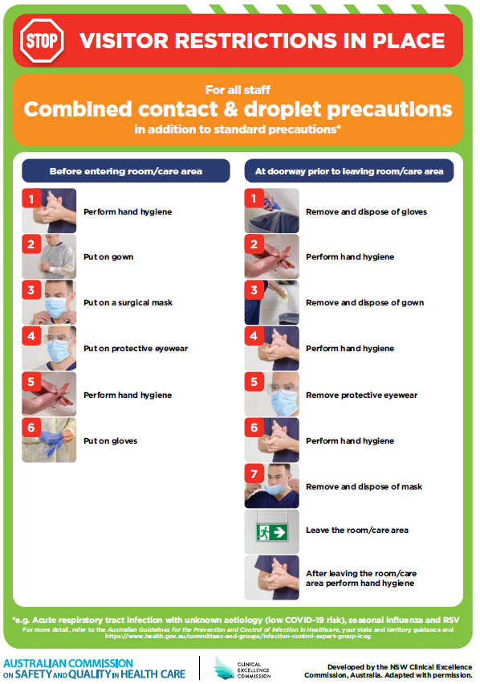](https://www.safetyandquality.gov.au/publications-and-resources/resource-library/poster-combined-contact-and-droplet-precautions)
* ***Poster – Combined airborne and contact precautions*** <https://www.safetyandquality.gov.au/publications-and-resources/resource-library/poster-combined-airborne-and-contact-precautions>   
  [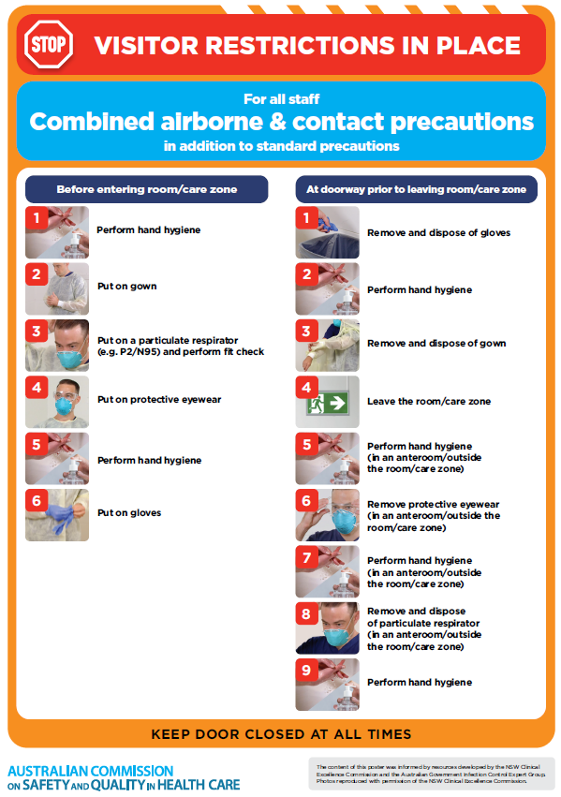](https://www.safetyandquality.gov.au/publications-and-resources/resource-library/poster-combined-airborne-and-contact-precautions)
* ***Environmental Cleaning and Infection Prevention and Control*** [www.safetyandquality.gov.au/environmental-cleaning](http://www.safetyandquality.gov.au/environmental-cleaning)
* ***COVID-19 infection prevention and control risk management – Guidance*** <https://www.safetyandquality.gov.au/publications-and-resources/resource-library/covid-19-infection-prevention-and-control-risk-management-guidance>
* ***Safe care for people with cognitive impairment during COVID-19***<https://www.safetyandquality.gov.au/our-work/cognitive-impairment/cognitive-impairment-and-covid-19>
* ***Stop COVID-19: Break the chain of infection*** posterhttps://www.safetyandquality.gov.au/publications-and-resources/resource-library/break-chain-infection-poster-a3  
  **[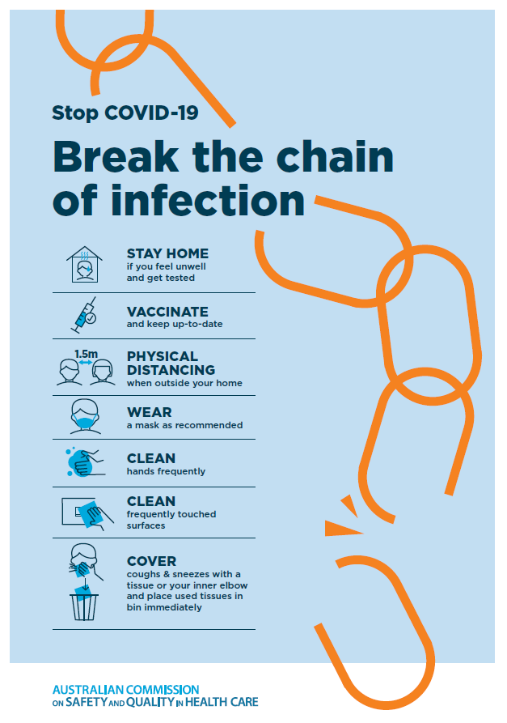](https://www.safetyandquality.gov.au/publications-and-resources/resource-library/break-chain-poster-a3https:/www.safetyandquality.gov.au/publications-and-resources/resource-library/break-chain-poster-a3)**
* ***FAQs for clinicians on elective surgery*** <https://www.safetyandquality.gov.au/node/5724>
* ***FAQs for consumers on elective surgery*** <https://www.safetyandquality.gov.au/node/5725>
* ***COVID-19 and face masks – Information for consumers*** <https://www.safetyandquality.gov.au/publications-and-resources/resource-library/covid-19-and-face-masks-information-consumers>

[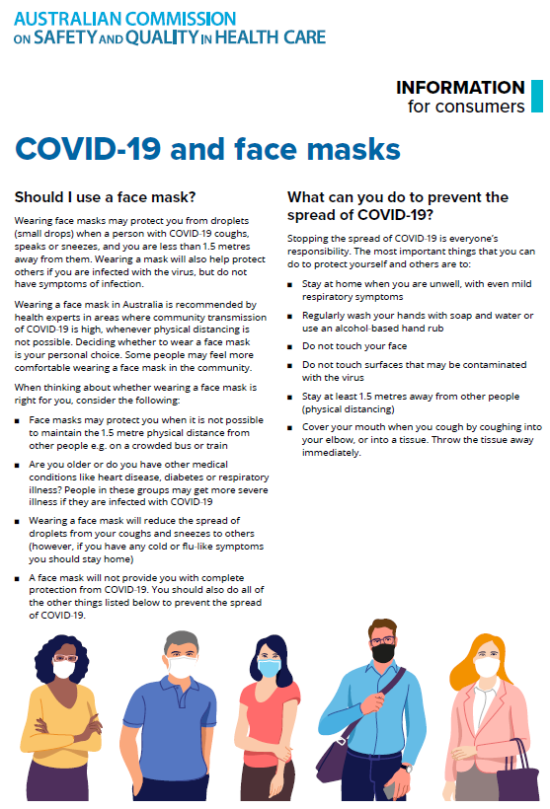](https://www.safetyandquality.gov.au/sites/default/files/2020-07/covid-19_and_face_masks_-_information_for_consumers.pdf)

*National COVID-19 Clinical Evidence Taskforce*

<https://covid19evidence.net.au/>

The National COVID-19 Clinical Evidence Taskforce is a collaboration of peak health professional bodies across Australia whose members are providing clinical care to people with COVID-19. The taskforce is undertaking continuous evidence surveillance to identify and rapidly synthesise emerging research in order to provide national, **evidence-based guidelines and clinical flowcharts for the clinical care of people with COVID-19**. The guidelines address questions that are specific to managing COVID-19 and cover the full disease course across mild, moderate, severe and critical illness. These are ‘living’ guidelines, updated with new research in near real-time in order to give reliable, up-to-the minute advice to clinicians providing frontline care in this unprecedented global health crisis.

*COVID-19 Critical Intelligence Unit*

<https://www.aci.health.nsw.gov.au/covid-19/critical-intelligence-unit>

The Agency for Clinical Innovation (ACI) in New South Wales has developed this page summarising rapid, evidence-based advice during the COVID-19 pandemic. Its operations focus on systems intelligence, clinical intelligence and evidence integration. The content includes a daily evidence digest, a COVID status monitor, a risk monitoring dashboard and evidence checks on a discrete topic or question relating to the current COVID-19 pandemic. There is also a ‘Living evidence’ section summarising key studies and emerging evidence on **COVID-19 vaccines** and **SARS-CoV-2 variants**. The most recent updates include:

* ***Hospital visitor policies*** – What is the evidence for hospital visitor policies during and outside of the COVID-19 pandemic?
* ***Surgical masks, eye protection and PPE guidance*** –What is the evidence for surgical masks in the endemic phase in hospitals and for eyewear to protect against COVID-19?
* ***Paediatrics and COVID-19 reporting rates and differences*** – How are paediatric patients with COVID-19 reported, and what are the differences in rates and severity with Omicron?
* ***Incidental COVID-19*** – How are incidental COVID-19 cases being reported internationally, and what is the proportional of incidental COVID-19 cases?
* ***Sotrovimab*** –What is the evidence for sotrovimab as a treatment for COVID-19?
* ***Omicron - symptoms and hospitalised patients*** – What are the symptoms associated with Omicron and what is the risk of hospitalisation for Omicron
* ***COVID-19 vaccines in Australia*** – What is the evidence on COVID-19 vaccines in Australia?

**Disclaimer**

On the Radar is an information resource of the Australian Commission on Safety and Quality in Health Care. The Commission is not responsible for the content of, nor does it endorse, any articles or sites listed. The Commission accepts no liability for the information or advice provided by these external links. Links are provided on the basis that users make their own decisions about the accuracy, currency and reliability of the information contained therein. Any opinions expressed are not necessarily those of the Australian Commission on Safety and Quality in Health Care.