# Australian Commission on Safety and Quality logotypeOn the Radar

Issue 548

28 February 2022

*On the Radar* is a summary of some of the recent publications in the areas of safety and quality in health care. Inclusion in this document is not an endorsement or recommendation of any publication or provider. Access to particular documents may depend on whether they are Open Access or not, and/or your individual or institutional access to subscription sites/services. Material that may require subscription is included as it is considered relevant.

*On the Radar* is available online, via email or as a PDF or Word document from <https://www.safetyandquality.gov.au/publications-and-resources/newsletters/radar>

If you would like to receive *On the Radar* via email, you can subscribe on our website <https://www.safetyandquality.gov.au/publications-and-resources/newsletters>  
or by emailing us at H[Umail@safetyandquality.gov.auU](mailto:mail@safetyandquality.gov.au).   
You can also send feedback and comments to H[Umail@safetyandquality.gov.auU](mailto:mail@safetyandquality.gov.au).

For information about the Commission and its programs and publications, please visit <https://www.safetyandquality.gov.au>

You can also follow us on Twitter @ACSQHC.

**On the Radar**

Editor: Dr Niall Johnson [niall.johnson@safetyandquality.gov.au](mailto:niall.johnson@safetyandquality.gov.au)

Contributors: Niall Johnson, Dr Jan Gralton, Jennifer Caldwell, Kim Stewart

**New aseptic technique resources**

<https://www.safetyandquality.gov.au/our-work/infection-prevention-and-control/aseptic-technique>

Two new resources on aseptic technique are now available on the Commission’s website at <https://www.safetyandquality.gov.au/our-work/infection-prevention-and-control/aseptic-technique>

Contact [hai@safetyandquality.gov.au](mailto:hai@safetyandquality.gov.au) if you have any enquiries in relation to these resources.

**NSQHS Standards Implementation Guide for Action 3.11 Aseptic Technique**

Australian Commission on Safety and Quality in Health Care

Sydney: ACSQHC; 2021. p. 6.

<https://www.safetyandquality.gov.au/publications-and-resources/resource-library/nsqhs-standards-implementation-guide-action-311-aseptic-technique>

The *Implementation Guide for Action 3.11 Aseptic technique* supports health service organisations meet the actions of the [National Safety and Quality Health Service Standards](https://www.safetyandquality.gov.au/standards/nsqhs-standards):

* Identify procedures where aseptic technique is required in a health service organisation
* Assess the competence of the workforce in performing aseptic technique
* Provide training to address gaps in competency
* Monitor compliance with the organisation’s policies on aseptic technique.

**NSQHS Standards Implementation Guide for Action 3.11 Aseptic Technique** [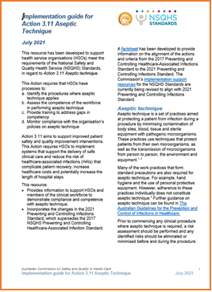](https://www.safetyandquality.gov.au/publications-and-resources/resource-library/nsqhs-standards-implementation-guide-action-311-aseptic-technique)The *Implementation Guide* includes practical information on the importance of ongoing support for aseptic technique and the types of evidence that health service organisations could provide to demonstrate compliance. This new resource supersedes the Commission’s 2018 *Aseptic Technique Risk Matrix*.

**Principles of aseptic technique: Information for healthcare workers**

Australian Commission on Safety and Quality in Health Care

Sydney: ACSQHC; 2021. p. 5.

<https://www.safetyandquality.gov.au/publications-and-resources/resource-library/principles-aseptic-technique-information-healthcare-workers>

[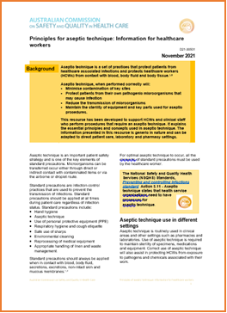](https://www.safetyandquality.gov.au/publications-and-resources/resource-library/principles-aseptic-technique-information-healthcare-workers)The *Principles of aseptic technique: Information for healthcare workers* has been developed to support healthcare workers and clinical staff who perform procedures that require an aseptic technique. It explains the essential principles and concepts used in aseptic technique. The information presented in this resource is generic and can be adapted for direct patient care, laboratory and pharmacy settings. This resource also supports implementation of Action 3.11 (aseptic technique) of the NSQHS standards.

**Risk management of infectious agents and diseases eLearning module**

<https://nhhi.southrock.com>

The Australian Commission on Safety and Quality in Health Care continues to develop and support online learning for infection prevention and control (IPC) and hand hygiene for health care workers through its centralised online Learning Management System (LMS).

The Commission has recently updated the *Risk management of infectious agents and diseases* eLearning module to ensure consistency with the National Safety and Quality Health Service Standards, specifically the *Preventing and Controlling Infections Standard*, and the *Australian Guidelines for the Prevention and Control of Infection in Healthcare*. The module has also been enhanced to improve the learner experience.

The updated module is available in the National Hand Hygiene Initiative (NHHI) LMS at <https://nhhi.southrock.com>. Access to the NHHI LMS is free and modules can be accessed after a learner has registered a profile on the system.

[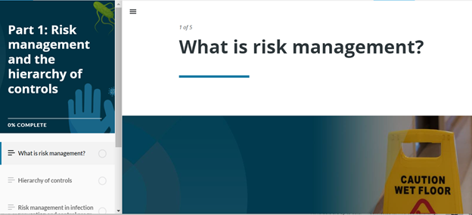](https://nhhi.southrock.com)

**Reports**

*We are not visitors: Working together with family caregivers and care partners*

Cousins J, Graham S, Montgomery N, Serge T, Serrao C, Sterling M, et al

Nashville: The Beryl Institute; 2022.

|  |  |
| --- | --- |
| URL | <https://www.theberylinstitute.org/store/viewproduct.aspx?id=19723335> |
| Notes | The Beryl Institute in the USA has released this guidebook for family caregivers and those who support them. The guidebook defines the major components of the family caregiver experience and how they differ from the patient experience, as well as providing tools for caregivers to use as they advocate for themselves and those they care for. |

For information on the Commission’s work on partnering with consumers, see <https://www.safetyandquality.gov.au/our-work/partnering-consumers>

**Journal articles**

*Emergency department care-related causal factors of in-patient deterioration*

Nassief K, Azer M, Watts M, Tuala E, McLennan P, Curtis K

Australian Health Review. 2022;46(1):35-41.

*Discrepancy between emergency department admission diagnosis and hospital discharge diagnosis and its impact on length of stay, up-triage to the intensive care unit, and mortality*

Bastakoti M, Muhailan M, Nassar A, Sallam T, Desale S, Fouda R, et al

Diagnosis. 2022;9(1):107-114.

|  |  |
| --- | --- |
| DOI | Nassief et al <https://doi.org/10.1071/AH21190>  Bastakoti et al <https://doi.org/10.1515/dx-2021-0001> |
| Notes | Nassief et al present an Australian study that sought to examine factors related to emergency department (ED) care that contributed to in-patient deterioration. This was a retrospective cohort study that examined in-patient records in a regional health service in New South Wales, Australia, between March 2016 and February 2017. Deterioration was defined as either the initiation of a medical emergency team call, cardiac arrest, or unplanned admission to the intensive care unit. The study found that ‘of the 1074 patients who deteriorated within 72 hours of admission via the ED, the care received in the ED was a contributing factor for 101 patients (9%). The most common human causal factors were **poor communication** between staff, **medical management errors**, **delayed treatment**, medical **documentation errors**, **nursing management errors** and **unclear policies or guidelines**.’ The authors suggest ‘that there is a need for the clarification and revision of policies and guidelines pertaining to the management of elderly patients, education regarding the critical importance of the often clinically masked vital sign deviations in younger patients and improved communication between staff, especially regarding patients with more comorbidities.’  Also looking at ED is the paper from Bastakoti et al. Here they seek to understand the extent of diagnostic discrepancy between diagnoses between the ED and on hospital discharge and ‘its impact on length of hospital stay (LOS), up-triage to the intensive care unit (ICU) and in-hospital mortality.’ Using data from retrospective chart review of 636 patients at a US tertiary hospital, the study found that 21.77% had discordant diagnoses. Patients with a discordant diagnosis experienced ‘increased mortality (OR: 3.64; 95% CI: 1.026–12.91; p=0.045) and up-triage to the ICU (OR: 5.51; 95% CI: 2.43–12.5; p<0.001)’ and their ‘median LOS was significantly greater for patients with discordant diagnoses (7 days) than for those with concordant diagnoses (4.7 days) (p=0.004).’ |

*Perioperative Delirium/Agitation Associated With the Use of Anesthetics and/or Adjunct Agents: A Study of Patient Behaviors, Injuries, and Interventions to Mitigate Risk*

Taylor MA, Pileggi W

Patient Safety. 2021 12/17;3(4):16-27.

|  |  |
| --- | --- |
| DOI | <https://doi.org/10.33940/med/2021.12.2> |
| Notes | Cognitive impairment is an important safety and quality issue. Cognitive impairment is common, but is often not identified, or it is dismissed or misdiagnosed. For example, symptoms of delirium may be dismissed as a normal part of ageing, or as dementia, potentially preventing further assessment and action.  This paper reports on the issue of delirium and agitation associated with the use of anaesthetics and adjunct agents. Using the Pennsylvania Patient Safety Reporting System (PA-PSRS) database, the study identified 97 event reports from 63 healthcare facilities over a two-year period that included bouts of delirium/agitation associated with anaesthetics and/or adjunct agents that occurred during the pre-, intra-, or postoperative period. Of the identified events, 84% occurred postoperatively, ‘62% of the reports described dangerous/nonviolent behavior and 26% described dangerous/violent behavior. Additionally, 40% of the event reports described one or more patient injuries (e.g., cardiopulmonary arrest, asphyxiation, hematoma, prolapse/dehiscence, progressive ischemia) and 36% of the patients required additional healthcare services or monitoring (e.g., intra- or interfacility transfer, additional surgical procedure). Finally, 54% of the event reports described patient behavior that created an immediate and high risk of staff harm.’. The paper also offers a range of suggested interventions to prevent, treat, and de-escalate bouts of delirium/agitation.  [Visual abstract for Perioperative Delirium/Agitation Associated With the Use of Anesthetics and/or Adjunct Agents: A Study of Patient Behaviors, Injuries, and Interventions to Mitigate Risk.](https://doi.org/10.33940/med/2021.12.2) |

For information on the Commission’s work on cognitive impairment, including delirium, see <https://www.safetyandquality.gov.au/our-work/cognitive-impairment>

*Achieving Diagnostic Excellence for Older Patients*

Cassel C, Fulmer T

JAMA. 2022 [epub].

*At-home Diagnostics and Diagnostic Excellence: Devices vs General Wellness Products*

Simon DA, Shachar C, Cohen IG

JAMA. 2022;327(6):523-524.

*Preventing Digital Overdiagnosis*

Capurro D, Coghlan S, Pires DEV

JAMA. 2022;327(6):525-526.

|  |  |
| --- | --- |
| DOI | Cassel and Fulmer <https://doi.org/10.1001/jama.2022.1813>  Simon et al <https://doi.org/10.1001/jama.2022.0047>  Capurro et al <https://doi.org/10.1001/jama.2021.22969> |
| Notes | These first two items are the latest pieces in the JAMA’s occasional series on diagnostic excellence.  Cassel and Fulmer argue that ‘Diagnostic error in older adults is common and involves both overdiagnosis and underdiagnosis.’ They discuss some of the factors that can contribute, including differences in profiles of risk and expression of disease, communication issues, evidence gaps, etc. They stress that ‘A personalized approach to setting goals of care is desirable for all patients, and it is especially important for older adults’ and that ‘Understanding how the goals of care may change with a patient’s age or change in circumstances is central to diagnostic excellence for older adults.’  Simon et al examine the possibility of consumers increasing use of ‘wellness’ products, including devices and/or apps, that may complicate the diagnostic process. Among the issues raised are those of regulation, consumer understanding, physician use and interpretation, privacy, reimbursement, and equity.  Simon et al’s piece chimes somewhat with Capurro et al’s piece that raises the possibility of ‘digital overdiagnosis’. Again, with the proliferation of digital technologies into our lives, there is a concern that these may carry a risk of diagnostic error, or more particularly, overdiagnosis. Here, the issue may not be so much consumer use as the development of large databases of data collected by these digital technologies. |

*Equity and Quality—Improving Health Care Delivery Requires Both*

Dzau VJ, Mate K, O’Kane M

JAMA. 2022;327(6):519-520.

*The Quintuple Aim for Health Care Improvement: A New Imperative to Advance Health Equity*

Nundy S, Cooper LA, Mate KS

JAMA. 2022;327(6):521-522.

|  |  |
| --- | --- |
| DOI | Dzau et al <https://doi.org/10.1001/jama.2022.0283>  Nundy et al <https://doi.org/10.1001/jama.2021.25181> |
| Notes | Over the years we have seen the proposing of the “triple aim” (improving population health, enhancing the care experience, and reducing costs) for health and then the “quadruple aim” (addressing burnout). In these two pieces the focus is on recognising the importance of health equity and making equity the ‘quintuple aim for health care improvement’ (Nundy et al)  Dzau et al reflect on the issues of quality and equity with particular reference to the US health environment. However, the assertion that ‘There is no quality without equity, and there is no equity without quality’ is arguably universal. |

*Health Care Safety during the Pandemic and Beyond — Building a System That Ensures Resilience*

Fleisher LA, Schreiber M, Cardo D, Srinivasan A

New England Journal of Medicine. 2022 2022/02/17;386(7):609-611.

|  |  |
| --- | --- |
| DOI | <https://doi.org/10.1056/NEJMp2118285> |
| Notes | Another piece that looks to how healthcare systems could be improved, in this instance suggesting how healthcare could be more resilient. While the pieces in equity were partly prompted by the experiences of the COVID-19 pandemic, this piece is explicitly framed by that experience and how to provide a health care system that is safe and resilient. The authors saw in the USA, ‘the pandemic degraded patient safety so quickly and severely’ that this indicates the US ‘health care system lacks a sufficiently resilient safety culture and infrastructure.’ The piece is a call to build ‘a more resilient health care delivery system, capable not only of achieving safer routine care but also of maintaining high safety levels in times of crisis.’ |

*Journal of Patient Safety*

Vol. 18, No. 2, March 2022

|  |  |
| --- | --- |
| URL | <https://journals.lww.com/journalpatientsafety/toc/2022/03000> |
| Notes | A new issue of the *Journal of Patient Safety* has been published. Articles in this issue of the *Journal of Patient Safety* include:   * Training Effectiveness and Impact on Safety, Treatment Quality, and Communication in **Prehospital Emergency Care**: The Prospective Longitudinal Mixed-Methods EPPTC Trial (David Häske, Stefan K. Beckers, Marc Dieroff, Bernhard Gliwitzky, M Hofmann, R Lefering, M Münzberg) * Improving Safety and Quality During **Interhospital Transfer of Patients With Nontraumatic Intracranial Hemorrhage**: A Simulation-Based Pilot Program (Jessica M Ray, Ambrose H Wong, Emily B Finn, Kevin N Sheth, Charles C Matouk, S N Sudikoff, M A Auerbach, J E Sather, A K Venkatesh) * The **Second Victim Experience and Support Tool**: A Cross-Cultural Adaptation and Psychometric Evaluation in Italy (IT-SVEST) (Enrico Scarpis, Luigi Castriotta, Edoardo Ruscio, Beatrice Bianchet, Anna Doimo, Valentina Moretti, Roberto Cocconi, Federico Farneti, Rosanna Quattrin) * Development and Validation of a **Fall Prevention Efficiency Scale** (Patricia C Dykes, Srijesa Khasnabish, Zoe Burns, Lesley E Adkison, Lois Alfieri, Michael Bogaisky, Diane L Carroll, Eileen J Carter, Ann C Hurley, Emily Jackson, Susan Kurian, Mary Ellen Lindros, Virginia Ryan, Maureen Scanlan, Kelly Sessler, A Shelley, L B Spivack, M-A Walsh, D W Bates, J S Adelman) * Cross-Cultural Adaptation, Validation, and Piloting of the **Patient Reported Experiences and Outcomes of Safety in Primary Care Questionnaire** for Its Use in Spain (María J Serrano-Ripoll, Joan Llobera, José M Valderas, Antonio Olry de Labry Lima, María A Fiol-deRoque, J Ripoll, I Ricci-Cabello) * **Second Victim Experience and Support Tool**: An Assessment of Psychometric Properties of Italian Version (Alessia Pieretti, Luca Bastiani, Tommaso Bellandi, Sabrina Molinaro, Paolo Zoppi, Laura Rasero) * Understanding the “**Swiss Cheese Model**” and Its Application to Patient Safety (Douglas A Wiegmann, Laura J Wood, Tara N Cohen, S A Shappell) * **Patient Safety Education in Entry to Practice Pharmacy Programs**: A Systematic Review (Alla El-Awaisi, Sarra Koummich, Somaya Koraysh, Maguy Saffouh El Hajj) * Decreasing Foot Traffic in the **Orthopedic Operating Room**: A Narrative Review of the Literature (Laura Buckner, Jordan Lacy, K Young, D Dishman) * **Advanced Medication Alert System** Decreased Hospital-Based Outpatient Duplicated Medications: A Longitudinal Hospital Cohort Study (Yu-Chun Kuo, Shou-Hsia Cheng, Herng-Chia Chiu) * Frequency and Nature of **Communication and Handoff Failures in Medical Malpractice Claims** (Kate E Humphrey, Melissa Sundberg, Carly E Milliren, Dionne A Graham, Christopher P Landrigan) * The Effect of **Health Care Professional Disruptive Behavior** on Patient Care: A Systematic Review (Sophia Hicks, Charitini Stavropoulou) * **Central Venous Catheter Guidewire Retention**: Lessons From England’s Never Event Database (Maryanne Z A Mariyaselvam, Vikesh Patel, Holly E Young, Mark C Blunt, Peter J Young) * The Trigger Tool Method for **Routine Pharmacovigilance**: A Retrospective Cohort Study of the Medical Records of Hospitalized Geriatric Patients (Floriane Marseau, Joaquim Prud’Homm, Guillaume Bouzillé, Elisabeth Polard, Emmanuel Oger, Dominique Somme, M-N Osmont, L-M Scailteux) * Morbidity and Mortality Caused by **Noncompliance With California Hospital Licensure**: Immediate Jeopardies in California Hospitals, 2007–2017 (Micha Y Zheng, Hansen Lui, German Patino, Nnenaya Mmonu, Andrew J Cohen, Benjamin N Breyer) * Engaging Patients in the **Use of Real-Time Electronic Clinical Data** to Improve the Safety and Reliability of Their Own Care (Kumiko Schnock, Stephanie Roulier, Jorie Butler, Patricia Dykes, Julie Fiskio, Bryan Gibson, Stuart Lipsitz, Susanne Miller, Shimon Shaykevich, David Bates, D Classen) * **Primary Care Physicians’, Psychiatrists’, and Oncologists’ Coordination While Prescribing Medications** for Patients With Multiple Chronic Conditions (Cassidi C McDaniel, Chiahung Chou, Christina Camp, Natalie S Hohmann, Tessa J. Hastings, Matthew L Maciejewski, Joel F Farley, Marisa Elena Domino, Richard A Hansen) * **Ambulatory Virtual Care During a Pandemic**: Patient Safety Considerations (Jyotsna Mullur, Yih-C Chen, P Wickner, A Licurse, S Desai) * An Analysis of Judicial Cases Concerning **Analgesic-Related Medication Errors** in the Republic of Korea (Susie Yoon, Soo Ick Cho, SuHwan Shin, Wonjong Lee, Youkang Ko, Jee Youn Moon, Ho-Jin Lee) * Current Situation of **Medication Errors in Saudi Arabia**: A Nationwide Observational Study (Thamir M Alshammari, Khalidah A Alenzi, Yasser Alatawi, Afnan S Almordi, Ali F Altebainawi) * Bedside Clinicians’ Perceptions on the Contributing Role of **Diagnostic Errors in Acutely Ill Patient Presentation**: A Survey of Academic and Community Practice (Chanyan Huang, Amelia Barwise, Jalal Soleimani, Yue Dong, Herasevich Svetlana, Syed Anjum Khan, Anne Gavin, Scott A Helgeson, Pablo Moreno-Franco, Yuliya Pinevich, Rahul Kashyap, Vitaly Herasevich, Ognjen Gajic, Brian W Pickering) * Understanding the **Second Victim Experience** Among Multidisciplinary Providers in Obstetrics and Gynecology (Enid Rivera-Chiauzzi, Robyn E Finney, K A. Riggan, A L Weaver, M E Long, V E Torbenson, M A Allyse) * Pediatric Trainee Perspectives on the Decision to **Disclose Medical Errors** (Matthew Lin, Leora Horwitz, Rachel S Gross, Hannah Famiglietti, A Caplan) * **Cost of Health Care–Associated Infections** in the United States (Joseph D Forrester, Paul M Maggio, Lakshika Tennakoon) * **Patient Safety Monitoring in Acute Care** in a Decentralized National Health Care System: Conceptual Framework and Initial Set of Actionable Indicators (Labella Barbara, De Blasi Roberta, Raho Vanda, Tozzi Quinto, Caracci Giovanni, Klazinga Niek Sieds, Carinci Fabrizio) * Introduction of an **Ambulatory Care Medication Reconciliation Service in Dialysis Patients**: Positive Impact on Medication Prescribing and Economic Benefit (Sarah S Alghanem, Tania Bayoud, Sameer Taher, Mai Al-Hazami, Nasser Al-Kandari, Monther Al-Sharekh) * **Medication Errors in the Operating Room**: An Analysis of Contributing Factors and Related Drugs in Case Reports from a Japanese Medication Error Database (Ryohei Suzuki, Tsuneo Imai, Takamasa Sakai, Kouichi Tanabe, Fumiko Ohtsu) * **Occupational Therapy Utilization in Veterans With Dementia**: A Retrospective Review of Root Cause Analyses of Falls Leading to Adverse Events (Elizabeth K Rhodus, Elizabeth A Lancaster, Elizabeth G Hunter, Tina Nudell, Casey Humphrey, Mary Duke, Andrew M Harris) * Can Emergency Department Wait Times Predict Rates of **Hospital-Acquired Clostridioides difficile Infection**? A Study of Acute Care Facilities in New York State (Danielle J Durant, Claudia Guerrazzi Young) * Patterns of **Medication Errors Involving Older Adults** Reported to the French Medication Error Guichet (Christine Azar, Laure Thomas, Valérie Gras-Champel, Marie-Laure Laroche, M Grau, D Allué, N Saleh, P Maison) * **Collaborative Case Review**: A Systems-Based Approach to **Patient Safety Event Investigation and Analysis** (Ronilda Lacson, Ramin Khorasani, Karen Fiumara, Neena Kapoor, Patrick Curley, Giles W Boland, S Eappen) * The Effects of **Safety Climate** on Psychosocial Factors: An Empirical Study in Healthcare Workplaces (Jiana-Fu Wang, Chieh-Liang Wu, Yao-Te Tsai, Shao-Jen Weng, Ya-Chen Hsu) * Construction of a Scale Assessing Patients’ Perceptions Regarding **Sanitation and Hygiene in a Clinical Setting** (Nestor Asiamah, Mavis Aggrey, Kwame Adu-Gyamfi, Frank Frimpong Opuni) * Implementation of an **Electronic Health Record–Based Messaging System in the Emergency Department**: Effects on Physician Workflow and Resident Burnout (Tiffany Luu, Lindsey Spiegelman, David Nykin, Kimberly Abido, Jennifer Roh, Scott Rudkin, Shannon Toohey) * **Optimizing Hospital Electronic Prescribing Systems**: A Systematic Scoping Review (Jac Williams, Stephen Malden, Catherine Heeney, Matt Bouamrane, Mike Holder, Uditha Perera, David W. Bates, Aziz Sheikh) * **Patient Perceptions of Hospital Experiences**: Implications for Innovations in Patient Safety (Jorie M. Butler, Bryan Gibson, Kumiko Schnock, David Bates, David Classen) * Evaluation of the Efficiency and Safety of a **Safe Label System**: A Prospective Simulation Study (Hong Jye Neo, Ming Ann Sim, Lian Kah Ti, Sophia Bee Leng Ang) * Communication Patterns During Routine Patient Care in a **Pediatric Intensive Care Unit**: The Behavioral Impact of In Situ Simulation (Francis F Ulmer, Andrea M Lutz, Fabienne Müller, Thomas Riva, L Bütikofer, R Greif) * The Perceived Knowledge of **Fall Prevention** in Nurses Working in Acute Care Hospitals in China and the United States (Lin Wang, Li Zhang, Elizabeth Roe, Sally Decker, Gwen Howard, Angela Luth, Kristine Marks, B Whitman) * **Neonatal Adverse Events’ Trigger Tool** Setup With Random Forest (Kun Feng, Li Zhang, Huayun He, Xueqin You, Qiannan Zhang, Hong Wei, Z Hua) * Which Health Impacts of **Medical Device Adverse Event** Should Be Reported Immediately in Korea? (Sooin Choi, Soo Jeong Choi, Jin Kuk Kim, Chiho Yoon, Ki Chang Nam, Bum Sun Kwon, You Kyoung Lee) * Linking Technology to Address the **Social and Medical Determinants of Health for Safe Medicines Use** (Raymond L. Woosley, June Simmons, Ester M. Sefilyan, Sandy Atkins, Kristin Black, William A Read) * A Novel Color-Coding Method to Prevent **Wrong-Site Surgery in Ophthalmology** (Bruttendu Moharana, Ashok Gupta, Reeti Saini, Nishtha Singh, Easha Ramawat) |

*health Expectations*

Volume 25 Number 1, February 2022

|  |  |
| --- | --- |
| URL | <https://onlinelibrary.wiley.com/toc/13697625/2022/25/1> |
| Notes | A new issue of *health Expectations* has been published. Articles in this issue of *health Expectations* include:   * Editorial: How can we achieve **health equity**? Revisit the premise informing the scientific method (Karen L Fortuna, Matthew F Hudson, Amanda Myers, Arya Kadakia, Jennifer Rivera, Tony Nutz) * Participatory codesign of **patient involvement in a Learning Health System**: How can data-driven care be patient-driven care? (Sarah E Knowles, Dawn Allen, Ailsa Donnelly, Jackie Flynn, Kay Gallacher, Annmarie Lewis, Grace McCorkle, Manoj Mistry, Pat Walkington, Lisa Brunton) * **Patients as team members**: Factors affecting involvement in treatment decisions from the perspective of patients with a chronic condition (Martina Buljac-Samardzic, Mark A Clark, N Job A van Exel, Jeroen D H.van Wijngaarden) * Healthcare needs, experiences and treatment burden in primary care patients with multimorbidity: An evaluation of **process of care from patients' perspectives** (Xiu-Jing Hu, Harry H X Wang, Yu-Ting Li, Xiao-Ya Wu, Yi Wang, Jia-Heng Chen, Jia-Ji Wang, Samuel Y S Wong, Stewart W Mercer) * **Young adults' healthcare utilisation and healthcare needs**: Perceptions and experiences of healthcare providers (Lisa Viktorsson, , Eva Törnvall, Magnus Falk, Ingrid Wåhlin, Pia Yngman-Uhlin) * **Patients at the centre after a health care incident**: A scoping review of hospital strategies targeting communication and nonmaterial restoration (Rachel I Dijkstra, Ruud T J Roodbeen, Renée J R Bouwman, Antony Pemberton, Roland Friele) * **Tailored patient therapeutic educational interventions**: A patient-centred communication model (Laetitia Ricci, Julie Villegente, Déborah Loyal, Carole Ayav, Joëlle Kivits, Anne-Christine Rat) * Part of the solution: A survey of community organisation perspectives on barriers and facilitating actions to **Advance Care Planning** in British Columbia, Canada (Ellie G Siden, Rachel Z Carter, Doris Barwich, Eman Hassan) * Development and field testing of a decision aid to facilitate shared decision making for **adults newly diagnosed with attention-deficit hyperactivity disorder** (Yumi Aoki, Takashi Tsuboi, Yoshikazu Takaesu, Koichiro Watanabe, Kazuhiro Nakayama, Yasuhito Kinoshita, Mami Kayama) * Views of **healthcare consumer representatives on defensive practice**: ‘We are your biggest advocate and supporter… not the enemy’ (Nola M. Ries, Briony Johnston, Jesse Jansen) * How paediatric departments in Sweden facilitate **giving children a voice on their experiences of healthcare**: A cross-sectional study (Anna Nordlind, Ann-Sofie Sundqvist, Agneta Anderzén-Carlsson, A-C Almblad, K Ängeby) * Swallowing the pill of adverse effects: A qualitative study of patients' and pharmacists' experiences and decision-making regarding the **adverse effects of chronic pain medications** (Lise Dassieu, Emilie Paul-Savoie, Élise Develay, A Cecilia V Guilhon, A Lacasse, L Guénette, K Perreault, H Beaudry, L Dupuis, the Quebec Consortium on Adverse Effects of Pain Medications) * The relative importance of information items and preferred mode of delivery when **disseminating results from trials to participants**: A mixed-methods study (Jessica Wood, Seonaidh C. Cotton, Katie Gillies) * **Adolescents encouraging healthy lifestyles** through a peer-led social marketing intervention: Training and key competencies learned by peer leaders (Elisabet Llauradó, Magaly Aceves-Martins, Jordi Prades-Tena, Maria Besora-Moreno, Ignasi Papell-Garcia, Montse Giralt, Amy Davies, L Tarro, R Solà) |

*BMJ Quality & Safety* online first articles

|  |  |
| --- | --- |
| URL | <https://qualitysafety.bmj.com/content/early/recent> |
| Notes | *BMJ Quality &Safety* has published a number of ‘online first’ articles, including:   * •The problem with … **using stories as a source of evidence** and learning (Rick Iedema) |

**Online resources**

***[UK] NICE Guidelines and Quality Standards***

<https://www.nice.org.uk/guidance>

The UK’s National Institute for Health and Care Excellence (NICE) has published new (or updated) guidelines and quality standards. The latest reviews or updates are:

* NICE Guideline NG191 *COVID-19 rapid guideline:* ***managing COVID-19*** <https://www.nice.org.uk/guidance/ng191>

***[USA] Effective Health Care Program reports***

<https://effectivehealthcare.ahrq.gov/>

The US Agency for Healthcare Research and Quality (AHRQ) has an Effective Health Care (EHC) Program. The EHC has released the following final reports and updates:

* *Models of Care That Include* ***Primary Care for Adult Survivors of Childhood Cancer****: A Realist Review* <https://effectivehealthcare.ahrq.gov/products/childhood-cancer-survivorship-care/research>

***ICD-11 comes into effect***

<https://www.who.int/news/item/11-02-2022-who-s-new-international-classification-of-diseases-(icd-11)-comes-into-effect>

The World Health Organization (WHO) Eleventh Revision of the International Classification of Diseases (ICD-11) was released in February 2022. Changes incorporated in ICD 11 include alignment of codes relating to antimicrobial resistance with the Global Antimicrobial Resistance Surveillance System (GLASS). ICD-11 is also more capable of capturing data on health-care safety, thus identifying and reducing unnecessary events that may harm health such as unsafe workflows in hospitals.

**COVID-19 resources**

https://www.safetyandquality.gov.au/covid-19

The Australian Commission on Safety and Quality in Health Care has developed a number of resources to assist healthcare organisations, facilities and clinicians. These and other material on COVID-19 are available at <https://www.safetyandquality.gov.au/covid-19>

These resources include:

* ***OVID-19 infection prevention and control risk management*** <https://www.safetyandquality.gov.au/publications-and-resources/resource-library/covid-19-infection-prevention-and-control-risk-management-guidance>
* ***Poster – Combined contact and droplet precautions*** <https://www.safetyandquality.gov.au/publications-and-resources/resource-library/poster-combined-contact-and-droplet-precautions>  
  [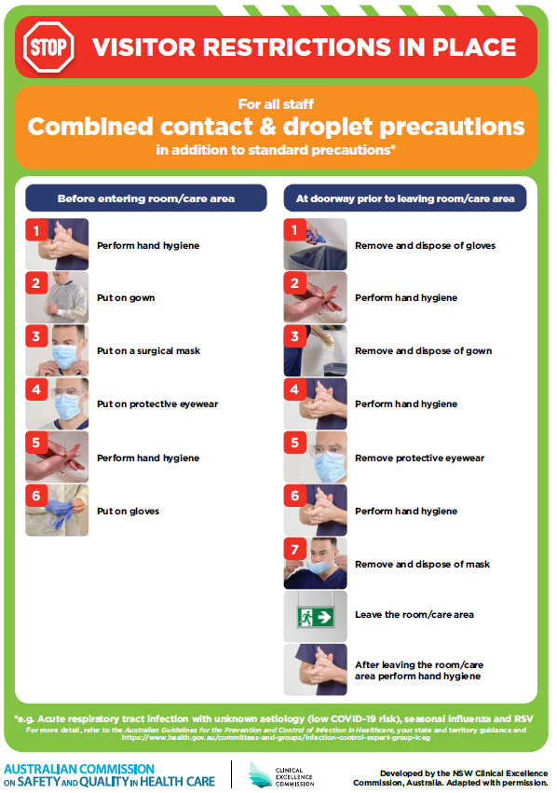](https://www.safetyandquality.gov.au/publications-and-resources/resource-library/poster-combined-contact-and-droplet-precautions)
* ***Poster – Combined airborne and contact precautions*** <https://www.safetyandquality.gov.au/publications-and-resources/resource-library/poster-combined-airborne-and-contact-precautions>   
  [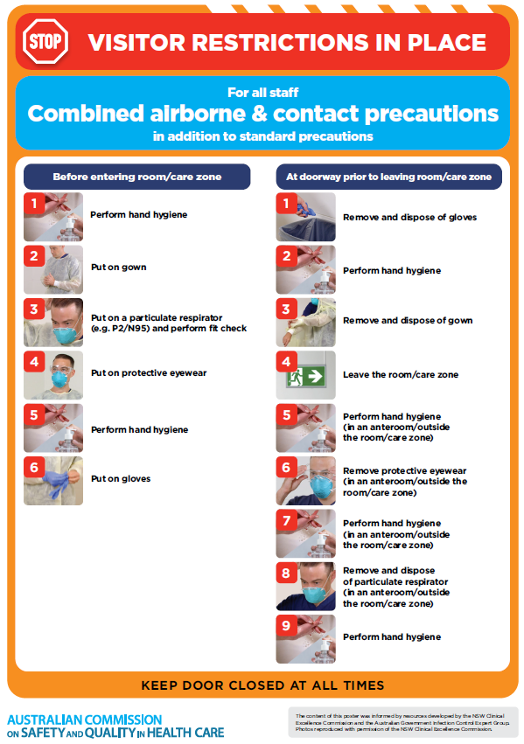](https://www.safetyandquality.gov.au/publications-and-resources/resource-library/poster-combined-airborne-and-contact-precautions)
* ***Environmental Cleaning and Infection Prevention and Control*** [www.safetyandquality.gov.au/environmental-cleaning](http://www.safetyandquality.gov.au/environmental-cleaning)
* ***COVID-19 infection prevention and control risk management – Guidance*** <https://www.safetyandquality.gov.au/publications-and-resources/resource-library/covid-19-infection-prevention-and-control-risk-management-guidance>
* ***Safe care for people with cognitive impairment during COVID-19***<https://www.safetyandquality.gov.au/our-work/cognitive-impairment/cognitive-impairment-and-covid-19>
* ***Stop COVID-19: Break the chain of infection*** posterhttps://www.safetyandquality.gov.au/publications-and-resources/resource-library/break-chain-infection-poster-a3  
  **[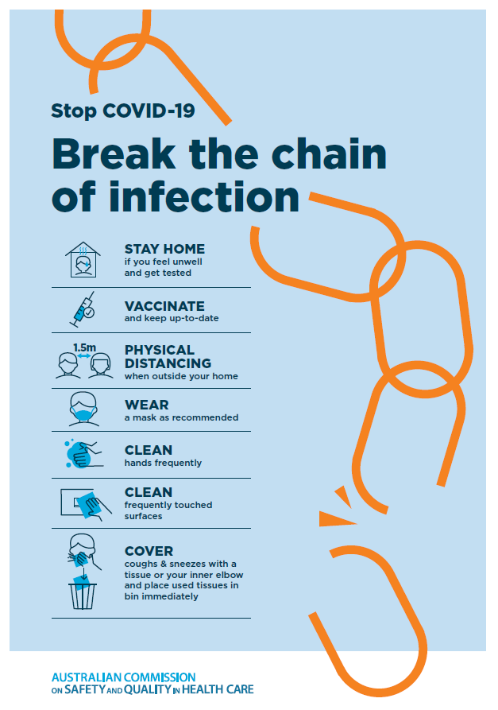](https://www.safetyandquality.gov.au/publications-and-resources/resource-library/break-chain-poster-a3https:/www.safetyandquality.gov.au/publications-and-resources/resource-library/break-chain-poster-a3)**
* ***FAQs for clinicians on elective surgery*** <https://www.safetyandquality.gov.au/node/5724>
* ***FAQs for consumers on elective surgery*** <https://www.safetyandquality.gov.au/node/5725>
* ***COVID-19 and face masks – Information for consumers*** <https://www.safetyandquality.gov.au/publications-and-resources/resource-library/covid-19-and-face-masks-information-consumers>

[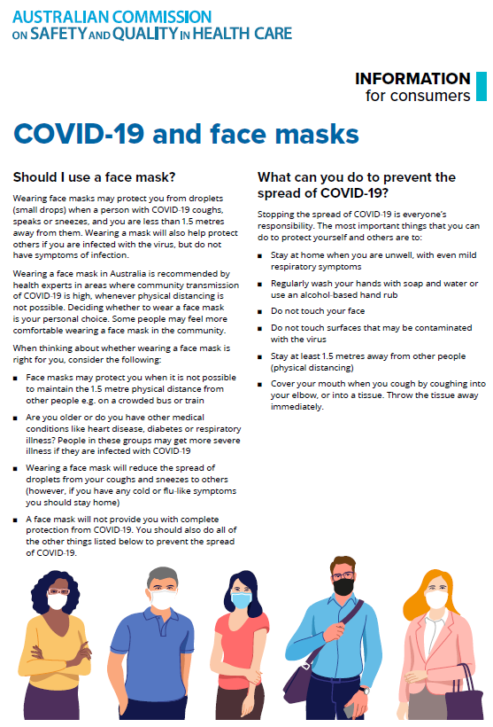](https://www.safetyandquality.gov.au/sites/default/files/2020-07/covid-19_and_face_masks_-_information_for_consumers.pdf)

*National COVID-19 Clinical Evidence Taskforce*

<https://covid19evidence.net.au/>

The National COVID-19 Clinical Evidence Taskforce is a collaboration of peak health professional bodies across Australia whose members are providing clinical care to people with COVID-19. The taskforce is undertaking continuous evidence surveillance to identify and rapidly synthesise emerging research in order to provide national, **evidence-based guidelines and clinical flowcharts for the clinical care of people with COVID-19**. The guidelines address questions that are specific to managing COVID-19 and cover the full disease course across mild, moderate, severe and critical illness. These are ‘living’ guidelines, updated with new research in near real-time in order to give reliable, up-to-the minute advice to clinicians providing frontline care in this unprecedented global health crisis.

*COVID-19 Critical Intelligence Unit*

<https://www.aci.health.nsw.gov.au/covid-19/critical-intelligence-unit>

The Agency for Clinical Innovation (ACI) in New South Wales has developed this page summarising rapid, evidence-based advice during the COVID-19 pandemic. Its operations focus on systems intelligence, clinical intelligence and evidence integration. The content includes a daily evidence digest, a COVID status monitor, a risk monitoring dashboard and evidence checks on a discrete topic or question relating to the current COVID-19 pandemic. There is also a ‘Living evidence’ section summarising key studies and emerging evidence on **COVID-19 vaccines** and **SARS-CoV-2 variants**. The most recent updates include:

* ***COVID-19 pandemic and wellbeing of critical care and other healthcare workers*** – Evidence in brief on the impact of the COVID-19 pandemic on the wellbeing of critical care and other healthcare workers.
* ***Surgery post COVID-19*** – What is the evidence for the timing of surgery, and outcomes following surgery, for people who have recovered from COVID-19?
* Show summary | Download full Evidence Check (PDF 189 KB)
* ***Disease modifying treatments for COVID-19 in children*** – What is the evidence for disease modifying treatments for COVID-19 in children?
* ***Omicron (BA.2 sub-lineage)*** – What is the available evidence for the BA.2 sub-lineage of the Omicron variant of concern?
* ***Mask type for COVID-19 positive wearer*** – What is the evidence for different mask types for COVID-19 positive wearers?
* ***Post acute and subacute COVID-19 care*** – What published advice and models of care are available regarding post-acute and subacute care for COVID-19 patients?
* ***COVID-19 vaccines in Australia*** – What is the evidence on COVID-19 vaccines in Australia?
* ***Hospital visitor policies*** – What is the evidence for hospital visitor policies during and outside of the COVID-19 pandemic?
* ***Surgical masks, eye protection and PPE guidance*** –What is the evidence for surgical masks in the endemic phase in hospitals and for eyewear to protect against COVID-19?

**Disclaimer**

On the Radar is an information resource of the Australian Commission on Safety and Quality in Health Care. The Commission is not responsible for the content of, nor does it endorse, any articles or sites listed. The Commission accepts no liability for the information or advice provided by these external links. Links are provided on the basis that users make their own decisions about the accuracy, currency and reliability of the information contained therein. Any opinions expressed are not necessarily those of the Australian Commission on Safety and Quality in Health Care.