# Australian Commission on Safety and Quality logotypeOn the Radar

Issue 549

7 March 2022

*On the Radar* is a summary of some of the recent publications in the areas of safety and quality in health care. Inclusion in this document is not an endorsement or recommendation of any publication or provider. Access to particular documents may depend on whether they are Open Access or not, and/or your individual or institutional access to subscription sites/services. Material that may require subscription is included as it is considered relevant.

*On the Radar* is available online, via email or as a PDF or Word document from <https://www.safetyandquality.gov.au/publications-and-resources/newsletters/radar>

If you would like to receive *On the Radar* via email, you can subscribe on our website <https://www.safetyandquality.gov.au/publications-and-resources/newsletters>  
or by emailing us at H[Umail@safetyandquality.gov.auU](mailto:mail@safetyandquality.gov.au).   
You can also send feedback and comments to H[Umail@safetyandquality.gov.auU](mailto:mail@safetyandquality.gov.au).

For information about the Commission and its programs and publications, please visit <https://www.safetyandquality.gov.au>

You can also follow us on Twitter @ACSQHC.

**On the Radar**

Editor: Dr Niall Johnson [niall.johnson@safetyandquality.gov.au](mailto:niall.johnson@safetyandquality.gov.au)

Contributors: Niall Johnson, Angie Dalli

**Reports**

*Using social media as a tool to facilitate consumer engagement in service design and quality improvement: A guide for hospitals, service providers and consumers*

Walsh L, Hill S, Hyett N, Hewson D, Howley J, Juniper N, et al

Melbourne: Centre for Health Communication and Participation, La Trobe University; 2022. p. 51.

|  |  |
| --- | --- |
| URL | <https://opal.latrobe.edu.au/articles/report/Using_social_media_as_a_tool_to_facilitate_consumer_engagement_in_service_design_and_quality_improvement_A_guide_for_hospitals_service_providers_and_consumers/17169089/1> |
| Notes | This guide for using social media to engage consumers in hospital service design and improvement activities was co-created with Australian hospital service providers and consumers, and is now available. The aim of the guide is to:   * Help hospitals, service providers, and consumers understand how social media can be used as a consumer engagement tool * Provide evidence-based strategies and actions for implementing social media as a consumer engagement tool in Australian public hospital service design and quality improvement (QI) * Provide implementation tools for social media-based consumer engagement.   The guide was developed for three main groups of people involved in service design and QI in hospitals:   * Hospital decision makers: Service providers and consumer representatives in hospital executive and/or governance roles; Communications professionals who are responsible for managing organisational social media pages and developing communication plans * People who are involved in service design and QI projects: Service providers and consumer representatives who are involved in planning, implementing, and evaluating service design and QI projects * Consumers: Patients, family members, and carers; People in consumer representative roles. |

For information on the Commission’s work on partnering with consumers, see <https://www.safetyandquality.gov.au/our-work/partnering-consumers>

*Digital and remote primary care: the inverse care law with a 21st century twist?*

Paddison C

London: Nuffield Trust; 2022

*Approach to the telemedicine physical examination: partnering with patients*

Russell SW, Artandi MK

Medical Journal of Australia. 2022; 216(3):131-134.

|  |  |
| --- | --- |
| URL / DOI | Paddison <https://www.nuffieldtrust.org.uk/news-item/digital-and-remote-primary-care-the-inverse-care-law-with-a-21st-century-twist>  Russell and Artandi <https://doi.org/10.5694/mja2.51398> |
| Notes | The COVID-19 pandemic saw the marked expansion in the use of telehealth. This item from the Nuffield Trust in the UK examines the move to greater use of digital primary care risks making access easier for people with less need and harder for those more likely to be in poorer health – and describes the actions that would help in getting access right.  In a recent piece in the *Medical Journal of Australia,* Russell and Artandi sought to provide guidance on how a clinician can optimise the telemedicine physical examination. The authors observe that ‘To fully serve our patients, providers must make sure to acquire, and teach, the competencies required for a high quality telemedicine visit.’ |

*Unintentional overdose of paracetamol in adults with low bodyweight*

Independent report by the Healthcare Safety Investigation Branch I2020/027.

Healthcare Safety Investigation Branch

Farnborough: HSIB; 2022. p. 109.

|  |  |
| --- | --- |
| URL | <https://www.hsib.org.uk/investigations-and-reports/unintentional-overdose-of-paracetamol-in-adults-with-low-bodyweight/> |
| Notes | This latest investigation report from the UK’s Healthcare Safety Investigation Branch examined the issue of paracetamol overdoses that can occur in low bodyweight (<50kg) patients. The reference event concerned of Dora, an 83-year-old woman who weighed less than 50kg on admission following a fall and lost further weight in hospital. She was prescribed oral paracetamol 1g four times a day while in hospital. She developed multiorgan failure due to sepsis and was diagnosed with paracetamol-induced liver toxicity. The HSIB made a number of observations, including ‘It may be beneficial for electronic prescribing and medication administration systems to include an alert for oral paracetamol that prompts documentation of a patient’s weight and consideration of the risk of liver toxicity when their weight is less than 50kg.’ and ‘It may be beneficial for available technological solutions, such as beds with built-in scales, to be used to weigh patients.’ |

**Journal articles**

*3 Ways Hospitals Can Boost Worker Engagement*

Garud N, Pati R, Sojo V, Bell SJ, Hudson R, Shaw H

Harvard Business Review. 2022 (16 February 2022).

|  |  |
| --- | --- |
| URL | <https://hbr.org/2022/02/3-ways-hospitals-can-boost-worker-engagement> |
| Notes | This piece in the *Harvard Business Review* is based on analysis of six years of data from more than 80 hospitals and more than 192,000 employees in Victoria, Australia. The authors report finding that ‘greater engagement had a positive impact on outcomes such as hospital costs (e.g., insurance claims against the hospital for injuries or complications due to negligence), treatment effectiveness (measured by patient readmission rates), and the level of hospital-acquired infections and conditions (e.g., pressure injuries and surgical complications). For example, our longitudinal analysis revealed that a small (1%) increase in employee engagement leads to a 3% reduction in hospital-acquired complications and a 7% reduction in hospital readmissions.’ The authors offer ‘three key ways that hospitals can improve worker engagement’:   1. Prioritising patient and staff safety 2. Building a culture of accountability 3. Providing proof that new practices will be worthwhile. |

*The Top Six: Standardized Safety Practices in U.S. Army Medical Department Treatment Facilities Worldwide*

Hartstein B, Munante M, Toor Phyllis A

NEJM Catalyst. 2022;3(2):CAT.21.0266.

|  |  |
| --- | --- |
| DOI | <https://doi.org/10.1056/CAT.21.0266> |
| Notes | Implementing standardised approaches is a common means of seeking to ensure safe and reliable practice. This piece describes and evaluates the implementation of the U.S. Army Medical Department’s systemwide rollout of the Top Six High Reliability Organization Communication Practices. The campaign saw six systemwide initiatives implemented with a view to improving reliability. The six were:   1. daily safety briefings 2. safety leadership rounds 3. unit-based huddles 4. Situation Background Assessment Recommendation (SBAR) for communication 5. briefs and debriefs for surgical cases 6. Universal Protocol, a routinized mandatory final verification, before every procedure. |

*Australian health service organisation assessment outcome data for the first 2 years of implementing the Comprehensive Care Standard*

Murgo M, Dalli A

Australian Health Review. 2022 [epub].

|  |  |
| --- | --- |
| DOI | <https://doi.org/10.1071/AH21299> |
| Notes | The National Safety and Quality Health Service Standards (NSQHS Standards) have been used as the basis for assessment of hospital quality and safety in Australia since 2013. The intention of the Comprehensive Care Standard is to ensure that patients receive comprehensive health care that meets their individual needs, and considers the impact of their health issues on their life and wellbeing. It also aims to ensure that risks of harm for patients during health care are prevented and managed through targeted strategies. It was developed to fill previously identified gaps and protect the public from harm. The Comprehensive Care Standard has not previously been assessed as part of Australian hospital accreditation processes. Data pertaining to the Comprehensive Care Standard has never been published. This examination provides information of the early implementation status in Australian health service organisations and provides insights for health service organisations that are yet to be assessed to the new Standard. Some of the frequent service gaps are identified as well as opportunities for improvement. |

For information on the National Safety and Quality Health Service Standards, see <https://www.safetyandquality.gov.au/standards/nsqhs-standards>

*BMJ Quality & Safety*

March 2022 Volume 31 - 3

|  |  |
| --- | --- |
| URL | <https://qualitysafety.bmj.com/content/31/3> |
| Notes | A new issue of *BMJ Quality & Safety* has been published. Many of the papers in this issue have been referred to in previous editions of *On the Radar* (when they were released online). Articles in this issue of *BMJ Quality & Safety* include:   * Editorial: **Antibiotic overuse**: managing uncertainty and mitigating against overtreatment (Carolyn Tarrant, Eva M Krockow) * Editorial: Deconstructing **improvements and hospital variation in COVID-19 mortality** rates during the early pandemic wave: the effects of wave evolution and advances in testing, treatment, and hospital care quality (Chanu Rhee) * Editorial: Have we forgotten **the moral justification for patient-centred care**? (Grant Russell) * Editorial: Understanding the complexities of collecting and using **PRO data in a primary care context** (Joanne Greenhalgh) * Influence of **drug safety advisories on drug utilisation**: an international interrupted time series and meta-analysis (Richard L Morrow, Barbara Mintzes, Patrick C Souverein, Marie L De Bruin, Elizabeth Ellen Roughead, Joel Lexchin, Anna Kemp-Casey, Lorri Puil, Ingrid Sketris, Dee Mangin, Christine E Hallgreen, Sallie-Anne Pearson, Ruth Lopert, Lisa Bero, Richard Ofori-Asenso, Danijela Gnjidic, Ameet Sarpatwari, Lucy T Perry, Colin R Dormuth) * **Patient-centred care delivered by general practitioners**: a qualitative investigation of the experiences and perceptions of patients and providers (Bryce Brickley, Lauren T Williams, Mark Morgan, Alyson Ross, Kellie Trigger, Lauren Ball) * Understanding decisions about **antibiotic prescribing in ICU**: an application of the Necessity Concerns Framework (Alyssa M Pandolfo, Robert Horne, Yogini Jani, Tom W Reader, Natalie Bidad, David Brealey, Virve I Enne, David M Livermore, Vanya Gant, Stephen J Brett) * Patient-level and hospital-level variation and related time trends in **COVID-19 case fatality rates** during the first pandemic wave in England: multilevel modelling analysis of routine data (Alex Bottle, Puji Faitna, Paul P Aylin) * Primary care physician’s (PCP) perceived value of **patient-reported outcomes (PROs) in clinical practice**: a mixed methods study (Danny Mou, Daniel M Horn, Marilyn Heng, Manuel Castillo-Angeles, Keren Ladin, Daniel Frendl, Manraj Kaur, Marcela del Carmen, Thomas Dean Sequist, R C Sisodia) * We’re all in this together: how COVID-19 revealed the **co-construction of mindful organising and organisational reliability** (Timothy J Vogus, Amy D Wilson, Kelly Randall, Mary C Sitterding) * The problem with … using **stories as a source of evidence and learning** (Rick Iedema) |

*Journal for Healthcare Quality*

Vol. 44, No. 2, March/April 2022

|  |  |
| --- | --- |
| URL | <https://journals.lww.com/jhqonline/toc/2022/04000> |
| Notes | A new issue of the *Journal for Healthcare Quality* has been published. Articles in this issue of the *Journal for Healthcare Quality* include:   * Factors Associated With **Hospital Readmissions Among U.S. Dialysis Facilities** (Amber Paulus, Marianne Baernholdt, T Kear, T Jones, L Thacker) * Improving **Emergency Department Throughput** Using Audit-and-Feedback With Peer Comparison Among Emergency Department Physicians (Jean Scofi, Vivek Parwani, Craig Rothenberg, Amitkumar Patel, Shashank Ravi, Mark Sevilla, Gail D'Onofrio, Andrew Ulrich, Arjun K Venkatesh) * How Total Performance Scores of **Medicare Value-Based Purchasing Program Hospitals** Change Over Time (Adriana G Ramirez, Katherine M Marsh, Timothy L McMurry, Florence E Turrentine, M A Tracci, R S Jones) * Factors Contributing to **Late Cancellation and No-Show for Otolaryngologic Surgery**: A Prospective Study (Adam W Kaplon, Timothy Logan Lindemann, Punam A Patel, Ahmed MS Soliman) * **Opioid-Prescribing Practices Between Total Knee and Hip Arthroplasty** in an Outpatient Versus Inpatient Setting (Cyrus M Nouraee, R S McGaver, J J Schaefer, O R O'Neill, S D Anseth, J Lehman-Lane, R M Uzlik, M R Giveans) * **Reducing Cardiovascular Risk for Patients With Diabetes**: An Evidence-Based, Population Health Management Program (Carly Levitz, Maggie Jones, J Nudelman, M Cox, D Camacho, A Wielunski, M Rothman, J Tomlin, M Jaffe) * Improving the **Discharge Experience of Hospital Patients** Through Standard Tools and Methods of Education (Andrew Thum, Lily Ackermann, Mary Beth Edger, Jeffrey Riggio) * The Impact of **Electronic Health Records and Meaningful Use on Inpatient Quality** (Kate E Trout, Li-Wu Chen, Fernando A Wilson, Hyo Jung Tak, David Palm) * Multicenter Study of **Needle-Free Blood Collection System** for Reducing Specimen Error and Intravenous Catheter Replacement (Brian Pendleton, Ryan LaFaye) |

*Healthcare Policy*

Volume 17 Number 3, February 2022

|  |  |
| --- | --- |
| URL | <https://www.longwoods.com/publications/healthcare-policy/26725> |
| Notes | A new issue of *Healthcare Policy* has been published. Articles in this issue of *Healthcare Policy* include:   * Editorial: **Health Services and Policy Research** in Canada: An Editor’s Reflections (Jason Sutherland) * Re: Canada’s System of **Liability Coverage in the Event of Medical Harm**: Is It Time for No-Fault Reform? (Lisa Calder) * **COVID-19 Vaccine Task Force** and Conflicts of Interest (Joel Lexchin) * Commentary – **From Transparency to Accountability**: Finding Ways to Make Expert Advice Trustworthy (Quinn Grundy) * Association of **Homelessness with COVID-19** Positivity among Individuals Visiting a Testing Centre: A Cross-Sectional Study (Tara Kiran, A Craig-Neil, P Das, J Lockwood, R Wang, N Nathanielsz, E Rosenthal and S W Hwang) * **Pharmaceutical Company Payments to Healthcare Professionals and Healthcare Organizations** in Canada: An Observational Study (Joel Lexchin) * **Effects of the COVID-19 Pandemic on Healthcare Providers**: Policy Implications for Pandemic Recovery (Jacqueline Limoges, Jesse Mclean, Daniel Anzola and Nathan J Kolla) * Exploring **Privatization in Canadian Primary Care**: An Environmental Scan of Primary Care Clinics Accepting Private Payment (Aidan Bodner, Sarah Spencer, M Ruth Lavergne and Lindsay Hedden) * The Importance of and Challenges with Adopting **Life-Cycle Regulation and Reimbursement** in Canada (Melanie McPhail, Christopher McCabe, Dean A Regier and Tania Bubela) |

*BMJ Quality & Safety* online first articles

|  |  |
| --- | --- |
| URL | <https://qualitysafety.bmj.com/content/early/recent> |
| Notes | *BMJ Quality &Safety* has published a number of ‘online first’ articles, including:   * **Comparing antibiotic prescribing between clinicians** in UK primary care: an analysis in a cohort study of eight different measures of antibiotic prescribing (Tjeerd Van Staa, Yan Li, Natalie Gold, Tim Chadborn, William Welfare, Victoria Palin, Darren M Ashcroft, Joanna Bircher) |

**Online resources**

*[Victoria] Duty of Candour*

[*https://www.bettersafercare.vic.gov.au/news-and-media/australian-first-legislative-changes-to-increase-transparency-after-patient-harm*](https://www.bettersafercare.vic.gov.au/news-and-media/australian-first-legislative-changes-to-increase-transparency-after-patient-harm)

The Victorian government has passed legislation aimed at improving transparency in Victoria’s health system, by encouraging staff to report adverse outcomes, and talk openly with patients if something goes wrong. Coming into effect in November 2022, Victorian public and private hospitals will be required to:

* apologise to any person seriously harmed while receiving care
* explain what went wrong
* describe what action will be taken and improvements put in place.

Building on the *Australian Open Disclosure Framework*, the legislative amendments introduce legal protections around health service apologies and clinical incident reviews.

For information on the Commission’s work on open disclosure, including the *Australian Open Disclosure Framework*, see <https://www.safetyandquality.gov.au/our-work/clinical-governance/open-disclosure>

*[USA] Patient Safety Primers*

<https://psnet.ahrq.gov/primers/>

The Patient Safety Primers from the (US) Agency for Healthcare Research and Quality (AHRQ) discuss key concepts in patient safety. Each primer defines a topic, offers background information on its epidemiology and context, and provides links to relevant materials.

* ***COVID-19 and Dentistry****: Challenges and Opportunities for Providing Safe Care*<https://psnet.ahrq.gov/primer/covid-19-and-dentistry-challenges-and-opportunities-providing-safe-care>
* *Coronavirus Disease 2019 (****COVID-19****) and Safety of Older Adults Residing in* ***Nursing Homes***<https://psnet.ahrq.gov/primer/coronavirus-disease-2019-covid-19-and-safety-older-adults>

***[UK] NICE Guidelines and Quality Standards***

<https://www.nice.org.uk/guidance>

The UK’s National Institute for Health and Care Excellence (NICE) has published new (or updated) guidelines and quality standards. The latest reviews or updates are:

* NICE Guideline NG212 ***Mental wellbeing at work*** <https://www.nice.org.uk/guidance/ng212>

*[UK] NIHR Evidence alerts*

<https://evidence.nihr.ac.uk/>alerts/

The UK’s National Institute for Health Research (NIHR) has posted new evidence alerts on its site. Evidence alerts are short, accessible summaries of health and care research which is funded or supported by NIHR. This is research which could influence practice and each Alert has a message for people commissioning, providing or receiving care. The latest alerts include:

* Good communication and clear role boundaries help **paramedics work effectively in primary care**
* Combining the risks of cancer and IBD would allow more **people with abdominal symptoms** to have fast-track referrals
* One in two people **hospitalised with** **COVID-19 develop complications** and may need support
* Dexamethasone should not be given to people with a **chronic subdural haematoma**
* Combination inhaler is effective in **mild asthma**
* People with the skin condition, **hidradenitis suppurativa**, need earlier diagnoses, more treatment options and wider support.

**COVID-19 resources**

https://www.safetyandquality.gov.au/covid-19

The Australian Commission on Safety and Quality in Health Care has developed a number of resources to assist healthcare organisations, facilities and clinicians. These and other material on COVID-19 are available at <https://www.safetyandquality.gov.au/covid-19>

These resources include:

* ***OVID-19 infection prevention and control risk management*** <https://www.safetyandquality.gov.au/publications-and-resources/resource-library/covid-19-infection-prevention-and-control-risk-management-guidance>
* ***Poster – Combined contact and droplet precautions*** <https://www.safetyandquality.gov.au/publications-and-resources/resource-library/poster-combined-contact-and-droplet-precautions>  
  [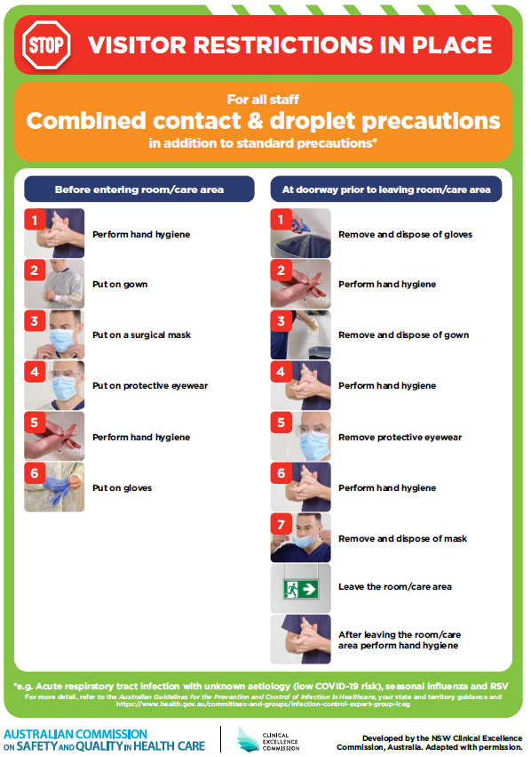](https://www.safetyandquality.gov.au/publications-and-resources/resource-library/poster-combined-contact-and-droplet-precautions)
* ***Poster – Combined airborne and contact precautions*** <https://www.safetyandquality.gov.au/publications-and-resources/resource-library/poster-combined-airborne-and-contact-precautions>   
  [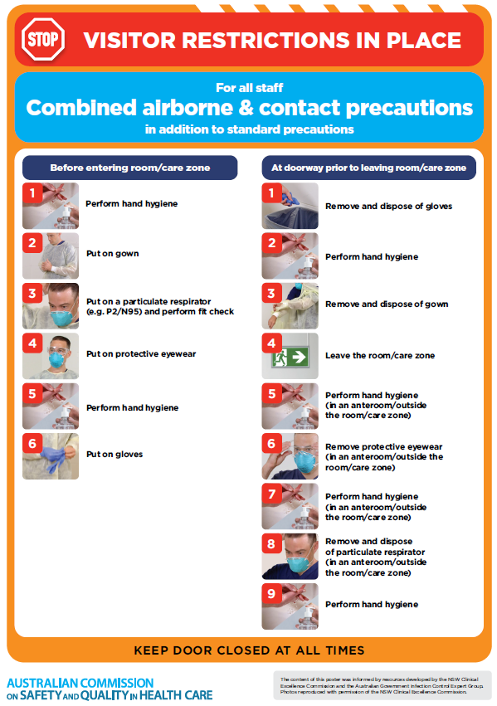](https://www.safetyandquality.gov.au/publications-and-resources/resource-library/poster-combined-airborne-and-contact-precautions)
* ***Environmental Cleaning and Infection Prevention and Control*** [www.safetyandquality.gov.au/environmental-cleaning](http://www.safetyandquality.gov.au/environmental-cleaning)
* ***COVID-19 infection prevention and control risk management – Guidance*** <https://www.safetyandquality.gov.au/publications-and-resources/resource-library/covid-19-infection-prevention-and-control-risk-management-guidance>
* ***Safe care for people with cognitive impairment during COVID-19***<https://www.safetyandquality.gov.au/our-work/cognitive-impairment/cognitive-impairment-and-covid-19>
* ***Stop COVID-19: Break the chain of infection*** posterhttps://www.safetyandquality.gov.au/publications-and-resources/resource-library/break-chain-infection-poster-a3  
  **[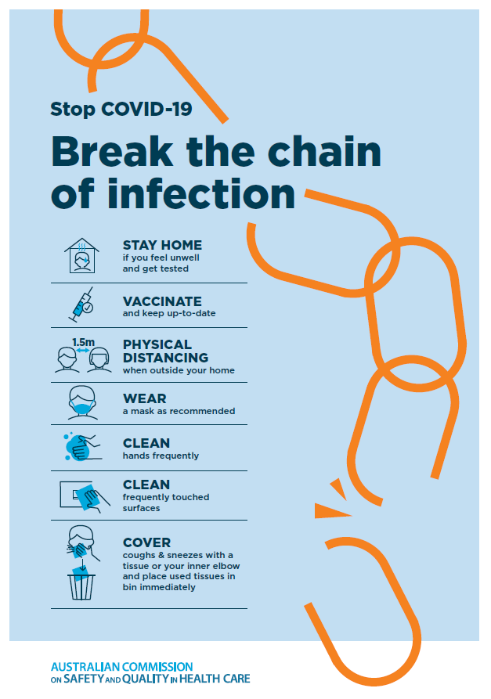](https://www.safetyandquality.gov.au/publications-and-resources/resource-library/break-chain-poster-a3https:/www.safetyandquality.gov.au/publications-and-resources/resource-library/break-chain-poster-a3)**
* ***FAQs for clinicians on elective surgery*** <https://www.safetyandquality.gov.au/node/5724>
* ***FAQs for consumers on elective surgery*** <https://www.safetyandquality.gov.au/node/5725>
* ***COVID-19 and face masks – Information for consumers*** <https://www.safetyandquality.gov.au/publications-and-resources/resource-library/covid-19-and-face-masks-information-consumers>

[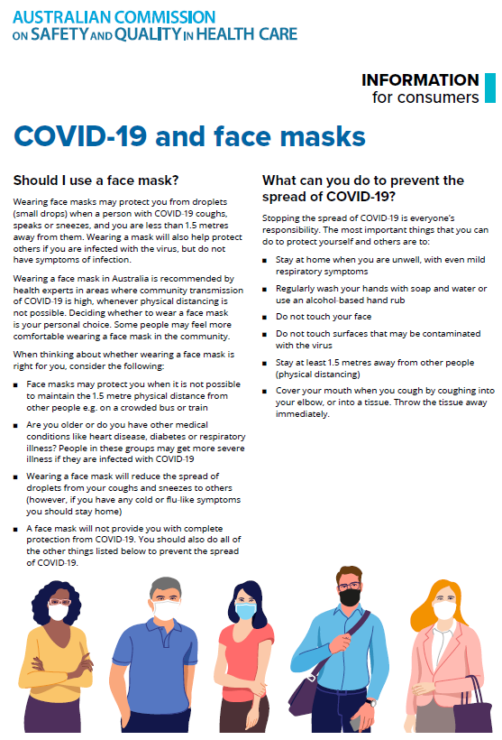](https://www.safetyandquality.gov.au/sites/default/files/2020-07/covid-19_and_face_masks_-_information_for_consumers.pdf)

*National COVID-19 Clinical Evidence Taskforce*

<https://covid19evidence.net.au/>

The National COVID-19 Clinical Evidence Taskforce is a collaboration of peak health professional bodies across Australia whose members are providing clinical care to people with COVID-19. The taskforce is undertaking continuous evidence surveillance to identify and rapidly synthesise emerging research in order to provide national, **evidence-based guidelines and clinical flowcharts for the clinical care of people with COVID-19**. The guidelines address questions that are specific to managing COVID-19 and cover the full disease course across mild, moderate, severe and critical illness. These are ‘living’ guidelines, updated with new research in near real-time in order to give reliable, up-to-the minute advice to clinicians providing frontline care in this unprecedented global health crisis.

*COVID-19 Critical Intelligence Unit*

<https://www.aci.health.nsw.gov.au/covid-19/critical-intelligence-unit>

The Agency for Clinical Innovation (ACI) in New South Wales has developed this page summarising rapid, evidence-based advice during the COVID-19 pandemic. Its operations focus on systems intelligence, clinical intelligence and evidence integration. The content includes a daily evidence digest, a COVID status monitor, a risk monitoring dashboard and evidence checks on a discrete topic or question relating to the current COVID-19 pandemic. There is also a ‘Living evidence’ section summarising key studies and emerging evidence on **COVID-19 vaccines** and **SARS-CoV-2 variants**. The most recent updates include:

* ***Budesonide and aspirin for pregnant women with COVID-19 –*** What is the evidence for the use of Budesonide for pregnant women with COVID-19? What is the evidence for aspirin prophylaxis for pre-eclampsia in pregnant women with a COVID-19 infection?
* ***Omicron (BA.2 sub-lineage)*** – What is the available evidence for the BA.2 sub-lineage of the Omicron variant of concern?
* ***COVID-19 vaccines in Australia*** – What is the evidence on COVID-19 vaccines in Australia?
* ***COVID-19 pandemic and wellbeing of critical care and other healthcare workers*** – Evidence in brief on the impact of the COVID-19 pandemic on the wellbeing of critical care and other healthcare workers.
* ***Surgery post COVID-19*** – What is the evidence for the timing of surgery, and outcomes following surgery, for people who have recovered from COVID-19?
* Show summary | Download full Evidence Check (PDF 189 KB)
* ***Disease modifying treatments for COVID-19 in children*** – What is the evidence for disease modifying treatments for COVID-19 in children?
* ***Mask type for COVID-19 positive wearer*** – What is the evidence for different mask types for COVID-19 positive wearers?
* ***Post acute and subacute COVID-19 care*** – What published advice and models of care are available regarding post-acute and subacute care for COVID-19 patients?
* ***Hospital visitor policies*** – What is the evidence for hospital visitor policies during and outside of the COVID-19 pandemic?
* ***Surgical masks, eye protection and PPE guidance*** –What is the evidence for surgical masks in the endemic phase in hospitals and for eyewear to protect against COVID-19?

**Disclaimer**

On the Radar is an information resource of the Australian Commission on Safety and Quality in Health Care. The Commission is not responsible for the content of, nor does it endorse, any articles or sites listed. The Commission accepts no liability for the information or advice provided by these external links. Links are provided on the basis that users make their own decisions about the accuracy, currency and reliability of the information contained therein. Any opinions expressed are not necessarily those of the Australian Commission on Safety and Quality in Health Care.