# Australian Commission on Safety and Quality logotypeOn the Radar

Issue 554

11 April 2022

*On the Radar* is a summary of some of the recent publications in the areas of safety and quality in health care. Inclusion in this document is not an endorsement or recommendation of any publication or provider. Access to particular documents may depend on whether they are Open Access or not, and/or your individual or institutional access to subscription sites/services. Material that may require subscription is included as it is considered relevant.

*On the Radar* is available online, via email or as a PDF or Word document from <https://www.safetyandquality.gov.au/publications-and-resources/newsletters/radar>

If you would like to receive *On the Radar* via email, you can subscribe on our website <https://www.safetyandquality.gov.au/publications-and-resources/newsletters>  
or by emailing us at H[Umail@safetyandquality.gov.auU](mailto:mail@safetyandquality.gov.au).   
You can also send feedback and comments to H[Umail@safetyandquality.gov.auU](mailto:mail@safetyandquality.gov.au).

For information about the Commission and its programs and publications, please visit <https://www.safetyandquality.gov.au>

You can also follow us on Twitter @ACSQHC.

**On the Radar**

Editor: Dr Niall Johnson [niall.johnson@safetyandquality.gov.au](mailto:niall.johnson@safetyandquality.gov.au)

Contributors: Niall Johnson, Amy Forsyth

[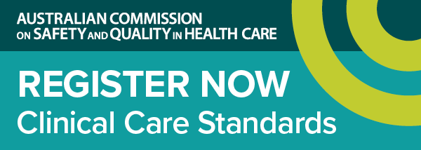](https://kapara.rdbk.com.au/landers/cab6db.html)

**Webcast launch of national standard for opioid analgesics**

<https://www.safetyandquality.gov.au/standards/clinical-care-standards/opioid-analgesic-stewardship-acute-pain-clinical-care-standard>

The Australian Commission on Safety and Quality in Health Care will launch the first national *Opioid Analgesic Stewardship in Acute Pain Clinical Care Standard* on Wednesday, 27 April 2022.

Every day in Australia, nearly 150 hospitalisations and 14 emergency department presentations involve opioid harm, and three people die after using an opioid. Many people become persistent users of opioid analgesics after being prescribed opioids for acute pain in hospital. Appropriate use of opioid analgesics minimises the risk of opioid-related harms.

The new clinical care standard outlines appropriate use of opioid analgesics in the emergency department and following surgery, excluding major trauma.

Panellists

* Conjoint Professor Anne Duggan – Chief Medical Officer, the Commission (Host)
* Conjoint Associate Professor Jennifer Stevens – Anaesthetist and pain medicine specialist, St Vincent’s Hospitals, Sydney
* Dr Andrew Sefton – Orthopaedic surgeon, VMO Dubbo Base Hospital NSW, VMO North Shore Private Hospital
* Thuy Bui – Analgesic Stewardship Pharmacist and Perioperative Services Pharmacist Alfred Health, Melbourne
* Dr Hester Wilson – General Practitioner and Staff Specialist in Addiction, Drug and Alcohol Services, South East Sydney Local Health District

Date: Wednesday 27 April

Time: 12:00pm – 1:00pm AEST

Location: Online

Click [here](https://kapara.rdbk.com.au/landers/cab6db.html) to register

For more information, email [ccs@safetyandquality.gov.au](mailto:ccs@safetyandquality.gov.au) or visit our web page <https://www.safetyandquality.gov.au/standards/clinical-care-standards/opioid-analgesic-stewardship-acute-pain-clinical-care-standard>

*Australian Journal of Primary Health*

Volume 28 Number 2 April 2022

|  |  |
| --- | --- |
| URL | <https://www.publish.csiro.au/py/issue/10792> |
| Notes | A new issue of the *Australian Journal of Primary Health* has been published. Articles in this issue of the *Australian Journal of Primary Health* include:   * Effectiveness of health literacy- and patient activation-targeted interventions on **chronic disease self-management outcomes in outpatient settings**: a systematic review (H Hosseinzadeh, S Downie and M. Shnaigat) * **Medical homes and chronic care**: consumer lessons for regional Australia (Mary O'Loughlin, Caryn West and Jane Mills) * Socioeconomic disadvantage and the **practice location of recently Fellowed Australian GPs**: a cross-sectional analysis (Dominica Moad, Alison Fielding, Amanda Tapley, Mieke L van Driel, Elizabeth G Holliday, J I Ball, A R Davey, K FitzGerald, M Bentley, N A Spike, C Kirby, A Turnock and P Magin) * About face: regional **allied health professional early adaptation during the COVID-19 pandemic** (Meredith Castle, Rowan O'Hagan, Erin Anderberg, Amanda Wangman, Helen Harrington and Lakshmi Dhakal) * Evaluation of a **visiting credentialled diabetes educator program** in remote western Queensland, Australia (Leanne Mullan and David Skinner) * Availability of **drinking water in rural and remote communities** in New South Wales, Australia (Christina Perry, Yvonne Dimitropoulos, John Skinner, Chris Bourke, Kate Miranda, Elyse Cain, Damien Beaufils, Vita Christie, Boe Rambaldini and Kylie Gwynne) * ‘I didn’t want to visit a doctor unless it was extremely necessary’: perspectives on **delaying access to sexual and reproductive health care during the COVID-19 pandemic** in Australia from an online survey (Helen Bittleston, Jane L Goller, Meredith Temple-Smith, Jane S Hocking and J Coombe) * Factors associated with **choice of health service delivery for after-hours, urgent, non-life-threatening conditions**: a patient survey (John William Adie, Wayne Graham and Marianne Wallis) * Improving **access for the vulnerable**: a mixed-methods feasibility study of a pop-up model of care in south-eastern Melbourne, Australia (Grant Russell, Susannah Westbury, Sharon Clifford, Elizabeth Sturgiss, Anna Fragkoudi, Rob Macindoe, Deborah Stuart, Marina Kunin, Jill Walsh and Cathie Scott) * Barriers and facilitators to **nurse-led advance care planning and palliative care** practice change in primary healthcare: a qualitative study (Srivalli V Nagarajan, Virginia Lewis, Elizabeth Halcomb, Joel Rhee, Rachael L Morton, G K Mitchell, J Tieman, J L Phillips, K Detering, J Gavin and J M Clayton) * Feasibility and outcomes of a **general practice and specialist alcohol and other drug collaborative care program** in Sydney, Australia (H K Wilson, M Schulz, L Mills and N Lintzeris) * A ‘joint’ approach: design, implementation and preliminary outcomes of an **early conservative knee and hip osteoarthritis service** in northern New South Wales, Australia (Brayden Campbell, Luke Schultz, Evan Bryant, Jason D. Tsung, Brett Lynam and Alexandre S Stephens) * **Health care support following miscarriage** in Australia: a qualitative study. How can we do better? (Alice Y Yu, Meredith J Temple-Smith and J E Bilardi) |

*Australian Health Review*

Volume 46 Number 2 April 2022

|  |  |
| --- | --- |
| URL | <https://www.publish.csiro.au/ah/issue/10698> |
| Notes | A new issue of *Australian Health Review* has been published. Articles in this issue of *Australian Health Review* include:   * Election 2022 should address **unfinished business in health and aged care** (Stephen Duckett) * Paying for value: options for **value-based payment reform** in Australia (Sarah Wise, Jane Hall, P Haywood, N Khana, L Hossain and K van Gool) * What has driven **acute public hospital expenditure growth in South Australia**? An analysis of the relative importance of major expenditure drivers between 2006–07 and 2017–18 (Allison Larg and John R. Moss) * Application of an **economic evaluation approach to making regulatory decisions regarding access to medicines**: advantages, challenges and recommendations (Bonny Parkinson and Henry Cutler) * Bevacizumab for **blinding eye disease** – is it time for the PBS to list for off-label use? (Peter Heyworth) * Cost and economic determinants of **paediatric tonsillectomy** (Aimy H L Tran, Danny Liew, Rosemary S C Horne, Joanne Rimmer and G M Nixon) * **Overtime claiming among Australian doctors-in-training** (Andrew Coulshed, Brian Fernandes and Sanjay Hettige) * Opportunities for further changes to the **Medicare Benefits Schedule to support Aboriginal Community Controlled Health Organisations** (H Beks, V L Versace, R Zwolak and T Chatfield) * Closing the Gap in **Aboriginal health disparities**: is there a place for Elders in the neoliberal agenda? (Terrance Cox, Ha Hoang, J Mond and M Cross) * Development and implementation of a **shared governance model** in a mainstream health unit: a case study of **embedding Aboriginal voices in organisational decision making** (K Crooks, B Tully, L Allan, K Gillham, D Durrheim and J Wiggers) * **Integrating virtual models of care** through infrastructure innovation in healthcare facility design (Reema Harrison, Robyn Clay-Williams and Alexander Cardenas) * Nurses’ and midwives’ experiences of the first phase of the implementation of an **electronic medical records system** (Karen Wynter, Sara Holton, Lemai Nguyen, Helen Sinnott, Nilmini Wickramasinghe, S Crowe and B Rasmussen) * Survey of **paediatric telehealth benefits** from the caregiver perspective (Harriet Hiscock, Rachel Pelly, Xinyang Hua, Sue West, Dianne Tucker, Chin-Mae Raymundo and Kim Dalziel) * Comparison of the **quality of documentation between electronic and paper medical records** in orthopaedic trauma patients (Chris Witkowski, Lara Kimmel, Elton Edwards and Filip Cosic) * Australian health service organisation assessment outcome data for the first 2 years of implementing the **Comprehensive Care Standard** (Margherita Murgo and Angie Dalli) * Association between Western Australian **children’s unplanned dental presentations** and the socioeconomic status of their residential area (Parmis Aminian, Estie Kruger and Marc Tennant) * Characteristics of patients aged 50–74 years with a request for an **immunochemical faecal occult blood test** in the Australian general practice setting (Allan Pollack, Doreen Busingye, Jill Thistlethwaite, Suzanne Blogg and Kendal Chidwick) * **How patient centric is health policy development?** The case of the Parliamentary Inquiry into Sleep Health Awareness in Australia (Aaron Schokman, Nick Glozier, Melissa Aji, Y S Bin, K Kairaitis and J M Y Cheung) * **Cognitive impairment in older hospital inpatients**: prevalence, care needs and carer perceptions (Alison M Mudge, Karen Lee-Steere, Elise Treleaven, Margaret Cahill, Simon Finnigan and Prue McRae) * **Healthcare worker infections with the SARS-CoV-2 virus** following the inception of an adult COVID-19 intensive care unit (Allanah Baukes, Alison Brannelly, Winston Cheung, Rosalba Cross, Thomas Gottlieb, Timothy Gray, Karina Griffiths, Rhiannon Hunt, Mark Kol, Ying Li, Genevieve Mckew, Anne Mendes, Asim Shah, Katina Skylas, Gemma Smith, Atul Wagh and Helen Wong) |

*Health Affairs*

Volume 41, Number 4 (April 2022)

|  |  |
| --- | --- |
| URL | <https://www.healthaffairs.org/toc/hlthaff/41/4> |
| Notes | A new issue of *Health Affairs* has been published with the themes “Access To Care, Hospitals & More”. Articles in this issue of *Health Affairs* include:   * **National Health Expenditure Projections**, 2021–30: Growth To Moderate As COVID-19 Impacts Wane (John A Poisal, Andrea M Sisko, Gigi A Cuckler, S D Smith, S P Keehan, J A Fiore, A J Madison, and K E Rennie) * Many **Medicare Beneficiaries Do Not Fill High-Price Specialty Drug Prescriptions** (Stacie B Dusetzina, Haiden A Huskamp, Russell L Rothman, Laura C Pinheiro, Andrew W Roberts, Nilay D Shah, Theresa L Walunas, William A Wood, Autumn D Zuckerman, Leah L Zullig, and N L Keating) * Title X Improved **Access To Most Effective And Moderately Effective Contraception** In US Safety-Net Clinics, 2016–18 (Blair G Darney, Frances M Biel, Megan Hoopes, Maria I Rodriguez, Brigit Hatch, Miguel Marino, Anna Templeton, Jee Oakley, Teresa Schmidt, and Erika K Cottrell) * Trends In Self-Pay **Charges And Insurance Acceptance For Abortion** In The United States, 2017–20 (Ushma D Upadhyay, Chris Ahlbach, Shelly Kaller, Clara Cook, and Isabel Muñoz) * **Trends In Hospital Prices** Paid By Private Health Plans Varied Substantially Across The US (Zachary Levinson, Nabeel Qureshi, J L Liu, and C M Whaley) * Financial Impacts And Operational Implications Of **Private Equity Acquisition Of US Hospitals** (Marcelo Cerullo, Yu-Li Lin, Jose Alejandro Rauh-Hain, Vivian Ho, and Anaeze C. Offodile II) * Association Between **Medicaid Expansion And Closure Of Hospital-Based Obstetric Services** (Caitlin Carroll, Julia D Interrante, Jamie R Daw, and Katy Backes Kozhimannil) * **Value-Based Payment Models In The Commercial Insurance Sector**: A Systematic Review (M A Milad, R C Murray, A S Navathe, and A M Ryan) * Relationship Between **Physician Burnout And The Quality And Cost Of Care** For Medicare Beneficiaries Is Complex (Lawrence P Casalino, Jing Li, L E Peterson, D R Rittenhouse, M Zhang, E M O’Donnell, and R L Phillips) * **Health-Related Social Needs Among Older Adults** Enrolled In Medicare Advantage (Charron L Long, Stephanie M Franklin, Angela S Hagan, Yong Li, Jeremiah S Rastegar, Bill Glasheen, William H Shrank, and Brian W Powers) * Unequal Housing Conditions And Code Enforcement Contribute To **Asthma Disparities** In Boston, Massachusetts (Evan Lemire, Elizabeth A Samuels, Wenyi Wang, and Adam Haber) * Trends In **Outpatient Mental Health Services** Use Before And During The **COVID-19 Pandemic** (Jane M Zhu, Renae Myers, K John McConnell, Ximena Levander, and Sunny C Lin) * The **Association Of HIV With Health Care Spending And Use** Among Medicare Beneficiaries (José F Figueroa, Ingrid T Katz, Emily P Hyle, Kathryn E Horneffer, Kavya Nambiar, Jessica Phelan, E John Orav, and Ashish K Jha) * A Comprehensive Assessment Of **Child Care Vaccination Laws** Across The US (Alexandra Bhatti, Cristina Carias, F C Mendez, Y Choi, and A Skolnik) * Measuring **Racial Inequities In The Quality Of Care Across Oncology Practices** In The US (Nancy L Keating, Mary Beth Landrum, Cleo Samuel-Ryals, Anna D Sinaiko, Alexi Wright, G A Brooks, B Bai, and A M Zaslavsky) * **Where Are You From?** (Zhaohui Su) |

*BMJ Quality & Safety* online first articles

|  |  |
| --- | --- |
| URL | <https://qualitysafety.bmj.com/content/early/recent> |
| Notes | *BMJ Quality &Safety* has published a number of ‘online first’ articles, including:   * Effect of the **surgical safety checklist** on provider and patient outcomes: a systematic review (Bonnie A Armstrong, Ilinca A Dutescu, Lori Nemoy, Ekta Bhavsar, Diana N Carter, Kimberley-Dale Ng, S Boet, P Trbovich, V Palter) * Evaluation of the NHS England **evidence-based interventions programme**: a difference-in-difference analysis (Michael Anderson, Aoife Molloy, Laia Maynou, Ilias Kyriopoulos, Alistair McGuire, Elias Mossialos) * Impact of COVID-19 restrictions on **diabetes health checks and prescribing for people with type 2 diabetes**: a UK-wide cohort study involving 618 161 people in primary care (Matthew J Carr, Alison K Wright, L Leelarathna, H Thabit, N Milne, N Kanumilli, D M Ashcroft, M K Rutter) * Effect of clinical peer review on **mortality in patients ventilated for more than 24 hours**: a cluster randomised controlled trial (J Schmitt, M Roessler, P Scriba, F Walther, X Grählert, M Eberlein-Gonska, R Kuhlen, O Schoffer) |

*International Journal for Quality in Health Care* online first articles

|  |  |
| --- | --- |
| URL | <https://academic.oup.com/intqhc/advance-articles> |
| Notes | *International Journal for Quality in Health Care* has published a number of ‘online first’ articles, including:   * The Future of **Quality and Accreditation Surveys**: Digital Transformation and Artificial Intelligence (Zuhal Çayirtepe, Figen Çizmeci Şenel) |

**Online resources**

***[USA] Toolkit for preventing CLABSI and CAUTI in Intensive Care Units***

<https://www.ahrq.gov/hai/tools/clabsi-cauti-icu/index.html>

The Agency for Healthcare Research and Quality (AHRQ) in the USA has produced this toolkit to assist ICUs in reducing rates of central line-associated bloodstream infection (CLABSI) and catheter-associated urinary tract infection (CAUTI). The toolkit provides customisable tools and training resources. It includes resources to assess current clinical and safety practices, implement a reduction plan, and overcome common cultural and technical challenges in reduction efforts.

For information on the Commission’s work on healthcare-associated infections, see <https://www.safetyandquality.gov.au/our-work/healthcare-associated-infection>

For information on the Commission’s work on infection prevention and control, see <https://www.safetyandquality.gov.au/our-work/infection-prevention-and-control>

***[USA] Patient Safety Primers***

<https://psnet.ahrq.gov/primers/>

The Patient Safety Primers from the (US) Agency for Healthcare Research and Quality (AHRQ) discuss key concepts in patient safety. Each primer defines a topic, offers background information on its epidemiology and context, and provides links to relevant materials.

* *Strategies and Approaches for* ***Investigating Patient Safety Events*** <https://psnet.ahrq.gov/primer/strategies-and-approaches-investigating-patient-safety-events>

***[USA] AHRQ Perspectives on Safety***

<https://psnet.ahrq.gov/psnet-collection/perspectives>

The US Agency for Healthcare Research and Quality (AHRQ) publishes Perspectives on Safety essays. Recent essays include:

* ***Topics in Medication Safety***<https://psnet.ahrq.gov/perspective/annual-perspective-topics-medication-safety>
* ***Psychological Safety of Healthcare Staff***<https://psnet.ahrq.gov/perspective/annual-perspective-psychological-safety-healthcare-staff>

**COVID-19 resources**

https://www.safetyandquality.gov.au/covid-19

The Australian Commission on Safety and Quality in Health Care has developed a number of resources to assist healthcare organisations, facilities and clinicians. These and other material on COVID-19 are available at <https://www.safetyandquality.gov.au/covid-19>

These resources include:

* ***OVID-19 infection prevention and control risk management*** This primer provides an overview of three widely used tools for investigating and responding to patient safety events and near misses. Tools covered in this primer include incident reporting systems, Root Cause Analysis (RCA), and Failure Modes and Effects Analysis (FMEA).   
  <https://www.safetyandquality.gov.au/publications-and-resources/resource-library/covid-19-infection-prevention-and-control-risk-management-guidance>
* ***Poster – Combined contact and droplet precautions*** <https://www.safetyandquality.gov.au/publications-and-resources/resource-library/poster-combined-contact-and-droplet-precautions>  
  [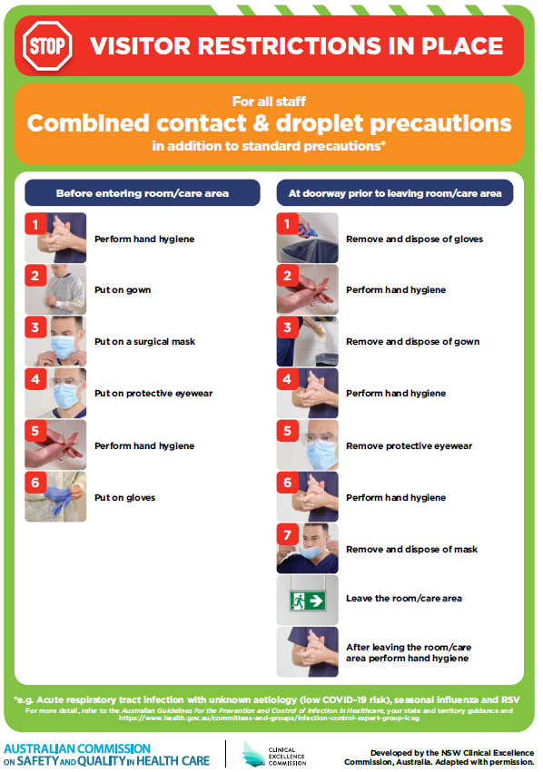](https://www.safetyandquality.gov.au/publications-and-resources/resource-library/poster-combined-contact-and-droplet-precautions)
* ***Poster – Combined airborne and contact precautions*** <https://www.safetyandquality.gov.au/publications-and-resources/resource-library/poster-combined-airborne-and-contact-precautions>   
  [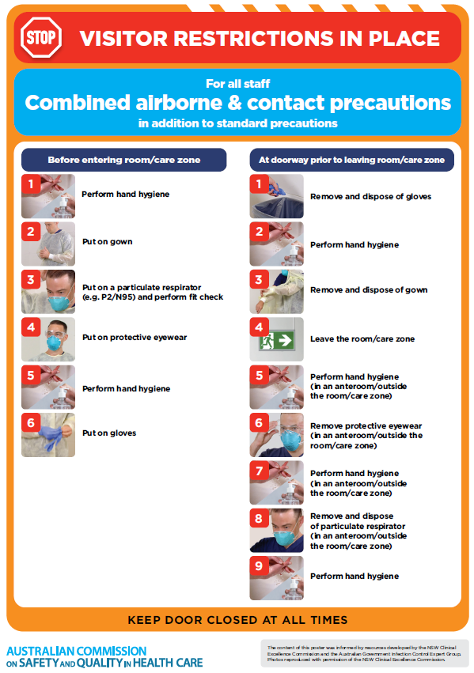](https://www.safetyandquality.gov.au/publications-and-resources/resource-library/poster-combined-airborne-and-contact-precautions)
* ***Environmental Cleaning and Infection Prevention and Control*** [www.safetyandquality.gov.au/environmental-cleaning](http://www.safetyandquality.gov.au/environmental-cleaning)
* ***COVID-19 infection prevention and control risk management – Guidance*** <https://www.safetyandquality.gov.au/publications-and-resources/resource-library/covid-19-infection-prevention-and-control-risk-management-guidance>
* ***Safe care for people with cognitive impairment during COVID-19***<https://www.safetyandquality.gov.au/our-work/cognitive-impairment/cognitive-impairment-and-covid-19>
* ***Stop COVID-19: Break the chain of infection*** posterhttps://www.safetyandquality.gov.au/publications-and-resources/resource-library/break-chain-infection-poster-a3  
  **[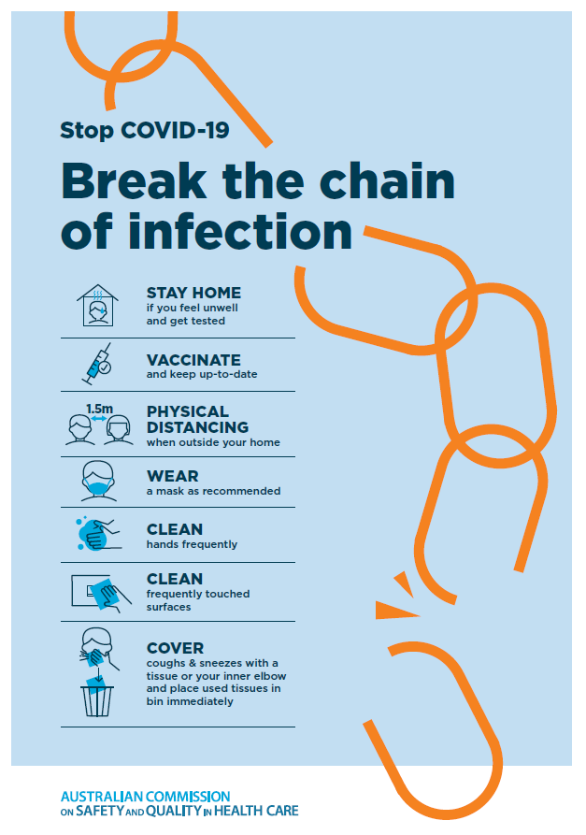](https://www.safetyandquality.gov.au/publications-and-resources/resource-library/break-chain-poster-a3https:/www.safetyandquality.gov.au/publications-and-resources/resource-library/break-chain-poster-a3)**
* ***FAQs for clinicians on elective surgery*** <https://www.safetyandquality.gov.au/node/5724>
* ***FAQs for consumers on elective surgery*** <https://www.safetyandquality.gov.au/node/5725>
* ***COVID-19 and face masks – Information for consumers*** <https://www.safetyandquality.gov.au/publications-and-resources/resource-library/covid-19-and-face-masks-information-consumers>

[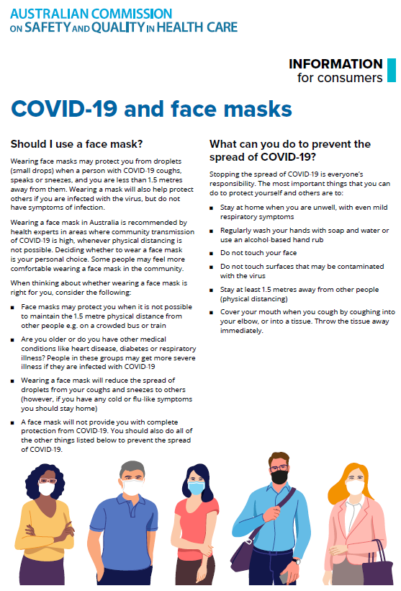](https://www.safetyandquality.gov.au/sites/default/files/2020-07/covid-19_and_face_masks_-_information_for_consumers.pdf)

*National COVID-19 Clinical Evidence Taskforce*

<https://covid19evidence.net.au/>

The National COVID-19 Clinical Evidence Taskforce is a collaboration of peak health professional bodies across Australia whose members are providing clinical care to people with COVID-19. The taskforce is undertaking continuous evidence surveillance to identify and rapidly synthesise emerging research in order to provide national, **evidence-based guidelines and clinical flowcharts for the clinical care of people with COVID-19**. The guidelines address questions that are specific to managing COVID-19 and cover the full disease course across mild, moderate, severe and critical illness. These are ‘living’ guidelines, updated with new research in near real-time in order to give reliable, up-to-the minute advice to clinicians providing frontline care in this unprecedented global health crisis.

*COVID-19 Critical Intelligence Unit*

<https://www.aci.health.nsw.gov.au/covid-19/critical-intelligence-unit>

The Agency for Clinical Innovation (ACI) in New South Wales has developed this page summarising rapid, evidence-based advice during the COVID-19 pandemic. Its operations focus on systems intelligence, clinical intelligence and evidence integration. The content includes a daily evidence digest, a COVID status monitor, a risk monitoring dashboard and evidence checks on a discrete topic or question relating to the current COVID-19 pandemic. There is also a ‘Living evidence’ section summarising key studies and emerging evidence on **COVID-19 vaccines** and **SARS-CoV-2 variants**. The most recent updates include:

* ***Post-acute sequelae of COVID-19*** – What is the evidence on the post-acute sequelae of COVID-19?
* ***Budesonide and aspirin for pregnant women with COVID-19 –*** What is the evidence for the use of Budesonide for pregnant women with COVID-19? What is the evidence for aspirin prophylaxis for pre-eclampsia in pregnant women with a COVID-19 infection?
* ***Omicron (BA.2 sub-lineage)*** – What is the available evidence for the BA.2 sub-lineage of the Omicron variant of concern?
* ***COVID-19 vaccines in Australia*** – What is the evidence on COVID-19 vaccines in Australia?
* ***COVID-19 pandemic and wellbeing of critical care and other healthcare workers*** – Evidence in brief on the impact of the COVID-19 pandemic on the wellbeing of critical care and other healthcare workers.
* ***Surgery post COVID-19*** – What is the evidence for the timing of surgery, and outcomes following surgery, for people who have recovered from COVID-19?
* ***Disease modifying treatments for COVID-19 in children*** – What is the evidence for disease modifying treatments for COVID-19 in children?
* ***Mask type for COVID-19 positive wearer*** – What is the evidence for different mask types for COVID-19 positive wearers?
* ***Post acute and subacute COVID-19 care*** – What published advice and models of care are available regarding post-acute and subacute care for COVID-19 patients?
* ***Hospital visitor policies*** – What is the evidence for hospital visitor policies during and outside of the COVID-19 pandemic?
* ***Surgical masks, eye protection and PPE guidance*** –What is the evidence for surgical masks in the endemic phase in hospitals and for eyewear to protect against COVID-19?

**Disclaimer**

On the Radar is an information resource of the Australian Commission on Safety and Quality in Health Care. The Commission is not responsible for the content of, nor does it endorse, any articles or sites listed. The Commission accepts no liability for the information or advice provided by these external links. Links are provided on the basis that users make their own decisions about the accuracy, currency and reliability of the information contained therein. Any opinions expressed are not necessarily those of the Australian Commission on Safety and Quality in Health Care.