# Australian Commission on Safety and Quality logotypeOn the Radar

Issue 555

26 April 2022

*On the Radar* is a summary of some of the recent publications in the areas of safety and quality in health care. Inclusion in this document is not an endorsement or recommendation of any publication or provider. Access to particular documents may depend on whether they are Open Access or not, and/or your individual or institutional access to subscription sites/services. Material that may require subscription is included as it is considered relevant.

*On the Radar* is available online, via email or as a PDF or Word document from <https://www.safetyandquality.gov.au/publications-and-resources/newsletters/radar>

If you would like to receive *On the Radar* via email, you can subscribe on our website <https://www.safetyandquality.gov.au/publications-and-resources/newsletters>  
or by emailing us at H[Umail@safetyandquality.gov.auU](mailto:mail@safetyandquality.gov.au).   
You can also send feedback and comments to H[Umail@safetyandquality.gov.auU](mailto:mail@safetyandquality.gov.au).

For information about the Commission and its programs and publications, please visit <https://www.safetyandquality.gov.au>

You can also follow us on Twitter @ACSQHC.

**On the Radar**

Editor: Dr Niall Johnson [niall.johnson@safetyandquality.gov.au](mailto:niall.johnson@safetyandquality.gov.au)

Contributors: Niall Johnson, Jennifer Caldwell

***Updated Clean and safe healthcare environment eLearning module***

<https://nhhi.southrock.com>

The Australian Commission on Safety and Quality in Health Care continues to develop and support online learning for infection prevention and control (IPC) and hand hygiene for healthcare workers through its centralised online Learning Management System (LMS).

The Commission has recently developed the new *Clean and safe healthcare environment* eLearning module to ensure consistency with the National Safety and Quality Health Service Standards, specifically the *Preventing and Controlling Infections Standard*, and the *Australian Guidelines for the Prevention and Control of Infection in Healthcare*. The module has also been developed to improve the learner experience

updated the

The module is available in the National Hand Hygiene Initiative (NHHI) LMS at <https://nhhi.southrock.com>. Access to the NHHI LMS is free for all users and modules can be accessed after a learner has registered a profile on the system.

[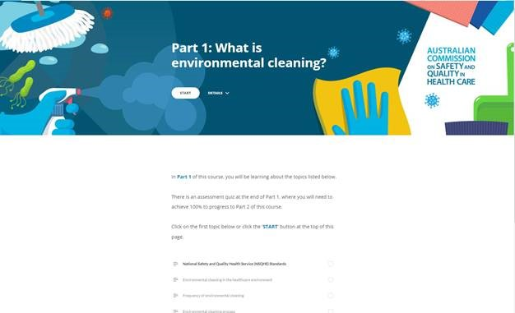](https://nhhi.southrock.com)

**Reports**

*Quality of life tools to support measurement of aged care quality*

Siette J, Knaggs G, Haddock R

Deeble Institute Evidence Brief No. 23

Canberra: Australian Healthcare and Hospitals Association; 2022. p. 19.

|  |  |
| --- | --- |
| URL | <https://ahha.asn.au/publication/health-policy-evidence-briefs/evidence-brief-no-23-quality-life-tools-support> |
| Notes | The quality of aged care is one of the topics of the era and appears likely to be a key topic in the federal election. How to measure that quality of care in aged care is the focus of this Evidence brief from the Australian Healthcare and Hospitals Association‘s Deeble Institute. The authors examine the evidence for how tools assessing quality of life indicators in aged care settings can foster change in the system; and provide improved health and wellbeing outcomes for residents. It is argued that it is essential that a set of long-term and comprehensive indicators of quality in aged care provision is established and that these must not only be both realistic and attainable but they must also meet public expectations for high quality, caring, person-centred aged care. |

*The voice of Australian health consumers: The 2021 Australian Health Consumer Sentiment Survey*

Report prepared for the Consumers Health Forum of Australia

Zurynski Y, Ellis LA, Dammery G, Smith C, Halim N, Ansell J, et al.

Sydney: NHMRC Partnership Centre for Health System Sustainability; 2022.

|  |  |
| --- | --- |
| URL | <https://healthsystemsustainability.com.au/the-voice-of-australian-health-consumers/> |
| Notes | Based on two phases of surveys that canvassed 1024 respondents in December 2018 and 5100 in October 2021 this report gives a perspective on what Australian consumers think about their health system’s performance before and during the COVID-19 pandemic.  The authors report ‘Despite ongoing disruptions to the Australian healthcare system as a result of the COVID-19 pandemic, overall, Australian’s satisfaction and favourable views of their healthcare system continued to increase. However, there are continued concerns over inadequate workforce capacity in the health system and ability to afford needed care, especially among people with chronic conditions. Use of telehealth and other virtual care services increased, and such services were highly rated. Almost a quarter reported serious levels of psychological distress and were more likely to use virtual care. With over 20% of people reporting disrespect or discrimination, especially among vulnerable populations, interventions to increase cultural competency in the health system are needed.’  [Key results from the 2021 Australian Health Consumer Sentiment Survey](https://healthsystemsustainability.com.au/the-voice-of-australian-health-consumers/) |

For information on the Commission’s work on partnering with consumers, see <https://www.safetyandquality.gov.au/our-work/partnering-consumers>

*Personalised prescribing: using pharmacogenomics to improve patient outcomes*

Report of a working party

Royal College of Physicians and British Pharmacological Society

London: Royal College of Physicians and British Pharmacological Society; 2022. p. 51.

|  |  |
| --- | --- |
| DOI | <https://www.rcp.ac.uk/projects/outputs/personalised-prescribing> |
| Notes | The potential of personalised, precision or genomic medicine has been touted for some time. This report produced by a Royal College of Physicians and British Pharmacological Society joint working party (and the patient summary that is also available) suggests that pharmacogenomic testing, should now be deployed across the NHS to ensure all patients have an equal chance of being prescribed a medicine at a dose that is likely to be safe and effective for them, with minimal side effects.  Infographic showing how a pharmacogenomic approach to medication compares with the current standard approach. The patient's genomic information helps ensure the right medication at the right dose for them is provided. |

For information on the Commission’s work on medication safety see <https://www.safetyandquality.gov.au/our-work/medication-safety>

*Findings, Conclusions and Essential Actions from the Independent Review of Maternity Services at The Shrewsbury and Telford Hospital NHS Trust*

Our Final Report

Ockenden D

London2022. p. 250.

*Ockenden: another shocking review of maternity services*Knight M, Stanford S  
BMJ. 2022;377:o898.

|  |  |
| --- | --- |
| URL / DOI | Ockenden <https://www.gov.uk/government/publications/final-report-of-the-ockenden-review>  Ockenden Knight and Stanford <https://doi.org/10.1136/bmj.o898> |
| Notes | The UK government has released the final report of the review of maternity services at the Shrewsbury and Telford Hospital NHS Trust. As an editorial in the *BMJ* (<https://doi.org/10.1136/bmj.o898>) observes this is ‘at least the fourth similar report [into lapses in maternity care in the UK] in recent years, with two more in progress.’ The report finds that this was ‘an NHS maternity service that failed. It failed to investigate, failed to learn and failed to improve, and therefore often failed to safeguard mothers and their babies at one of the most important times in their lives.’  The *BMJ* editorial observes that there have been ‘enormous improvements in the safety of pregnancy over the 20th century because of advances in maternity care. Here perhaps lies part of the problem. The fact that pregnancy is now considered so safe seems to have led those managing services to forget that improved outcomes were achieved only by deploying sufficient skilled staff, multidisciplinary care, and a laser focus on patient safety.’  They also suggest that while the report ‘focuses on maternity services, …efforts to ensure safe pregnancy and childbirth must take a wider perspective. Women have complex care needs before, during, and after pregnancy. The need to improve that care … is the concern of all health professionals caring for women of reproductive age.’ Also identified are the need properly resource care and to genuinely listen to the concerns of women and families. |

**Journal articles**

*Cognitive impairment in older hospital inpatients: prevalence, care needs and carer perceptions*

Mudge AM, Lee-Steere K, Treleaven E, Cahill M, Finnigan S, McRae P

Australian Health Review. 2022;46(2):244-250.

|  |  |
| --- | --- |
| DOI | <https://doi.org/10.1071/AH20286> |
| Notes | Cognitive impairment is an important safety and quality issue. Cognitive impairment is common, but is often not identified, or it is dismissed or misdiagnosed. For example, symptoms of delirium may be dismissed as a normal part of ageing, or as dementia, potentially preventing further assessment and action.  This paper seeks to ‘describe the prevalence of cognitive impairment in hospital inpatients, the associated need for assistance with activities of daily living (ADL) and carer perceptions of hospital care.’ Using a prospective cross-sectional observational study conducted in a large metropolitan teaching hospital in Brisbane, the authors found that 92 of 216 older inpatients (43%) had cognitive impairment, including 52 (24%) with probable delirium. Such prevalence supports the argument that ‘Cognitive impairment is common in older inpatients. Hospitals and healthcare professionals must be prepared and equipped to recognise cognitive impairment, and address the accompanying patient and carer needs.’ |

For information on the Commission’s work on cognitive impairment, see <https://www.safetyandquality.gov.au/our-work/cognitive-impairment>

*Medication Safety in the Emergency Department: A Study of Serious Medication Errors Reported by 101 Hospitals From 2011 to 2020*

Kukielka E, Jones R

Patient Safety. 2022 03/17;4(1):49-59.

|  |  |
| --- | --- |
| DOI | <https://doi.org/10.33940/data/2022.3.5> |
| Notes | Paper reporting on a study of medication errors reported to the Pennsylvania Patient Safety Reporting System (PA-PSRS) that occurred in emergency departments (EDs) in the period 1 January 2011 to 31 December 2020. Having identified 250 reports of serious medication error reports the study found:   * 61.2% of patients were female * Events were significantly more likely to occur Friday through Sunday [weekends] versus Monday through Thursday (p = .0214) and in the p.m. hours versus a.m. hours, (p = .0007) * The most common prescribed medications mentioned in reports were epinephrine, insulin, hydromorphone, sodium chloride, heparin, propofol, diltiazem, ketamine, and morphine. * Events occurred most often at the prescribing stage of the medication-use process (42.0%; 105 of 250) * The most common medication error type was a wrong dose (42.0%; 105 of 250).   Visual abstract for Medication Safety in the Emergency Department: A Study of Serious Medication Errors Reported by 101 Hospitals From 2011 to 2020. |

For information on the Commission’s work on medication safety see <https://www.safetyandquality.gov.au/our-work/medication-safety>

*Patient Harm and Institutional Avoidability of Out-of-Hours Discharge From Intensive Care: An Analysis Using Mixed Methods*

Vollam S, Gustafson O, Morgan L, Pattison N, Thomas H, Watkinson P

Critical Care Medicine. 2022 [epub]

|  |  |
| --- | --- |
| DOI | <https://doi.org/10.1097/ccm.0000000000005514> |
| Notes | Transitions of care are recognised as having potential for harm. This study looked at discharge from the intensive care unit (ICU) to the ward, particularly out-of-hours discharge (defined as between 1600 and 0759). The study was conducted in 3 U.K. National Health Service hospitals using qualitative interviews with patients, family members, and staff. The authors report that out-of-hours discharge was common. They also observed:   * Patients and staff described out-of-hours discharge as unsafe due to a reduction in staffing and skill mix at night. * Patients discharged out-of-hours were commonly discharged prematurely, had inadequate handover, were physiologically unstable, and did not have deterioration recognized or escalated appropriately. * They identified five interdependent function keys to facilitating timely ICU discharge: multidisciplinary team decision for discharge, patient prepared for discharge, bed meeting, bed manager allocation of beds, and ward bed made available. |

*Learning the Art and Science of Diagnosis*

Detsky AS

Journal of the American Medical Association. 2022 [epub].

|  |  |
| --- | --- |
| DOI | <https://doi.org/10.1001/jama.2022.4650> |
| Notes | The latest in JAMA’s examination of diagnostic excellence is this Viewpoint piece in which the complexity in learning and applying the art and science of diagnosis.  The piece concludes ‘Diagnostic excellence requires a comprehensive knowledge of diseases, skills in data gathering, competency in communication, and judgment in fact integration and problem solving. As such, diagnosis involves both the art and the science of medicine. At times, diagnosis involves fast thinking via pattern recognition (for people who have findings that are highly specific for a certain disease), whereas at other times, it involves slower thinking with iterative analyses. Putting it all together to achieve diagnostic excellence requires caring, curiosity, practice, experience, and feedback, all components of lifelong learning that contribute to the joy and satisfaction derived from the practice of medicine.’ |

*Synthesizing Dimensions of Digital Maturity in Hospitals: Systematic Review*

Duncan R, Eden R, Woods L, Wong I, Sullivan C

J Med Internet Res. 2022 2022/3/30;24(3):e32994.

|  |  |
| --- | --- |
| DOI | <https://doi.org/10.2196/32994> |
| Notes | As the authors note, ‘Digital health in hospital settings is viewed as a panacea’. They continue that ‘To optimize digital health outcomes, a strategic approach is necessary, requiring digital maturity assessments’. This study sought to ‘identify the current dimensions used to assess the digital maturity of hospitals.’  The systematic review identified 29 articles describing 27 distinct maturity models. From these the authors produced a consolidated mature model framework that has 7 dimensions that can be evaluated using 24 indicators. The dimensions include: strategy; information technology capability; interoperability; governance and management; patient-centred care; people, skills, and behaviour; and data analytics. |

For information on the Commission’s work on e-Health safety, see <https://www.safetyandquality.gov.au/our-work/e-health-safety>

*Realising the potential: leveraging clinical quality registries for real world clinical research*

Ahern S, Gabbe BJ, Green S, Hodgson CL, Wood EM, Zalcberg Oam JR, et al

Medical Journal of Australia. 2022;216(6):273-277.

|  |  |
| --- | --- |
| DOI | <https://doi.org/10.5694/mja2.51443> |
| Notes | The information in clinical quality registries can contain many insights and can be used to guide and understand clinical research, care delivery, patient outcomes and quality improvement. This piece focuses on how clinical quality registries can figure in research. This is the latest addition to the literature on clinical quality registries going back more than a decade that has made similar points, including:  Evans S. Clinical Registries and quality measurement. Australian Patient Safety Bulletin. 2008;10:8.  McNeil JJ, Evans SME, Johnson NP, Cameron PA. Clinical-quality registries: their role in quality improvement. Medical Journal of Australia. 2010 1 March 2010;192(5):244-245.  Evans SM, Bohensky M, Cameron PA, McNeil J. A survey of Australian clinical registries: can quality of care be measured? Internal Medicine Journal. 2011 Jan;41(1a):42-48.  Evans SM, Scott IA, Johnson NP, Cameron PA, McNeil JJ. Development of clinical-quality registries in Australia: the way forward. Medical Journal of Australia. 2011 Apr 4;194(7):360-363.  Wilcox N, McNeil JJ. Clinical quality registries have the potential to drive improvements in the appropriateness of care. Medical Journal of Australia. 2016 Nov 21;205(10 Supplement):S21-S26.  Ahern S, Hopper I, Evans SM. Clinical quality registries for clinician-level reporting: strengths and limitations. Medical Journal of Australia. 2017 Jun 5;206(10):427-429.  Hoque DME, Kumari V, Hoque M, Ruseckaite R, Romero L, Evans SM. Impact of clinical registries on quality of patient care and clinical outcomes: A systematic review. PLoS ONE. 2017;12(9):e0183667.  Veronesi G, Zambon A, Beltrame JF, Gianfagna F, Corrao G, Ferrario MM. Monitoring quality of care in acute myocardial infarction patients using retrospective registry data. International Journal for Quality in Health Care. 2018 Jun 1;30(5):344-350.  Ahern S, Evans S, Hopper I, Zalcberg J. Towards a strategy for clinical quality registries in Australia. Australian Health Review. 2019 Jul;43(3):284-287.  Perren A, Cerutti B, Kaufmann M, Rothen HU, Swiss Society of Intensive Care M. A novel method to assess data quality in large medical registries and databases. International Journal for Quality in Health Care. 2019 Jan 4;31(7):1-7.  Litton E, Guidet B, de Lange D. National registries: Lessons learnt from quality improvement initiatives in intensive care. Journal of Critical Care. 2020 Aug 18;60:311-318. |

For information on the Commission’s work on clinical quality registries, see <https://www.safetyandquality.gov.au/our-work/health-and-human-research/national-arrangements-clinical-quality-registries>

*BMJ Quality & Safety*

May 2022 Volume 31 - 5

|  |  |
| --- | --- |
| URL | <https://qualitysafety.bmj.com/content/31/5> |
| Notes | A new issue of *BMJ Quality & Safety* has been published. Many of the papers in this issue have been referred to in previous editions of *On the Radar* (when they were released online). Articles in this issue of *BMJ Quality & Safety* include:   * Editorial: **Physician variation in opioid prescribing**: the importance of sex and gender (Paula Rochon, Parya Borhani, Jennifer Akerman, A Mishra) * Editorial: Applying a systems lens to understand **patient safety effectiveness in low-and-middle-income countries** (Meredith Kimball, Bradley Wagenaar) * Editorial: Challenge of **optimising medication in people with severe mental illness** (Ian Maidment, Dolly Sud, Carolyn Chew-Graham) * Association of clinical competence, specialty and physician country of origin with **opioid prescribing for chronic pain**: a cohort study (Robyn Tamblyn, Nadyne Girard, John Boulet, Dale Dauphinee, Bettina Habib) * **Implementation challenges to patient safety in Guatemala**: a mixed methods evaluation (Bria J Hall, Melany Puente, Angie Aguilar, Isabelle Sico, Monica Orozco Barrios, Sindy Mendez, Joy Noel Baumgartner, David Boyd, E Calgua, R Lou-Meda, C C Ramirez, A Diez, A Tello, J B Sexton, H Rice) * Evaluating the **safety of** **mental health-related prescribing in UK primary care**: a cross-sectional study using the Clinical Practice Research Datalink (CPRD) (Wael Y Khawagi, Douglas Steinke, Matthew J Carr, Alison K Wright, Darren M Ashcroft, Anthony Avery, Richard Neil Keers) * Impact of the **COVID-19** pandemic on the incidence and mortality of **hospital-onset bloodstream infection**: a cohort study (John Karlsson Valik, Pontus Hedberg, Fredrik Holmberg, Suzanne D van der Werff, P Nauclér) * **Overdiagnosis of urinary tract infection linked to overdiagnosis of pneumonia**: a multihospital cohort study (Ashwin Gupta, Lindsay Petty, Tejal Gandhi, Scott Flanders, Lama Hsaiky, Tanima Basu, Qisu Zhang, Jennifer Horowitz, Zainab Masood, Vineet Chopra, Valerie M Vaughn) * Barriers and enablers to monitoring and deprescribing **opioid analgesics for chronic non-cancer pain**: a systematic review with qualitative evidence synthesis using the Theoretical Domains Framework (Amanda J Cross, Rachelle Buchbinder, Stephanie Mathieson, Allison Bourne, Christopher G Maher, Chung-Wei Christine Lin, Denise A O'Connor) * The problem with **making Safety-II work in healthcare** (Merel J Verhagen, Marit S de Vos, Mark Sujan, Jaap F Hamming) |

*International Journal for Quality in Health Care*

Volume 34, Issue Supplement 1, April 2022

|  |  |
| --- | --- |
| URL | <https://academic.oup.com/intqhc/issue/34/Supplement_1> |
|  | A supplement issue of the *International Journal for Quality in Health Care* has been published with a theme of PROM Report. Articles in this issue of the *International Journal for Quality in Health Care* include:   * Editorial: The **power of the patient’s voice** in the modern health care system (Jan Mainz, Solvejg Kristensen, David Roe) * Measuring patient voice matters: setting the scene for **patient-reported indicators** (Katherine de Bienassis, Solvejg Kristensen, Emily Hewlett, David Roe, Jan Mainz, Niek Klazinga) * **Patient-reported indicators in mental health care**: towards international standards among members of the OECD (Katherine de Bienassis, Solvejg Kristensen, Emily Hewlett, David Roe, Jan Mainz, Niek Klazinga) * A systematic review of **patient-reported outcome measurement (PROM) and provider assessment in mental health**: goals, implementation, setting, measurement characteristics and barriers (Marc Gelkopf, Yael Mazor, D Roe) * **Patient-reported outcome measurements (PROMs) and provider assessment in mental health**: a systematic review of the context of implementation (David Roe, Yael Mazor, Marc Gelkopf) * **Using patient-reported outcome measures in psychiatric hospital care**: an observational study describing an iterative implementation process in Denmark (Solvejg Kristensen, Jens Holmskov, Karen Pølund, Anne-Louise Lind Hjermitslev, Karin Bergh-Hanssen , I H Christensen, M Bonde, J Mainz) * Evaluating the implementation and use of **patient-reported outcome measures in a mental health hospital** in Denmark: a qualitative study (Solvejg Kristensen, J Holmskov, L Baandrup, P Videbech, M Bonde, J Mainz) * **Patient-reported outcomes as hospital performance measures**: the challenge of confounding and how to handle it (Pia Kjær Kristensen, Søren Paaske Johnsen) * Prospectively identifying **adults with serious mental illness at risk for poor physical health**: The role of person reported outcomes (Limor Hochman, Galia S Moran, Marc Gelkopf, David Roe, Efrat Shadmi) * **Patient-reported outcome measures in mental health clinical research**: a descriptive review in comparison with clinician-rated outcome measures (Lone Baandrup, Jesper Østrup Rasmussen, Jan Mainz, Poul Videbech, S Kristensen) * Exploring the relation between **clinician ratings and patient-reported experience and outcomes** (Shlomo Mendlovic, David Roe, Geffen Markusfeld, Jan Mainz, Solvejg Kristensen, Gil Goldzweig) * Comparing **outcome measures of persons with severe mental illness** in vocational rehabilitation programs: a dual perspective of consumers and providers (Gilad Gal, Efrat Shadmi, Gili Hoter-Ishay, Marc Gelkopf, D Roe) |

*Healthcare Papers*

Volume 20, Number 2, 2022

|  |  |
| --- | --- |
| URL | <https://www.longwoods.com/publications/healthcarepapers/26784/> |
| Notes | A new issue of *Healthcare Papers* has been published with a theme of ‘Applying **population health principles to pandemics**’. Articles in this issue of *Healthcare Papers* include:   * **Public Health Practice Informed by Population Health Principles**: What Can We Learn? (Audrey Laporte and Arjumand Siddiqi) * **Applying Population Health Principles to Pandemics**: A Guide to Effective Public Health Practice to Address 21st-Century Pandemics (John W Frank, Geoffrey M Anderson, Fiona A Miller and Iffath U Syed) * **How Can a Population Health Approach Be Both Useful and Credible?** (Kevin A Bryan) * Structure, Agency and Vision: **Public Health in the 21st Century** (Pierre-Gerlier Forest) * Building **Systems to Support Resilience** (Evelyn L Forget) * **Disaster Commercialism and Disaster Capitalism** (Mark Petticrew) * Moving the **Principles of Population Health Science to the Heart of Public Health Practice** (Sandro Galea) * Effective **Public Health Practice for the 21st Century**: Expert Advice Based on Population Health Principles (John W Frank, Geoffrey M Anderson, Fiona A Miller and Iffath U Syed) |

*Healthcare Quarterly*

Volume 24, Special Issue, 2022

|  |  |
| --- | --- |
| URL | <https://www.longwoods.com/publications/healthcare-quarterly/26763> |
| Notes | A new issue of *Healthcare Quarterly* has been published with a theme of ‘**Engaging patients in research evidence uptake**’. Articles in this issue of *Healthcare Quarterly* include:   * Editorial: The **Growing Imperative for Patient and Caregiver Partnership** (Anne Wojtak) * Empowering and Accelerating **Impacts of Patient-Oriented Research** (Peter J Gill, Diana Urajnik and Rebecca Ganann) * Priority Setting and Best Practices. EMPOWER Retinoblastoma: **Engaging Patient Partners** in Solving the Top 10 Priorities for Eye Cancer Research in Canada (Ivana Ristevski, Jill Robert, Richelle Baddeliyanage, Roxanne Noronha, M Gelkopf, K Flegg, L Low, J Steeves, B Crooks, B L Gallie, and H Dimaras on Behalf of the Canadian Retinoblastoma Research Advisory Board) * Equity In Patient Partnerships. Partnering with Youth and Parents for Greatest **Impact of Top Patient-Oriented Priorities** in Pediatric Chronic Pain Research, Care and Policy (Kathryn A Birnie, Carley Ouellette, Justina Marianayagam, Fiona Campbell, Christine Lamontagne, Paula Forgeron and J Stinson and the Partnering For Pain Priority Setting Partnership Team) * Equity In Patient Partnerships. Ensuring **Equity and Inclusion in Virtual Care** Best Practices for Diverse Populations of Youth with Chronic Pain (Kathryn A Birnie, Tieghan Killackey, Gillian Backlin, Frank Gavin, Christine Harris, Isabel Jordan, Laesa Kim, Justina Marianayagam, Jenna Swidrovich, Corinne Lalonde, Lanre Tunji-Ajayi, Tim Oberlander, Melanie Kirby-Allen, Simon Lambert, Hal Siden, Jaris Swidrovich, M Noel, C Lalloo and J Stinson) * Equity In Patient Partnerships. **Parent Engagement in a COVID-19 Cohort Study** of Children and Families: Successes, Challenges and Next Steps (Shelley M Vanderhout, C S Birken, P D Wong, S Weir, J Batten and J L Maquire) * Co-Designing Interventions and Tools. Building **Capacity for Patient-Oriented Research**: Utilizing **Decision Aids to Translate Evidence** into Practice, Policy and Outcomes (Monica Parry, Dawn P Richards, David Wells, Adhiyat Najam, Salima Hemani and Susan Marlin on Behalf of the Patient-Oriented Research Decision Aids Investigative Team) * Co-Designing Interventions and Tools. Evaluation of **Experiences and Impact of Patient Engagement on e-Health Research**: A Qualitative Study (Rachel Y Pan, Kendra Zhang, Arani Sivakumar, Dorothy Choi, Angel H. Wang, Pauline Wijeyesekera) * Co-Designing Interventions and Tools. In Pursuit of **Better Care Transitions**: Lessons Learned from a Co-Designed Project (Kerry Kuluski, Ida McLaughlin, Lisa Bennett, Gordon MacGregor, Lucy Bilotta, Bernadette Farrell, Murray Powell and Monika Syed) * Co-Designing Interventions and Tools. The Youth Wellness Quest: A Comprehensive **Online Mental Health Literacy and Self-Advocacy Resource Developed by Youth** for Youth (Asavari Syanp, Janice Y Lamp, Lisa D Hawke, Karleigh Darnay and Joanna Henderson) * Tools for Patient Engagement. The Retinoblastoma Research Booklet: **A Catalyst for Patient Involvement** in Retinoblastoma Research (Ivana Ristevski, Jay Kiew, Mitch Hendry, Michelle Prunier, Roxanne Noronha, Mawj Al-Hammadi, Kaitlyn Flegg, Brenda L. Gallie, Katherine Paton and Helen Dimaras on Behalf of the Canadian Retinoblastoma Research Advisory Board) * Tools For Patient Engagement. **Partnering with Patients to Enhance Access to Kidney Transplantation** and Living Kidney Donation (Kyla L Naylor, Susan Q McKenzie, Amit X Garg, S Yohanna and J M Sontrop) * Tools For Patient Engagement. Building **a Platform for Meaningful Patient Partnership** to Accelerate “Bench-to-Bedside” Translation of Promising New Therapies (Grace Fox, D A Fergusson, M Foster, T Hawrysh, S Dupont,. D J Walling, M Irwin, N Kekre, J Presseau, G Castillo, J Montroy and M M Lalu) * Patient- Or Community-Driven Projects. Patient Engagement in a Multi-Stakeholder Workshop to Plan the Collection of **Patient-Oriented Outcomes for Children with Inherited Metabolic Diseases** (Kylie Tingley, Maureen Smith, Nicole Pallone, Pranesh Chakraborty and Beth K Potter) * Patient- Or Community-Driven Projects. Equity-Mobilizing Partnerships in Community (EMPaCT): **Co-Designing Patient Engagement to Promote Health Equity** (Ambreen Sayani, Alies Maybee, Jackie Manthorne, Erika Nicholson, Gary Bloch, J A Parsons, S W Hwang, J A Shaw and A Lofters) * Patient- Or Community-Driven Projects. Research, Sovereignty and Action: Lessons from a **First Nations-Led Study on Aging** in Ontario (Carol Mulder, Derek Debassige, Maureen Gustafson, Morgan Slater, Eugenia Eshkawkogan and Jennifer D Walker) * Patient- Or Community-Driven Projects. “This Is About My Health”: Partnering with Patients and Families to Share Knowledge and Tools about **Healthcare Communication for Adults with Intellectual and Developmental Disabilities** (Muhammad Irfan Jiwa, Janet Durbin, Victor Pereira, Erica Streisslberger, Lee Steel and Yona Lunsky on Behalf of the H-CARDD Healthcare Communication Group) * Conclusion. **Advancing Patient-Partnered Research**: Empowerment, Innovation and Evolution (Annette McKinnon and Maureen Smith) * Conclusion. **Patient-Oriented Research**: Enhancing Partnership-Engaged Knowledge Mobilization for Impact (Diana Urajnik, Rebecca Ganann and Peter J Gill) |

*BMJ Quality & Safety* online first articles

|  |  |
| --- | --- |
| URL | <https://qualitysafety.bmj.com/content/early/recent> |
| Notes | *BMJ Quality &Safety* has published a number of ‘online first’ articles, including:   * **Nursing implications of an early warning system implemented to reduce adverse events**: a qualitative study (Emilie J Braun, Siddhartha Singh, Annie C Penlesky, Erin A Strong, Jean M Holt, Kathlyn E Fletcher, Michael E Stadler, Ann B Nattinger, Bradley H Crotty) * Examining the effect of quality improvement initiatives on decreasing **racial disparities in maternal morbidity** (Christina Davidson, Stacie Denning, Kristin Thorp, Lynda Tyer-Viola, M Belfort, H Sangi-Haghpeykar, M Gandhi) * Editorial: **Unacceptable behaviours between healthcare workers**: just the tip of the patient safety iceberg (Ellen Bamberger, Peter Bamberger) * **Prioritising Responses Of Nurses To deteriorating patient Observations** (PRONTO): a pragmatic cluster randomised controlled trial evaluating the effectiveness of a facilitation intervention on recognition and response to clinical deterioration (Tracey K Bucknall, Julie Considine, Gillian Harvey, Ian D Graham, Jo Rycroft-Malone, Imogen Mitchell, Bridey Saultry, Jennifer J Watts, Mohammadreza Mohebbi, Shalika Bohingamu Mudiyanselage, Mojtaba Lotfaliany, Alison Hutchinson) * Epidemiology of **adverse drug events and medication errors in four nursing homes** in Japan: the Japan Adverse Drug Events (JADE) Study (Nobutaka Ayani, Nozomu Oya, Riki Kitaoka, Akiko Kuwahara, Takeshi Morimoto, Mio Sakuma, Jin Narumoto) |

*International Journal for Quality in Health Care* online first articles

|  |  |
| --- | --- |
| URL | <https://academic.oup.com/intqhc/advance-articles> |
| Notes | *International Journal for Quality in Health Care* has published a number of ‘online first’ articles, including:   * Designing **Clinical Indicators for Common Residential Aged Care Conditions and Processes of Care**: The CareTrack Aged Development and Validation Study (Peter D Hibbert, Charlotte J Molloy, Louise K Wiles, Ian D Cameron, Leonard C Gray, Richard L Reed, Alison Kitson, Andrew Georgiou, Susan J Gordon, Johanna Westbrook, Gaston Arnolda, Rebecca J Mitchell, Frances Rapport, Carole Estabrooks, Gregory L Alexander, Charles Vincent, Adrian Edwards, Andrew Carson-Stevens, Cordula Wagner, Brendan McCormack, Jeffrey Braithwaite) * Global and Regional Burden and Quality of Care of **Non-Rheumatic Valvular Heart Diseases**; A Systematic Analysis of Global Burden of Disease 1990-2017 (Mohammad-Mehdi Mehrabinejad, Naser Ahmadi, Esmaeil Mohammadi, Mahya Shabani, Alborz Sherafati, , Armin Aryannejad, Negar Rezaei, Ali Ghanbari, Moein Yoosefi, Arya Aminorroaya, Mahsima Shabani, Nazila Rezaei, Tina Salavati, Bagher Larijani, Shohreh Naderimagham, F Farzadfar) * A Simulation Study on the Association of **HRO Communication Patterns and Surgical Team Performance** (Amanda Baty, T I Matis, J Griswold) * Re-Booting **Effective Clinical Supervision Practices** to Support Healthcare Workers Through and Following the COVID-19 Pandemic (Priya Martin, Saravana Kumar, Esther Tian, Geoff Argus, Srinivas Kondalsamy-Chennakesavan, Lucylynn Lizarondo, Tiana Gurney, David Snowdon) * **Systemic Resilience and COVID-19**: Lessons from Taiwan (V Y Wang) |

**Online resources**

*Trauma-informed care and practice in mental health services*

<https://aci.health.nsw.gov.au/networks/mental-health/trauma-informed-care>

Trauma-informed care is described as ‘an approach to service delivery based on an understanding of the ways trauma affects people’s lives, their service needs and service usage’.

The NSW Agency for Clinical Innovation (ACI) has added a framework for change that explores what good practice should look like for the system, the service provider and the people who access mental care.

*[UK] NICE Guidelines and Quality Standards*

<https://www.nice.org.uk/guidance>

The UK’s National Institute for Health and Care Excellence (NICE) has published new (or updated) guidelines and quality standards. The latest reviews or updates are:

* NICE Guideline NG128 ***Stroke and transient ischaemic attack*** *in over 16s: diagnosis and initial management*   
  <https://www.nice.org.uk/guidance/ng128>
* NICE Guideline NG215 ***Medicines associated with dependence or withdrawal symptoms****: safe prescribing and withdrawal management for adults*  
  <https://www.nice.org.uk/guidance/ng215>

**COVID-19 resources**

https://www.safetyandquality.gov.au/covid-19

The Australian Commission on Safety and Quality in Health Care has developed a number of resources to assist healthcare organisations, facilities and clinicians. These and other material on COVID-19 are available at <https://www.safetyandquality.gov.au/covid-19>

These resources include:

* ***OVID-19 infection prevention and control risk management*** This primer provides an overview of three widely used tools for investigating and responding to patient safety events and near misses. Tools covered in this primer include incident reporting systems, Root Cause Analysis (RCA), and Failure Modes and Effects Analysis (FMEA).   
  <https://www.safetyandquality.gov.au/publications-and-resources/resource-library/covid-19-infection-prevention-and-control-risk-management-guidance>
* ***Poster – Combined contact and droplet precautions*** <https://www.safetyandquality.gov.au/publications-and-resources/resource-library/poster-combined-contact-and-droplet-precautions>  
  [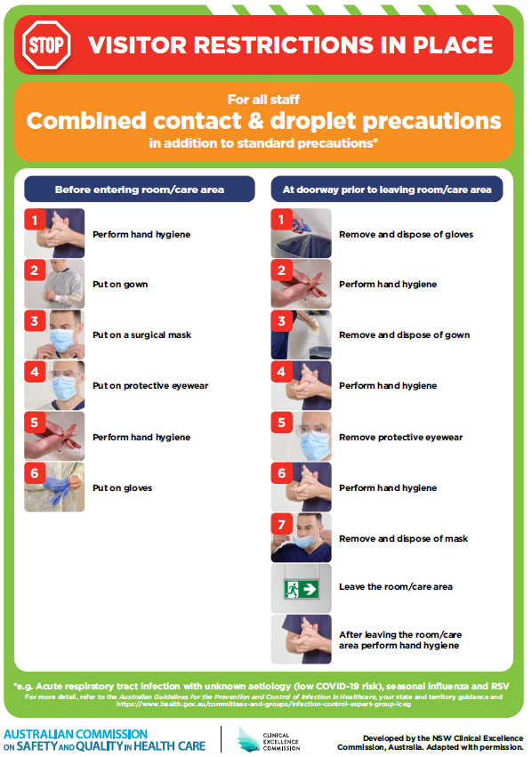](https://www.safetyandquality.gov.au/publications-and-resources/resource-library/poster-combined-contact-and-droplet-precautions)
* ***Poster – Combined airborne and contact precautions*** <https://www.safetyandquality.gov.au/publications-and-resources/resource-library/poster-combined-airborne-and-contact-precautions>   
  [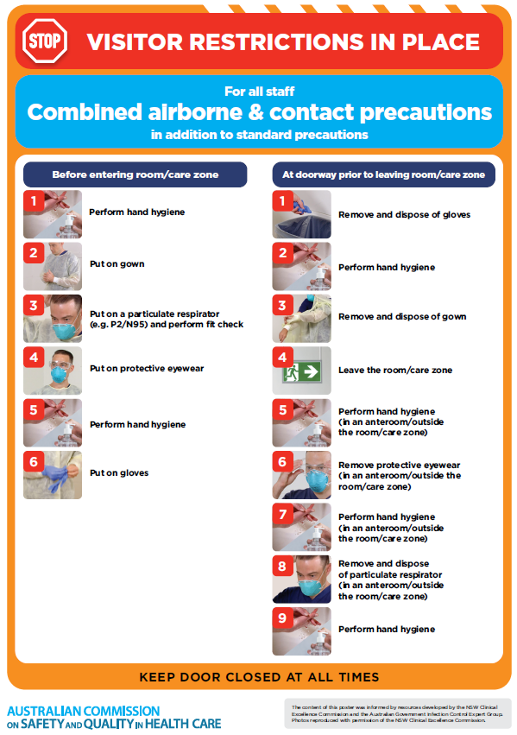](https://www.safetyandquality.gov.au/publications-and-resources/resource-library/poster-combined-airborne-and-contact-precautions)
* ***Environmental Cleaning and Infection Prevention and Control*** [www.safetyandquality.gov.au/environmental-cleaning](http://www.safetyandquality.gov.au/environmental-cleaning)
* ***COVID-19 infection prevention and control risk management – Guidance*** <https://www.safetyandquality.gov.au/publications-and-resources/resource-library/covid-19-infection-prevention-and-control-risk-management-guidance>
* ***Safe care for people with cognitive impairment during COVID-19***<https://www.safetyandquality.gov.au/our-work/cognitive-impairment/cognitive-impairment-and-covid-19>
* ***Stop COVID-19: Break the chain of infection*** posterhttps://www.safetyandquality.gov.au/publications-and-resources/resource-library/break-chain-infection-poster-a3  
  **[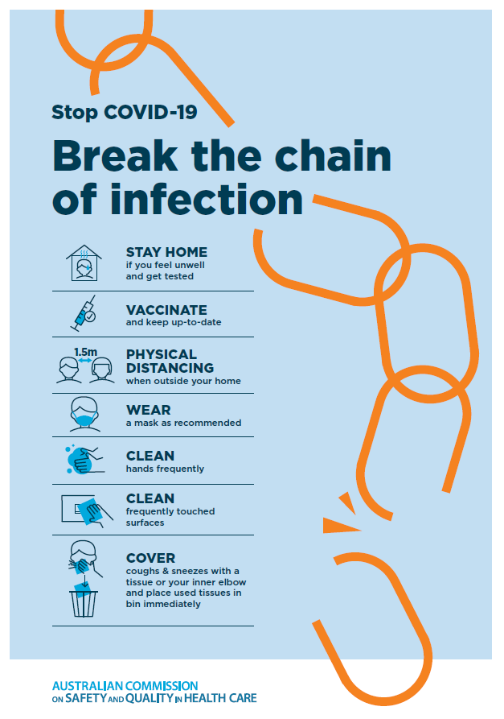](https://www.safetyandquality.gov.au/publications-and-resources/resource-library/break-chain-poster-a3https:/www.safetyandquality.gov.au/publications-and-resources/resource-library/break-chain-poster-a3)**
* ***FAQs for clinicians on elective surgery*** <https://www.safetyandquality.gov.au/node/5724>
* ***FAQs for consumers on elective surgery*** <https://www.safetyandquality.gov.au/node/5725>
* ***COVID-19 and face masks – Information for consumers*** <https://www.safetyandquality.gov.au/publications-and-resources/resource-library/covid-19-and-face-masks-information-consumers>

[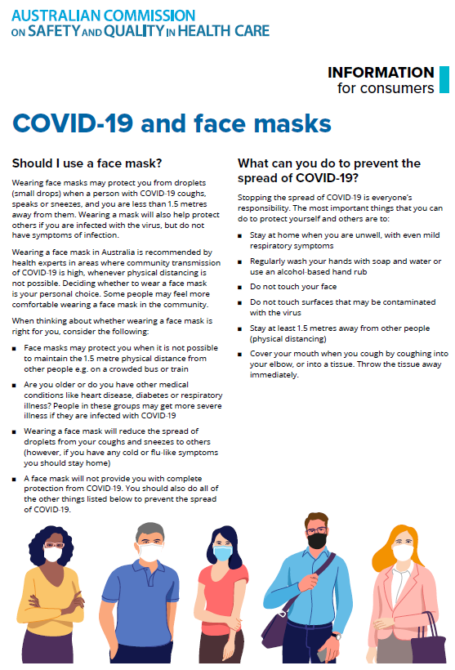](https://www.safetyandquality.gov.au/sites/default/files/2020-07/covid-19_and_face_masks_-_information_for_consumers.pdf)

*National COVID-19 Clinical Evidence Taskforce*

<https://covid19evidence.net.au/>

The National COVID-19 Clinical Evidence Taskforce is a collaboration of peak health professional bodies across Australia whose members are providing clinical care to people with COVID-19. The taskforce is undertaking continuous evidence surveillance to identify and rapidly synthesise emerging research in order to provide national, **evidence-based guidelines and clinical flowcharts for the clinical care of people with COVID-19**. The guidelines address questions that are specific to managing COVID-19 and cover the full disease course across mild, moderate, severe and critical illness. These are ‘living’ guidelines, updated with new research in near real-time in order to give reliable, up-to-the minute advice to clinicians providing frontline care in this unprecedented global health crisis.

*COVID-19 Critical Intelligence Unit*

<https://www.aci.health.nsw.gov.au/covid-19/critical-intelligence-unit>

The Agency for Clinical Innovation (ACI) in New South Wales has developed this page summarising rapid, evidence-based advice during the COVID-19 pandemic. Its operations focus on systems intelligence, clinical intelligence and evidence integration. The content includes a daily evidence digest, a COVID status monitor, a risk monitoring dashboard and evidence checks on a discrete topic or question relating to the current COVID-19 pandemic. There is also a ‘Living evidence’ section summarising key studies and emerging evidence on **COVID-19 vaccines** and **SARS-CoV-2 variants**. The most recent updates include:

* ***COVID-19 pandemic and influenza*** – What is the evidence for COVID-19 pandemic and influenza?
* ***Post-acute sequelae of COVID-19*** – What is the evidence on the post-acute sequelae of COVID-19?
* ***Budesonide and aspirin for pregnant women with COVID-19 –*** What is the evidence for the use of Budesonide for pregnant women with COVID-19? What is the evidence for aspirin prophylaxis for pre-eclampsia in pregnant women with a COVID-19 infection?
* ***Omicron (BA.2 sub-lineage)*** – What is the available evidence for the BA.2 sub-lineage of the Omicron variant of concern?
* ***COVID-19 vaccines in Australia*** – What is the evidence on COVID-19 vaccines in Australia?
* ***COVID-19 pandemic and wellbeing of critical care and other healthcare workers*** – Evidence in brief on the impact of the COVID-19 pandemic on the wellbeing of critical care and other healthcare workers.
* ***Surgery post COVID-19*** – What is the evidence for the timing of surgery, and outcomes following surgery, for people who have recovered from COVID-19?
* ***Disease modifying treatments for COVID-19 in children*** – What is the evidence for disease modifying treatments for COVID-19 in children?
* ***Mask type for COVID-19 positive wearer*** – What is the evidence for different mask types for COVID-19 positive wearers?
* ***Post acute and subacute COVID-19 care*** – What published advice and models of care are available regarding post-acute and subacute care for COVID-19 patients?
* ***Hospital visitor policies*** – What is the evidence for hospital visitor policies during and outside of the COVID-19 pandemic?
* ***Surgical masks, eye protection and PPE guidance*** –What is the evidence for surgical masks in the endemic phase in hospitals and for eyewear to protect against COVID-19?

**Disclaimer**

On the Radar is an information resource of the Australian Commission on Safety and Quality in Health Care. The Commission is not responsible for the content of, nor does it endorse, any articles or sites listed. The Commission accepts no liability for the information or advice provided by these external links. Links are provided on the basis that users make their own decisions about the accuracy, currency and reliability of the information contained therein. Any opinions expressed are not necessarily those of the Australian Commission on Safety and Quality in Health Care.