# Australian Commission on Safety and Quality logotypeOn the Radar

Issue 557

9 May 2022

*On the Radar* is a summary of some of the recent publications in the areas of safety and quality in health care. Inclusion in this document is not an endorsement or recommendation of any publication or provider. Access to particular documents may depend on whether they are Open Access or not, and/or your individual or institutional access to subscription sites/services. Material that may require subscription is included as it is considered relevant.

*On the Radar* is available online, via email or as a PDF or Word document from <https://www.safetyandquality.gov.au/publications-and-resources/newsletters/radar>

If you would like to receive *On the Radar* via email, you can subscribe on our website <https://www.safetyandquality.gov.au/publications-and-resources/newsletters>  
or by emailing us at H[Umail@safetyandquality.gov.auU](mailto:mail@safetyandquality.gov.au).   
You can also send feedback and comments to H[Umail@safetyandquality.gov.auU](mailto:mail@safetyandquality.gov.au).

For information about the Commission and its programs and publications, please visit <https://www.safetyandquality.gov.au>

You can also follow us on Twitter @ACSQHC.

**On the Radar**

Editor: Dr Niall Johnson [niall.johnson@safetyandquality.gov.au](mailto:niall.johnson@safetyandquality.gov.au)

Contributors: Niall Johnson, Jennifer Caldwell, Jan Gralton

***National Hand Hygiene Initiative factsheets***

<https://www.safetyandquality.gov.au/our-work/infection-prevention-and-control/national-hand-hygiene-initiative/materials-support-improved-hand-hygiene-australia>

Three new NHHI factsheets have been designed to provide information on the importance of hand hygiene for patients and carers, children and carers, and mental health workers.

These new factsheets are available on the Commission’s website, along with other resources, including posters, presentations and videos, at <https://www.safetyandquality.gov.au/our-work/infection-prevention-and-control/national-hand-hygiene-initiative/materials-support-improved-hand-hygiene-australia>

***Preventing and managing occupational exposure to infectious agents in healthcare eLearning module***

<https://nhhi.southrock.com>

The Australian Commission on Safety and Quality in Health Care continues to develop and support online learning for infection prevention and control (IPC) and hand hygiene for healthcare workers through its centralised online Learning Management System (LMS).

The Commission has recently updated the *Preventing and managing occupational exposure to infectious agents in healthcare* eLearning module to ensure consistency with the National Safety and Quality Health Service Standards, specifically the *Preventing and Controlling Infections Standard*, and the *Australian Guidelines for the Prevention and Control of Infection in Healthcare*. The module has also been developed to improve the learner experience.

The module is available in the National Hand Hygiene Initiative (NHHI) LMS at <https://nhhi.southrock.com>. Access to the NHHI LMS is free for all users and modules can be accessed after a learner has registered a profile on the system.

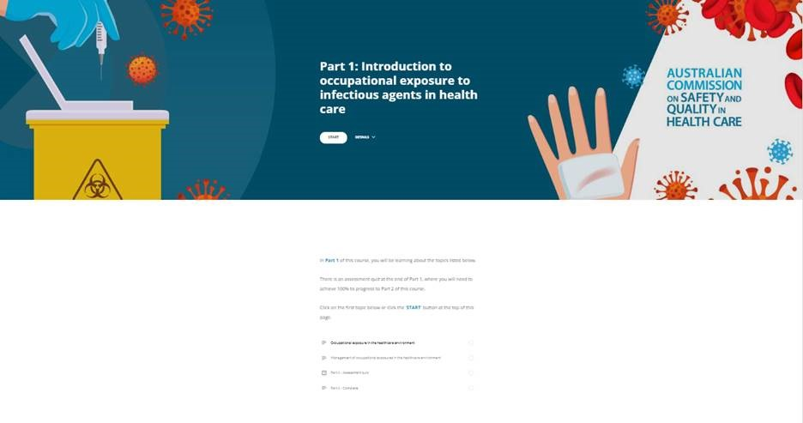

*Journal for Healthcare Quality*

Volume 44, Number 3, May/June 2022

|  |  |
| --- | --- |
| URL | <https://journals.lww.com/jhqonline/toc/2022/06000> |
| Notes | A new issue of the *Journal for Healthcare Quality* has been published. Articles in this issue of the *Journal for Healthcare Quality* include:   * Utilization of **Improvement Methodologies** by Healthcare Quality Professionals **During the COVID-19 Pandemic** (Lucie Pesch, Terry Stafford, Jaclyn Hunter, Glenda Stewart, Rebecca Miltner) * Methods of **Capturing Process Outcomes in Quality Improvement Trials**: A Systematic Review (Gorjana Radisic, Lenore de la Perrelle, K Laver) * **30-Day Readmission Reduction** in a Skilled Facility Population Through Pharmacist-Driven **Medication Reconciliation** (Marc Phillips, Megan Dillaman, Rebekah Matuga, Michael Sweet, N Lerfald, T Krupica, F Briggs) * **REadmission PREvention in SepSis**: Development and Validation of a Prediction Model (Ami A Grek, Emily R Rogers, Sarah H Peacock, Tonja M Hartjes, Launia J White, Zhuo Li, James M Naessens, Pablo M Franco) * Analysis of **Readmissions in a Mobile Integrated Health Transitional Care Program** Using Root Cause Analysis and Common Cause Analysis (Ivan Buitrago, Kristin L Seidl, Daniel B Gingold, David Marcozzi) * **Mitigating COVID-19 Vaccine Waste** Through a Multidisciplinary Inpatient Vaccination Initiative (Natalie Baumann, Sara Chen, Jay R McDonald, Matifadza Hlatshwayo Davis, Courtney Petroff, Patricia McKelvy) * **Opioid Prescribing Patterns** Among Orthopedic Hand Surgeons After Implementation of a Divisional Protocol (Emily M Pflug, Shengnan Huang, Jacques H Haquebord, Lorraine Hutzler, Nader Paksima) * Association of **Adverse Events in Opioid Addiction Treatment** With Quality Measure for Continuity of Pharmacotherapy (Ying Liu, Andrew Becker, Soeren Mattke) |

*Pediatric Quality & Safety*

Volume 7, Issue 2, March/April 2022

|  |  |
| --- | --- |
| URL | <https://journals.lww.com/pqs/toc/2022/03000> |
|  | A new issue of *Pediatric Quality & Safety* has been published. Articles in this issue of *Pediatric Quality & Safety* include:   * **Perioperative Pediatric Anxiety**: A Cry for Universal Scale Adoption (Romy Yun, Kristin M Kennedy, Thomas J Caruso) * **Reducing Imaging in Pediatric Appendicitis**: Another Surgeon’s Perspective (Richard A Falcone Jr) * A Standardized **Diagnostic Pathway for Suspected Appendicitis** in Children Reduces Unnecessary Imaging (Roshan J D’Cruz, Allison F Linden, C L Devin, J Savage, A Zomorrodi, K W Reichard, A Choudhary, L Berman) * Impact of the COVID-19 Pandemic on the Severity of **Diabetic Ketoacidosis Presentations** in a Tertiary Pediatric Emergency Department (Kaileen Jafari, Ildiko Koves, Lori Rutman, Julie C Brown) * Using Quality Improvement to Improve Identification and Documentation of **Malnutrition in Hospitalized Pediatric Patients** (Shea T Osburn, Mary Towne-Merritt, Roberta Baranda, Rhonda M Keosheyan) * A Pilot Quality Improvement Project to Reduce **Intraoperative MRI Hypothermia in Neurosurgical Patients** (Becky J Wong, Asheen Rama, Thomas J Caruso, Charles K Lee, Ellen Wang, Michael Chen) * Deimplementation of **Polycythemia Screening in Asymptomatic Infants** in a Level 1 Nursery (Scarlett C Johnson, Elizabeth Bigus, Patricia L Thompson, David G Bundy, Michelle I Amaya) * **De-escalation of High-flow Respiratory Support** for Children Admitted with Bronchiolitis: A Quality Improvement Initiative (Jennifer A Hoefert, A L Molina, H M Gardner, K H Miller, C L Wu, K Grizzle, K N Miller, M M Orr) * Minimizing the “Kitchen Sink” Approach: **De-implementation of Unnecessary Care for Patients with Anaphylaxis** in a Pediatric Emergency Department (L Vanston, K Ogawa, J Freeman, M Bauer, K Carel, I Topoz) * QI Project Promoting **NP Compliance with an AOM Bundle** in Pediatric Hospital-owned Retail Clinic (Kimberly R Joo, Kelly Sandberg, Bonnie Albertini, Lisa Sowar, Lisa S Ziemnik) * Parental Insights into **Improving Home Pulse Oximetry Monitoring in Infants** (Daria F Ferro, Christopher P Bonafide, Nicole Fregene, Halley Ruppel, Maria N. Nelson, Whitney Eriksen, Sara B. DeMauro) * Effect of a **Multispecialty Faculty Handoff Initiative** on Safety Culture and Handoff Quality (Katie M Fitzgerald, Taruna R Banerjee, Amy J Starmer, Gregory H Caplan, Mohammed Alkuwari, Debra F Hillier, Anne M Stack) * **Engagement and Bundle Compliance during COVID-19**: A Virtual Strategy (Richelle M Reinhart, Alia Fink, Sopnil Bhattarai, Jenhao Jacob Cheng, Anit Saha, Katherine Worten, Jessica Cronin, Rahul Shah) * Factors Influencing Health Equity of **Influenza Vaccination in Pediatric Patients** (Lane F Donnelly, M Wood, J Chantra, L Loh, B Burkart, G M Lee) * Trainee-led Engagement of the Care Team Improves Application of an Institutional **Blood Culture Clinical Decision Algorithm to Pediatric Oncology Inpatients**: A Single-institution Quality Improvement Project (Kathryn M Lemberg, Danielle W Koontz, David J Young, P G DiDomizio, A King, A R Chen, C J Gamper, E Colantuoni, A M Milstone, S L Cooper) * Improving **Diagnostic Accuracy for Distinguishing Buckle Fractures** From Other Distal Radius Fractures in Children (Lynne Ruess, Margarita Chmil, Satbir Singh, Julie B Samora) * An **Opioid Sparing Anesthesia Protocol** for Pediatric Open Inguinal Hernia Repair: A Quality Improvement Project (Jennifer L Chiem, Amber Franz, Nicholas Bishop, David Liston, Daniel K Low) * Improving Primary Care **Adolescent Depression Screening and Initial Management**: A Quality Improvement Study (Kristen E Beck, Dane Snyder, C Toth, C A Hostutler, J Tinto, T B Letostak, A Chandawarkar, A R Kemper) * **Slips, Trips, and Falls**: A Quality Improvement Initiative (Gene H. Peir, Alia Fink, Nick Mantasas, Jenhao J Cheng, Katherine Worten, Rahul K Shah) |

*Healthcare Quarterly*

Volume 25, Number 1, 2022

|  |  |
| --- | --- |
| URL | <https://www.longwoods.com/publications/healthcare-quarterly/26803/1/vol.-25-no.-1-2022> |
| Notes | A new issue of *Healthcare Quarterly* has been published. Articles in this issue of *Healthcare Quarterly* include:   * **Machine Learning Applied to Routinely Collected Health Administrative Data** (Laura C Rosella and Vinyas Harish) * Impact of the **COVID-19 Pandemic on the Health Workforce** in Canada (Amanda Tardif, Babita Gupta, Lynn McNeely and Walter Feeney) * **Legal Privilege Legislation**: Consequences for Patient Safety (Robert Robson, Carolyn Canfield, Darrell Horn, Allison Kooijman, Nelly D. Oelke, Sam Sheps, Ryan Sidorchuk and Fiona MacDonald) * Measuring **Board Impact on Hospital Finance and Quality** (L Hooper) * Commentary: **Is Your Organization Providing Quality Care?** (Janet M Davidson) * **Vested Contracting to Improve Patient Care and Promote Innovation** within a Newfoundland and Labrador Regional Health Authority (Scott Taylor and Michael Doyle) * Ready or Not: Key Insights to Enabling **Adolescents’ Access to Their Personal Health Information** (Nelson Shen, David McLay, Daria Ilkina, Valerie Gural, Iman Kassam and Abigail Carter-Langford) * **Key Healthcare Leadership Competencies**: Perspectives from Current Healthcare Leaders (Gillian Parker, Tina Smith, Christine Shea, Tyrone A. Perreira and Abi Sriharan) * A New Way Forward for **Primary Care Advancement**: A Case Study Review (Mira Backo-Shannon and Andrew Bilton) * **Cross-Training Nurses to Support an Intensive Care Unit** during a Pandemic: An Urban Community Hospital Experience (Jennifer Reguindin, Kim Capoccitti* and Victoria Serapion) |

*Health Affairs*

Volume 41, Number 5 (May 2022)

|  |  |
| --- | --- |
| URL | <https://www.healthaffairs.org/toc/hlthaff/41/5> |
| Notes | A new issue of *Health Affairs* has been published with the themes “Telemedicine, Disparities, Pharmaceuticals & More”. Articles in this issue of *Health Affairs* include:   * The **Aging Of The US Prison Population**: A Public Health Crisis (J S Bor) * **Subsidy Cliff** Looms; Fixing The Family Glitch (Katie Keith) * A Different Kind Of **First Responder** (Brian Rinker) * Medicare Beneficiaries In **Disadvantaged Neighborhoods Increased Telemedicine Use** During The COVID-19 Pandemic (Sanuja Bose, Chen Dun, George Q Zhang, Christi Walsh, Martin A Makary, and Caitlin W Hicks) * Policy Considerations To Ensure **Telemedicine Equity** (Elaine C Khoong) * Reducing **Disparities In Telemedicine**: An Equity-Focused, Public Health Approach (Jen Lau, and Janine Knudsen) * Medicare And **Telehealth**: Delivering On Innovation’s Promise For **Equity, Quality, Access, And Sustainability** (Meena Seshamani) * **End-Of-Life Care In Assisted Living Communities**: Race And Ethnicity, Dual Enrollment Status, And State Regulations (Helena Temkin-Greener, Wenhan Guo, Yechu Hua, Yue Li, Thomas Caprio, L Schwartz, and S Cai) * Disparities In The **Quality Of Clinical Care Delivered To American Indian/Alaska Native** Medicare Advantage Enrollees (Steven C Martino, Marc N Elliott, David J Klein, Ann Haas, Amelia M Haviland, John L Adams, Jacob W Dembosky, Jessica L Maksut, S J Gaillot, and R Weech-Maldonado) * Social Vulnerability And Outcomes For **Access-Sensitive Surgical Conditions** Among Medicare Beneficiaries (Yuqi Zhang, Nicholas Kunnath, Justin B Dimick, John W Scott, Adrian Diaz, and Andrew M Ibrahim) * Patterns Of **Food Security And Dietary Intake** During The First Half Of The Child Tax Credit Expansion (Elizabeth Adams, Tegwyn Brickhouse, Roddrick Dugger, and Melanie Bean) * **Home-Based Care Reimagined**: A Full-Fledged Health Care Delivery Ecosystem Without Walls (Christine Ritchie, and Bruce Leff) * Trends In The Use Of **Treatment For Substance Use Disorders**, 2010–19 (Brendan Saloner, Wenshu Li, S N Bandara, E E McGinty, and C L Barry) * **Prenatal Substance Use** Policies And Infant Maltreatment Reports (Johanna Catherine Maclean, A Witman, C P Durrance, D N Atkins, and A Meinhofer) * Unwanted Advice? Frequency, Characteristics, And Outcomes Of **Negative Advisory Committee Votes For FDA-Approved Drugs** (C Joseph Ross Daval, Ameet Sarpatwari, and Aaron S Kesselheim) * Changes In **Catastrophic Health Expenditures For Major Diseases** After A 2013 Health Insurance Expansion In South Korea (Hwa-Young Lee, Juhwan Oh, and Ichiro Kawachi) * **Aging In Jail**: Retrospective Analysis Of Older Patients In New York City’s Jail System, 2015–19 (Rachael Bedard, Zina Huxley-Reicher, Kelsey Burke, Ross MacDonald, and Patsy Yang) * **Price Effects Of Vertical Integration And Joint Contracting** Between Physicians And Hospitals In Massachusetts (Vilsa Curto, Anna D Sinaiko, and Meredith B Rosenthal) * **Resident Mortality And Worker Infection Rates From COVID-19** Lower In Union Than Nonunion US Nursing Homes, 2020–21 (Adam Dean, Jamie McCallum, Simeon D Kimmel, and Atheendar S Venkataramani) * In **Medicaid Managed Care Networks**, Care Is Highly Concentrated Among A Small Percentage Of Physicians (Avital B Ludomirsky, William L Schpero, Jacob Wallace, A Lollo, S Bernheim, J S Ross, and C D Ndumele) * Halfway Around The World, Echoes Of **Physician Moral Injury** (J Prior) |

*BMJ Quality & Safety* online first articles

|  |  |
| --- | --- |
| URL | <https://qualitysafety.bmj.com/content/early/recent> |
| Notes | *BMJ Quality &Safety* has published a number of ‘online first’ articles, including:   * Editorial: **Diagnosing diagnostic errors**: it’s time to evolve the patient safety research paradigm (David C Stockwell, Paul Sharek) * Editorial: **Transition of care from adult intensive care settings** – implementing interventions to improve medication safety and patient outcomes (Suzanne McCarthy, Raisa Laaksonen, Virginia Silvari) * Impact of **COVID-19 restrictions on diabetes health checks and prescribing for people with type 2 diabetes**: a UK-wide cohort study involving 618 161 people in primary care (Matthew J Carr, Alison K Wright, Lalantha Leelarathna, Hood Thabit, Nicola Milne, Naresh Kanumilli, Darren M Ashcroft, Martin K Rutter) |

*International Journal for Quality in Health Care* online first articles

|  |  |
| --- | --- |
| URL | <https://academic.oup.com/intqhc/advance-articles> |
| Notes | *International Journal for Quality in Health Care* has published a number of ‘online first’ articles, including:   * Development of a **Quality Assurance Tool for Intensive Care Units** in Lebanon During the COVID-19 Pandemic (Märit Halmin, Ghada Abou Mourad, Adam Ghneim, Alissar Rady, Tim Baker, Johan von Schreeb) * Training the **Next Generation of Journal Editors**: The Case for Editorial Apprenticeship Programmes (Erica Barbazza, David Crosby, Emily O’Dowd, Elom Otchi) |

**Online resources**

*Future Leaders Communiqué*

Volume 7 Issue 2 April 2022

<https://www.thecommuniques.com/post/future-leaders-communiqu%C3%A9-volume-7-issue-2-april-2022>

This issue of *Future Leaders Communiqué* focuses on sepsis with a case study of the preventable death of a six-year-old child from **sepsis**. The timely recognition and management of sepsis in children remains a significant challenge.

For information on the Commission’s work on sepsis, see <https://www.safetyandquality.gov.au/our-work/partnering-consumers/national-sepsis-program>

**COVID-19 resources**

https://www.safetyandquality.gov.au/covid-19

The Australian Commission on Safety and Quality in Health Care has developed a number of resources to assist healthcare organisations, facilities and clinicians. These and other material on COVID-19 are available at <https://www.safetyandquality.gov.au/covid-19>

These resources include:

* ***OVID-19 infection prevention and control risk management*** This primer provides an overview of three widely used tools for investigating and responding to patient safety events and near misses. Tools covered in this primer include incident reporting systems, Root Cause Analysis (RCA), and Failure Modes and Effects Analysis (FMEA).   
  <https://www.safetyandquality.gov.au/publications-and-resources/resource-library/covid-19-infection-prevention-and-control-risk-management-guidance>
* ***Poster – Combined contact and droplet precautions*** <https://www.safetyandquality.gov.au/publications-and-resources/resource-library/poster-combined-contact-and-droplet-precautions>  
  [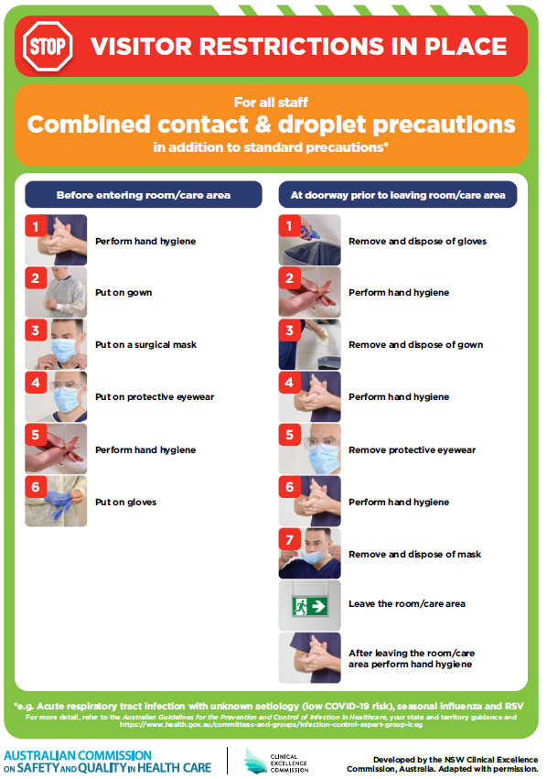](https://www.safetyandquality.gov.au/publications-and-resources/resource-library/poster-combined-contact-and-droplet-precautions)
* ***Poster – Combined airborne and contact precautions*** <https://www.safetyandquality.gov.au/publications-and-resources/resource-library/poster-combined-airborne-and-contact-precautions>   
  [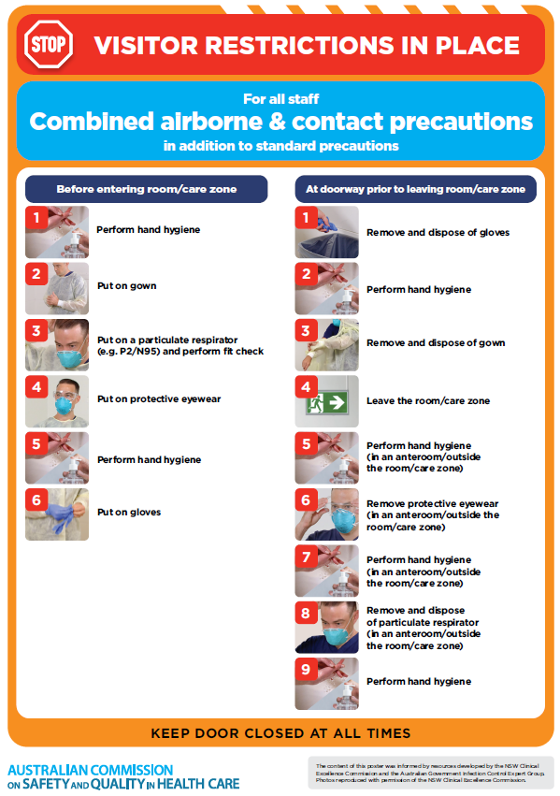](https://www.safetyandquality.gov.au/publications-and-resources/resource-library/poster-combined-airborne-and-contact-precautions)
* ***Environmental Cleaning and Infection Prevention and Control*** [www.safetyandquality.gov.au/environmental-cleaning](http://www.safetyandquality.gov.au/environmental-cleaning)
* ***COVID-19 infection prevention and control risk management – Guidance*** <https://www.safetyandquality.gov.au/publications-and-resources/resource-library/covid-19-infection-prevention-and-control-risk-management-guidance>
* ***Safe care for people with cognitive impairment during COVID-19***<https://www.safetyandquality.gov.au/our-work/cognitive-impairment/cognitive-impairment-and-covid-19>
* ***Stop COVID-19: Break the chain of infection*** posterhttps://www.safetyandquality.gov.au/publications-and-resources/resource-library/break-chain-infection-poster-a3  
  **[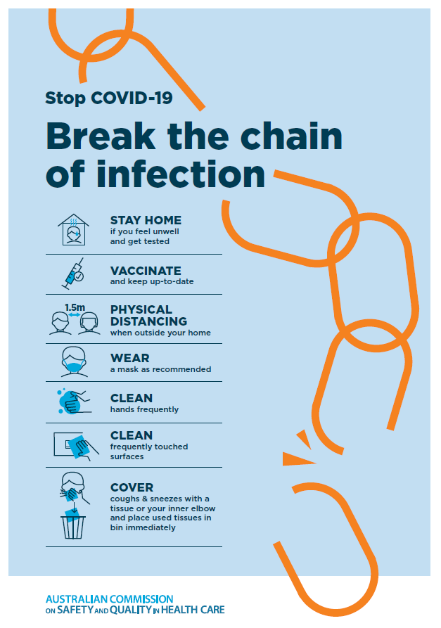](https://www.safetyandquality.gov.au/publications-and-resources/resource-library/break-chain-poster-a3https:/www.safetyandquality.gov.au/publications-and-resources/resource-library/break-chain-poster-a3)**
* ***FAQs for clinicians on elective surgery*** <https://www.safetyandquality.gov.au/node/5724>
* ***FAQs for consumers on elective surgery*** <https://www.safetyandquality.gov.au/node/5725>
* ***COVID-19 and face masks – Information for consumers*** <https://www.safetyandquality.gov.au/publications-and-resources/resource-library/covid-19-and-face-masks-information-consumers>

[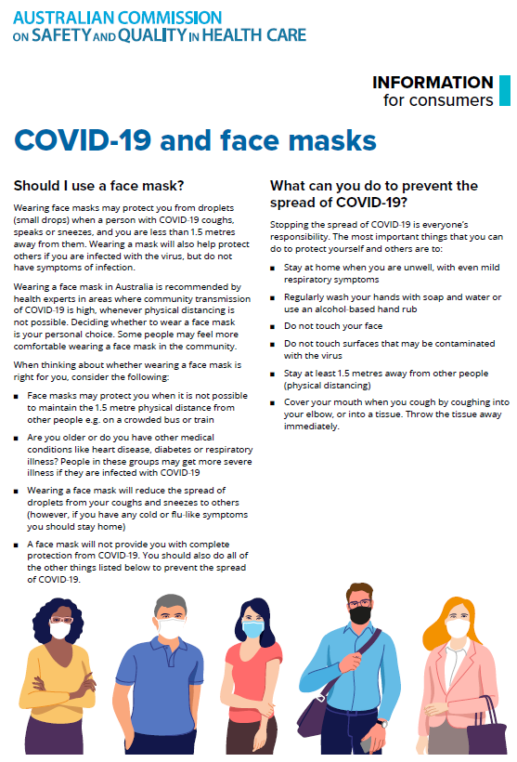](https://www.safetyandquality.gov.au/sites/default/files/2020-07/covid-19_and_face_masks_-_information_for_consumers.pdf)

*National COVID-19 Clinical Evidence Taskforce*

<https://covid19evidence.net.au/>

The National COVID-19 Clinical Evidence Taskforce is a collaboration of peak health professional bodies across Australia whose members are providing clinical care to people with COVID-19. The taskforce is undertaking continuous evidence surveillance to identify and rapidly synthesise emerging research in order to provide national, **evidence-based guidelines and clinical flowcharts for the clinical care of people with COVID-19**. The guidelines address questions that are specific to managing COVID-19 and cover the full disease course across mild, moderate, severe and critical illness. These are ‘living’ guidelines, updated with new research in near real-time in order to give reliable, up-to-the minute advice to clinicians providing frontline care in this unprecedented global health crisis.

*COVID-19 Critical Intelligence Unit*

<https://www.aci.health.nsw.gov.au/covid-19/critical-intelligence-unit>

The Agency for Clinical Innovation (ACI) in New South Wales has developed this page summarising rapid, evidence-based advice during the COVID-19 pandemic. Its operations focus on systems intelligence, clinical intelligence and evidence integration. The content includes a daily evidence digest, a COVID status monitor, a risk monitoring dashboard and evidence checks on a discrete topic or question relating to the current COVID-19 pandemic. There is also a ‘Living evidence’ section summarising key studies and emerging evidence on **COVID-19 vaccines** and **SARS-CoV-2 variants**. The most recent updates include:

* ***Chest pain or dyspnoea following COVID-19 vaccination*** – What is evidence for chest pain or dyspnoea following COVID-19 vaccination?
* ***Cardiac investigations and elective surgery post-COVID-19*** – What is evidence for cardiac investigations and elective surgery post-COVID-19?
* ***Breathlessness post COVID-19*** – How to determine those patients who present with ongoing breathlessness in need of urgent review or intervention due to suspected pulmonary embolus?
* ***COVID-19 pandemic and influenza*** – What is the evidence for COVID-19 pandemic and influenza?
* ***Post-acute sequelae of COVID-19*** – What is the evidence on the post-acute sequelae of COVID-19?
* ***Budesonide and aspirin for pregnant women with COVID-19 –*** What is the evidence for the use of Budesonide for pregnant women with COVID-19? What is the evidence for aspirin prophylaxis for pre-eclampsia in pregnant women with a COVID-19 infection?
* ***COVID-19 vaccines in Australia*** – What is the evidence on COVID-19 vaccines in Australia?
* ***COVID-19 pandemic and wellbeing of critical care and other healthcare workers*** – Evidence in brief on the impact of the COVID-19 pandemic on the wellbeing of critical care and other healthcare workers.
* ***Surgery post COVID-19*** – What is the evidence for the timing of surgery, and outcomes following surgery, for people who have recovered from COVID-19?
* ***Disease modifying treatments for COVID-19 in children*** – What is the evidence for disease modifying treatments for COVID-19 in children?
* ***Mask type for COVID-19 positive wearer*** – What is the evidence for different mask types for COVID-19 positive wearers?
* ***Post acute and subacute COVID-19 care*** – What published advice and models of care are available regarding post-acute and subacute care for COVID-19 patients?
* ***Hospital visitor policies*** – What is the evidence for hospital visitor policies during and outside of the COVID-19 pandemic?
* ***Surgical masks, eye protection and PPE guidance*** –What is the evidence for surgical masks in the endemic phase in hospitals and for eyewear to protect against COVID-19?

**Disclaimer**

On the Radar is an information resource of the Australian Commission on Safety and Quality in Health Care. The Commission is not responsible for the content of, nor does it endorse, any articles or sites listed. The Commission accepts no liability for the information or advice provided by these external links. Links are provided on the basis that users make their own decisions about the accuracy, currency and reliability of the information contained therein. Any opinions expressed are not necessarily those of the Australian Commission on Safety and Quality in Health Care.